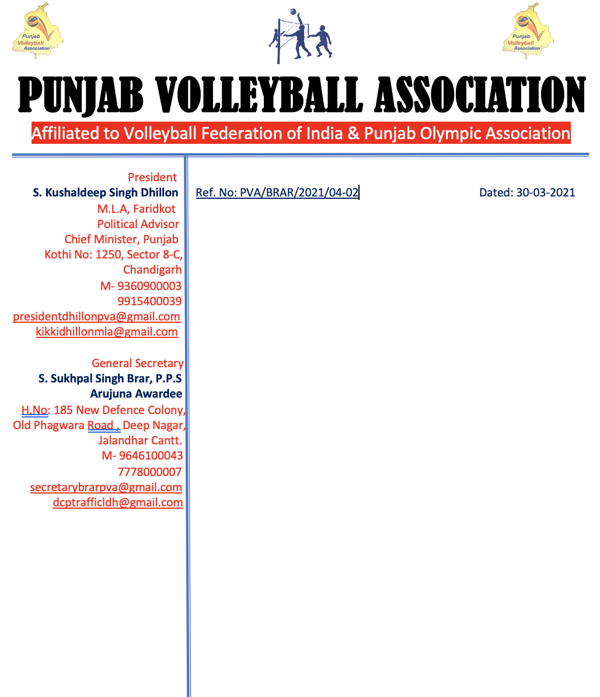

v`l:

spwrtn sports kMpnI

jlMDr

ivSw: tUrnwmYNt iv`c vwlIbwl Aqy nYt dyx sbMDI

auprokq ivSy dy sbMD iv`c Awp jI nUM d`isAw jWdw hY ik Awp jI nUM sInIAr styt vwlIbwl cYNpIAniSp (mrd Aqy AorqW) jo ik izlwH vwlIbwl AYsosIeySn, PrIdkot v``loN imqI 10 Aqy 11 ApRYl, 2021 idn SnIvwr Aqy AYqvwr nUM PrIdkot ivKy krvweI jw rhI hY Awp jI nUM ies tUrnwmYNt iv`c 10 vwlIbwl Aqy 04 nYt dyx dI ikrpwlqw kIqI jwvy jI[

DMnvwd sihq

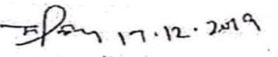

suKpwl isMG brwV, Arujnw AvwrfI

jnrl sk`qr

pMjwb vwlIbwl AYsoSIeySn