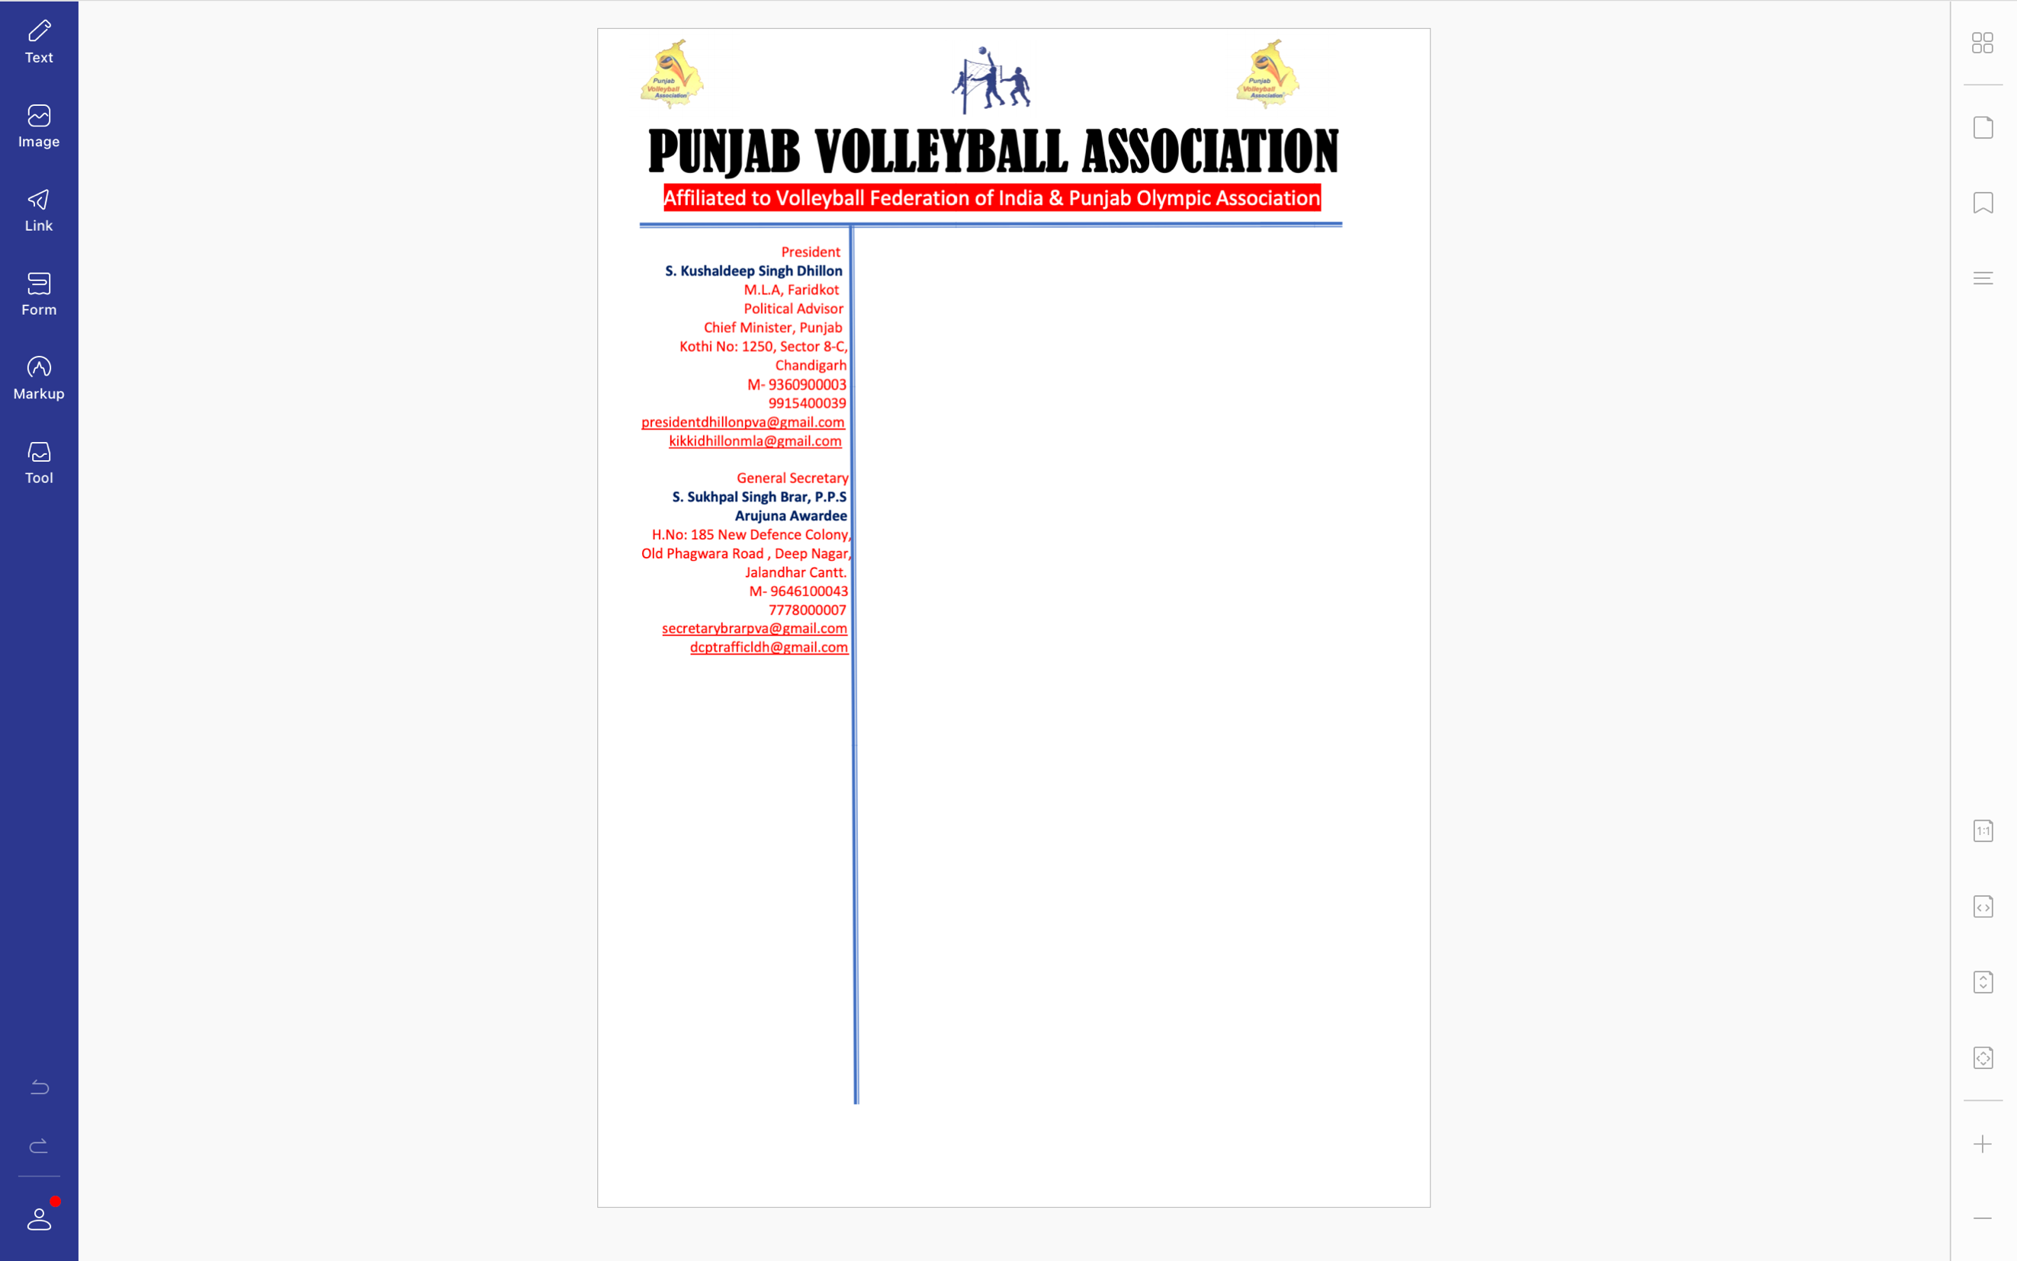



**Ref. PVA/BRAR/2021/Spl.-(2)/2010** Dated: 20-09-2021

v`l:

ipRMsIpl

sports skUl, Gu`dw

ivSw: cOx kmytI sbMDI (lVkIAW)

auprokq ivSy dy sbMD iv`c Awp jI nUM d`isAw jWdw hY ik Awp jI nUM sInIAr styt vwlIbwl cYNpIAniSp (mrd Aqy AorqW) jo ik izlwH vwlIbwl AYsosIeySn, PrIdkot v``loN imqI 1,2 Aqy 3 AkqUbr, 2021 idn Sukrvwr, SnIvwr Aqy AYqvwr nUM PrIdkot ivKy krvweI jw rhI hY ijs iv`c hyT ilKy mYNbr cOx kmytI iv`c hoxgy[

s. dlbIr isMG irtw. vwlIbwl koc ies cox kmytI dy cyArmYn hoxgy[

1. plivMdr kOr koc, sports ivBwg, jlMDr mYNbr
2. hukmjIq kOr koc, sports skUl, biTMfw mYNbr
3. gunjIq kOr koc, sports ivBwg, luiDAwxw mYNbr
4. rwjivMdr kOr koc, sports ivBwg, pitAwlw mNYbr
5. blijMdr kOr koc, sports skUl, Gu`dw mYNbr

**cox kmytI nUM hdwieq kIqI jWdI hY ik tIm dI cox inrOl mYirt qy Aqy inrp`K kIqI jwvy[ies dI irport s. dlbIr isMG nUM id`qI jwvy[**

DMnvwd sihq

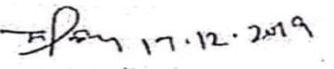

suKpwl isMG brwV, Arujnw AvwrfI

jnrl sk`qr

pMjwb vwlIbwl AYsoSIeySn