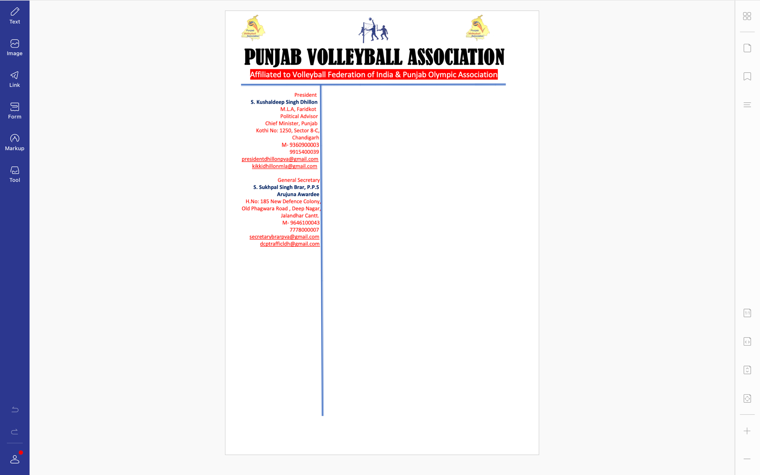



To,

S. Harcharan Singh Bhullar, I.P.S

Chief Patron

Punjab Volleyball Association

Sub: Invitation to the Senior State Volleyball Championship

Respected Sir,

Its an honour and privilege on behalf of the Punjab volleyball fraternity to invite you for the Senior State Volleyball Championship under your able and blessed patronage to be held from 1st to 3rd October, 2021 at Government Barjindra College Faridkot. I am, on behalf of all Volleyball fraternity, looking forward for your worthy presence and blessings, that you always shower for the upliftment of the game in state , to grace the occasion

Regards.

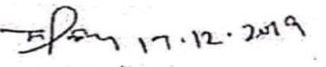

S. Sukhpal Singh Brar, Arjuna Awardee

General Secretary

Punjab Volleyball Association