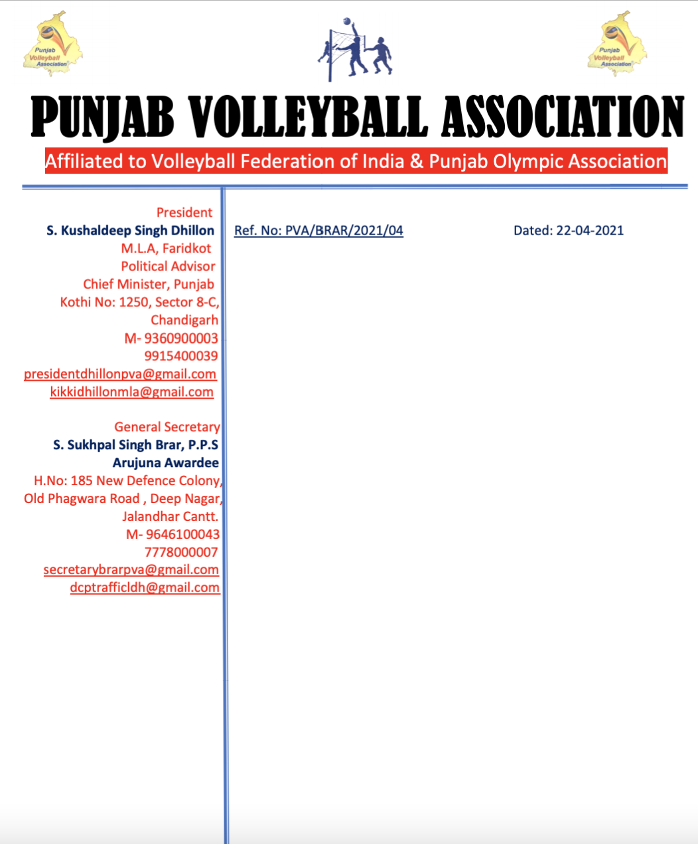

v`l:

sports APsr

pI.AY`s.pI.sI.A`Yl,

muK dPqr pitAwlw, pMjwb

ivSw: sInIAr styt vwlIbwl cYNpIAniSp (mrd Aqy AorqW)

auprokq ivSy dy sbMD iv`c Awp jI nUM d`isAw jWdw hY ik sInIAr styt vwlIbwl cYNpIAniSp (mrd Aqy AorqW) jo ik izlwH vwlIbwl AYsosIeySn, PrIdkot v``loN imqI 10 Aqy 11 ApRYl, 2021 idn SnIvwr Aqy AYqvwr nUM PrIdkot ivKy krvweI jw rhI hY[ swry mwnqw pRwpq izilHAW nUM hdwieq kIqI jWdI hY ik izlHy dIAW dono tImW (mrdW Aqy AOrqW) Sukrvwr imqI 09-04-2021 nUM PrIdkot ivKy phuMcxw XkInI bxwieAw jwvy [ hr tIm dw sports ik`t iv`c Kyfxw zrUrI hovygw[ vDyry jwxkwrI leI hyT ilKy nMbrW qy sMprk kIqw jw skdw hY[

s. blivMdr isMG 98723-35764

s. inrml isMG idaul 98761-54337

**nwl n`QI pRoPwrmw Br ky ilAwauxw lwzmI hY[**

DMnvwd sihq



suKpwl isMG brwV, Arujnw AvwrfI

jnrl sk`qr

pMjwb vwlIbwl AYsoSIeySn