Step1:-Azure-search-> databricks—select Azure Databricks
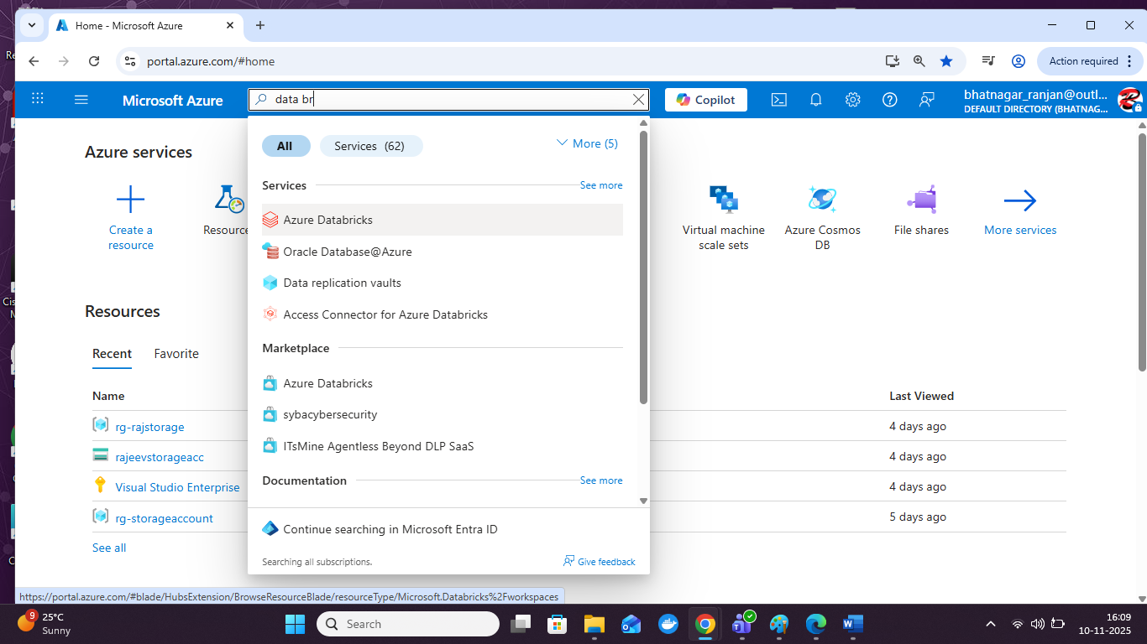
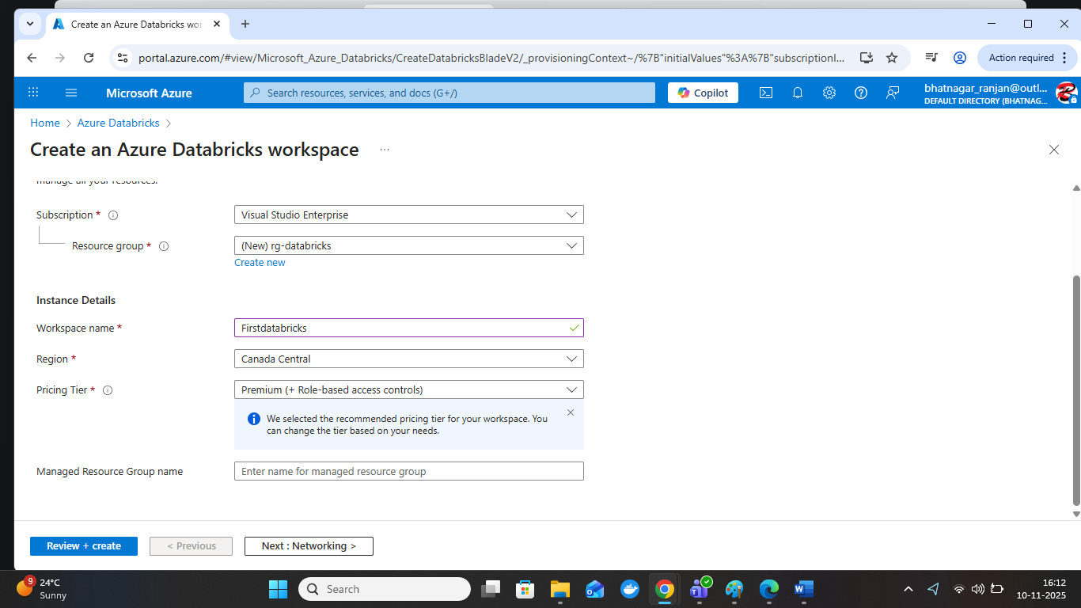

Create databrick also by Command prompts and power cell
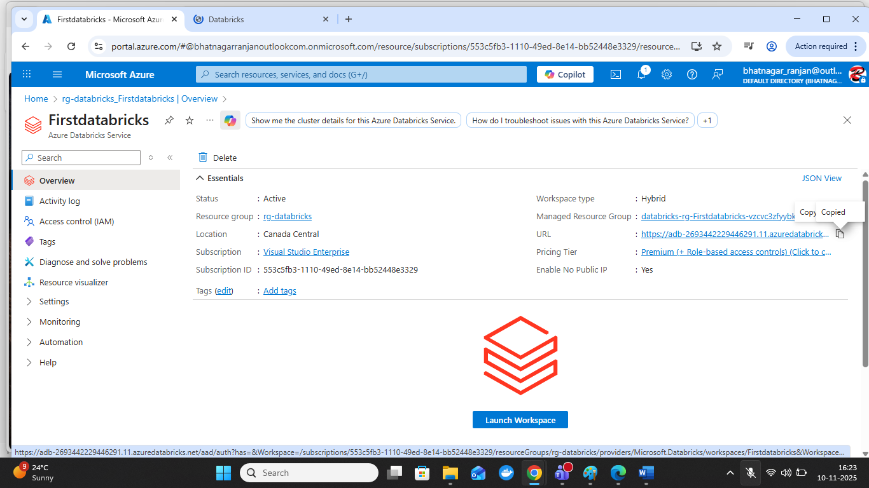
Click on Launch Workspace
Copy the URL
https://adb-2693442229446291.11.azuredatabricks.
Run on browser
open:-
