
M.V ORNAMENTS
NEXT IMPLEMENTATION PLAN
Developer Handoff - Production Completion Roadmap

Architecture | Hydrogen / React Router / TypeScript + Shopify Basic
Commerce | Shopify products, inventory, cart and hosted checkout
Catalogue | 600-700 SKUs planned
Document version | 1.0 - 16 August 2026
Purpose | Direct implementation instructions for the development team

INSTRUCTION TO DEVELOPER: Treat this document as the production roadmap. Preserve the approved visual direction; focus the next development cycle on commerce integration, routing, data architecture, MCX rate service, bulk orders, SEO, QA and launch readiness.

How to Use This Document
- P0 = launch blocker. Complete before any production launch.
- P1 = required for V1 quality and customer experience.
- P2 = can follow immediately after core commerce is stable.
- Do not upload all 600-700 SKUs until the 20-SKU pilot passes the complete browse -> cart -> checkout -> order flow.
- All dummy images/data must remain replaceable by Shopify data without redesigning React components.

Contents
1. Frozen Product & Architecture Decisions
2. Current Prototype Audit
3. Target Production Architecture
4. Completion Roadmap & Indicative Schedule
Phase 0 - Freeze, Backup & Repository Discipline
Phase 1 - Shopify Basic & Product Data Model
Phase 2 - Migrate Current UI to Hydrogen
Phase 3 - Routing & Global Page Shell
Phase 4 - Shopify Catalogue Integration
Phase 5 - Cart, Checkout & Payment Flow
Phase 6 - MCX Gold/Silver Rate Integration
Phase 7 - Bulk & Corporate Orders
Phase 8 - Internal Pages & Customer Journeys
Phase 9 - SEO, Analytics, Performance & Accessibility
Phase 10 - Full 600-700 SKU Migration
11. QA, UAT, Security & Launch
12. Post-Launch Stabilisation
13. Definition of Done / Acceptance Criteria
14. Inputs Required from M.V Ornaments
Appendices - Routes, Metafields, API Contracts & Technical References

1. Frozen Product & Architecture Decisions
DO NOT REOPEN VISUAL ARCHITECTURE: The homepage visual direction is approved enough to move from prototyping to production integration. Refinement is allowed, but do not rebuild the site from scratch.

Decision | Approved Direction | Developer Rule
Frontend | Hydrogen + React Router + TypeScript | Custom M.V UI remains fully controlled by the development team.
Commerce backend | Shopify Basic | Products, collections, variants, inventory, discounts, customers, orders and checkout.
Hosting | Shopify Oxygen | Use the Hydrogen channel/Oxygen deployment path unless the owner later approves a different host.
Checkout | Shopify hosted checkout | React cart redirects using the cart checkout URL returned by Shopify; no custom card-data handling.
Product count | 600-700 SKUs | Pilot with 20 representative SKUs first.
Market rates | MCX delayed website display | Fetch server-side through an authorised/licensed source; never hard-code production rates.
Bulk orders | Dedicated quote journey | Homepage entry + /pages/bulk-orders; retail checkout must not be the only bulk workflow.
Design system | Warm ivory + charcoal + champagne | Retain premium, light-commerce pages with dark editorial sections.

2. Current Prototype Audit
The uploaded project is a useful visual prototype, but it is not yet a production ecommerce system. The following findings are based on the current source package.
Priority | Task | Implementation Instruction | Definition of Done
P0 | No Shopify connection | Current package uses React/Vite with local dummy product data. | Replace dummy data layer with Shopify Storefront API through Hydrogen.
P0 | Cart is not real commerce | Cart drawer and product actions are prototype logic. | Implement Shopify cart creation, line add/update/remove, totals and persistence.
P0 | Checkout is not connected | Checkout button does not complete a Shopify checkout journey. | Use the Shopify cart checkout URL to redirect to hosted checkout.
P0 | MCX prices are hard-coded | MetalRates.jsx contains fixed gold/silver values and timestamp. | Replace with server-side delayed-rate service and resilient UI states.
P0 | Bulk order feature is missing | No homepage component, route, quote form or workflow exists. | Add homepage CTA + dedicated bulk orders page + server-side quote submission.
P1 | Routing is incomplete | Several footer/header links resolve to 404; generic collection routing is insufficient. | Implement explicit route map and correct collection/page templates.
P1 | SEO is SPA-level only | Static document title/meta are insufficient for product/collection routes. | Move to server-rendered route metadata, canonicals and structured data.
P1 | Asset paths risk production breakage | Current dummy product/banner assets are outside a robust production media workflow. | During migration use valid public/import paths; then replace product media with Shopify CDN assets.
P1 | Filters/search are prototype-level | UI exists but data behavior is not backed by Shopify metadata. | Define product metafields first, then implement real search/filter queries.
P2 | Wishlist persistence | Wishlist experience requires a defined persistence strategy. | V1: local persistence for guests; later optional customer-linked sync.

Current Source Files That Must Be Reworked
src/App.jsx - Replace SPA-only routing with Hydrogen/React Router route architecture and complete route map.
src/pages/Home.jsx - Keep visual composition; replace dummy collections/products and insert BulkOrderBanner.
src/components/MetalRates.jsx - Remove hard-coded values; consume /api/metal-rates data and handle loading/error/stale states.
src/data/dummy.js - Use only during pilot fallback; remove as production source of truth.
src/components/CartDrawer.jsx - Replace fake lines with Shopify cart state/actions.
src/pages/ProductDetail.jsx - Fetch Shopify product by handle; variants and availability must be real.
src/pages/ProductListing.jsx - Connect filters/sort/pagination to Shopify collection/search data.

3. Target Production Architecture
The frontend remains fully customised while Shopify becomes the source of truth for commerce. Custom services should be isolated server-side so the storefront is not tied directly to any market-data or third-party vendor format.
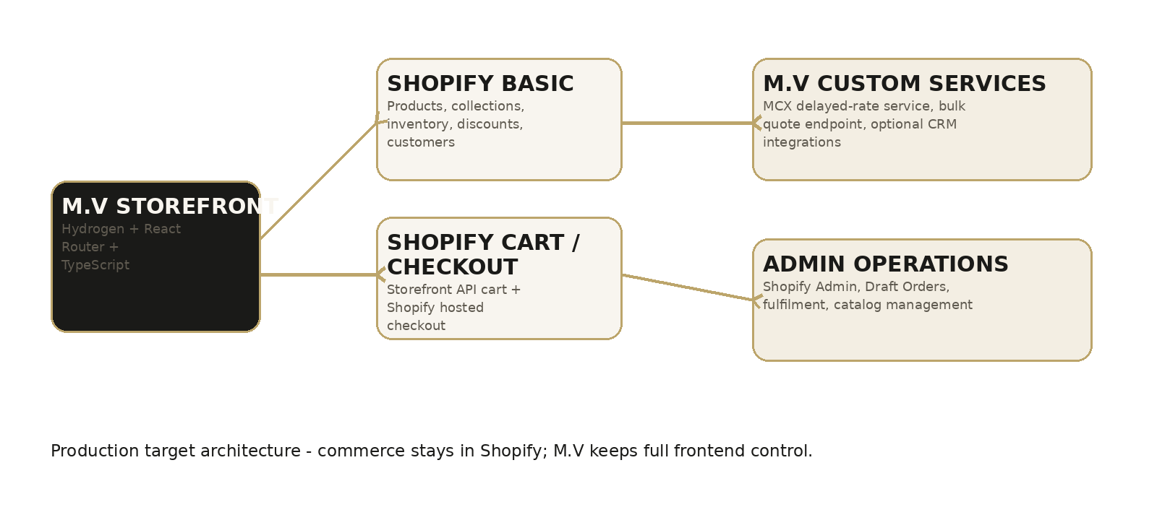
SECURITY RULE: Private Shopify tokens, MCX/provider credentials, Admin API credentials and other secrets must never be bundled into browser JavaScript or VITE_* variables.

Recommended Repository Structure
app/
components/
routes/
lib/
shopify/
metalRates.server.ts
bulkOrders.server.ts
graphql/
styles/
public/
assets/
brand/
editorial/
.env (local only; never committed)

4. Completion Roadmap & Indicative Schedule
Recommended sequence for one experienced developer or a small development team. The sequence is more important than the exact calendar. Product photography/data readiness can extend the schedule.
Window | Primary Work | Output | Gate
Days 1-2 | Freeze UI, Git backup, Shopify store/channel access | Stable baseline + migration branch | No new dummy features
Week 1 | Shopify product schema + Hydrogen migration | Current homepage running in Hydrogen/Oxygen | Build/deploy successful
Week 2 | Routes + 20-SKU pilot + PLP/PDP/search | Real Shopify catalogue browsing | Product/variant data correct
Week 3 | Cart + checkout + payment + customer state | End-to-end test order | Order appears in Shopify Admin
Week 4 | MCX delayed rates + Bulk Orders + internal pages | Custom service features complete | Error states and submissions verified
Week 5 | SEO, analytics, performance + 600-700 SKU import | Production catalogue | Data QA sample passes
Week 6 | UAT, responsive QA, security, launch rehearsal | Release candidate | Owner sign-off
Week 7-8 if required | Content/data cleanup, photography replacement, post-UAT fixes | Final production launch | No P0/P1 launch blockers
PHASE 0 | FREEZE, BACKUP & REPOSITORY DISCIPLINE
Objective: Protect the approved UI and stop accumulating prototype-only debt.
Priority | Task | Implementation Instruction | Definition of Done
P0 | Create a clean Git repository/branch strategy | Commit the current working prototype as a tagged baseline. Create a dedicated production-migration branch. Exclude node_modules, .env and local build output. | Current prototype can be restored at any time; secrets are not tracked.
P0 | Freeze homepage visual hierarchy | Do not redesign section order while commerce migration is underway. Only make agreed refinement fixes. | Homepage screenshot remains visually recognisable after migration.
P1 | Inventory reusable components | Mark components as reusable, to be migrated, or obsolete. Preserve Header, Hero, ProductCard, rails, banners, promise, story and footer where possible. | A component migration checklist exists before coding starts.
P1 | Clean build assets | Move temporary static assets into valid public/import paths so development builds do not silently rely on root files. | Production build contains all required temporary assets until Shopify media replaces them.
PHASE 1 | SHOPIFY BASIC & PRODUCT DATA MODEL
Objective: Make Shopify the source of truth before importing the full catalogue.

1.1 Shopify Store Setup
- Create/confirm Shopify Basic production store and staff/admin access.
- Install/configure the Hydrogen channel for the storefront.
- Create development/staging and production environment values separately.
- Configure store currency, India market, taxes/GST settings with the business/accounting team, shipping zones and checkout branding.
- Configure the approved India payment provider in Shopify Checkout after merchant KYC/onboarding is complete.
- Reserve main storefront domain and checkout subdomain/DNS plan; do not switch production DNS until UAT passes.

1.2 Product & Variant Schema - Define Before Import
Priority | Task | Implementation Instruction | Definition of Done
P0 | Create product categories/collections | At minimum: Silver Jewellery, Gold Jewellery, Rings, Necklaces, Earrings, Bracelets, New Arrivals, Bestsellers, Gifts. | Handles and navigation mapping are stable and documented.
P0 | Define SKU/variant rules | Use M.V SKU as primary internal SKU. Ring size/colour/purity variations must be variants rather than duplicated products where appropriate. | 20-SKU pilot proves all required variant patterns.
P0 | Create jewellery metafields | Create structured metafields for metal, purity, gross weight, net weight, stone type, stone colour, finish, gender, occasion, style, hallmark/certification information, care and dimensions. | PDP and filters read structured fields rather than parsing descriptions.
P1 | Create collection metafields | Optional fields for hero media, subtitle, SEO copy and collection editorial content. | Collection templates can render marketing content without hard-coded page-specific JSX.
P1 | Define product status/content rules | Draft products stay hidden; publish only complete products with price, inventory, primary image, SKU and required attributes. | No incomplete product can appear on storefront.

1.3 20-SKU Pilot Dataset
Do not begin the full 600-700 SKU upload yet. First create a representative pilot containing:
- 5 necklaces/pendants
- 5 rings including at least two size variants
- 4 earrings
- 3 bracelets
- 3 additional products with discount/out-of-stock/new-arrival cases
- At least 2 products with multiple variants
- At least 2 temporarily out-of-stock products
- At least 2 products with compare-at pricing
- At least 1 gold product if gold inventory is ready
PHASE 2 | MIGRATE CURRENT UI TO HYDROGEN
Objective: Retain the approved React UI but move it onto Shopify's headless commerce framework and server-rendered routing.
Priority | Task | Implementation Instruction | Definition of Done
P0 | Create Hydrogen app | Start a TypeScript Hydrogen/React Router project connected to the Shopify development storefront. | Local dev server reads real Shopify data and production build succeeds.
P0 | Migrate design system | Move global colours, typography, spacing tokens and reusable components into the Hydrogen project. | Homepage matches the existing prototype at desktop and mobile breakpoints.
P0 | Set server/client boundaries | Shopify private access and third-party secrets remain server-only. Client components receive only required public data. | No secret appears in built JS or browser network source code.
P1 | Deploy staging to Oxygen | Connect repository/deployment and create a shareable staging URL. | Owner can review every milestone on a stable staging site.
P1 | Add error boundaries | Implement route-level 404/500 behavior and graceful data failure UI. | Storefront never renders a blank screen on API failure.
PHASE 3 | ROUTING & GLOBAL PAGE SHELL
Objective: Create a stable route map so navigation, SEO and analytics can be implemented once.
Route | Template / Purpose
/ | Homepage
/collections/silver-jewellery | Silver landing/PLP
/collections/gold-jewellery | Gold landing/PLP
/collections/rings | Rings PLP
/collections/necklaces | Necklaces PLP
/collections/earrings | Earrings PLP
/collections/bracelets | Bracelets PLP
/collections/new-arrivals | New arrivals PLP
/collections/gifts | Gifting landing
/products/:handle | PDP
/search | Search
/wishlist | Wishlist
/cart | Cart
/account | Customer account entry
/pages/metal-rates | Metal rates
/pages/bulk-orders | Bulk & corporate orders
/pages/about-us | About M.V
/pages/contact-us | Contact
/pages/size-guide | Size guide
/pages/jewellery-care | Care guide
/pages/faqs | FAQ
/pages/shipping-policy | Shipping policy
/pages/returns-exchanges | Returns/exchanges
/pages/privacy-policy | Privacy
/pages/terms-conditions | Terms
PHASE 4 | SHOPIFY CATALOGUE INTEGRATION
Objective: Replace dummy products/collections with real Storefront API queries and reusable server-rendered data loading.
Priority | Task | Implementation Instruction | Definition of Done
P0 | Homepage collections | Map New Arrivals and Most Loved rails to Shopify collections/merchandising. Do not hard-code product arrays. | Changing a collection in Shopify Admin changes the homepage without code deployment.
P0 | Collection/PLP queries | Fetch collection by handle with pagination, prices, availability, product options and filter metadata. | PLP renders real products and pagination/load-more does not duplicate items.
P0 | PDP by handle | Fetch product, media, variants, selected options, price/compare-at price, availability and metafields. | PDP supports real variant selection and prevents invalid add-to-cart.
P1 | Search | Use Shopify storefront search; implement query parameter and no-results state. | Search is driven by Shopify data and URLs are shareable.
P1 | Filters & sorting | Map UI filters to Shopify product attributes/metafields; keep state in URL where practical. | Filters persist on refresh/back navigation and return correct products.
P1 | Image component | Use responsive Shopify images with proper dimensions, alt text, lazy loading below fold and no layout shift. | Product grid remains visually stable and fast on mobile.
PHASE 5 | CART, CHECKOUT & PAYMENT FLOW
Objective: Complete the full revenue path using Shopify cart state and hosted checkout.
Priority | Task | Implementation Instruction | Definition of Done
P0 | Cart creation/persistence | Create/retrieve Shopify cart and retain cart ID securely across sessions as supported by Hydrogen. | Refresh does not unexpectedly lose cart.
P0 | Add to bag | PDP/ProductCard adds the selected product variant with correct quantity. | Added item, price and variant match Shopify Admin.
P0 | Cart drawer | Display real line items, variants, images, quantity controls, remove action, discount/estimated totals. | Every drawer action updates Shopify cart and UI immediately.
P0 | Cart page | Use same cart source of truth; support gift message/attributes only if approved. | Cart drawer and cart page never disagree.
P0 | Checkout redirect | Retrieve Shopify Cart checkoutUrl and send customer to hosted Shopify checkout. | Test order completes and appears in Shopify Admin.
P0 | Payment test | Configure approved payment gateway in Shopify and execute test/small real transaction per gateway rules. | Success, failure and cancellation paths are understood and documented.
P1 | Order attribution/analytics | Ensure Hydrogen/storefront channel attribution and analytics events are present. | Purchase can be traced back to storefront channel and marketing analytics.
CHECKOUT RULE: Do not build a custom React card/UPI form. Shopify checkout/payment integrations should handle sensitive payment entry.

PHASE 6 | MCX GOLD & SILVER RATE INTEGRATION
Objective: Replace hard-coded prices with a compliant, server-side delayed market reference service.
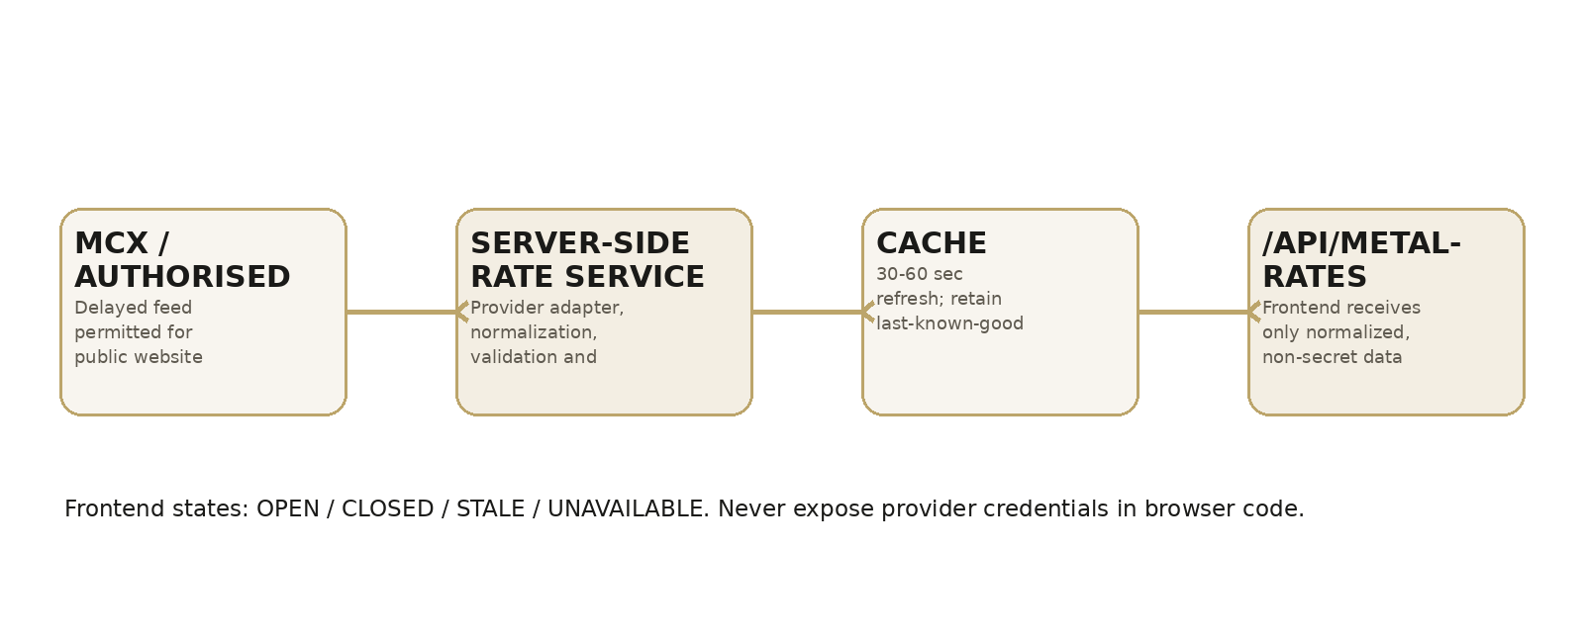

6.1 Business / Data Subscription Prerequisite
- M.V must obtain the required MCX data subscription/permission directly or through an authorised data distributor before public website display.
- For a public website, implement delayed MCX data, not a frontend claim of unrestricted real-time/live MCX data.
- Choose the exact Gold and Silver instruments/contracts to display and document the contract/expiry selection rule.
- Do not scrape exchange pages or use an undocumented third-party endpoint in production.

6.2 Server-Side Implementation
Priority | Task | Implementation Instruction | Definition of Done
P0 | Provider adapter | Create metalRates.server.ts that fetches the approved provider/MCX feed and maps vendor-specific fields into M.V normalized fields. | Changing vendor requires changing adapter, not UI components.
P0 | Cache and refresh | Cache the delayed rate; target 30-60 second internal refresh unless the provider agreement/API specifies otherwise. | 100 visitors do not trigger 100 provider calls.
P0 | Validation | Reject missing/negative/obviously malformed prices and timestamps. Keep last-known-good response with status STALE when appropriate. | Bad vendor payload never displays ₹0 or corrupt values.
P0 | API endpoint | Expose a storefront endpoint such as /api/metal-rates containing normalized non-secret data only. | Browser response contains no API key/token.
P0 | Status handling | Return marketStatus OPEN/CLOSED/STALE/UNAVAILABLE plus updatedAt and delayMinutes. | Frontend communicates data freshness clearly.
P1 | Rate page | Create /pages/metal-rates with market-reference explanation, timestamp, selected contract/expiry details and disclaimer. | Customer can distinguish MCX market reference from M.V jewellery selling price.
P1 | Logging/alerts | Log provider failures and repeated stale data; optional error monitoring. | Operations team can diagnose rate outages.

6.3 Normalized API Contract
GET /api/metal-rates
{
"source": "MCX",
"feedType": "delayed",
"delayMinutes": 1,
"marketStatus": "open",
"updatedAt": "2026-08-16T17:03:00+05:30",
"gold": {
"symbol": "GOLD",
"expiry": "YYYY-MM-DD",
"price": 0,
"unit": "10g",
"change": 0,
"changePercent": 0
},
"silver": {
"symbol": "SILVER",
"expiry": "YYYY-MM-DD",
"price": 0,
"unit": "kg",
"change": 0,
"changePercent": 0
}
}

6.4 Homepage Component States
- OPEN: show rates, change %, MCX • DELAYED and last-updated time.
- CLOSED: show last market rate and MARKET CLOSED; do not animate as if values are moving.
- STALE: show last available rate + “Last updated …” and a subtle stale indicator.
- UNAVAILABLE: show “Market data temporarily unavailable”; never substitute zero or a made-up rate.
PRICING DISTINCTION: MCX reference rates must not be presented as the final selling price of M.V jewellery. Product prices include product-specific purity, weight, making/stone costs, taxes and business pricing rules.

PHASE 7 | BULK & CORPORATE ORDERS
Objective: Add the missing B2B entry point and quote workflow without damaging the premium retail journey.
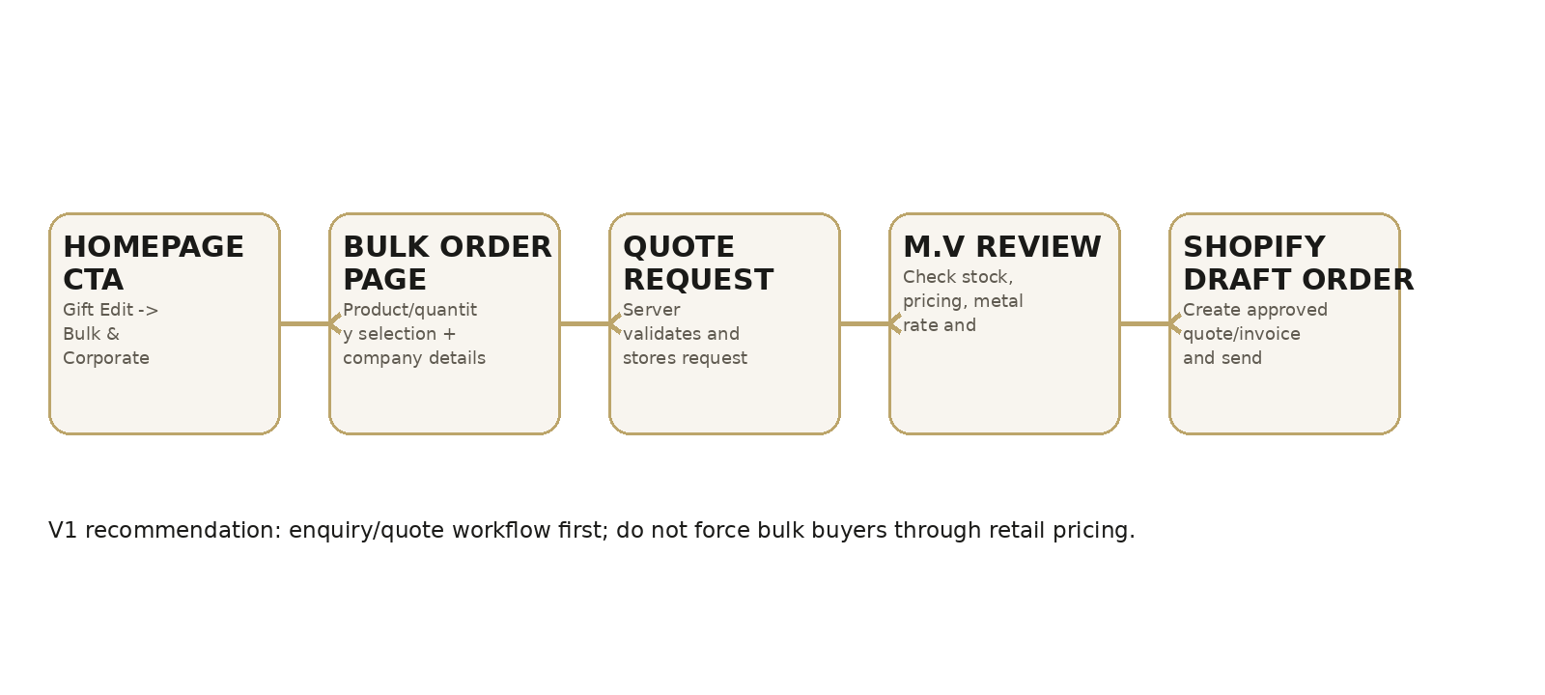

7.1 Homepage Placement
Insert the new section in Home after GiftBanner and before PromiseSection:
<OccasionGrid />
<GiftBanner />
<BulkOrderBanner />
<PromiseSection />
<BrandStory />

7.2 Homepage Content
Eyebrow: FOR BUSINESS & CELEBRATIONS
Heading: Bulk & Corporate Jewellery Orders
Body: Planning corporate gifting, wedding jewellery, retail requirements or a large-volume purchase? M.V Ornaments offers personalised assistance for bulk orders and special requirements.
Primary CTA: REQUEST A BULK QUOTE
Route: /pages/bulk-orders

7.3 Quote Form Fields
- Full name *
- Company/organisation
- Phone *
- Email *
- GSTIN
- City *
- Business type: Corporate / Retailer / Distributor / Wedding-Event / Personal / Other
- Expected quantity: 25-50 / 50-100 / 100-250 / 250-500 / 500+
- Products interested in / selected products and quantities
- Required-by date
- Custom packaging: Yes/No
- Additional requirements
- Consent/acknowledgement checkbox if required by privacy policy

7.4 Recommended V1 Processing
1. Submit through a server-side endpoint; validate and rate-limit the request.
2. Store request in an approved database/CRM or send structured email to the sales/admin team; avoid only client-side mailto behavior.
3. M.V team reviews stock, requested quantity, delivery date and market/pricing conditions.
4. After approval, create a Shopify Draft Order manually in Shopify Admin and send the approved invoice/checkout link to the buyer.
5. Automate Draft Order creation later only after V1 process and permissions are stable.
PHASE 8 | INTERNAL PAGES & CUSTOMER JOURNEYS
Objective: Complete every route already exposed by the navigation/footer and make each page production-ready.
Page / Template | Minimum V1 Content
Silver/Gold landing | Editorial hero, category discovery, featured collection, SEO copy.
Category PLP | Breadcrumb, H1, count, filters, sort, 2-column mobile / 4-column desktop target, load-more/pagination.
PDP | Media gallery, price, variant/size, availability, delivery check placeholder/integration, add to bag, details accordions, recommendations.
Search | Search box, results count, product grid, related terms, empty state.
Wishlist | Persistent saved products, add-to-bag, empty state. V1 guest persistence may use local storage.
Account | Customer account entry and order history using Shopify-supported customer account architecture.
Gifting | Recipient/occasion/budget discovery and premium gifting content.
Metal Rates | MCX reference data, explanation and disclaimer.
Bulk Orders | Dedicated quote page/form as defined above.
About | Brand story, Quality With Creativity, values and craftsmanship.
Size Guide | Ring/bracelet/necklace measuring instructions.
Jewellery Care | Silver/gold/stone care content.
Contact / FAQ | Support channels and accordion FAQ.
Policy pages | Shipping, returns, privacy, terms; content supplied/approved by M.V, not invented by developer.
404 / error | Premium empty state with home/shop links.
PHASE 9 | SEO, ANALYTICS, PERFORMANCE & ACCESSIBILITY
Objective: Make the custom React storefront indexable, measurable, fast and usable before the catalogue scales.
Priority | Task | Implementation Instruction | Definition of Done
P0 | Route metadata | Unique title, meta description, canonical and robots behavior for home, collection, product and content routes. | No important route shares only the homepage metadata.
P0 | Server-rendered commerce content | Important product/collection title, price, availability and copy must be present in server-rendered HTML. | View-source/server response contains core page content.
P1 | Structured data | Add valid Organization/WebSite on site level; Product/Offer/BreadcrumbList on applicable pages. | Schema validation has no critical errors.
P1 | Analytics | Track view_item_list, select_item, view_item, add_to_cart, view_cart, begin_checkout, purchase, search, wishlist, metal_rate_view and bulk_order_submit. | Events fire once with correct product/value context.
P1 | Performance | Optimise hero and product media, lazy-load below fold, reserve image dimensions, avoid unnecessary client JS and large app bundles. | Mobile release candidate passes agreed performance review/Core Web Vitals target.
P1 | Accessibility | Semantic headings, keyboard navigation, visible focus, labels, alt text, contrast and usable touch targets. | Critical purchase journey can be completed by keyboard and basic accessibility audit passes.
P1 | Sitemap/robots | Ensure Shopify/headless routing has production sitemap and correct robots behavior. | Published products/collections are discoverable; staging is not indexed.

Homepage SEO Content Baseline
Title: M.V Ornaments | Premium Silver & Gold Jewellery Online
H1: Modern Jewellery, Crafted to Shine
Meta description: Shop premium silver and gold jewellery at M.V Ornaments. Discover elegant rings, necklaces, earrings, bracelets, gifts and contemporary designs crafted for every occasion.
PHASE 10 | FULL 600-700 SKU MIGRATION
Objective: Scale the catalogue only after the pilot proves the data model and commerce path.

10.1 Import Gate
Proceed to full import only when all of the following are true:
- 20 pilot SKUs display correctly on PLP/PDP
- Variants and inventory behave correctly
- Cart and checkout complete successfully
- Metafields drive filters and product details
- Shopify images display correctly with no broken asset paths
- SEO metadata is generated per product/collection
- Owner has approved naming, price and product-data conventions

10.2 Full Import Process
1. Clean and validate master product spreadsheet.
2. Generate/import Shopify-compatible product data in controlled batches (for example 100-150 products at a time).
3. Attach correct media and alt text.
4. Assign collections/tags/metafields.
5. Spot-check every batch before proceeding.
6. Reconcile SKU counts, inventory and pricing between source sheet and Shopify.
7. Publish only complete products.

10.3 Data Quality Checks
- Duplicate SKU
- Duplicate handle
- Missing primary image
- Missing price
- Invalid compare-at price
- Inventory mismatch
- Incorrect metal/purity
- Variant size mapping
- Incorrect collection
- Broken alt text / filename dependency
- Out-of-stock behavior
- Product draft/published status

11. QA, UAT, Security & Launch
LAUNCH GATE: Do not switch the main domain until all P0 issues are closed and M.V has completed a successful end-to-end test order on the release candidate.

11.1 Device / Browser Matrix
- Mobile: 360, 375, 390, 412/430 px representative widths
- Tablet: portrait and landscape representative devices
- Desktop: 1366 and 1440+ widths
- Chrome, Safari/WebKit, Edge; current mainstream mobile browser engines
- Real-device test for at least one iPhone and one Android device if available

11.2 Commerce UAT Scenarios
- Browse home -> silver -> ring -> PDP
- Select ring size -> add to bag
- Update quantity -> remove -> re-add
- Discounted product compare-at pricing
- Out-of-stock variant cannot be purchased
- Search exact and broad term
- Apply filters/sort and use browser back button
- Wishlist save/remove
- Begin checkout as guest
- Successful payment/order
- Payment failure/cancel then return
- Order confirmation and Shopify Admin order record
- Metal rate normal/closed/unavailable state
- Bulk quote submission and admin receipt
- 404 and broken-route check
- Policy/footer links

11.3 Security / Release Checklist
- No secrets in client bundle or repository
- Production environment values configured in Shopify/Oxygen
- Staging environment protected from search indexing
- Forms have validation and anti-spam/rate limiting
- MCX/provider endpoint is server-side and cached
- Checkout uses Shopify URL and HTTPS
- Error messages do not expose tokens/internal stack details
- Remove unused prototype packages/assets and console debug logs
- Run dependency/security review before launch
- Back up product master data before bulk import

11.4 DNS & Launch Sequence
1. Freeze production content changes during final launch window.
2. Run final build and staging UAT.
3. Confirm Shopify checkout/payment production mode.
4. Configure main storefront domain to Hydrogen/Oxygen.
5. Configure checkout domain/subdomain according to Shopify headless setup and final DNS plan.
6. Verify SSL, redirect rules, canonical host and www/non-www behavior.
7. Place one live low-value order and verify order, email and fulfilment workflow.
8. Monitor logs, checkout conversion and error rate closely for the first 48 hours.

12. Post-Launch Stabilisation
- Daily error/log review for first 7 days
- Verify MCX timestamps and stale-state behavior each trading day
- Check failed search terms and zero-result queries
- Review abandoned-cart/checkout behavior
- Review top collection/product traffic and mobile conversion
- Fix broken images/metadata found after full catalogue indexing
- Confirm bulk quote submissions are reaching the assigned team
- Schedule first performance and SEO review after enough production traffic exists

13. Definition of Done / Acceptance Criteria
Area | Acceptance Requirement
Architecture | Production storefront runs on Hydrogen/React Router/TypeScript and is deployed to an approved production host/Oxygen.
Shopify | Products, collections, inventory, prices and variants are read from Shopify; dummy.js is not production source of truth.
Catalogue | 600-700 SKUs can be managed from Shopify Admin without developer edits to product data.
Cart | All cart actions modify a real Shopify cart and survive expected navigation/refresh behavior.
Checkout | Checkout uses Shopify hosted checkout and at least one production/test transaction has been verified.
MCX | Metal rate widget uses an approved delayed source server-side, shows freshness/status and has a metal-rates detail page.
Bulk | Homepage contains a visible Bulk & Corporate Orders entry; quote form submits successfully and has an operational business follow-up path.
Routes | All header/footer links resolve to intentional pages; no accidental 404s.
SEO | Important routes have unique metadata/canonicals; product/collection content is server-rendered and structured data is present.
Responsive | Core journeys are approved on mobile-first widths and desktop.
Performance | Images and JS are optimised and the release candidate passes the agreed mobile performance review.
Security | No credentials/secrets in client bundle; forms and custom APIs are server-side validated.
Operations | M.V staff can add/edit a product, update stock/price and see the storefront change without developer intervention.

14. Inputs Required from M.V Ornaments
The developer cannot complete production without the following owner/business inputs. Track these in parallel with development.
Input | Required from M.V
Shopify | Store/admin access; business/KYC details; approved plan.
Domain | Final domain/registrar access and DNS approval.
Payments | Selected gateway account/KYC and settlement details.
MCX data | Approved direct subscription or authorised data provider credentials/agreement.
Product master | Validated 600-700 SKU sheet with names, SKUs, prices, inventory, categories, attributes and variants.
Photography | Final product images and campaign/banner assets; dummy images may remain only until replacement.
Policies | Approved shipping, return/exchange, cancellation, privacy and terms content.
Shipping | Serviceable regions, shipping fees/free-shipping thresholds, courier/aggregator decision and tracking workflow.
Bulk orders | Sales contact/email, quote approval owner, MOQ/pricing policy and SLA for replying to enquiries.
Brand/contact | Customer support phone, WhatsApp, email, social links and business address/required disclosures.

Immediate Next Sprint - Developer Action List
RECOMMENDED NEXT ACTION: The next sprint should be integration-first, not more dummy-page design. Complete the following tasks in order and demo each gate on staging.

Priority | Task | Implementation Instruction | Definition of Done
P0 | 1. Backup and tag current prototype | Create Git baseline and migration branch. | Baseline can be restored.
P0 | 2. Create Shopify Basic/Hydrogen staging | Connect Hydrogen channel and deploy minimal storefront to Oxygen/staging. | Staging URL is live.
P0 | 3. Define metafields + 20 pilot products | Build product schema and load representative products. | Pilot data covers variants, discount and stock states.
P0 | 4. Migrate homepage shell | Port existing approved components; preserve visual direction. | Homepage looks like prototype on staging.
P0 | 5. Replace dummy homepage data | New Arrivals/Most Loved/categories read Shopify collections. | Admin merchandising changes storefront.
P0 | 6. Build real PLP/PDP | Real Shopify data, variants, media, filters/pagination. | Browse to real products reliably.
P0 | 7. Implement cart + checkout | Shopify cart and hosted checkoutUrl. | Successful order reaches Admin.
P0 | 8. Add BulkOrderBanner + page | Insert section after GiftBanner and build quote endpoint/form. | Test quote reaches business team.
P0 | 9. Implement MCX server service | Use authorised delayed source, cache, status/error handling. | Homepage no longer hard-coded.
P1 | 10. Finish routes + SEO + analytics | Resolve footer pages and route metadata/events. | No broken links; measurable journeys.
P1 | 11. Full catalogue batch import | Import after pilot sign-off. | SKU count and data audit pass.
P0 | 12. UAT and launch rehearsal | Run all launch scenarios before DNS. | Owner signs release candidate.

Appendix A - Recommended Shopify Metafields
Metafield | Type | Use
custom.metal | Single line text / reference | Silver, Gold
custom.purity | Single line text | 925, 18K, 22K, etc.
custom.gross_weight | Decimal + unit | Display on PDP
custom.net_weight | Decimal + unit | If operationally maintained
custom.stone_type | Single line/list | CZ, zircon, etc. as actual data permits
custom.stone_colour | Single line/list | White, Green, etc.
custom.finish | Single line | High polish, rhodium plated, etc.
custom.style | Single line/list | Minimal, Floral, Statement, Classic
custom.occasion | List | Everyday, Festive, Wedding, Gift
custom.gender | Single line/list | As applicable
custom.hallmark | Single line / boolean / reference | Only factual verified information
custom.dimensions | Multi-line / structured | Length, width, pendant size
custom.care | Multi-line text | Product care instructions

Appendix B - Bulk Quote Data Object (Suggested)
{
"requestId": "BULK-2026-0001",
"createdAt": "ISO_TIMESTAMP",
"name": "",
"company": "",
"phone": "",
"email": "",
"gstin": "",
"city": "",
"businessType": "corporate|retailer|distributor|event|personal|other",
"quantityBand": "",
"items": [{"productId":"","variantId":"","sku":"","quantity":0}],
"requiredBy": "YYYY-MM-DD",
"customPackaging": false,
"notes": "",
"status": "new"
}

Appendix C - Technical Reference Notes
Technical assumptions in this plan were checked against official documentation on 16 August 2026. The development team should re-check current documentation during implementation, especially before production launch.
- Shopify Developer - Options for building headless
- Shopify Developer - Create and update a cart with the Storefront API
- Shopify Developer - Storefront API
- MCX - Datafeed

