https://itlinfosys.udemy.com
What is Rest Assured?
Rest-Assured is a Java-based library that is used to test RESTful Web Services/API’s.
3 simple steps to setup Rest Assured Project:
- Install java and set in system variables
- Install Eclipse and Create Java Maven Project
- Configure Rest Assured Jars into Project
Or
We can add below dependence required to add POM.xml:
- Rest assured
<dependency>
<groupId>io.rest-assured</groupId>
<artifactId>rest-assured</artifactId>
<version>6.3.0</version>
</dependency>

- TestNg for assertions
<dependency>
<groupId>org.testng</groupId>
<artifactId>testng</artifactId>
<version>7.12.0</version>
</dependency>
- Hamcrest for match the JSON response with actual respons
<dependency>
<groupId>org.hamcrest</groupId>
<artifactId>hamcrest</artifactId>
<version>3.0</version>
</dependency>
Rest assured will work with three principles.
Given, When and Then
Given: what are the values we need to give to API, those details should be wrapped under given method. Means input to the API.
When: submit the API, also we need to pass here resources and HTTP method.
Then: here validate the response
.log().all() : for getting log details we need to give this in given and then methods.

First, we need to declare base url. So for that we need to write below line
RestAssured.baseURI="https://rahulshettyacademy.com";
It will import from import io.restassured.RestAssured;
Next we need to use given method, it will import from import static io.restassured.RestAssured.*;
Since it will under static package. We need to import this it will add automatically.

1st Code:
package Sample;
import io.restassured.RestAssured;
import static io.restassured.RestAssured.*;
import static org.hamcrest.Matchers.*;
public class Basics {

public static void main(String[] args) {

RestAssured.baseURI="https://rahulshettyacademy.com";
given().log().all().queryParam("key","qaclick123").header("Content-Type","application/json")
.body("{\r\n"
+ " \"location\":{\r\n"
+ " \"lat\":-38.383494,\r\n"
+ " \"lng\":33.427362\r\n"
+ " },\r\n"
+ " \"accuracy\":50,\r\n"
+ " \"name\":\"Rahul Shetty Academy\",\r\n"
+ " \"phone_number\":\"(+91) 983 893 3937\",\r\n"
+ " \"address\":\"29,side layout,cohen 09\",\r\n"
+ " \"types\":[\r\n"
+ " \"shoe park\",\r\n"
+ " \"shop\"\r\n"
+ " ],\r\n"
+ " \"website\":\"http://rahulshettyacademy.com\",\r\n"
+ " \"language\":\"French-IN\"\r\n"
+ "}").when().post("maps/api/place/add/json")
.then().log().all().assertThat().statusCode(200).body("scope",equalTo("APP"));

}

}

Note: whenever you copy paste Json string into eclipse editor, it has to change in below format.
+ " \"location\":{\r\n"
+ " \"lat\":-38.383494,\r\n"

Otherwise we need select below option
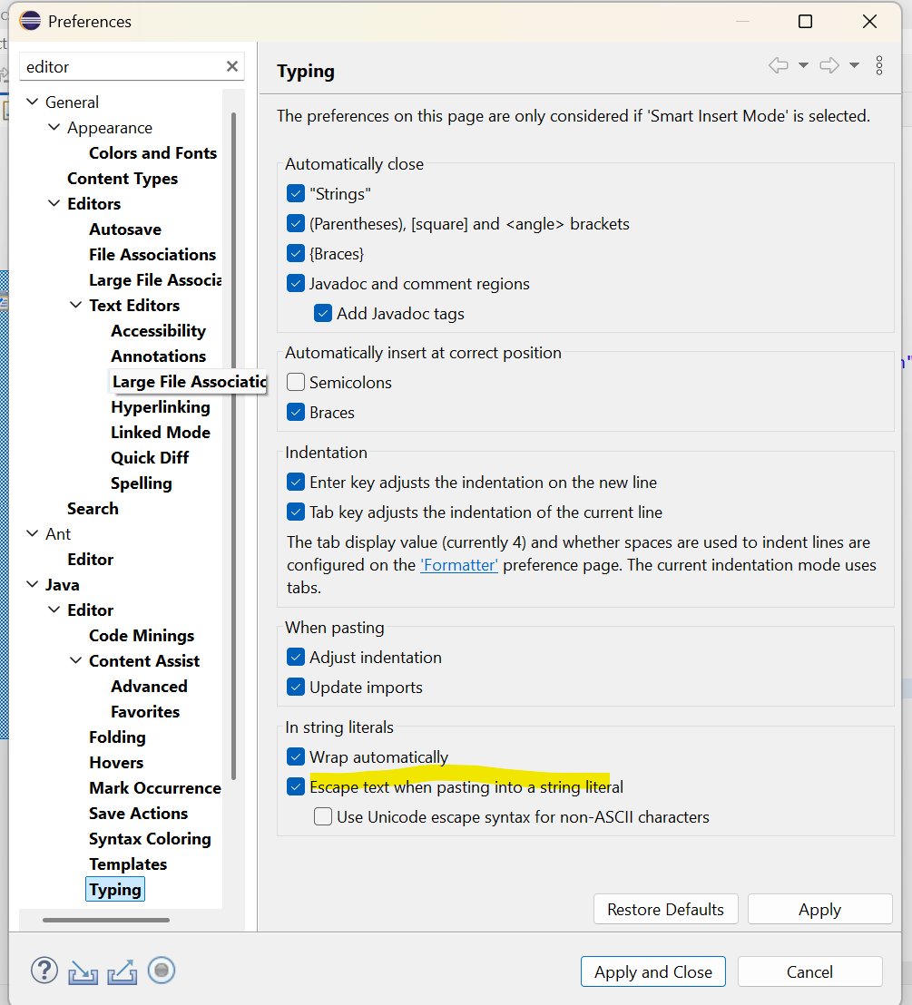

JsonPath: it is class, to convert string into JSON format. It is useful parson the JSON.
Syn:
JsonPath js=new JsonPath(<string variable>);
Ex
JsonPath js=new JsonPath(response);

getString: it is the method in JsonPath class, with using this we can get the JSON node value.
Syn:
<JsonPath object>.getString(<Path of the node>)
Ex:
js.getString(“place_id”);
Payload class:
package files;

public class Payload {

public static String addPlace() {
return "{\r\n"
+ " \"location\":{\r\n"
+ " \"lat\":-38.383494,\r\n"
+ " \"lng\":33.427362\r\n"
+ " },\r\n"
+ " \"accuracy\":50,\r\n"
+ " \"name\":\"Rahul Shetty Academy\",\r\n"
+ " \"phone_number\":\"(+91) 983 893 3937\",\r\n"
+ " \"address\":\"29,side layout,cohen 09\",\r\n"
+ " \"types\":[\r\n"
+ " \"shoe park\",\r\n"
+ " \"shop\"\r\n"
+ " ],\r\n"
+ " \"website\":\"http://rahulshettyacademy.com\",\r\n"
+ " \"language\":\"French-IN\"\r\n"
+ "}";
}
}

Reusable class:
package files;

import io.restassured.path.json.JsonPath;

public class ReusebleMathods {

public static JsonPath rawToJon(String response) {
JsonPath js=new JsonPath(response);
return js;
}
}
Basic class:
package sample;

import io.restassured.RestAssured;
import io.restassured.path.json.JsonPath;

import static io.restassured.RestAssured.*;
import static org.hamcrest.Matchers.*;

import org.testng.Assert;

import files.Payload;
import files.ReusebleMathods;

public class Basics {

public static void main(String[] args) {

//Add place
RestAssured.baseURI="https://rahulshettyacademy.com";
String response=given().log().all().queryParam("key","qaclick123").header("Content-Type","application/json")
.body(Payload.addPlace()).when().post("maps/api/place/add/json")
.then().assertThat().statusCode(200).body("scope",equalTo("APP"))
.header("Server", "Apache/2.4.52 (Ubuntu)").extract().response().asString();

System.out.println(response);

JsonPath js=new JsonPath(response);
String placeId=js.getString("place_id");
System.out.println(placeId);

//Update place
String new_Address="70 Summer Road ,USA";
String updateRespone=given().log().all().queryParam("key","qaclick123").header("Content-Type","application/json")
.body("{\r\n"
+ "\"place_id\":\""+placeId+"\",\r\n"
+ "\"address\": \""+new_Address+"\",\r\n"
+ "\"key\":\"qaclick123\"\r\n"
+ "}")
.when().put("maps/api/place/update/json")
.then().assertThat().log().all().statusCode(200).body("msg",equalTo("Address successfully updated")).extract().response().asString();
System.out.println("Update Response : "+updateRespone);

//Get
String getPlaceResponse=given().log().all().queryParam("key","qaclick123").queryParam("place_id",placeId)
.when().get("maps/api/place/get/json")
.then().assertThat().log().all().statusCode(200).extract().response().asString();
JsonPath js1=ReusebleMathods.rawToJon(getPlaceResponse);
String actualAddress=js1.getString("address");
System.out.println(actualAddress);
Assert.assertEquals(actualAddress, new_Address);

}

}
1.Print no of courses returned by API
2.Print purchase amount
3.Print title of the first course
4.Print All course title and their respective prices
5.Print no of copies sold by RPA course
6.Verify if sum of all course prices match with purchase amount
Need to work on below JSON for above test cases.
{
"dashboard":{
"purchaseAmount":910,
"website":"rahulshettyacademy.com"
},
"courses":[
{
"title":"Selenium Pyhton",
"price":50,
"copies":6
},
{
"title":"Cypress",
"price":40,
"copies":4
},
{
"title":"RPA",
"price":45,
"copies":10
}
]
}
Before doing just check JSON file with Json online editor(https://jsoneditoronline.org/#right=local.kocevo&left=local.ligono) as below screen.
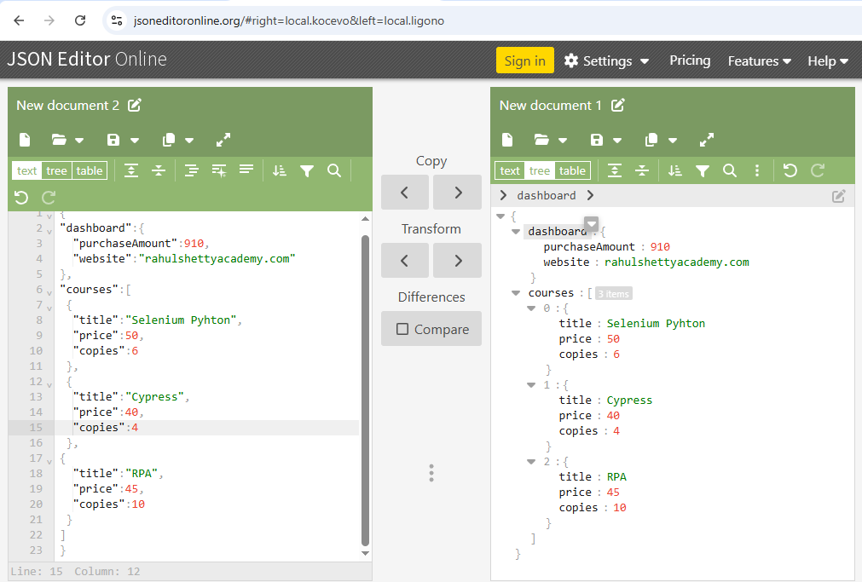
Need to add below method in Payload class
public static String coursePrice() {
return "{\r\n"
+ "\"dashboard\":{\r\n"
+ " \"purchaseAmount\":910,\r\n"
+ " \"website\":\"rahulshettyacademy.com\"\r\n"
+ "},\r\n"
+ "\"courses\":[\r\n"
+ " {\r\n"
+ " \"title\":\"Selenium Pyhton\",\r\n"
+ " \"price\":50,\r\n"
+ " \"copies\":6\r\n"
+ " },\r\n"
+ " {\r\n"
+ " \"title\":\"Cypress\",\r\n"
+ " \"price\":40,\r\n"
+ " \"copies\":4\r\n"
+ " },\r\n"
+ "{\r\n"
+ " \"title\":\"RPA\",\r\n"
+ " \"price\":45,\r\n"
+ " \"copies\":10\r\n"
+ " }\r\n"
+ "]\r\n"
+ "}";
}

Add one more class with name as ComplexJsonParse clsss and write below code.
package sample;

import org.testng.Assert;

import files.Payload;
import io.restassured.path.json.JsonPath;

public class ComplexJsonParse {

public static void main(String[]args) {
JsonPath js=new JsonPath(Payload.coursePrice());
System.out.println("Print no of courses returned by API : "+js.getInt("courses.size()"));
int purchaseAmount=js.getInt("dashboard.purchaseAmount");
System.out.println("Print purchase amount : "+purchaseAmount);
System.out.println("Print title of the first course : "+js.getString("courses[0].title"));
System.out.println("Print title of the first course : "+js.getString("courses[0].title"));

System.out.println("Print All course title and their respective prices");
int noOfCourses=js.getInt("courses.size()");
for(int i=0;i<noOfCourses;i++) {
System.out.println(js.get("courses["+i+"].title")+":"+js.get("courses["+i+"].price")+" ");
}
System.out.println("Print no of copies sold by RPA course");
for(int i=0;i<noOfCourses;i++) {
String courseTtile=js.get("courses["+i+"].title");
if(courseTtile.equals("RPA")) {
System.out.println("RPA Copies Sold:"+js.get("courses["+i+"].copies")+" ");
break;
}
}
//Verify if sum of all course prices match with purchase amount
int total=0;
for(int i=0;i<noOfCourses;i++) {
int temp=(int)js.get("courses["+i+"].price")*(int)js.get("courses["+i+"].copies");
total+=temp;
}
System.out.println(total);
if(total==purchaseAmount) {
Assert.assertEquals(purchaseAmount, total);
}
else
{
Assert.assertFalse(true);
}
}

}
Advanced Payload Creation Strategies:
Dynamically build JSON payload with external data inputs
Parameterize the API tests with multiple data sets
How to send static Json files(payload) directly into Post method of Rest Assured.
Feed Json payload from using excel using HashMap
We can use POJO class to build Payload.
Library API-
Addbook
120
Bookname,author name,isbn
Dynamically build JSON payload with external data inputs:
Below code in payload class.
public static String addBook(String isbn,String aisle) {
String payload="{\r\n"
+ "\"name\":\"Learn Appium Automation with Java\",\r\n"
+ "\"isbn\":\""+isbn+"\",\r\n"
+ "\"aisle\":\"'"+aisle+"\",\r\n"
+ "\"author\":\"John foe\"\r\n"
+ "}";
return payload;
}

Below code in DyanamiJson class.
@Test()
public void addBook() {

RestAssured.baseURI="http://216.10.245.166";
String response=given().log().all().header("Content-Type","application/json")
.body(Payload.addBook(“xyz”,”001”))
.when().post("/Library/Addbook.php")
.then().assertThat().log().all().statusCode(200)
.extract().response().asString();
JsonPath js=ReusebleMathods.rawToJon(response);
String id=js.get("ID");
System.out.println(id);
}
Parameterize the API tests with multiple data sets
Below code in DyanamiJson class.

@DataProvider(name="BooksData")
public Object[][] getData(){

/*Object [][]object= {
{"xyz","002"},
{"abc","003"}
};

return object;*/
return new Object[][] {{"xyz","002"},{"abc","003"}};

}

@Test(dataProvider="BooksData")
public void addBook(String isbn,String aisle) {

RestAssured.baseURI="http://216.10.245.166";
String response=given().log().all().header("Content-Type","application/json")
.body(Payload.addBook(isbn,aisle))
.when().post("/Library/Addbook.php")
.then().assertThat().log().all().statusCode(200)
.extract().response().asString();
JsonPath js=ReusebleMathods.rawToJon(response);
String id=js.get("ID");
System.out.println(id);
}

How to send static Json files(payload) directly into Post method of Rest Assured.

Save below data with file name as addPlace.json
{
"location": {
"lat": -38.383494,
"lng": 33.427362
},
"accuracy": 50,
"name": "Rahul Shetty Academy",
"phone_number": "(+91) 983 893 3937",
"address": "29,side layout,cohen 09",
"types": [
"shoe park",
"shop"
],
"website": "http://rahulshettyacademy.com",
"language": "French-IN"
}

Test with below code for the Json file
RestAssured.baseURI="https://rahulshettyacademy.com";
String response=given().log().all().queryParam("key","qaclick123").header("Content-Type","application/json")
.body(new String(Files.readAllBytes(Paths.get("F:\\Selenium_2026\\workspace_Cucumber\\RestAPI\\src\\test\\java\\files\\addPlace.json")))).when().post("maps/api/place/add/json")
.then().assertThat().statusCode(200).body("scope",equalTo("APP"))
.header("Server", "Apache/2.4.52 (Ubuntu)").extract().response().asString();

System.out.println(response);

OAuth 2.0 Authorization:

API Contract download
******************************************************************
Authorization Server End Point:
https://rahulshettyacademy.com/oauthapi/oauth2/resourceOwner/token

HTTP Method: POST

Form parameters:

client_id:
692183103107-p0m7ent2hk7suguv4vq22hjcfhcr43pj.apps.googleusercontent.com
client_secret: erZOWM9g3UtwNRj340YYaK_W
grant_type: client_credentials
scope: trust
******************************************************************

Get Course Details End Point (Secured by OAuth) :
https://rahulshettyacademy.com/oauthapi/getCourseDetails

HTTP Method: GET
Query Parameter: access_token

Implemented in Postman:
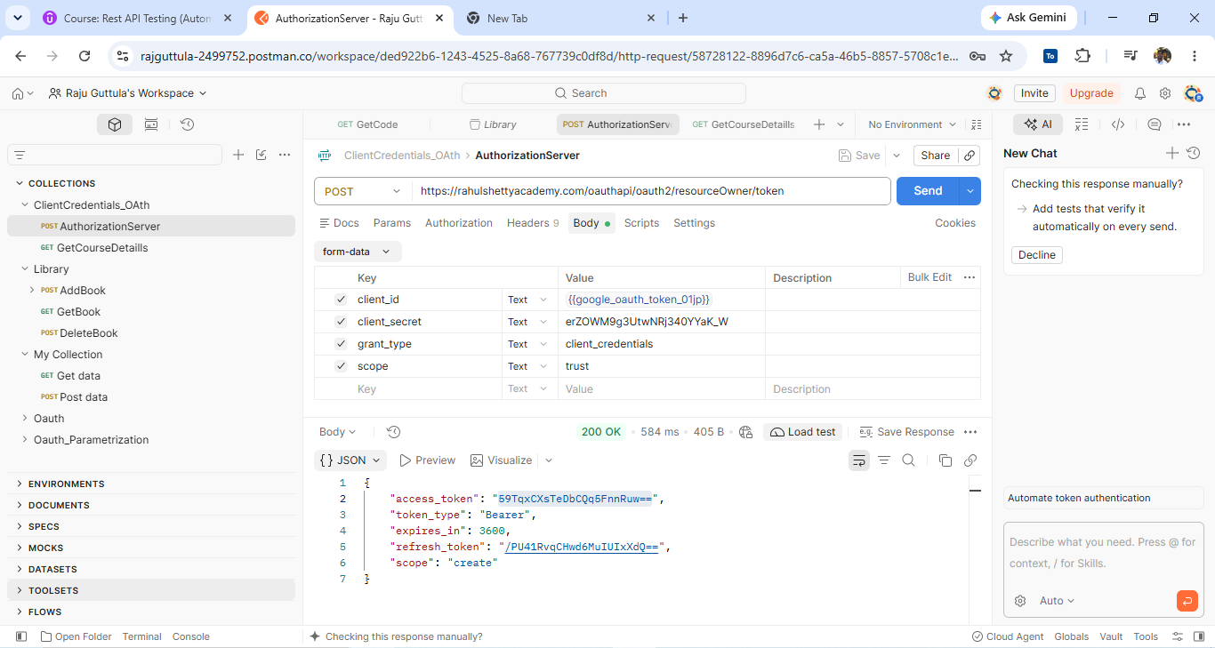
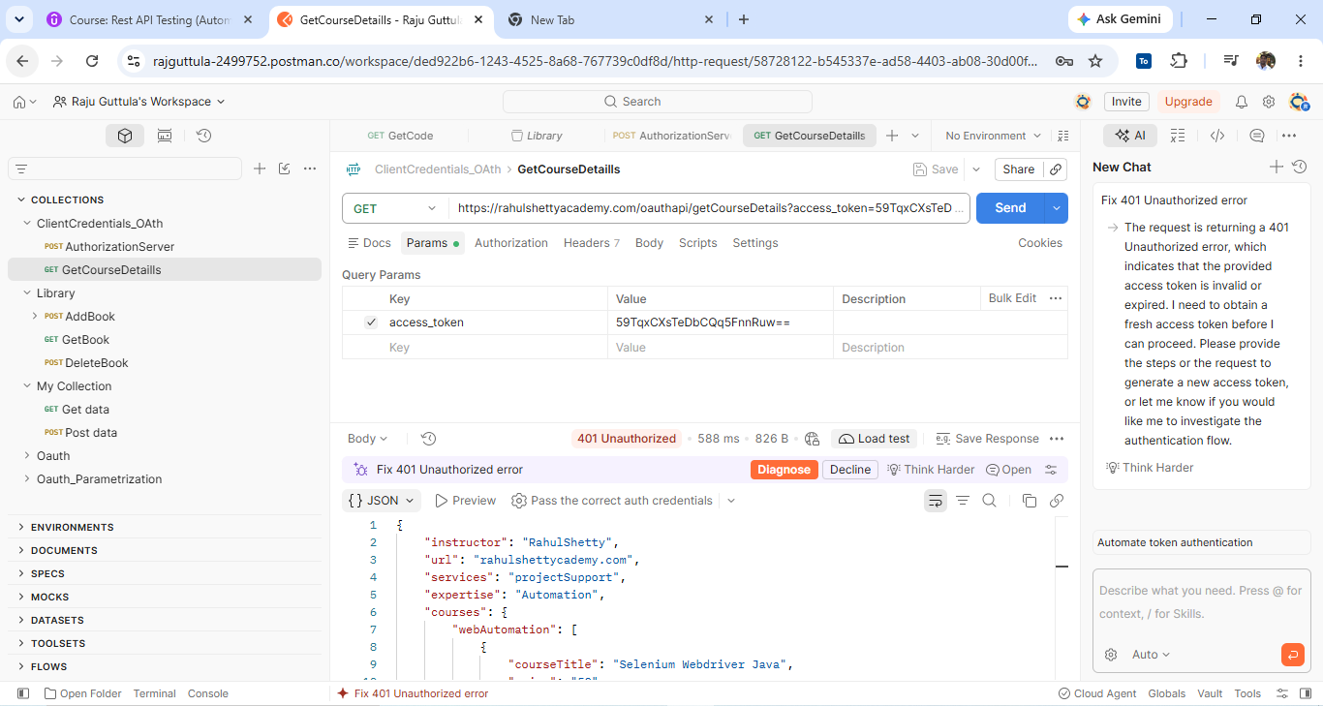
Implemented In Eclipse:
package sample;

import static io.restassured.RestAssured.given;

import io.restassured.path.json.JsonPath;
public class test1 {
public static void main(String[] args) throws InterruptedException {
String response =
given()
.formParams("client_id", "692183103107-p0m7ent2hk7suguv4vq22hjcfhcr43pj.apps.googleusercontent.com")
.formParams("client_secret", "erZOWM9g3UtwNRj340YYaK_W")
.formParams("grant_type", "client_credentials")
.formParams("scope", "trust")
.when().log().all()
.post("https://rahulshettyacademy.com/oauthapi/oauth2/resourceOwner/token").asString();
System.out.println(response);
JsonPath jsonPath = new JsonPath(response);
String accessToken = jsonPath.getString("access_token");
System.out.println(accessToken);
String r2= given()
.queryParams("access_token", accessToken)
.when()
.get("https://rahulshettyacademy.com/oauthapi/getCourseDetails")
.asString();
System.out.println(r2);
}
}

Serialization & Deserialization of Request/Responses with POJO classes
Serialization: in Rest Assured context is a process of converting a Java object into Request body (Payload).
Rest Assured also supports Deserialization by converting response body back to Java object.
Advantages:
Easy to parse and extract response (Json/XML) values if they are wrapped as Java object. User friendly methods can be created which makes code more readable.
Design Approach:
Java object is constructed with the support of POJO classes
POJO classes are created bases on Request/Response Payload.
What Additional Libraries required?
For JSON you need to have either Jackson,Jackson2, Gson or Johnon in the classpath and for XML you need JAXB.
Serialization:
Sample POJO class creation for below JSON request
{
"message":"Hello",
"greet":""
}

//POJO Classes

public class Message{
private String message;
private String greet;

public strng getMessage(){
return message;
}

public void setMessage(String message){
this.message=message;
}
public String getGreet(){
return greet;
}
public void setGreet(String greet){
this.greet=greet;
}
}

//Create java object
Message m=new Message();
m.setMessage("Hello");
m.setGreet("Hi");

//Rest Assured
Message messge=new Message();
message.setMessage("My message")

//Run time request creation
given().body(m).when().post("/message");
Deserialization:
Sample POJO class creation for below JSON response
{
"message":"Hello",
"greet":""
}

//POJO Classes

public class Message{
private String message;
private String greet;

public strng getMessage(){
return message;
}

public void setMessage(String message){
this.message=message;
}
public String getGreet(){
return greet;
}
public void setGreet(String greet){
this.greet=greet;
}
}

//Create java object
Message m=new Message();
m. setMessage();
m. getGreet();
Add Jackson dependencies:
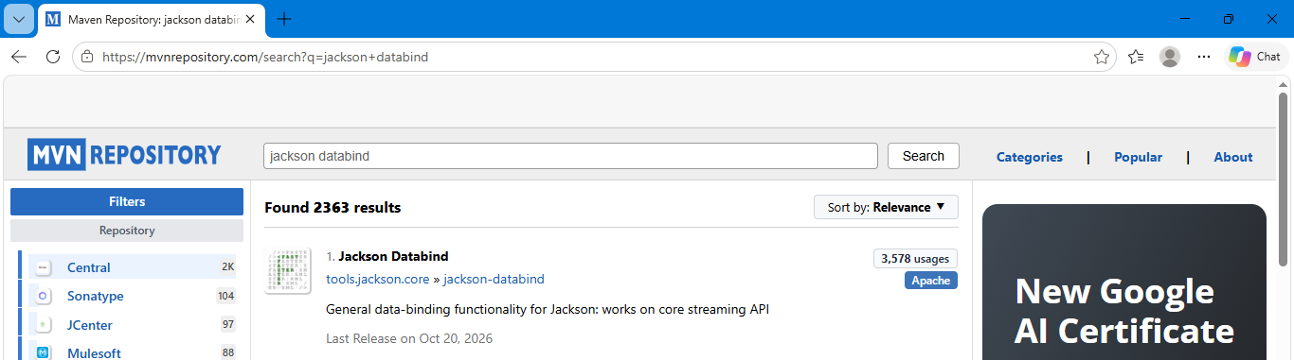

<dependency>
<groupId>tools.jackson.core</groupId>
<artifactId>jackson-databind</artifactId>
<version>3.2.4</version>
<scope>compile</scope>
</dependency>
Create Pojo class for below JSON:
{
"instructor": "RahulShetty",
"url": "rahulshettyacademy.com",
"services":"projectSupport",
"expertise":"Automation",
"courses":{
"webAutomation":[
{
"courseTitle":"Selenium Webdriver Java",
"price":"50"
},
{
"courseTitle":"Cypress",
"price":"40"
},
{
"courseTitle":"Protractor",
"price":"40"
}
],
"api":[

{
"courseTitle":"Rest Assured Automation using Java",
"price":"50"
},
{
"courseTitle":"SoapUI Webservices testing",
"price":"40"
}
],
"mobile":[
{
"courseTitle":"Appium Mobile Automation using java",
"price":"50"
}
]
},
"linkedIn":"https://www.linkedin.com/in/rajul-shetty-trainer/"
}
____________
Create pojo package with below classes:
GetCource class: it is the main parent class to get the data.
package pojo;

public class GetCourse {

private String url;
private String services;
private String expertise;
public Courses course;
private String instructor;
private String linkedIn;

public String getUrl() {
return url;
}
public void setUrl(String url) {
this.url = url;
}
public String getServices() {
return services;
}
public void setServices(String services) {
this.services = services;
}
public String getExpertise() {
return expertise;
}
public void setExpertise(String expertise) {
this.expertise = expertise;
}
public Courses getCourse() {
return course;
}
public void setCourse(Courses course) {
this.course = course;
}
public String getInstructor() {
return instructor;
}
public void setInstructor(String instructor) {
this.instructor = instructor;
}
public String getLinkedIn() {
return linkedIn;
}
public void setLinkedIn(String linkedIn) {
this.linkedIn = linkedIn;
}

}
____
Course class:
package pojo;

import java.util.*;

public class Courses {

private List<WebAutomation> webAutomation;
private List<Api> api;
private List<Mobile> mobile;

public List<WebAutomation> getWebAutomation() {
return webAutomation;
}
public void setWebAutomation(List<WebAutomation> webAutomation) {
this.webAutomation = webAutomation;
}
public List<Api> getApi() {
return api;
}
public void setApi(List<Api> api) {
this.api = api;
}
public List<Mobile> getMobile() {
return mobile;
}
public void setMobile(List<Mobile> mobile) {
this.mobile = mobile;
}

}
____
WebAutomation class:
package pojo;

public class WebAutomation {
private String courseTitle;
private String price;

public String getCourseTitle() {
return courseTitle;
}
public void setCourseTitle(String courseTitle) {
this.courseTitle = courseTitle;
}
public String getPrice() {
return price;
}
public void setPrice(String price) {
this.price = price;
}
}
___
Api class:
package pojo;

public class Api {
private String courseTitle;
private String price;

public String getCourseTitle() {
return courseTitle;
}
public void setCourseTitle(String courseTitle) {
this.courseTitle = courseTitle;
}
public String getPrice() {
return price;
}
public void setPrice(String price) {
this.price = price;
}
}
____
Mobile class:
package pojo;

public class Mobile {
private String courseTitle;
private String price;

public String getCourseTitle() {
return courseTitle;
}
public void setCourseTitle(String courseTitle) {
this.courseTitle = courseTitle;
}
public String getPrice() {
return price;
}
public void setPrice(String price) {
this.price = price;
}
}
____
Deserialization implementation in API call, using all above class.
package api_calls;

import static io.restassured.RestAssured.given;

import java.util.ArrayList;
import java.util.List;

import io.restassured.path.json.JsonPath;
import pojo.Api;
import pojo.GetCourse;
import pojo.Mobile;
import pojo.WebAutomation;

public class oAuthTest_Deserialization {

public static void main(String[] args) throws InterruptedException {

String response = given()
.formParams("client_id", "692183103107-p0m7ent2hk7suguv4vq22hjcfhcr43pj.apps.googleusercontent.com")
.formParams("client_secret", "erZOWM9g3UtwNRj340YYaK_W")
.formParams("grant_type", "client_credentials")
.formParams("scope", "trust")
.when().log().all()
.post("https://rahulshettyacademy.com/oauthapi/oauth2/resourceOwner/token").asString();

System.out.println(response);

JsonPath jsonPath = new JsonPath(response);

String accessToken = jsonPath.getString("access_token");

System.out.println(accessToken);

GetCourse gc=given()
.queryParams("access_token", accessToken)
.when()
.get("https://rahulshettyacademy.com/oauthapi/getCourseDetails").as(GetCourse.class);

System.out.println(gc.getLinkedIn());
System.out.println(gc.getInstructor());
List<Api> apiCourses=gc.getCourse().getApi();
System.out.println(apiCourses.get(1).getCourseTitle());

for(int i=0;i<apiCourses.size();i++) {
if(apiCourses.get(i).getCourseTitle().equalsIgnoreCase("SoapUI Webservices testing")) {
System.out.println(apiCourses.get(i).getPrice());
}

}

String []arr_Courses= {"Selenium Webdriver Java","Cypress","Protractor"};
boolean blnFound=true;
List<WebAutomation>webAutomation =gc.getCourse().getWebAutomation();
for(int i=0;i<webAutomation.size();i++) {
String str_Title=webAutomation.get(i).getCourseTitle();
if(!str_Title.equalsIgnoreCase(arr_Courses[i])) {
blnFound=false;
}
}
if(blnFound) {
System.out.println("All Course Names Are Matched");
}
else {
System.out.println("All Course Names Are Not Matched");
}

List<Mobile> mobile=gc.getCourse().getMobile();
for(int i=0;i<mobile.size();i++) {
System.out.println(mobile.get(i).getCourseTitle()+":"+mobile.get(i).getPrice());
}
}
}
___________
Google Maps Add API (JSON Format):
Complete URL: https://rahulsheetyacademy.com/maps/api/place/add/json?key=qaclick123
Base URL: https://rahulshettyacademy.com Or http://216.10.245.166-(Will be removed soon)
Resource:/maps/api/place/add/json
Parametter:key
Http request:POST
Note: Key value is hardcoded and it is always qaclick123
Sample Body:
{
"location": {
"lat": -38.383494,
"lng": 33.427362
},
"accuracy": 50,
"name": "Rahul Shetty Academy",
"phone_number": "(+91) 983 893 3937",
"address": "29,side layout,cohen 09",
"types": [
"shoe park",
"shop"
],
"website": "http://rahulshettyacademy.com",
"language": "French-IN"
}

Serialization implementation:
Create AddPlace class:
package pojo;

import java.util.*;

public class AddPlace {

private Location location;
private int accuracy;
private String name;
private String phone_number;
private String address;
private List<String> types;
private String website;
private String language;

public Location getLocation() {
return location;
}
public void setLocation(Location location) {
this.location = location;
}
public int getAccuracy() {
return accuracy;
}
public void setAccuracy(int accuracy) {
this.accuracy = accuracy;
}
public String getName() {
return name;
}
public void setName(String name) {
this.name = name;
}
public String getPhone_number() {
return phone_number;
}
public void setPhone_number(String phone_number) {
this.phone_number = phone_number;
}
public String getAddress() {
return address;
}
public void setAddress(String address) {
this.address = address;
}
public List<String> getTypes() {
return types;
}
public void setTypes(List<String> types) {
this.types = types;
}
public String getWebsite() {
return website;
}
public void setWebsite(String website) {
this.website = website;
}
public String getLanguage() {
return language;
}
public void setLanguage(String language) {
this.language = language;
}
}
__
Create Location class:
package pojo;

public class Location {

private double lat;
private double lng;

public double getLat() {
return lat;
}
public void setLat(double lat) {
this.lat = lat;
}
public double getLng() {
return lng;
}
public void setLng(double lng) {
this.lng = lng;
}
}
____
Created main method to call Map API:
package api_calls;

import static io.restassured.RestAssured.given;
import static io.restassured.RestAssured.*;
import static org.hamcrest.Matchers.equalTo;

import java.util.ArrayList;
import java.util.List;

import files.Payload;
import io.restassured.RestAssured;
import pojo.AddPlace;
import pojo.Location;

public class Test_Serialization {

public static void main(String []args) {

AddPlace p=new AddPlace();
p.setAccuracy(50);
p.setName("Rahul Shetty Academy");
p.setPhone_number("(+91) 983 893 3937");
p.setAddress("29,side layout,cohen 09");
p.setWebsite("http://rahulshettyacademy.com");
p.setLanguage("French-IN");

List<String>myList=new ArrayList<String>();
myList.add("shoe park");
myList.add("shop");
p.setTypes(myList);

Location l=new Location();
l.setLat(-38.383494);
l.setLng(33.427362);
p.setLocation(l);

RestAssured.baseURI="https://rahulshettyacademy.com";
String response=given().log().all().queryParam("key","qaclick123").header("Content-Type","application/json")
.body(p).when().post("maps/api/place/add/json")
.then().assertThat().statusCode(200).extract().response().asString();

System.out.println(response);

}
}
Request and Response Spec Builders
Spec Builder means, we will create a class for reuse the API parameters like queryParam,contentType, base URI..
Request Spec Builder:
we will create a class for reuse request API parameters like queryParam,contentType, base URI..
example for create request spec builder:
req=new RequestSpecBuilder().setContentType(ContentType.JSON)
.setBaseUri(“XXX”)
.addQueryParam(“key”,”qaclick123”)
.build();
Example for how to use spec builder in api call:
Given.spec(req).body(app_place_json).post(“/maps/api/place/add/json”)
Response Spec Builder:
we will create a class for reuse response API parameters like statusode, contentType..
example for create response spec builder:
res=new ResponseSpecBuilder().expectStatusCode(200).expectContentType(ContentType.JSON).build();
Example for how to use spec builder in api call:
Then.spec(res).extract().response();
Rewriting Test with Request and Response Spec Builder:
Given().spec(req).body(add_place_json).post(“/maps/api/place/add/json”).
Then().spec(res).extract().response();
Implementation for both Request and Response Spec Builder:
package api_calls;

import static io.restassured.RestAssured.given;
import static io.restassured.RestAssured.*;
import static org.hamcrest.Matchers.equalTo;

import java.util.ArrayList;
import java.util.List;

import files.Payload;
import io.restassured.RestAssured;
import io.restassured.builder.RequestSpecBuilder;
import io.restassured.builder.ResponseSpecBuilder;
import io.restassured.http.ContentType;
import io.restassured.response.Response;
import io.restassured.specification.RequestSpecification;
import io.restassured.specification.ResponseSpecification;
import pojo.AddPlace;
import pojo.Location;

public class SpecBuilderTest {

public static void main(String []args) {

AddPlace p=new AddPlace();
p.setAccuracy(50);
p.setName("Rahul Shetty Academy");
p.setPhone_number("(+91) 983 893 3937");
p.setAddress("29,side layout,cohen 09");
p.setWebsite("http://rahulshettyacademy.com");
p.setLanguage("French-IN");

List<String>myList=new ArrayList<String>();
myList.add("shoe park");
myList.add("shop");
p.setTypes(myList);

Location l=new Location();
l.setLat(-38.383494);
l.setLng(33.427362);
p.setLocation(l);

RequestSpecification req=new RequestSpecBuilder().setBaseUri("https://rahulshettyacademy.com").addQueryParam("key","qaclick123")
.setContentType(ContentType.JSON).build();

ResponseSpecification res=new ResponseSpecBuilder().expectStatusCode(200).expectContentType(ContentType.JSON).build();
RequestSpecification reqGiven=given().log().all().spec(req);
Response response=reqGiven
.body(p).when().post("maps/api/place/add/json")
.then().assertThat().spec(res).extract().response();
System.out.println(response.asString());
}
}
End to End Flow:
Injecting JWT session token into API calls using Postman
How to work with POST call from-data
How to send attachments through request using postman
Unauthorized 403 API example with Postman
End to End Flow:
Login API->Create Product->Purchase Order on created product->Delete Order->Delete Product

First need to generate the token.
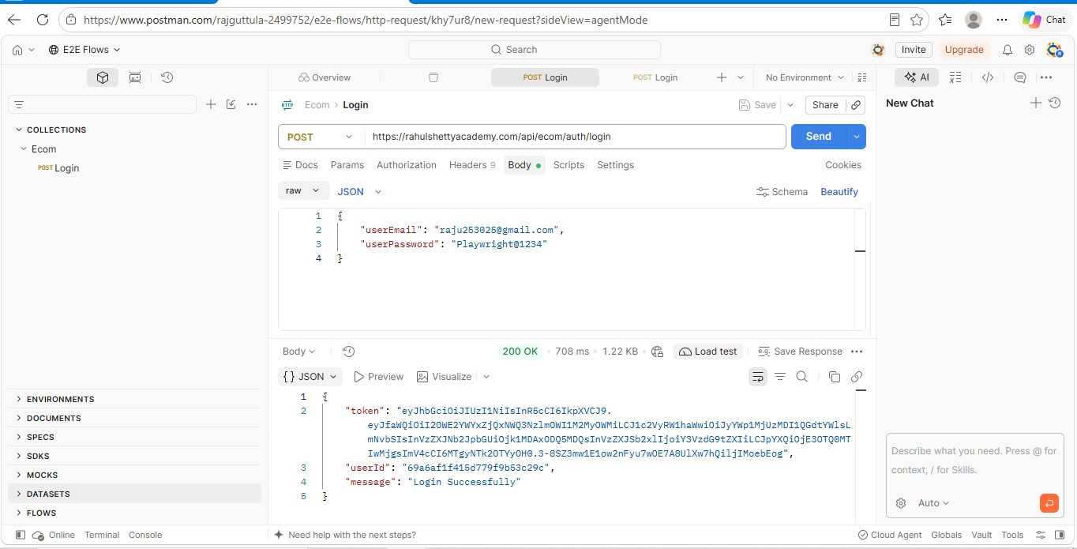
End Point:
https://rahulshettyacademy.com/api/ecom/product/add-product
Http Method-Post
Form Data: it is nothing but JSON data, but here we are passing keys and values as a API body.
productName:qwerty
productAddedBy:{{userId}}
productCategory:fashion
productSubCategory:shirts
productPrice:11500
productDescription:Addias Originals
productFor:women

Delete Product :

https://rahulshettyacademy.com/api/ecom/product/delete-product/{{productId}}

Http Method DELETE

relaxedHTTPSValidation:
if API expect valid SSL certification , with using this we can bypass the SSL certification. Also we can bypass invalid SSL certification
Ex:
Given().relaxedHTTPSValidation().log().all.spec(req).body();

