Description

* I’ve created two microservices, one Account Service that will handle all the operations to be performed for an account of a customer and second is Customer Service to handle all the operations related to customer management.
* I have established an inter-service communication using Feign Client so that when needed each service can utilize the services of the other microservice.
* Apart from this I’ve also created Service Registery which is a Eureka Server, where instances of each of the microservices are registered.
* Also, I’ve implemented an API gateway which will act as an entry point for all the API calls made by the client. This is also a Eureka Client Service.
* To manage all the common configurations of our application, a centralized Config Server is implemented where all the common configurations of eureka server for all the services is defined. This configuration file is stored locally on the disk.
* To run the application, make sure to start the server and services in the mentioned order – ServiceRegistery, ConfigServer, AccountService, CustomerService, ApiGateway.
* Below is the flowchart of our application.

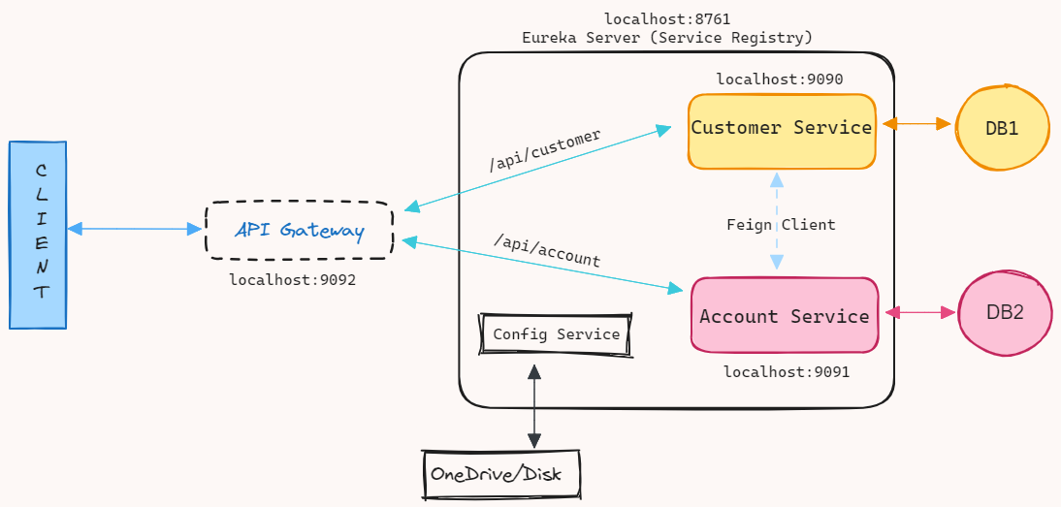

Sample URLs:

1. Customer Service:

* Add Customer: <http://localhost:9092/api/customer/add>
* Get all Customers: <http://localhost:9092/api/customer/get-all>
* Get single customer: <http://localhost:9092/api/customer/get?id=103>
* Update customer: <http://localhost:9092/api/customer/update?id=103>
* Delete customer: <http://localhost:9092/api/customer/delete?id=201>

1. Account Service:

* Add Money: <http://localhost:9092/api/account/deposit?accountId=12&amount=9000>
* Withdraw Money: <http://localhost:9092/api/account/withdraw?accountId=12&amount=289>
* Get account details: <http://localhost:9092/api/account/get?accountId=12>
* Delete Account: <http://localhost:9092/api/account/delete?accountId=13>