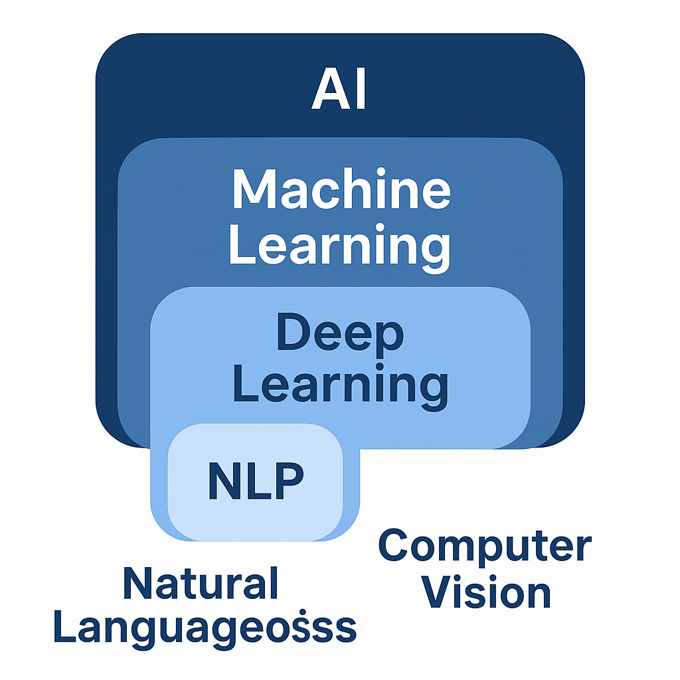

NLP

🧠 Real-World Applications of NLP
Application Area | Description / Use | How It Works (NLP Concept Used)
1. Customer Service (Chatbots) | Chatbots handle ~70% of customer queries, improving efficiency and response time. | Uses Intent Recognition and Named Entity Recognition (NER) to understand user input and generate meaningful responses using dialogue management and language generation.
2. Content Moderation | NLP models filter harmful or toxic content with ~98% accuracy to ensure online safety. | Uses Text Classification and Sentiment Analysis models trained on large datasets to detect hate speech, abuse, or spam.
3. Medical Records Analysis | Automates the analysis of medical data, saving ~50% of clinicians’ time. | Uses Information Extraction and Entity Linking to identify patient names, diseases, medicines, and symptoms from unstructured text.
4. Legal Document Review | Speeds up legal document review by ~80%, improving accuracy and efficiency. | Uses Text Summarization and Keyword Extraction to identify clauses, entities, and important sections within lengthy legal documents.
5. Market Sentiment Analysis | Helps investors understand trends by analyzing social media and market data. | Uses Sentiment Analysis and Opinion Mining to classify market mood (positive, negative, neutral) from financial news and social media posts.

🟩 1️⃣ Lexical Preprocessing (Word Level)
Definition:
Lexical preprocessing involves breaking text into words (tokens) and cleaning them for further analysis.
Main Goal:
To normalize text and reduce noise at the word level.
Common Techniques:
- Tokenization: Breaking text into individual words or sentences.
Example: “I love NLP” → [“I”, “love”, “NLP”]
- Stop-word Removal: Removing common words like “is”, “a”, “the”, etc.
- Stemming: Cutting words to their base form.
Example: “Playing”, “Played” → “Play”
- Lemmatization: Converting words to their dictionary form using grammar rules.
Example: “Better” → “Good”
- Lowercasing, Removing Punctuation, Removing Numbers, etc.
Example Sentence:
“Cat is sitting on a mat.”
→ After lexical preprocessing → [“cat”, “sitting”, “mat”]

🟦 2️⃣ Syntactical Preprocessing (Sentence Level)
Definition:
Syntactical preprocessing ensures that sentences follow proper grammatical structure.
Main Goal:
To understand how words are arranged to form meaningful sentences.
Techniques Used:
- POS Tagging (Part of Speech Tagging): Identifies nouns, verbs, adjectives, etc.
Example: “She plays football.” → [She (PRON), plays (VERB), football (NOUN)]
- Parsing: Analyzes sentence structure (subject–verb–object relationships).
- Dependency Parsing: Finds how words depend on each other in a sentence.
Example:
Correct: “He runs fast.”
Incorrect: “He run fast.”

🟨 3️⃣ Semantic Preprocessing (Meaning Level)
Definition:
Semantic preprocessing focuses on understanding the meaning and context of words or sentences.
Main Goal:
To extract actual meaning rather than just word structure.
Techniques Used:
- Named Entity Recognition (NER): Identifies entities like names, places, or organizations.
Example: “Apple launched a new iPhone in California.” → [Apple = Organization, California = Location]
- Word Sense Disambiguation: Determines which meaning of a word is used in context.
Example: “Bank” → (River bank or financial bank?)
- Coreference Resolution: Finds what pronouns refer to.
Example: “Raj loves his car. He washes it every day.” → “He” → “Raj”, “it” → “car”.

🟥 4️⃣ Pragmatic / Discourse Level Preprocessing (Context Level)
Definition:
Pragmatic or discourse preprocessing deals with the context, intent, and tone of text across sentences or conversation.
Main Goal:
To interpret how meaning changes depending on context or user intent.
Techniques Used:
- Dialogue Act Recognition: Identifies if a statement is a question, command, or request.
- Sarcasm Detection / Sentiment Context: Understands tone and implied meaning.
Example: “Oh great, another meeting!” → negative sentiment, even though “great” is a positive word.
- Context Tracking: Maintains meaning across multiple sentences.

🧩 Summary Table
Type of Preprocessing | Level | Focus / Goal | Common Techniques
Lexical | Word level | Cleaning and normalization | Tokenization, Stop-word removal, Stemming, Lemmatization
Syntactical | Sentence level | Grammar and structure | POS tagging, Dependency parsing
Semantic | Meaning level | Understanding context and entities | NER, Word sense disambiguation, Coreference resolution
Pragmatic / Discourse | Context level | Intent, tone, and conversation flow | Dialogue act recognition, Sarcasm detection, Context tracking

🧠 Key Takeaway
In theory, NLP preprocessing is often divided into Lexical and Syntactical types.
But in real-world NLP, we also include Semantic and Pragmatic preprocessing for deeper language understanding.

🟩 Lexical Preprocessing Steps(Cleaning and normalization)
Lexical preprocessing deals with cleaning and preparing text at the word level before analysis.
It helps remove noise and make the text machine-readable.

Step | Task | Why It Comes Here | Example
1️⃣ Tokenization | Split text into words/tokens | We need tokens before we can modify them. | "I love NLP!" → ["I", "love", "NLP", "!"]
2️⃣ Lowercasing | Convert all words to lowercase | So that “The” and “the” are treated the same. | ["i", "love", "nlp", "!"]
3️⃣ Removing Punctuation | Remove symbols like . , ! ? | These don’t affect meaning (usually). | ["i", "love", "nlp"]
4️⃣ Removing Numbers | Remove digits like 2025, 100 | Numbers often don’t add meaning (task dependent). | "I have 2 cats" → "I have cats"
5️⃣ Stop-word Removal | Remove common function words (is, the, and, a, to, of, in) | Comes after punctuation and number removal because stop words are actual words — not symbols or digits. | ["i", "love", "the", "nlp"] → ["love", "nlp"]
6️⃣ Lemmatization / Stemming | Reduce words to their base form | Final cleanup step to unify similar word forms. | ["playing", "played"] → ["play"]

Aspect | Stemming | Lemmatization
Definition | Reduces a word to its root form by chopping off suffixes or prefixes (without understanding grammar). | Converts a word to its base or dictionary form (lemma) by analyzing grammar and meaning.
Method Used | Uses rule-based cutting of word endings. | Uses vocabulary + morphological analysis (WordNet or SpaCy).
Output Type | May produce non-meaningful or truncated words. | Always produces real, meaningful words.
Example | “Playing”, “Played”, “Plays” → “Play” ✅“Studies” → “Studi” ❌ | “Playing”, “Played”, “Plays” → “Play” ✅“Studies” → “Study” ✅
Speed | Very fast (simple rules). | Slower (does grammatical lookup).
Accuracy | Less accurate (no context awareness). | More accurate, context-aware.
Tool Example | PorterStemmer, SnowballStemmer (in NLTK). | WordNetLemmatizer (NLTK), spaCy lemmatizer.
When to Use | When you need speed over accuracy (e.g., search engines). | When you need clean, meaningful text (e.g., deep learning NLP tasks).

💬 In Simple Words:
- 🪓 Stemming = Cutting (rough and fast)
- 🔍 Lemmatization = Understanding (accurate and meaningful)

🟦 Syntactical Preprocessing (Grammar and Structure)
Syntactical preprocessing ensures that sentences follow proper grammatical structure.
It focuses on the relationship between words, sentence formation, and subject–verb agreement.
This helps NLP models understand how words are arranged to create meaningful sentences.

Step | Task | Why It Comes Here | Example
🟦 1️⃣ Part-of-Speech (POS) Tagging | Identifies the grammatical role of each word (noun, verb, adjective, etc.). | Helps the system understand sentence structure and how words function grammatically. | Sentence: “The cat sat on the mat.”  POS Tags → [('The', 'DET'), ('cat', 'NOUN'), ('sat', 'VERB'), ('on', 'ADP'), ('the', 'DET'), ('mat', 'NOUN')]
🟦 2️⃣ Dependency Parsing | Analyzes how words depend on each other in a sentence. | Builds a tree-like structure showing which words modify or depend on others. | “The cat sat on the mat.” → ‘cat’ is subject of ‘sat’, ‘mat’ is object of ‘on’
🟦 3️⃣ Constituency Parsing | Breaks a sentence into sub-phrases (noun phrase, verb phrase, etc.). | Helps identify phrase-level grammar and structure for language generation or correction. | “The quick brown fox jumps over the lazy dog.” → NP (The quick brown fox), VP (jumps over the lazy dog)
🟦 4️⃣ Subject–Verb Agreement Check | Checks whether the subject and verb agree in number and tense. | Ensures grammatical correctness, important for grammar correction or text validation systems. | ✅ “She runs fast.”  ❌ “She run fast.”

✅ Key Points
- Focuses on sentence grammar and syntactic structure, not on meaning.
- Provides the foundation for semantic analysis, translation, and chatbot grammar.
- Typically done using libraries like spaCy, NLTK, or Stanza.

___________________________________________________________________

📘 TF-IDF (Term Frequency – Inverse Document Frequency)
Definition:
TF-IDF is a technique to find important words in a document by giving more weight to terms that appear frequently in a specific document but more rarely across the entire corpus. GeeksforGeeks+2Amir Masoud Sefidian - Sefidian Academy+2

When It Comes / Where It Fits:
- It’s used after preprocessing (tokenization, cleaning, stop-word removal, etc.).
- It is part of Text Representation / Feature Extraction, converting cleaned text into numeric features.
- Suitable when you need a representation that emphasises words specific to each document while reducing the influence of common words.

When to Use:
- When you need a vector representation of text for models (e.g., classification, clustering).
- When simple frequency (like Bag of Words) isn’t enough and you want to down-weight very common terms and highlight more meaningful ones.
- Great for tasks like document classification, keyword extraction, search & retrieval. Built In+1

How It Works (in Simple Terms):
- Term Frequency (TF): How often a word appears in a document.
- Inverse Document Frequency (IDF): How common or rare a word is across all documents (rare words get higher weight). codingthepast.com
- TF-IDF score = TF × IDF — so a high score means a word appears often in a document but not in many documents overall. Wikipedia+1

Example:
Sentences (documents):
Doc1: “Data science is fun and data science is exciting.”
Doc2: “Python makes data science easy and fun.”

Vocabulary might be: ["data", "science", "is", "fun", "exciting", "python", "makes", "easy", "and"]
- The word “data” appears frequently in both docs → TF high but IDF lower (because appears in many docs) → moderate TF-IDF.
- The word “exciting” appears frequently in Doc1 but not in Doc2 → TF high, IDF high → higher TF-IDF weight for Doc1.

Python Library / Function:
- In Python, you can use sklearn.feature_extraction.text.TfidfVectorizer to apply TF-IDF easily. Scikit-learn+1
Example:
from sklearn.feature_extraction.text import TfidfVectorizer
sentences = ["Data science is fun", "Python makes data science easy"]
vectorizer = TfidfVectorizer()
X = vectorizer.fit_transform(sentences)
print(vectorizer.get_feature_names_out())
print(X.toarray())

Note (Important):
TF-IDF is better than plain Bag of Words for capturing word importance, but it still does not capture context or word order — techniques like Word2Vec or BERT are needed for that.

✅ TF-IDF Formula (in words):
TF-IDF = TF × IDF
- High TF → word is frequent in this document
- High IDF → word is rare across all documents
- Both high → important word
🔹 High TF + High IDF = Important word (High TF-IDF)
🔹 High TF + Low IDF = Common word (Low TF-IDF)

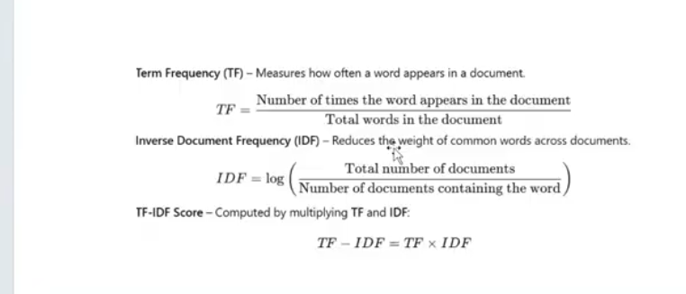

IDF = log(Total documents / Number of documents containing the word)

Word | Appears In (Docs) | IDF Value | Importance
“the” | in 100 out of 100 docs | log(100/100) = log(1) = 0 | ❌ Very low
“dog” | in 10 out of 100 docs | log(100/10) = log(10) = 1 | 🟡 Medium
“daughter” | in 1 out of 100 docs | log(100/1) = log(100) = 2 | 🟢 Very high
✅ So the fewer documents a word appears in,
the higher its IDF → meaning it’s more unique and important.
__________________________________________________________________

Library | Import Example | Purpose / Use in NLP
nltk | import nltk | Natural Language Toolkit — used for text preprocessing like tokenization, stopword removal, stemming, and lemmatization.
nltk.tokenize | from nltk.tokenize import word_tokenize, PunktSentenceTokenizer, sent_tokenize | Breaks text into words or sentences (tokenization).
nltk.corpus.stopwords | from nltk.corpus import stopwords | Provides a list of common English stopwords to remove from text (like the, is, and).
nltk.stem | from nltk.stem import PorterStemmer, WordNetLemmatizer | Used for reducing words to their root or base form (stemming & lemmatization).
sklearn.feature_extraction.text | from sklearn.feature_extraction.text import CountVectorizer, TfidfVectorizer | Converts text into numerical form using Bag of Words or TF-IDF.
tensorflow.keras.preprocessing.text | from tensorflow.keras.preprocessing.text import Tokenizer | Converts text into integer sequences for deep learning models.
tensorflow.keras.preprocessing.sequence | from tensorflow.keras.preprocessing.sequence import pad_sequences | Pads sequences to make all inputs the same length for RNN/LSTM models.
tensorflow.keras.models | from tensorflow.keras.models import Sequential | Builds deep learning models layer by layer.
tensorflow.keras.layers | from tensorflow.keras.layers import Embedding, SimpleRNN, Dense | Adds neural network layers like embedding, RNN, and dense layers.
tensorflow.keras.optimizers | from tensorflow.keras.optimizers import Adam | Optimizer used for efficient model training.

In Simple Words
🧩 NLTK & sklearn → For text preprocessing and feature extraction
🤖 TensorFlow / Keras → For building and training deep learning models in NLP
_____________________________________________________________

Resource | Used For | Needed When
'punkt' | Tokenization | Always
'stopwords' | Stopword removal | Always
'wordnet' | Lemmatization | Always
'averaged_perceptron_tagger' | POS tagging | Only if doing syntactical analysis

Feature | sent_tokenize() | PunktSentenceTokenizer()
Definition | A pre-trained sentence tokenizer that comes ready to use with NLTK. | A trainable sentence tokenizer that you can train on your own data.
Training | Already trained on large English text corpus. | Can be trained on new text using .train() to adapt to your writing style or domain.
Accuracy | Generally more accurate for most text since it uses a pre-trained model. | Might break sentences incorrectly if trained on a very short or domain-specific text.
Example Behavior | Correctly treats “Dr.” and “U.S.” as abbreviations (doesn’t split sentences incorrectly). | Because you trained it on the same small text, it learns that “Dr.” ends a sentence → splits incorrectly.
Use Case | Use when working with normal English sentences. | Use when you want to train a tokenizer for a specific writing style (like medical reports, legal text, etc.).
_______________________________________________________________

Aspect | Bag of Words (BoW) | TF-IDF | Word Embeddings
Representation | Words as individual counts | Word frequency adjusted by rarity | Dense vector representation
Context Understanding | No understanding of context | No understanding of context | Captures context and relationships between words
Vector Size | High-dimensional, sparse | High-dimensional, sparse | Low-dimensional, dense
Word Similarity | Doesn’t capture word similarity | Doesn’t capture word similarity | Words with similar meanings are closer in vector space
Computation | Simple and fast | Requires computation of IDF | Requires training on large datasets

🧾 Conclusion
- Bag of Words (BoW) and TF-IDF are simple yet limited methods for representing text.
They rely on word counts or frequencies and do not capture the meaning or relationships between words.
While effective for basic NLP tasks, they fail to understand context or semantics.
- Word Embeddings, on the other hand, offer a more advanced and meaningful representation of text.
They encode both the semantic meaning and contextual relationships between words,
making them far more powerful for modern NLP tasks such as sentiment analysis, translation, chatbot systems, and recommendation engines.
___________________________________________________________________

🧠 Steps for Text Classification (NLP Pipeline)

1. Collecting Data
- Gather text data from sources like:
  - Social media posts, emails, reviews, articles, etc.
- Example: Tweets for sentiment analysis (positive/negative/neutral).

2. Labeling Data
- Each text must have a label (category) in supervised learning.
- Example:
  - “I love this product” → Positive
  - “This is terrible” → Negative
- Labeling can be manual or automated (if dataset already labeled).

3. Preprocessing the Text
Clean and prepare the text for modeling.
Steps include:
Tokenization: Split text into words/sentences.
from nltk.tokenize import word_tokenize
tokens = word_tokenize(text)

- Lowercasing: Convert text to lowercase.
- Removing Stopwords: Remove common words like the, is, in.
- Lemmatization/Stemming: Convert words to root form (e.g., “running” → “run”).
- Removing Special Characters/Numbers: Remove unwanted symbols and digits.

4. Vectorization (Convert Text to Numbers)
Machine learning models only understand numbers.
You can use one of the following techniques:
Technique | Description
Bag of Words (BoW) | Counts word occurrences. Simple but ignores meaning.
TF-IDF | Weighs words by importance across documents.
Word Embeddings (Word2Vec, GloVe, SentenceTransformer) | Captures semantic meaning and context between words/ Word2Vec captures relationships between words.
(SentenceTransformer or Word2Vec are best for deep learning and modern NLP.)

Examples

✅ 1) Bag of Words (BoW)

Example
Document: "I love dogs"
Vocabulary = [I, love, dogs]
BoW Vector = [1, 1, 1]
(Each number = count of that word)

When to use
- Simple NLP tasks
- No need for meaning or context
- Small datasets
- Basic Logistic Regression / Naive Bayes models

✅ 2) TF–IDF (Term Frequency – Inverse Document Frequency)
Here is the most crystal-clear example with two documents 👇

📄 Two Documents
Doc 1: "I love machine learning"
Doc 2: "Machine learning is powerful"
Let’s calculate TF-IDF for "powerful" and "machine".

🔹 Example 1: Word “powerful” → HIGH TF-IDF

TF (Term Frequency):
- In Doc 1 → 0
- In Doc 2 → 1

IDF (Inverse Doc Frequency):
Total docs = 2
Word appears in 1 document.
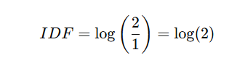
➡️ IDF is high (word is rare)

TF-IDF = TF × IDF
- Doc 1: 0 × log(2) = 0
- Doc 2: 1 × log(2) = high score

✔ Interpretation
➡️ “powerful” is important and unique in Document 2.

🔹 Example 2: Word “machine” → LOW TF-IDF

TF
- Doc 1 → 1
- Doc 2 → 1

IDF
Word appears in both documents:

➡️ IDF is 0 (word appears everywhere → NOT important)

TF-IDF
- 1 × 0 = 0

✔ Interpretation
➡️ “machine” is not unique, appears everywhere → low importance.

When to use TF-IDF
- Document classification
- Search engines
- Keyword extraction
- When you want important words, not common words

✅ 3) Word2Vec (Embeddings)

Example
Word2Vec produces vectors like:
- “king” → [0.52, -0.18, 0.44, …]
- “queen” → similar vector
It captures relationships:
king−man+woman=queenking - man + woman = queenking−man+woman=queen

When to use
- Chatbots
- Semantic search
- Intent detection
- When meaning, context, and similarity are important
____________________________________________________________

Feature | Skip-Gram (sg = 1) | CBOW (sg = 0)
What it predicts? | Predicts context words(nearby words) from a target word | Predicts target word from context words(nearby words)
Training pairs look like | (target → context) | (context → target)
Best for | Small datasets | Large datasets
Rare word performance | ✔ Very good | ❌ Not very good
Training speed | ❌ Slower | ✔ Faster
Noise handling | ❌ Less smooth | ✔ Smooths noise
Vector quality | ✔ Higher-quality semantic embeddings | ✔ Good embeddings but less detailed
Focus | Learns detailed relationships | Learns general meaning
Real-world analogy | “Given one word, guess the words around it.” | “Given surrounding words, guess the missing middle word.”

5. Model Selection and Building
Choose a model for classification.
Common algorithms:
- Naive Bayes → Best for small datasets, spam detection.
- Support Vector Machine (SVM) → Works well for text classification.
- Deep Learning Models → CNN, RNN, LSTM for complex NLP tasks.

6. Training the Model
Split data into Training and Test sets.
from sklearn.model_selection import train_test_split
X_train, X_test, y_train, y_test = train_test_split(X, y, test_size=0.2)

- Train model on labeled training data.
- Tune hyperparameters for better accuracy.

7. Evaluating the Model
After training, check how well your model performs.
Common evaluation metrics:
- Accuracy: (Correct predictions / Total predictions)
- Precision: Correctly predicted positives / All predicted positives
- Recall: Correctly predicted positives / All actual positives
- F1-Score: Balance between Precision and Recall

✅ Summary: Full Text Classification Workflow
- Collect Data
- Label Data
- Preprocess Text (cleaning, tokenization, stopwords, lemmatization)
- Convert Text → Numbers (TF-IDF / Word Embeddings)
- Choose & Train Model (Naive Bayes / SVM / Deep Learning)
- Evaluate Performance (Accuracy, Precision, Recall, F1-Score)

✅ Standard NLP Preprocessing Order
1️⃣ Lowercasing
2️⃣ Remove punctuation / special characters
3️⃣ Tokenization
4️⃣ Remove stopwords
5️⃣ Lemmatization (or stemming)

