**Task -11**

**1. What are the four access modifiers available in Java and what is their significance in terms of class, method, and variable accessibility?**

There are four types of Java access modifiers:

1. **Private**: The access level of a private modifier is only within the class. It cannot be accessed from outside the class.
2. **Default**: The access level of a default modifier is only within the package. It cannot be accessed from outside the package. If you do not specify any access level, it will be the default.
3. **Protected**: The access level of a protected modifier is within the package and outside the package through child class. If you do not make the child class, it cannot be accessed from outside the package.
4. **Public**: The access level of a public modifier is everywhere. It can be accessed from within the class, outside the class, within the package and outside the package.

**2. What is the difference between Exception and error?**

**Exception:**

* Exception can be recovered by using the try-catch block. An error cannot be recovered.
* It can be classified into two categories i.e. checked and unchecked.
* It occurs at compile time or run time.
* Only checked exceptions are known to the compiler.
* **Checked Exceptions:** SQLException, IOException  
  **Unchecked Exceptions:** ArrayIndexOutOfBoundException, NullPointerException, ArithmaticException
* Errors:
* All errors in Java are unchecked.
* It occurs at run time.
* Errors will not be known to the compiler.
* It is mostly caused by the environment in which the application is running.

3. What is the difference between checked Exception and unchecked Exception?

**checked Exception:**

Checked exceptions occur at compile time.

The compiler checks a checked exception.

These types of exceptions can be handled at the time of compilation.

**unchecked Exception:**

Unchecked exceptions occur at runtime.

The compiler does not check these types of exceptions.

These types of exceptions cannot be a catch or handle at the time of compilation, because they get generated by the mistakes in the program.

They are runtime exceptions and hence are not a part of the Exception class.

**4. Write a Java program that reads user input for two integers and performs division. Handle**

**the exception that is thrown when the second number is zero, and display an error**

**message to the user.**

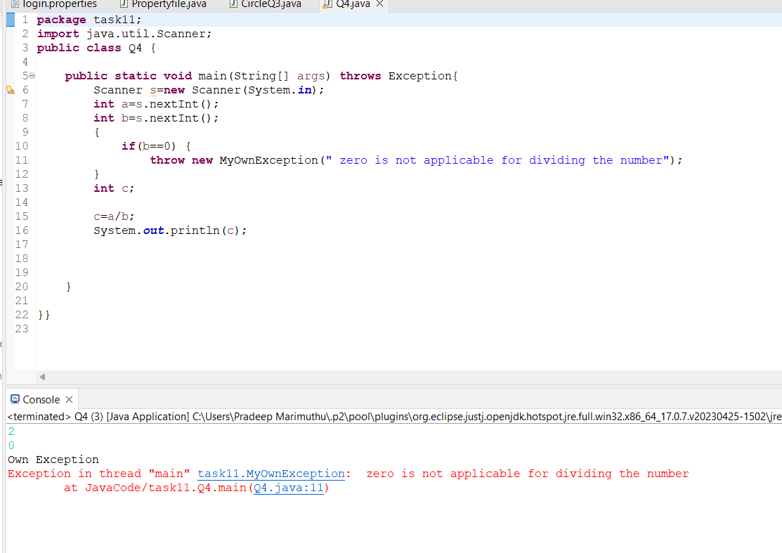

**5.** **Write the code of ArrayIndexOutOBoundsException &**

**StringIndexOutOBoundsException?**

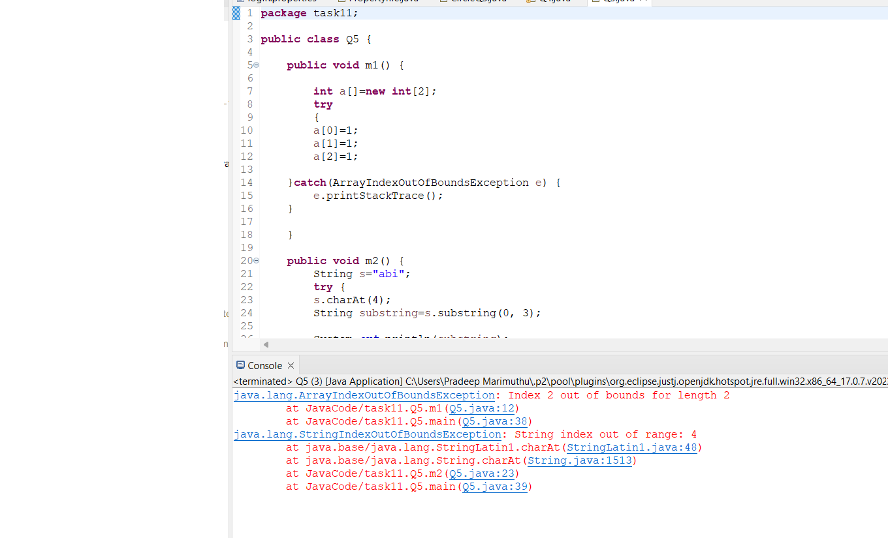

**6. You are building a login system for a website using Java. If the user enters an incorrect**

**password, you want to display a message informing them of the error. How would you**

**use exception handling to handle this situation?**

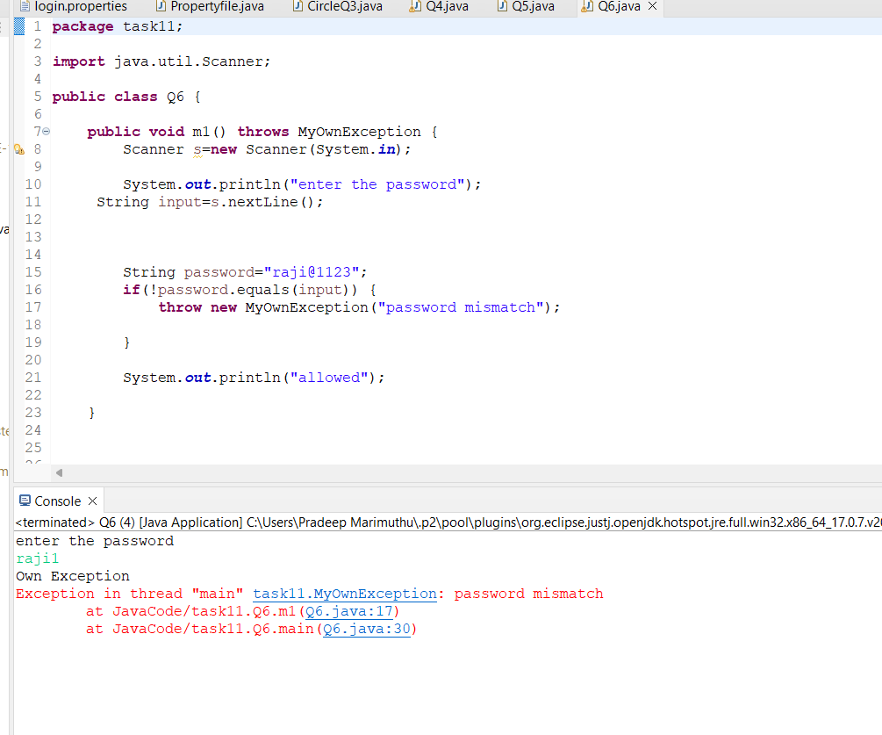

**7. Create a custom exception in Java called "1nvalidAgeException" that is thrown when the user enters an age less than 18. Implement exception handling in a Java program to catch the "1nvalidAgeException" and display an error message.**

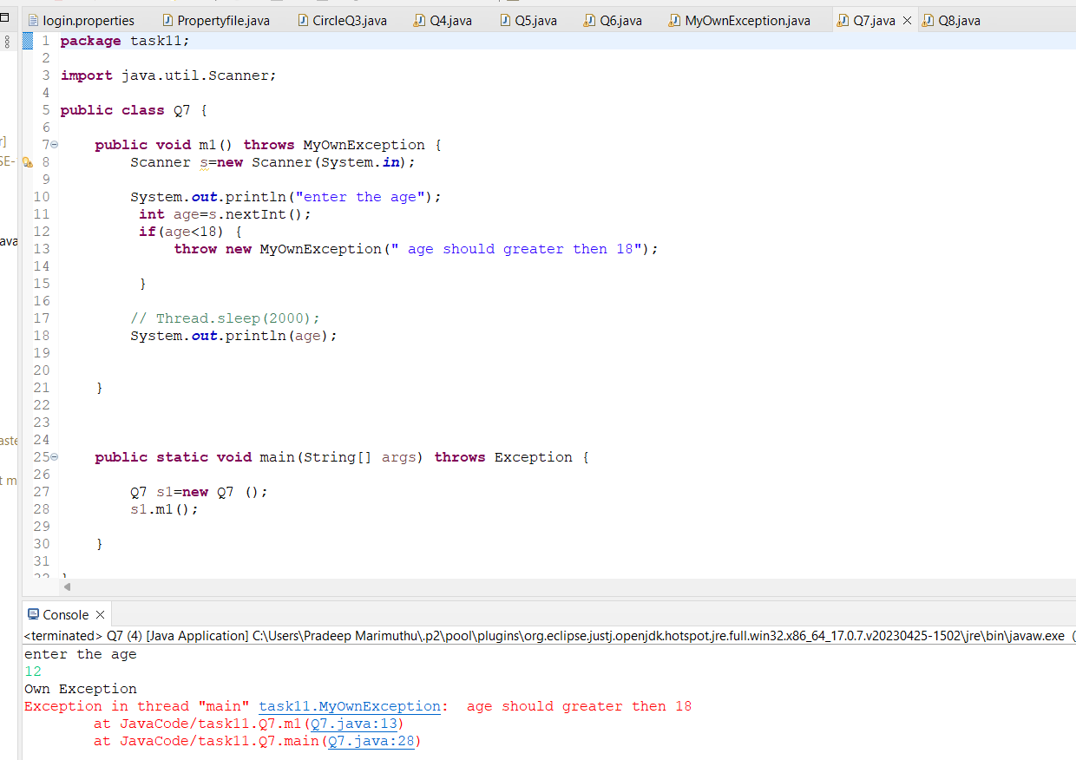

**8.** **Implement exception handling in a Java program that reads data from a file. Ifthe file**

**does not exist, throw a "FileNotFoundException" and display an error message to the**

**user.**

