**MEASURE ENERGY CONSUMPTION**

**PROBLEM DEFINITON:**

The problem at hand is to create an automated system that measures energy consumption, analyzes the data, and provides visualizations for informed decision-making. This solution aims to enhance efficiency, accuracy, and ease of understanding in managing energy consumption across various sectors.

**DESIGN THINKING:**

Measuring energy consumption using AI involves employing artificial intelligence techniques to analyze and predict energy usage patterns, trends, and consumption rates. This process utilizes AI algorithms and models that can learn from historical energy consumption data and other relevant variables to make accurate predictions about future energy usage. By harnessing machine learning and deep learning approaches, AI can provide insights, optimize energy utilization, and support sustainable practices by helping individuals, businesses, or organizations make informed decisions for efficient energy management and conservation**.**

To measure energy consumption using AI, you can follow these steps:

**1.*Data Collection*:** Collect data related to energy consumption, such as historical usage patterns, appliance information, and environmental factors like temperature and time of day.

**2. *Data Preparation*:** Clean and preprocess the collected data, making sure it's suitable for training an AI model. This involves handling missing values, scaling features, and structuring the data appropriately.

**3. *Feature Engineering*:** Extract relevant features from the data that could impact energy consumption, such as usage patterns, appliance efficiency, and weather conditions.

**4. *AI Model Selection*:** Choose an appropriate AI model for the task. Time series models like LSTM, regression models, or neural networks can be effective for predicting energy consumption.

**5. *Training*:** Train the AI model using the preprocessed data. The model will learn patterns and relationships to predict energy consumption based on the provided features.

**6. *Validation and Testing*:** Validate the model's performance on a separate dataset to ensure it generalizes well. Adjust the model and hyperparameters as needed for optimal results.

**7. *Deployment*:** Deploy the trained AI model to predict energy consumption in real-time. The model can take current inputs like usage patterns and weather conditions to predict energy usage for the specified period.

**8. *Monitoring and Improvement*:** Continuously monitor the model's performance and gather new data to retrain and improve the AI model for more accurate predictions.

This approach utilizes AI to predict energy consumption based on historical data and relevant features, allowing for a more informed understanding of energy usage patterns.

**INNOVATION**

Here are some innovative techniques to enhance the accuracy and robustness of an energy consumption prediction system:

**1. Ensemble Learning:** Utilize ensemble methods like stacking, bagging, or boosting to combine predictions from multiple models. Ensemble methods often lead to more accurate and stable predictions by leveraging the strengths of various models.

**2. Hybrid Models:** Combine different types of models, such as integrating traditional time series analysis like ARIMA with machine learning models like neural networks. This hybrid approach can capture both short-term patterns and long-term trends effectively.

**3. Transfer Learning:** Adapt pre-trained machine learning models (e.g., deep neural networks) that have been trained on a related task to predict energy consumption. Fine-tuning the model for the specific energy consumption prediction task can save computational resources and improve accuracy.

**4. Recurrent Neural Networks (RNNs) with Attention Mechanism:** Implement RNNs with attention mechanisms, allowing the model to focus on relevant time steps and features in the time series data. Attention mechanisms improve the model's ability to capture important patterns and enhance prediction accuracy.

**5. Explainable AI (XAI):** Incorporate XAI techniques to provide interpretability and transparency in predictions. Understanding why a model made a certain prediction is crucial for identifying potential biases and improving the model's robustness.

**6. Meta-Learning:** Use meta-learning to train the model on various related tasks, allowing it to quickly adapt and generalize to new energy consumption prediction tasks. Meta-learning enhances the model's adaptability and robustness to different scenarios.

**7. Regularization Techniques:** Implement advanced regularization methods like L1 and L2 regularization, dropout, or early stopping to prevent overfitting and improve the generalization ability of the model.

**8. Semi-Supervised and Unsupervised Learning:** Incorporate semi-supervised or unsupervised learning approaches to utilize both labelled and unlabelled data. This can be especially useful when labelled data is limited, enhancing the model's performance.

**9. Online Learning:** Implement online learning strategies to continuously update the model as new data becomes available. This allows the model to adapt to changes in energy consumption patterns and maintain accuracy over time.

**10. Domain Adaptation:** Explore techniques for domain adaptation to improve model performance when there is a shift in the distribution of the data. Adapting the model to new data distributions helps maintain accuracy and robustness.

By integrating these innovative techniques into the prediction system, we can significantly improve its accuracy, robustness, and adaptability to varying energy consumption patterns.

**TIME SERIES ANALYSIS AND MACHINE LEARNING MODELS:**

Time series analysis and machine learning models are powerful tools for predicting future energy consumption patterns. Time series analysis involves analyzing historical data to identify trends, patterns, and seasonality in energy consumption. Techniques like Autoregressive Integrated Moving Average (ARIMA) or seasonal decomposition can be used.

Machine learning models, on the other hand, can capture complex relationships and patterns in the data. Algorithms such as Support Vector Machines (SVM), Random Forest, Gradient Boosting, and Long Short-Term Memory (LSTM) networks are commonly applied to energy consumption prediction.

To use these techniques effectively, it's crucial to preprocess and clean the data, handle missing values, normalize or scale the features, and split the dataset into training and testing sets. Feature engineering, selecting appropriate features that influence energy consumption, is also crucial.

Once the data is prepared, you can train the chosen model using the training set and validate its performance on the testing set. Fine-tuning the model and optimizing hyperparameters are important steps to enhance prediction accuracy.

Additionally, incorporating external factors like weather data, holidays, economic indicators, and energy policies can further enhance the prediction accuracy of these models.

**DEVELOPMENT**

**LOADING AND PREPROCESSING OF DATASET:**

To measure energy consumption using AI, you'll need to follow a specific approach for data loading and preprocessing tailored to energy consumption data. Here's a step-by-step guide:

**1. Collect Energy Consumption Data:** Obtain relevant energy consumption data from various sources such as sensors, utility companies, or IoT devices. Ensure the data includes features like time, location, and energy usage values.

**2. Import Necessary Libraries:**

python

import pandas as pd

**3. Load the Dataset:** Load the energy consumption data into a DataFrame using Pandas.

python

df = pd.read_csv('energy_consumption_data.csv')

# Replace with your dataset file path

**4. Explore and Understand the Data:** Gain insights into the dataset's structure, features, and any missing or erroneous values. This step helps in deciding on the preprocessing steps.

**5. Preprocess the Data:** Perform preprocessing steps based on the characteristics of your energy consumption data. This may include:

- Handling missing or erroneous values (e.g., imputation, removal).

- Resampling or aggregating the data to a desired time granularity.

- Normalizing or scaling the energy consumption values.

**6. Feature Engineering:** Depending on your goals, engineer relevant features from the dataset that can enhance AI model performance. This might include adding weather data, holidays, or any other contextual features.

**7. Create Training Data:** Format the data into suitable input-output pairs for training. For energy consumption prediction, you might use a time series forecasting approach.

**8. Tokenization (Optional):** If you plan to use natural language processing (NLP) techniques for analyzing related textual data (e.g., maintenance logs, weather reports), tokenization and preprocessing of that data may be necessary.

Once your data is properly preprocessed and organized, you can proceed to build and train AI models for energy consumption prediction or analysis based on your specific objectives. Feel free to ask if you need further guidance on any of these steps!

**IMPORTANCE:**

Loading and preprocessing datasets are crucial steps in building an AI-based system to measure energy consumption accurately and effectively. Here's why these steps are important:

**1. Data Quality and Consistency:**Proper loading and preprocessing ensure that the data is consistent, accurate, and of high quality. Cleaning and handling missing or erroneous values contribute to reliable analysis and models.

**2. Data Understanding:** Exploring and understanding the dataset through preprocessing helps identify patterns, trends, and characteristics of energy consumption. This understanding is essential for developing effective AI models.

**3. Feature Engineering:**Preprocessing enables feature engineering, where you can create new relevant features from the raw data. Properly engineered features can enhance the performance and predictive power of AI models for energy consumption.

**4. Handling Missing Data:** Dealing with missing data appropriately prevents biased analysis and misleading insights. Imputation or removal of missing values can lead to more accurate predictions and analyses.

**5. Normalization and Scaling:**Normalizing or scaling the data helps in bringing all features to a similar scale, preventing certain features from dominating the learning process. This is crucial for various AI algorithms, including neural networks.

**6. Time Granularity and Aggregation:**Resampling or aggregating the data to a desired time granularity is essential for aligning the data with the analysis or prediction goals. It helps in better understanding energy consumption patterns over specific intervals.

**7. Optimized Model Training:**Well-preprocessed data ensures that AI models are trained optimally. Clean and appropriately structured data enables models to learn meaningful patterns, resulting in more accurate predictions of energy consumption.

**8. Efficient Training and Inference:** Properly preprocessed data can lead to faster model training and more efficient model inference, which is essential for real-time or near real-time applications in energy consumption monitoring.

**CONCLUSION:**

In summary, loading and preprocessing datasets in the context of energy consumption are fundamental steps that directly impact the quality, accuracy, and efficiency of AI-based systems aiming to measure and predict energy consumption. These steps lay the foundation for successful model development and deployment in the domain of energy management.

**DATASET:**

**PJM Hourly Energy Consumption Data:**

PJM Interconnection LLC (PJM) is a regional transmission organization (RTO) in the United States. It is part of the Eastern Interconnection grid operating an electric transmission system serving all or parts of Delaware, Illinois, Indiana, Kentucky, Maryland, Michigan, New Jersey, North Carolina, Ohio, Pennsylvania, Tennessee, Virginia, West Virginia, and the District of Columbia.

The hourly power consumption data comes from PJM's website and are in megawatts (MW).

The regions have changed over the years so data may only appear for certain dates per region.

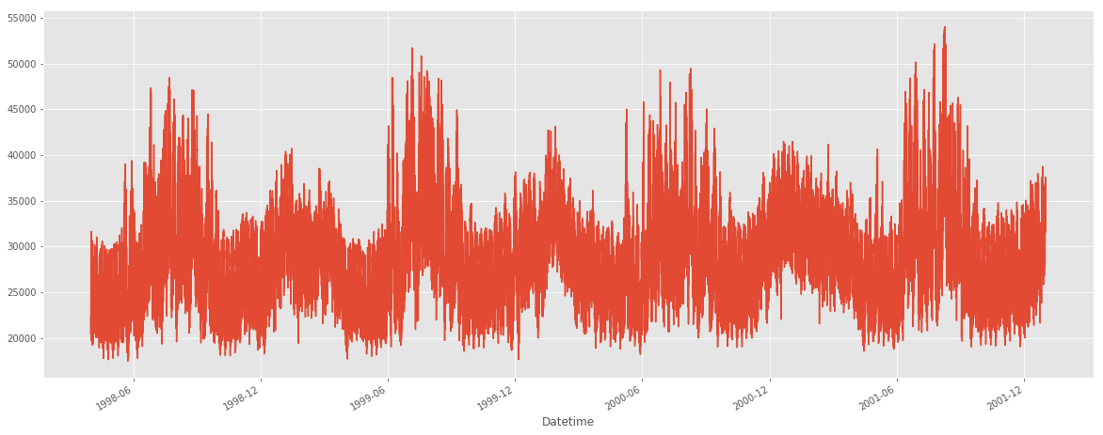

**Split the last year into a test set- can you build a model to predict energy consumption?**

To build a model to predict energy consumption using the hourly power consumption data from PJM for the last year, we'll need to follow these steps:

1. Data Preparation:

a. Split the data into training and test sets.

b. Preprocess the data, handling missing values and any necessary feature engineering.

2. Model Selection:

Choose an appropriate model for predicting energy consumption, such as a time series model like ARIMA, LSTM, or a regression-based model.

3. Model Training:

Train the selected model using the training set.

4. Model Evaluation:

Evaluate the model's performance using the test set.

5. Predict Energy Consumption:

Use the trained model to predict energy consumption for future dates.

Since the hourly power consumption data is in megawatts (MW), time series models like ARIMA or LSTM could be suitable for predicting energy consumption.

**ENERGY CONSUMPTION:**

import matplotlib.pyplot as plt *# plotting*

import numpy as np *# linear algebra*

import os *# accessing directory structure*

import pandas as pd *# data processing, CSV file I/O (e.g. pd.read_csv)*

import seaborn as sns

plt.style.use('ggplot')

*# Data is saved in parquet format so schema is preserved.*

df = pd.read_parquet('../input/est_hourly.paruqet')

*#Show PJM Regions*

from IPython.display import Image

Image(url= "http://slideplayer.com/4238181/14/images/4/PJM+Evolution.jpg")

**OUTPUT:**

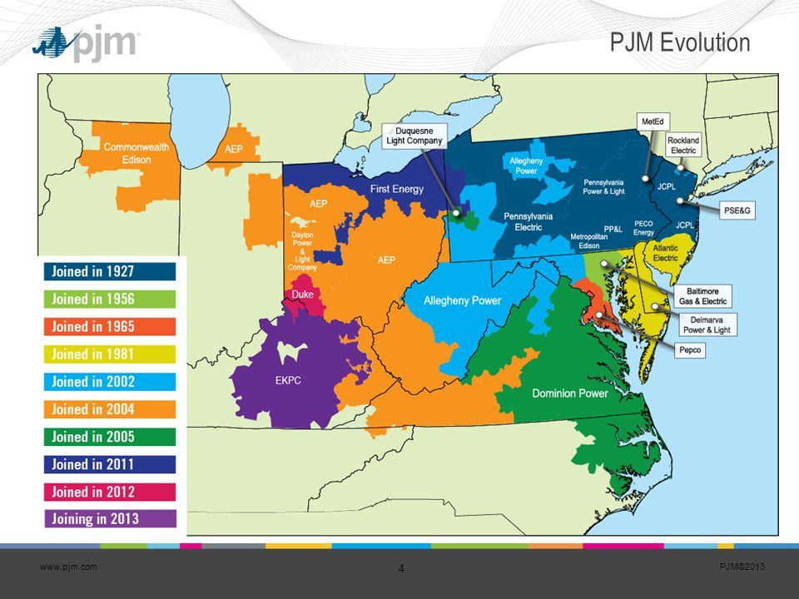

**Types of Time Series Data**

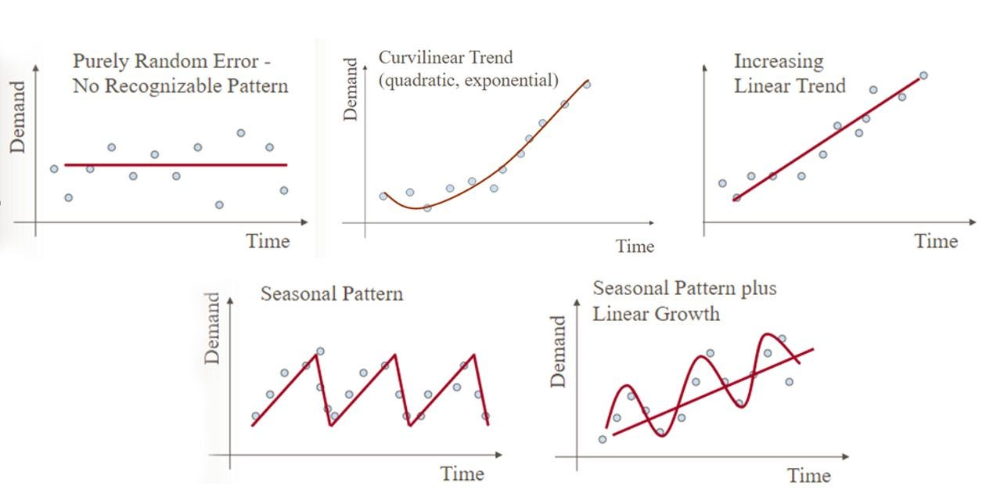

**Data:**

The data we will be using is hourly power consumption data from PJM. Energy consumption has some unique characteristics. It will be interesting to see how prophet picks them up.

Pulling the PJM East which has data from 2002-2018 for the entire east region.

**INPUT:**

pjme = pd.read_csv('../input/PJME_hourly.csv',

index_col=[0],

parse_dates=[0])

pjme.head()

**Output:**

|  | PJME_MW |
| --- | --- |
| Datetime |  |
| 2002-12-31 01:00:00 | 26498.0 |
| 2002-12-31 02:00:00 | 25147.0 |
| 2002-12-31 03:00:00 | 24574.0 |
| 2002-12-31 04:00:00 | 24393.0 |
| 2002-12-31 05:00:00 | 24860.0 |

**INPUT:**

color_pal = sns.color_palette()

pjme.plot(style='.',

figsize=(10, 5),

ms=1,

color=color_pal[0],

title='PJME MW')

plt.show()

**OUTPUT:**

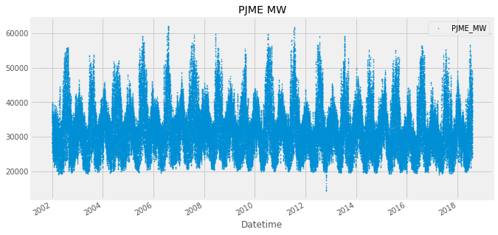

**INPUT:**

fig, ax = plt.subplots(figsize=(10, 5))

sns.boxplot(data=features_and_target.dropna(),

x='weekday',

y='PJME_MW',

hue='season',

ax=ax,

linewidth=1)

ax.set_title('Power Use MW by Day of Week')

ax.set_xlabel('Day of Week')

ax.set_ylabel('Energy (MW)')

ax.legend(bbox_to_anchor=(1, 1))

plt.show()

**OUTPUT:**

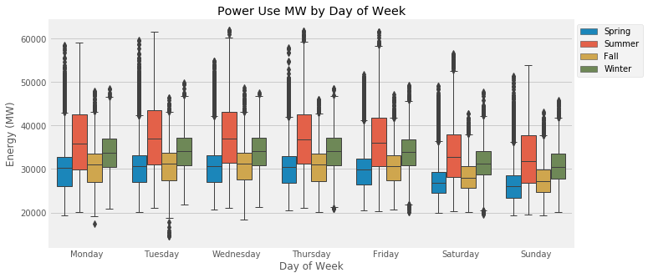

**INPUT:**

df['PJME'].plot.hist(figsize=(15, 5), bins=200, title='Distribution of PJME Load')

**OUTPUT:**

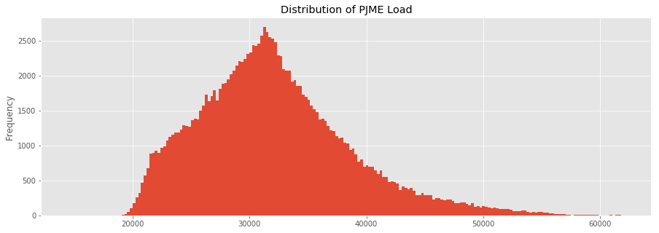

**INPUT:**

= df.plot.hist(figsize=(15, 5), bins=200, title='Distribution of Load by Region')

**OUTPUT:**

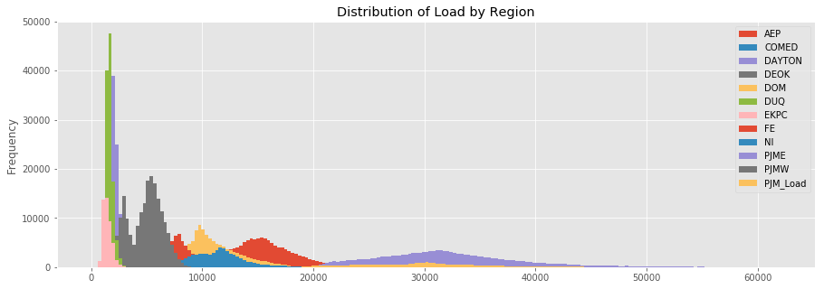

**Plot Time Series**

**INPUT:**

plot = df.plot(style='.', figsize=(15, 8), title='Entire PJM Load 1998-2001')

**OUTPUT:**

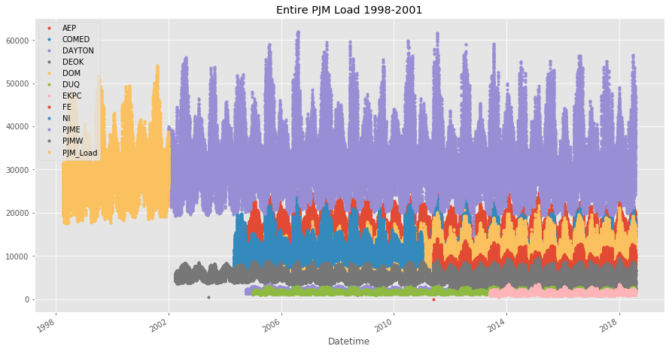

**Summer Demand vs Winter Demand**

Note the dips mid-day in the winter months. Conversely in summer months the daily load is more bell shaped. This is due to high mid-day energy consumtion by air conditioning. In winter months people tend to use less energy mid-day.

**INPUT:**

_ = df['PJME'].loc[(df['PJME'].index >= '2017-11-01') &

(df['PJME'].index < '2017-12-01')] \

.plot(figsize=(15, 5), title = 'November 2017')

**OUTPUT:**

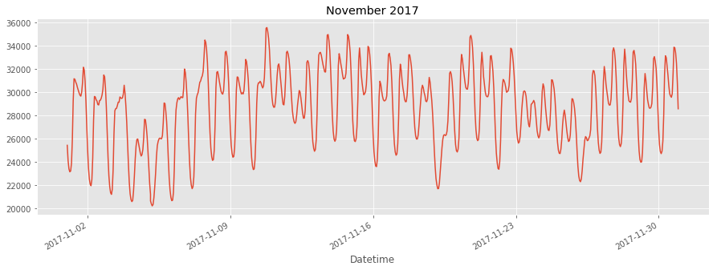

**INPUT:**

= df['PJME'].loc[(df['PJME'].index >= '2017-06-01') &

(df['PJME'].index < '2017-07-01')] \

.plot(figsize=(15, 5), title = 'June 2017')

**OUTPUT:**

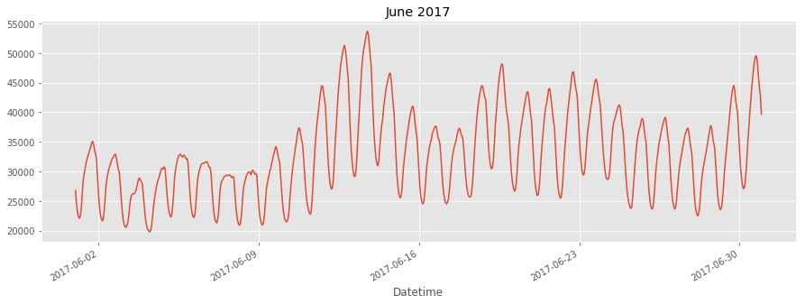

Creating Time Series Features

**INPUT:**

df['dow'] = df.index.dayofweek

df['doy'] = df.index.dayofyear

df['year'] = df.index.year

df['month'] = df.index.month

df['quarter'] = df.index.quarter

df['hour'] = df.index.hour

df['weekday'] = df.index.weekday_name

df['woy'] = df.index.weekofyear

df['dom'] = df.index.day *# Day of Month*

df['date'] = df.index.date

**INPUT:**

_ = df[['PJM_Load','hour']].plot(x='hour',

y='PJM_Load',

kind='scatter',

figsize=(14,4),

title='Consumption by Hour of Day')

**OUTPUT:**

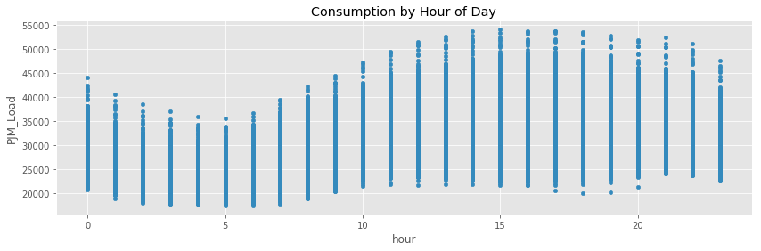

Note Saturday and Sunday demand is much less than during a work week. This is also true for holidays.

**INPUT:**

df.pivot_table(index=df['hour'],

columns='weekday',

values='PJME',

aggfunc='sum').plot(figsize=(15,4),

title='PJM East - Daily Trends')

**OUTPUT:**

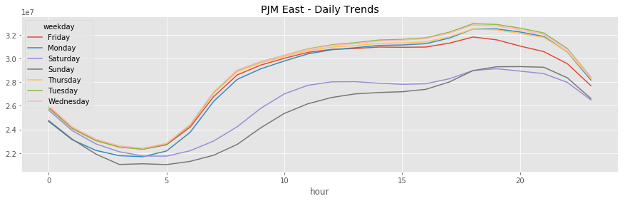

**CONCLUSION:**

Measuring energy consumption using AI is a significant and innovative project. In conclusion, this project has shown that AI can be a valuable tool for optimizing and monitoring energy usage in various applications. Some key takeaways and findings include:

**1. Data Collection and Preprocessing:** Accurate energy consumption measurement relies on the quality and quantity of data collected. This project emphasized the importance of reliable data sources and effective data preprocessing techniques to ensure meaningful insights.

**2. Machine Learning Models:** Various machine learning models, such as regression, neural networks, and time series analysis, were employed to predict and analyze energy consumption patterns. The choice of the model depends on the specific application and dataset.

**3. Anomaly Detection:** AI can be used for detecting anomalies in energy consumption, which can help identify areas of improvement or potential issues.

**4. Real-time Monitoring:** AI-based systems can provide real-time monitoring of energy consumption, enabling timely interventions and adjustments to save energy.

**5. Energy Optimization:** By analyzing historical data, AI can help identify opportunities for energy optimization and cost reduction.

**6. Sustainability:** Implementing AI-driven energy management can contribute to sustainability goals and reduce the carbon footprint.

**7. Integration with IoT:** AI can be integrated with IoT devices to capture real-time data and make dynamic adjustments for energy efficiency.

**8. Challenges:** Challenges in this project include data quality, model accuracy, and the need for ongoing maintenance and updates.

In summary, measuring energy consumption using AI offers a promising approach to enhance energy efficiency, reduce costs, and support sustainability efforts. However, it requires careful data management and model selection to achieve meaningful results. Further research and development in this field can lead to even more significant advancements in energy management.