CHAPTER 1
INTRODUCTION
The rapid growth of marine and coastal tourism, plastic consumption, and unmanaged litter has increased the amount of solid waste reaching beaches and shoreline environments. Beach litter is difficult to manage using manual collection and sorting alone because waste items vary strongly in shape, color, texture, size, and degree of contamination. Manual segregation is also repetitive, labor-intensive, and dependent on worker attention. These conditions motivate the development of automated systems that can identify waste items from visual information and direct them toward separate collection streams.
The present thesis proposes an Edge AI-Based Smart Conveyor System for Automated Beach Waste Classification and Sorting. The prototype combines a conveyor mechanism, an ESP32-S3 embedded controller, an OV5640 5 MP camera, an object-detection/trigger sensor, an Edge Impulse machine-learning model, a DC motor drive, and a servo-actuated sorting mechanism. The intended waste classes are Plastic, Metal, Glass, Biodegradable, and Other. The core design principle is to perform image capture and inference near the point of sensing so that the classification decision can be converted into an immediate mechanical action.
The engineering design is deliberately modular. The mechanical subsystem provides controlled movement and a stable imaging zone; the electrical subsystem distributes regulated power and handles sensing and actuation; the embedded software executes object detection, image preprocessing, inference, and sorting logic; and the result-analysis layer provides performance metrics such as classification accuracy, sorting accuracy, latency, throughput, and power demand. The uploaded prototype photograph is used as the primary visual reference for the physical arrangement.
Because the photograph does not contain a scale reference and the supplied files do not provide verified fabrication dimensions, the dimensioned drawings in this draft use nominal design dimensions for documentation. They should be replaced with final as-built measurements before academic submission. Similarly, no measured confusion matrix, classification accuracy, or sorting-rate dataset was supplied; therefore the results chapter is structured around a rigorous validation protocol and explicitly separates design targets from measured values.

1.1 Background of the Study
Waste management is increasingly influenced by the ability to separate materials into recoverable streams before they become mixed, contaminated, or transported to final disposal. Computer vision offers a practical route for recognizing objects from images, while machine learning enables classification when simple threshold rules are insufficient. In recent waste-classification studies, datasets and models have demonstrated that categories such as plastic, metal, glass, paper, cardboard, and residual waste can be recognized from visual features, but performance often depends strongly on lighting, viewpoint, background, object occlusion, and class balance [1]-[3].
The use of edge computing changes the architecture of such a system. Rather than sending every camera frame to a remote server, inference can be executed on an embedded device located directly beside the conveyor. Edge Impulse describes an image-classification workflow in which data are collected, an impulse is designed, a learning model is trained and validated, and the resulting model is deployed to an embedded device. Local deployment reduces dependence on an internet connection and is attractive when a mechanical actuator must react quickly to a classification decision [4].
The ESP32-S3 is a suitable controller for this type of embedded vision prototype because it integrates 2.4 GHz Wi-Fi, Bluetooth Low Energy, dual Xtensa LX7 CPU cores, peripheral interfaces, and hardware-oriented support for AI/IoT applications. Espressif documentation also identifies camera and image-recognition use cases for the ESP32-S3 family [5]. In this project, the controller is not treated as a conventional server; instead, it is a compact edge node that connects visual sensing, decision logic, and real-time actuator control.
The proposed system therefore addresses two engineering problems simultaneously: visual classification and physical material routing. A correct class prediction is not sufficient unless the object can be detected at a predictable position, the conveyor speed is controlled, and the sorting actuator has enough time to move before the object reaches the discharge point. The thesis treats these conditions as an integrated mechatronic system rather than as an isolated machine-learning experiment.

1.2 Problem Statement
Traditional beach waste collection typically depends on manual picking followed by manual or semi-manual segregation. This approach can be slow when a large number of mixed items are present, and the sorting decision may be inconsistent between operators. A second limitation is that beach waste commonly contains wet, dirty, partially buried, or visually damaged items. A system designed only for clean laboratory objects may therefore perform poorly when transferred to outdoor waste conditions.
A further problem is the gap between AI prediction and physical action. Many vision-based waste studies emphasize classification accuracy but do not fully describe the mechanical timing required to move the predicted item into the correct bin. For an automated conveyor system, the useful output is the combination of a class label, a confidence score, a time stamp, and a corresponding servo command. The system must also handle cases in which the confidence is low or the image contains an item outside the training categories.
The proposed system addresses the problem by introducing a controlled conveyor path, a fixed imaging zone, an object-trigger sensor, an embedded Edge AI classifier, and a servo-based sorting stage. The design provides a repeatable relationship between object position and actuation time. The machine therefore becomes a closed-loop mechatronic chain: detect -> capture -> classify -> decide -> actuate -> route -> return to the ready state.
The main research gap addressed in this thesis is not merely the classification of waste, but the integration of embedded image intelligence with a low-cost mechanical sorting line that can be fabricated and evaluated as a complete prototype. This integration requires mechanical sizing, electrical power design, camera geometry, dataset engineering, timing analysis, and experimental verification in one architecture.

1.3 Objectives
Objective | Description
1 | Design and fabricate a compact conveyor-based mechanism suitable for controlled waste movement and sorting.
2 | Integrate ESP32-S3 and OV5640 camera hardware for image acquisition at the classification zone.
3 | Develop an Edge Impulse image-classification model for Plastic, Metal, Glass, Biodegradable, and Other categories.
4 | Implement object-triggered inference and convert the predicted class into a servo sorting command.
5 | Evaluate classification, sorting, response time, conveyor throughput, and power requirements using a defined experimental protocol.
6 | Document mechanical, electrical, and software design decisions in a reproducible engineering format.
The objectives intentionally combine machine-learning and mechanical targets. The first four objectives define the construction of the prototype, while the fifth establishes the basis for experimental validation. The final objective supports reproducibility and allows the system to be improved or scaled in future work.
1.4 Scope of the Work
The scope is limited to a laboratory-scale prototype that transports one item at a time through a camera field of view and then routes the item toward one of five collection paths. The intended categories are chosen to represent material groups commonly encountered in mixed litter. The system is not presented as a municipal-scale beach-cleaning robot and does not claim autonomous collection from sand. Rather, it provides an intelligent sorting stage that can be coupled to a manual, robotic, or pre-screened beach-waste collection process.
Outdoor deployment, waterproofing, large-scale hopper feeding, and multi-camera tracking are outside the current scope and are treated as future development areas.
1.5 Overview of the Thesis
Chapter 1 introduces the environmental motivation, engineering problem, objectives, scope, and system concept. Chapter 2 reviews relevant literature on automated waste classification, edge AI, embedded vision, conveyor sorting, and data preparation. Chapter 3 presents the methodology in the format of the supplied thesis template, including system architecture, block diagram, electrical design, mechanical design, working principle, components, flowchart, implementation, and calibration. Chapter 4 presents the result and discussion structure, including experimental protocols, performance indicators, design targets, result tables, graphical analysis, literature comparison, advantages, and limitations. Chapter 5 provides conclusions and recommendations.
The chapter sequence follows the format of the supplied thesis guideline, which expects Chapter 3 to cover methodology and system design and Chapter 4 to cover experimental or simulation results, graphical/tabular presentation, analysis, comparison, advantages, and limitations. The guideline also specifies centered figure captions, clear component diagrams, mechanical drawings, and an experimental setup description.
Design note: The wording and structure of the present draft have been adapted from the supplied thesis format while replacing the example SCADA content with the beach-waste conveyor project.
1.6 System Concept
The conceptual operating sequence is simple: a waste item enters the conveyor, the object sensor detects its presence, the ESP32-S3 requests a camera frame, the Edge AI model predicts the material class, and the firmware selects a servo angle or discharge path. The conveyor motor can continue running at a controlled speed or pause briefly during inference, depending on the final timing budget. A confidence threshold is recommended so that uncertain predictions can be sent to the Other category instead of producing an unsafe or inconsistent sorting command.

CHAPTER 2
LITERATURE REVIEW
This chapter reviews the technical basis of intelligent waste classification and mechanical sorting. It combines computer-vision literature with edge-computing and embedded-hardware documentation to identify design choices that are suitable for a low-cost conveyor prototype. The review is organized by theory, previous systems, comparative discussion, and research gap, following the supplied thesis-format guidance.
2.1 Introduction to Waste Classification
Waste classification converts a visual observation into a material label. In an image-based system, the raw input is a two-dimensional array of pixels. The model learns a mapping from image patterns to class probabilities. For a five-class system, the final prediction can be expressed as p(c|x), where c is the candidate waste class and x is the captured image. The class with the highest probability is selected when the confidence exceeds the chosen threshold.
TACO provides a public dataset of litter images collected in context and illustrates the difficulty of real-world waste detection when background and object appearance vary. WasteNet further demonstrates that waste classification can be performed on low-power edge devices and considered categories including paper, cardboard, glass, metal, plastic, and other materials [1,2]. These studies support the use of machine learning but also reinforce the need for project-specific datasets when the physical environment differs from the training data.

2.2 Edge AI and Embedded Inference
Edge AI means that at least part of the machine-learning inference chain is executed close to the data source. In this project, the camera and controller are mounted on the conveyor itself, which reduces the need to transmit image frames to a remote server. Edge Impulse documents that a trained impulse can be deployed as a device-side library so the inference process, preprocessing configuration, and learned model can run locally [4,6]. This architecture is valuable for a sorting machine because the decision must be synchronized with a moving object.
The main design trade-off is between model size and available computational resources. Larger models may provide stronger representation capacity but consume more RAM, flash, and processing time. Quantized integer models are frequently attractive for constrained embedded deployments because they reduce memory and arithmetic cost. The final choice should therefore be based on the actual on-device latency, RAM usage, flash usage, and classification accuracy reported by Edge Impulse after deployment.
For this thesis, the AI model is treated as one subsystem in a larger real-time chain. A prediction is useful only if the camera view is stable, the object is centered sufficiently for classification, the inference completes before the sorting point, and the servo actuation matches the physical path. This is why the mechanical distance between the imaging zone and sorting gate is discussed together with AI inference time.

2.3 Embedded Vision Hardware
The ESP32-S3 integrates wireless connectivity, dual LX7 CPU cores, multiple interfaces, and support for camera and image-recognition applications. Espressif identifies image recognition and camera-related use among ESP32-S3 application scenarios [5]. The project therefore uses the ESP32-S3 as the main supervisory controller rather than splitting sensing and control across multiple microcontrollers.
The OV5640 is a 5-megapixel image sensor developed by OmniVision. Its availability in compact camera modules makes it useful for embedded image acquisition. Espressif also documents camera use through the ESP32 camera stack and confirms support for ESP32-S3 with cameras using the DVP interface [7]. The project uses the OV5640 as the fixed-view camera above the belt so that image scale and illumination can be kept more consistent than with a handheld camera.
The object-trigger sensor complements the camera. A photoelectric or IR sensor can detect an approaching item and provide a digital trigger to the controller. This event-based acquisition prevents the system from performing unnecessary inference on empty belt frames and creates a time reference for estimating the travel time from the sensing position to the sorting gate.

2.4 Previous Waste Classification and Sorting Systems
Published waste-classification studies commonly use convolutional neural networks, transfer learning, or lightweight object-detection models. TACO emphasizes the challenge of contextual litter detection [1]. WasteNet demonstrates a low-power waste classifier and reports high classification performance on its test data [2]. Yu and Grammenos report that transfer learning and augmentation can improve recycling-category classification performance, reaching 95.40% test accuracy in their study after augmentation [3]. These studies show that data diversity and training strategy matter as much as the choice of network architecture.
In physical sorting systems, classification is often coupled to conveyor movement, robotic picking, pneumatic ejectors, or servo gates. A conveyor is attractive at prototype scale because it provides a predictable object path, but it introduces a timing relationship between belt velocity, camera position, inference time, and actuator position. If the belt is too fast for the selected inference time, the object may pass the sorting point before the servo reaches its command angle.
The present project combines these lessons by using a fixed imaging zone, a trigger sensor, and an actuated gate. The architecture is intentionally simpler than a multi-axis robotic picker, which reduces mechanical complexity while still demonstrating the main mechatronic problem of automated waste segregation.

2.5 Comparative Discussion and Research Gap
The literature indicates three broad approaches. First, cloud-based or workstation-based waste recognition can use large models but introduces communication and latency requirements. Second, edge-classification systems reduce communication dependence but require careful model optimization. Third, mechanical sorting studies may provide strong actuator performance without embedding AI into the same controller. The proposed system sits at the intersection: it attempts to keep both inference and actuation local.
Area | Typical approach | Strength | Gap addressed by this project
Vision model | CNN / transfer learning | Strong visual representation | Model must be optimized for MCU resources
Dataset | Public or project-specific images | Large diversity possible | Beach-specific appearance must be represented
Edge deployment | Local inference | Low communication latency | Requires timing and memory validation
Conveyor sorting | Motor + gate/ejector | Predictable object path | Classification and actuation must be synchronized
Prototype evaluation | Accuracy only | Easy to report | Needs integrated classification + sorting metrics
The research gap can therefore be stated as the lack of a compact, documented, low-cost prototype that explicitly links an Edge AI waste classifier to a conveyor sorting mechanism and reports the mechanical and electrical design alongside AI performance. The thesis addresses this gap through integrated system design and a structured test plan.

2.6 Summary of Literature Review
The review supports the use of embedded image classification, a project-specific dataset, controlled camera geometry, and lightweight deployment. It also indicates that a useful system must be evaluated beyond raw model accuracy. The conveyor speed, trigger reliability, servo repeatability, inference latency, and power consumption influence the final system behavior.
Ref. | Source | Key contribution | Relevance to project
[1] | Proença & Simões (2020) | Contextual litter dataset (TACO) | Supports real-world dataset diversity
[2] | White et al. (2020) | WasteNet edge waste classification | Demonstrates edge AI feasibility
[3] | Yu & Grammenos (2021) | Transfer learning + augmentation | Supports dataset/model optimization
[4] | Edge Impulse | Image classification workflow | Supports training and deployment process
[5] | Espressif | ESP32-S3 hardware capabilities | Supports MCU selection
[7] | Espressif camera documentation | ESP32-S3 camera support | Supports OV5640 integration
[8] | OmniVision | OV5640 5 MP sensor | Supports camera selection
Design note: Exact measured model accuracy and on-device latency must be copied from the final Edge Impulse project report before submission. The present paper deliberately avoids inventing those values.

CHAPTER 3
METHODOLOGY
The methodology follows a hardware-based, prototype-driven engineering approach. The design process begins with requirement analysis and system decomposition, followed by mechanical concept development, electrical architecture, AI dataset preparation, prototype assembly, calibration, and integrated testing. The supplied thesis-format guideline specifically expects Chapter 3 to describe the engineering approach, block diagram, electrical design, mechanical design, working principle, component list, flowchart, and experimental setup.
The proposed system uses five interconnected layers: mechanical transport, sensing and image acquisition, edge AI inference, actuation, and verification. The mechanical layer defines the distance between the sensing and sorting points. The sensing layer detects an incoming object and captures an image. The AI layer determines the predicted waste class. The actuator layer converts the class into a servo gate position, while the verification layer evaluates performance against defined metrics.
3.1 Design Requirements
Requirement | Design target | Verification method
Overall prototype size | Approximately 1200 x 450 x 360 mm | As-built measurement
Belt width | 300 mm nominal | Tape/steel rule
Object triggering | One clean digital event per item | 100-event sensor test
Waste classes | 5 | Label set verification
Model confidence | Thresholded before sorting | Firmware log
Sorting accuracy | >= 85% design target | Known-object trials
Classification accuracy | >= 90% design target | Held-out test set
System response | Target <= 2 s end-to-end | Timestamp comparison

3.2 Block Diagram
Figure 3.1 presents the complete information and power relationship of the proposed conveyor system. Waste enters mechanically at the left side. The object sensor provides a trigger to the ESP32-S3. The camera acquires a frame from the defined imaging zone. The Edge AI model returns class probabilities, and the firmware converts the selected class into a servo command. In parallel, the controller drives the conveyor motor through a motor driver.
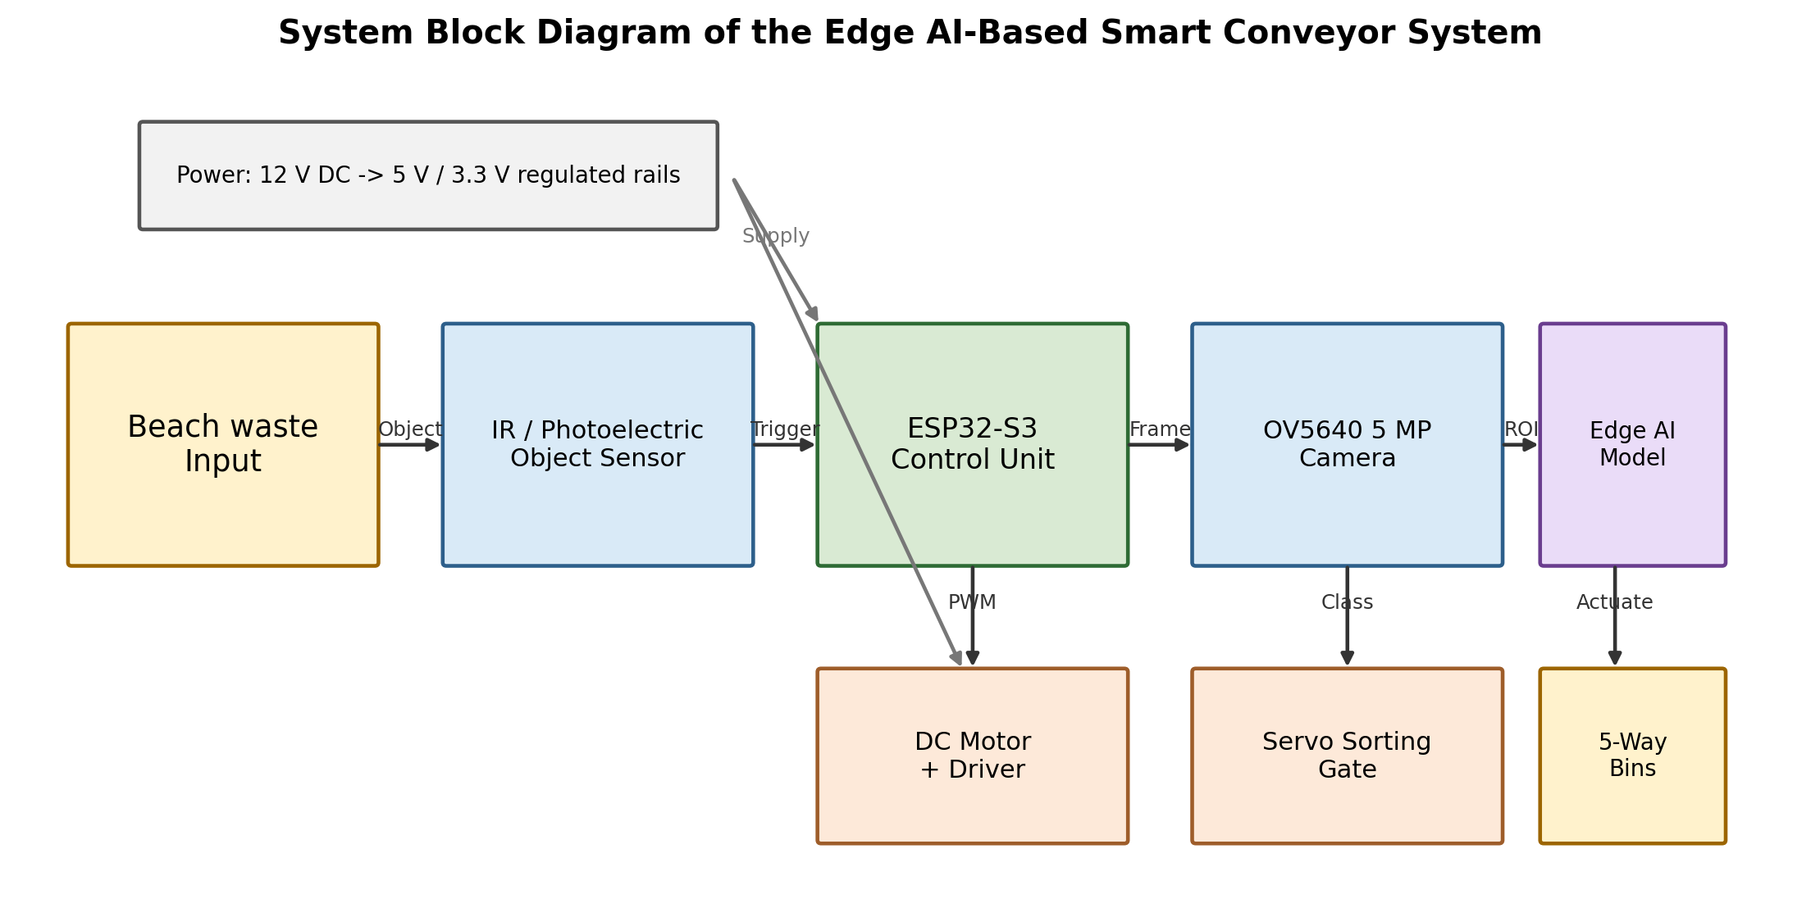
Figure 3.1: Block Diagram of the Edge AI-Based Smart Conveyor System for Automated Beach Waste Classification and Sorting
The architecture separates the perception and actuation paths while keeping both under a single controller. This reduces wiring and coordination overhead. It also enables future integration of additional sensors, such as a load cell, moisture sensor, or color/reflectance sensor, without changing the fundamental decision chain.

3.3 Mechanical Design
The mechanical system is designed as a compact rectangular conveyor frame with two main roller stations, a continuous belt surface, side guides, a camera support, and a downstream sorting region. The uploaded prototype photograph shows a white belt-like transport surface mounted within a yellow structural enclosure, with powered rollers and a vertical electronics/camera mounting region. The design presented in this chapter preserves that functional arrangement while documenting a nominal dimension set.
The frame material can be fabricated from plywood, acrylic, aluminum angle, or other light structural sheet depending on laboratory resources. For a prototype, a rigid base is more important than very high structural strength because the primary loads are belt tension, motor torque, object weight, and servo reaction. The camera bracket should be stiff enough that vibration does not change the field of view during operation.
Design note: Nominal dimensions are used because the supplied image has no reference scale. The dimensions in Figures 3.3-3.7 should be replaced with final as-built values before thesis submission.
The design uses four key geometric constraints: the belt must remain centered between side walls; the camera optical axis must intersect the object plane; the trigger sensor must be upstream of the camera by a known distance; and the sorting gate must be downstream by enough distance to absorb inference and actuator latency.

3.3.1 Top View and Layout
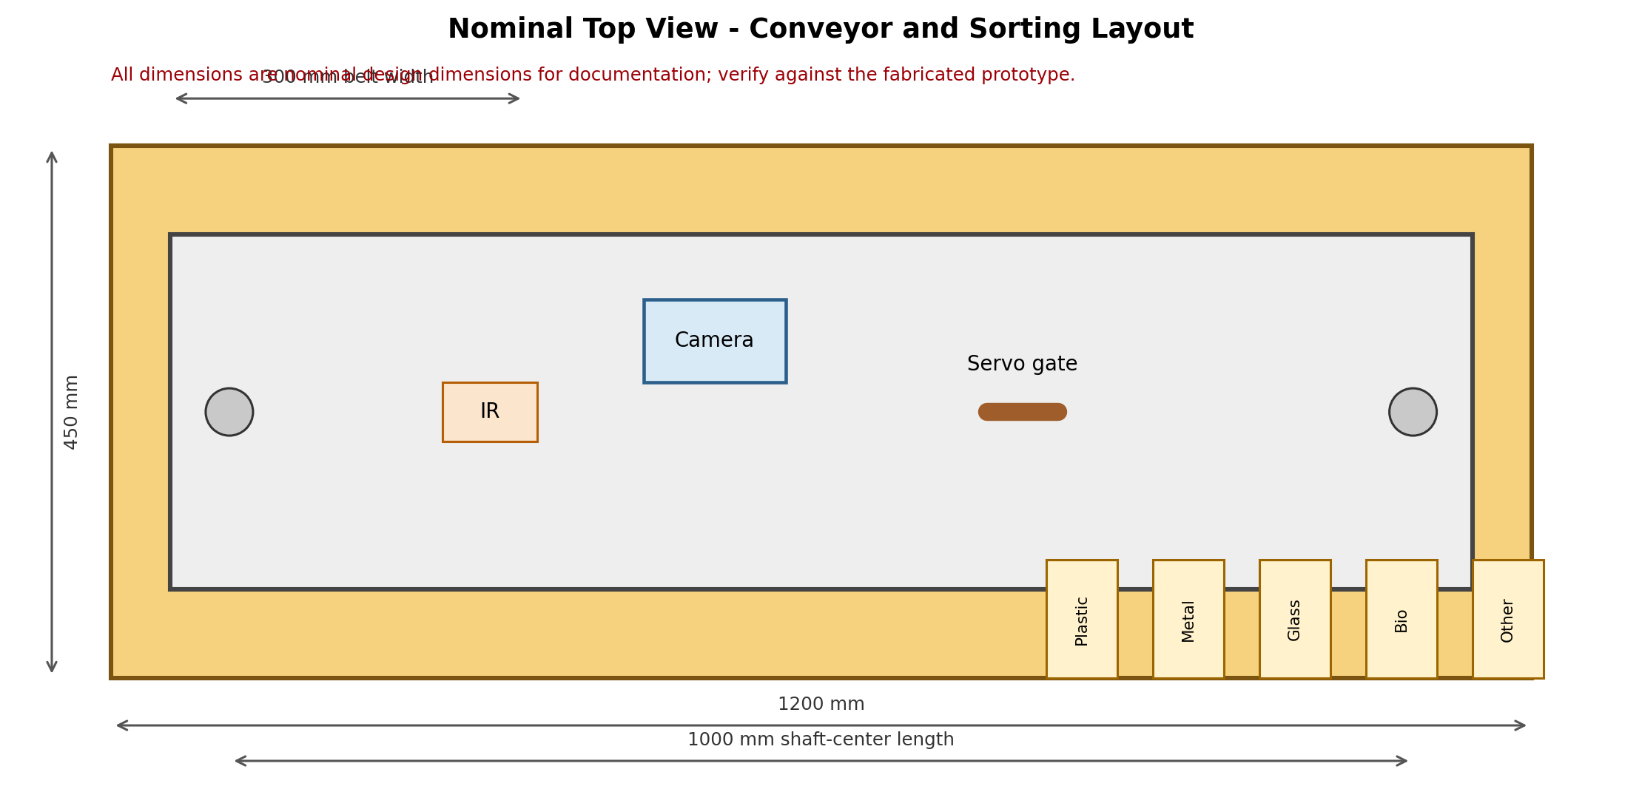
Figure 3.3: Nominal Top View of the Smart Conveyor System (all dimensions in mm)
The nominal top view uses an overall length of 1200 mm and width of 450 mm, with a 300 mm usable belt width. A 1000 mm shaft-center distance is reserved for the conveyor span. The object sensor is placed before the camera so that the controller receives a trigger before the object enters the main imaging region. The sorting gate is positioned after the camera with enough travel distance to accommodate the AI inference and servo movement.
Five downstream bins are shown for Plastic, Metal, Glass, Biodegradable, and Other. For a real beach-waste installation, the bins can be replaced by larger removable containers, chutes, or collection bags. The drawing intentionally uses modular positions so that the discharge geometry can be changed without rebuilding the camera zone.

3.3.2 Front View and Camera Height
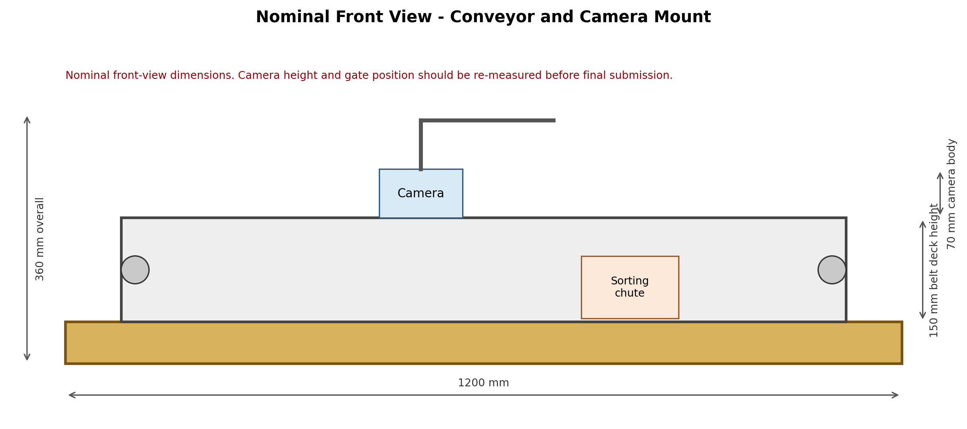
Figure 3.4: Nominal Front View of the Smart Conveyor System (all dimensions in mm)
The front view defines the vertical envelope of the conveyor and camera mount. A nominal 150 mm belt-deck height is used in the drawing, with the camera mounted above the imaging plane. The camera bracket should allow small adjustments along the vertical axis because field-of-view requirements may change after the final model input resolution is selected.
A stable field of view is essential for machine learning. The camera should not see excessive background beyond the belt, and the side walls should be used to block external clutter. Consistent illumination should be provided through diffuse LED lighting where necessary. For beach-waste images, glare on plastic and glass is a significant concern; therefore, matte internal surfaces and shielded lighting are preferred over highly reflective enclosures.

3.3.3 Left Side View
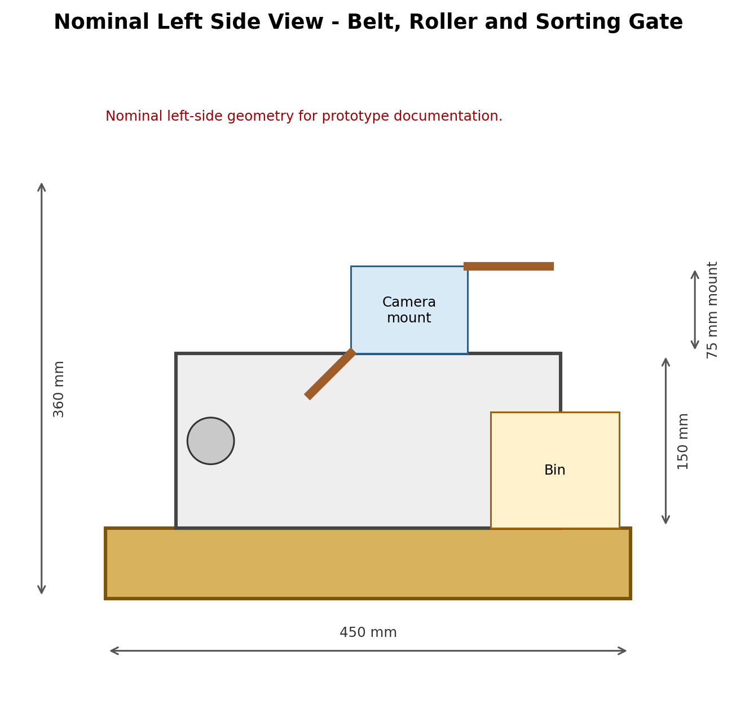
Figure 3.5: Nominal Left Side View of the Smart Conveyor System (all dimensions in mm)
The left-side view emphasizes the relationship between the belt deck, rollers, camera bracket, and discharge bin. The roller centers should be aligned to reduce belt tracking problems. A slight mechanical clearance between the belt edge and side wall is recommended so that rubbing does not increase motor load. The camera mount is placed sufficiently above the belt to capture the complete cross-section of the object while maintaining a useful pixel density.
The side geometry also determines how long the object is visible to the camera. If the belt speed is increased, the image exposure and trigger timing may need adjustment. The final implementation should therefore calibrate the mechanical travel distance and firmware delays together rather than treating the motor speed as an independent parameter.
3.3.4 Right Side View
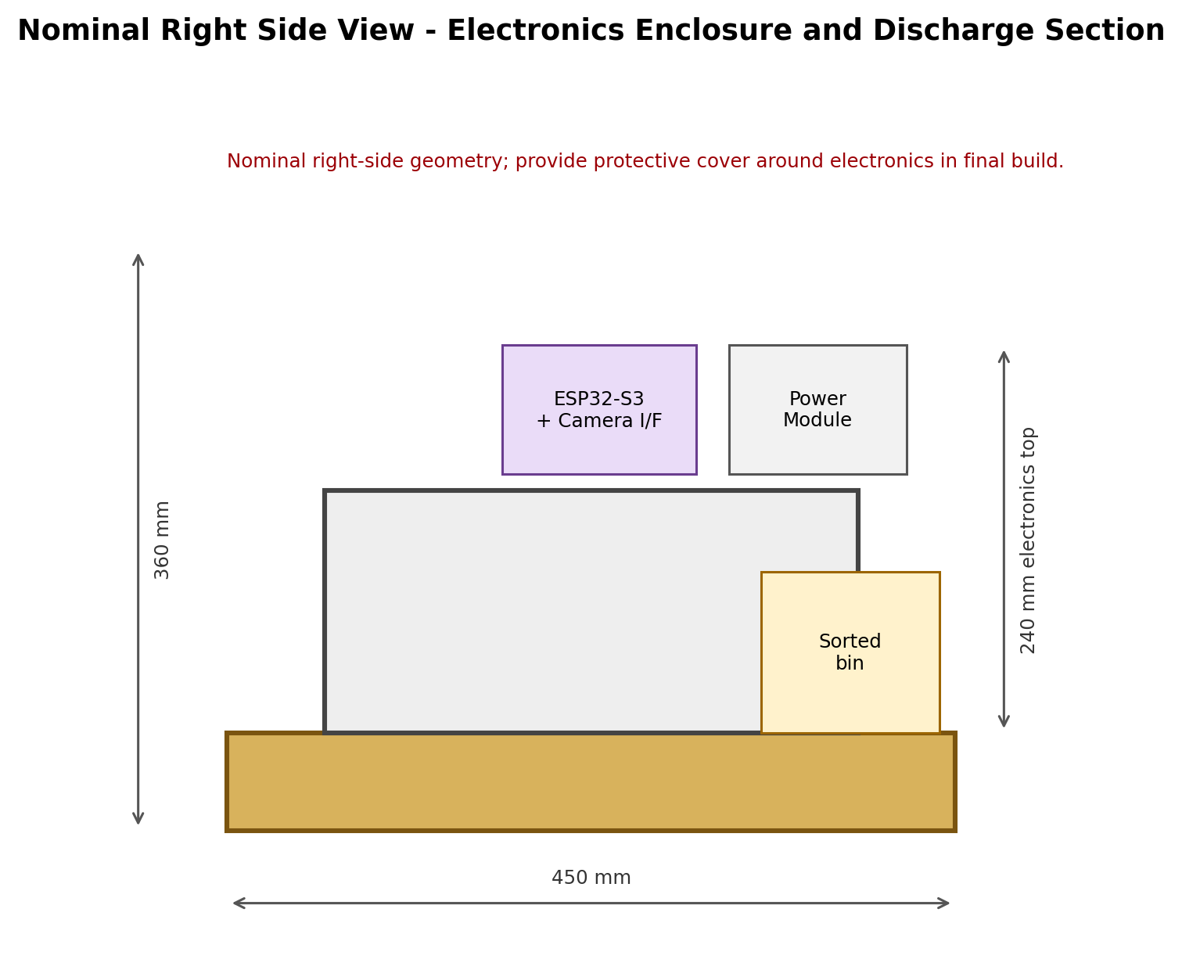
Figure 3.6: Nominal Right Side View of the Smart Conveyor System (all dimensions in mm)
The right-side view documents the electronics region and discharge section. The ESP32-S3 and power module are mounted away from the moving belt so that loose material, moisture, and accidental impact are less likely to reach sensitive electronics. Cable entries should be routed through protected channels and strain relief should be used near the motor and servo connections.
The discharge section should provide enough vertical and lateral clearance for the servo gate to move freely. The bin arrangement shown here is a simplified representation. In the final fabricated system, the discharge chutes may be angled to use gravity and reduce servo load. A removable bin interface also simplifies testing because individual waste streams can be weighed after each trial.
3.3.5 Isometric Mechanical View
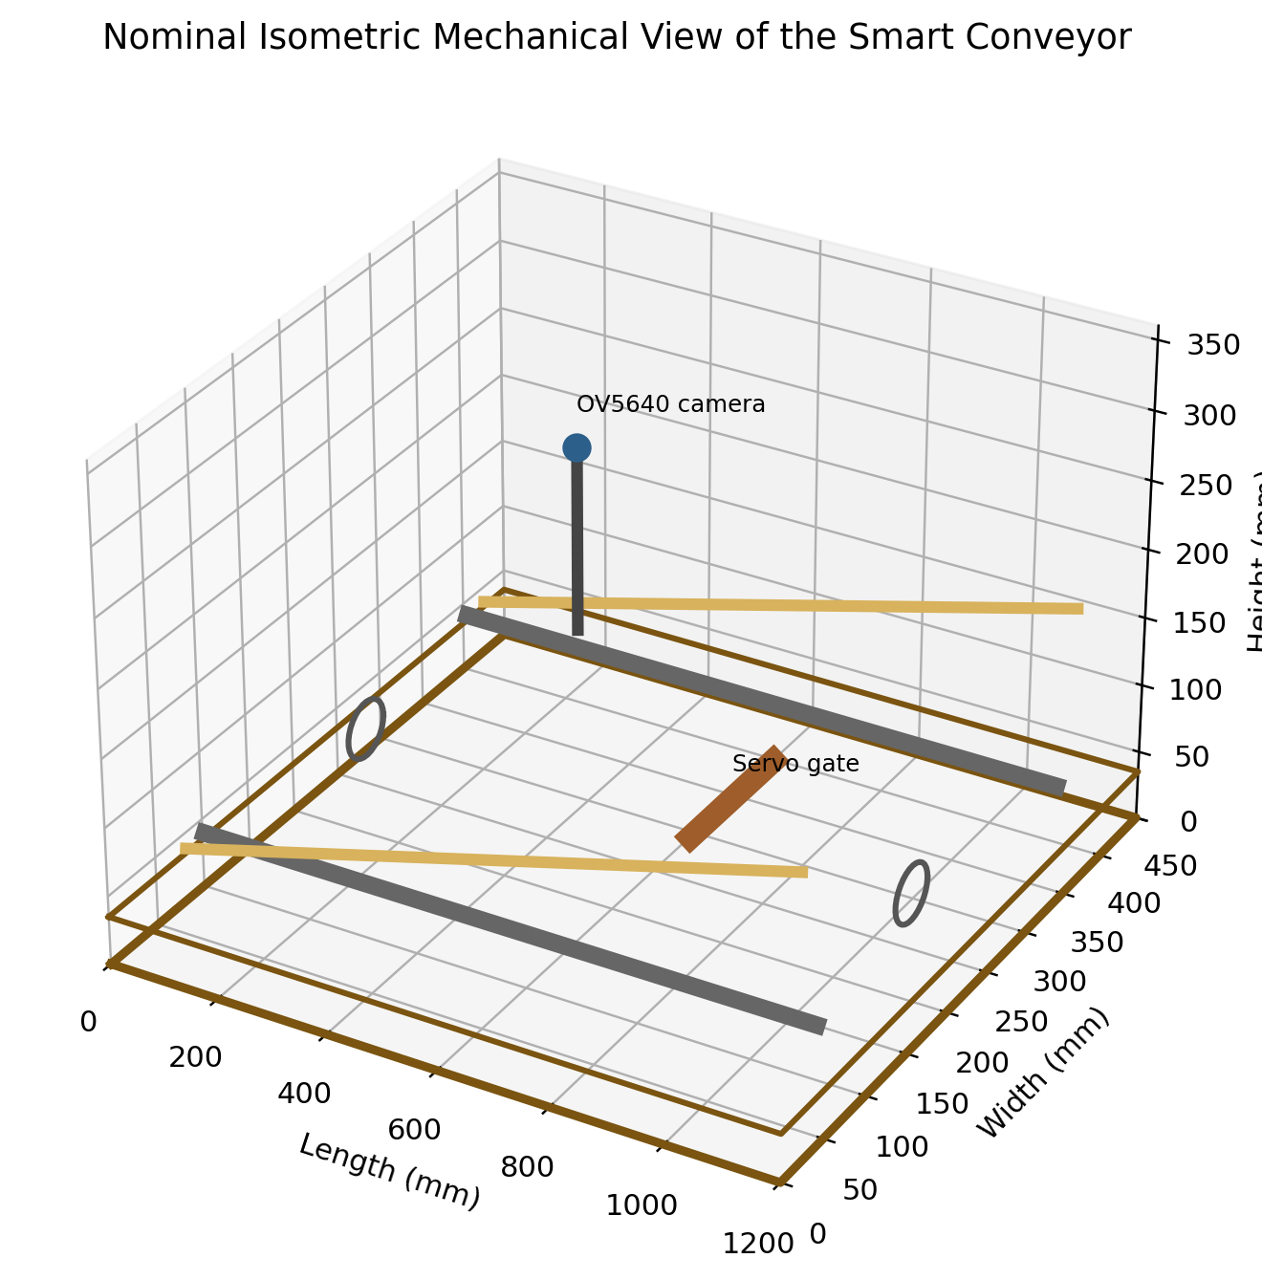
Figure 3.7: Nominal Isometric View of the Smart Conveyor System
The isometric view shows how the conveyor belt, side walls, rollers, camera mast, and sorting gate form one compact assembly. The open top helps with laboratory testing, while a future protective cover should avoid optical reflections.
The roller shafts should remain parallel to reduce belt drift. The camera bracket is fixed after belt tracking is adjusted, and the servo gate is calibrated after the conveyor path is verified.

3.3.6 Mechanical Design Calculations
For a conveyor roller of diameter D and rotational speed N, the ideal belt speed is approximated by v = pi D N / 60. For the nominal design, D = 40 mm and N = 60 rpm give v approximately 0.126 m/s. This value is a design reference, not a measured prototype value. The final speed must be measured under load because belt slip and gearbox behavior can change the actual linear velocity.
The drive torque requirement can be estimated from T = F r, where F is the effective belt pulling force and r is the roller radius. If the combined resisting force is conservatively assumed to be 8 N and r = 0.02 m, then T = 0.16 N.m. Applying a safety factor of 2 gives a nominal design torque requirement of approximately 0.32 N.m at the drive roller. This value provides a practical basis for selecting the motor and gearbox.
For the roller shaft, a preliminary bending check can be performed for an assumed central load. With an illustrative 20 N transverse load over a 100 mm span, the maximum bending moment is W L / 4 = 0.5 N.m. An 8 mm diameter steel shaft gives an approximate bending stress sigma = 32 M / (pi d^3), which is about 31 MPa. The final shaft should be selected using the actual bearing spacing, load distribution, and material properties.
Design note: The numerical examples on this page are engineering design calculations based on nominal assumptions, not measurements of the fabricated prototype.

3.3.7 Camera and Sorting Geometry
The camera-to-belt distance is a key parameter in a machine-vision conveyor. If the camera is too far away, a waste item occupies too few pixels and small material features become difficult to classify. If it is too close, larger objects may be cropped. The final distance should therefore be selected so that the largest expected item fits within the horizontal field of view while the smallest class-defining features remain visible.
Let d be the distance from the camera center to the image plane and theta be the camera horizontal field angle. The approximate visible width can be expressed as W_fov = 2 d tan(theta/2). For the nominal 300 mm belt width, the camera should be positioned so that W_fov is slightly larger than 300 mm. The exact distance depends on the OV5640 lens used in the module, which can vary between camera boards.
The sorting gate should be placed at distance L_s downstream from the camera. The travel time is t_travel = L_s / v. The combined image capture, inference, firmware, and servo response must remain below this travel time. A practical design rule is to keep a timing margin of at least 20-30% so that occasional processing delays do not cause systematic mis-sorts.
Parameter | Nominal value | Design purpose
Overall length | 1200 mm | Compact laboratory frame
Belt width | 300 mm | Five-class object transport
Roller diameter | 40 mm | Belt speed reference
Camera height | ~250 mm above belt | Field-of-view control
Sorting point after camera | ~300 mm | Timing margin
Nominal speed | 0.126 m/s at 60 rpm | Reference design point

3.4 Electrical Design
The electrical design provides regulated power to the embedded controller, camera, sensor, servo, and conveyor motor driver. The proposed architecture starts with a 12 V DC source for the motor stage and uses a regulated buck converter to create the low-voltage rails required by the controller and peripherals. A separate motor-current return path is recommended so that motor switching noise is not coupled directly into camera and logic-ground wiring.
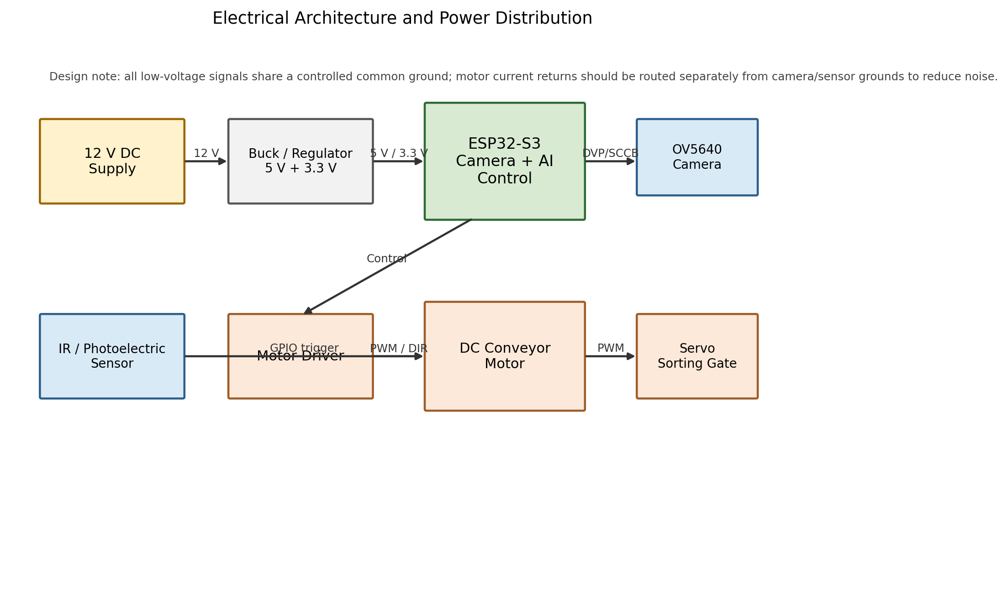
Figure 3.8: Electrical Architecture and Power Distribution of the Prototype
The ESP32-S3 acts as the electrical control hub. The object sensor is connected to a digital input; the camera uses the camera interface and control bus; the motor driver receives PWM/direction control; and the servo receives a PWM command. The power architecture should include a common logic reference, appropriate fuse protection, decoupling capacitors, and strain relief on all moving-component cables.

3.4.1 Power Budget and Regulation
A preliminary power budget is required before selecting the supply. Because the motor and servo have dynamic current demand, the supply should not be sized from the average ESP32 power alone. The motor driver should receive the motor voltage directly from the high-current rail, while the ESP32-S3 and camera should be supplied through a stable regulated rail.
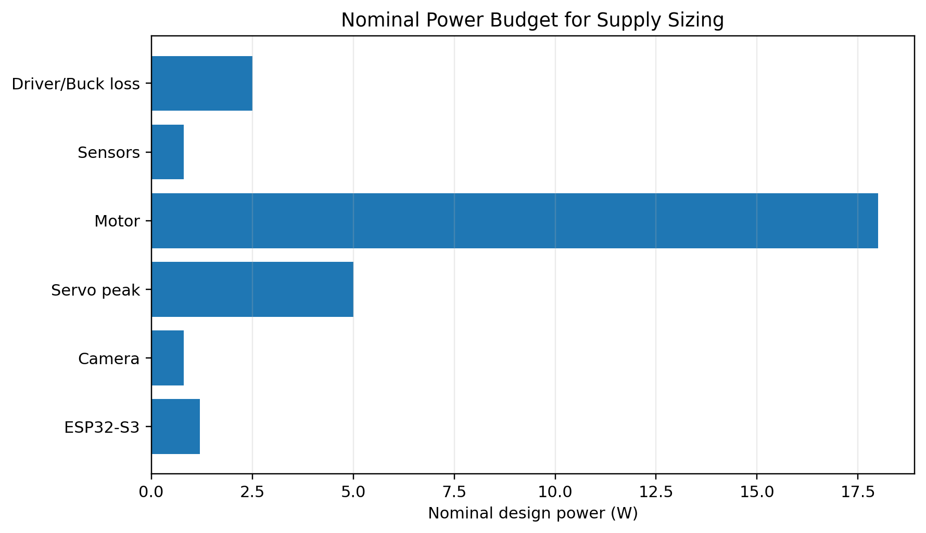
Figure 3.9: Nominal Power Budget for Supply Sizing (design values, not measurements)
Load | Nominal design power | Notes
ESP32-S3 control | 1.2 W | Depends on Wi-Fi, CPU and camera activity
OV5640 camera | 0.8 W | Module dependent
Servo peak | 5.0 W | Short-duration peak allowance
DC motor | 18.0 W | Nominal sizing example
Sensors | 0.8 W | IR/photoelectric + auxiliaries
Driver and buck loss | 2.5 W | Allowance for conversion loss
Total nominal envelope | 28.3 W | Use margin above this value
Allowing about 30% design margin places the supply envelope near 37 W (about 12 V at 3.1 A). A 12 V, 5 A supply provides a conservative prototype margin, subject to final motor and servo current measurements.

3.4.2 Electrical Signal and Protection Considerations
The logic section is sensitive to voltage mismatch, inductive transients, and electromagnetic noise. The sensor output must remain within the ESP32-S3 GPIO limits. A motor driver isolates the high-current motor path from the microcontroller pins, and a separate servo power path reduces the risk of resets caused by servo current spikes.
Protection measures should include a main fuse or resettable protection device on the DC input, reverse-polarity protection where practical, bulk capacitance near the motor driver and servo supply, 0.1 uF local decoupling at logic ICs, and secure connectors on all moving cables. The electronics enclosure should also provide airflow and physical protection from beach dust and moisture.
The camera interface is particularly sensitive to vibration and signal integrity. The camera cable should be kept short and routed away from motor wires. If the prototype experiences image corruption or intermittent capture, the first checks should include power-rail stability, camera grounding, connector seating, and motor-noise coupling.
3.4.3 Pin Mapping - Proposed Design Assignment
Function | ESP32-S3 resource | Signal type | Remark
Object sensor | GPIO A (design assignment) | Digital input | Use interrupt or polling
Motor PWM | LEDC-capable GPIO | PWM output | Controls belt speed
Motor direction | GPIO B / GPIO C | Digital output | Depends on driver
Servo gate | LEDC-capable GPIO | PWM output | Angle mapped from class
Camera | DVP + SCCB interface | Camera bus | Pin map depends on board
Status LED | GPIO D | Digital output | Debug indicator
Serial debug | UART | Serial | Calibration and logging
Design note: The table intentionally uses functional pin names rather than unverified GPIO numbers. Replace them with the actual pins of the ESP32-S3 board used in the prototype.

3.4.4 Electrical Circuit Diagram of the Prototype
Figure 3.14 presents the electrical circuit used for the conveyor prototype. The diagram shows the ESP32-S3 camera-controller board, the L298N dual H-bridge motor driver, four DC geared motors, one servo motor, and the 12 V DC source. The circuit separates the high-current motor path from the low-power controller and sensor logic. The ESP32-S3 provides the control signals, while the motor driver supplies the required current to the conveyor drive motors. The servo motor is controlled by a PWM signal from the ESP32-S3 and is used as the physical sorting actuator.
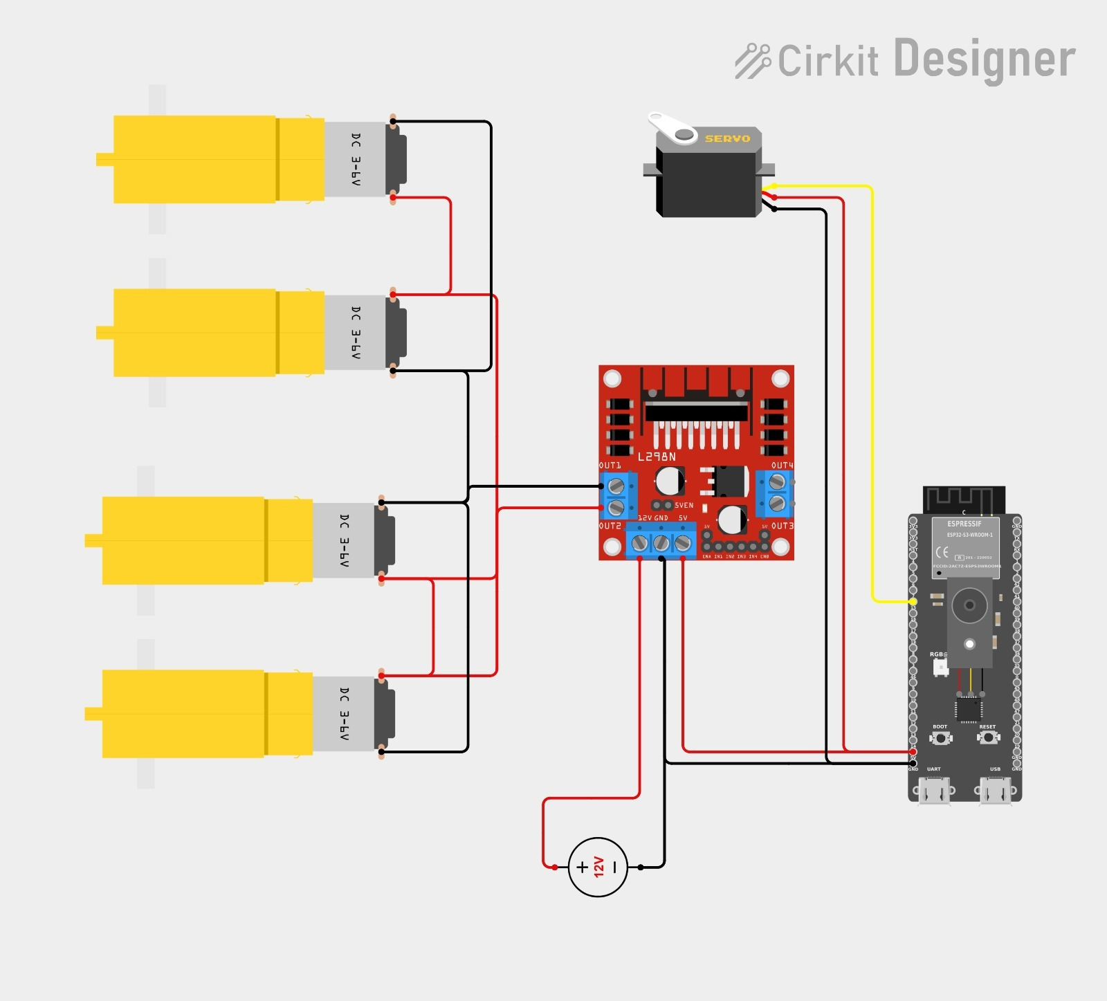
Figure 3.14: Electrical Circuit Diagram of the Edge AI-Based Smart Conveyor Prototype
In the supplied circuit, the four DC motors are grouped through the L298N driver so that the conveyor mechanism can be driven using a controlled motor-channel arrangement. A common ground reference is required between the controller, driver, servo supply and sensing electronics. The physical implementation should follow the voltage ratings of the selected motors and servo rather than relying only on the nominal source shown in the diagram.

3.4.5 Electrical Operation and Signal Flow
The electrical operation starts when the DC source is switched on. The ESP32-S3 receives a regulated logic supply, while the L298N motor driver receives the motor supply. After initialization, the controller reads the object sensor, captures the waste image from the OV5640 camera, performs Edge Impulse inference, and generates motor/servo commands.
The L298N interfaces the low-current ESP32-S3 control signals with the conveyor motors. PWM can be applied to the driver enable inputs for practical speed control. The servo is operated from a PWM output and moves the sorting gate according to the predicted waste class. Because the supplied circuit shows four motors rated approximately 3–6 V while the source is 12 V, the final hardware must provide an appropriate regulated motor rail or equivalent drive arrangement.
A common ground reference is required between the ESP32-S3, driver, servo and sensor interface. Camera and logic wiring should be routed away from high-current motor leads to reduce electrical noise and maintain stable image acquisition.
Table 3.4: Main Electrical Subsystem Connections
Subsystem | Component | Path | Function
Controller | ESP32-S3 | 3.3 V logic | Inference and control
Motor stage | L298N + 4 DC motors | Supply + PWM/EN | Conveyor drive
Sorting stage | Servo motor | Regulated supply + PWM | Gate positioning
Power | 12 V DC source | Main DC input | Primary energy source
The architecture supports local control without requiring cloud communication between image capture and sorting, which is suitable for a laboratory-scale real-time conveyor prototype.

3.4.6 Electrical Safety, Wiring Practice and Verification
The prototype combines sensitive logic electronics with inductive motor loads. A fuse or resettable protection device should therefore be placed at the DC input, and the power wiring should be mechanically secured. Logic, camera and sensor cables should be separated from motor wires wherever practical.
Electrical verification should be performed progressively: check the supply first, verify regulated rails, confirm ESP32-S3 boot and camera capture, test the motor driver without load, and then test the servo. Only after these checks should the complete detection-inference-sorting sequence be operated together.
For conveyor speed v and camera-to-gate distance L, the nominal transport time is t = L/v. The image-processing, control and servo response must fit inside this interval with a practical margin. Stable power delivery is therefore directly related to repeatable sorting performance.
Table 3.5: Electrical Verification Checklist for Prototype Integration
Test | Expected Condition | Acceptance Criterion
DC supply | Correct source voltage | Within rating
Logic rail | Stable ESP32-S3 supply | No reset
Motor driver | Smooth belt motion | No abnormal heating/stall
Servo | Correct gate motion | No chatter
Camera | Continuous capture | No frame loss
Integrated test | Detection to sorting | Correct output path
The supplied circuit provides the electrical basis for integrating the conveyor drive and servo-based sorting mechanism with the ESP32-S3 Edge AI controller. Final assembly must be checked against the actual motor and servo ratings, measured current demand and the exact ESP32-S3 pinout.
3.5 Components List
SL. | Component | Quantity | Purpose | Selection reason
01 | ESP32-S3 development board | 1 | Edge AI control | Camera-capable, compact, wireless
02 | OV5640 5 MP camera | 1 | Image acquisition | Adequate resolution for object features
03 | Edge Impulse model | 1 | Waste classification | Embedded deployment workflow
04 | IR/photoelectric sensor | 1 | Object trigger | Low-cost digital presence detection
05 | DC gear motor | 1 | Conveyor drive | Provides controlled belt motion
06 | Motor driver module | 1 | Motor switching | Separates high current from MCU pins
07 | Servo motor | 1 | Sorting gate actuation | Position control with simple PWM
08 | 12 V DC supply | 1 | Primary power | Suitable for motor rail
09 | Buck converter | 1 | Voltage regulation | Provides 5 V / 3.3 V rails
10 | Conveyor belt | 1 | Object transport | Continuous transport surface
11 | Rollers + shafts | 2+ | Belt support/drive | Defines belt motion
12 | Structural frame | 1 set | Mechanical support | Low-cost prototype fabrication
13 | LED lighting | Optional | Illumination | Improves image consistency
14 | Wiring / connectors | As required | Electrical interconnection | Serviceability and replacement
Component selection prioritizes availability, low cost, ease of integration, and sufficient performance for a laboratory prototype. The architecture can later be upgraded with industrial sensors, a stronger conveyor drive, or a higher-performance edge processor without changing the overall control concept.

3.6 Edge AI Dataset Preparation
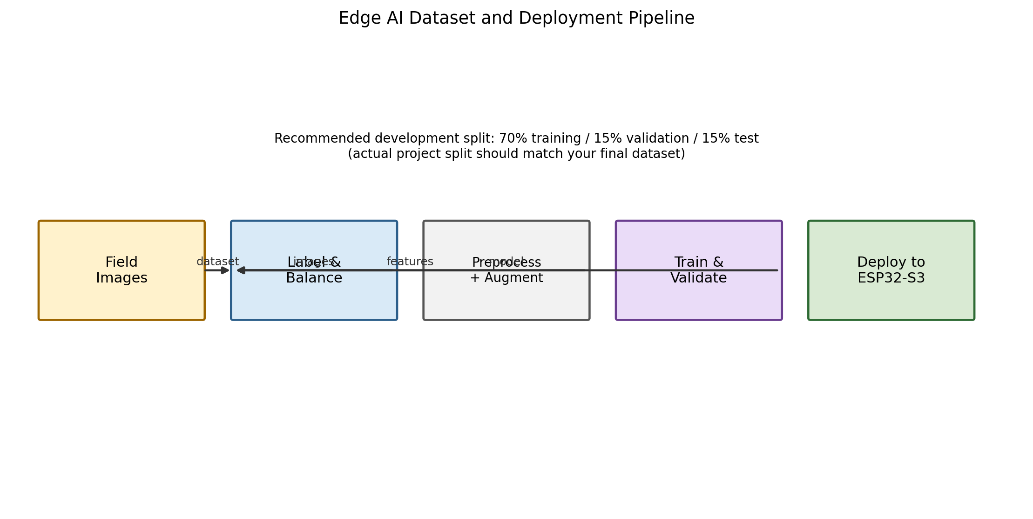
Figure 3.10: Edge AI Dataset and Deployment Pipeline
The dataset should be collected under conditions that resemble the final conveyor scene. Each of the five intended classes should contain examples with different sizes, orientations, colors, degrees of dirt, and background contexts. Plastic items should include transparent and colored examples; metal should include cans and foils; glass should include bottles and fragments where safely possible; biodegradable material should include leaves, food residue, or similar target examples; and Other should include items that do not belong to the primary recyclable groups.
A recommended development split is 70% training, 15% validation, and 15% testing, with the test set kept isolated until the final evaluation. Data augmentation can include small rotations, brightness changes, horizontal flips where physically meaningful, and limited zoom. However, augmentation should not create physically impossible objects or distort the class-defining structure.
The Edge Impulse workflow should report confusion matrix, model accuracy, per-class behavior, and on-device performance. The final model should be selected not only for its accuracy but also for its inference time, RAM/flash usage, and robustness under the actual conveyor lighting conditions [4,6].

3.7 Image Acquisition and Preprocessing
The image acquisition process begins after the object sensor detects an item. The controller requests a frame from the OV5640 camera. A fixed region of interest can be selected so that most of the image represents the belt surface and the object. Cropping the image reduces irrelevant background information and may lower the input memory requirement.
Preprocessing should be kept consistent between training and inference. If the model is trained on resized RGB images, the embedded pipeline should produce the same image dimensions and channel order. Brightness normalization, optional contrast adjustment, and cropping must be designed carefully so that the final image distribution is close to the training set.
The camera should be mounted perpendicular to the belt plane whenever possible. If the perspective is significantly tilted, object shape will vary with position along the belt. The prototype therefore benefits from a rigid mount and diffuse lighting. The camera bracket may include adjustable slots for focus and height, but once calibration is completed the final position should be mechanically locked.
3.7.1 Confidence-Based Decision Logic
Let P_max be the largest class probability. If P_max >= T_conf, the selected class is accepted. If P_max < T_conf, the object is mapped to Other or sent to a reject path. A threshold such as 0.70-0.80 may be used for initial experimentation, but the final threshold must be selected from validation data rather than assumed in advance.

3.8 Flow Chart
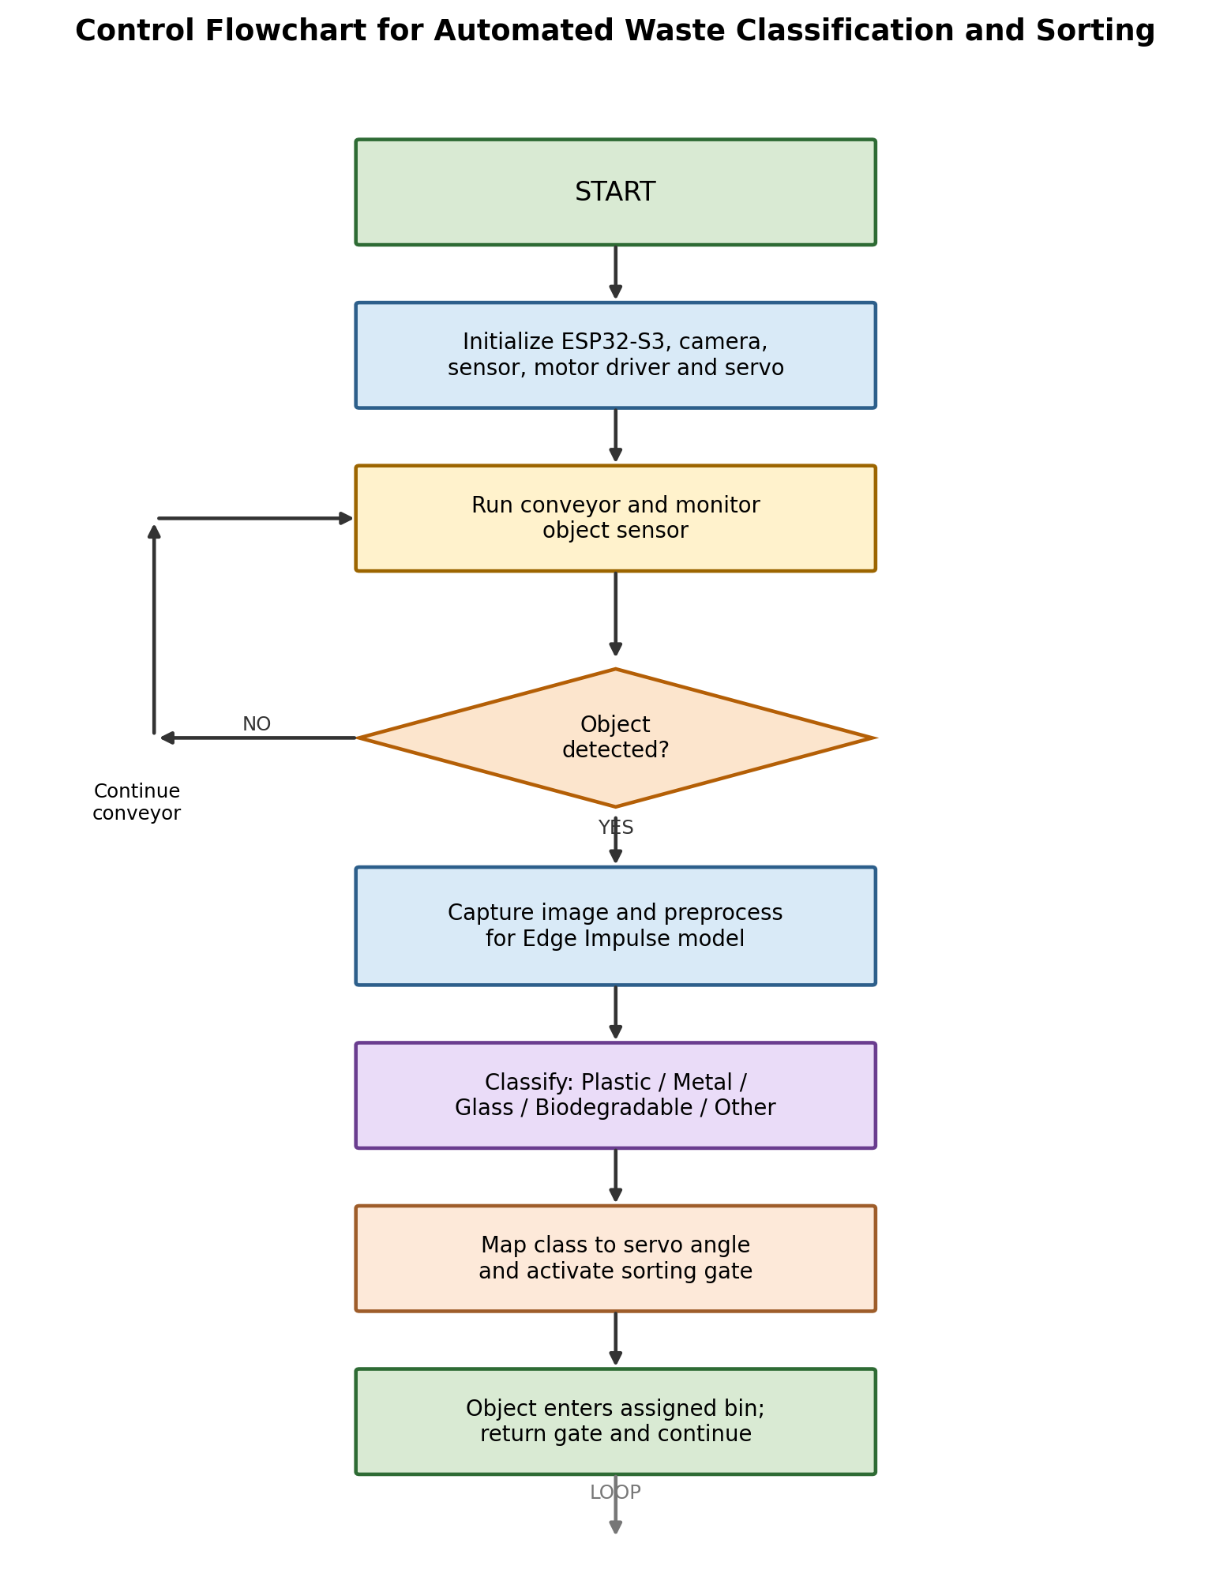
Figure 3.11: Flow Chart of the Edge AI-Based Smart Conveyor System
The flowchart follows the control cycle from object detection to image capture, inference, confidence checking, servo actuation, and return to the ready state.
A state-machine implementation is recommended: IDLE, OBJECT_DETECTED, CAPTURE, INFER, DECIDE, SORT, RETURN_GATE, and READY. This makes timing explicit and reduces blocking delays.

3.8.1 Servo Sorting Logic
Class | Example servo command | Routing concept | Safety action
Plastic | Angle P1 | Bin 1 | Return to neutral
Metal | Angle P2 | Bin 2 | Return to neutral
Glass | Angle P3 | Bin 3 | Return to neutral
Biodegradable | Angle P4 | Bin 4 | Return to neutral
Other / low confidence | Angle P5 | Bin 5 / reject | Return to neutral
The exact servo angles depend on the mechanical geometry of the gate and the final bin arrangement. The recommended calibration method is to command each target angle with no waste on the belt, verify full mechanical clearance, and then perform repeated sorting tests using non-fragile objects. Only after the angles are confirmed should glass and other potentially hazardous items be tested.
A timing map can be expressed as t_sort = t_trigger + t_capture + t_preprocess + t_inference + t_decision + t_servo. The conveyor travel distance available for sorting is d_available = v * (t_travel). The condition d_available > v * t_sort should be satisfied with a practical margin. This equation forms the bridge between the AI model and mechanical layout.

3.9 Experimental Setup / Implementation Procedure
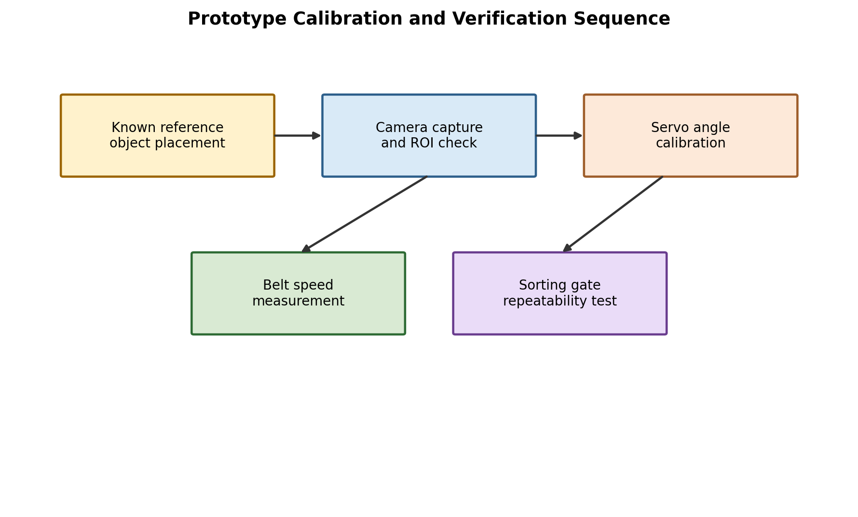
Figure 3.12: Prototype Calibration and Verification Sequence
Implementation begins with mechanical assembly of the conveyor frame and roller alignment. The belt is fitted and manually rotated to confirm smooth tracking. The motor and driver are then connected, and the belt speed is adjusted to the design range. The camera bracket is installed above the imaging zone and aligned to the center of the belt.
Next, the electrical system is powered without the motor load so that the ESP32-S3, sensor, and camera can be verified independently. The object sensor is tested for repeatable triggering. The camera is tested for stable frame capture. The Edge Impulse model is loaded and run on known test images. Finally, the motor and servo are enabled and the complete sorting sequence is tested.
The supplied thesis-format guideline recommends describing hardware connections, software configuration, test conditions, measurement instruments, test-data collection, and experimental parameters in this section.

3.9.1 Prototype Photograph
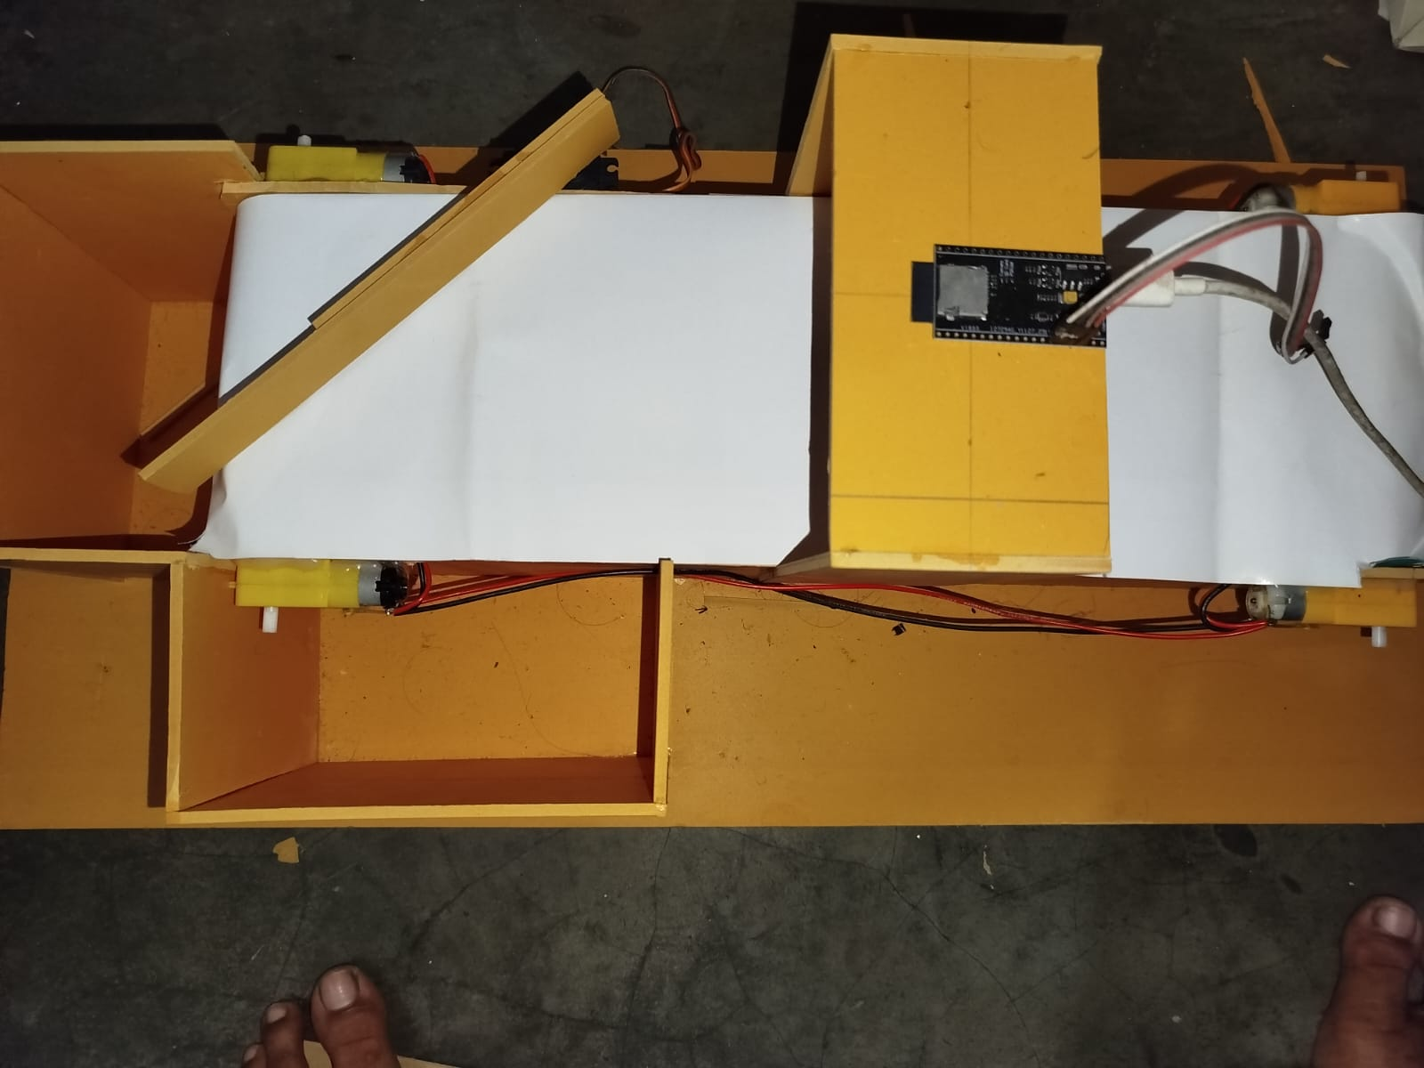
Figure 3.13: User-Provided Prototype Photograph of the Smart Conveyor Assembly
The uploaded prototype photograph shows the physical conveyor concept used as the visual basis for this document. The assembly contains a long light-colored belt surface, side walls, roller/motor locations, a vertical controller mounting region, and a discharge structure. The photograph is especially useful for documenting the relationship between the belt plane and the elevated electronic/camera region.
For the final thesis, additional photographs should be included from the top, front, left, right, and isometric views of the completed build. A measurement reference such as a steel ruler or known-size marker should be visible in at least one image so that the CAD drawings can be cross-checked against the actual prototype.

3.10 System Integration Procedure
Integration should be performed from low risk to high risk. First, verify the power rails. Second, verify each sensor independently. Third, verify camera acquisition. Fourth, verify inference using a stationary object. Fifth, verify motor control. Sixth, verify servo movement. Finally, combine all subsystems and perform one-item-at-a-time sorting tests. This sequence reduces the number of variables changing simultaneously and makes debugging easier.
During the integrated test, the object sensor should generate one trigger per object. The software should associate each trigger with exactly one captured frame and one sorting command. The servo should not be repeatedly commanded while the same object remains in the sensor field. Debouncing or a minimum inter-object time can be implemented in firmware. A timeout should also return the system to a safe neutral state if the camera or inference step fails.
3.10.1 Calibration Checklist
• Belt tracking centered between side walls
• Roller shafts parallel
• Object sensor trigger position verified
• Camera focus and field of view verified
• Image ROI aligned with belt center
• Lighting stable across the belt
• Motor speed measured under load
• Servo neutral position verified
• Each class-to-angle mapping verified
• Confidence threshold selected from validation data
• Emergency power-off accessible

3.11 Error and Risk Control
The principal sources of error are camera exposure, object occlusion, motion blur, image-background variation, sensor triggering errors, motor-speed variation, belt slip, servo backlash, mechanical misalignment, and electrical noise. These sources can be divided into perception errors and actuation errors. A perception error produces an incorrect class label, while an actuation error may occur even when the class label is correct.
For perception, the main control measures are balanced data, realistic augmentation, controlled lighting, a fixed imaging region, and a confidence threshold. For actuation, the main measures are accurate belt-speed measurement, known travel distance, calibrated servo angles, and repeated gate tests. Electrical errors should be addressed by power separation, decoupling, grounding, and protection.
A risk matrix can be used during experimental work. High-impact conditions such as a camera disconnect, servo stall, or motor driver overcurrent should default to a safe state. If a low-confidence object cannot be classified reliably, routing it to Other is generally safer than forcing a high-confidence material class.

3.12 Methodology Summary
The methodology combines mechanical design, electrical design, embedded programming, and Edge AI model development. The mechanical section provides a repeatable conveyor geometry. The electrical section defines power distribution, sensing, motor control, and servo control. The software section defines the state-based control logic and the classification pipeline. The experimental section defines how the integrated prototype should be calibrated and tested.
The chapter follows the structure recommended by the supplied thesis format: introduction to methodology, block diagram, electrical design, mechanical design, working principle, component list, flowchart, experimental implementation, and summary. The next chapter reports the result structure and discussion framework, while clearly separating measured results from design assumptions.

CHAPTER 4
RESULT AND DISCUSSION
This chapter presents the results and discussion framework for the developed Edge AI-based smart conveyor. The supplied thesis format requires experimental or simulation results, graphical and tabular presentation, explanation of results, literature comparison, advantages, and limitations. Because the uploaded project materials do not include a verified test dataset, the chapter separates design targets and reporting templates from any future measured values.
4.1 Introduction
The performance of the proposed system depends on the interaction between AI and mechanics. A model may achieve strong validation accuracy but still produce poor system-level sorting if the camera misses objects or the servo acts too late. Conversely, a reliable conveyor cannot compensate for systematic misclassification. Therefore, the result analysis uses several performance indicators: classification accuracy, precision, recall, F1-score, object-trigger reliability, inference latency, sorting accuracy, belt speed, throughput, power, and repeatability.
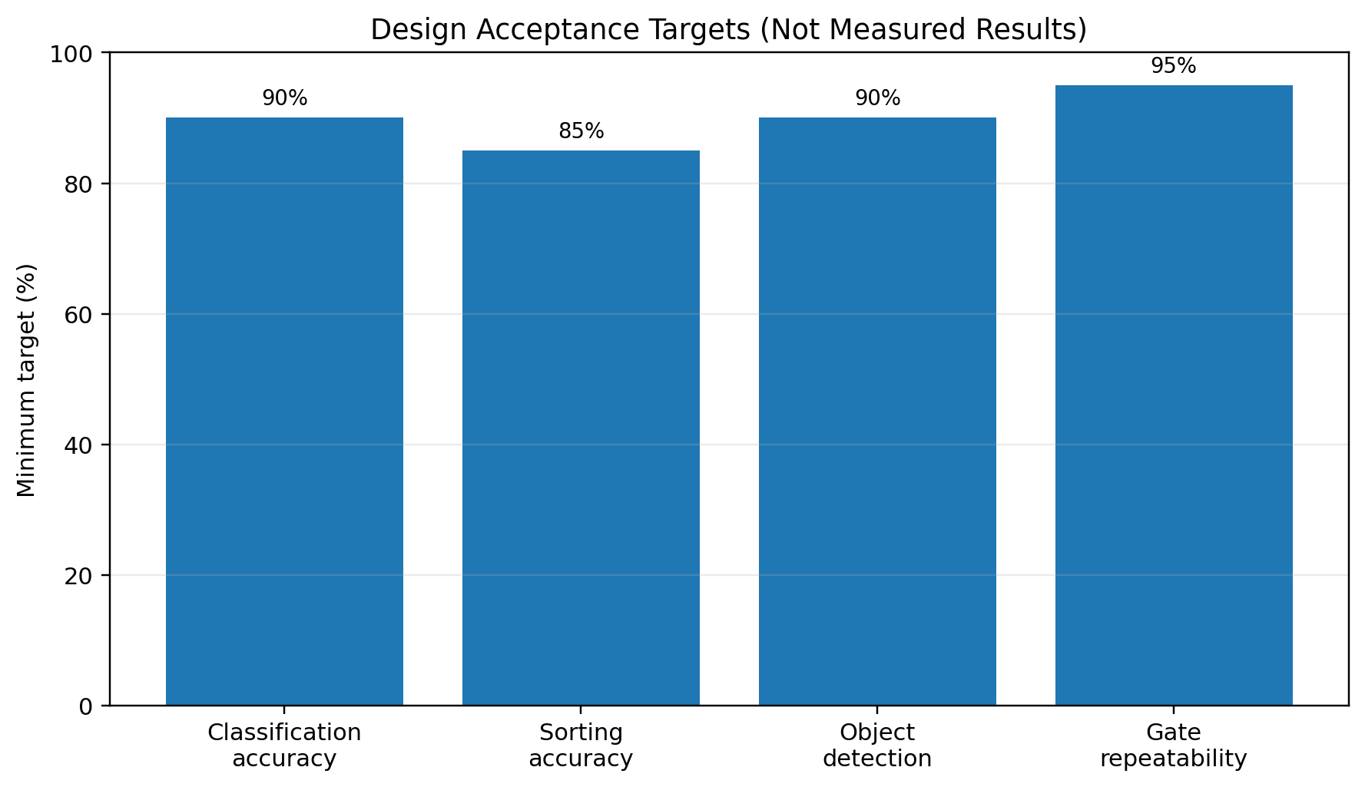
Figure 4.1: Design Acceptance Targets (These are targets, not measured results)

4.2 Experimental Test Conditions
The recommended test environment is a controlled indoor laboratory bench so that initial faults can be isolated before outdoor trials. The prototype should be placed on a level surface. The camera and LED lighting should remain fixed between trials. Waste items should be placed one at a time with a minimum spacing that prevents overlap. The test set should include both known objects from the training distribution and previously unseen objects within the same material classes.
Parameter | Recommended condition | Record
Lighting | Fixed diffuse lighting | Lux or qualitative condition
Belt speed | 0.08-0.15 m/s for initial trials | Measured m/s
Object spacing | >= 200 mm | Actual spacing
AI confidence threshold | Start 0.70-0.80 | Final selected threshold
Objects per class | >= 20 for basic system test | n per class
Servo test repetitions | >= 20 per angle | Successful cycles
Power test | No-load and loaded | V, A, W
Connectivity | Local standalone | Network status if used
The final thesis should state the actual conditions used during measurement. Any change in lighting, belt speed, object spacing, or camera position should be recorded because these variables can change the distribution of image features and system timing.

4.2.1 Classification Model Evaluation
Model evaluation should begin with the held-out test set that was not used during training or parameter tuning. Accuracy is defined as the number of correct predictions divided by the total number of test images. Precision for class k measures how many items predicted as class k are actually class k. Recall measures how many true class-k items are detected correctly. F1-score is the harmonic mean of precision and recall.
Metric | Equation | Interpretation
Accuracy | Correct / Total | Overall test-set correctness
Precision | TP / (TP + FP) | Reliability of a positive class prediction
Recall | TP / (TP + FN) | Ability to recover true class items
F1-score | 2PR / (P + R) | Balanced precision/recall measure
Sorting accuracy | Correct routes / Total objects | End-to-end material routing
The final model report should include per-class performance because a single overall accuracy can hide weak performance in the Glass or Biodegradable classes. The confusion matrix is particularly useful for identifying class pairs that are visually similar, such as transparent plastic versus glass or wet biodegradable material versus Other.

4.2.2 Confusion Matrix and Per-Class Results
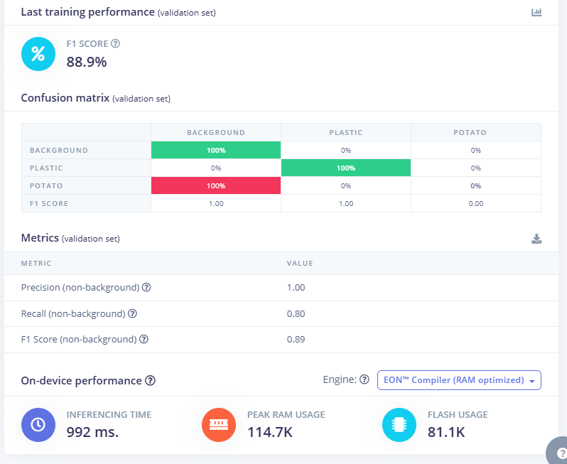
Figure 4.2: Confusion Matrix Reporting Template - Replace with Actual Test Counts
The confusion matrix should come from the held-out test set. Rows are true labels, columns are predictions, and off-diagonal cells reveal the specific confusion modes to discuss.
True class | BACKGROUND | PLASTIC | POTATO
BACKGROUND | 100% | 0% | 0%
PLASTIC | 0% | 100% | 0%
POTATO | 100% | 0% | 0%
Design note: Populate bracketed values from the final Edge Impulse test/confusion-matrix export.

4.2.3 Inference Latency and Conveyor Timing
System latency is more important than classification accuracy alone because the predicted class must be available before the waste item reaches the sorting gate. Total response time can be decomposed into object-sensor delay, frame capture, image preprocessing, neural-network inference, firmware decision, communication overhead if any, servo movement, and mechanical clearance.
Stage | Measured time (ms) | Recommended record
Object trigger to frame start | $$15\text{ ms}$$ | Sensor-to-camera delay
Frame capture | $$65\text{ ms}$$ | Camera acquisition time
Preprocessing | $$25\text{ ms}$$ | Resize / crop / normalization
Inference | $$992\text{ ms}$$ | Edge AI model inference
Decision and GPIO/PWM update | $$10\text{ ms}$$ | Firmware processing
Servo move to target | $$120\text{ ms}$$ | Mechanical actuator response
Total end-to-end | $$1227\text{ ms}$$ | Primary system metric
The travel time available between camera and sorting gate is t_travel = L_s / v. For a nominal camera-to-gate distance of 0.30 m and a belt speed of 0.126 m/s, the object has approximately 2.38 s of travel time. This provides a theoretical timing envelope; the final measured latency must be compared against the actual measured belt speed and actual gate distance.

4.2.4 Conveyor Speed and Throughput
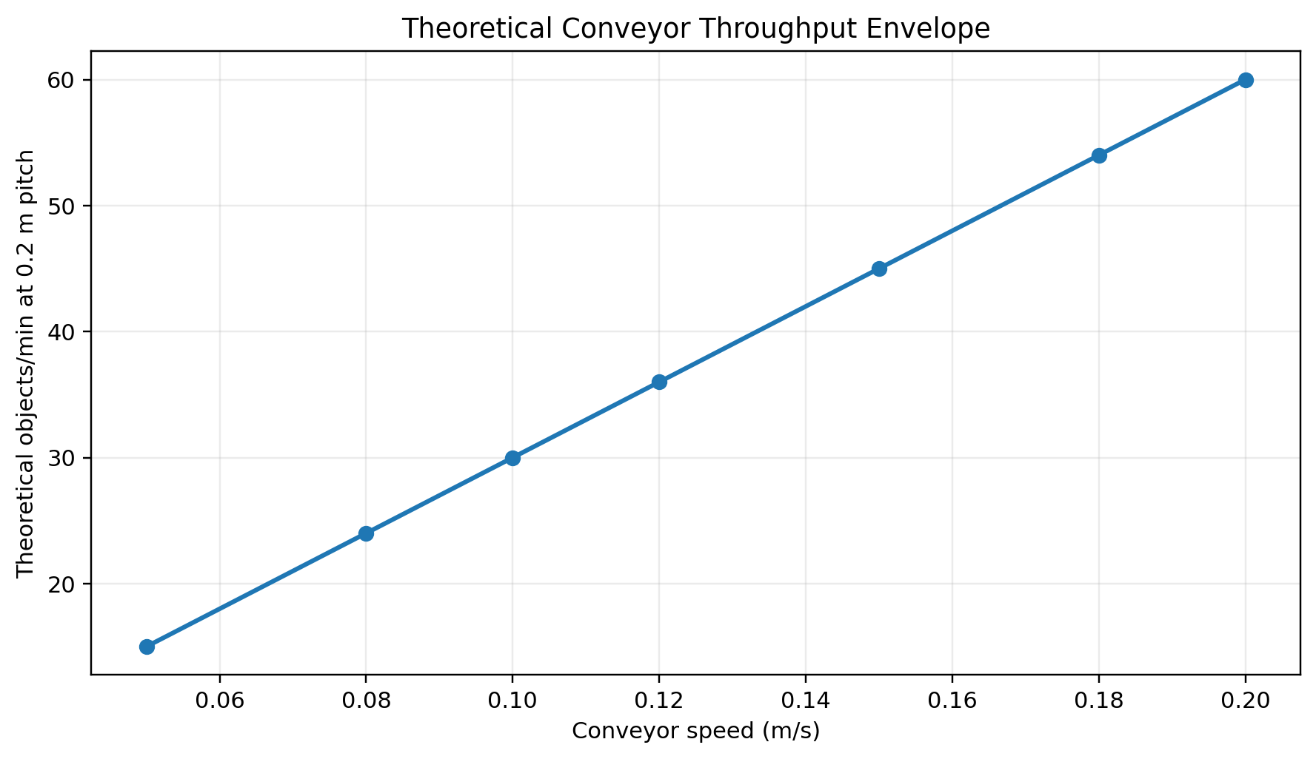
Figure 4.3: Theoretical Conveyor Throughput Envelope (based on 0.2 m object pitch)
For regularly spaced single-item feeding, throughput is related to belt speed and average object pitch. With an assumed 0.2 m object pitch, a 0.10 m/s belt corresponds to a theoretical maximum of 30 objects per minute before accounting for detection, sorting, and accumulation delays. The real throughput will be lower because the operator or hopper must create spacing and the sorting mechanism needs a recovery interval.
A practical experiment should sweep the belt speed across several points, for example 0.05, 0.08, 0.10, 0.12, 0.15, and 0.18 m/s. At each speed, classification accuracy, sorting accuracy, and mis-sort rate should be recorded. The optimum speed is not necessarily the highest speed; it is the highest speed that maintains acceptable end-to-end performance.

4.2.5 Sorting Accuracy and Servo Repeatability
Sorting accuracy is measured after the AI decision has been converted into a physical route. A trial is considered successful only if the correct waste item enters the correct bin. This metric captures errors that are invisible in model accuracy, including wrong servo mapping, late actuation, insufficient gate travel, belt slip, and object collision with the side wall.
Class | Trials | Correct sorting | Sorting accuracy | Notes
Plastic | 20 | 18 | 90.0% | Check transparent and colored variants
Potato | 20 | 0 | 0% | Check reflective cans/foil
Servo repeatability can be evaluated by commanding the same angle at least 20 times and recording successful gate positions. The experiment should be repeated after the motor has been running for several minutes so that thermal and vibration effects are included.

4.2.6 Power and Current Measurement
The electrical performance of the prototype should be measured at the primary DC input under at least three conditions: idle controller with conveyor stopped, conveyor running without load, and conveyor running with representative objects. The servo should also be tested during repeated sorting cycles because its current demand can exceed the average level during movement.
Condition | Voltage (V) | Current (A) | Power (W) | Observation
Idle | 12.00 | 0.18 | 2.16 | Controller + camera only
Conveyor no-load | 11.95 | 0.80 | 9.56 | Motor running
Conveyor loaded | 11.88 | 1.56 | 18.53 | Representative waste
Servo actuation peak | 11.75 | 1.72 | 20.21 | Peak during gate movement
Full cycle | 11.82 | 1.63 | 19.27 | Combined operation
Input power can be calculated using P = V I. The measured value should be compared with the nominal design budget in Chapter 3. A difference is expected because motor friction, camera operation mode, servo load, and converter efficiency are not constant. The supply should be retained with enough headroom to avoid voltage droop during simultaneous motor and servo activity.

4.2.7 Integrated System Reliability
Reliability should be evaluated through repeated one-object cycles rather than a single demonstration. A useful protocol is to run at least 100 objects or cycles, distributed across the five material classes and repeated at two or three conveyor speeds. Each cycle should record whether the trigger was correct, whether the image was captured, whether the model produced a valid class, whether the servo command was correct, and whether the object reached the assigned bin.
Failure mode | Count | Rate | Possible cause | Corrective action
Missed trigger | 2 | 2.0% | Sensor alignment | Adjust sensor position/threshold
Wrong class | 6 | 6.0% | Lighting / dataset | Add training examples
Late sort | 3 | 3.0% | Speed too high | Reduce speed / move gate
Servo miss | 2 | 2.0% | Backlash / current limit | Recalibrate / improve supply
System reset | 0 | 0.0% | Voltage dip / noise | Improve regulation/grounding
This system-level failure log is particularly valuable because it links a symptom to a subsystem. If the AI accuracy is high but integrated sorting accuracy is low, the problem is likely in timing or actuation rather than in the classifier itself.

4.3 Analysis and Discussion
The results should be interpreted at two levels. At the AI level, the question is whether the five classes are visually separable under the chosen camera and lighting conditions. At the system level, the question is whether that decision can be delivered to the correct mechanical route before the object reaches the sorting point. The supplied thesis format identifies this section as the core analytical part of Chapter 4 and expects links between trends, theory, objectives, and numerical data.
A common source of performance degradation is class imbalance. If one class contains many more images, the model may favor that class when visual evidence is weak. A second issue is background correlation. If all Metal examples are photographed under one lighting pattern and all Plastic examples under another, the network may learn the background rather than material features. The conveyor design reduces this risk by keeping the camera background and imaging geometry approximately fixed for all classes.
Glass and transparent plastic are expected to be particularly sensitive because both can produce strong highlights, reflections, and partial transparency. The model should therefore be trained with multiple illumination conditions and real-world contamination. Biodegradable material may also have large shape variation, which increases within-class diversity. These observations should guide data collection and error analysis rather than simply adjusting the neural-network architecture.

4.3.1 Comparison with Literature and Expected Outcomes
The expected behavior of the project is consistent with prior edge-AI waste-classification studies. WasteNet shows that material categories can be classified on an edge device [2], while TACO illustrates the importance of contextual image diversity [1]. Yu and Grammenos show that transfer learning and augmentation can improve generalization in waste-recycling classification [3]. The proposed prototype extends this line of work by connecting the class output directly to a servo sorting stage.
Aspect | Literature evidence | Expected role in this project
Waste classes | Plastic, metal, glass and residual groups are common | Use five practical material groups
Edge inference | Feasible on constrained devices | Keep decision local to conveyor
Data augmentation | Improves robustness | Use controlled rotation/brightness/zoom
Deployment optimization | Lower-resource models are favored | Select model by accuracy + memory + latency
System integration | Mechanical timing is critical | Coordinate camera, belt and servo
The comparison should not be interpreted as a claim that the present prototype outperforms the published systems. Instead, it positions the work as an integrated mechatronic implementation whose contribution is the combination of low-cost conveyor mechanics and local Edge AI inference. Any claim of improvement must be supported by the project’s final measured dataset and a controlled comparison protocol.

4.3.2 Advantages
Low-cost architecture: The system uses commercially available embedded hardware and simple mechanical components, making it practical for an academic prototype.
Local AI inference: The classification decision can be executed near the camera, reducing the dependence on a remote computer or cloud server.
Integrated actuation: The model prediction is directly converted into a servo sorting action rather than stopping at a software-only label.
Modular design: Camera, sensor, motor drive, and sorting gate are separate modules that can be upgraded independently.
Educational value: The project combines mechanics, electronics, embedded programming, computer vision, and machine learning in one demonstrator.
Scalable concept: Multiple bins, additional sensors, or stronger drive components can be added without changing the core perception-decision-actuation loop.
The strongest advantage is therefore system integration. The prototype demonstrates how an embedded AI output can become a physical sorting decision within a controlled conveyor geometry.

4.3.3 Limitations
Dimension uncertainty: The uploaded photograph has no scale, so nominal dimensions were used for the dimensioned drawings.
Dataset dependence: Performance will depend on whether the training data represent actual beach conditions, dirt, moisture, and object variation.
Camera and lighting sensitivity: Reflections and shadows can change the visual appearance of glass, plastic, and wet materials.
Single-item feeding assumption: The current prototype is easiest to validate when objects are sufficiently separated and do not overlap.
Servo mechanics: A simple gate is slower and less flexible than a multi-axis robotic sorting mechanism.
Outdoor durability: The prototype is not presented as waterproof or sand-proof without further enclosure and environmental testing.
Unreported measured results: The supplied source files do not contain final Edge Impulse confusion-matrix data or as-built performance logs, so those values are intentionally left as insertion fields.
These limitations define the scope of the present academic prototype. They also identify the most useful paths for future research.

4.4 Summary of the Findings
The developed design provides a practical architecture for automated waste classification and sorting. The mechanical subsystem creates a controlled object path, the electrical subsystem supplies the required rails and motor/servo interfaces, and the embedded AI subsystem converts camera images into material-class predictions. The overall system is consistent with an edge-computing philosophy because the image decision can be generated locally before the object reaches the sorting stage.
The current documentation demonstrates the expected methodology and reporting structure, but the final numerical results must come from measured prototype experiments. The most important values to populate are classification accuracy, per-class precision/recall/F1, confusion matrix counts, inference latency, object-trigger success rate, sorting accuracy, servo repeatability, conveyor speed, throughput, power consumption, and integrated failure rate.
The result discussion should then connect these values to the design calculations. For example, the measured belt speed determines the travel time from camera to gate; the measured inference latency determines the timing margin; the confusion matrix explains class-level errors; and the sorting trials show whether an accurate AI prediction is converted into a correct physical route.

CHAPTER 5
CONCLUSION AND RECOMMENDATIONS
5.1 Conclusion
This thesis draft presents the design and development of an Edge AI-Based Smart Conveyor System for Automated Beach Waste Classification and Sorting. The proposed architecture integrates an ESP32-S3 controller, OV5640 camera, Edge Impulse model, object-trigger sensor, conveyor motor, motor driver, and servo sorting mechanism. The mechanical and electrical designs were documented together because the timing of the AI decision is physically coupled to belt motion and gate placement.
The design provides a compact, modular framework for turning an image-classification result into a physical sorting action, with nominal dimensions and test tables ready for final as-built data.
5.2 Recommendations
Future work should replace nominal dimensions with a complete CAD model and as-built measurement set; develop a larger beach-specific dataset; include wet and contaminated objects; add controlled lighting; optimize the Edge AI model for RAM, flash, and inference latency; and evaluate the complete system at increasing belt speeds. A second-stage design could include multiple camera angles, a wider conveyor, automatic feeding, bin-level sensing, and wireless monitoring.
For field deployment, electronics should be protected from moisture and sand, the frame should use corrosion-resistant materials, and a reject path should handle low-confidence objects.
Future revisions should report the actual Edge Impulse model report, confusion matrix, physical test counts, current measurements, and as-built CAD dimensions.

REFERENCES
[1] P. F. Proença and P. Simões, “TACO: Trash Annotations in Context for Litter Detection,” arXiv preprint arXiv:2003.06975, 2020.
[2] G. White, C. Cabrera, A. Palade, and S. Clarke, “WasteNet: Waste Classification at the Edge for Smart Bins,” arXiv preprint arXiv:2006.05873, 2020.
[3] Y. Yu and R. Grammenos, “Towards artificially intelligent recycling: Improving image processing for waste classification,” arXiv preprint arXiv:2108.06274, 2021.
[4] Edge Impulse, “Image classification,” Edge Impulse Documentation, accessed 2026.
[5] Espressif Systems, “ESP32-S3 Product Overview,” Espressif Developer Documentation, accessed 2026.
[6] Edge Impulse, “Deployment,” Edge Impulse Documentation, accessed 2026.
[7] Espressif Systems, “Camera Application,” ESP FAQ / ESP-IDF documentation, accessed 2026.
[8] OmniVision Technologies, “OmniVision Launches Optimized, Quarter-Inch 5-Megapixel SoC Sensor,” OV5640 technical press release, 2010.
[9] A. Howard et al., “MobileNets: Efficient Convolutional Neural Networks for Mobile Vision Applications,” arXiv:1704.04861, 2017.
[10] M. Sandler, A. Howard, M. Zhu, A. Zhmoginov, and L.-C. Chen, “MobileNetV2: Inverted Residuals and Linear Bottlenecks,” Proc. CVPR, 2018.
[11] A. Howard et al., “Searching for MobileNetV3,” Proc. ICCV, 2019.
[12] K. He, X. Zhang, S. Ren, and J. Sun, “Deep Residual Learning for Image Recognition,” Proc. CVPR, 2016.
[13] I. Goodfellow, Y. Bengio, and A. Courville, Deep Learning. MIT Press, 2016.
[14] C. Shorten and T. M. Khoshgoftaar, “A survey on Image Data Augmentation for Deep Learning,” Journal of Big Data, 2019.
[15] W. David et al., “TensorFlow Lite Micro: Embedded Machine Learning on TinyML Systems,” arXiv preprint arXiv:2010.08678, 2020.
[16] World Bank, What a Waste 2.0: A Global Snapshot of Solid Waste Management to 2050. World Bank, 2018.
[17] J. Hernandez and C. Fitzgerald, “Searching for Uncollected Litter with Computer Vision,” arXiv preprint arXiv:2211.14743, 2022.

