Draft for owner review (2026-10-29): not yet reviewed by the owner.

Earnings and implied volatility: an event study
Not investment advice. This report describes how option prices behaved around past earnings announcements of 50 large US companies. It recommends no trade, no position and no size. It ignores transaction costs. Past patterns in implied volatility do not predict future returns.
Every result here is provisional. The session that each announcement reached the option market ("day 0") depends on a before-open or after-close label. ADR 0002 requires 473 of these labels to be checked against a document. 20 are checked. The other 453 wait for SEC EDGAR filing times, which need the owner's contact string before the first request. Until then, those events keep the earnings calendar's label, and a few of them may sit on the wrong day 0.
Data: DoltHub post-no-preference/earnings at fjrb6h5le9h1qiif2j4pl6cpaas7pnee and post-no-preference/options at msfqpodh24viv7prdqdan8517rkjp861; parameters hash 74bed6f4b1281810; app data contract 0.5.0, exported from commit 28e06b3. Every measured number in this report is filled in by tools/report_numbers.py from data/derived/results.parquet, the app's JSON files and the kept ρ̄ output (section 8); one count, the 473 required look-ups, is pinned in that script. Design parameters quoted from the ADRs (window lengths, minimum counts) are written by hand.

Summary
- The crush is large and almost universal. From the last close before the news (day −1) to the first close after it (day 0), the 30-day implied volatility (IV) falls by 0.199 log points on average, net of the market's volatility: about 18.1%. The market-adjusted change is negative in 99.1% of the 347 events. The test that allows for events on the same date and for one company's events being alike gives p = 5.8e−23 (Holm 4.1e−22).
- The crush is the event leaving the 30-day horizon. Ordinary volatility (σ_d, the volatility outside the event day) does not change measurably (+0.003 log points, p = 0.782), and IV is back at its baseline ten sessions later (+0.008, p = 0.743).
- IV is high before the news. At day −1 the 30-day IV sits +0.232 log points above its own quiet baseline. The direction is not in doubt. Whether it passes the multiple-testing correction depends on how many earnings seasons the sample is cut into (section 4.3).
- The options priced the earnings-day move about right on average. The realised squared move is 0.77 times the implied variance (95% interval [0.46, 1.07], so 1 is inside). 40.1% of the moves were larger than the expected move, against the 42.5% that fair pricing of a normal move gives.
- Neither the earnings surprise nor the prior volatility level explains the size of the crush in a way that survives the checks. The statistics for these driver tests are liberal at this design (they reject 9.55%, 8.10% and 16.15% of the time under a true null at 5%), and none is rejected.

1. The question
A stock's implied volatility usually rises before an earnings announcement and falls once the news is out. Traders call the fall the IV crush. This study measures five things for large US companies:
1. Does IV run up before the announcement? (H2)
2. How large is the crush from day −1 to day 0? (H1)
3. Is IV back at its baseline ten sessions later? (H3)
4. Does ordinary volatility change across the event? (H4)
5. What changes the size of the crush (H5: the earnings surprise; H6: the prior volatility level), and did the options price the earnings-day move correctly (H7)?
The seven hypotheses were declared in ADR 0005 before any data was seen. They are corrected together for multiple testing (Holm, 7 hypotheses). Everything else in this report is labelled robustness or exploratory.

2. Data and the sample funnel
Sources. The earnings calendar (with before-open and after-close labels) and the EPS history come from DoltHub's open post-no-preference/earnings dataset. The option chains come from DoltHub's post-no-preference/options. Both are CC BY-SA 4.0. Company names and GICS sectors come from Wikipedia's list of S&P 500 companies. The risk-free rate is FRED's 3-month Treasury bill (DTB3). The market adjustment uses the VIX close (FRED VIXCLS, a Cboe index); only aggregates of VIX-adjusted values are published. Yahoo Finance prices are used locally for the size regressor and a timing diagnostic. DATA.md gives each source's terms.
Universe. Today's 50 largest S&P 500 members by market capitalisation. This has survivorship bias: companies that shrank or left the index since 2020 are missing.
The daily sample. DoltHub's option snapshots are daily only from September 2024 (weekly, then Monday, Wednesday and Friday, before that). The baseline needs 60 sessions before day 0, so the primary sample's day-0 window runs from 2024-12-05 to 2026-10-26; its 347 events have day 0 from 2024-12-10 to 2026-10-22. The older coarse snapshots form a lower-resolution robustness sample.
Step | Events left | Removed | Why
Calendar events of the 50 companies | 1,353 | –
One row per release, and day 0 can be placed | 1,320 | 33 | duplicate rows, timing not placeable
Day 0 in the daily range | 366 | 954 | outside 2024-12-05 to 2026-10-26
Option snapshots on day −1 and day 0 | 356 | 10 | a missing snapshot
A 30-day IV on day −1 and day 0 | 353 | 3 | no 30-day IV
At least 20 clean baseline sessions and 15 changes | 347 | 6 | short baseline

The 1,353 calendar events split into 368 daily-era, 49 mixed-era, 868 coarse-era and 68 outside every sample's date range. Each hypothesis then has its own eligibility rules, so its event count (the n in section 4) differs a little from 347.
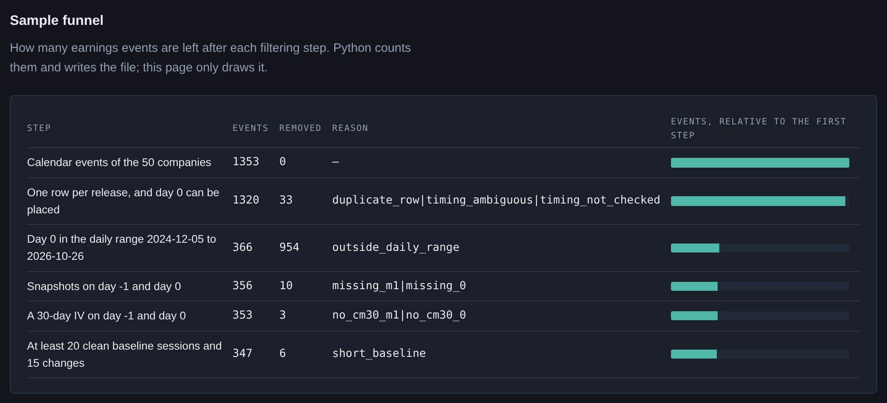
The sample funnel, as the app draws it from sample_funnel.json
Timing labels. 20 labels were checked against press releases (16 confirmed, 2 corrected, 1 with a corrected date and 1 inferred). 1,333 events keep the calendar's label. A wrong label puts the crush on the wrong day, which makes a crush look smaller and a run-up look longer.

3. Method

3.1 Day 0
Day 0 is the first session close after the news reaches the market: the announcement day for a before-open report, the next session for an after-close one (ADR 0002). The label comes from a document, never from the size of the stock's move: a price-gap rule would fix the labels of big movers and leave the quiet events wrong. Time is counted in NYSE sessions.

3.2 IV measures
Every IV is recomputed from bid/ask mid prices with Black-76 on the forward price implied by put-call parity, so no spot price, dividend or snapshot time is needed (ADR 0003). The stored quantity is the at-the-money total variance w = σ²T of each expiry. From it:
- The 30-day IV (the primary series): constant maturity of 21 sessions, interpolated only between expiries on the same side of the event, so it never borrows event variance from an expiry on the wrong side. The vendor's chain lists only a few expiries, so the weekly expiry right after an announcement is usually absent.
- The front-expiry IV: the first listed expiry after the event, followed through the window (exploratory).

3.3 Event variance and the implied move
For two expiries that both span the event, w_j = σ_d² τ_j + E, where τ_j is the time to expiry in sessions, σ_d² the ordinary variance per session and E the extra variance of the event day. Two expiries give both unknowns: σ_d² is the forward variance between them, and E = w₁ − σ_d² τ₁. The implied move is √E, the standard deviation of the earnings-day move that the options price. E is read at day −1. Its median over the 343 events with E > 0 is a move of 6.5% (10% of events below 3.3%, 10% above 11.1%). 4 of the 347 primary events have E ≤ 0 and no implied move.
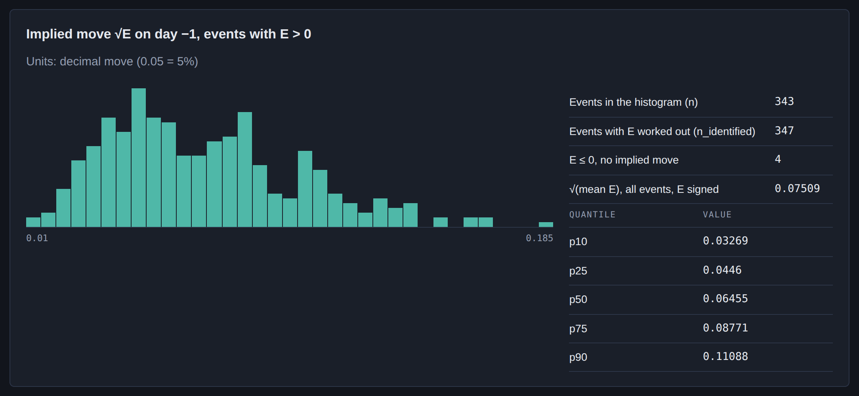
The implied move √E at day −1 (iv_measures.json)

3.4 Abnormal IV
Abnormal IV is log IV against the event's own quiet baseline (ADR 0004):
- The baseline is sessions [−60, −22] before day 0, minus every session within [−21, +10] of another announcement by the same company. It must keep at least 20 clean sessions. It ends at −22 because from −21 on the 30-day horizon already contains day 0.
- The market adjustment removes β × the change in ln VIX, with β estimated for each company from its pooled clean baseline changes. A mean-adjusted twin (no VIX) is kept as a check.
- The tested quantities are levels and one-session changes in log points, not cumulated abnormal IV: IV is a level, so summing abnormal levels counts one persistent shift many times. RUNUP is the abnormal level at day −1, CRUSH the abnormal change from day −1 to day 0, PERSIST_10 the abnormal level at day +10, ΔSIGMA_D the abnormal change in ln σ_d from day −1 to day 0. The event window is [−10, +10].

3.5 The test suite
Events are not independent. Many companies report in the same weeks, so one market move hits many events at once, and one company's events resemble each other. The primary statistic is a t-test of the equal-weighted mean with two-way cluster-robust standard errors (ADR 0005):
- for the one-session measures (CRUSH, ΔSIGMA_D): clusters by day-0 date and by company;
- for the multi-week measures (RUNUP, PERSIST_10): clusters by earnings season and by company;
- t on min(G) − 1 degrees of freedom; when the seasons are very unbalanced, a randomisation (Rademacher) p-value by season replaces the t, as the ADR declared in advance.
The drivers (H5, H6) are coefficients in a regression of CRUSH on z-scored regressors: |surprise| (the EPS surprise over the option forward price), ln σ_d at day −1, the term-structure slope at day −1 and size (ln market cap), with sector and season fixed effects. H7 regresses the squared realised move r₀² on the implied variance E + σ_d²/252 (σ_d annualised) and tests a = 0 and b = 1 jointly. Both use two-way clustering by day-0 date and company.
Robustness rows (one-way clustering, BMP, Kolari-Pynnönen, Patell, sign and rank tests, mean-adjusted twins) are reported but never decide a hypothesis. Holm corrects the seven primaries together; Benjamini-Hochberg gives q-values within each family of exploratory rows.

3.6 Gate G1: checking the tests before trusting them
A test at 5% should reject a true null 5% of the time. Gate G1 checks this on the real event structure before the results run: the results run refuses to start without the gate's report, and the milestone pages record that each gate ran before its hypotheses' results (an order the files themselves cannot prove). It simulates 2,000 null data sets per design with the real dates, companies, gaps and baselines, re-estimates every input with the package's own code, and counts how often each statistic rejects. A statistic passes when its rate is at most 6.30%, the top of the exact 99% binomial band [3.80%, 6.30%] for 2,000 replications.
 | H1 | H2 | H3 | H4 | H5 | H6 | H7
Primary rejects under the null (target 5%) | 4.60% | 0.40% | 0.50% | 4.60% | 9.55% | 8.10% | 16.15%
Verdict | pass | pass | pass | pass | fail | fail | fail

H1–H4 pass (H2 and H3 are conservative). H5–H7 fail: their statistics are liberal at this design, so a rejection by them would not be trusted. They stay in the declared Holm family with their real p-values (section 4.1). A robustness row that G1 finds oversized keeps its estimate and loses its p-value: 14 rows are withheld this way (H1: bmp_t, cluster_date_t, gen_sign_z, kp_ow_t, kpp_t, patell_z, rank_t; H4: gen_sign_z, rank_t; H5: cluster_date_t, twoway_date_t (mean-adjusted twin); H6: cluster_date_t, twoway_date_t (mean-adjusted twin); H7: cluster_date_wald).

4. Results

4.1 The seven hypotheses
Daily sample, market-adjusted, equal-weighted means (H1–H4) and two-way clustered regressions (H5–H7). Estimates are in log points; H5 and H6 are log points of crush per standard deviation of the regressor.
 | Question | n | Estimate | 95% interval | p | G1 size | Holm p (H1–H7, binding)
H1 | Does the 30-day IV fall from day −1 to day 0? | 347 | −0.199 | [−0.222, −0.177] | 5.8e−23 | 4.60% | 4.1e−22
H2 | Is IV abnormally high at day −1? | 356 | +0.232 | – | 0.0078 | 0.40% | 0.0469 (G = 7: 0.0781)
H3 | Is IV back at its baseline at day +10? | 329 | +0.008 | [−0.049, 0.065] | 0.743 | 0.50% | 1
H4 | Does ordinary volatility change? | 262 | +0.003 | [−0.019, 0.026] | 0.782 | 4.60% | 1
H5 | Does a bigger surprise change the crush? | 347 | +0.013 | [0.003, 0.023] | 0.0102 | 9.55% | 0.0511
H6 | Does the prior volatility level change it? | 347 | −0.001 | [−0.023, 0.020] | 0.895 | 8.10% | 1
H7 | Is the implied variance unbiased (a = 0, b = 1)? | 336 | b = 0.77 | [0.46, 1.07] (b) | 0.275 | 16.15% | 1

Rejected at 5% after Holm: H1 and H2. H2's verdict depends on the season count (section 4.3). H3–H7 are not rejected. Bold G1 sizes failed the gate.
Which Holm family binds is an open owner decision. The binding family is the one declared at milestone 0, H1–H7. A descriptive sensitivity drops the three hypotheses whose size check failed and corrects over H1–H4 only: H1 2.3e−22, H2 0.0234, and H2 with 7 seasons 0.0469, which would be rejected. Dropping hypotheses after seeing their size check can only lower the others' Holm p, so it is not used as binding here (milestone 4, decisions table row 24).

4.2 H1: the crush
The 30-day IV falls by 0.1994 log points from day −1 to day 0 (se 0.0112, t = −17.73 on 49 df, 172 day-0 dates and 50 companies). The mean-adjusted twin, with no VIX adjustment, is −0.201. The median log change of the 30-day IV with no VIX adjustment (the mean-adjusted crush, which for one session is the plain change of ln IV) is −0.189; 10% of events are below −0.343 and 10% above −0.063.
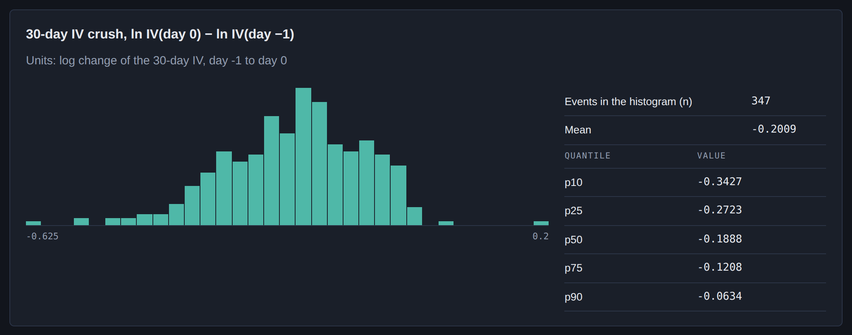
The distribution of the crush (iv_measures.json)
The crush is larger for after-close reporters (−0.230, n = 182) than for before-open ones (−0.165, n = 165); this split is exploratory. The front-expiry IV, which holds a larger share of event variance, falls by 0.299 (mean-adjusted, n = 264). The older samples agree in sign and size: −0.250 in the mixed era (n = 33) and −0.190 in the coarse era (n = 110, where the crush can span two sessions), both exploratory.

4.3 H2: the run-up, and its season-count dependence
At day −1 the abnormal 30-day IV is +0.2319 log points. The primary statistic is the randomisation p-value by season, because the 8 seasons are unbalanced. With 8 seasons and every season mean on the same side, the p-value sits on its floor 2/2^8 = 0.0078, and Holm's multiplier for the second-smallest p gives 0.0469: rejected.
This verdict is a property of the season count, not of the data's strength. ADR 0005 expected the October 2026 tail to be merged into July, which gives 7 seasons. Then the floor is 0.0156 and the Holm p is 0.0781: not rejected. The direction is not in doubt: the two-way season × company t, a robustness row, is 13.43 (p 3.0e−6), and every season mean is positive (milestone 3 §6.2).
The mean path shows where the run-up sits. The abnormal IV is already +0.239 [0.197, 0.280] at day −10 and +0.232 [0.191, 0.274] at day −1: the 30-day IV holds the event from day −21 on, and the last ten sessions add nothing on average. After-close reporters run higher at day −1 (+0.270) than before-open ones (+0.191).
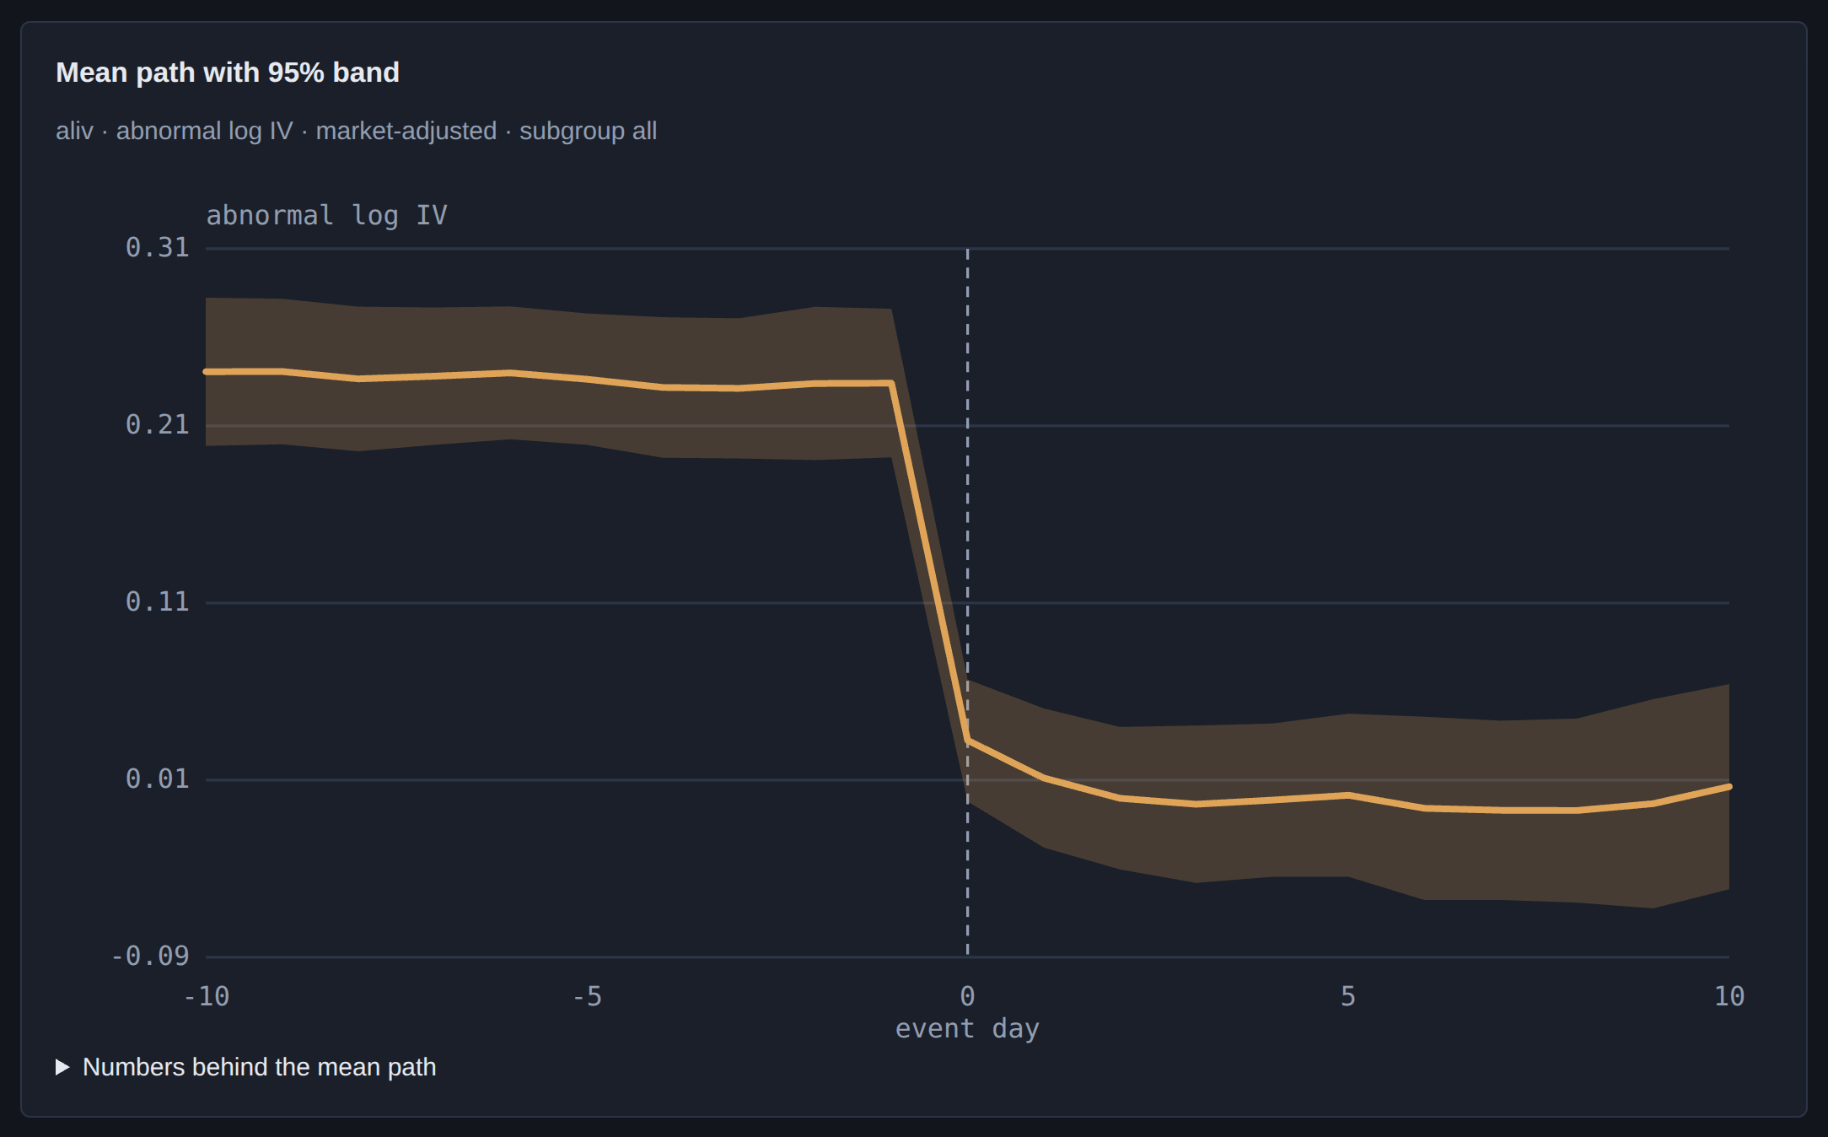
The mean abnormal path with its 95% band (event_paths.json, market-adjusted aggregate)

4.4 H3 and H4: what is left after the event
At day +10 the abnormal IV is +0.0080 (interval [−0.049, 0.065], 7 seasons, 6 df). The path is +0.033 at day 0, +0.012 at day +1, +0.002 at day +5 and +0.007 at day +10. Under the calibrated design the test detects a persistence of 0.121 log points 80% of the time, so a smaller lasting effect could go undetected.
Ordinary volatility changes by +0.0031 log points (interval [−0.019, 0.026], n = 262); the test has 80% power at 0.036 log points. So the crush is the event variance leaving the 30-day horizon, not the market becoming calmer about the stock.
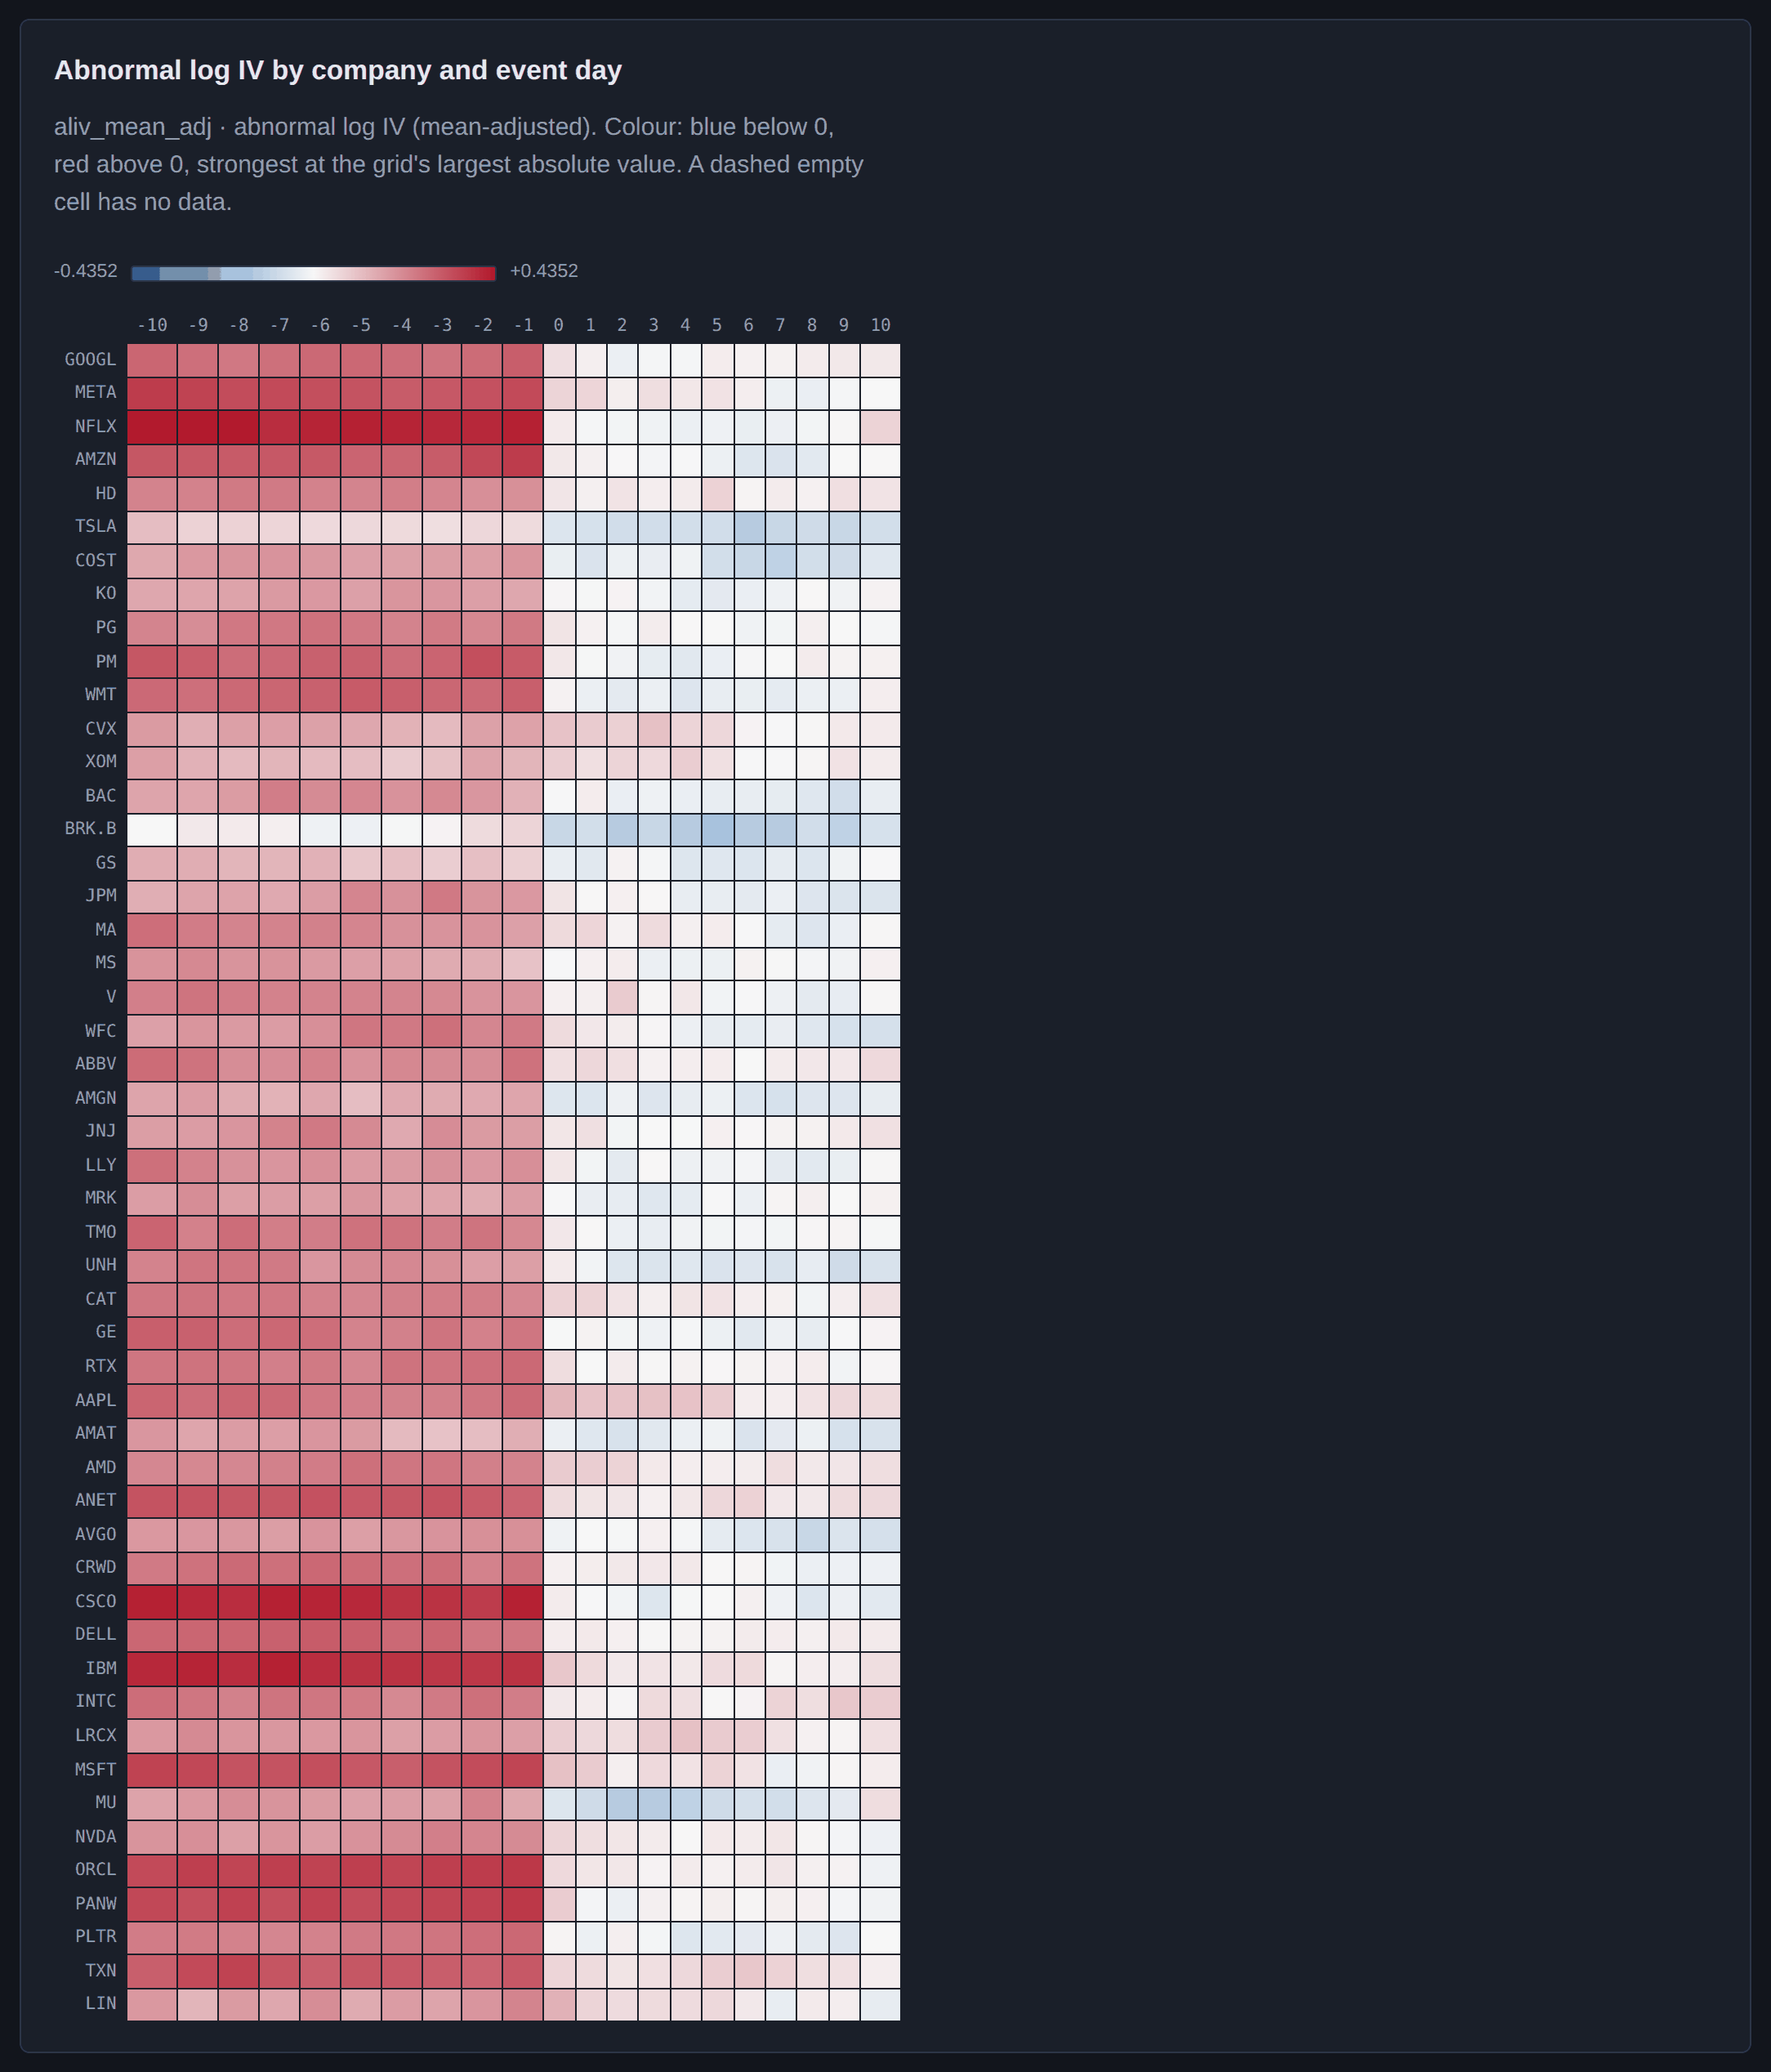
Abnormal log IV by company and event day (heatmap.json; mean-adjusted, descriptive)

4.5 H5–H7: the drivers, with liberal statistics
The crush regression has R² 0.427 on 347 events. A positive coefficient means a smaller fall.
- H5, the surprise: +0.0132 per sd (interval [0.003, 0.023], p 0.0102, Holm 0.0511): a bigger surprise goes with a slightly smaller crush. The statistic rejects 9.55% of the time under the null, so the p is weaker than it looks, and Holm does not reject. The effect does not survive other surprise measures: with the surprise scaled by its own history it is +0.002 (q 0.750), with analyst dispersion +0.003 (q 0.773), and with company fixed effects +0.008 (q 0.587).
- H6, the prior volatility level: −0.0014 per sd (interval [−0.023, 0.020], p 0.895): no measurable effect.
- The slope (exploratory): a steeper term structure at day −1 goes with a larger crush, −0.032 per sd (p 3.9e−5, q 0.0006). That is expected and partly mechanical: the slope proxies the event's share of the 30-day variance. Its p and q come from the same two-way t that G1 found liberal for H5 and H6; G1 never sized the slope's own coefficient, so read it as an indication, not a test at 5%.
- Size (exploratory): +0.013 per sd (q 0.177).
Power, from G1's calibrated design: H5's test detects 0.026 log points per sd 80% of the time, H6's 0.042. These powers belong to oversized tests.

5. Implied against realised moves
On day −1 the options price the event variance E and the ordinary variance σ_d²/252 of one session. If the day-0 move is normal with that variance, its expected absolute size is √(2/π)·√(E + σ_d²/252), and fair pricing exceeds it 42.5% of the time, not 50%. The realised move r₀ is the change of the option-implied forward from day −1 to day 0, on the same expiry both days.
Measure | Value
Events (E, σ_d and r₀ all present) | 336
Events with E > 0, so with an expected move | 332
Median expected |move| | 5.4%
Median realised |move| (all 336 events) | 4.4%
Median ratio realised / expected | 0.82
Share of moves beyond the expected |move| (fair: 42.5%) | 40.1% (p 0.319)
Mean r₀² over mean implied variance | 0.90
H7 regression r₀² = a + b(E + σ_d²/252): b | 0.767, interval [0.46, 1.07]
H7 joint test a = 0, b = 1 | F(2, 49) = 1.33, p 0.275, Holm 1
The same with E read at day −2 (n = 331): b; joint p | 0.92; 0.822

The typical realised move is smaller than the expected one (median ratio 0.82), but the mean squared move is 0.90 of the mean implied variance, so large moves weigh heavily in the average. On variance the options are close to unbiased: b = 0.77 with 1 inside its interval, and the share of moves beyond the expected size (40.1%) is close to the fair 42.5%. With E read one session earlier, b is 0.92: day −1 quotes are often wide on after-close announcement days, which may inflate E a little. The joint test's G1 size is 16.15%, so even a rejection would not have been trusted; the b and share rows come from the same kind of two-way statistic.
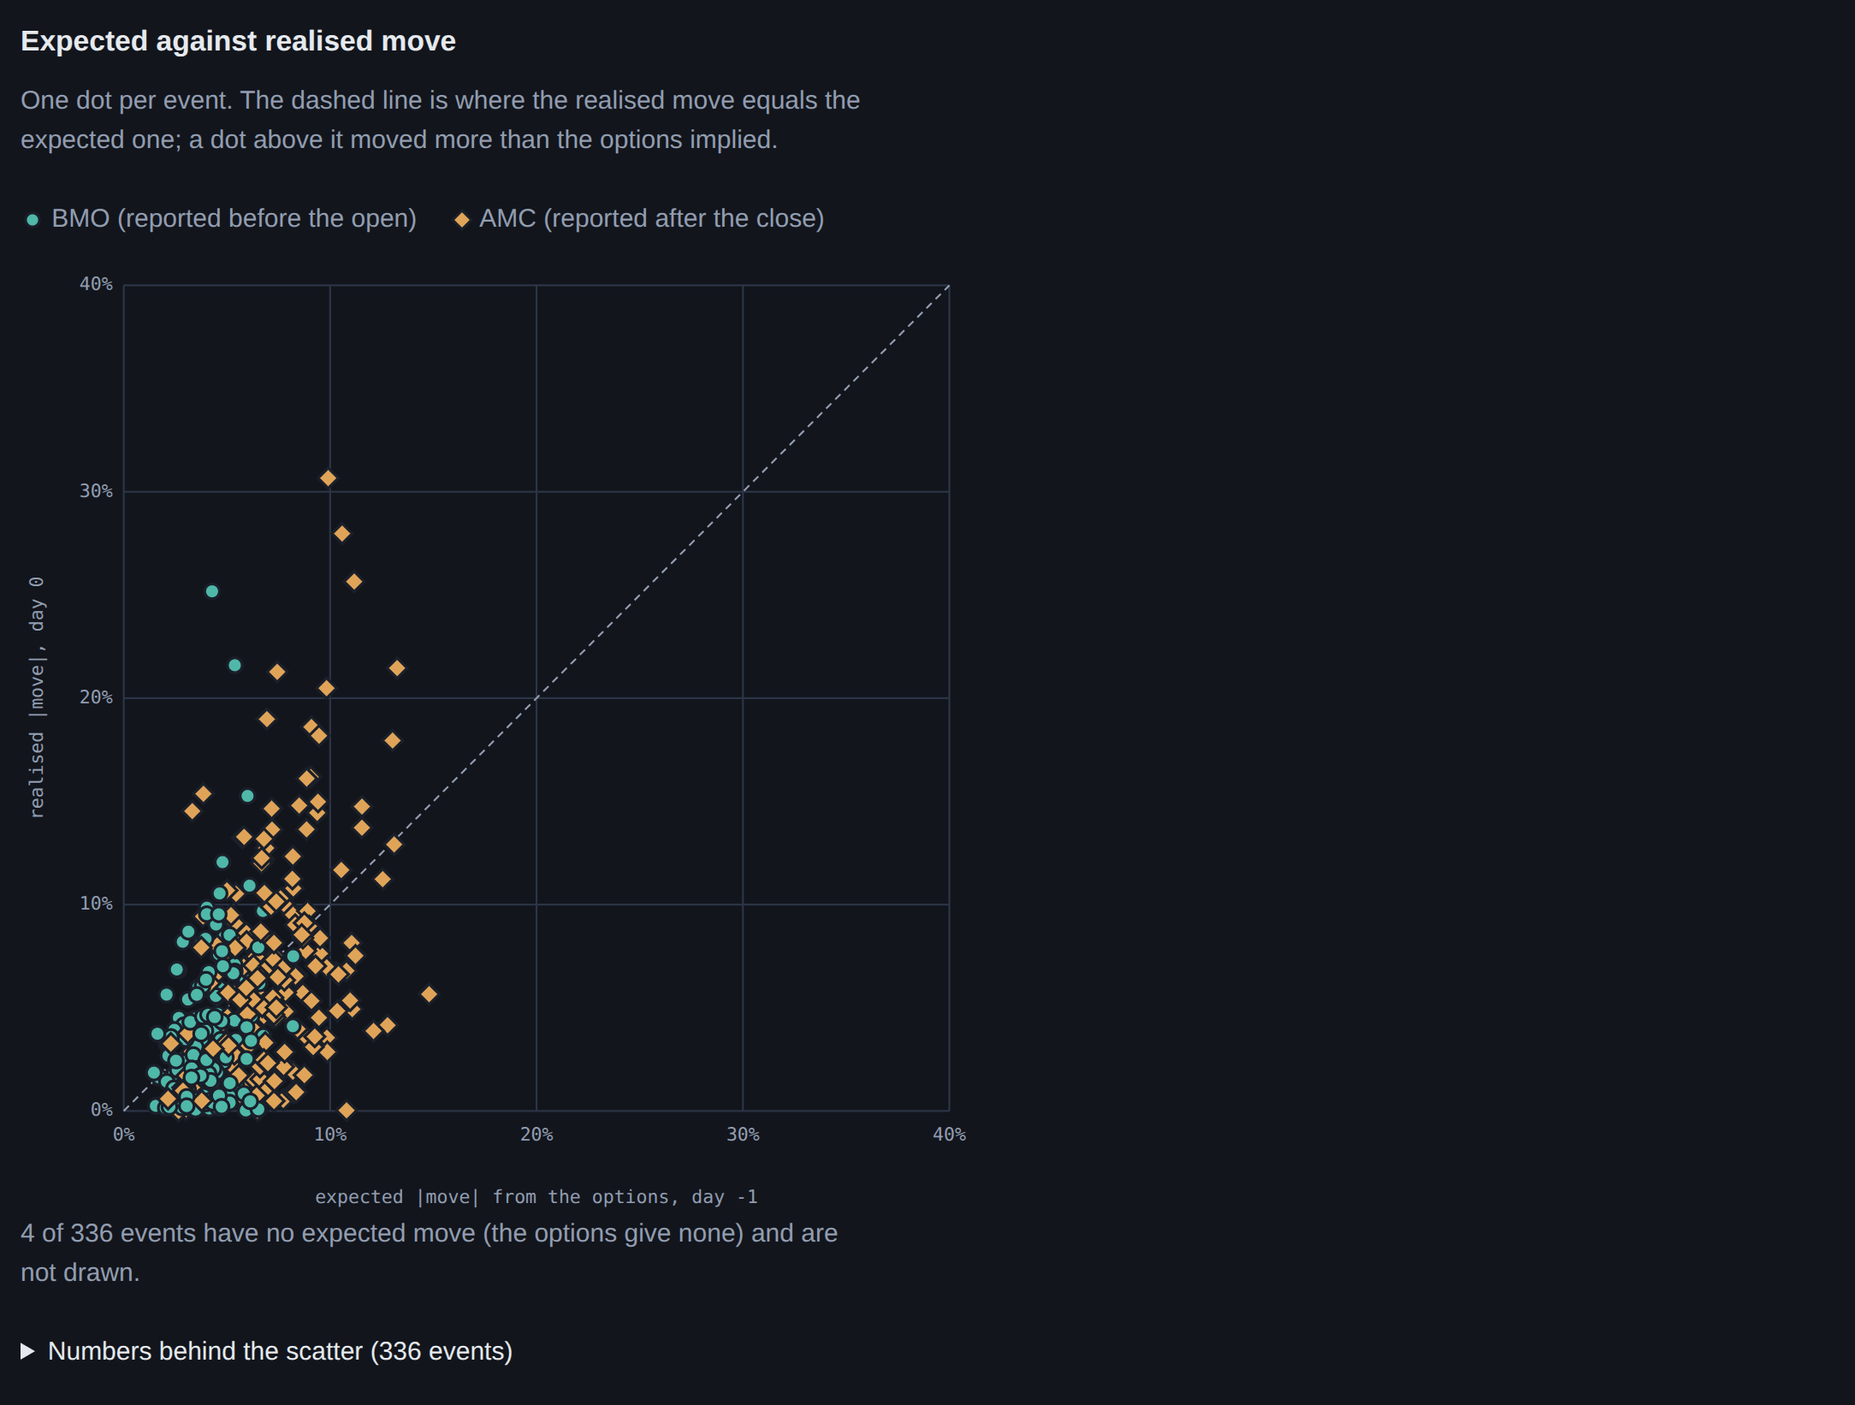
Expected against realised move, one dot per event (implied_vs_realised.json)

6. Trading implications: observations and their limits
This section is not investment advice. It gives no recommendation, no position and no size. It says what the measured numbers describe about the past, and what they cannot say.
What the numbers describe.
1. The IV fall was near-universal in direction in this sample. In this sample the market-adjusted 30-day IV fell from day −1 to day 0 in 99.1% of events, by 0.199 log points on average. But the fall is the event variance leaving the horizon (H4: ordinary volatility unchanged), and the term structure showed that variance in advance: E is read from it at day −1. A falling IV is not by itself a gain for anyone short options: that position's result depends on the realised move against the implied one, plus costs.
2. On average the options priced the move about right. b = 0.77 [0.46, 1.07], 40.1% of moves beyond the expected size against 42.5% for fair pricing. The data show no reliable average over- or under-pricing of the earnings-day move in this sample. The typical move was smaller than expected (median ratio 0.82), while the mean squared move was 0.90 of the mean implied variance.
3. The run-up is in place ten sessions early. The 30-day IV already holds the event from 21 sessions before day 0; the abnormal level at day −10 (+0.239) and at day −1 (+0.232) are about the same on average.
4. A steeper term structure went with a larger crush (−0.032 per sd). This is exploratory, partly mechanical, and from a statistic that is liberal at this design.
5. The surprise does not reliably size the crush, and the surprise is unknown before the event anyway.
What they cannot say.
- Nothing about profit. There are no bid-ask spreads, commissions, margin, slippage or position limits here. Day −1 quotes on after-close days are often wide. A cost-aware test belongs to the sibling project vol-strategy-backtester.
- Nothing intraday. The data are daily closes, so they cannot say when during day 0 the IV falls or how the stock moves on the way.
- A narrow, survivor sample. 50 of today's largest S&P 500 companies, day 0 from 2024-12-10 to 2026-10-22. Smaller, less liquid names and other periods may behave differently.
- Provisional timing labels. 453 of 473 required look-ups are not done.
- Liberal driver statistics. H5–H7's tests reject 9.55%, 8.10% and 16.15% of the time under a true null at 5%.
- The averages hide the spread. The heaviest-tailed events drive the squared-move regression, and a single event can move far more than its options priced (the scatter in section 5).

7. Caveats, in one place
1. Provisional timing labels: 20 of 473 required look-ups are done; 453 wait for SEC EDGAR (accepted as the timing source on 2026-10-28; no request has been made, because the client needs the owner's contact string).
2. H2 depends on the season count: rejected with 8 seasons (Holm 0.0469), not rejected with the 7 that ADR 0005 expected (Holm 0.0781).
3. H5–H7's statistics are liberal: G1 sizes 9.55%, 8.10% and 16.15% at 5% (one-way versions 18.45%, 20.10%, 17.00%). Every exploratory regression p and q comes from the same two-way t.
4. Withheld robustness rows: 14 rows keep their estimates but not their p-values, because G1 found them oversized.
5. A common date component: after the VIX adjustment the crush's average same-date correlation ρ̄ is 0.30 (above ADR 0005's warning line of about 0.2). It is spread over most dates (0.19 without the ten largest), not a stale snapshot, and a leave-one-company-out IV factor removes it (−0.028). It is linearly unrelated to the change in ln VIX, which is close to automatic because β is fitted on that change. H1's two-way statistic is robust to same-date dependence; the Kolari-Pynnönen rows, which model it, are withheld for the crush. Adding a second market factor would change every market-adjusted number and is an owner decision.
6. Which Holm family binds (H1–H7 declared, or H1–H4 after the gate) is an owner decision (section 4.1).
7. Survivorship: the universe is today's largest companies.
8. Not built: the Cboe single-stock volatility index cross-check (VXAPL and others), the coarse-sample scale correction, the SPY placebo and the drop-the-largest-companies check of ADR 0004.
9. No 3D hero render: Blender was unreachable on 2026-10-29, so the Blender script (tools/blender/event_terrain.py) has not run. The 3D figures are three.js stills of the app's terrain view.

The 3D terrain: each company's mean abnormal log IV (mean-adjusted) by event day, a three.js still from the app

8. How this report is built
The report is written in docs/report/templates/earnings-vol-report.md. tools/report_numbers.py fills every placeholder in it (a key in double braces) from data/derived/results.parquet, the app's JSON files and the kept output research/prototypes/rhobar_crush.out.txt, and writes this file. One number is pinned instead of read: the 473 required look-ups, which need a Yahoo flag that stays local (--check compares it with the local stage report when one exists). The same script fills the results blocks of the README and the PR/FAQ.
uv sync --frozen --group report # once: python-docx and markdown-it-py
uv run --frozen python tools/report_numbers.py # fill the numbers (--check: verify only)
uv run --frozen --with playwright==1.64.1 python tools/screenshots.py # app screenshots, figures, 3D stills
uv run --frozen --group report --with playwright==1.64.1 python tools/build_report.py # PDF and DOCX

tools/build_report.py turns this Markdown into earnings-vol-report.docx (python-docx) and earnings-vol-report.pdf (Chromium's print-to-PDF through Playwright). pandoc is not installed on the build machine.

9. Questions for the owner
1. Audience. Who is this report for: interviewers reading a portfolio, practitioners who know event studies, or a record for yourself? The answer decides how much of section 3 stays in the body.
2. Tone. Keep the cautious "measured and provisional" voice throughout, or open with a plainer executive summary and move the caveats to the end?
3. What to cut. Candidates: the robustness-row list (section 3.6), the exploratory driver variants (section 4.5), the older-sample numbers (section 4.2), the ρ̄ paragraph (section 7, item 5). Should any of them move to an appendix or out?
4. The Holm family (milestone 4, decisions table row 24). Keep the declared family H1–H7 as binding (H2 rejected with 8 seasons, not with 7), or adopt the post-gate family H1–H4 (H2 rejected either way)?
5. Trading implications. Keep section 6 as observations with their limits, shorten it to the "cannot say" list, or drop it? Should it point to vol-strategy-backtester for a cost-aware test?
6. Timing labels. Publish with 20 of 473 labels checked, or wait until SEC EDGAR has run (it needs your contact string in SEC_EDGAR_USER_AGENT)?
7. The common date component. Add an equal-weighted single-stock IV factor next to VIX in the market model? It would change every market-adjusted number.
8. Exports. Are a PDF and a DOCX the right formats, and is the app's dark theme right for the printed figures?

