Task: |  | 4
Task Title: |  | Case Study
Task Code: |  | AT2

Assessment type (☒):
☐ | Questioning (Oral/Written) |  | ☒ | Portfolio
☐ | Practical Demonstration |  | ☐ | Project
☐ | 3rd Party Report |  | ☐ | Other – Please Specify
Assessment # and title |  |  | VU23216 |  | AT3 Project
Lecturer name |  |  | Student to fill this section out
Student name |  |  | Student to fill this section out
Student ID number |  |  | Student to fill this section out
Telephone contact number |  |  | Student to fill this section out
Email |  |  | Student to fill this section out
By completing and submitting this signed form to my lecturer, I am stating that:
- The attached submission is completely my own work.
- I have correctly cited all sources of information used in this work (if required)
- I have kept a copy of this assessment (where practicable)
- I understand a copy of my assessment will be kept by the NMTAFE for their records.
- I understand my assessment may be selected for use in the NMTAFE’s validation and audit process to ensure student assessment meets requirements
Student Signature | Student to fill this section out |  |  |  |  | Date |  | Student to fill this section out
Assessors please note: Where verbal clarification has been sought from a student to gather additional assessment evidence from an assessment item, question/s and response/s must be recorded, signed, and dated by the assessor, against the relevant assessment item/s.
NB: Feedback will be given via Blackboard when possible.
Submission 1 ​☐​ | Result | Satisfactory / Not Yet Satisfactory |  |  |  |  | Date
To satisfy requirements for this assessment, you need to complete the following: |  | Feedback to student…
Submission 2 ​☐​ | Result | Satisfactory / Not Yet Satisfactory |  |  |  |  | Date
To satisfy requirements for this assessment, you need to complete the following: |  | Feedback to student…
Student Feedback |  | Feedback from student…
Lecturer Signature |  |  |  | Student Signature
Answering Questions
When a step includes a question, you must attempt to answer it. A word count is sometimes given, but most answers require at most 1-3 paragraphs.
All answers must be in complete sentences unless indicated. You must use your own words unless otherwise specified.

Reasonable Adjustment
Information on reasonable adjustment can be found in the Learning and Assessment Plan for the Unit

Recognition of Prior Learning (RPL)
Information on RPL can be found in the Learning and Assessment Plan for the Unit

Assessment Due
NOTICE: This assessment is due by session 8

Assessment Requirements
The base requirements this assessment task include:
- Splunk Enterprise
- Splunk Login
- Example Dashboard (Appendix A)

Assessment Instructions

Registering for your Splunk Training Account
NM Tafe provides access to certified Splunk Training, you will need to take the following steps:
- Register using your student account - https://workplus.splunk.com/ (link)
- Ensure you following the registration instruction properly.
Once you have completed the 4 steps (including waiting for verification from Splunk), you will then have access to the required training here: https://www.splunk.com/en_us/training/splunk-pledge.html (link)

There is one Splunk training module you need to complete which will be listed in the learning materials for the weekly session.

Part 1 – Complete Splunk Modules
You then need to register & complete for the following modules:
- Introduction to Splunk
The completion of this module and lab in these modules will form the basis of your assessments.

In the next few pages, you are required to insert your completion certification.

Part 2 – Convert Search Tutorial Data to focus on Cyber Security
Student will use the assessment data to create a 5-section dashboard focusing on Cyber Security. Submit this completed document and the completed, exported dashboard into Blackboard.
The assessment data can be found in the Useful Resources section of Blackboard. In the VU23216 folder then select AT2 Assessment Data.

Important

You will need to have registered using your student email before you can enrol for these classes.

This verification will include a coupon code to receive the 100% discount on the training courses.

Using ChatGPT and other LLMs
If you use any form of generative AI (large language models, or LLMs) to help you answer questions, then ensure:
- The answers you place here are phrased in your words not the AI’s. Failure to comply may be evidence of academic misconduct!
- Retain a history of your chat transcript with the AI, as you may be asked to show it.
- Consider: LLMs are not a source of truth, they hallucinate and can provide incorrect answers. If you attained facts from ChatGPT, or a similar service, you may need to confirm those facts with an authoritative website.
- Remember: at any time, lectures may call on you to explain in your own words your answers to questions.

Attaching screenshots
Images of dashboards can be exported as jpeg/png files from Splunk Enterprise. Information can be found here:
Part 8: Save and export the dashboard - Splunk Documentation

Step 1: Complete the Intro to Splunk Module

Insert a screenshot of your Splunk completion certificate here:
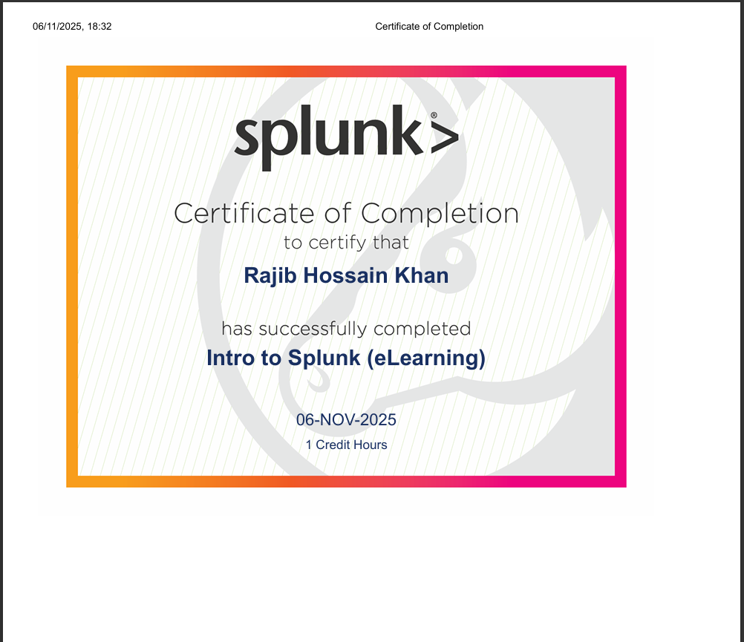
Step 2: Convert Data to a Cyber Security Dashboard

- Upload the assessment 2 test data and create an index of “security”.
- Using SPL select and visualise fields to build a cyber security focused dashboard for your client.
- When creating a visualisation ensure you have:
  - a relevant title
  - where using graphs you have correctly labelled x & y axis

Create a Splunk Dashboard that contains the following 5 sections:

- Total Visitors Location – Last 30 Days

- map of the total requests to access the site using the clientip from www2/access.log to create locations for the last 30 days.
Insert a copy of your search SPL code below:
source="access.log" index="security" sourcetype="access_combined_wcookie" earliest=-30d@d latest=now
| iplocation clientip
| stats count by City, Country, lat, lon
| geostats latfield=lat longfield=lon count
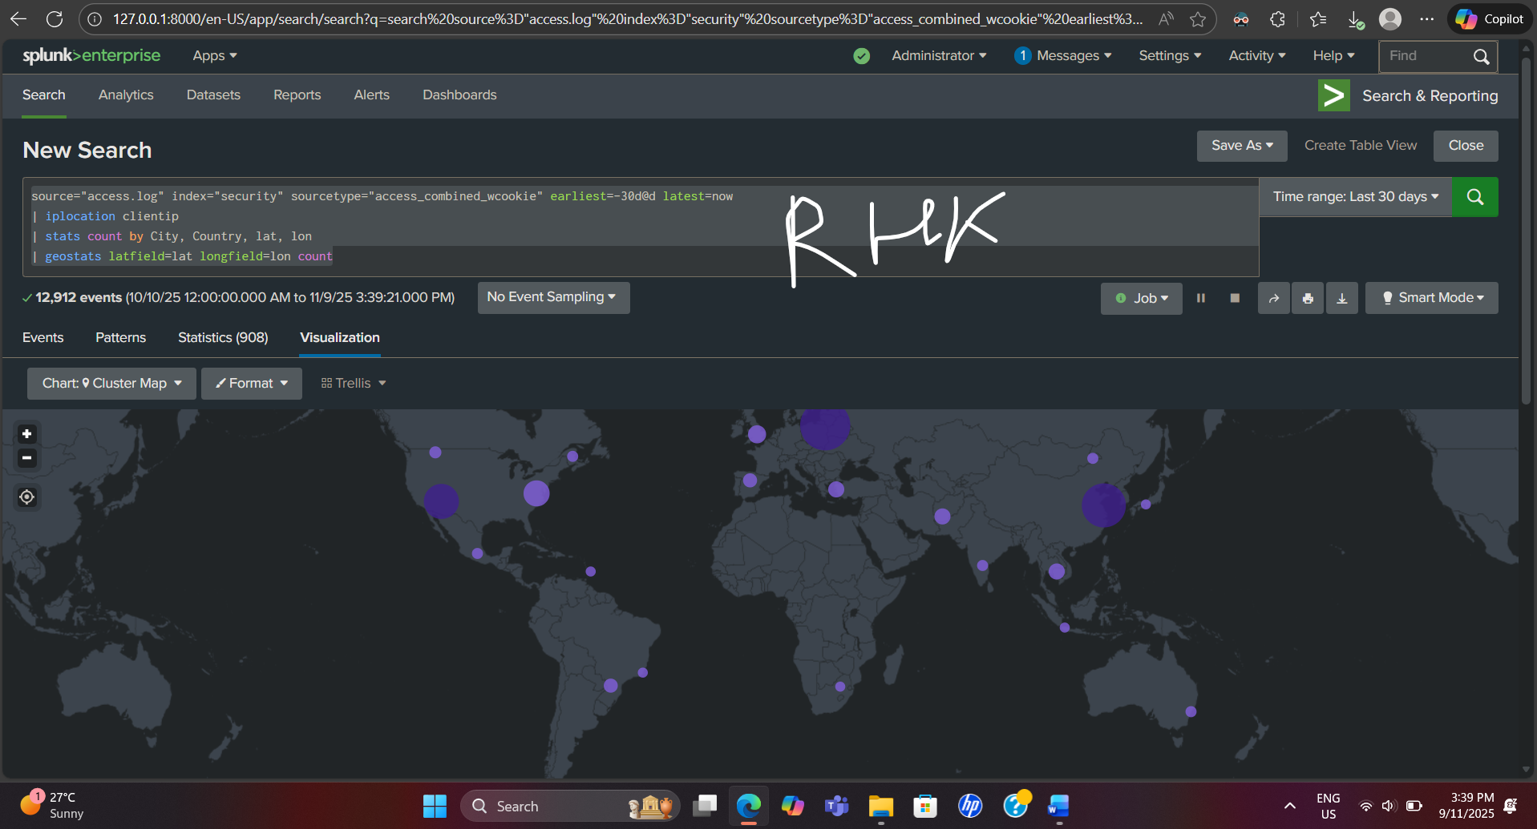

- Failed Login IP Addresses – All Time

- use the www2/secure.log to capture all the Failed Password attempts which returned invalid user.
- extract a new field from the data to create a user_ip address & create a bar chart of the count of the ip addresses that were the source of the failed login attempts for all time.
Insert a copy of your search SPL code below:
source="secure.log" index="security" sourcetype="www2/secure.log" "Failed password" "invalid user"
| rex "from (?<user_ip>\d{1,3}\.\d{1,3}\.\d{1,3}\.\d{1,3})"
| stats count by user_ip
| sort -count
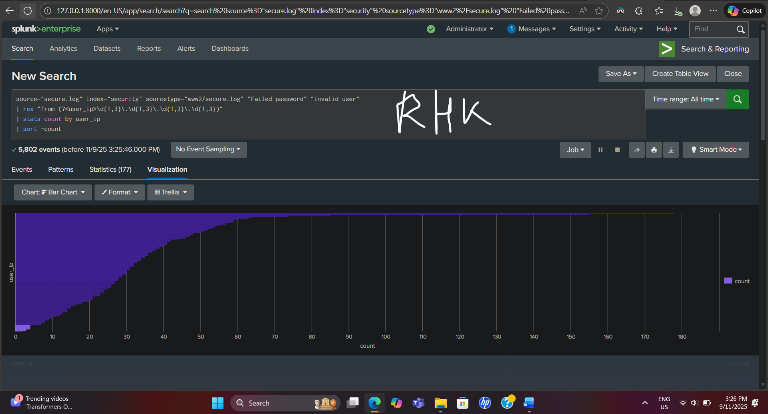

- Failed Password Users – Last 7 Days

- use the www2/secure.log to capture all the Failed Password attempts.
- Using the existing user fields create a pie chart of the users that were the source of these failed login attempts in the last 7 days
Insert a copy of your SPL code below:
source="secure.log" index="security" sourcetype="www2/secure.log" "Failed password" earliest=-7d@d latest=now
| rex "Failed password for (?<user>\w+)"
| stats count by user
| sort -count

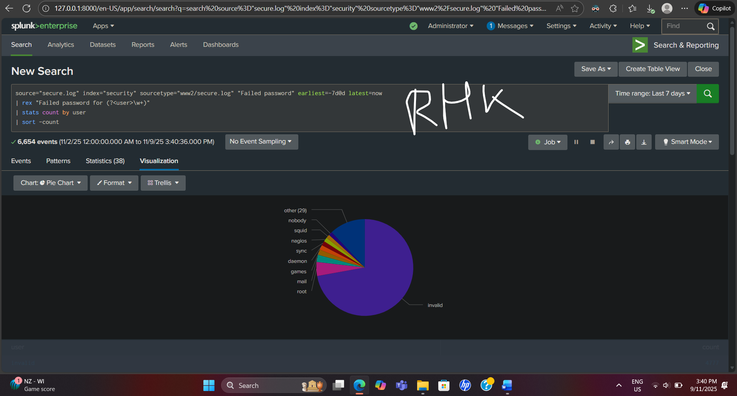

- Failed Login Attempt Location – All Time

- use the www2/secure.log to capture all the Failed Password attempts.
- use this data to create a map of the total requests to access the site using the user_ip from to create locations.
Insert a copy of your SPL code below:

source="secure.log" index="security" sourcetype="www2/secure.log" "Failed password"
| rex "from (?<user_ip>\d{1,3}\.\d{1,3}\.\d{1,3}\.\d{1,3})"
| iplocation user_ip
| stats count by City, Country, lat, lon
| geostats latfield=lat longfield=lon count
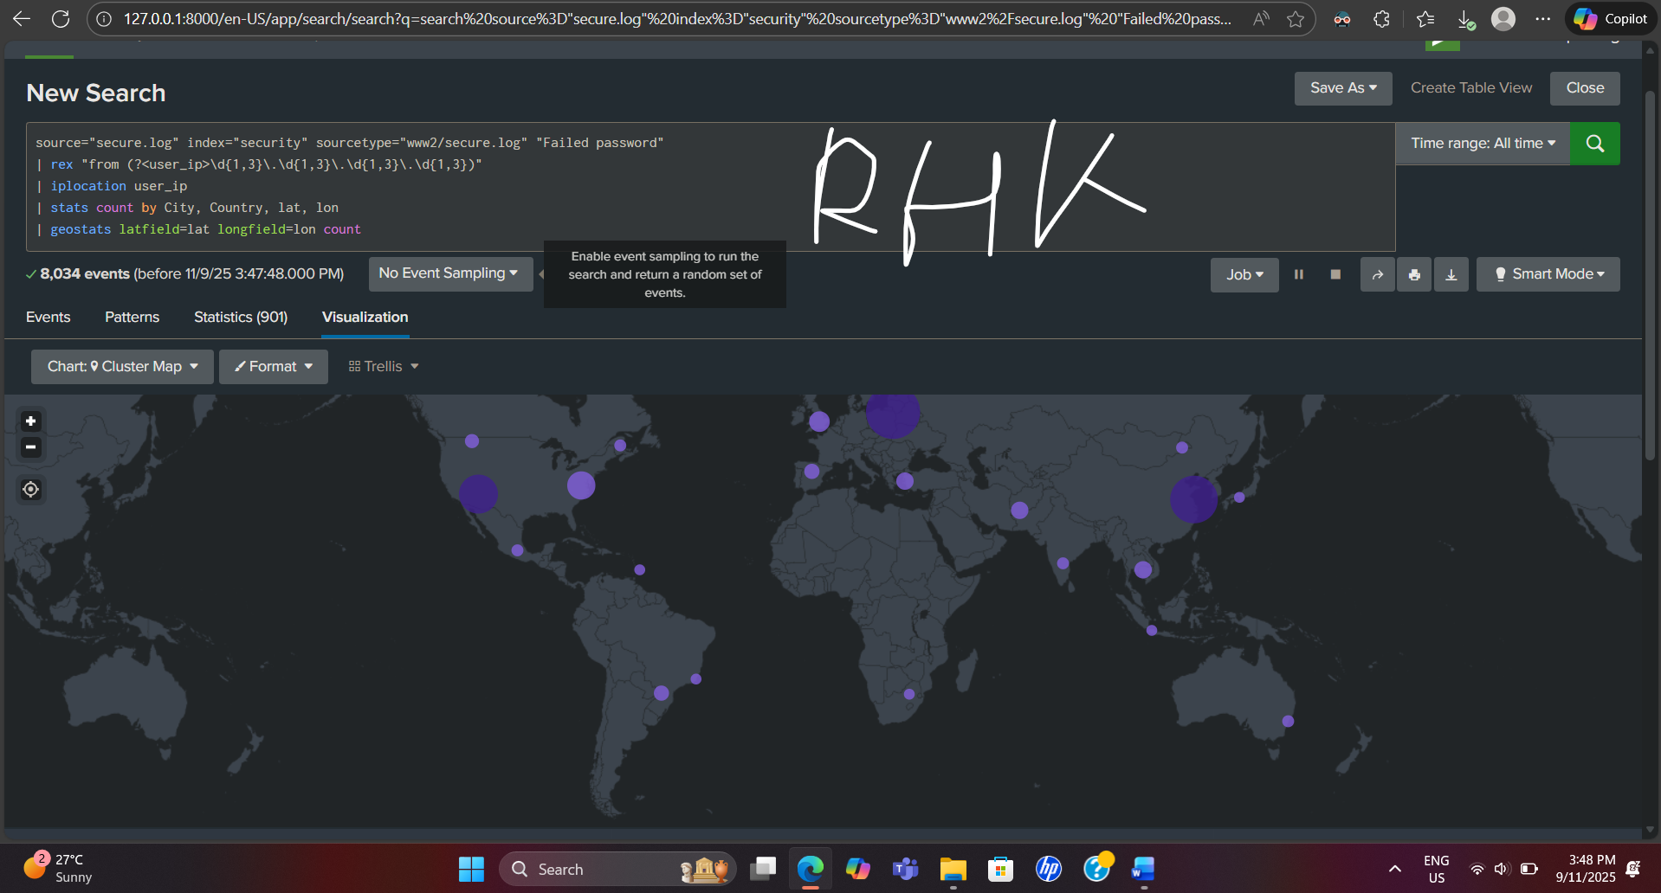

- Client Actions - last 7 Days

- use the www2/access.log to capture all the clientip actions (excluding those equal to NULL)
- create a bar chart showing the number of each action, limiting the search to 10 days.

Insert a copy of your SPL code below:

source="access.log" index="security" sourcetype="access_combined_wcookie" earliest=-7d@d latest=now
| where isnotnull(clientip)
| stats count by action
| sort -count
| head 10

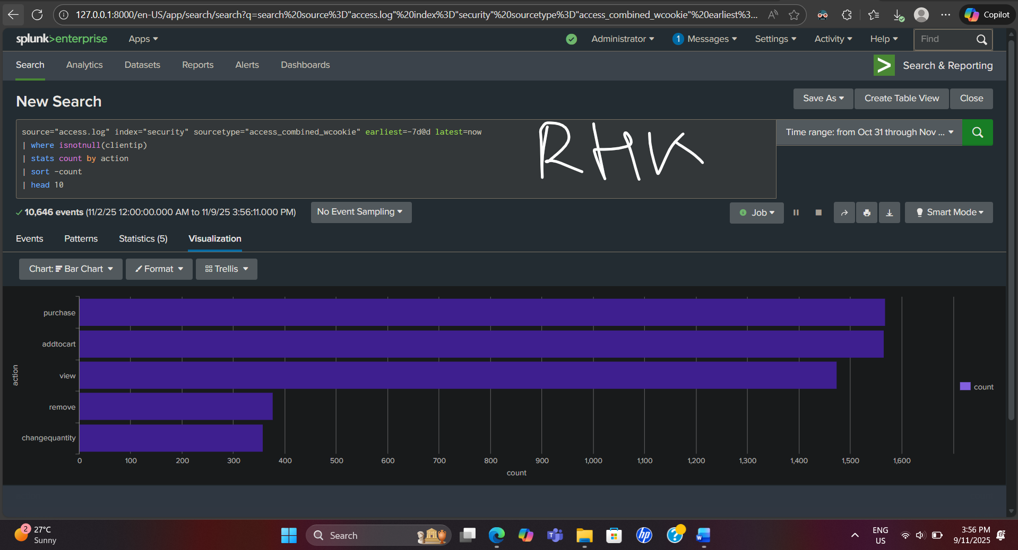

- Data Cleaning: Using this exercise, describe what Data Cleaning is and how you perform this task? Include an example of your SPL code to explain your answer.

The process of locating and fixing erroneous, missing, or unnecessary data in order to guarantee accurate analysis is known as data cleaning in Splunk. It entails removing unneeded fields, duplicates, and null values. For instance, the quality of the results is enhanced by eliminating empty client IPs before to analysis.

source="access.log" index="security" sourcetype="access_combined_wcookie" earliest=-7d@d latest=now
| where isnotnull(clientip)
| stats count by action
| sort -count
| head 10

- Automation: List the critical SPL queries & Visualisations from your report, that you feel your client will need to receive automated alerts & notifications from. Explain your reasoning.

Critical alerts:
1) Failed-login spikes — SPL: source="secure.log" index="security" sourcetype="www2/secure.log" "Failed password" | rex "from (?<user_ip>\d+\.\d+\.\d+\.\d+)" | stats count by user_ip → Bar.

2) Traffic anomalies — SPL: source="access.log" index="security" sourcetype="access_combined_wcookie" earliest=-15m | stats count by clientip → Timechart. 3) Geo attack clusters — SPL: ... | iplocation user_ip | stats count by City,Country,lat,lon → Map. Reason: security, availability, and rapid response.

- Data exploration: From your data analysis list at least 2 security issues that you think the client should consider. What possible security threats might be the cause of these issues? For each issue propose a solution for the client.

Problem 1: Several unsuccessful attempts to log in from the same IP point to a potential brute-force attack. Danger: Credential stuffing or unauthorized access. Solution: Set up multi-factor authentication, implement account lockout policies, and use automated notifications to track recurring IP login failures.
Problem 2: A high volume of requests from unidentified areas points to possible DDoS operations. Service interruption poses a threat. Solution: To limit suspicious traffic and preserve service availability, use a web application firewall (WAF), rate limitation, and geo-blocking.

- Feature engineering: List at least two pieces of cyber security data that were not present in the provided data that you think might be useful for the client’s security team to see in the dashboard?

There are two helpful missing data types: 1) User activity logs, which are essential for identifying insider threats, provide information on successful logins, session lengths, and privilege levels. 2) Alerts from intrusion detection systems (IDS) or malware—to link access logs to possible signs of compromise. Incorporating them would improve situational awareness for proactive defense, threat visibility, and incident correlation.

Final steps

Important: Export and upload a pdf copy of your finished dashboard with this completed document. Please upload the two files separately (not as a compressed file).

You can find an example of the finished dashboard the end of this template.

Appendix A: Example dashboard
