Assessment type (þ):
☐ Questioning (Oral/Written)
☐ Practical Demonstration
☐ 3rd Party Report
☒ Other – Lab

Assessment Resources:
The base requirements this assessment task include:
- IDE or editor for developing Python programs (only IDLE and PyCharm supported by the college)
- Access to Office 365 & Microsoft Word
- Virtual machine
You may not need all these for every part in this assessment

Assessment Due:
This assessment is due after the weekly session, Week 5, Friday 17:00.

Assessment Instructions:
- Your code must be written in IDLE or PyCharm IDEs. If you are using a different IDEs or a different structure for your application, then assistance from your lecturers may be limited (at best).
Discuss with your lecturer before straying too far off the path!
- All resources used should be referenced with the question. Answers may not be copied and pasted from any resource. All answers must be reworded to display your understanding.
- You may only use Python functionality, methods and libraries which were taught in this unit.
- First line of code in a program should have the student’s name and number, as proof of authenticity.
- Screenshots of all programs must be included in this document, with the appropriate question.
- Screenshots of testing, showing your code works as intended, should be included with the relevant question.
- Python programs should be named: XXX_Lab##_SYY_QZZ
Replace XXX with your initials
Replace ## with Lab number
Replace YY with Section number,
Replace ZZ with Question number
- It is a submission requirement that all screen shots be signed in some way. Some acceptable examples of signed screen shots are shown below.
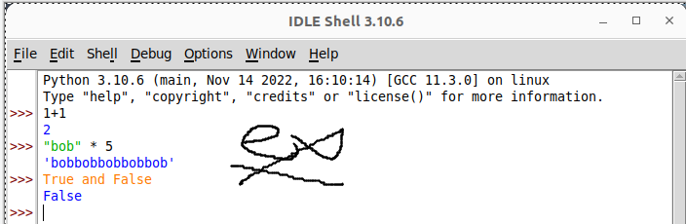
Example 1: Signed using a simple drawing tool.
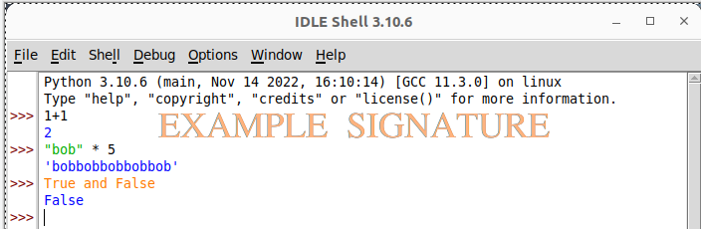
Example 2: Water marked signature.
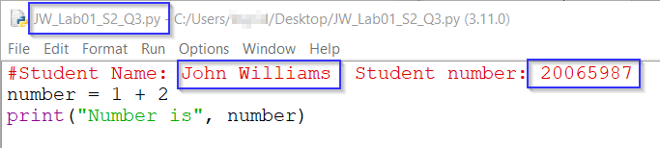
Example 3: Program named as prescribed, as well as first line comment with student name and number. Program saved as pre-described.
- All python programs must be included in the submission, as well as this document.

Assessment Instrument:

Section 1: Incremental short cuts
Begin this lab by exploring some of the short cuts commonly used in a loop. Run the following exercises in the Python shell/interpreter.
Run the following operations and evaluate the output:
Code | Screenshot of output
x = 0  x+=1  print(x) | 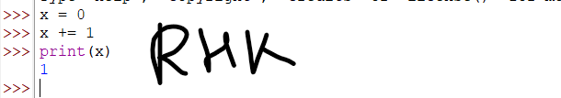
x-=1  print(x) | 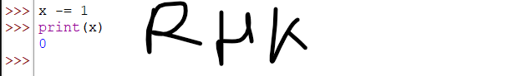
x+=5  x*=10  print(x) | 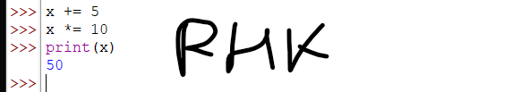

Section 2: While loops
Occasionally, you may need to repeat a set of instructions while any given condition evaluates to true. Complete the following tasks in the Python shell/interpreter.
- Run the following code and evaluate the output:
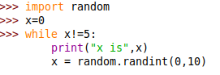

Screenshot of output
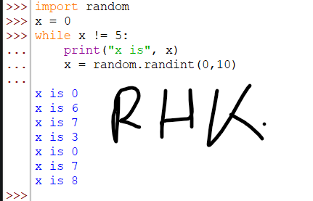
- How many times did the above loop run?
7 times
- What condition must exist for the loop to stop running?
x != 5
- Create an infinite loop by running the following code (stop execution with control + C):
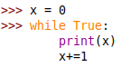

Screenshot of output
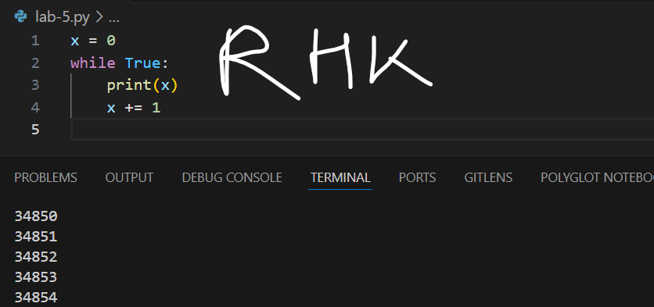
- Why was the last block of code run infinitely?
Bcs True will always be evaluated as True & won’t allow to break the loop
- Using a code file, create a working similar block of code that will do the following:
  - Generate two random numbers.
  - Display the maths equation the user needs to complete E.g. a + b =
  - Repeatedly ask the user to input the correct answer to the sum of those two numbers until they input the correct answer.
  - Ensure error handling and helpful user messages.
Screenshot of Code | Screenshot of Output
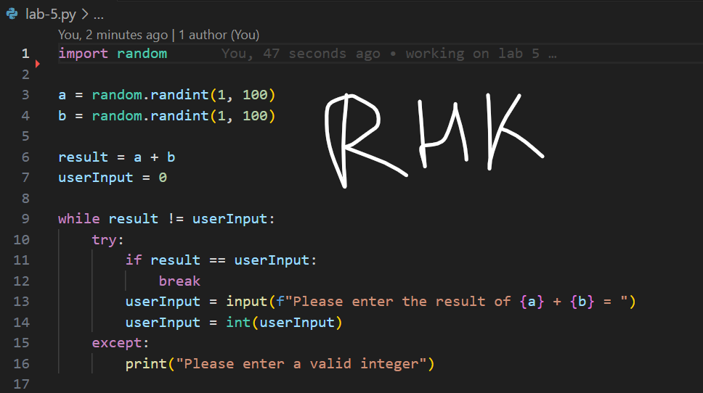 | 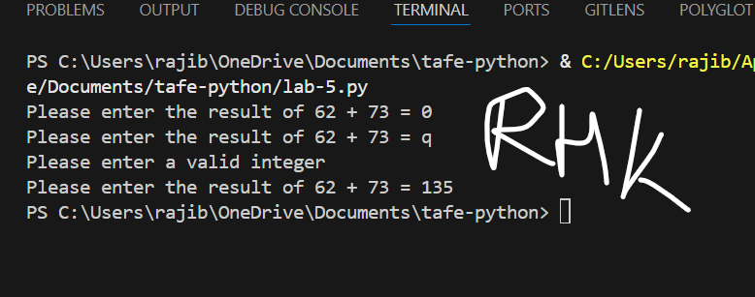

Section 3: For loops
Sometimes you will need to iterate through a set number of things. Complete the following tasks in the Python shell/interpreter.
- Run the following code and evaluate the output:
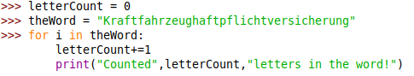

Screenshot of output
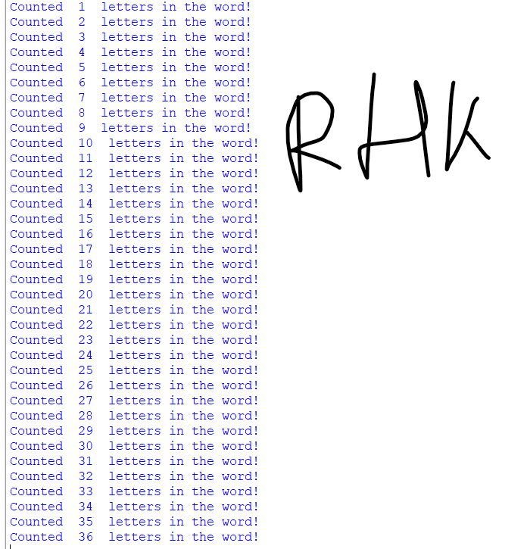
Evaluation of code
For loop is iterating through the string of the theWord variable and on each iteration incrementing the value of the letterCount by 1
- There is a useful Python string method called count, it will count the number of occurrences of any character you want with in a provided object. You can replicate its functionality using a for loop. Run the following code and evaluate the output:
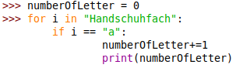

Screenshot of output
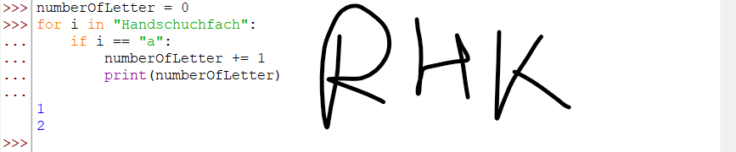
- Describe why the above code output the observed result.
We are running the loop through the string object and if any item matches “a” we are incrementing the numberOfLetter variable by one and as there is only 2 “a” in the string object we are getting 2
- Using a code file, create a working similar block of code that will do the following:
  - Ask the user to input a word
  - Ask the user to input another word
  - Ask the user to input a letter.
  - Use loops to count how many occurrences of that letter occur in both words.
  - Tell the user which word has the most occurrences of the selected letter, if the words have the same number of occurrences of the letter, the program should state that.
Screenshot of Code | Screenshot of Output
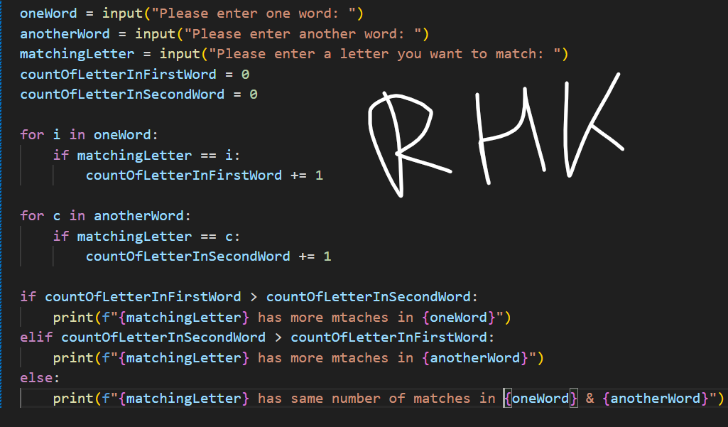 | 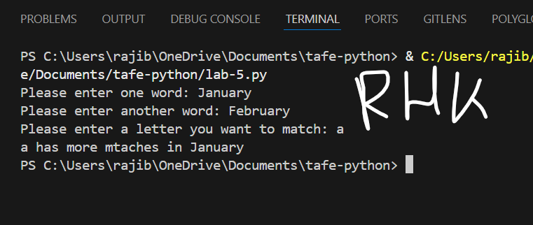

Section 4: A challenge
Complete the following challenge as described and demonstrated using a code file. Using the sample screen shots and pseudocode, create a script that will do the following:
- Ask the user to input numbers until the user inputs the word “done”.
- Use a try and except to validate and ask the user to re-input any numbers if the input is not valid as per requirement number 1.
- The try and except block should be as narrow as possible; only code that may crash the code should be in the try block
- Tell the user how many numbers they input and calculate the running total of those numbers.
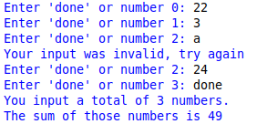

Note: To be marked as satisfactory for this task, your solution must:
- Have output formatted the same way as the demonstration screen shots.
- Contain comprehensive commenting.
- Demonstrate through screen shots, that your solution addresses all the above points.
You must submit the code file with this document
Screenshot of output:
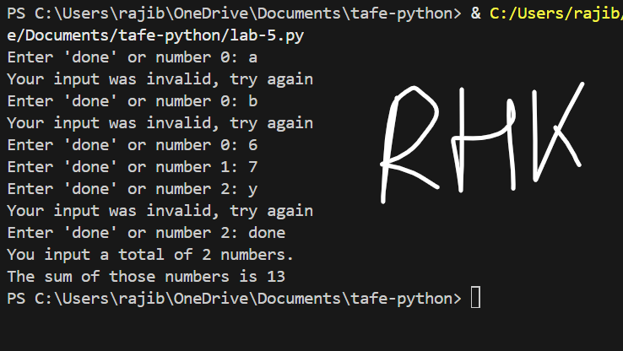

Screenshot of code:
