Assessment type ():
☐ Questioning (Oral/Written)
☐ Practical Demonstration
☐ 3rd Party Report
☒ Other – Lab

Assessment Resources:
The base requirements this assessment task include:
- IDE or editor for developing Python programs (only IDLE and PyCharm supported by the college)
- Access to Office 365 & Microsoft Word
- Virtual machine
You may not need all these for every part in this assessment

Assessment Due :
This assessment is due after the weekly session, Week 7, Friday 17:00.

Assessment Instructions:
- Your code must be written in IDLE or PyCharm IDEs. If you are using a different IDEs or a different structure for your application, then assistance from your lecturers may be limited (at best).
Discuss with your lecturer before straying too far off the path!
- All resources used should be referenced with the question. Answers may not be copied and pasted from any resource. All answers must be reworded to display your understanding.
- You may only use Python functionality, methods and libraries which were taught in this unit.
- First line of code in a program should have the student’s name and number, as proof of authenticity.
- Screenshots of all programs must be included in this document, with the appropriate question.
- Screenshots of testing, showing your code works as intended, should be included with the relevant question.
- Python programs should be named: XXX_Lab##_SYY_QZZ
Replace XXX with your initials
Replace ## with Lab number
Replace YY with Section number,
Replace ZZ with Question number
- It is a submission requirement that all screen shots be signed in some way. Some acceptable examples of signed screen shots are shown below.
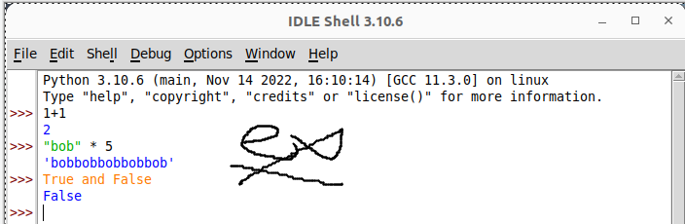
Example 1: Signed using a simple drawing tool.
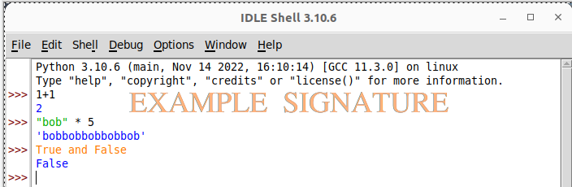
Example 2: Water marked signature.
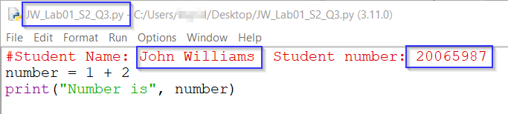
Example 3: Program named as prescribed, as well as first line comment with student name and number. Program saved as pre-described.
- All python programs must be included in the submission, as well as this document.

Assessment Instrument:

Section 1: Opening files
Opening and working with the contents of files will be a crucial skill for the upcoming project. Run the following exercises in the Python shell/interpreter.
- Start by downloading the sample text file from the P4e web site (mbox.txt).
- Open the mbox.txt file using code like the following (ensure you modify the file path to match your location of mbox.txt, in this example, the file was stored in the /tmp/ directory on a Linux machine):
Question |  | Answer / Screenshot
- Using the type() function to determine what type of object file is. | 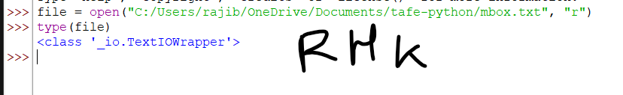
- Use the read() function save the contents of the file to a new variable. | 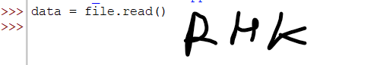
- Use len() to calculate how many characters in total are in the variable’s contents. | 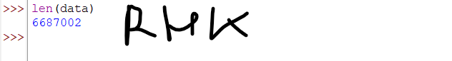
- Print the new variable (it should list everything in the file you read).  If you get the following result, double click on it to expand | 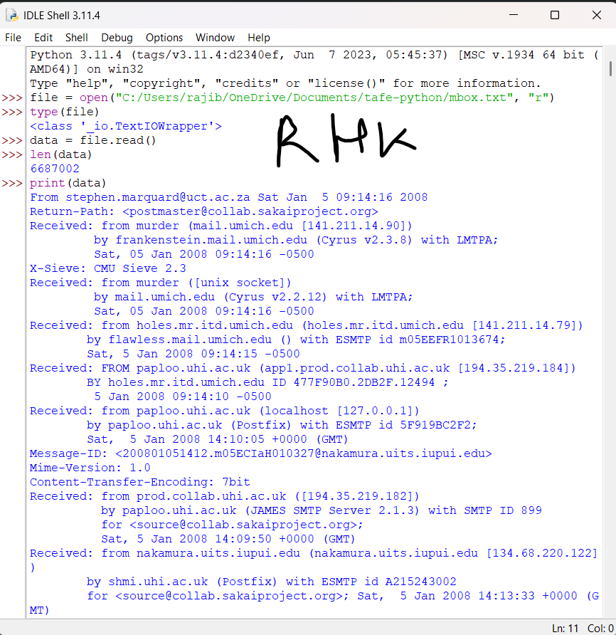
- Print only the first 100 characters in the variable. | 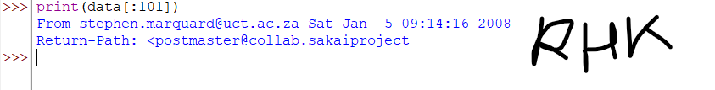
- Print only the last 100 characters in the variable. | 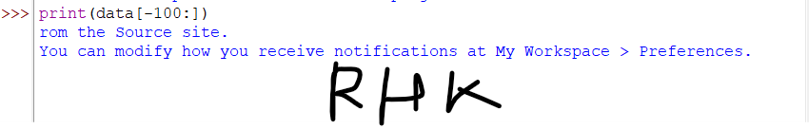
- Check if the word ssl appears in the file list.  (The answer should return True). | 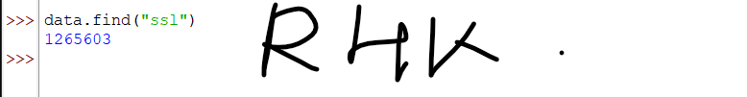
- Create a simple if statement to check if any word you want appears in the list. The if statement should produce True or False based on the word (demonstrate this with two different words to show your statement works as intended). | 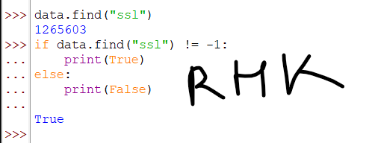  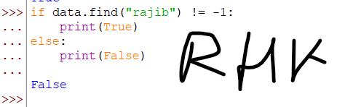

Section 2: Create and modify your own files
You will now begin some practice loading and writing to files using Python.
Step 1:
- In the Python interpreter, create ten new variables with movie titles in them; you should name them after your favourite movies. Example:
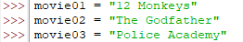
- Use open() to open a new file in write mode.
- Use write() to write your data to the file.
- Use close() to complete the write process and release the file.
- Double check the contents of the file using your operating system to ensure the data was correctly written to the file.
Code | File Content
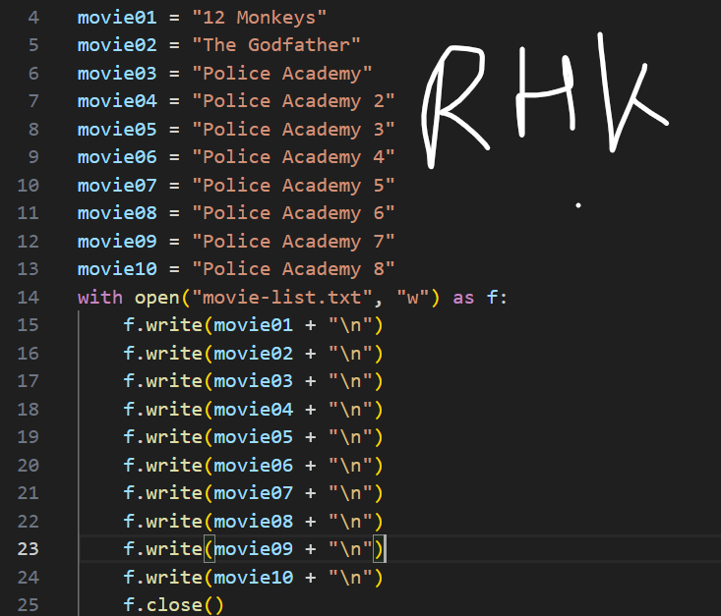 | 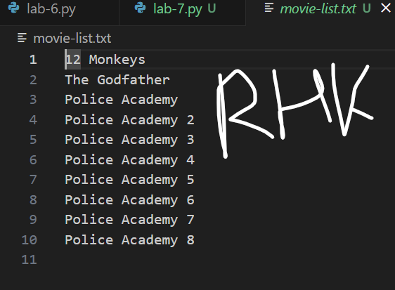
Step 2:
- Create five more variables with five more movie titles that you enjoy allocated to the variables.
- Again, open() the file in write mode and write() your movies to the file and close() it.
Code | File Content
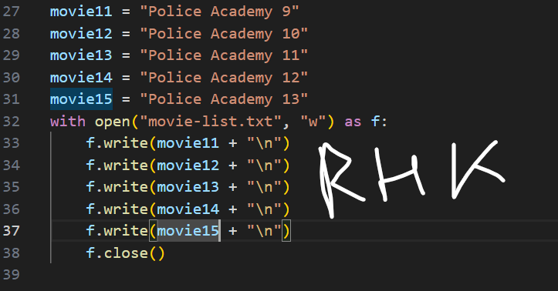 | 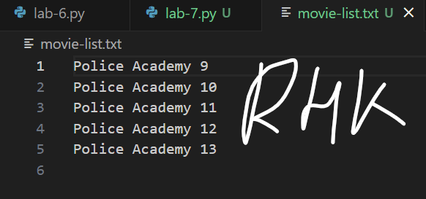
Question | Answer
Examine the file in your operating system.  - What happened to the file? What is now inside it? |  | The old content replaced with the new content
- Conclusion: What does the write function do? |  | Write function is writing the specified content in the file
Step 3
- Create five more variables with movie titles to use
- Use open() to open the file in append mode and write() the data to it, close() it afterwards.
Code | File Content
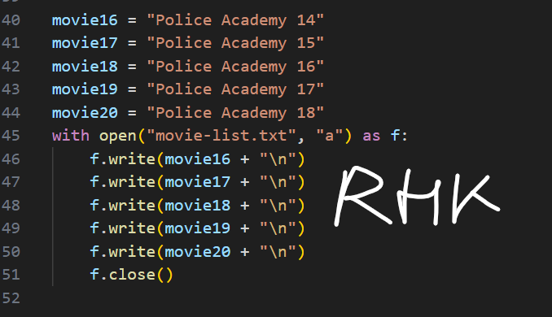 | 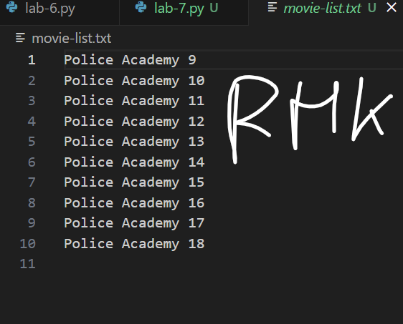
Question | Answer
Examine the file in your operating system.  - What happened to the file? What is now inside it? |  | Now the code appended the new content to the existing content
- What is the difference between write and append when using open()? |  | Write overwrites the existing content and append adds the new content without overwriting it
- If you do not parse any mode (write, append, read etc) to the open() function, what mode does it use by default? |  | read
Step 4
- Lastly, try to open() your text file in read mode but do not close() it yet.
- In your operating system, try to delete the file Python currently has open. What happens?
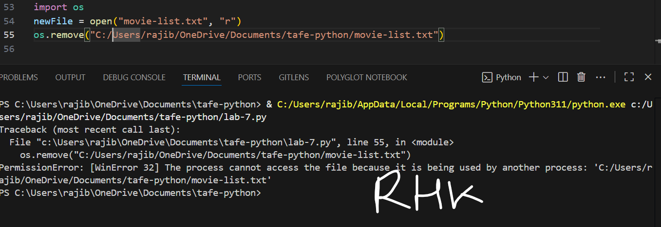

Section 3: A practical example on a server
This section of the lab is optional, it is not required to be marked as satisfactory for this assessment.
The process of working with (opening, writing, and closing files) can vary depending on the operating system you are working with. This section will ask you to demonstrate writing a script that will run and work on a Linux server system.
The system used as a demonstration in this example is Rocky Linux 9 minimal. You can obtain this VM from BlackBoard or build your own.

Screen shots are provided as an example of what you should see, ensure you provide your own signed screen shots to demonstrate that you have completed this section in full.
- Start the VM.
- Log in with:
  - Username user
  - Password Password1
- Verify your virtual machine has internet connectivity by using the command curl http://example.com. If this command was successful, you should see the html code used to build the example.com web site.
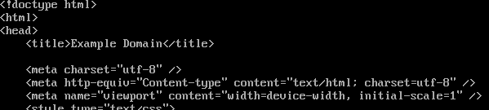

- Install Python and nano using the command sudo dnf install nano python3 (they may already be installed depending on your circumstances).
- Determine which version of Python you have installed by using the command python -V.
- Figure out where the Python interpreter is located on the file system by using the command which python.
- Open a new file (example.py) by using the command nano example.py.
- Write a script to show the first 10 characters in any file you parse to it using command line arguments:
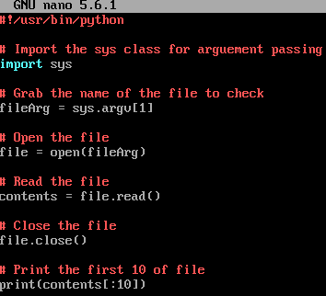
Note, the first line in any bash (Linux interpreter) script is known as the shebang and must provide the path to the Python interpreter as found in an earlier step. This tells the Linux bash know which interpreter it should run the script though.
- Save and close with Control + X.
- When done, make the script executable with the command chmod +x /example.py.
- Run the script several times providing any file as an argument (example files may be found in /etc/).
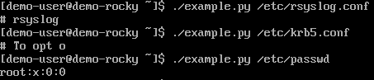

Section 4: A challenge
Complete the following challenge by creating code and demonstrating its functionality.
You are required to create a script on any operating system (Linux/Windows etc) that can
- open a file and
- count all occurrences of a select letter and
- check if a certain word occurs in the file.
- Print the results to the screen
- The script must then save those results to a file named results.
Your script must ask the user for the following information:
- The name of a file to open.
  - If the file cannot be found, then keep prompting until a valid file name is entered
- Which letter to count the occurrences of, in the file
  - If a single letter of the alphabet is not entered, then keep prompting until entered
- A string used to check for the existence of in the file.
Task:
- Write pseudocode to demonstrate how your script will function.
- Once your pseudocode has been created, complete your solution by translating your pseudocode into Python code.
Note: To be marked as satisfactory for this task, your solution must:
- Produce and submit your pseudocode.
- Demonstrate through screen shots, that your solution addresses all the above points.
- You must submit the code file with this document
- The code file must contain comprehensive commenting
- The output must be formatted as shown below
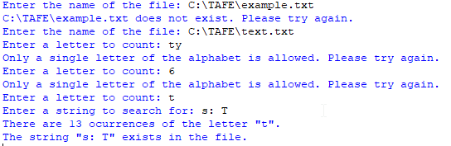

Pseudocode:
- 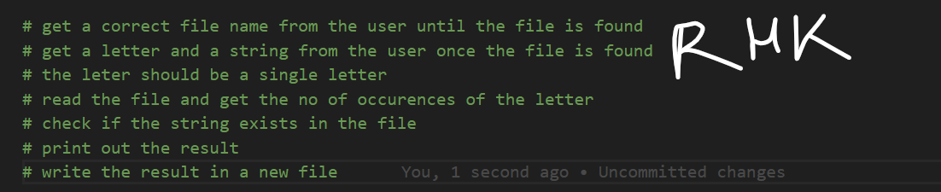

Python Code
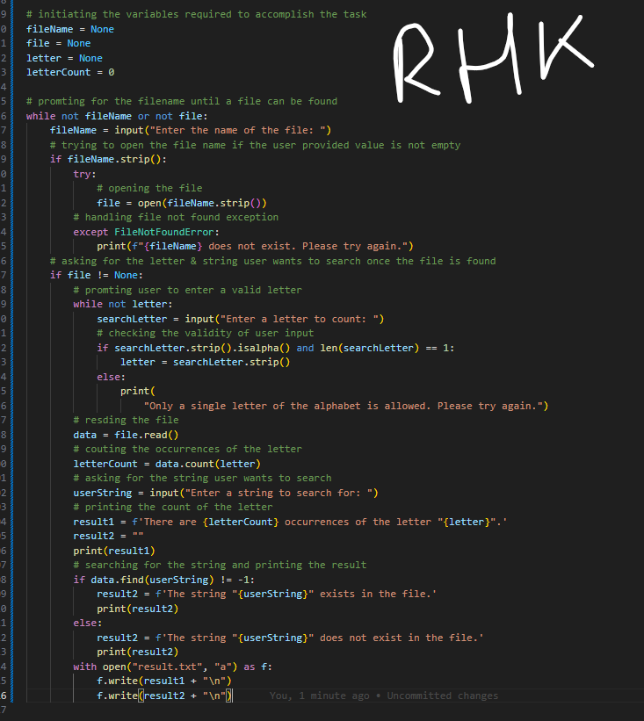

Program screenshots showing all possible outcomes.
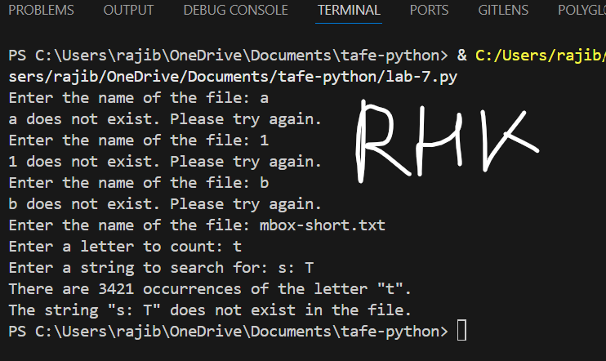
Screenshots of:
- Input file and
- Result file output
