Assessment type ():
☐ Questioning (Oral/Written)
☐ Practical Demonstration
☐ 3rd Party Report
☒ Other – Lab

Assessment Resources:
The base requirements this assessment task include:
- IDE or editor for developing Python programs (only IDLE and PyCharm supported by the college)
- Access to Office 365 & Microsoft Word
- Virtual machine
You may not need all these for every part in this assessment

Assessment Due :
This assessment is due after the weekly session, Week 8, Friday 17:00.

Assessment Instructions:
- Your code must be written in IDLE or PyCharm IDEs. If you are using a different IDEs or a different structure for your application, then assistance from your lecturers may be limited (at best).
Discuss with your lecturer before straying too far off the path!
- All resources used should be referenced with the question. Answers may not be copied and pasted from any resource. All answers must be reworded to display your understanding.
- You may only use Python functionality, methods and libraries which were taught in this unit.
- First line of code in a program should have the student’s name and number, as proof of authenticity.
- Screenshots of all programs must be included in this document, with the appropriate question.
- Screenshots of testing, showing your code works as intended, should be included with the relevant question.
- Python programs should be named: XXX_Lab##_SYY_QZZ
Replace XXX with your initials
Replace ## with Lab number
Replace YY with Section number,
Replace ZZ with Question number
- It is a submission requirement that all screen shots be signed in some way. Some acceptable examples of signed screen shots are shown below.
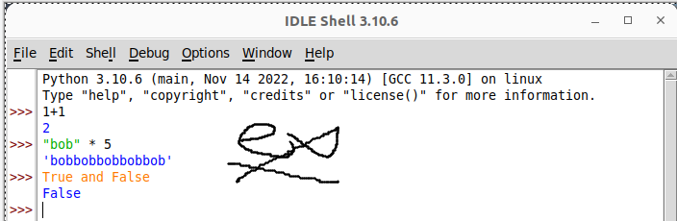
Example 1: Signed using a simple drawing tool.
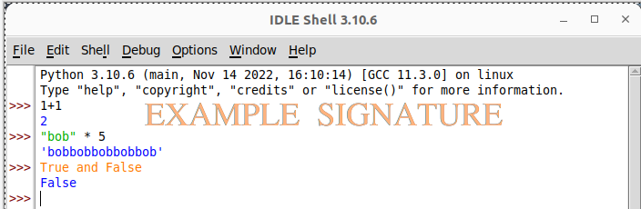
Example 2: Water marked signature.
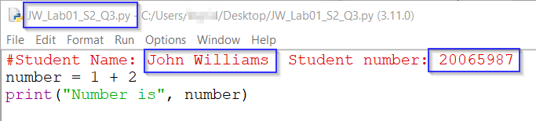
Example 3: Program named as prescribed, as well as first line comment with student name and number. Program saved as pre-described.
- All python programs must be included in the submission, as well as this document.

Assessment Instrument:

Section 1: Working with lists
Lists are a sequence of values (like strings). Unlike strings, lists can be comprised of more than one type of variable. Run the following exercises in the Python shell/interpreter.
- Create the list in the image and assign the four assorted colours into the list
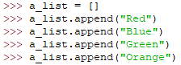
- What is the index value of Blue?
Screenshot:
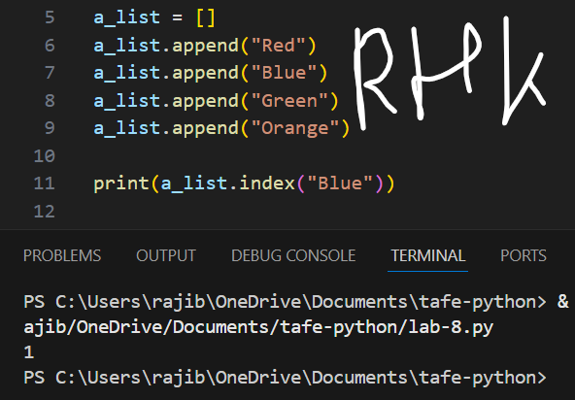
- Add the values Purple and Cyan to the list.
Print the list to demonstrate, Purple and Cyan were added to the list
Screenshot:
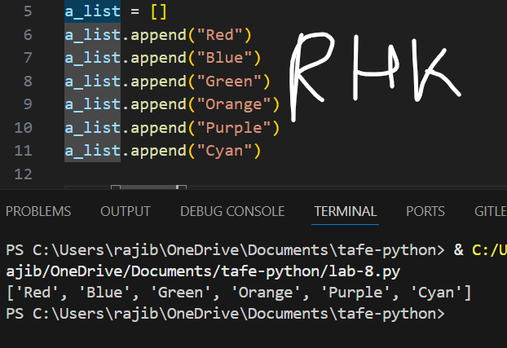
- Remove the value Blue from the list.
Print the list to demonstrate, Blue was removed from the list
Screenshot:
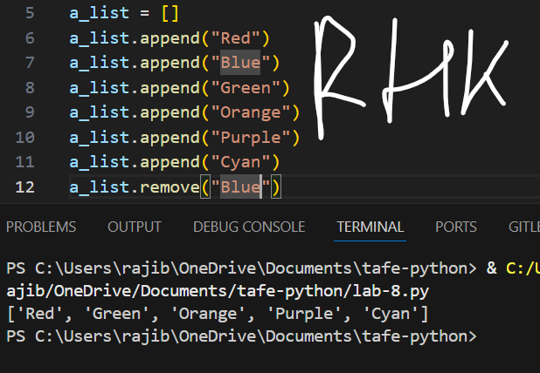
- Sort the list and print it to demonstrate the sorting worked.
Screenshot:
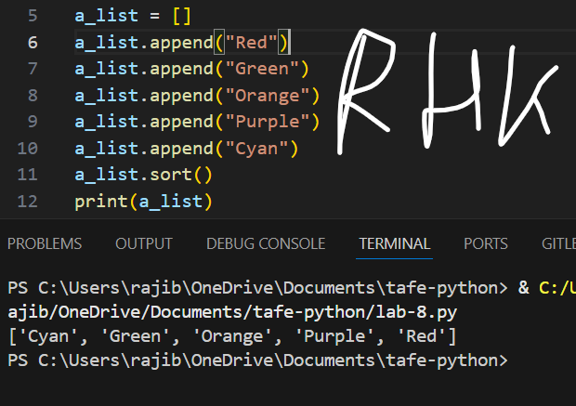
- Insert the value Yellow into index position 1 and print it back to demonstrate the value is in the correct position.
Screenshot:
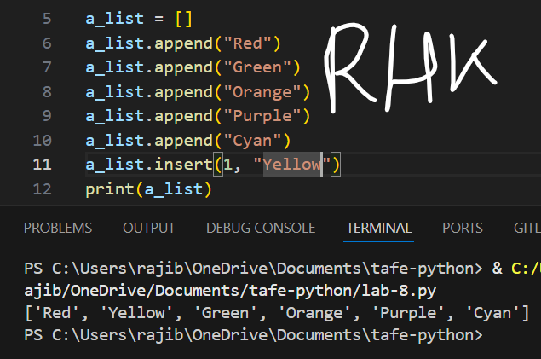
- Lastly, demonstrate how to create a new list from a string by entering the following code:
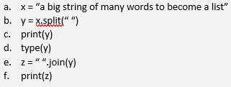
Screenshot:
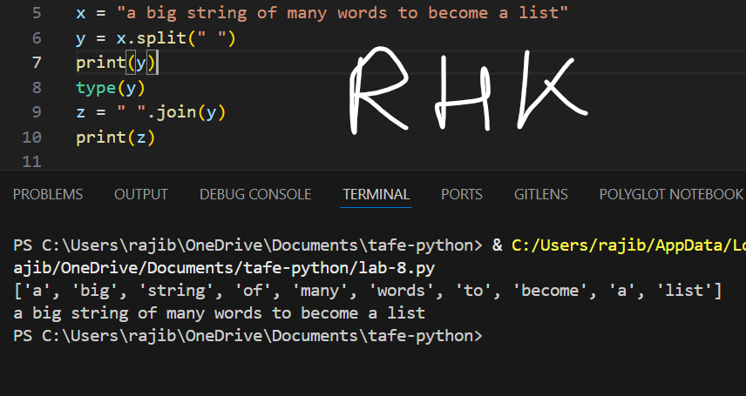

Section 2: Slicing and using functions on a list
Complete the following tasks using the interpreter.
- Create a new list called num and add the integers 1, 50, 23, 77, 12, 23, 57, 2 and 7.
- Print only the first value in the list.
Screenshot
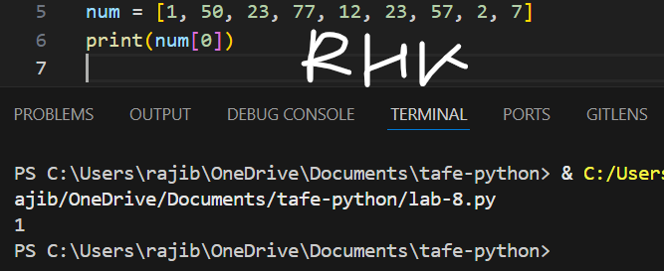
- Print the maximum value in the list using a list method.
Screenshot
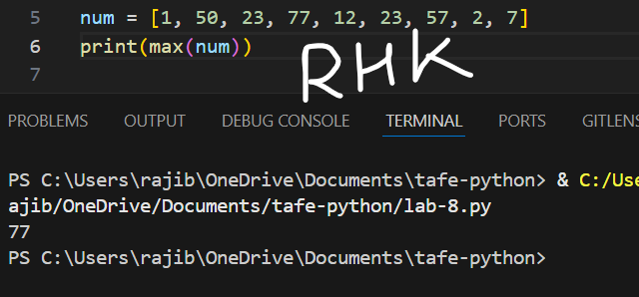
- Print the minimum value in the list using a list method.
Screenshot
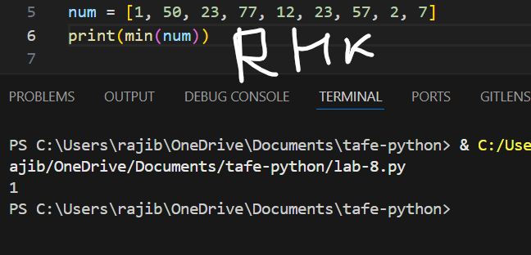
- Print .
Screenshot
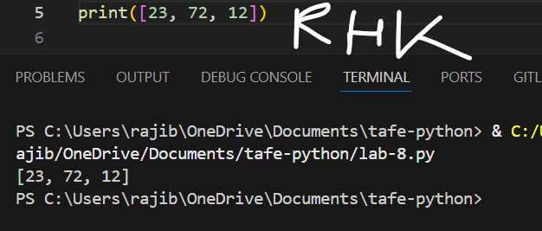

Section 3: Working with a list
Complete the following tasks using the interpreter.
- In the Python interpreter, create a new list with at least seven movies.
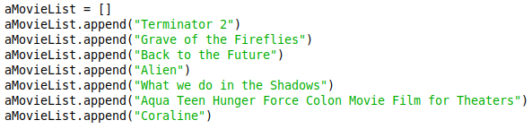
- Print the list back.
Screenshot
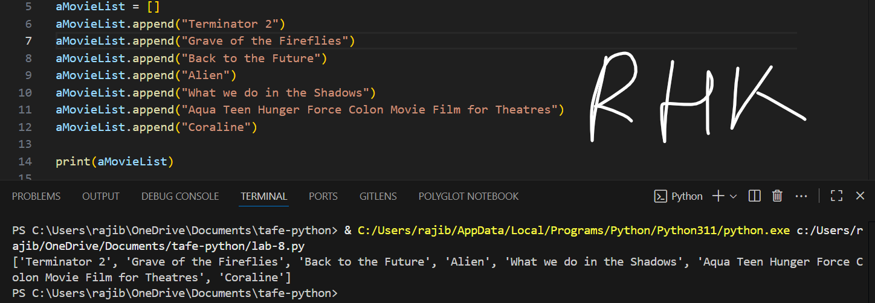

- Use a loop to collect input from the user to add seven more movies to the list.
- Print the complete list back.
Screenshot
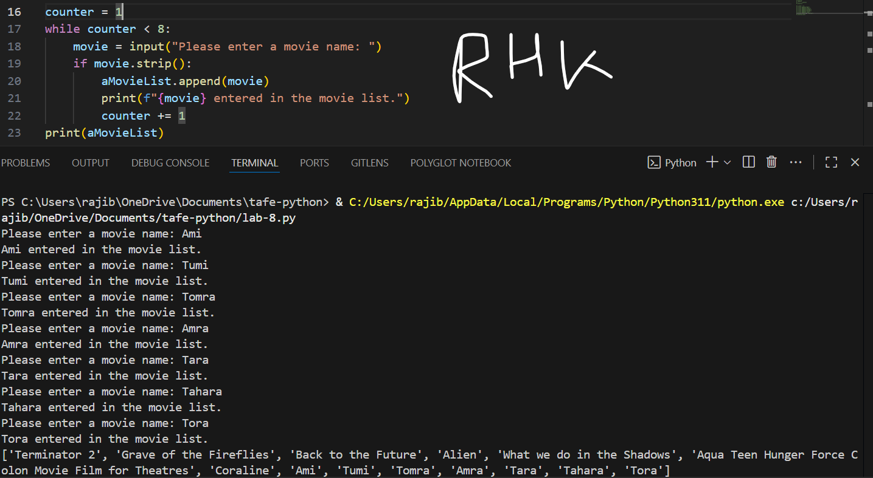

- Remove a movie from the list using the input function to ask the user which movie to remove.
- Print the complete list back.
Screenshot
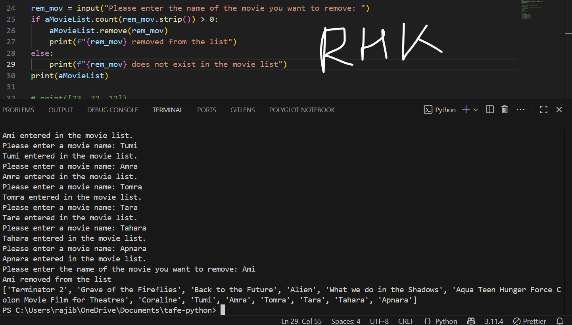

- Use the input function to ask the user for a movie. Give a message to the user, indicating if the movie exists in the list or not. Show both possible outcomes.

Screenshot
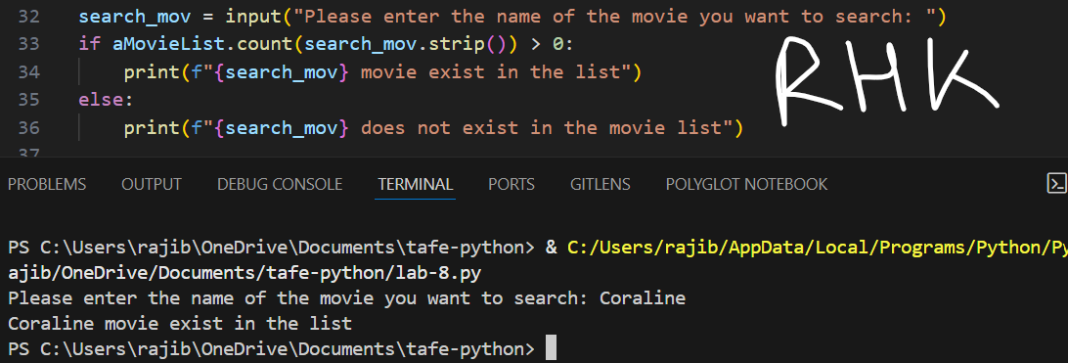
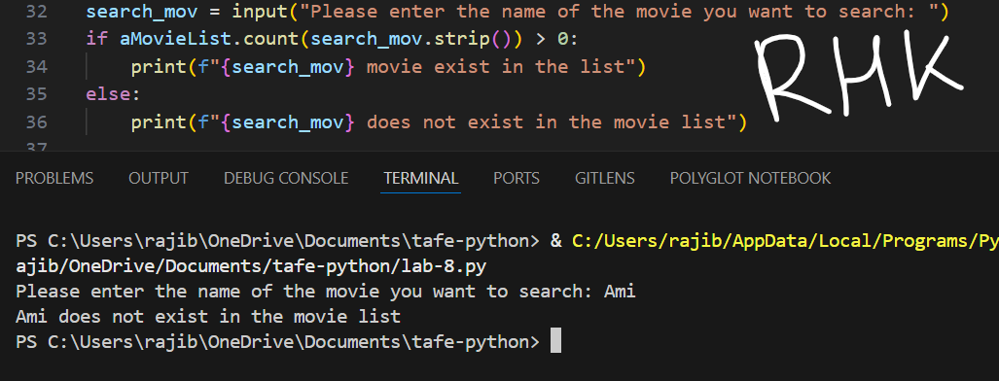

- Open a new file in write mode and save the movie list to a file.
- Show the file contains the movies within your operating system.
Code Screenshot | File Screenshot
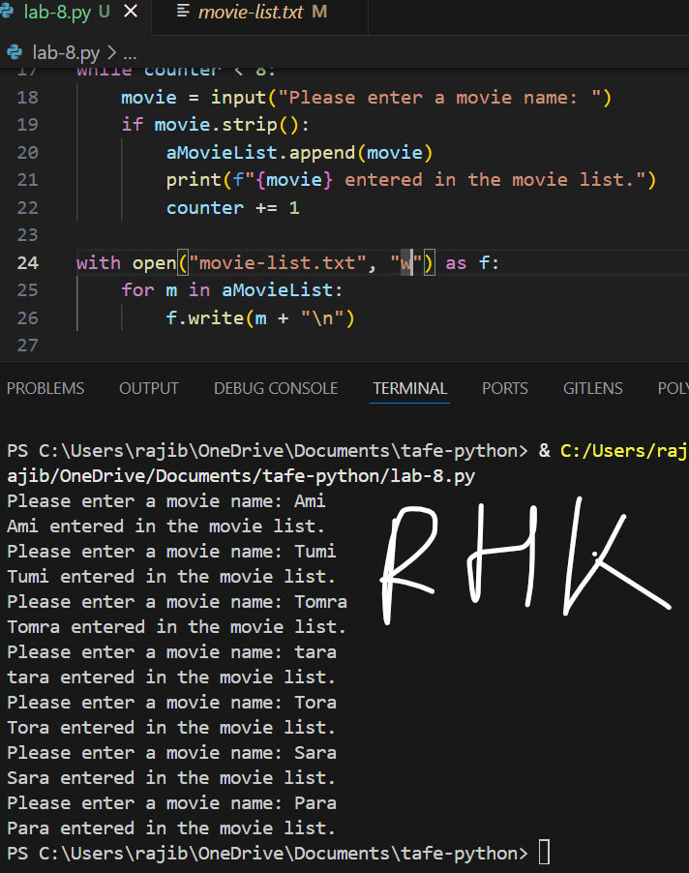 | 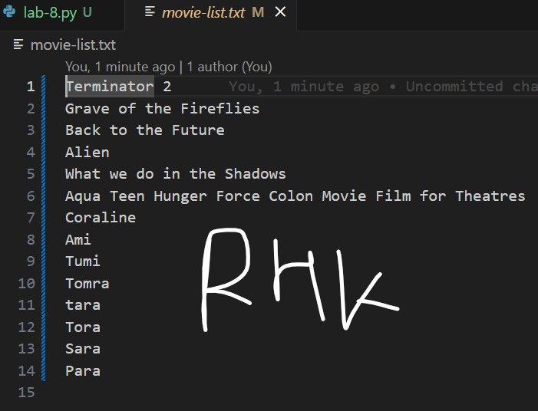

Section 4: Tuples
Tuples are sometimes used in place of lists. Answer the following questions and complete the following tasks in the interpreter.
- What makes a Tuple different from a list?
Tuple is unchangeable & written in round brackets
- What is an advantage to using a Tuple over a list?
Python can optimize memory allocation for tuples because they are immutable, which could result in somewhat faster iteration and access times than lists, particularly when working with huge datasets.
- Create a Tuple with five of your favourite songs and print it back.
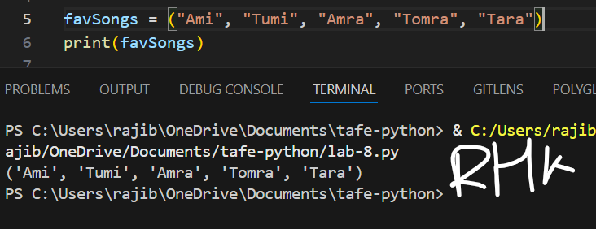
- Use a loop to display all the items in the tuple.
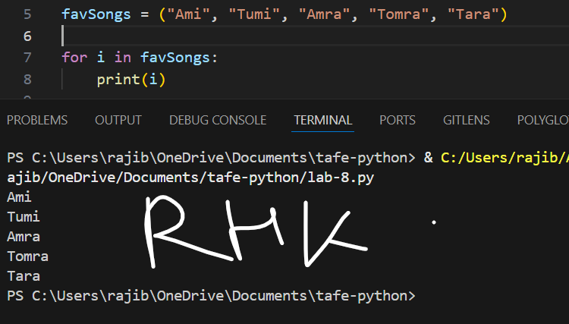
- Can Tuple items be updated, changed, or deleted?
No

Section 5: A challenge
Complete the following challenge by creating code and demonstrating its functionality.
You are required to create a small script that will create a list of friend's names from a user’s input. The script must do the following:
- Use a menu system.
- Run under an endless loop until the user decides to quit.
- Allow the user to add friends to their list.
- Allow the user to print back the list of friends.
- Allow the user to delete a friend from the list.
- The script must account for all situations by gracefully handling invalid input from the user (blank spaces or wrong case input for menu selection for example).
- A friend’s name must be:
  - A single name
  - Made up of letters from the alphabet
  - Be capitalised – that is the first letter must be uppercase, and the remaining letters must be lowercase

A demo screen shot of a functioning solution is provided here.
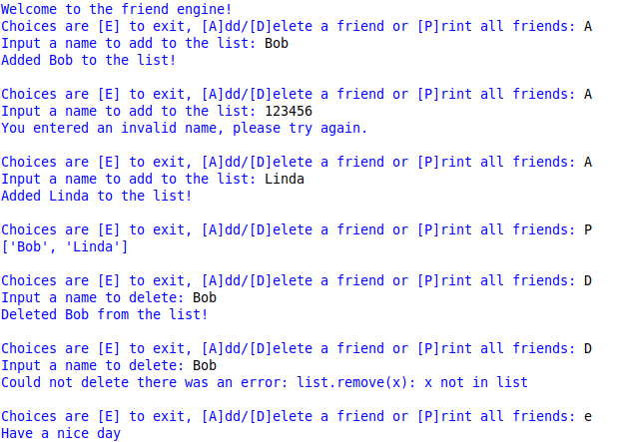
Note: The output “Could not delete there was an error:” must show the actual error thrown. The command
print(‘Could not delete there was an error: list.remove(x): x not in list’)
is not the correct way to do this.

You must use the start code file on BlackBoard.

Note: To be marked as satisfactory for this task, your solution must:
- To demonstrate your ability to control output, your final out put must be formatted the same way as the example screen shot.
- Contain adequate internal commenting to be read and understood by a third party.
- Demonstrate through screen shots, that your solution addresses all the above points.
- You must submit the code file with this document.
Code:
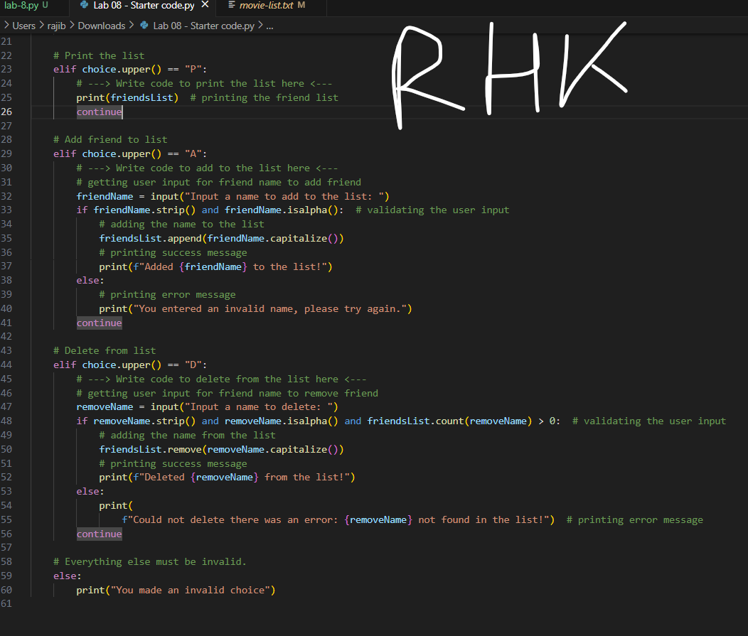
Program output:
