Assessment type ():
☐ Questioning (Oral/Written)
☐ Practical Demonstration
☐ 3rd Party Report
☒ Other – Project/Portfolio (Part of assessment task 1)
Assessment Resources:
- PC
- Google
- Computer components PowerPoint

Assessment Instructions:
Instructions to the assessor:
This lab is a part of Assessment Task 1 portfolio, it is a practical lab based on the performance criteria requirements of the unit. Each student should be given a copy of this lab to complete either in class or out of class. As the student completes each section of this lab you should verify, check off and sign off the section (Use this document as the observation checklist). Use the assessor section at the bottom to provide feedback to the student if required.
See the instructions to the student section for the remainder of the instructions.

Instructions to the student:
This lab consists of short answer questions where you will be asked to research and answer questions relating to cyber security. You are encouraged to use the documentation in the resource section to help you work on the requirements.
Time:
Roughly 30mins

Due date:
This lab is part of assessment 1 and inherits its due date.

Submission instructions:
When the lab is complete, submit the assessment via Blackboard.

Reasonable adjustment:
Should there be difficulty with reading technical manuals relating to disability of language and literacy levels you are encouraged to use online video tutorials similar to the following:
- https://www.youtube.com/watch?v=HBP8_LqBj44
The lab can be delivered in combination with support software like “Cortana” to help verbalise the tasks. Tasks may also be re-phrased by the assessor if required. If there are issues with resources (e.g. Blackboard/Routers) the lab can be modified to suit assuming it does not compromise its original intent.

- Online Identity


  - Why is online identity protection important?

Because it helps secure personal information—like names, addresses, and financial information—from cybercriminals who might use it for fraud, identity theft, or illegal transactions, online identity protection is essential. Identity protection lowers the chance of monetary loss, harm to your reputation, and psychological distress. Additionally, it guards against online account abuse and helps preserve privacy. In an increasingly interconnected world, robust identity protection guarantees safety and trust when interacting on digital platforms.

1.2 What are some common threats to online identity?

Phishing scams that deceive users into disclosing personal information, malware that steals login credentials, and data breaches that expose sensitive information are common risks to online identity. While identity theft is criminals exploiting stolen information for fraudulent purposes, social engineering coerces people into disclosing private information. Vulnerability is further increased by weak passwords and unprotected networks, which facilitate hackers' capacity to obtain personal accounts and identity-related data without authorization.

1.3 How can you protect your online identity?

By creating strong, one-of-a-kind passwords and turning multi-factor authentication on for all accounts, we can safeguard our online identities. Malware and phishing assaults can be avoided by avoiding dubious links, confirming the legitimacy of websites, and routinely updating software. Security can also be improved by restricting the sharing of personal information on social media, using secure Wi-Fi connections, and running trustworthy antivirus software. Additional protection against identity theft and illegal access is provided by routinely checking accounts for odd activity.

1.4 What happens if your online identity is stolen?

Cybercriminals may use your personal information to open bank accounts, make unlawful transactions, or apply for loans in your name if your online identity is stolen. Financial loss, lowered credit scores, and legal issues may arise from this. Additionally, you can experience emotional discomfort and have to invest a lot of time in rectifying fraudulent activity. Additionally, if your identity is utilized improperly for dangerous or unlawful online activities, your reputation may suffer.

- Personal Data
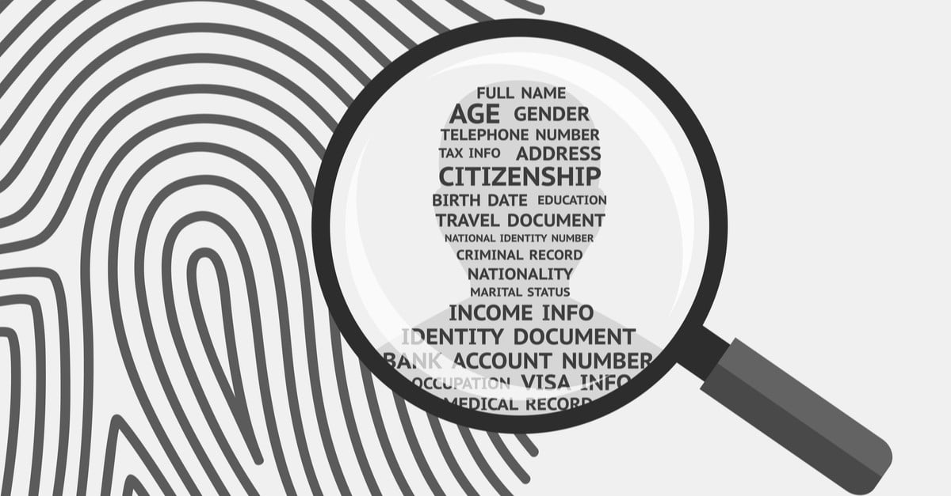

  - What is the purpose of protecting personal data?

Ensuring privacy, preventing unwanted access, and safeguarding people from fraud, identity theft, and information misuse are the goals of preserving personal data. People can have control over how their information is used and shared by protecting their personal data. Additionally, it promotes legal adherence to data protection laws, fosters confidence in digital services, and guards against the financial, psychological, and reputational loss that might result from data breaches or malicious exploitation.
  - Why is personal data considered sensitive information?

Because it discloses important information about a person's identity, including name, address, financial records, and health information, personal data is regarded as sensitive. This information may be used for discrimination, fraud, or identity theft if it is obtained by unauthorized people. A person's security, privacy, and reputation can all be negatively impacted by sensitive information. Thus, safeguarding personal information is crucial to avoiding abuse, defending individual liberties, and preserving confidence in online communications.
  - What are the consequences of not protecting personal data?

Identity theft, financial fraud, and illegal account access can result from a failure to protect personal data. People may experience monetary losses, tarnished credit ratings, and legal problems. They might experience mental anguish if their privacy and reputation are jeopardized. Data breaches can result in fines, a decline in consumer confidence, and harm to an organization's brand. In the end, ignoring data privacy puts people and companies at serious danger and has long-term repercussions.
  - How can personal data be protected?

Strong passwords, multi-factor authentication, and frequent software updates to address security flaws can all help protect personal information. Unauthorized access can be avoided by avoiding dubious connections, encrypting private information, and utilizing secure networks. Security can be improved by frequently backing up data and limiting the amount of personal information shared online. Additionally, the danger of data misuse is decreased by being careful about what information is posted and adhering to social media privacy settings.
  - Why is it important to regularly update data protection measures?

Because cyber dangers are always changing and out-of-date security systems can be subject to new attacks, it's critical to update data protection measures on a regular basis. Updates aid in improving encryption, addressing security vulnerabilities, and bolstering general security. People and businesses may better avoid identity theft, cyberattacks, and data breaches by keeping up with the most recent tools and procedures. Frequent updates preserve confidence in digital security and guarantee ongoing adherence to regulatory obligations.

- Protecting an organisation’s data
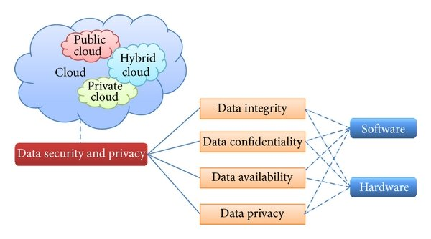

  - What is the importance of protecting an organization's data?
Maintaining consumer trust, preventing financial loss, and protecting sensitive information all depend on an organization's data being protected. Robust data protection lowers the risk of business disruptions, fines, and cyberattacks. It maintains the company's competitive edge in the market, supports regulatory compliance, and guarantees business continuity.

  - Why is it necessary to secure an organization's data?
To preserve sensitive data, uphold client confidence, and guarantee regulatory compliance, a firm must secure its data. It protects the company's reputation, continuity, and competitive edge in a digital world by preventing monetary loss, intellectual property theft, and operational disruptions brought on by cyberattacks or data breaches.

  - What are the consequences of not protecting an organization's data?
Financial losses, fines, and non-compliance with regulations can result from an organization's failure to protect its data. It raises the possibility of business disruptions, data breaches, and intellectual property theft. It also undermines customer trust, harms reputation, and can lead to long-term strategic and competitive failures.

  - How can an organization protect its data?
By putting in place strict access controls, encrypting private data, upgrading software often, and carrying out security audits, a business may safeguard its data. Additionally crucial are employee training, safe backup options, and suspicious activity monitoring. Organizational information is completely protected when data protection rules and legal requirements are followed.

  - Why is it important to regularly review and update an organization's data protection measures?
To ensure defences against changing cyberthreats and vulnerabilities, data protection methods should be reviewed and updated on a regular basis. It lowers the chance of data breaches, protects sensitive data, and aids in maintaining regulatory compliance. In a hostile and more digital world, continuous improvement guarantees business continuity, preserves reputation, and fortifies organizational resilience.

- Cyber security awareness
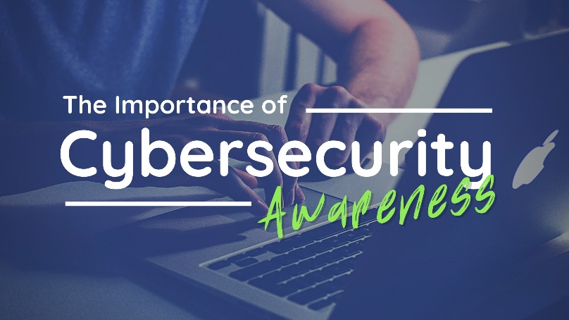
  - What is the purpose of cyber security awareness in an organization?
In a company, cybersecurity awareness informs staff members on security policies, safe practices, and possible risks. Its goals are to increase the entire security posture, avoid data breaches, and lessen human error. As the first line of defence, knowledgeable employees safeguard confidential data and make sure the company is resilient to cyberattacks.

  - Why is it important for employees to be aware of cyber security?
Because human mistake frequently results in data breaches, employee understanding of cybersecurity is essential. Knowledgeable staff members can protect sensitive data, adhere to security procedures, and identify phishing, malware, and other dangers. This knowledge lowers risks, protects company resources, guarantees adherence, and fortifies the organization's security culture as a whole.

  - What are some best practices for promoting cyber security awareness in an organization?
Regular training sessions, simulated phishing exercises, transparent security policies, and easily available guidelines are all examples of best practices for raising awareness of cybersecurity. Employees may stay alert, lower risks, and actively participate in safeguarding the company's data and systems by being encouraged to report suspicious activities, receiving updates on new threats, and cultivating a security-conscious culture.

  - What should an employee do if they suspect a cyber security incident?

Employees should notify the IT or security team right away if they suspect a cybersecurity attack, stay away from dubious emails or systems, and save any supporting documentation. Timely reporting facilitates a quick organizational response to reduce risks and safeguard data, helps contain threats, and stops more harm.

  - Why is it important to regularly review and update an organization's cyber security awareness practices?

Employees are kept up to date on changing threats, new attack methods, and revised policies when cybersecurity awareness procedures are routinely reviewed and updated. It preserves organizational resilience, lowers human error, and strengthens a security-conscious culture. Constant improvement reduces the chance of cyber events, guarantees compliance, and helps safeguard critical data.

- Cyber threats
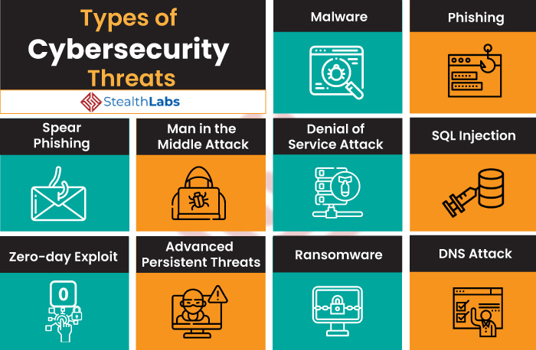

  - What are cyber threats?

Cyber threats are malevolent actions that aim to steal, harm, or interfere with data and operations by targeting computers, networks, or digital systems. They consist of social engineering, ransomware, phishing, malware, and hacking. Organizations and individuals are at danger from cyber threats, which can result in compromised sensitive data, financial loss, and harm to one's reputation.
  - What are some common types of cyber threats?
Malware, ransomware, phishing, spyware, and viruses that corrupt systems or data are examples of common cyberthreats. Social engineering, denial-of-service assaults, and hacking take advantage of flaws in human nature. Risks could include weak passwords and insider threats. Data breaches, monetary losses, business interruptions, and reputational harm are all possible outcomes of these dangers.
  - How can cyber threats affect an individual or an organization?
Identity theft, financial loss, and privacy violations can result from cyber threats that corrupt personal or business data. They could cause operational disruptions, harm to one's reputation, and legal or regulatory repercussions. Long-term repercussions for both people and organizations include diminished trust, a competitive edge, and heightened susceptibility to subsequent attacks.
  - What are some steps that can be taken to protect against cyber threats?
Use multi-factor authentication, create strong passwords, and update software frequently to guard against online attacks. Put firewalls, antivirus software, and data encryption into practice. Educate staff members on security best practices, regularly backup data, and keep an eye out for unusual activity on systems. Risks are further decreased by following incident response strategies and security policies.

  - Why is it important to be aware of and stay updated on cyber threats?
To foresee and protect against changing attacks, it is essential to be informed about and stay abreast of cyberthreats. It makes it possible to put security measures into place on time, lowers the chance of data breaches, safeguards private data, guarantees legal compliance, and increases organizational and human resilience in a world that is becoming more and more digital.

- Cyber Professionals


  - What is the role of a cyber security professional?
By detecting, stopping, and reacting to cyberthreats, a cybersecurity specialist safeguards an organization's digital assets. They put security measures into place, keep an eye on networks, look into incidents, and make sure rules are followed. In order to protect sensitive data and uphold organizational resilience, they also have to set rules, train employees, and continuously enhance defenses.

  - Why are cyber security professionals important?
Professionals in cybersecurity are crucial because they protect an organization's IT infrastructure, sensitive data, and digital assets from online attacks. They stop attacks from causing operational problems, monetary loss, and harm to one's reputation. Their knowledge guarantees adherence to regulations, fortifies security culture, and permits enterprises to function securely in a setting that is becoming more digital and susceptible.
  - What are some of the skills and qualifications required for a career in cyber security?
Network security, ethical hacking, risk assessment, incident response, and threat analysis are all necessary for a job in cybersecurity. It is crucial to be proficient in security tools, encryption, and programming. Degrees in computer science or information technology, cybersecurity certifications, and ongoing education to stay current with emerging risks and technologies are sometimes required.

  - Why is it important for organizations to invest in cyber security professionals?
Organizations must invest in cybersecurity experts to safeguard confidential information, stop cyberattacks, and maintain corporate operations. Competent professionals minimize monetary losses, uphold legal requirements, protect reputations, and improve overall security posture. Organizations can foresee dangers and effectively respond in a changing digital ecosystem thanks to their proactive actions.

