Assessment type ():
☐ Questioning (Oral/Written)
☐ Practical Demonstration
☐ 3rd Party Report
☒ Other – Lab

Assessment Resources:
The base requirements this assessment task include:
- IDE or editor for developing Python programs (only IDLE and PyCharm supported by the college)
- Access to Office 365 & Microsoft Word
- Virtual machine
You may not need all these for every part in this assessment

Assessment Due :
This assessment is due after the weekly session, Week 11, Friday 17:00.

Assessment Instructions:
- Your code must be written in IDLE or PyCharm IDEs. If you are using a different IDEs or a different structure for your application, then assistance from your lecturers may be limited (at best).
Discuss with your lecturer before straying too far off the path!
- All resources used should be referenced with the question. Answers may not be copied and pasted from any resource. All answers must be reworded to display your understanding.
- You may only use Python functionality, methods and libraries which were taught in this unit.
- First line of code in a program should have the student’s name and number, as proof of authenticity.
- Screenshots of all programs must be included in this document, with the appropriate question.
- Screenshots of testing, showing your code works as intended, should be included with the relevant question.
- Python programs should be named: XXX_Lab##_SYY_QZZ
Replace XXX with your initials
Replace ## with Lab number
Replace YY with Section number,
Replace ZZ with Question number
- It is a submission requirement that all screen shots be signed in some way. Some acceptable examples of signed screen shots are shown below.
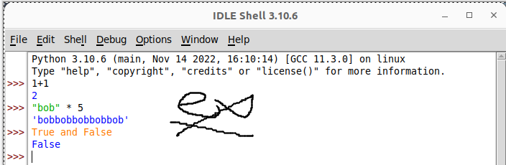
Example 1: Signed using a simple drawing tool.
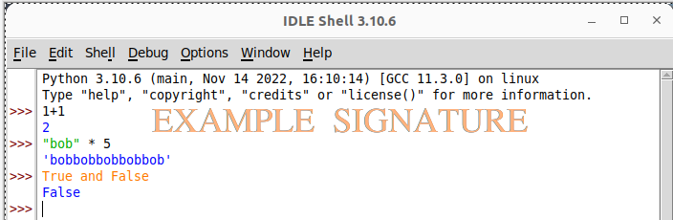
Example 2: Water marked signature.
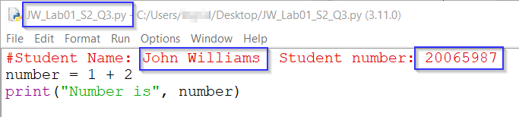
Example 3: Program named as prescribed, as well as first line comment with student name and number. Program saved as pre-described.
- All python programs must be included in the submission, as well as this document.

Assessment Instrument:

Section 1: TCP/IP
Answer the following questions:
- What are the four layers of TCP/IP?
Application Layer, Transport Layer, Internet Layer & Network Access Layer
- Which layer are sockets on?
Transport Layer
- What is the difference between UDP and TCP?
The primary distinction is that UDP is quicker and connectionless, surrendering guarantees for speed, whereas TCP is connection-oriented and dependable, guaranteeing that data arrives in order and without loss.

UDP: Because UDP transmits data packets without a handshake or delivery assurance, it is appropriate for real-time applications where speed is more crucial than precise correctness, such as online gaming, streaming videos, and DNS lookups.
TCP: TCP is appropriate for file transfers, email, and web browsing since it creates a connection before transferring data, employs acknowledgments, and resends missed packets.
- Why does each application communicating on a network require a socket?
Because it serves as a distinct endpoint for creating a two-way communication channel, similar to a phone line, between a particular process on one computer and another on another, a socket is necessary for any application interacting on a network.

Section 2: Connect to a basic web server with urllib
Complete the following example of using sockets to connect to a web server and download the html code available on it.
- Create a new python code file.
- Import urllib.request
- Connect to http://www.example.com and request the contents of the site.
- Display the contents of the site.
Code
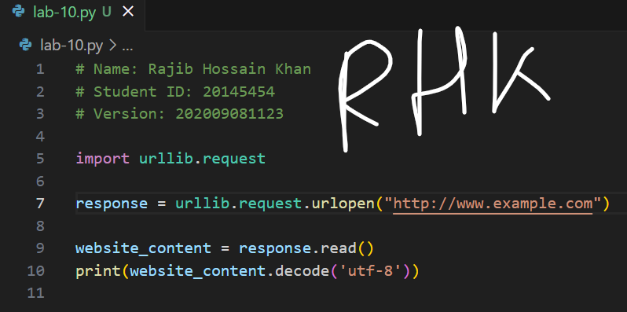

Output

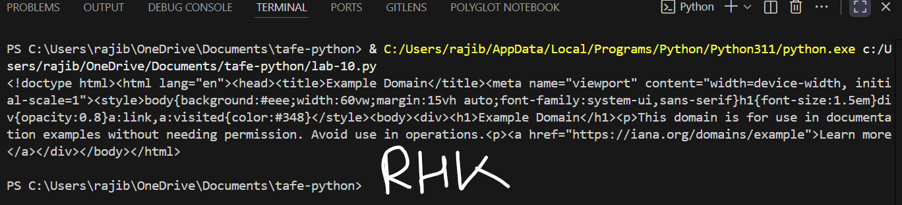

Section 3: Scanning sockets using Python
This section of the lab is optional; it is not required to be marked as satisfactory for this assessment.

There are several useful tools available for scanning and connecting to sockets, begin by working with NMAP. Complete the following using the Rocky Linux VM from previous exercises.
- Power on and log into the Linux VM.
- Ensure your VM has internet connectivity.
- Install the pip package for Python if it is not already installed, use
sudo dnf install python3-pip to install (the pip package facilitates the east installation of additional Python libraries into the system.
- Install nmap using sudo dnf install nmap.
- Install the python nmap library with pip install python-nmap.
- Use nano to write the following nmap-script.py script (replace the IP address 192.168.2.1 with the IP address of a device to scan on your network):
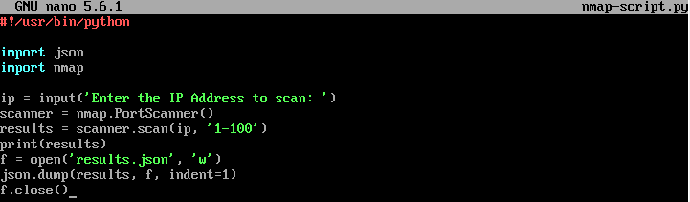
- Make the script executable using chmod +x nmap-script.py.
- Run the script using the command ./nmap-script.py.
- Once completed, the script should output the results to the console, but it should also output the results to a JSON file. Confirm this using ls to find the file and cat results.json to read it.
Screenshot

