Assessment type ():
☐ Questioning (Oral/Written)
☐ Practical Demonstration
☐ 3rd Party Report
☒ Other – Lab

Assessment Resources:
The base requirements this assessment task include:
- IDE or editor for developing Python programs (only IDLE and PyCharm supported by the college)
- Access to Office 365 & Microsoft Word
- Virtual machine
You may not need all these for every part in this assessment

Assessment Due :
This assessment is due after the weekly session, Week 12, Friday 17:00.

Assessment Instructions:
- Your code must be written in IDLE or PyCharm IDEs. If you are using a different IDEs or a different structure for your application, then assistance from your lecturers may be limited (at best).
Discuss with your lecturer before straying too far off the path!
- All resources used should be referenced with the question. Answers may not be copied and pasted from any resource. All answers must be reworded to display your understanding.
- You may only use Python functionality, methods and libraries which were taught in this unit.
- First line of code in a program should have the student’s name and number, as proof of authenticity.
- Screenshots of all programs must be included in this document, with the appropriate question.
- Screenshots of testing, showing your code works as intended, should be included with the relevant question.
- Python programs should be named: XXX_Lab##_SYY_QZZ
Replace XXX with your initials
Replace ## with Lab number
Replace YY with Section number,
Replace ZZ with Question number
- It is a submission requirement that all screen shots be signed in some way. Some acceptable examples of signed screen shots are shown below.
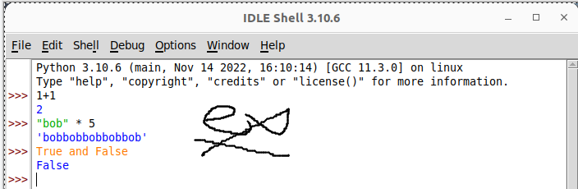
Example 1: Signed using a simple drawing tool.
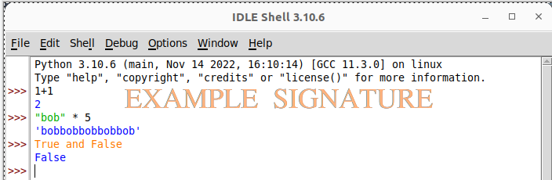
Example 2: Water marked signature.
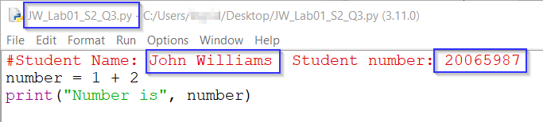
Example 3: Program named as prescribed, as well as first line comment with student name and number. Program saved as pre-described.
- All python programs must be included in the submission, as well as this document.

Assessment Instrument:

Section 1: Example
Try this example of objected oriented programming.
- Put the following code in a new code file, run it and observe the output:
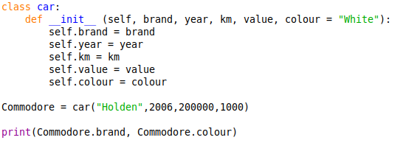
Output
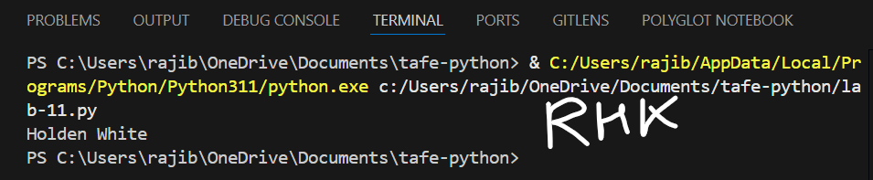

Code
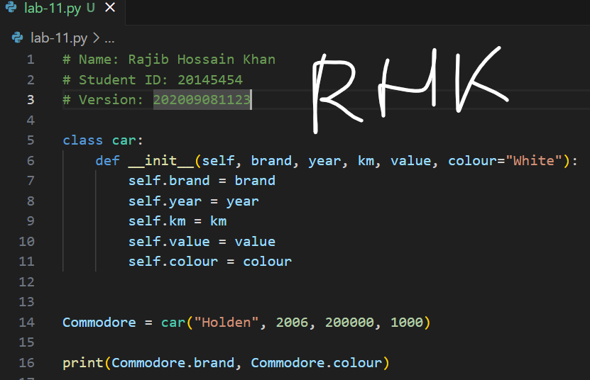

- What is the purpose of the __init__ function?
The __init__ function is a specific method (also known as a constructor) that is automatically invoked upon the creation of an object of a class.
It enables you to set initial values for the attributes of the newly generated object and initializes it. It establishes the state of the object.

- Why was the car “White” when it wasn’t specifically declared as such?
Because a default value was assigned in the __init__ function
- Add the following method code under the __init__ function
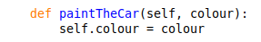
- Remove the print line and add the following code at the bottom of the code file:
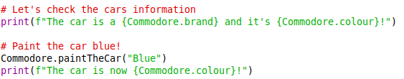
Output
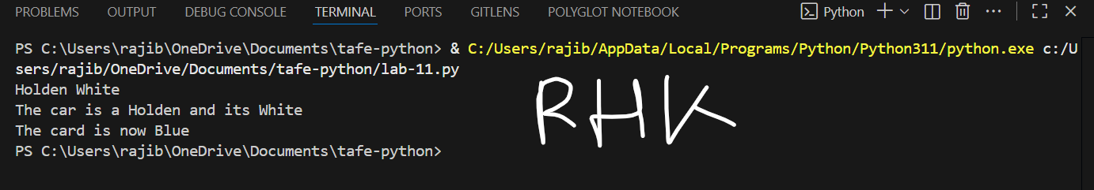
Code
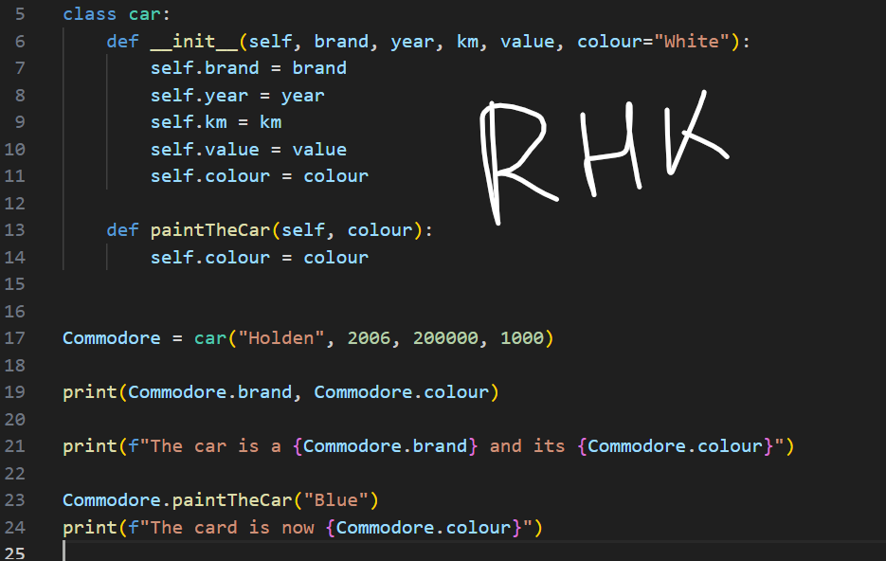

- What is an “f string”?
In Python, an f-string, or formatted string literal, is a readable and practical way to insert variables or expressions straight into string literals.
- Create a second car of your own choosing using the car class (example code provided, you must write your own).
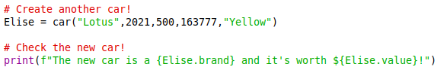
Output
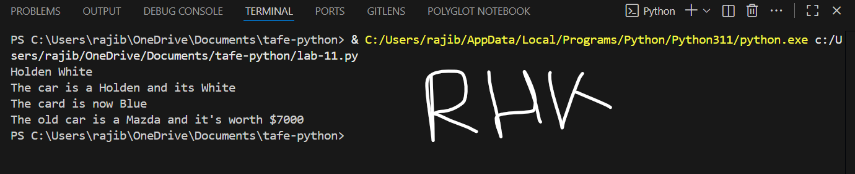

Code
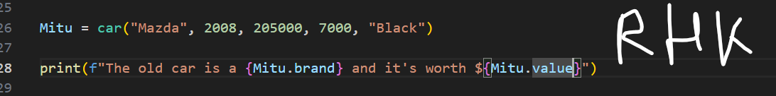
- Create another method for your car class of your own choosing, demonstrate how it works and provide comments in your code to explain it.
Code
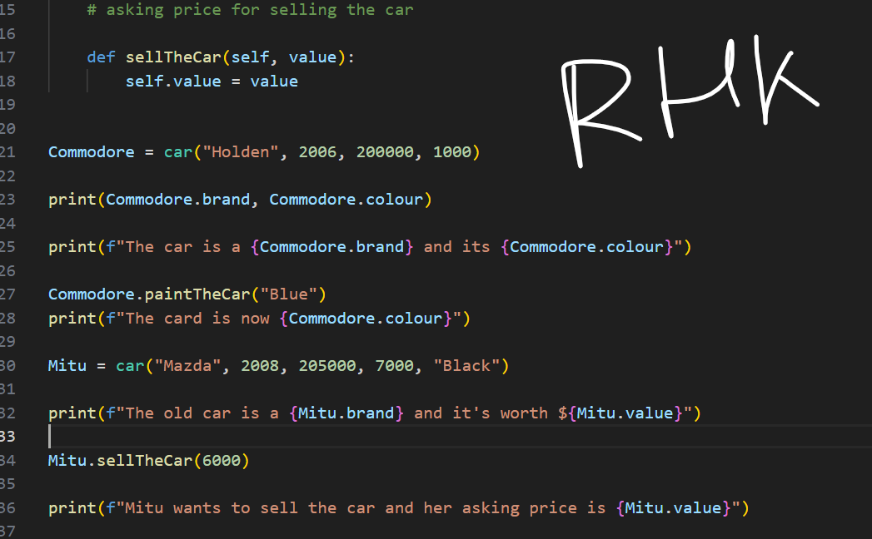
Output
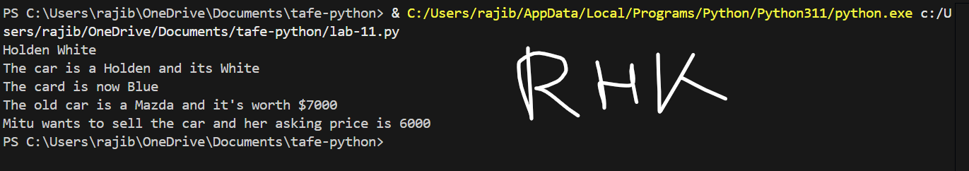

Section 2: Making your own object-oriented code.
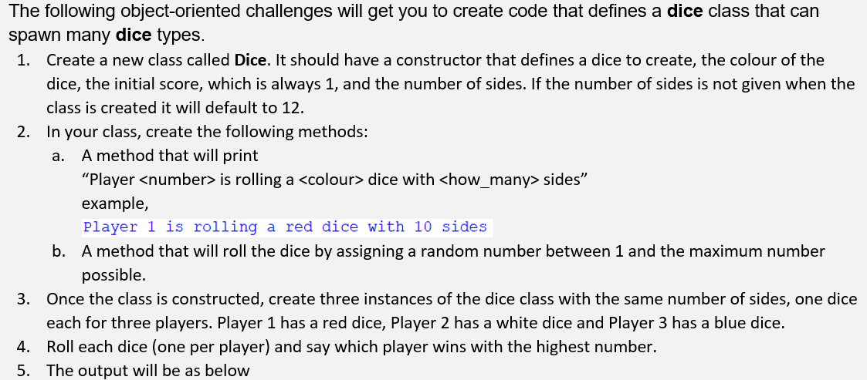
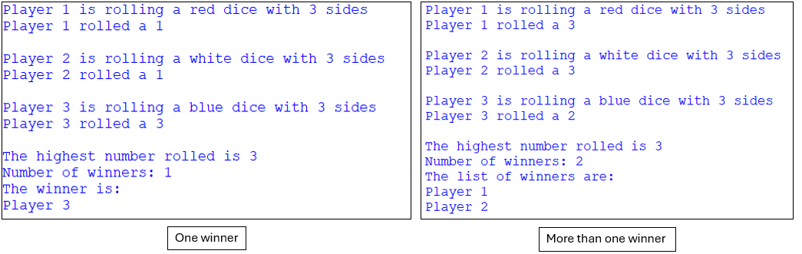
- The pseudocode developed for this program is shown below. Please note that pseudocode describes the logical flow of the solution. It does not describe exactly how to code it.
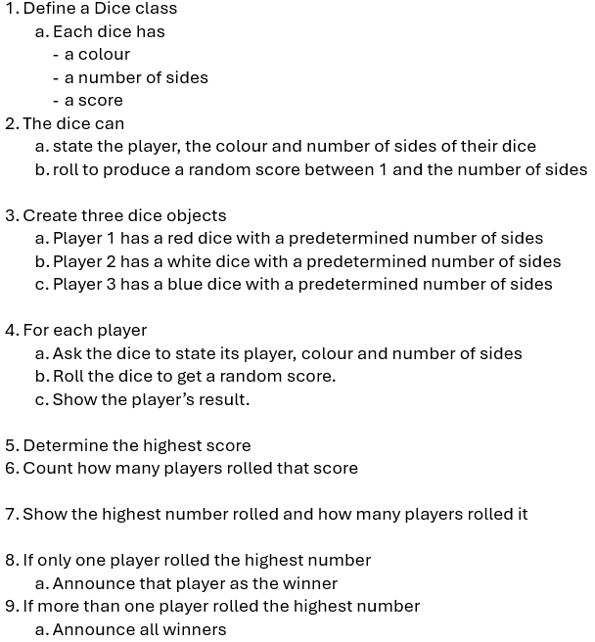
Code
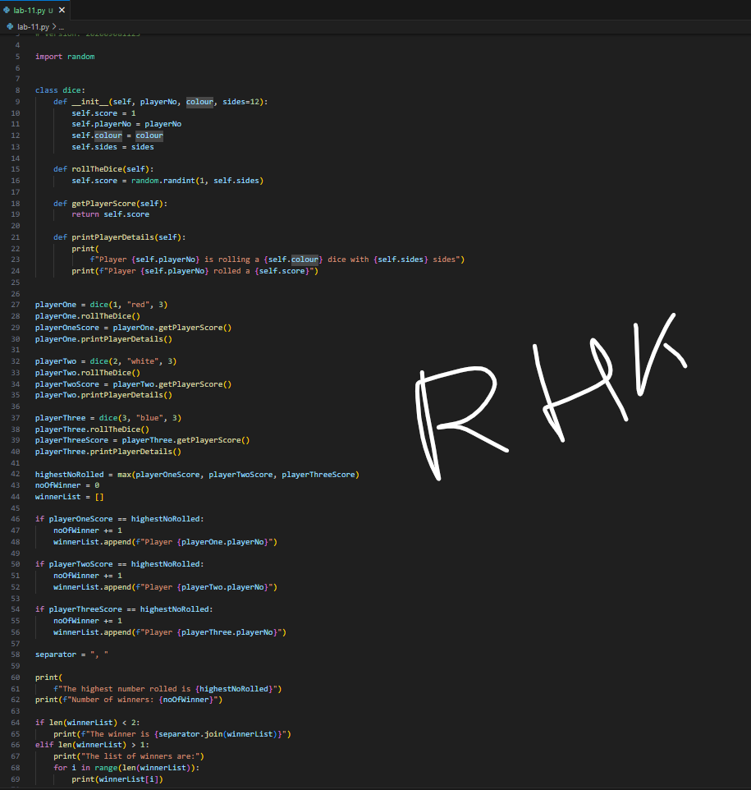
Output
