Assessment type (þ):
☐ Questioning (Oral/Written)
☐ Practical Demonstration
☐ 3rd Party Report
☒ Other – Project/Portfolio (Part of assessment task 2)
Assessment Resources:
- PC
- Google
- Cisco Packet Tracer

Assessment Instructions:
Instructions to the assessor:
This lab is a part of Assessment Task 2 portfolio, it is a practical lab based on the performance criteria requirements of the unit. Each student should be given a copy of this lab to complete either in class or out of class. As the student completes each section of this lab you should verify, check off and sign off the section (Use this document as the observation checklist). Use the assessor section at the bottom to provide feedback to the student if required.
See the instructions to the student section for the remainder of the instructions.

Instructions to the student:
This lab consists of activities that you perform on the hardware and software nominated concerning preventative maintenance and base level troubleshooting procedures.
There are several short answer questions where you will be asked to research and answer questions relating to these topics. You are encouraged to use the documentation in the resource section to help you work on the requirements.

Time:
Nominally 180 mins

Due date:
This lab is part of assessment 2 and inherits its due date.

Submission instructions:
When the lab is complete, submit the assessment via Blackboard.

Reasonable adjustment:
Should there be difficulty with reading technical manuals relating to disability of language and literacy levels you are encouraged to use online video tutorials similar to the following:
- https://www.youtube.com/watch?v=HBP8_LqBj44

Your Student ID:  20145454 | Your Name: Rajib Hossain Khan

Lab: Configuring and Troubleshooting Wired and Wireless Networks

Learning Objectives

By the end of this lab, students will be able to:
- Configure IP addresses on end devices.
- Configure and Test Wired LAN Connectivity

Network Setup

Step 1: Physical Connections
- PCs to Switches:
  - PC1 & PC2 → SW1 (192.168.1.0/24)
  - PC3 & PC4 → SW2 (10.0.0.0/8)
- Switches to Routers:
  - SW1 → Router1 (GigabitEthernet 0/0/0)
  - SW2 → Router2 (GigabitEthernet 0/0/0)
- Router-to-Router Connection:
  - Router1 (GigabitEthernet 0/0/1) ↔ Router2 (GigabitEthernet 0/0/1)
  - Assign the network: 192.168.2.0/30
Screenshot of Network Topology:

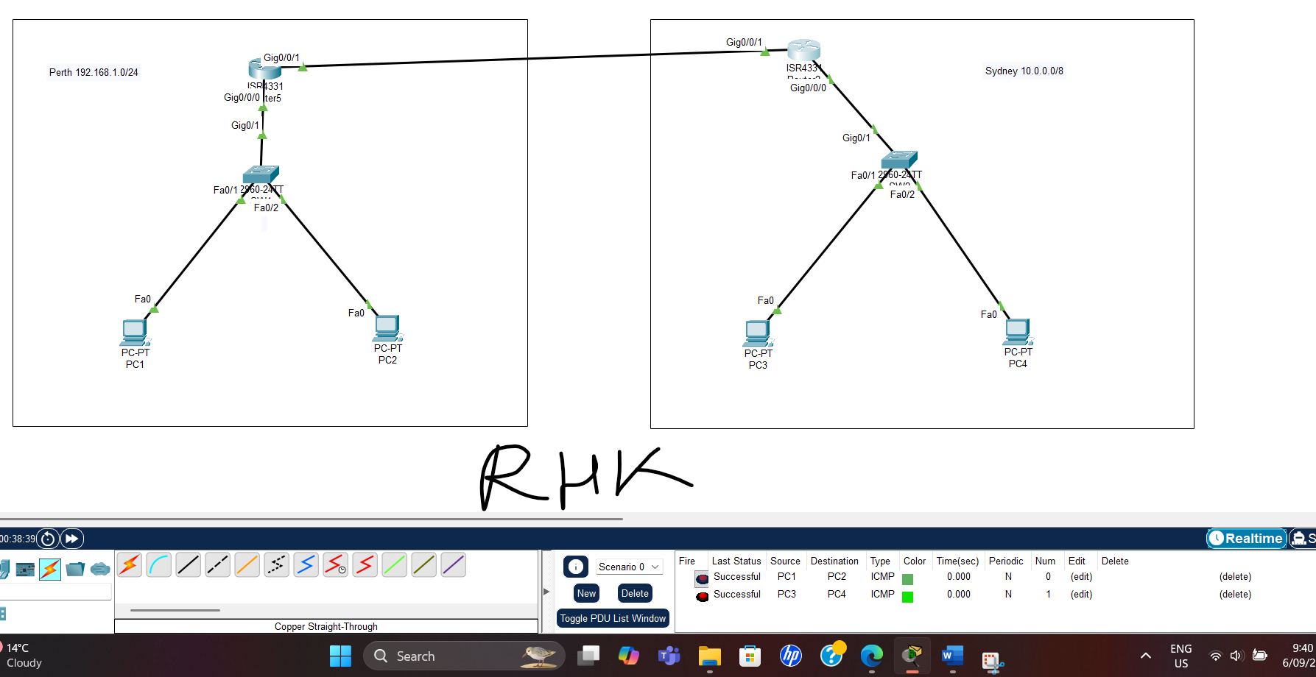

Step 2: Router Configurations

Router1 (R1) Configuration
Router> enable
Router# configure terminal

! Configure LAN Interface (Connects to SW1)
Router(config)# interface GigabitEthernet 0/0/0
Router(config-if)# ip address 192.168.1.1 255.255.255.0
Router(config-if)# no shutdown
Router(config-if)# exit

! Configure Gigabit Ethernet Link to Router2
Router(config)# interface GigabitEthernet 0/0/1
Router(config-if)# ip address 192.168.2.1 255.255.255.252
Router(config-if)# no shutdown
Router(config-if)# exit

Router(config)# exit
Router# write

Router2 (R2) Configuration
Router> enable
Router# configure terminal

! Configure LAN Interface (Connects to SW2)
Router(config)# interface GigabitEthernet 0/0/0
Router(config-if)# ip address 10.0.0.1 255.0.0.0
Router(config-if)# no shutdown
Router(config-if)# exit

! Configure Gigabit Ethernet Link to Router1
Router(config)# interface GigabitEthernet 0/0/1
Router(config-if)# ip address 192.168.2.2 255.255.255.252
Router(config-if)# no shutdown
Router(config-if)# exit

Router(config)# exit
Router# write

2 Screenshots of Routers (R1 & R2) Configuration

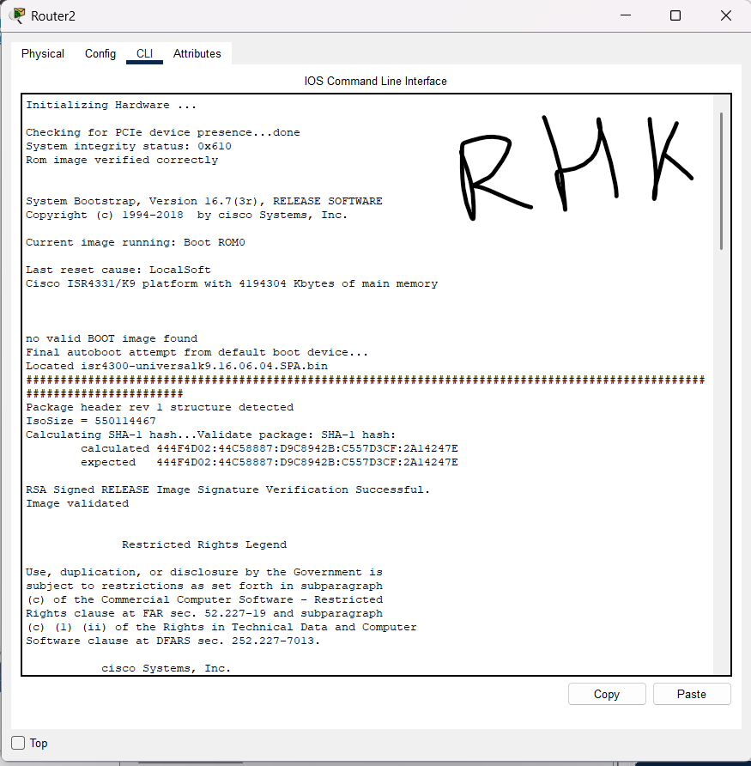

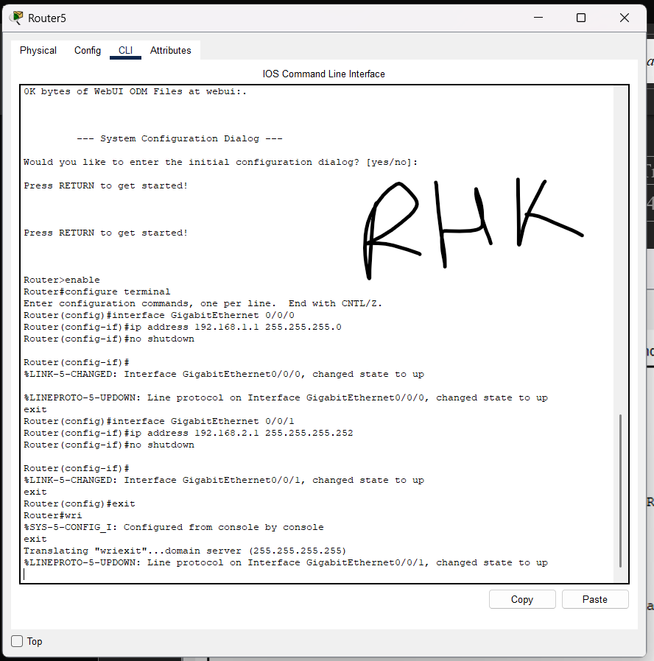

Step 3: Enable Routing (RIP v2)

On Router1 (R1)
Router> enable
Router# configure terminal
Router(config)# router rip
Router(config-router)# version 2
Router(config-router)# network 192.168.1.0
Router(config-router)# network 192.168.2.0
Router(config-router)# exit
Router# write

On Router2 (R2)
Router> enable
Router# configure terminal
Router(config)# router rip
Router(config-router)# version 2
Router(config-router)# network 10.0.0.0
Router(config-router)# network 192.168.2.0
Router(config-router)# exit
Router# write

2 Screenshots of RIP V2 Configuration on Routers (R1 & R2)
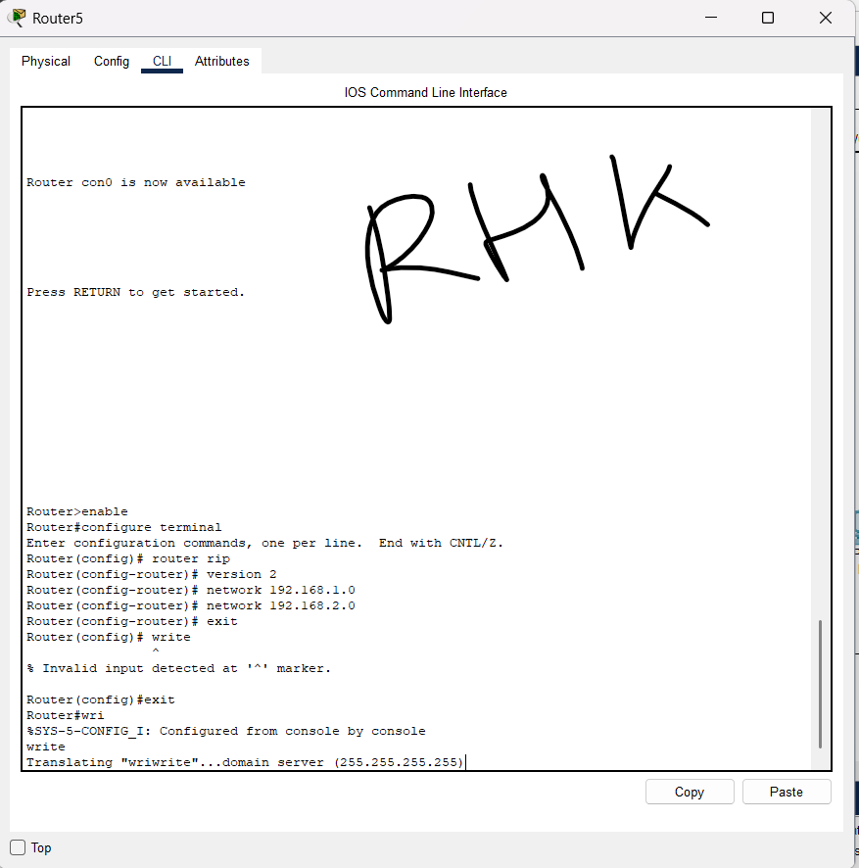

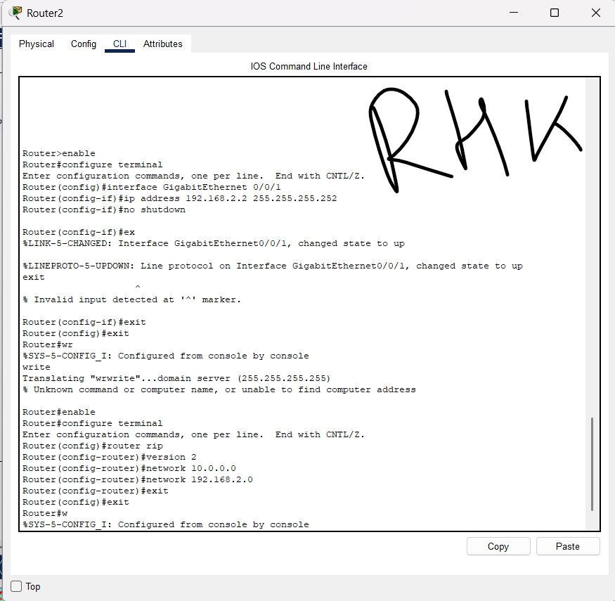

Step 4: Test Connectivity

Test 1: Verify Router-to-Router Connectivity
On Router1 (R1), test if it can reach Router2 (R2):
Router1# ping 192.168.2.2
On Router2 (R2), test if it can reach Router1 (R1):
Router2# ping 192.168.2.1
If the pings are successful, the routers are correctly connected.
2 Screenshots of Successful ping between Routers (R1 -> R2 & R2 -> R1)
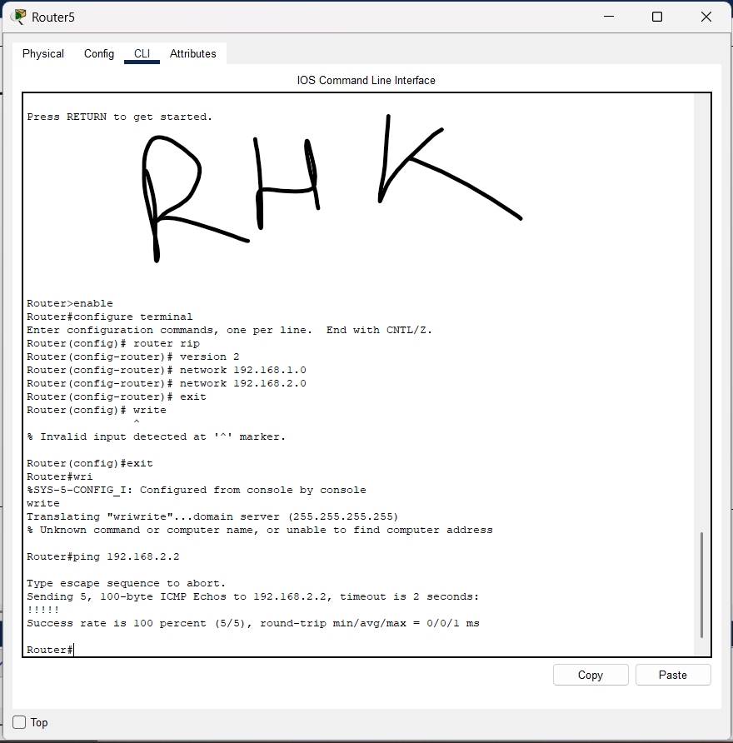
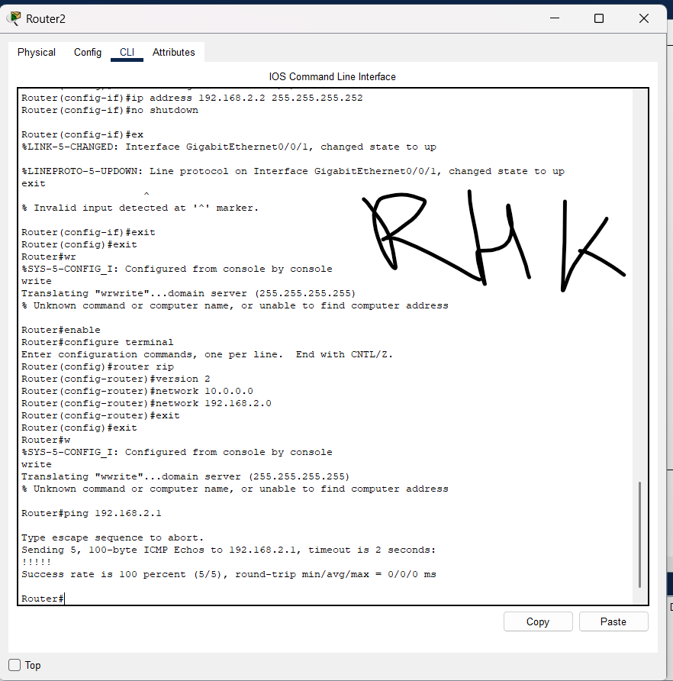

Test 2: Check Routing Tables on Both Routers
On Router1, display the routing table to ensure all networks are reachable:
Router1# show ip route
On Router2, display its routing table:
Router2# show ip route
You should see entries for 192.168.1.0/24, 10.0.0.0/8, and 192.168.2.0/30 via RIP.
2 Screenshots of “show ip route” from both Routers (R1 & R2)
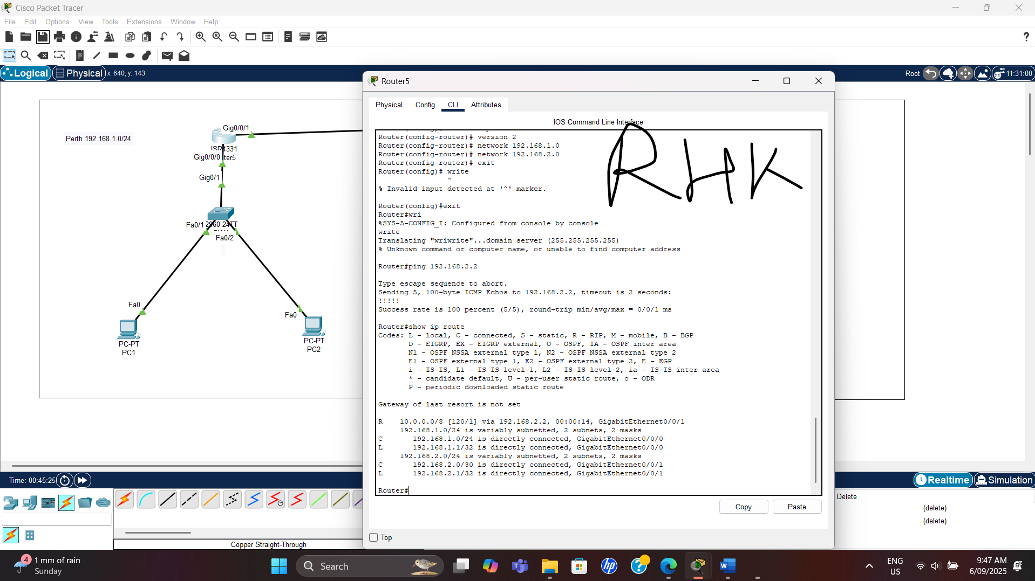
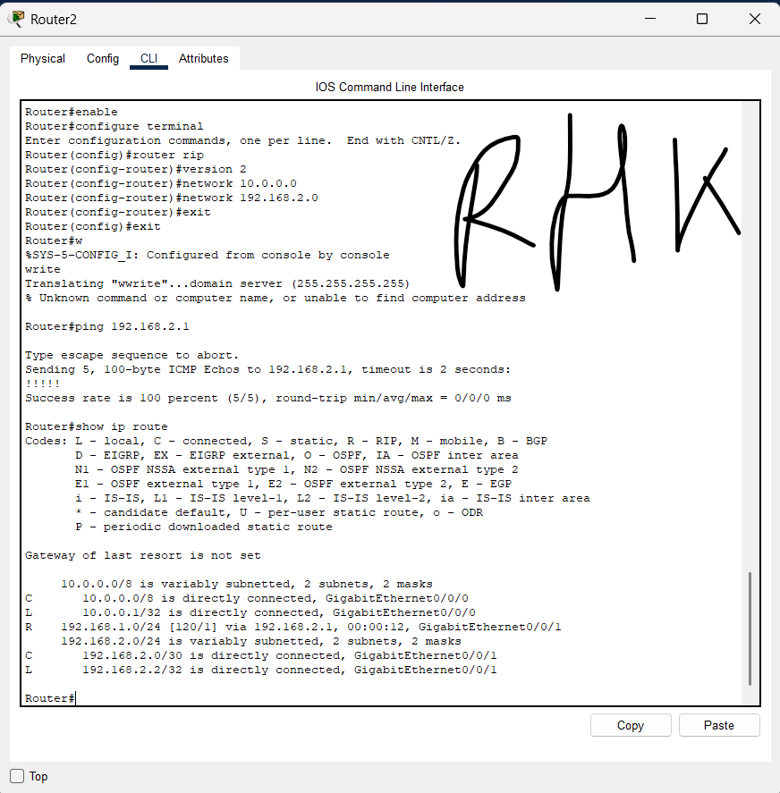

Test 3: Test End-to-End PC Communication
From PC1, test if it can communicate with PC3:
PC1> ping 10.0.0.2
From PC2, test if it can communicate with PC4:
PC2> ping 10.0.0.3
From PC3, test if it can communicate with PC1:
PC3> ping 192.168.1.2
From PC4, test if it can communicate with PC2:
PC4> ping 192.168.1.3
If all pings are successful, then the entire network is properly configured.
4 Screenshots of Successful ping between PCs (PC1 -> PC3 , PC2 -> PC4 , PC3 -> PC1 and PC4 -> PC2)
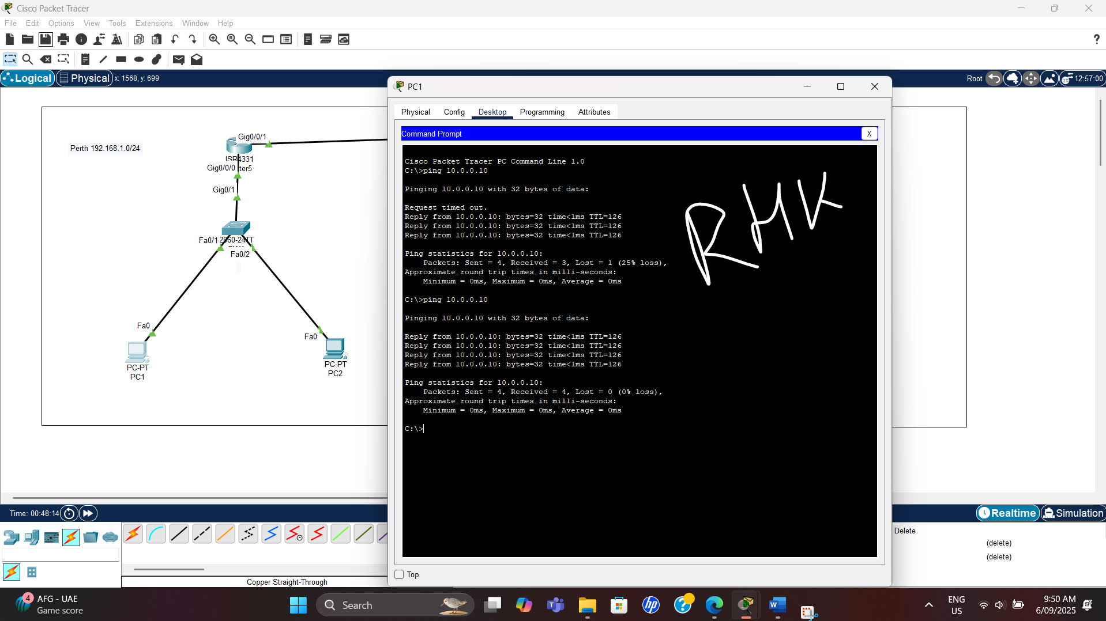

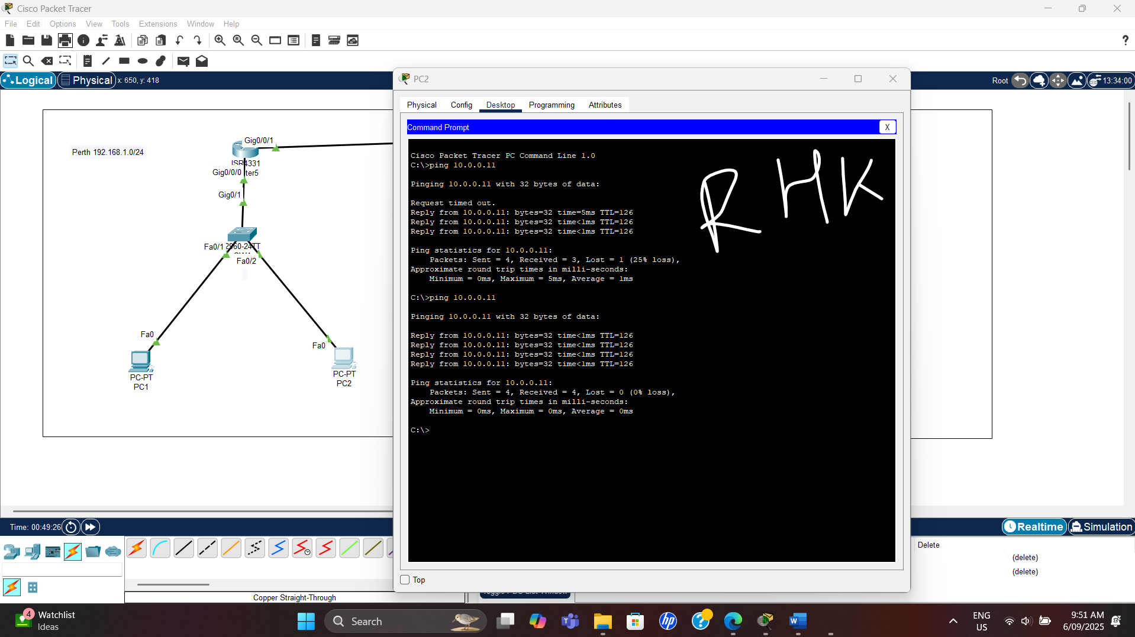
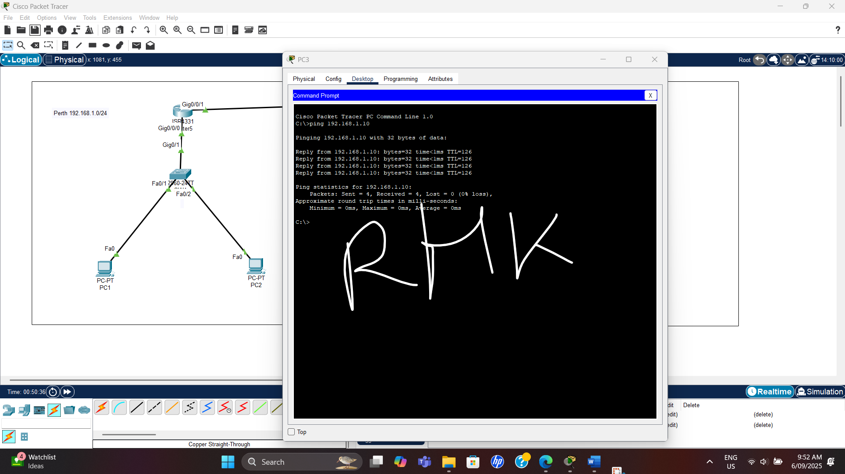
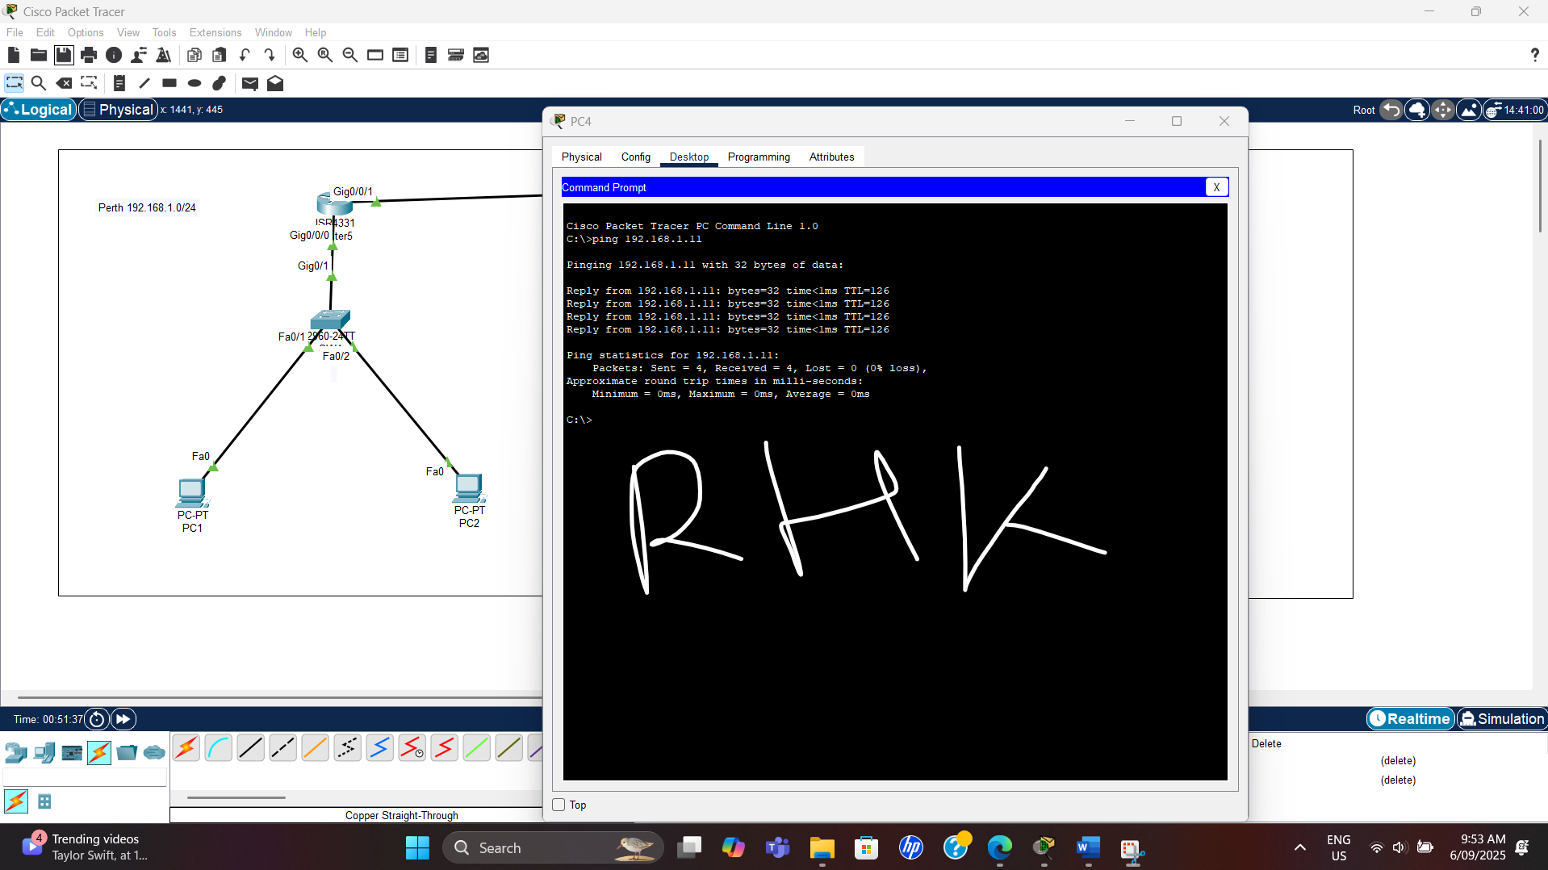

Test 4: Troubleshooting (If Pings Fail)
If a ping fails, use the following commands on the routers:

Check RIP Routing Configuration
Router1# show ip protocols
Router2# show ip protocols
Ensure that RIP version 2 is running and the correct networks are listed.
2 Screenshots of “show ip protocols” from both Routers (R1 & R2)

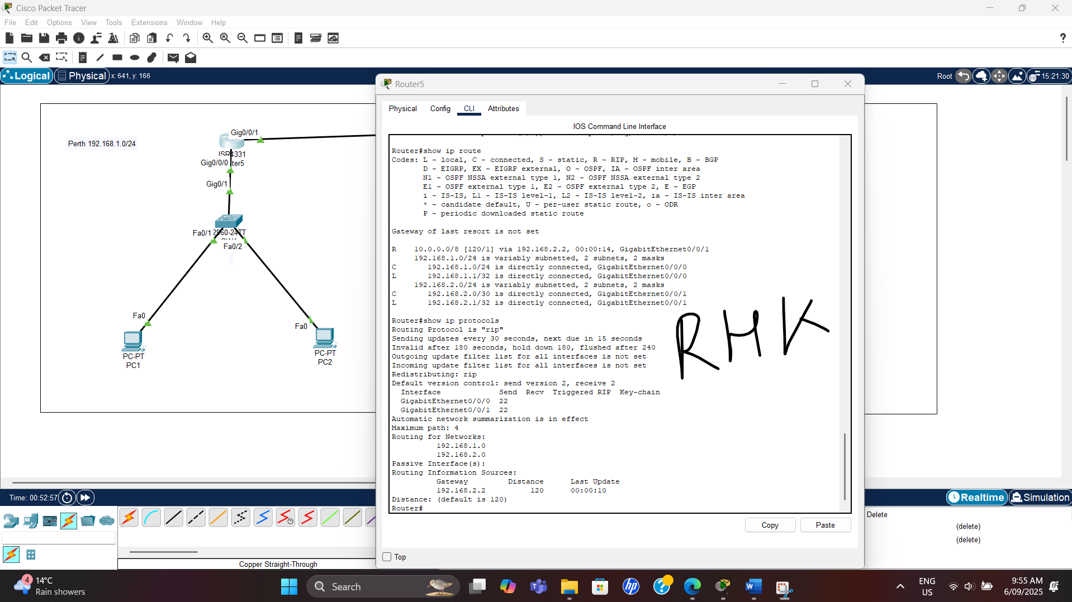
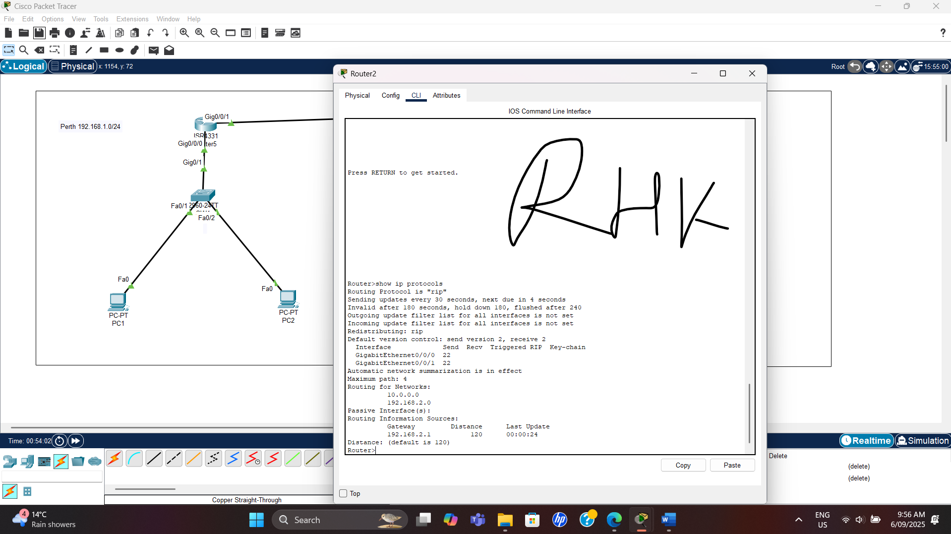

Check Interface Status
On Router1, check if interfaces are up:
Router1# show ip interface brief
On Router2, check interfaces:
Router2# show ip interface brief

Look for "up/up" status on interfaces.

2 Screenshots of “show ip interface brief” from both Routers (R1 & R2)

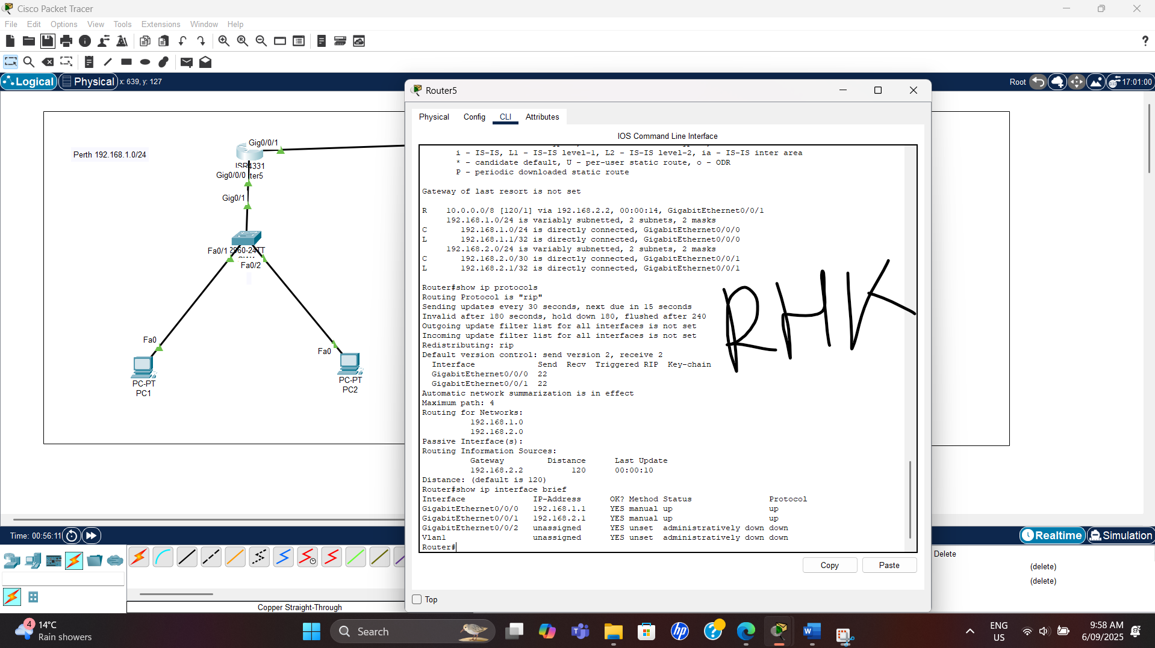

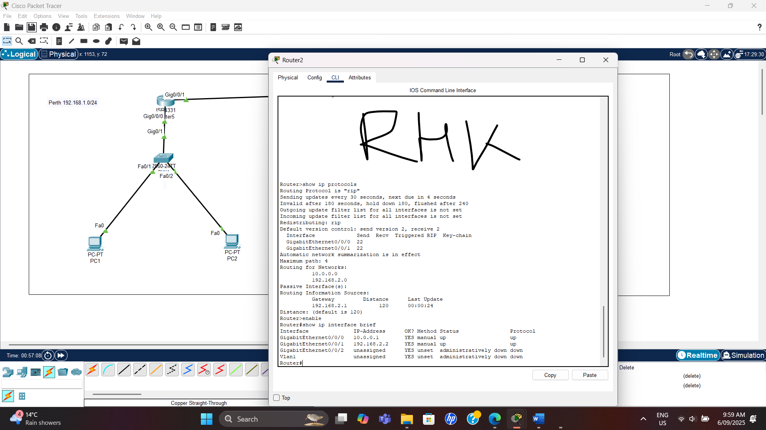

Check for Routing Issues
From Router1, test if it can reach Router2's LAN (10.0.0.1):
Router1# ping 10.0.0.1
From Router2, test if it can reach Router1's LAN (192.168.1.1):
Router2# ping 192.168.1.1

2 Screenshots of ping between Routers and LANs (R1 -> LAN2 & R2 -> LAN1)

