Assessment type (þ):
☐ Questioning (Oral/Written)
☐ Practical Demonstration
☐ 3rd Party Report
☒ Other – Lab

Assessment Resources:
The base requirements this assessment task include:
- IDE or editor for developing Python programs (only IDLE and PyCharm supported by the college)
- Access to Office 365 & Microsoft Word
- Virtual machine
You may not need all these for every part in this assessment

Assessment Due:
This assessment is due after the weekly session, Week 2, Friday 17:00.

Assessment Instructions:
- Your code must be written in IDLE or PyCharm IDEs. If you are using a different IDEs or a different structure for your application, then assistance from your lecturers may be limited (at best).
Discuss with your lecturer before straying too far off the path!
- All resources used should be referenced with the question. Answers may not be copied and pasted from any resource. All answers must be reworded to display your understanding.
- You may only use Python functionality, methods and libraries which were taught in this unit.
- First line of code in a program should have the student’s name and number, as proof of authenticity.
- Screenshots of all programs must be included in this document, with the appropriate question.
- Screenshots of testing, showing your code works as intended, should be included with the relevant question.
- Python programs should be named: XXX_Lab##_SYY_QZZ
Replace XXX with your initials
Replace ## with Lab number
Replace YY with Section number,
Replace ZZ with Question number
- It is a submission requirement that all screen shots be signed in some way. Some acceptable examples of signed screen shots are shown below.
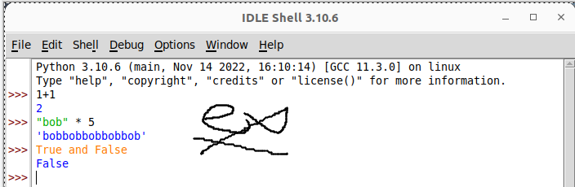
Example 1: Signed using a simple drawing tool.
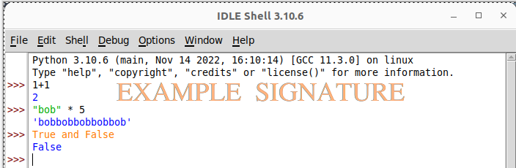
Example 2: Water marked signature.
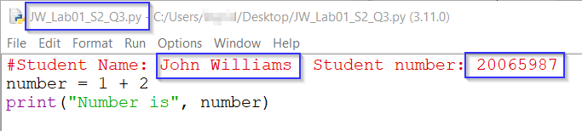
Example 3: Program named as prescribed, as well as first line comment with student name and number.
Program saved as pre-described.
- All python programs must be included in the submission, as well as this document.

Assessment Instrument:

Section 1: Variables
Use any python interpreter to execute the code in this section and verify you correctly understand the output.
- Run the following operations in the python shell/interpreter and observe the output, provide screen shot evidence you have completed each execution.
Code |  | Screenshot
print(4) |  | 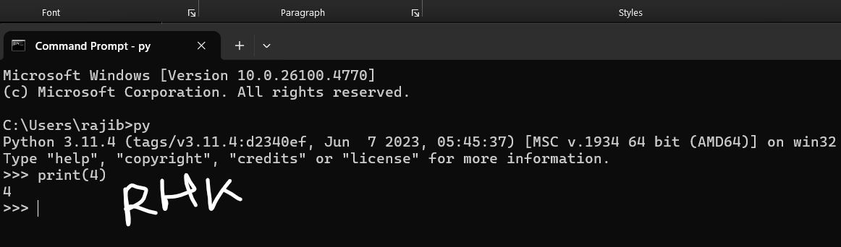
type(“Hello”) |  | 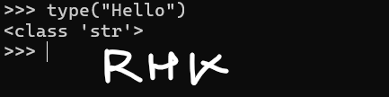
type(4) |  | 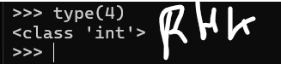
print(1,000,000) |  | 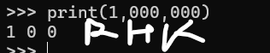
first = “bob’s”  second = “burgers”  print(first, second) |  | 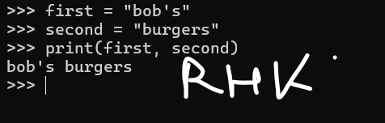
python_is_fun = “yes”  print(python_is_fun) |  | 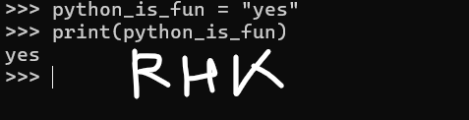
import math  print(math.pi) |  | 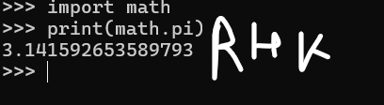
number1 = 123  print(number1)  number2 = 456  print(number2)  number3 = 789  print(number3) |  | 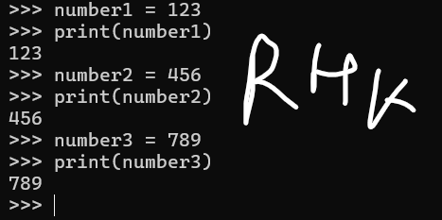
a = 1  b = 2  c = a + b  d = c – a  print(d) |  | 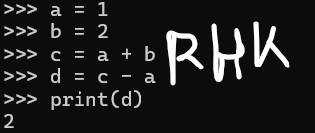
print(while)  This should result in an error |  | 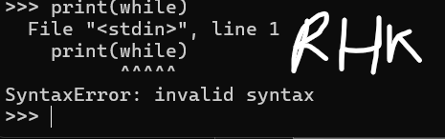
- Why did the command print(while) result in an error?
Because while is a keyword/reserve word
- Provide at least 5 python keywords that cannot be used as a variable name and describe them
Keyword | Description
while | To create a while loop
break | To break out of a loop
def | To define a function
if | To make a conditional statement
None Represents a null value

Section 2: Data types
You will need to create several different variables and correctly assign data to them. Make sure you use the type() function to demonstrate the exact data type of each. Complete the following exercises using the Python shell/interpreter.
- Create a string called str1
  - Assign the value “words” to it
  - Print the variable
  - Use type() to demonstrate the variable is a string data type
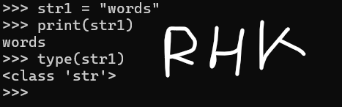
- Create an integer called int1
  - Assign the value 65 to it
  - Print the variable
  - Use type() to demonstrate the variable is an integer data type

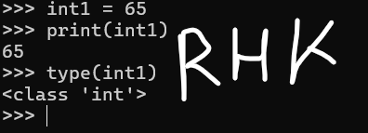

Section 3: input()
Capturing user input from the console is a common task in Python. This section of the lab will ask you to use the input() function to assign some data to some variables. Complete the following exercises in the Python shell/interpreter. Remember, you need to capture screen shot evidence of your work completion.
- Use input() to:
  - Ask the user to enter a common first name and store it into a variable called user_input_1
  - Print the variable back to demonstrate the input worked as expected.
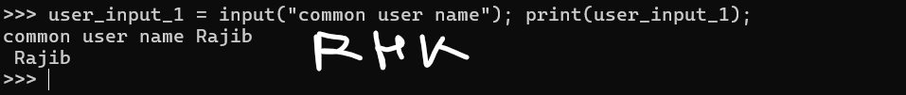
- Use input() to:
  - Ask the user to input a number and store it into a variable called user_input_2
  - Print the variable back to demonstrate the input worked as expected
Use type() to determine the data type of user_input_2
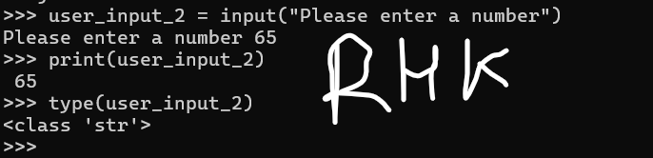
- Why is user_input_2 a string when the user clearly entered a number?
the input() function always returns a string, regardless of whether the user types in numbers or text.
- Enter the following code into the interpreter:
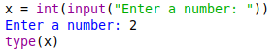
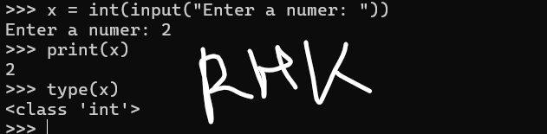
- Why did x become an integer rather than a string?
Because it was explicitly converted using type conversion functions like int()

- Do the following in the interpreter:
  - Create a variable called num1 and ask the user to input a number (make sure that input is converted to an integer)
  - Create a variable called num2 and ask the user to input a number (make sure that input is converted to an integer)
  - Use print(num1*num2) to multiply num1 by num2 and print the result (two integers should be multipliable)
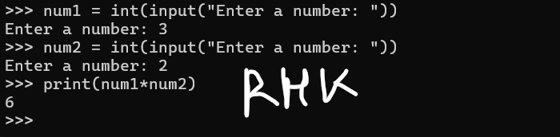

Section 4: print()
Here are some simple print commands that are used to demonstrate the functionality of the print() command. Complete the following exercises in the Python shell/interpreter.
- Run all the below commands taking screen shots to demonstrate how they function.
Code | Screenshot
a = 5  print(a)  type(a) | 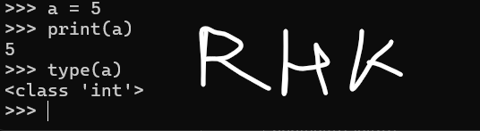
a = 5  b = “5”  print(a,b) | 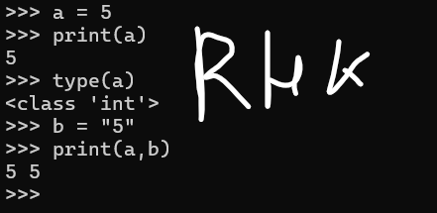
a = “Stirling”  b = “Archer”  c = “spy!”  print(“I am”, a , b , “I am a”, c) | 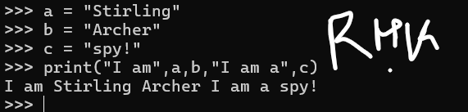
a = input(“Enter a number to multiply: “)  b = input(“Enter another number: “)  print(int(a)*int(b)) | 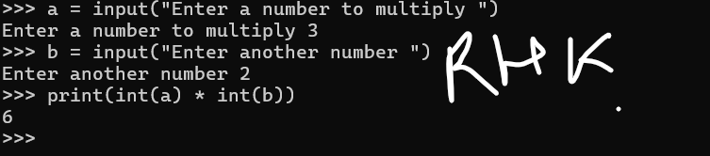

Section 5: Debugging problems
Here are a couple of code examples with errors, use any available means to debug them and explain the issue in each.
Problem 1:
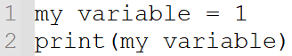
Why does this code fail to execute?
Variable name should not have any space in between
in the above code the variable declaration is done in an incorrect way

Problem 2:
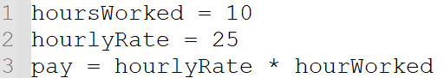
Why does this code fail to execute?
While calculating the pay hourWorked variable is misspelt and missing s after hour

Section 6: Challenge time
Combine your skills to complete the following challenge! This challenge needs to be done in a code file, not the shell/interpreter.
You are required to submit the code file and screen shots of the code working as intended, this includes formatting the output exactly as displayed in the example!
- Create a script that will accept a user’s full name, date of birth and hobbies then print them to the screen.
- Improve the script above by adding a question to ask the user for their favourite number.
- Once the favourite number is acquired, multiply that number by 10 and let the user know the result.
- Make the script tell the user a goodbye message including their name as the final line.
The final resulting script should produce an output formatted in the same way as the below screen example:
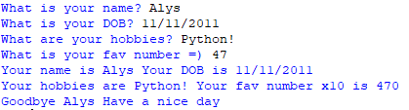
You might find the following pseudocode useful for building this script:
- Ask the user for their name and store is as username.
- Ask the user for the DOB and store it as userDOB.
- Ask the user for their hobbies and store it as userHobbies.
- Ask the user for their favourite number and store it as an integer called userNum.
- Print the username (username) and DOB (userDOB).
- Print their hobbies (userHobbies) and multiply userNum by 10.
- Print a goodbye message.
Code | Output
userHobbies = input("What are your hobbies? ")  userNum = int(input("What is your fav number =) "))  print("Your name is " + username + ". Your DOB is " + userDOB + ".")  print("Your hobbies are " + userHobbies +  " Your fav number x10 is " + str(userNum * 10) + ".")  print("Goodbye " + username + ". Have a nice day.") | 