FoodFleet
Multi-Branch Restaurant Delivery Platform
Architecture & Technical Reference Document — v2.0
Version | 2.0
API Stack | .NET 8 Web API (Clean Architecture)
Web App | Blazor WebAssembly (.NET 8)
Admin Panel | Blazor Server (.NET 8)
Mobile App | React Native + Expo
Database | PostgreSQL 16
Hosting | Azure PaaS + rajiblabs VPS (hybrid)

Table of Contents

1. Project Overview
FoodFleet is a multi-branch restaurant delivery platform. Customers open the app, their nearest branch is detected via GPS, they browse that branch's available menu, build a cart, provide a delivery address validated against the branch's configured delivery radius, select a payment method, and place the order. The platform is built API-first with a single .NET 8 backend serving a Blazor WebAssembly customer web app, a React Native mobile app, and a Blazor Server admin panel.

1.1 Application Suite
App | Tech Stack | Audience | Purpose
Customer Web App | Blazor WebAssembly (.NET 8) | End customers | Browse, order, checkout via browser
Customer Mobile | React Native + Expo | End customers | iOS & Android ordering app
Admin Panel | Blazor Server (.NET 8) | Restaurant ops staff | Manage branches, menus, orders, settings
Backend API | .NET 8 Web API | All clients | Central business logic & data

1.2 Core User Journey
- App opens → restaurant branding & splash screen
- Location: GPS auto-detects nearest branch OR manual dropdown selection
- Menu loads: items filtered to selected branch, out-of-stock items hidden
- Customer builds cart, reviews order
- Checkout: enters delivery address (map pin or typed)
- Geo-validation: address checked against branch delivery radius (default 3 km) — order blocked if outside range
- Payment: UPI / Razorpay / Stripe / Cash on Delivery
- Order confirmed: customer sees delivery partner name + phone number
- Customer can call delivery partner directly for status updates (no live tracking)

1.3 System Flow Diagrams
The three diagrams below show how the platform works from each perspective: the end customer, the restaurant admin, and the technical system. These can be used to explain the platform to restaurant owners and stakeholders.

Diagram 1 — Customer journey
This diagram traces exactly what a customer experiences from opening the app to receiving their order. The red dashed loop on the left shows the critical business rule: if the delivery address falls outside the branch radius, the order is blocked and the customer must correct their address before proceeding.

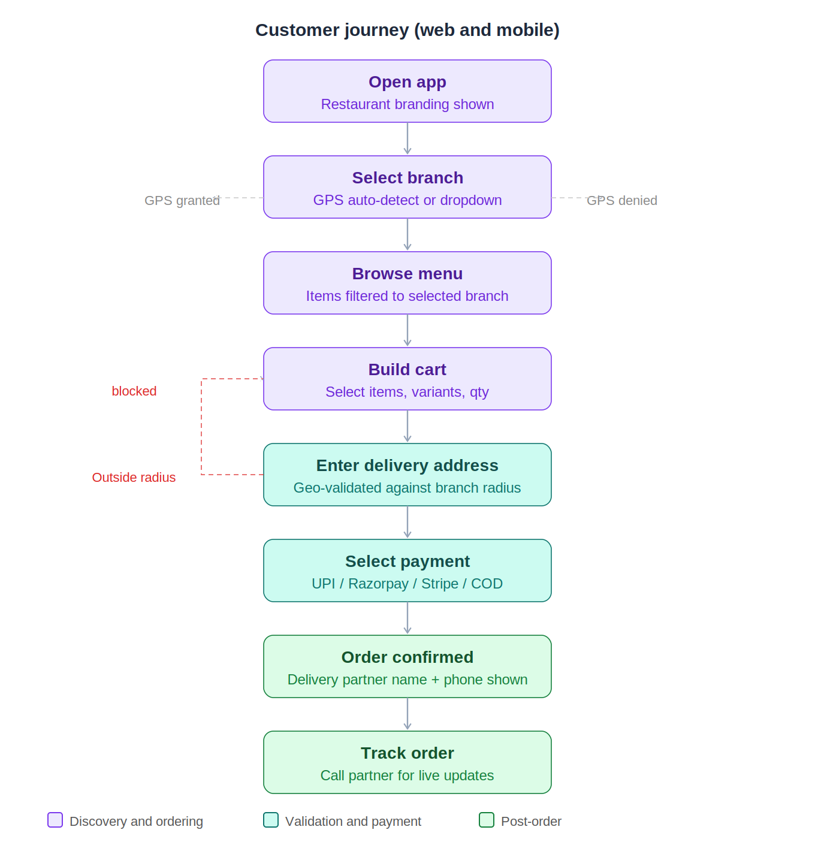

Diagram 2 — Admin panel workflow
The admin workflow is split into two columns. The amber column (left) is the one-time setup every restaurant completes: configure the restaurant name and branding, create branches with map-pinned locations, set the delivery radius per branch, build the menu (manually or via Excel import), and configure which payment gateways and notification channels are active. The red column (right) is the daily operations flow: staff monitor the live order queue, update statuses step by step, assign a delivery partner, and the system fires email and SMS notifications automatically.

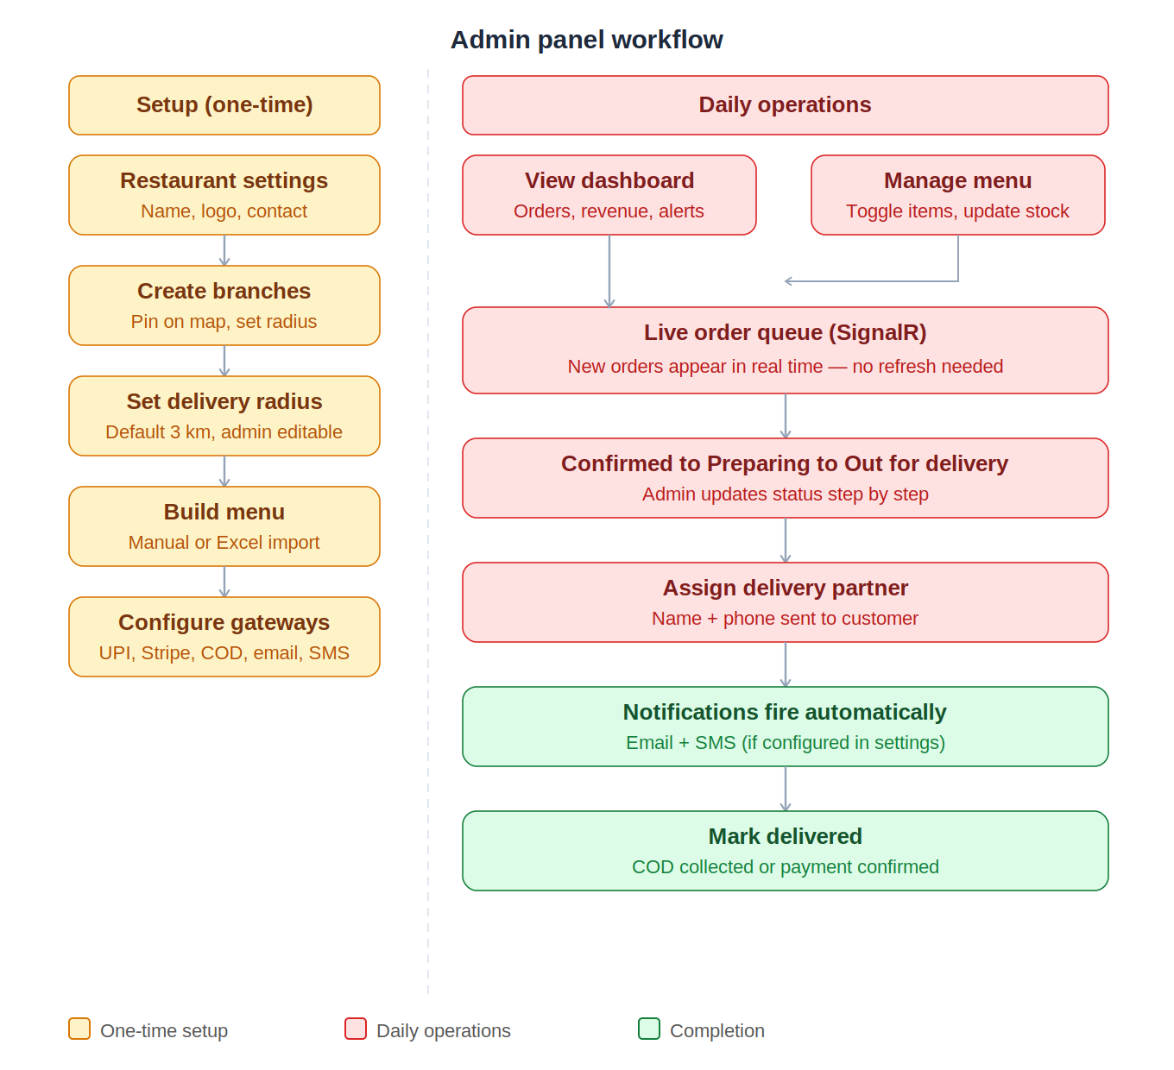

Diagram 3 — System architecture overview
This diagram shows the restaurant owner that all three customer-facing apps (web, mobile, admin) talk exclusively to one central API, which in turn connects to the database, cache, file storage, payment gateways, and notification services. The geo-validation engine is highlighted in teal because it enforces the delivery radius — the single most important business rule. Hosting is split across the rajiblabs VPS (API and admin) and Azure (static web app and blob storage).

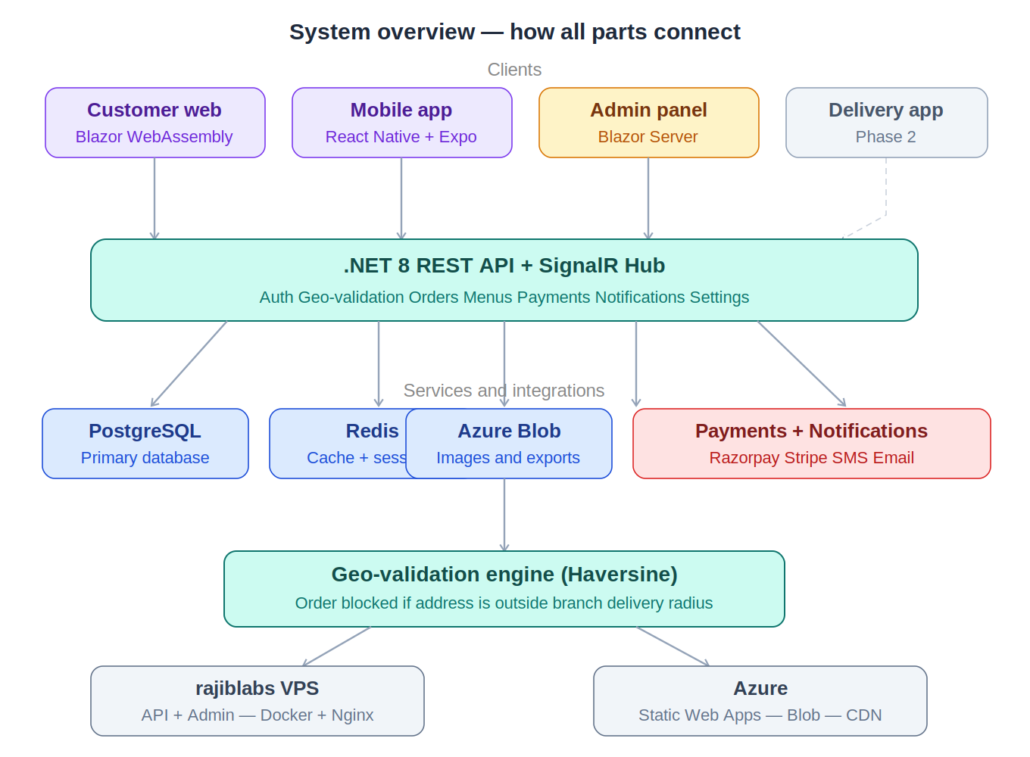

Design Decision | PostgreSQL is the correct database choice for this platform. SQLite is unsuitable for multi-user concurrent writes, lacks robust JSON support, and cannot be hosted on Azure PaaS services. PostgreSQL handles concurrent orders, complex geo-queries, and scales cleanly from a single VPS to Azure Flexible Server with no schema changes.

2. System Architecture

2.1 Architecture Layers
All client applications communicate exclusively with the .NET 8 REST API. No client has direct database access. The API enforces all business rules — including geo-validation — server-side.

Layer | Component | Technology
Clients | Customer Web, Mobile, Admin Panel | Blazor WASM, React Native, Blazor Server
API | REST API + SignalR Hub | .NET 8 (Clean Architecture)
Auth | JWT Bearer + Refresh Tokens | ASP.NET Core Identity
Business Logic | Services, Validators, Geo Engine | C# + FluentValidation + Haversine
Payments | Gateway Abstraction | IPaymentGateway (UPI/Razorpay/Stripe/COD)
Notifications | Email + SMS (toggleable) | SMTP/SendGrid + Twilio/fast2SMS
Data | Primary Store | PostgreSQL 16 via EF Core 8
Data | Cache | Redis (Azure Cache or Docker)
Data | Media Storage | Azure Blob Storage
Hosting | API + Admin | Azure App Service or Docker/VPS
Hosting | Customer Web | Azure Static Web Apps (CDN)

2.2 Clean Architecture Layout
Presentation | HTTP Controllers, DTOs, Middleware (auth, error, logging, rate-limit)
Application | MediatR handlers (CQRS), FluentValidation, AutoMapper, Use Cases
Domain | Entities, Domain Events, Business Rules, IRepository interfaces
Infrastructure | EF Core, Redis, Azure Blob, Payment Adapters, Email/SMS adapters, Geo Service

2.3 Database Schema
Entity | Key Fields | Notes
Restaurant | Id, Name, LogoUrl, ContactEmail, IsActive | Top-level brand record
Branch | Id, RestaurantId, Name, Lat, Lng, Address, DeliveryRadiusKm, IsActive | DeliveryRadiusKm defaults to 3.0; admin-configurable
MenuCategory | Id, BranchId, Name, DisplayOrder, IsActive | Scoped per branch
MenuItem | Id, CategoryId, Name, Desc, Price, ImageUrl, IsAvailable, StockCount | StockCount null = unlimited
MenuItemVariant | Id, MenuItemId, Label, AdditionalPrice | e.g. Small / Large / Extra Cheese
Customer | Id, Name, Email, Phone, PasswordHash, CreatedAt | Registered customer
CustomerAddress | Id, CustomerId, Label, FullAddress, Lat, Lng, IsDefault | Saved delivery addresses
Order | Id, CustomerId, BranchId, Status, TotalAmount, PaymentMethod, PlacedAt | Master order
OrderItem | Id, OrderId, MenuItemId, VariantId, Quantity, UnitPrice | Line items
DeliveryPartner | Id, BranchId, Name, Phone, IsAvailable | Assigned per branch
OrderDelivery | Id, OrderId, DeliveryPartnerId, AssignedAt | Links order to partner
Payment | Id, OrderId, Gateway, GatewayRefId, Status, Amount, PaidAt | Payment record
RestaurantSettings | Id, RestaurantId, Key, Value | Key-value config store (see Section 8)
NotificationLog | Id, OrderId, Channel, Status, SentAt | Audit trail for emails/SMS

3. Location & Geo-Validation

3.1 Branch Selection Flow
- App opens → request GPS permission
- GPS granted: device coordinates sent to GET /api/v1/branches/nearest?lat=&lng= → nearest active branch auto-selected
- GPS denied: dropdown of all active branches shown; user selects manually
- User can always override branch selection from header dropdown

3.2 Delivery Radius Rules
CRITICAL RULE | An order cannot be completed if the delivery address falls outside the branch's configured delivery radius. This is enforced server-side at order placement. Client-side validation is for UX feedback only and cannot be bypassed.

Default Radius | 3.0 km from branch coordinates (if not configured in admin)
Admin Override | Admin can set any radius per branch (e.g. 5 km, 10 km) from the Branch Settings page
Algorithm | Haversine formula — great-circle distance between branch lat/lng and delivery lat/lng
Validation Timing | 1) Real-time as customer types/pins address (UX feedback) 2) Enforced again at POST /api/v1/orders
Out-of-Range Behaviour | Checkout button disabled; message: 'Delivery not available. This branch delivers within X km.'
API Endpoint | POST /api/v1/geo/validate-delivery → { isDeliverable, distanceKm, radiusKm }
Error on Order | HTTP 422 Unprocessable Entity if address fails radius check at order placement

3.3 Geo-Validation API Contract
Request — POST /api/v1/geo/validate-delivery
Body: { "branchId": "uuid", "deliveryLat": 22.5726, "deliveryLng": 88.3639 }

Success Response (200):
{ "isDeliverable": true, "distanceKm": 1.84, "radiusKm": 3.0 }

Out-of-Range Response (200):
{ "isDeliverable": false, "distanceKm": 4.62, "radiusKm": 3.0 }

4. Payment System

4.1 Supported Payment Methods
Architecture Note | All gateways implement IPaymentGateway. Active gateways are determined by which ones have credentials configured in RestaurantSettings. If a gateway has no API key, it does not appear at checkout.

Gateway | Type | Integration | Notes
UPI (via Razorpay) | Digital — India | Razorpay .NET SDK | VPA input or QR code; primary India method
Razorpay (Cards/Wallets) | Digital — India | Razorpay .NET SDK | Net Banking, Debit/Credit Cards, Paytm, PhonePe
Stripe | Digital — International | Stripe .NET SDK | Cards, Apple Pay, Google Pay
Cash on Delivery | Offline | Internal (no API call) | Order confirmed immediately; payment on delivery

4.2 Payment Flow
- Customer selects payment method — only methods with credentials in RestaurantSettings shown
- POST /api/v1/payments/initiate → Order created (status: PendingPayment), gateway session/token returned
- Client opens gateway SDK / UPI QR / hosted checkout
- Gateway calls webhook → API verifies signature, updates Payment + Order status
- POST /api/v1/payments/confirm → client confirms with gateway reference; API performs final sync
- Order status moves to Confirmed; delivery partner assigned if available
- Customer receives confirmation with delivery partner name and phone number

4.3 COD Flow
- Customer selects Cash on Delivery
- POST /api/v1/orders → Order created with status Confirmed, PaymentMethod = COD
- No gateway call; Payment record created with status Pending
- On delivery: admin marks order as Delivered and payment as Collected

5. Delivery Partner

5.1 Design: Contact-Based Tracking
FoodFleet does not implement GPS live tracking for delivery partners in Phase 1. Instead, the customer is shown the assigned delivery partner's name and phone number after order confirmation. The customer can call the partner directly for status updates.

Phase 2 Note | Live GPS tracking via react-native-maps and a delivery partner mobile app can be added in Phase 2 without breaking the Phase 1 schema — the DeliveryPartner table already has CurrentLat / CurrentLng fields reserved for this.

5.2 Delivery Partner Data
Table | DeliveryPartner
Fields | Id, BranchId, Name, Phone, IsAvailable, CurrentLat (reserved), CurrentLng (reserved)
Assignment | Admin assigns a partner to an order from the order management screen
Customer View | Order confirmation screen shows: 'Your delivery partner is [Name], reachable at [Phone]'
Phone Format | Stored with country code (e.g. +91-XXXXXXXXXX) for future WhatsApp integration

6. Menu Management & Stock Control

6.1 Stock & Availability
IsAvailable | Toggle per item — admin can instantly show/hide an item from customer menus
StockCount | Optional integer. Null = unlimited. Decrements on each order placement.
Auto-Hide | When StockCount reaches 0, item is automatically set IsAvailable = false
Low Stock Alert | Admin dashboard shows items with StockCount <= 5 as a warning badge
Restock | Admin manually updates StockCount from the menu management screen or via import
Branch Scope | Availability and stock are per-branch; same item can be on at Branch A but off at Branch B

6.2 Excel Import / Export
Phase 1 Scope | Both import and export are included in Phase 1. The Excel template is downloadable from the Admin Panel. Admins fill it and upload to bulk-create or update menu items for a branch.

Export flow
- Admin clicks Export Menu on the branch menu page
- GET /api/v1/admin/branches/{id}/menu/export → API generates Excel using ClosedXML
- File downloaded: FoodFleet_Menu_{BranchName}_{Date}.xlsx

Import flow
- Admin downloads the template (same export format)
- Admin fills in: Category, Item Name, Description, Price, Variants, StockCount, IsAvailable
- Admin uploads file via Admin Panel
- POST /api/v1/admin/branches/{id}/menu/import (multipart/form-data)
- API parses with ClosedXML, validates each row
- Response: { imported: 42, skipped: 2, errors: [{ row: 5, reason: 'Price missing' }] }
- Admin sees summary; failed rows listed with reason — successful rows committed

Excel template columns
Column | Required | Notes
Category | Yes | Must match existing category name or new one is created
Item Name | Yes | Unique within category
Description | No | Max 500 characters
Price | Yes | Decimal, e.g. 149.00
Variant Labels | No | Pipe-separated: Small|Medium|Large
Variant Extra Prices | No | Pipe-separated, same order as labels: 0|20|40
Stock Count | No | Leave blank for unlimited
Is Available | Yes | TRUE or FALSE
Image URL | No | External URL or leave blank

7. Admin Panel (Blazor Server)

7.1 Admin Modules
Module | Key Features
Dashboard | Today's orders, revenue, pending order alerts, low-stock warnings, active branches
Branch Management | Add/edit branches, pin location on map, set delivery radius, activate/deactivate
Menu Management | Category CRUD, item CRUD, availability toggle, stock count update, image upload, Excel import/export
Order Management | Live order queue (SignalR), status updates, assign delivery partner
Delivery Partners | Add/edit partners per branch, toggle availability, assign to orders
Customer Management | View customer list, order history per customer
Payment Reports | Revenue by date/branch/gateway, COD reconciliation, export to Excel
Settings | All platform settings configurable here — see Section 8

7.2 Real-Time Order Queue
The Admin Panel connects to SignalR hub /hubs/orders. New orders trigger an instant notification on the kitchen screen without page refresh. Order status updates pushed from admin are also broadcast to the customer's web and mobile apps.

8. Settings & Configuration System

8.1 Design: Key-Value Config Store
All platform behaviour is driven by the RestaurantSettings table (Key / Value pairs). Features are only active when their configuration keys are present and valid. The platform can be deployed for any restaurant without code changes.

Principle | If a payment gateway has no API key configured, it does not appear at checkout. If email SMTP is not configured, no emails are sent. If SMS credentials are absent, no SMS is sent. Nothing breaks — the feature is simply inactive.

8.2 Configuration Categories
Category | Setting Key | Description | Required?
Restaurant | restaurant.name | Display name shown in app and emails | Yes
Restaurant | restaurant.logo_url | Logo image URL | Recommended
Restaurant | restaurant.contact_email | Contact email for support | Yes
Delivery | delivery.default_radius_km | Default radius if branch has none set (default: 3.0) | Yes
Payment | payment.razorpay.key_id | Razorpay Key ID — enables UPI + Razorpay | Optional
Payment | payment.razorpay.key_secret | Razorpay Key Secret (encrypted at rest) | Optional
Payment | payment.stripe.publishable_key | Stripe Publishable Key | Optional
Payment | payment.stripe.secret_key | Stripe Secret Key (encrypted at rest) | Optional
Payment | payment.cod_enabled | true/false — enables Cash on Delivery | Optional
Email | notification.email.enabled | true — activates order email notifications | Optional
Email | notification.email.smtp_host | SMTP server host | If email enabled
Email | notification.email.username | SMTP username / API key | If email enabled
Email | notification.email.from_address | From address for order emails | If email enabled
SMS | notification.sms.enabled | true — activates order SMS notifications | Optional
SMS | notification.sms.provider | Provider: twilio or fast2sms | If SMS enabled
SMS | notification.sms.api_key | SMS provider API key (encrypted at rest) | If SMS enabled

8.3 Notification Events
Event | Email | SMS
Order Placed | Order summary + items + delivery partner contact | 'Your order #XYZ has been confirmed.'
Order Preparing | 'Your order is being prepared' | Short status SMS
Out for Delivery | Partner name + phone number | 'Your order is on the way. Call [Name] on [Phone].'
Order Delivered | Receipt + feedback link | 'Delivered! Enjoy your meal.'
Order Cancelled | Reason + refund info if applicable | Cancellation notice

9. API Endpoint Reference

9.1 Auth
Method | Endpoint | Description
POST | /api/v1/auth/register | Register new customer
POST | /api/v1/auth/login | Customer login → access + refresh token
POST | /api/v1/auth/refresh | Refresh access token
POST | /api/v1/admin/auth/login | Admin login → admin JWT

9.2 Public (No Auth)
Method | Endpoint | Description
GET | /api/v1/branches | All active branches
GET | /api/v1/branches/nearest?lat=&lng= | Nearest branch by GPS coordinates
GET | /api/v1/branches/{id} | Branch details + delivery radius
GET | /api/v1/branches/{id}/menu | Full menu for branch (available items only)
POST | /api/v1/geo/validate-delivery | Validate delivery address against radius
GET | /api/v1/restaurant/info | Restaurant name, logo, contact

9.3 Customer (JWT Required)
Method | Endpoint | Description
GET/PUT | /api/v1/customers/me | Get / update profile
GET/POST | /api/v1/customers/me/addresses | List / add saved addresses
DELETE | /api/v1/customers/me/addresses/{id} | Remove address
POST | /api/v1/orders | Place order (geo-validated server-side)
GET | /api/v1/orders/{id} | Order detail + delivery partner contact
GET | /api/v1/orders/history | Past orders
POST | /api/v1/payments/initiate | Initiate payment → gateway session token
POST | /api/v1/payments/confirm | Confirm after gateway callback

9.4 Admin (Admin JWT Required)
Method | Endpoint | Description
GET/POST | /api/v1/admin/branches | List / create branches
PUT/DELETE | /api/v1/admin/branches/{id} | Update / delete branch
PUT | /api/v1/admin/branches/{id}/delivery-radius | Update delivery radius for branch
CRUD | /api/v1/admin/menu/categories | Manage menu categories
CRUD | /api/v1/admin/menu/items | Manage menu items
PUT | /api/v1/admin/menu/items/{id}/stock | Update stock count
PUT | /api/v1/admin/menu/items/{id}/availability | Toggle availability
GET | /api/v1/admin/branches/{id}/menu/export | Download menu as Excel
POST | /api/v1/admin/branches/{id}/menu/import | Upload Excel to bulk-import menu
GET | /api/v1/admin/orders | List orders (filter by branch, status, date)
PUT | /api/v1/admin/orders/{id}/status | Update order status
POST | /api/v1/admin/orders/{id}/assign-partner | Assign delivery partner
CRUD | /api/v1/admin/delivery-partners | Manage delivery partners
GET/PUT | /api/v1/admin/settings | Get / update restaurant settings
GET | /api/v1/admin/analytics/summary | Dashboard summary stats

10. Customer Web App (Blazor WebAssembly)

10.1 Stack
Framework | Blazor WebAssembly (.NET 8)
State Management | Fluxor (Redux-style) or cascading AppState service
HTTP Client | Typed HttpClient with JWT DelegatingHandler
Maps / Address | Leaflet.js via JSInterop — map pin drag → lat/lng
Geo Detection | navigator.geolocation via JSInterop
Hosting | Azure Static Web Apps (global CDN)
Token Storage | localStorage (access token), HttpOnly cookie (refresh token)

10.2 Key Components
- BranchSelector.razor — GPS detect + dropdown fallback; stores selected branch in AppState
- MenuGrid.razor — Category filter tabs, responsive card grid, out-of-stock items greyed out
- CartDrawer.razor — Slide-in cart panel, persisted in localStorage
- AddressPicker.razor — Leaflet map with draggable pin, shows radius circle overlay
- GeoValidationBadge.razor — Real-time: green 'Within delivery range' / red 'Outside range (X km)'
- PaymentSelector.razor — Only renders options that are configured in RestaurantSettings
- DeliveryPartnerCard.razor — Shows partner name + click-to-call phone link after order confirmed

11. Customer Mobile App (React Native)

11.1 Stack
Framework | React Native with Expo SDK 51+
Navigation | Expo Router (file-based routing)
State | Zustand (lightweight global store)
API Client | Axios + JWT interceptor
Maps | react-native-maps (Google Maps / Apple Maps)
Location | expo-location (GPS + reverse geocoding)
Storage | expo-secure-store (tokens), AsyncStorage (cart)
Notifications | expo-notifications + Firebase FCM
Payments | Razorpay React Native SDK + Stripe React Native SDK

11.2 GPS Flow
- Request expo-location foreground permission on app launch
- Granted: POST coordinates to /api/v1/branches/nearest → auto-select nearest branch
- Denied: show bottom-sheet with branch list for manual selection
- Checkout: customer pins delivery address on map; coordinates geocoded to address
- App calls POST /api/v1/geo/validate-delivery in real time as pin moves
- If outside radius: red overlay + message shown, 'Place Order' button disabled
- Server re-validates on POST /api/v1/orders; returns HTTP 422 if bypassed

12. Hosting & Deployment

12.1 Recommended Hybrid Strategy
Recommendation | Run the API and Admin Panel on the rajiblabs VPS (Docker) during development and early production to minimise cost. Use Azure Blob Storage for media and Azure Static Web Apps for the customer Blazor WASM app (global CDN). Migrate API to Azure App Service when traffic demands it.

12.2 Docker Compose (VPS)
Services | api, admin, postgres, redis, nginx
Nginx | TLS via Let's Encrypt; routes api.domain.com → api:8080, admin.domain.com → admin:8081
CI/CD | GitHub Actions: build → push Docker image → SSH to VPS → docker compose pull && up -d
Backups | pg_dump cron job → upload to Azure Blob Storage nightly

13. Development Phases

Phase 1 — MVP
- API: Auth, Branch, Menu (with stock), Order, Geo-validation, COD + Razorpay/UPI payments
- Settings system: restaurant info, payment gateway config, email + SMS toggles
- Menu import/export via Excel (ClosedXML)
- Admin Panel: branch + menu management, order queue (SignalR), delivery partner assignment
- React Native: branch select, menu, cart, checkout with geo-validation, order confirmation with partner contact
- Blazor WASM: same feature parity as mobile
- PostgreSQL schema + EF Core migrations, Redis cache, Docker Compose on VPS

Phase 2 — Enhanced
- Stripe payment gateway
- Push notifications (FCM) via expo-notifications
- Email / SMS notification templates (SendGrid + Twilio / fast2SMS)
- Admin analytics dashboard (revenue charts, order volume, popular items)
- Customer saved addresses with map picker

Phase 3 — Scale
- Delivery partner mobile app with GPS sharing (live tracking)
- Promo codes and discount engine
- Ratings and reviews per order
- WhatsApp notifications (WhatsApp Business API)
- Azure migration for API and database

14. Complete Technology Stack
Area | Technology | Purpose
API Runtime | .NET 8 Web API | Core backend
Architecture | Clean Architecture + MediatR (CQRS) | Separation of concerns
ORM | Entity Framework Core 8 | DB access + migrations
Database | PostgreSQL 16 | Primary data store
Cache | Redis | Menu caching, session, rate limiting
Auth | ASP.NET Core Identity + JWT | Authentication & roles
Validation | FluentValidation | Request input validation
Mapping | AutoMapper | DTO to Entity mapping
Geo | Haversine (custom C#) | Delivery radius validation
Excel | ClosedXML | Menu import/export
Payments | Razorpay SDK + Stripe .NET | UPI, cards, wallets
Email | SMTP / SendGrid (configurable) | Order notifications
SMS | Twilio / fast2SMS (configurable) | Order SMS alerts
Real-time | SignalR | Live order updates
Push Notifications | Firebase FCM | Mobile push
File Storage | Azure Blob Storage | Menu images, exports
Web App | Blazor WebAssembly (.NET 8) | Customer web frontend
Admin App | Blazor Server (.NET 8) | Ops dashboard
Mobile App | React Native + Expo | iOS & Android
Mobile State | Zustand | Global mobile state
Containers | Docker + Docker Compose | Deployment packaging
Reverse Proxy | Nginx | TLS, subdomain routing
CI/CD | GitHub Actions | Build & deploy pipeline

15. Security Considerations
- HTTPS enforced at Nginx; HTTP redirected
- JWT signed RS256 (admin), HS256 (customers); short-lived access tokens (15 min) + refresh rotation
- All payment gateway secrets and SMTP passwords encrypted via ASP.NET Core Data Protection before DB storage
- Geo-validation enforced server-side at order placement — client-side is UX only and cannot be bypassed
- Payment webhook endpoints validate gateway signatures before processing
- Role-based authorization: Customer, BranchManager, Admin roles
- Rate limiting on auth endpoints via .NET rate limiter middleware
- CORS restricted to known client origins
- Import endpoint: file size limit (5 MB max), extension whitelist (.xlsx only), row count cap (500 rows)
- NotificationLog records all outbound email/SMS for audit and replay capability

— End of Document | FoodFleet Platform v2.0 —

