Project Proposal

On

Office Appointment System

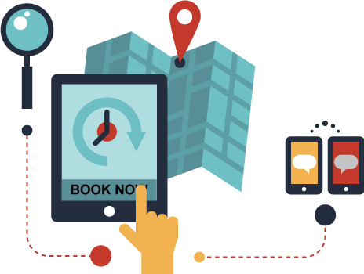

Module: STW300CEM Android Applications Development

Softwarica college of IT and E-Commerce

Mahakavi Marg, Kathmandu 44600, Nepal

Submitted By: Submitted to:

Rajib Shrestha Kiran Rana

160442 Module Leader

19 C

Table of Contents

1. Introduction 2

a. Project Introduction 2

b. Justification of the project 3

i. Background of the project 3

ii. Problem statement 3

c. Description of the Project 3

i. Features of the project 3

2. Aims and Objective of the project 3

3. Development Methodology 4

a. Description of the methodology 4

b. Design Pattern 4

i. MVC (Model – View – Controller) 4

c. System Architecture 5

i. Three tier architecture 5

4. Configuration Management (GitHub Screenshot) 6

5. Prototyping 7

a. Paper prototyping 7

6. Conclusion 8

7. References 8

# 1. Introduction

## Project Introduction

The project of Android Development includes to create a working android application and for that, I will be creating an Office Appointment System. This System allows Relationship Officer to make appointment and specify other details such as time, destination, date, time etc.

## Justification of the project

### i. Background of the project

The existing system allows to book an appointment with the related parties through an app and is fast and reliable.

### ii. Problem statement

The existing system to book appointment through physical meeting or a call and storing it in a record book is time consuming as well as might cause confusion. So, to solve these problems I have decided to go forward with this very project.

## c. Description of the Project

### i. Features of the project

* Login
* Make appointment
* Update Meeting Schedules
* Push Mails
* Remarks

# 2. Aims and Objective of the project

Aim

To Create an Android Application Office Appointment System for easy appointment booking in office.

Objectives

* To perform Analysis of market for the management system.
* To specify document requirements.
* To perform design.
* To fulfill requirements.
* To design database and GUI.
* To perform Unit Testing.
* To perform deployment.

# 3. Development Methodology

## Description of the methodology

Waterfall Model is the step by step development process where certain step are followed serially. This model is popular for Small Projects as it simple and easy to understand and use. We can move on to next step after the completion previous step.

## Design Pattern

### MVC (Model – View – Controller)

MVC Design Pattern puts user interaction in three parts. Model, View ad Controller where view represents domain model, the view interacts with the model through Controller. The controller receives user action, decides the impacted model and takes the response of latest model and send it back to view. The MVC is reusable as one model can be used for multiple views. It is easy to maintenance after separating view and model, it is easy for testing after separating UI and model but is hard if they are one.

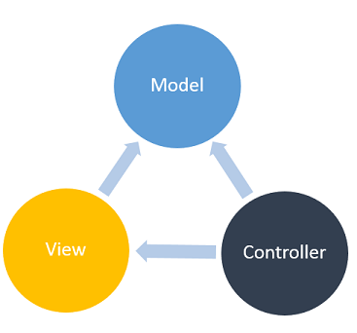

Figure 1: MVC Design Pattern

## System Architecture

### Three tier architecture

A 3-tier application architecture is a modular [client-server](https://searchnetworking.techtarget.com/definition/client-server) architecture that consists of a presentation tier, an application tier and a data tier. The data tier stores information, the application tier handles logic and the presentation tier is a graphical user interface ([GUI](https://searchwindevelopment.techtarget.com/definition/GUI)) that communicates with the other two tiers. (JReport, 2019) (TechTarget, 2019)

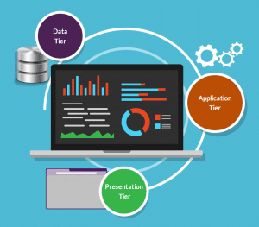

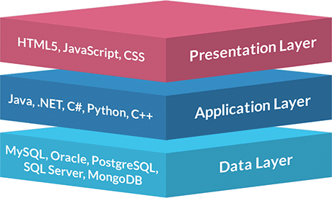

Figure 2: Three Tier Architecture

# 4. Configuration Management (GitHub Screenshot)

<https://github.com/rajibshresth/OfficeAppointmentSystem.git>

# 5. Prototyping

## a. Paper prototyping

# 6. Conclusion

An Android Application capable of booking an appointment is created and will store the contents of appointment in detail. All the Aims and Objectives of the listed will be completed.

# 7. References

*JReport*. (2019, April 12). Retrieved from jifonet: https://www.jinfonet.com/resources/bi-defined/3-tier-architecture-complete-overview/

*TechTarget*. (2019, April 12). Retrieved from TechTarget: https://searchsoftwarequality.techtarget.com/definition/3-tier-application