

**System Requirement Specification for**

**Request Management System**

|  |  |
| --- | --- |
| Project | Request Management System |
| Company | Headway Software Solutions Pvt Ltd. |
| Prepared by | Rajinder Kumar |

This document is copyright protected in content, presentation, and intellectual origin, except where noted otherwise. You may not modify, remove, augment, add to, publish, transmit, participate in the transfer or sale of, create derivative works from, or in any way exploit any of the elements of this document, in whole or in part without prior written permission from Headway Software Solutions Pvt Ltd.

**Table of Contents**

1. Introduction 5

1.1. Purpose and Intended Audience of SRS 5

1.2. Scope of Project 5

1.3. References/Reference Documents 5

1.4. Product Perspective and Functions 5

1.5. Operating Environment 6

1.6. Users of the Product 7

1.7. Assumptions and Dependencies 7

2. System Features 8

2.1. Request Management System 8

3 Non-functional Requirements 28

3.1 Software Quality Attributes 28

4 Execution Frequency 29

5 Appendix 1: Market, Time Zone 30

6 Revision History 31

# Introduction

## Purpose and Intended Audience of SRS

The purpose of this document is to state the requirements for the Request Management System for US Company. This SRS will give the detailed description of the functionality of the application and workflow of the process.

This document will be considered as a reference for both the Headway and Client stakeholders as a baseline for understanding the platform functionality and shall be referred by the development and testing team as the final basis for development of RMS.

## Scope of Project

The Request Management System will be used to manage and execute the daily assigned requests to the processors, The dashboard and reporting section will provide the overall quality and AHT of each request. Below processes are in scope for the Project:

1. User Management
2. Requests uploading and assignment
3. Request Processing and Audit interface and checklist
4. Reporting – SLA, AHT and Quality tracking

## References/Reference Documents

* Walkthrough session – RMS - Demo (1)
* Workflow Diagram

## Product Perspective and Functions

The platform will be used to process the requests with in standard SLA and quality as mentioned in the scope of the project. The solution will aim at reducing the manual efforts to assign and tracking the requests by the implementing RMS and thereby reducing FTE utilization.

The platform will comprise of robotic solution within workflow and rules configured to handle multiple cases of implementation.

## Operating Environment

|  |  |  |
| --- | --- | --- |
| Environment | Requirements | Description |
| **Development Environment Developer Desktop - 2 VMs** | 1. Microsoft Windows 10 64 bit | * .NET Framework is a software framework developed by Microsoft that runs primarily on Microsoft Windows.   It includes a large class library to develop RPA.   * Microsoft Visual Studio is an integrated development environment (IDE) from Microsoft. It is used to develop computer programs |
| 1. .NET Framework 4.7.2 |
| 1. Visual Studio 2017 |
| 1. Enable database port for SQL communication |
| 1. Minimum 12 GB RAM |
| 1. ODBC driver |
| 1. Microsoft Office |
| 1. Web Brower (latest version of Chrome, Firefox and IE) |
| 1. Communication Protocol to be opened (Default: 8733) |
| 1. SMTP server to relay emails |
|  |
| **Deployment (UAT and Prod) Environment** Virtual Machine (UAT and Prod)  **2 VMs** | 1. Microsoft Windows 10 64 bit |  |
| 1. .NET Framework 4.7.2 |
| 1. Visual Studio 2017 |
| 1. Enable Database port for SQL communication |
| 1. Minimum 12 GB RAM |
| 1. ODBC driver |
| 1. Microsoft Office |
| 1. Web Brower (latest version of Chrome, Firefox and IE) |
| 1. Communication Protocol to be opened (Default: 8733) |
| 1. SMTP server to relay emails |
|  |
| **App Server & IIS Server** 1 VM | 1. Microsoft Windows Server 2008 R2 64 bit or Microsoft Windows Server 2012 R2 64 bit | * App Server/ IIS Server required to host below: * RMS workflow application * Web Application code * Email Configuration |
| 1. .NET Framework 4.7.2 |
| 1. Minimum 12 GB RAM |
| 1. Communication Protocol to be opened (Default: 8733) |
| 1. SMTP server to relay emails |
|  |
| **Database Server**  1 VM | 1. Database | * Database server required to store the data scrape by bot from different applications |
| 1. SQL Server 2008 / 2012 |
| 1. Minimum 12 GB RAM |

## Users of the Product

Stakeholders from Client and Headway Software Solutions Pvt Ltd.

## Assumptions and Dependencies

Assumptions:

* Client will provision required accesses for Headway developers to develop the workflow.
* Remote desktop environment access will be provisioned for Headway Dev and Testing team members for workflow development and implementation
* Development, Deployment and UAT environment would be created on Client environment
* Client will assign a POC who will work with Headway BA team for detailed requirement gathering
* The rules for variations in the workflow will be shared by Client
* Client will share the email distribution list. This list will be used to send the auto mailers
* The RMS would work for shared request types only, if there is any change in the request type then extra development effort would be required to incorporate the changes.
* In current release, we will develop and deploy the following processes:
* User Management
* Requests uploading and assignment
* Request Processing and Audit Checklists
* Reporting – SLA, AHT and Quality tracking

**Dependencies:**

* + Access to shared location to pick the excel file having requests details to upload into RMS

### Third-party or Commercial Component Requirements

* Google Chrome browser required to run the application

### Development or Operating Environment Issues and Constraints

NA

### Corporate or Regulatory Policies

NA

### Hardware/Software Limitations

NA

# System Features

## Request Management System

Following section describes the Request Management System.

### RMS - Login

User will require credentials (username/password) to login into the application. There would be 3 roles processor, auditor and supervisor. There would be no signup page as the user would be created and assigned role by the supervisor. Below are the steps to login into application.

1. Open chrome browser and enter URL to open the application

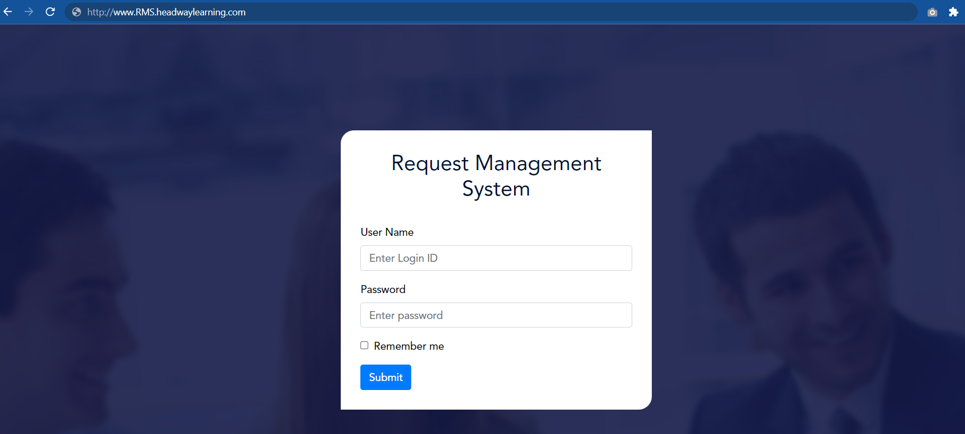

1. Enter Username and Password
2. Click on Submit button

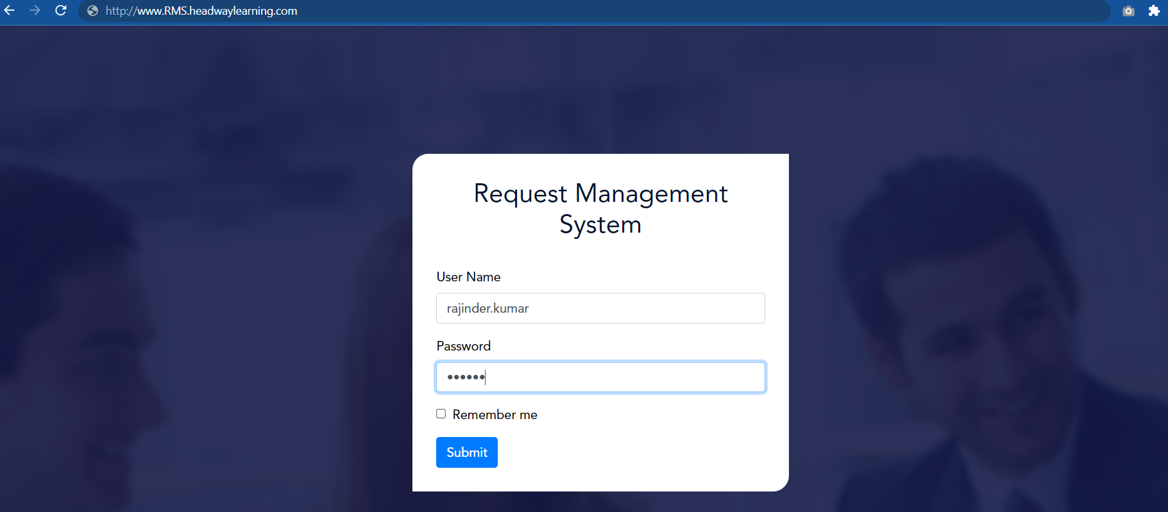

1. After login the landing page would be according to user role (processor, auditor or supervisor).
2. Login with Processor role

# Non-functional Requirements

## Software Quality Attributes

|  |  |
| --- | --- |
| Reliability | * The platform should provide intended functionalities given the input, assumptions & the environment remains consistent. |
| Maintainability | * The code should be maintained with all the coding standards defined at Headway Software Solutions. |
| Portability & Extensibility | * It should be easy enough to port the platform to any environment which falls under the defined operating environment. |
| Availability- | * The platform should be up 24x7 |
| Usability | * User training would be provided to the initial set of internal users. Further training to new users would be provided by the process team. |

# Summary Mailer Execution Frequency

|  |  |  |  |  |
| --- | --- | --- | --- | --- |
| **S No.** | **Bot Name** | **Run Type** | **Execution Frequency** | **Execution Time** |
| 1 | DailyAssignment_RMS | Daily | Twice a Day | 10:00 am EST and 4:00 EST |
| 2 | DailySLAQuality_RMS | Daily | Twice a Day | 10:00 am EST and 4:00 EST |

# Appendix 1: Master Request Type Mapping, SLA and Benchmark Quality

# Revision History

|  |  |  |  |
| --- | --- | --- | --- |
| Version | Change Date | Changed by | Change Summary |
| D0.1 | Dec 24, 2020 | Rajinder Kumar | * Initial Draft of Request Management System requirements |
| D0.2 | Jan 03, 2021 | Rajinder Kumar | * Added the steps for updating the User Management |