SAE J1939 -(SAE - Society of Automotive Engineers )

Characteristics
Uses the 29-bit extended CAN identifier
Standardized CAN baud rates of 250 kbits/s and 500 kbits/s.
Has point-to-point addressing (node addressing) and global addressing (message addressing)
Up to 1785 bytes can be transmitted with multi-packet messages
Bus access control via own network management
Standardized messages for the overall vehicle communication
Allows manufacturer-specific message definition
Defines own diagnostic interface

SAE J1939 and CAN
The SAE J1939 protocol uses CAN (Controller Area Network, ISO 11998-1 and ISO 11998-2) as the physical layer. The CAN protocol plays a major role in motor vehicle networking and represents a commonly used method for bit serial communication between electronic control units (ECUs). Typical ECUs include: Engine, transmission, and brake ECUs as well as the instrument panel and door ECUs.

ISO 11783 – Tractors and machinery for agriculture and forestry – Serial control and communication
Defines the communication in vehicles used for agriculture. Specifically, the communication between the tractor and add-on equipment, the so-called implement. The ISO 11783 standard specifies services at the application layer, for example, the control of add-on equipment via a Virtual Terminal. The add-on equipment itself brings along all graphic elements needed for its control, which the Virtual Terminal can display. Other application components are: Tractor ECU, Task Controller, File Server, and Sequence Control. The ISO 11783 standard has an extension of the multi-packet protocol defined for SAE J1939. The Working Set mechanism is also applied.

NMEA 2000® – Serial-data networking of marine electronic devices
Defines the ECU communication between vehicles in the maritime environment.
An extension of the multi-packet protocol – the so-called Fast Packet protocol – is also used here.

ISO 11992 – Interchange of digital information between towing and towed vehicle
Specifies the message exchange of road vehicles between the towing vehicle and the towed vehicle. ISO 11992 is based on the message format of J1939 but uses a different configuration of the physical layer, namely only 125 kbits/s.

FMS – Fleet Management System
The FMS standard defines a gateway between a J1939 network and the FMS.

Parameter Group
The J1939-21 document defines the scheme according to which the 29-bit CAN identifier must be interpreted. Similarly as for the 8-byte data field of a CAN message in which different signals are defined by a start bit and length, the CAN identifier is subdivided into different segments for a parameter group. By this only a part of the identifier represents the PGN itself, the rest is interpreted as source address, destination address, priority, and data page (DP).

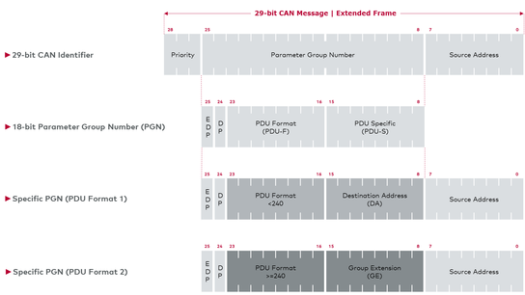

PGN Sections
The two bits “Data Page” (DP) and “Extended Data Page” (EDP) are also part of the PGN and are included for counting as the two most significant bits. As a result, the numeric range is arranged in four PGN pages, but only 3 are used for J1939.
The following data page definitions are available:

Extended Data Page (EDP) | Data Page (DP) | Description
0 | 0 | SAE J1939 and ISO 11783
0 | 1 | SAE J1939 NMEA 2000®
1 | 0 | SAE J1939 – reserved –
1 | 1 | ISO 11992 Diagnostics  (Important: no J1939 layout!)

Transport Protocol
Messages greater than 8 bytes in length are too large to fit into a single CAN Data Frame. Therefor they must be divided by the sender into individual packets, which can then be sent with a CAN message each. The receiver has to recombine the individual fragments in their original order. A set of rules is defined for this in the J1939 standard: a so-called transport protocol.
Two transport protocols are defined corresponding to the communication types.

Specific Communication – Connection Mode Data Transfer (RTS/CTS)
With this protocol the sender establishes a connection to the receiver. The receiver has the option of controlling and influencing the flow control of the individual data packets. Both the receiver and sender can abort the connection (e.g. in case of errors).
The Connection Mode Data Transfer protocol is not subject to any time limitation. All nodes potentially exchange their data with one another at their maximum possible speed.
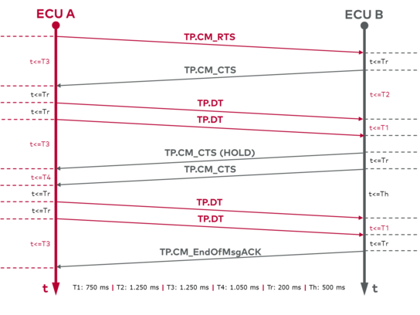

Global Communication – Broadcast Announce Message (BAM)
The sender alone manages the flow control. The message is always sent to all nodes. A receiver cannot intervene in the communication. If the receiver misses a message, it cannot signal this. The receiver must wait for a new message, if necessary.
Because the receiver is not able to influence the flow control in the BAM protocol, the sender must maintain a minimum interval between the individual packets. This is 50-200 ms. This allows possible slow network nodes to follow the communication.
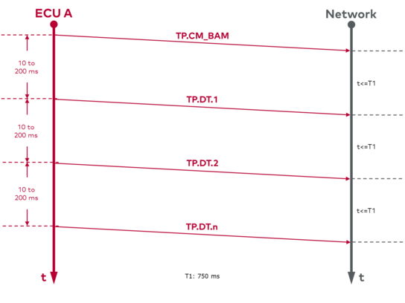

Diagnostics
The J1939 diagnostic interface defines a standard diagnostic connector as well as a set of PGNs for handling different diagnostic services. The PGNs designated as a Diagnostic Message (DM) largely fulfill the scope of functions of the UDS diagnostics (Unified Diagnostic Service). They also comply with the EU Directives and with the “California Code of Regulation” for Onboard Diagnostics (OBD II), as well as HD OBD (Heavy Duty OBD) and WWH (World Wide Harmonized) OBD (ISO 27145).
In contrast to the UDS diagnostics in which services have to be actively initiated via a software tool, J1939 ECUs also send diagnostic messages independently during standard operation. Errors that occur are evaluated directly in the network and visually displayed, if necessary. In parallel with that, errors can be read out with a tool via the diagnostic connector. Uniform error codes – so-called Diagnostic Trouble Codes (DTC) – contain the faulty SPN, the error pattern, and the frequency of occurrence of an error.

Diagnostic Trouble Code (DTC)
A DTC (Diagnostic Trouble Code) represents a faulty property in the system. It primarily represents an SPN whose current status is abnormal. This can have different causes. An indicator that gives the reason for the status is used to try to narrow down the actual cause of the error. A DTC has a uniform structure and consists of the following elements:
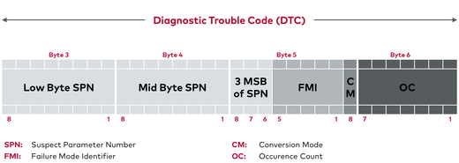

- Suspect Parameter Number (SPN)
Represents the SPN with error. Every defined SPN can be used in a DTC.
- Failure Mode Identifier (FMI)
Represents the nature and type of error that occurred, e.g., value range violation (high or low), sensor short-circuits, incorrect update rate, calibration error.
- Occurrence Counter (OC)
A counter that counts the occurrence of the error condition for each SPN and stores this even when the error is no longer active.
- SPN Conversion Method (CM)
Defines the byte alignment within the DTC. The value “0” represents the method shown in graphic “Structure of a DTC”. If CM has the value “1”, a distinction must be made between three previously valid methods; this must be known for the system.

