Exercise 1: Control Structures

Scenario 1: The bank wants to apply a discount to loan interest rates for customers above 60 years old.

Question: Write a PL/SQL block that loops through all customers, checks their age, and if they are above 60, apply a 1% discount to their current loan interest rates.

The above scenario can be executed using PL/SQL using the following code:
We initially, create the tables – ‘Customers’ and ‘Loans’.
-- Customer Table
CREATE TABLE Customers (
CustomerID NUMBER PRIMARY KEY,
Name VARCHAR2(100),
Age NUMBER,
Balance NUMBER,
IsVIP CHAR(1) DEFAULT 'N'
);

-- Loans Table
CREATE TABLE Loans (
LoanID NUMBER PRIMARY KEY,
CustomerID NUMBER,
InterestRate NUMBER,
DueDate DATE
);

Next, we add some sample values to the respective tables to verify the PL/SQL operations mentioned.

-- Insert values to verify the outputs

INSERT INTO Customers VALUES (1, 'Alice', 65, 12000, 'N');
INSERT INTO Customers VALUES (2, 'Bob', 45, 8000, 'N');
INSERT INTO Customers VALUES (3, 'Charlie', 70, 15000, 'N');

INSERT INTO Loans VALUES (101, 1, 5.5, SYSDATE + 10);
INSERT INTO Loans VALUES (102, 2, 6.0, SYSDATE + 40);
INSERT INTO Loans VALUES (103, 3, 7.0, SYSDATE + 20);

COMMIT;

We insert the values into both the tables i.e. ‘Customers’ and ‘Loans’. Also, we use the ‘COMMIT’ command in order to save the insertion operation, respectively.

The PL/SQL code for the scenario 1:

BEGIN
FOR rec IN (
SELECT c.CustomerID, l.LoanID, l.InterestRate
FROM Customers c
JOIN Loans l ON c.CustomerID = l.CustomerID
WHERE c.Age > 60
) LOOP
UPDATE Loans
SET InterestRate = InterestRate - 1
WHERE LoanID = rec.LoanID;
END LOOP;

COMMIT;
END;

-- for checking the output.
SELECT * FROM Loans;

Output screenshot for the above scenario:

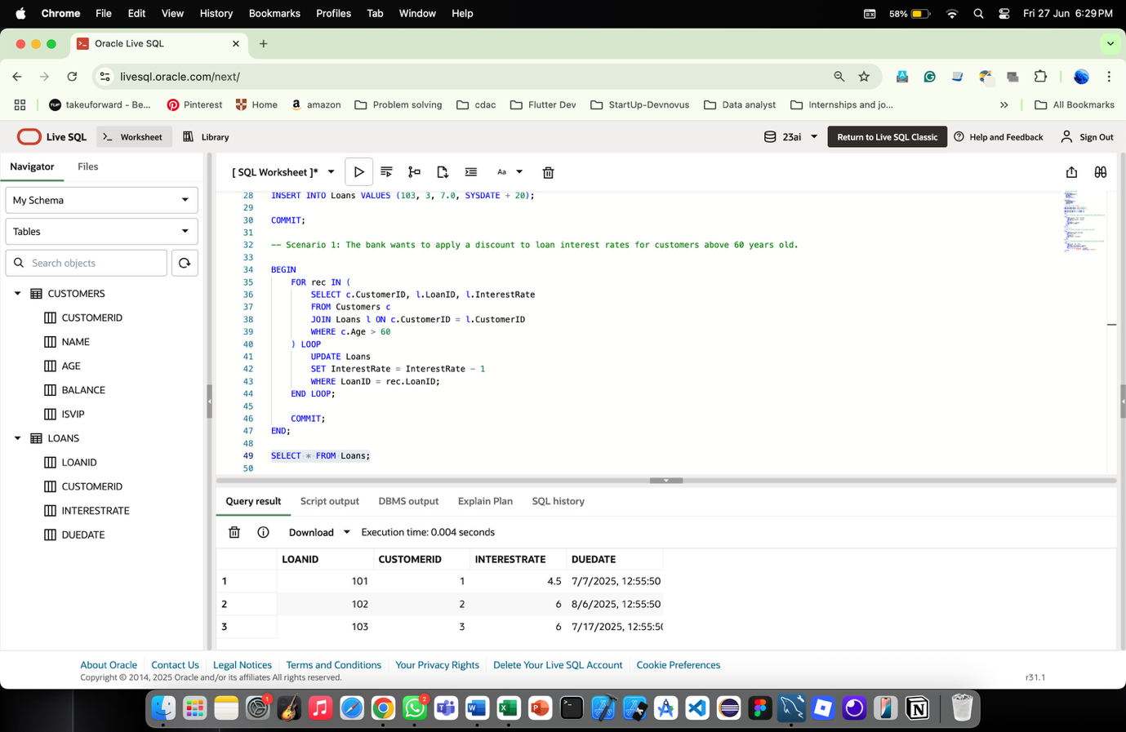

Scenario 2: A customer can be promoted to VIP status based on their balance.

Question: Write a PL/SQL block that iterates through all customers and sets a flag IsVIP to TRUE for those with a balance over $10,000.

The above scenario can be executed using PL/SQL using the following code:

BEGIN
FOR rec IN (
SELECT CustomerID, Balance FROM Customers
WHERE Balance > 10000
) LOOP
UPDATE Customers
SET IsVIP = 'Y'
WHERE CustomerID = rec.CustomerID;
END LOOP;

COMMIT;
END;

-- for checking the output
SELECT * FROM Customers;

Output screenshot for the above scenario:

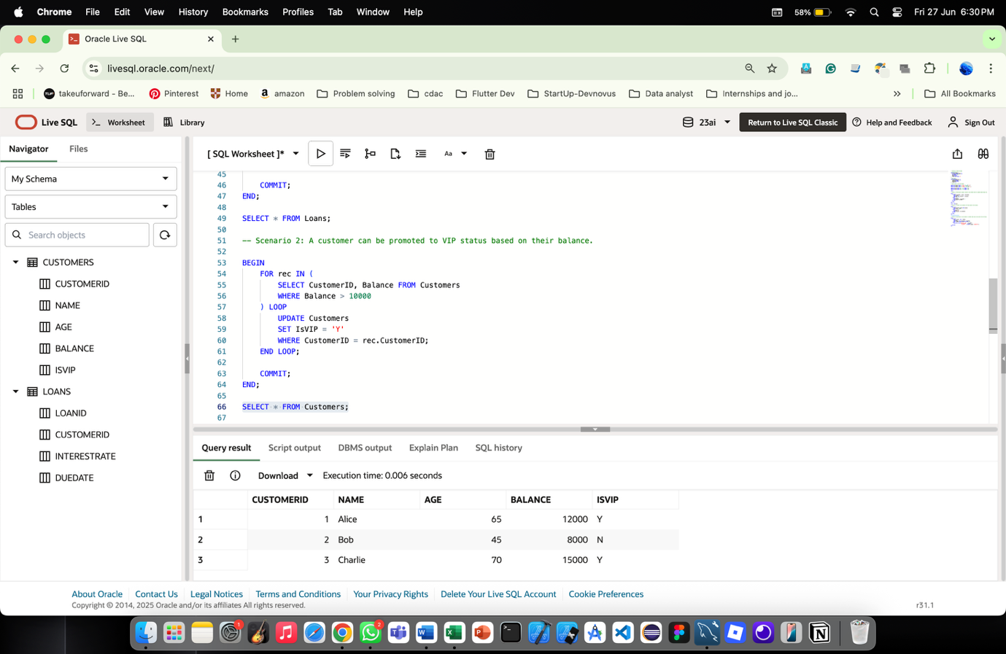

Scenario 3: The bank wants to send reminders to customers whose loans are due within the next 30 days.

Question: Write a PL/SQL block that fetches all loans due in the next 30 days and prints a reminder message for each customer.

The above scenario can be executed using PL/SQL using the following code:

BEGIN
FOR rec IN (
SELECT l.LoanID, c.Name, l.DueDate
FROM Loans l
JOIN Customers c ON l.CustomerID = c.CustomerID
WHERE l.DueDate BETWEEN SYSDATE AND SYSDATE + 30
) LOOP
DBMS_OUTPUT.PUT_LINE('Reminder: Loan ' || rec.LoanID ||
' for customer ' || rec.Name ||
' is due on ' || TO_CHAR(rec.DueDate, 'DD-MON-YYYY'));
END LOOP;
END;

Output screenshot for the above scenario:

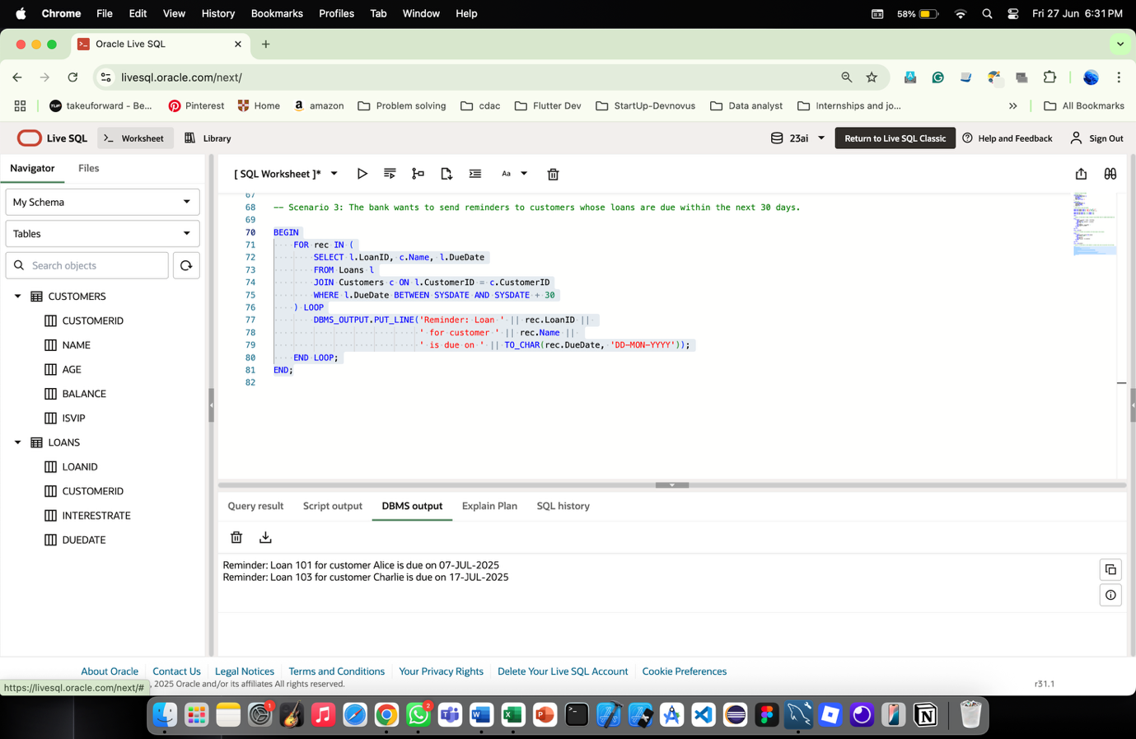

Exercise 3: Stored Procedures

Scenario 1: The bank needs to process monthly interest for all savings accounts.

Question: Write a stored procedure ProcessMonthlyInterest that calculates and updates the balance of all savings accounts by applying an interest rate of 1% to the current balance.

The above scenario can be executed using PL/SQL using the following code:
CREATE OR REPLACE PROCEDURE ProcessMonthlyInterest AS
BEGIN
UPDATE Accounts
SET Balance = Balance * 1.01
WHERE AccountType = 'Savings';

COMMIT;
END;
/
-- Run it
BEGIN
ProcessMonthlyInterest;
END;
/
-- Check results
SELECT * FROM Accounts;

Output for the above scenario:

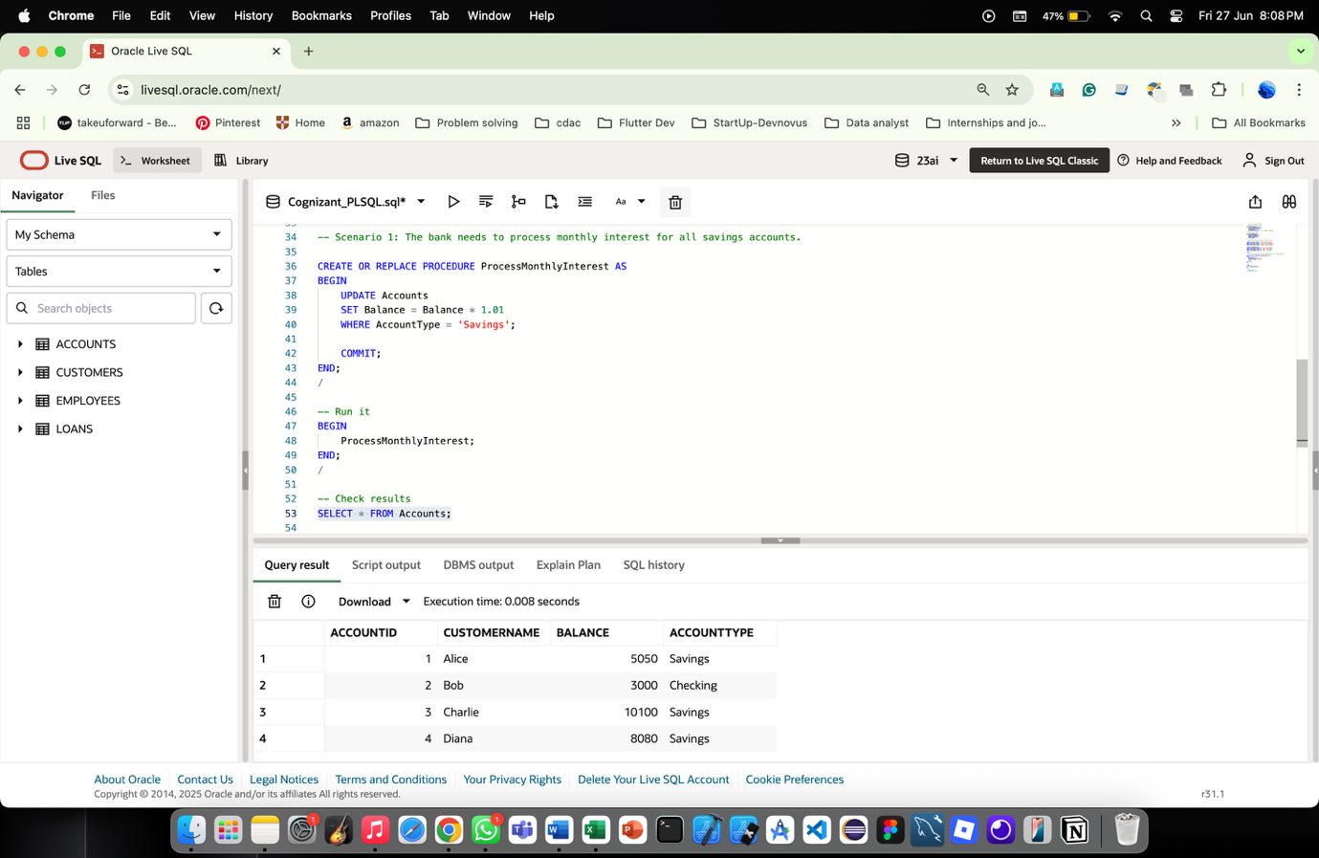
Scenario 2: The bank wants to implement a bonus scheme for employees based on their performance.

Question: Write a stored procedure UpdateEmployeeBonus that updates the salary of employees in a given department by adding a bonus percentage passed as a parameter.

The above scenario can be executed using PL/SQL using the following code:
CREATE OR REPLACE PROCEDURE UpdateEmployeeBonus (
p_Department IN VARCHAR2,
p_BonusPercent IN NUMBER
) AS
BEGIN
UPDATE Employees
SET Salary = Salary + (Salary * p_BonusPercent / 100)
WHERE Department = p_Department;

COMMIT;
END;
/
BEGIN
UpdateEmployeeBonus('Sales', 10);
END;
/
SELECT * FROM Employees;

Output for the above scenario:

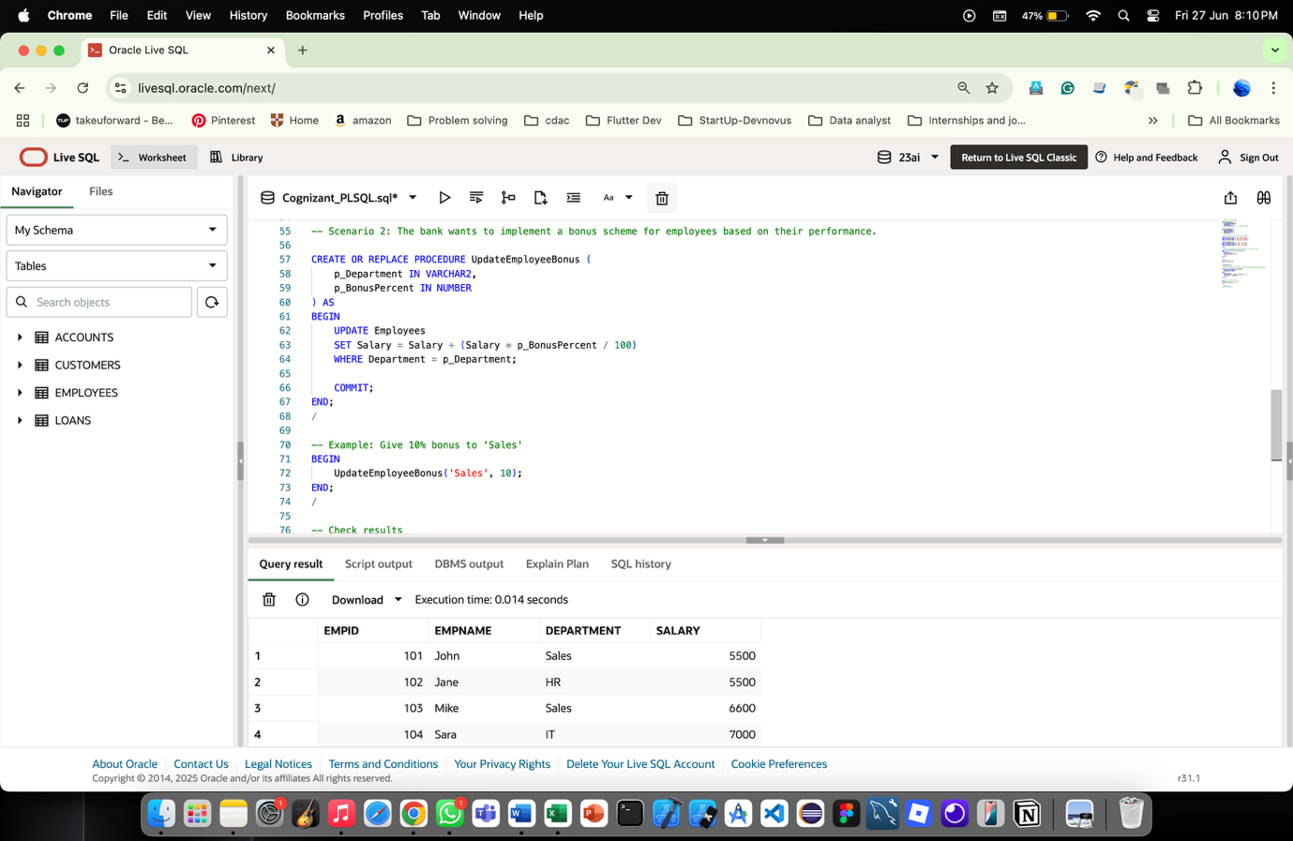
Scenario 3: Customers should be able to transfer funds between their accounts.

Question: Write a stored procedure TransferFunds that transfers a specified amount from one account to another, checking that the source account has sufficient balance before making the transfer.

The logic for the above scenario is:
CREATE OR REPLACE PROCEDURE TransferFunds (
p_FromAccount IN NUMBER,
p_ToAccount IN NUMBER,
p_Amount IN NUMBER
) AS
v_Balance NUMBER;
BEGIN
-- Check source balance
SELECT Balance INTO v_Balance FROM Accounts WHERE AccountID = p_FromAccount;

IF v_Balance < p_Amount THEN
RAISE_APPLICATION_ERROR(-20001, 'Insufficient funds.');
END IF;

-- Deduct from source
UPDATE Accounts
SET Balance = Balance - p_Amount
WHERE AccountID = p_FromAccount;

-- Add to target
UPDATE Accounts
SET Balance = Balance + p_Amount
WHERE AccountID = p_ToAccount;

COMMIT;
END;
/

-- Example: Transfer 1000 from Alice (1) to Bob (2)
BEGIN
TransferFunds(1, 2, 1000);
END;
/

-- Check results
SELECT * FROM Accounts;

Output for the above scenario is given below:
