

**INDIVIDUAL ASSIGNMENT**

**TECHNOLOGY PARK MALAYSIA**

**CT108-3-1-PYP**

**PYTHON PROGRAMMING**

**APU1F2009-CGD/IT/SE/CS(DA)/IT(IOT)/CS**

**MMT/MMT(VRAR)/CE/CS(DF)/CS(CYB)/CS(IS)** 

**HAND OUT DATE : 6thNovember 2020**

**HAND IN DATE : 22nd January 2021**

**WEIGHTAGE : 100%**

**NAME :** **RAJIN MUHTADEE SHIHAB**

**TP NUMBER : TP059508**

**INTAKE CODE :** **APD1F2009CS/APU1F2009CS**

**INSTRUCTIONS TO CANDIDATES:** 

1. Submit your assignment online in MS Teams unless advised otherwise

1. Late submission will be awarded zero (0) unless Extenuating Circumstances (EC) are upheld

1. Cases of plagiarism will be penalized

1. You must obtain at least 50% in each component to pass this module

**Table of Content**

**Content** **Page**

1. Introduction………………………………………………3
2. Assumption……………………………………………….3
3. Design - Pseudo Code………………………..………..(4-33)
4. Design – Flowchart……………………………………33
5. Sample Python Code…………………………………33-36
6. Description and Screenshots of Input / Output………36-54
7. Additional Features……………………………………..55
8. Conclusion………………………………………………56
9. Reference……………………………………………….57

**Introduction**

REAL CHAMPIONS SPORT ACADEMY is one of the fast-growing Sport Centers in Malaysia. They have employed many coaches to conduct classes spread out among different locations. The sports available are Swimming, Badminton, Football, Archery, Gymnastics, Volleyball, Basketball, Cricket, Tennis and Table Tennis. The coaches are paid on a per-hour basis ranging from 100RM to 500RM. The academy needs a system to store al coach information consisting of Coach ID, Name, Hourly Rate, Sport Centre Name etc. Within this system, students should be able to register for sports, add and modify their own details and also rate coaches from 1 to 5 stars. Students should also be able to access any information they might need post or prior to registration.  
There should be two user types, such as Admin and Student. Different Functionalities should be available for both user type and certain parts of the interface should require certain login credentials.

**Assumptions**

As per the requirement of the given task, I assume that -

1. The System is able to provide two user types [Admin , Student]
2. The System will require certain credentials to allow access to dedicated sections
3. The Admin staff will be able to add and modify records of :

* Coach
* Sports
* Sports schedule

1. The Admin staff will be able to search for specific records, such as :

* Coach by Coach ID
* Coach by Overall Performance (Rating)
* Sport by Sport ID
* Student by Student ID

1. The Admin staff will be able to sort and display records of :

* Coaches in ascending order by names
* Coaches in ascending order by hourly pay rate
* Coaches in ascending order by overall performance

1. Registered students will be able to :

* View records of coach, sport, sport schedule
* View and modify self-records
* Rate coaches and provide feedback

1. Unregistered students will be able to:

* Register
* View sport details and schedule

**Design - Pseudo Code**

**Main Menu Section**

Start

Function mainmenu()

Declare menuc1

Display "\t\tWELCOME TO REAL CHAMPIONS SPORT ACADEMY"

Display "\n\nChoose User Type (1/2)\n\n1. ADMIN\n2. STUDENT"

Display "\nEnter Your Choice : "

Read menuc1

if (menuc1 == 1)

Display "\n\t\tYou've Chosen The Admin User Type"

Call adminmenu1()

else if (menuc1 == 2)

Display "\n\t\tYou've Chosen The Student User Type"

Call studentmenu1()

Else if (menuc1 == 0)

Display "Program Terminated. Good Bye!"

else

Display "\n\t\tWrong Input"

Call mainmenu()  
 End if

**Admin Menu Login Section [Password 92125]**

Function adminmenu1()

Declare adminpass

Display "\n\n\t\tLOGIN TO USE ADMIN SYSTEMS"

Display "\n\nPlease Enter The Admin System Password : "

Read adminpass

if (adminpass == 92125)

Display "\n\t\tLogin Successful"

Call adminmenu2()

else

Display "Wrong Password!"

Call adminmenu1()  
  
End if

**Admin Menu Section [Logged In]**

Function adminmenu2()

Declare adminc1

Display "\n\n\t\tWELCOME TO REAL CHAMPIONS SPORT ACADEMY ADMIN SYSTEMS”

Display "\n\n\t\tHere Are The Functionalities!"

Display "\n\n1. Add Records of \n\n\t11. Coach\n\t12. Sport\n\t13. Sport Schedule\n\n2. Display All Records of\n\n\t21. Coach\n\t22. Sport\n\t23. Registered Students\n\t24. Coach Feedback""\n\n3. Search Specific Records of\n\n\t31. Coach by Coach ID\n\t32. Coach by Overall Performance (Rating)\n\t33. Sport by Sport ID\n\t34. Student by Student ID""\n\n4. Sort and display Record of\n\n\t41. Coaches in Ascending Order by Names.\n\t42. Coaches Hourly Pay Rate in Ascending Order\n\t43. Coaches Overall Performance in ascending order""\n\n5. Modify Record of\n\n\t51. Coach\n\t52. Sport\n\t53. Sport Schedule\n\n00. Exit")

Display "\nEnter Your Choice [FE 12 / 22 / 43] : "

Read adminc1

if (adminc1 == 11)

Call addcoach()

else if (adminc1 == 12)

Call addsport()

else if (adminc1 == 13)

Call addschedule()

else if (adminc1 == 21)

Call discoach()

else if (adminc1 == 22)

Call dissports()

else if (adminc1 == 23)

Call disregstud()

Else if (adminc1 == 24)

Call discoachfeed()

else if (adminc1 == 31)

Call discoachid()

else if (adminc1 == 32)

Call discoachperf()

else if (adminc1 == 33)

Call dissportid()

else if (adminc1 == 34)

Call disstudid()

else if (adminc1 == 41)

Call sortname()

else if (adminc1 == 42)

Call sortpay()

else if (adminc1 == 43)

Call sortperf()

else if (adminc1 == 51)

Call modcoach()

else if (adminc1 == 52)

Call modsport()

else if (adminc1 == 53)

Call modschedule()

else if (adminc1 == 00)

Call mainmenu()

End if

**Coach Addition Section [ADMIN CHOICE 11]**

Function addcoach()

Declare coachrec, Coachid, Name, DOB, Sport, Spcode, Location, Hrate, Jdate, rate,   
phone, X

Display "\n\n\t\tCoach Records")

Open file "CoachRecords.txt" in write mode as coachrec

Open file "CoachRecords.txt" in append mode

Display "\n\n\t\tEnter Coach Details"

Display "Coach ID : "

Read Coachid

Display "Name : "

Read Name

Display "Date of Birth : "

Read DOB

Display "Sport : "

Read Sport

Display "Sport Code : "

Read Spcode

Display "Location : "

Read Location

Display "Hourly Rate : "

Read Hrate

Display "Joining Date : "

Readl Jdate

Display "Initial Rating [ 1 / 2 / 3 / 4 / 5 ] "

Read rate

Display “Phone Number : “

Read phone

Write(Coachid+"\t"+Name+"\t"+DOB+"\t"+Sport+"\t"+Spcode+"\t"+Location+"\t"+Hrate+"\t"+Jdate+"\t"+rate) in “CoachRecords.txt”

Close file “CoachRecords.txt”

Display "Do You Want To Continue? [0 / 1] : "

if (X == 0)

Call adminmenu2()

else if (X == 1)

Call addcoach()

else

Display "Wrong Input"

Call mainmenu()

End if

**Sport Addition Section [ADMIN CHOICE 12]**

Function addsport()

Declare sportrec, Name, Spcode, Location, X

Display "\n\n\t\tSport Records")

Open file "Sport Records.txt" in write mode as sportrec

Open file "Sport Records.txt" in append mode

Display "\n\n\t\tEnter Sport Details"

Display "Enter Sport Name : "

Read Name

Display "Enter Sport Code : "

Read Spcode

Display "Enter Location : "

Read Location

Write (Name+"\t"+Spcode+"\t"+Location) in “Sport Records.txt”

Close file “Sport Records.txt”

Display "Do You Want To Continue? [0 / 1] "

Read X

if (X == 0)

Call adminmenu2()

else if (X == 1)

Call addsport()

else

Display "Wrong Input")

Call mainmenu()

End if

**Sport Schedule Addition Section [ADMIN CHOICE 13]**

Function addschedule():

Declare spsche, Spcode, Name, Location, Wkday, Time, X

Display "\n\n\t\tSport Schedule")

#Open file “Sport Schedule.txt" in write mode as spsche

#Write "Sport_Code\tSport\tLocation\tWeekdays\tTime [GMT +8]" in

“Sport Schedule.txt”

Open file "Sport Schedule.txt" in append mode

Display "\n\n\t\tEnter Sport Schedule Details"

Display "Enter Sport Code : "

Read Spcode

Display "Enter Sport Name : "

Read Name

Display "Enter Location : "

Read Location

Display "Enter Day of The Week [1 Max] : "

Read Wkday

Display "Enter Time of The Day [HH:MM AM/PM] : "

Read Time

Write (Spcode+"\t"+Name+"\t"+Location+"\t"+Wkday+"\t"+Time) in

“Sport Schedule.txt”

Close file “Sport Schedule.txt”

X = Display "Do You Want To Continue? [0 / 1] : "

if (X == 0)

Call adminmenu2()

else if (X == 1)

Call addschedule()

else

Display "Wrong Input")

Call mainmenu()

End if

**Display Coach Records Section [ADMIN CHOICE 21]**

Function discoach():

Declare X  
 Display”\nCoach_ID\tName\tDOB\tSport\tSport_Code\tLocation\tHourly_Rate\tJoined\tRating\tPhone”

Open file "CoachRecords.txt"," in read mode

Read “CoachRecords.txt”

Display “CoachRecords.txt”

Close file “CoachRecords.txt”

Display "Go Back To Admin? [0 / 1] : "

if (X == 1)

Call adminmenu2()

Else if (X == 0)

Display “Good Bye!"

End if

**Display Sport Section [ADMIN CHOICE 22]**

Function dissports():

Declare X

Display "\nSport Name\tSport Code\tLocation"

Open file "Sport Records.txt” in read mode

Read “Sport Records.txt”

Display “Sport Records.txt”

Display "Go Back To Admin? [0 / 1] : "

if (X == 1)

Call adminmenu2()

Else if (X == 0)

Display "Good Bye!"

End if

**Display Registered Students Section [ADMIN CHOICE 23]**

Function disregstud():

Declare X

Open file "Student Records.txt” in read mode

Read “Student Records.txt”

Display “Student Records.txt”

Display “Go Back To Admin? [0 / 1] : "

Read X

if (X == 1)

Call adminmenu2()

Else if (X == 0)

print("Good Bye!")

End if

**Display Coach Feedback Section [ADMIN CHOICE 24]**

Function discoachfeed():

Declare X

Open file "Feedback.txt" in read mode

Read "Feedback.txt"

Display "Feedback.txt"

Display “Go Back To Admin? [0 / 1] : "

Read X

if (X == 1)

Call adminmenu2()

Else if (X == 0)

print("Good Bye!")

End if

**Search Coach By Coach ID Section [ADMIN CHOICE 31]**

Function discoachid()

Declare a, sid, X

a = 0

Open file "CoachRecords.txt” in read mode

Display "\n\nEnter Coach ID To Search : "

Read sid Display”\nCoach_ID\tName\tDOB\tSport\tSport_Code\tLocation\tHourly_Rate\tJoined\tRating\tPhone”)

for line in file “CoachRecords.txt”

if sid in line:

Display “line”

a = a + 1

End if

if (a == 0)

Display “Entry Not Found. Try Again"

Call discoachid()

End if

Display "Go Back To Admin? [0 / 1] : "

Read X

if (X == 1)

Call adminmenu2()

Else if (X == 0)

Display "Good Bye!"

End if

**Search Coach By Performance Section [ADMIN CHOICE 32]**

Function discoachperf()

Declare a, rate, f, X  
   
a = 0

Open file "CoachRecords.txt" in read mode

Display "\n\nEnter Coach Rating To Search [1 / 2 / 3 / 4 / 5] : "

Read rate

Display"\nCoach_ID\tName\tDOB\tSport\tSport_Code\tLocation\tHourly_Rate\tJoined\t

Rating"

for line in file “CoachRecords.txt”

f = line

line = split(line,"\t")

if rate in line[8]:

Display “f”

a = a + 1

End if

if (a == 0)

Display "Entry Not Found. Try Again"

Call discoachperf()  
 End if

Close file “Coach Records.txt"

Display "Go Back To Admin? [0 / 1] : "

if (X == 1)

Call adminmenu2()

Else if (X == 0)

Display "Good Bye!"

End if

**Search Sport By Sport ID Section [ADMIN CHOICE 33]**

Function dissportid():

Declare a, spid, X

a = 0

Open file "Sport Records.txt" in read mode

Display "\n\nEnter Sport Code To Search : "

Read spid

Read line from “Sport Records.txt”

Display “line”

for line in file “Sport Records.txt”

if spid in line

Display “line”

a = a + 1

End if

if ( a == 0 )

Display "Entry Not Found"

Call dissportid()

End if

Display "Go Back To Admin? [0 / 1] : "

Read X

if (X == 1)

Call adminmenu2()

Else if (X == 0)

Display "Good Bye!"

End if

**Search Student By Student ID Section [ADMIN CHOICE 34]**

Function disstudid()

Declare a, stid, X

a = 0

Open file "Student Records.txt" in read mode

Display "\n\nEnter Student ID To Search [F.E : CSAXXXX] : "

Read stid

Read line from "Student Records.txt"

Display “line”

for line in file "Student Records.txt"

if stid in line

Display “line”

a = a + 1

End if

if (a == 0)

Display "Entry Not Found. Try Again"

Call disstudid()

End if

Close file "Student Records.txt"

Display "Go Back To Admin? [0 / 1] : "

Read X

if (X == 1)

Call adminmenu2()

Else if (X == 0)

Display "Good Bye!"

End if

**Sort Coach By Name Section [ ADMIN CHOICE 41 ]**

Function sortname():

Declare a, x, aux

Declare list as sortlist

Open file "CoachRecords.txt" in read mode

for line in "CoachRecords.txt"

line = split(line, "\t")

append line[1] into sortlist

a = True

while a:

a = False

for cnt in range 0 to (len(sortlist)-1)

if sortlist[cnt] > sortlist[cnt+1]

aux = sortlist[cnt]

sortlist[cnt] = sortlist[cnt+1]

sortlist[cnt+1] = aux

a = True

End if

End while

Display"\nCoach_ID\tName\tDOB\tSport\tSport_Code\tLocation\tHourly_Rate\tJoined\tRating\tPhone"

for x in sortlist:

Open file "CoachRecords.txt" in read mode

for line in coachrec

temp = line

line = line.split("\t")

if x in line[1]:

Display ("\n"+temp)

End if

Close file "CoachRecords.txt"

Display "Go Back To Admin? [0 / 1] : "

Read X

if (X == 1)

Call adminmenu2()

Else if (X == 0)

Display "Good Bye!"

End if

**Sort Coach By Hourly Pay Rate Section [ ADMIN CHOICE 42 ]**

Function sortname()

Declare a, x, aux

Declare list as sortlist

Open file "CoachRecords.txt" in read mode

for line in "CoachRecords.txt"

line = split(line, "\t")

append line[6] into sortlist

a = True

while a:

a = False

for cnt in range 0 to (len(sortlist)-1)

if sortlist[cnt] > sortlist[cnt+1]

aux = sortlist[cnt]

sortlist[cnt] = sortlist[cnt+1]

sortlist[cnt+1] = aux

a = True

End if

End while

Display"\nCoach_ID\tName\tDOB\tSport\tSport_Code\tLocation\tHourly_Rate\tJoined\tRating\tPhone"

for x in sortlist:

Open file "CoachRecords.txt" in read mode

for line in coachrec

temp = line

line = line.split("\t")

if x in line[6]:

Display ("\n"+temp)

End if

Close file "CoachRecords.txt"

Display "Go Back To Admin? [0 / 1] : "

Read X

if (X == 1)

Call adminmenu2()

Else if (X == 0)

Display "Good Bye!"

End if

**Sort Coach By Performance (Rating) Section [ ADMIN CHOICE 43 ]**

Function sortname():

Declare a, x, aux

Declare list as sortlist

Open file "CoachRecords.txt" in read mode

for line in "CoachRecords.txt"

line = split(line, "\t")

append line[8] into sortlist

a = True

while a:

a = False

for cnt in range 0 to (len(sortlist)-1)

if sortlist[cnt] > sortlist[cnt+1]

aux = sortlist[cnt]

sortlist[cnt] = sortlist[cnt+1]

sortlist[cnt+1] = aux

a = True

End if

End while

Display"\nCoach_ID\tName\tDOB\tSport\tSport_Code\tLocation\tHourly_Rate\tJoined\tRating\tPhone"

for x in sortlist:

Open file "CoachRecords.txt" in read mode

for line in coachrec:

temp = line

line = line.split("\t")

if x in line[8]:

Display ("\n"+temp)

End if

Close file "CoachRecords.txt"

Display "Go Back To Admin? [0 / 1] : "

Read X

if (X == 1)

Call adminmenu2()

Else if (X == 0)

Display "Good Bye!"

End if

**Modifying Coach Records Section [ADMIN CHOICE 51]**

Function modcoach():

Declare O, Y, temp, X

Display"\nCoach_ID\tName\tDOB\tSport\tSport_Code\tLocation\tHourly_Rate\tJoined\tRating\tPhone"

Open file "CoachRecords.txt" in read mode

Read "CoachRecords.txt"

Display "CoachRecords.txt"

Display "Enter The Word : "

Read O

Display "Replacement : "

Read Y

Open “out.txt" in write mode as temp

for line in "CoachRecords.txt"

write (line.replace(O, Y)) in “out.txt”

Close file "CoachRecords.txt"

Close file “out.txt”

Open file "out.txt" in read mode

Open file "CoachRecords.txt" in write mode

for line in “out.txt”

write line in "CoachRecords.txt"

Close “out.txt”

Close "CoachRecords.txt"

Display "Go Back To Admin? [0 / 1] : "

Read X

if (X == 1)

Call adminmenu2()

Else if (X == 0)

Display "Good Bye!"

End if

**Modifying Sport Records Section [ADMIN CHOICE 52]**

Function modsport():

Declare O, Y, temp, X

Display "\nSport Name\tSport Code\tLocation"

Open file "Sport Records.txt" in read mode

Read "Sport Records.txt"

Display "Sport Records.txt"

Display "Enter The Word : "

Read O

Display "Replacement : "

Read Y

Open “out.txt" in write mode as temp

for line in "Sport Records.txt"

write (line.replace(O, Y)) in “out.txt”

Close file "Sport Records.txt"

Close file “out.txt”

Open file "out.txt" in read mode

Open file "Sport Records.txt" in write mode

for line in “out.txt”

write line in "Sport Records.txt"

Close “out.txt”

Close "Sport Records.txt"

Display "Go Back To Admin? [0 / 1] : "

Read X

if (X == 1)

Call adminmenu2()

Else if (X == 0)

Display "Good Bye!"

End if

**Modifying Sport Schedule Records Section [ADMIN CHOICE 53]**

Function spsche():

Declare O, Y, temp, X

Display "Sport_Code\tSport\tLocation\tWeekdays\tTime [GMT +8]"

Open file "Sport Schedule.txt" in read mode

Read "Sport Schedule.txt"

Display "Sport Schedule.txt"

Display "Enter The Word : "

Read O

Display "Replacement : "

Read Y

Open “out.txt" in write mode as temp

for line in "Sport Schedule.txt"

write (line.replace(O, Y)) in “out.txt”

Close file "Sport Schedule.txt"

Close file “out.txt”

Open file "out.txt" in read mode

Open file "Sport Schedule.txt" in write mode

for line in “out.txt”

write line in "Sport Schedule.txt"

Close “out.txt”

Close "Sport Schedule.txt"

Display "Go Back To Admin? [0 / 1] : "

Read X

if (X == 1)

Call adminmenu2()

Else if (X == 0)

Display "Good Bye!"

End if

**Student Main Menu Section**

Function studentmenu1():

Declare studentc1

Display "\n\n\t\tWELCOME TO REAL CHAMPIONS SPORT ACADEMY STUDENT SECTION"

Display "\nStudent Type\n\n1. Registered\n2. New / Non-Registered\n0. Exit"

Display "\nChoose Student Type [0 / 1 / 2] : "

Read studentc1

if (studentc1 == 1)

Call studentmenu2()

Else if (studentc1 == 2)

Call studentmenu3()

Else if (studentc1 == 0)

Call mainmenu()

else

Display "Wrong Input"

Call studentmenu1()

End if

**Registered Student Login and Menu Section [ Password - Student ID ]**

Function studentmenu2()

Declare a, stdpass, X, F, Y, x, fback, cid, rate, tfeed

Display "\n\n\t\tLOGIN TO USE STUDENT SYSTEMS"

a = 0

Open "Student Records.txt" in read mode

Display "\n\nPlease Enter Your Student ID [F.E : CSAXXXX] : "

Read stdpass

for line in "Student Records.txt”

if stdpass in line

Display ("\n\n\t\tWelcome To The Student System Student "+stdpass)

Display "\n\nFunctionalities\n\n1. View Coach Details\n2. View Sport Details\n3. View Registered Sport Schedule\n4. View Self Record\n5. Modify Self Record\n6. Rate Coach"

Display "\n\nEnter Your Choice : "

Read X

if (X == 1)

Display"\nCoach_ID\tName\tDOB\tSport\tSport_Code\tLocation\tHourly_Rate\tJoined\tRating\tPhone"

Open "CoachRecords.txt" in read mode

Read file "CoachRecords.txt"

Close file "CoachRecords.txt"

Display "\nContinue? [0 / 1] : "

Read F

if (F == 1)

Call studentmenu2()

Else if (F == 0)

Display "Good Bye!"

End if

Else if (X == 2)

Display "\nSport Name\tSport Code\tLocation"

Open file "Sport Records.txt” in read mode

Read file "Sport Records.txt”

Display "Sport Records.txt”

Close file "Sport Records.txt”

Display "\nContinue? [0 / 1] : "

Read F

if (F == 1)

Call studentmenu2()

Else if (F == 0)

Display "Good Bye!"

End if

Else if (X == 3)

Open file “Student Records.txt" in read mode

for line in "Sport Records.txt”

line = line.strip()

x = split(line, "\t")

if stdpass == x[0]

Y = (x[3])

End if

Open "Sport Schedule.txt" in read mode

Read line in file "Sport Schedule.txt"

Display "line"

for line in "Sport Schedule.txt"

if Y in line

print (line)

End if

Display "\nContinue? [0 / 1] : "

Read F

if (F == 1)

Call studentmenu2()

Else if (F == 0)

Display “Good Bye!"

End if

Else if (X == 4)

Open file "Student Records.txt" in read mode

Read line in file "Student Records.txt"

Display “line”

for line in "Student Records.txt"

line = line.strip()

x = split(line, "\t")

if stdpass == x[0]

Display ("\n",x[0],"\t",x[1],"\t",x[2],"\t",x[3])

End if

Display "\nContinue? [0 / 1] : "

Read F

if (F == 1):

studentmenu2()

Else if(F == 0):

Display "Good Bye!"

End if

Else if (X == 5)

Open “Student Records.txt" in read mode

Read line in “Student Records.txt"

Display “line”

for line in “Student Records.txt"

if stdpass in line

Display ”line”

End if

Close file “Student Records.txt"

Open “Student Records.txt" in read mode

Display "Choose The Entry : "

Read O

Display "Replacement : "

Read Y

Open "out.txt" in write mode

for line in “Student Records.txt"

write (line.replace(O, Y)) in file “Student Records.txt"

Close file “out.txt”

Close “Student Records.txt"

Open "out.txt" in read mode

Open "Student Records.txt" in write mode

for line in “out.txt”

write line in “Student Records.txt"

Close file “out.txt”

Close file “Student Records.txt"

Display "\nContinue? [0 / 1] : "

Read F

if (F == 1)

Call studentmenu2()

Else if (F == 0)

Display "Good Bye!"

End if

Else if (X == 6):

Open file "Feedback.txt" in write mode as fback

Write "Student ID\tCoach ID\t\tRating\tFeedback" in "Feedback.txt"

Close file "Feedback.txt"

Open "Feedback.txt" in append mode

Display "Enter Coach ID : "

Read cid

Display "Rating [ 1 - 5 ] : "

Read rate

Display "How Was Your Experience With This Coach? : "

Read tfeed

Write ("\n"+stdpass+"\t\t"+cid+"\t\t"+rate+"\t"+tfeed) in "Feedback.txt"

Close file "Feedback.txt"

Display "\nContinue? [0 / 1] : "

Read F

If (F == 1)

Call studentmenu2()

Else if (F == 0)

Display "Good Bye!"

End if

**Unregistered Student Menu Section**

Function studentmenu3()

Display "\n\n\t\tWelcome To The Student Section"

Display "\n\nThe Functionalities Are\n\n1. Register\n2. Sport Details\n3. Sport Schedule\n0. Exit"

Display "Enter Your Choice : "

Read X

if (X == 1)

Call studreg()

Else if (X == 2)

print("\nSport Name\tSport Code\tLocation")

sportrec = open("Sport Records.txt","rt")

Read file “Sport Records.txt”

Display “Sport Records.txt”

Display "\nContinue? [0 / 1] : "

Read F

if (F == 1)

Call studentmenu3()

Else if (F == 0)

Display "Good Bye!"

End if

Else if(X == 3):

Open "Sport Schedule.txt" in read mode

Read file "Sport Schedule.txt"

Display "Sport Schedule.txt"

Display "\nContinue? [0 / 1] : "

Read F

if (F == 1)

Call studentmenu3()

Else if (F == 0)

Display "Good Bye!"

End if

Else if (X == 0)

Call studentmenu1()

else :

Display "\nWrong input"

Call studentmenu3()

mainmenu()

End

**Student Registration Section**

Function studreg()

Declare studrec, unid, name, dob, sport, phone, X

Display "\n\n\t\tWelcome To Registration Terminal"

Open "Student Records.txt" in write mode as studrec

Write "Student_ID\tName\tDOB\tSport" in "Student Records.txt"

Open "Student Records.txt" in append mode

Display "Create A Student ID [F.E : CSAXXXX] : "

Read unid

Display "Enter Your Name : "

Read name

Display "Enter Your Date of Birth : "

Read dob

Display "Enter Sport Name : "

Read sport

Display "Enter Your Phone Number : "

Read phone

Write ("\n"+unid+"\t"+name+"\t"+dob+"\t"+sport) in "Student Records.txt"

Close file "Student Records.txt"

Display "Do You Want To Continue? [0 / 1] : "

Read X

if (X == 0)

Call studentmenu1()

Else if (X == 1)

Call studentmenu2()

Else

Display "Wrong Input"

Call mainmenu()

**Design – Flowchart**

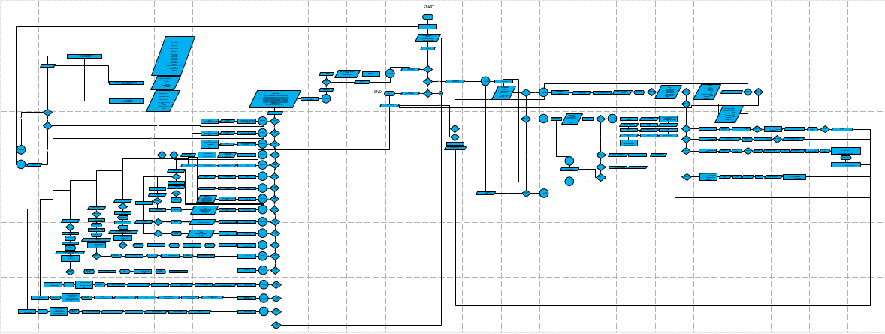

Figure : Flowchart

**Sample Python Source Code**

* **Variables:** A variable is an unstable value. In a program, depending on the information passed to it, variables can change.

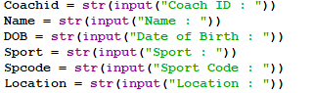

Figure : Variables

* **‘If’ Controlled Structure:** An ‘if’ controlled structure implements a condition on and runs a block of statements provided the condition is true



Figure : ‘If’ Controlled Structure

* **‘If-else’ Controlled Structure:** An ‘if-else’ controlled structured is essentially the same as an ‘if’ controlled structure, but with and an extra block of statements to run provided that the condition is false.

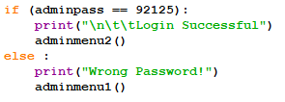

Figure : ‘In-else’ Controlled Structure

* **Nested ‘If-else’ Controlled Structure:** A nested ‘If-else’ Controlled Structure is basically an ‘If’ controlled structure within another ‘if ‘controlled structure.
* **While Loop Structure:** While loop uses a Boolean condition to determine either to run a block of statements again or stop after running it at least once.

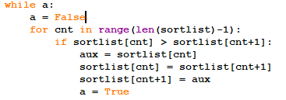

Figure : While Loop Structure

* **For Loop Structure:** For loop is used to loop a section of code to run it ‘n’ times. It uses a range and a counter.

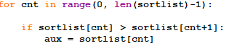

Figure : For Loop Structure

* **List Variable:** A list variable stores a list of variables inside to be used in a program. A list variable has to be declared before implementation in order to be used in further statements. Elements within the list can be removed and new elements can be either appended or inserted into specific positions.



Figure : List Variable

* **File:** Files can be created and manipulated by assigning the file to a variable. Contents of said file can be read, modified and new data can be written.
* **Write File:** Data can be written in a file if the file has been opened in write mode.



Figure : File Write Mode

* **Read File:** Contents of a file can be read for further use. To do this, the file must be opened read mode.



Figure : File Read Mode

* **Search & Modify File Data:** To search for specific data in a file, we use a for loop structure to search every line till we find the data. In order to modify it, we use replace().



Figure : Searching for Data in File

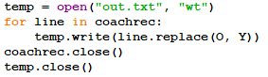

Figure : Modifying Data in File

* **Functions:** Functions can be used to isolate several blocks of code. Functions must be declared to be used. Parameters can be assigned to a function. To use a function at a certain point, it must be called.



Figure : Declaring a Function



Figure : Calling a Function

**Description and Screenshots of Input / Output**

After executing the program, The Main Menu comes up with a welcome message and asks me to choose a User type.

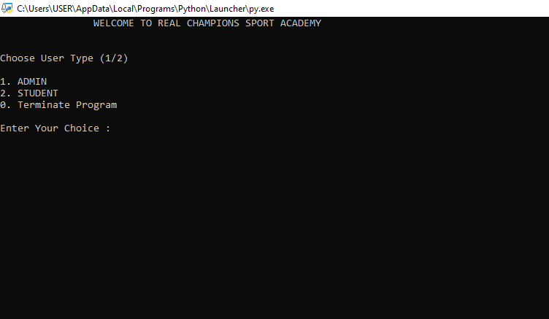

Entering 0 will terminate the program.

Entering 1 will take me to the Admin Login. There, I will have to enter the password ( 92125 ).

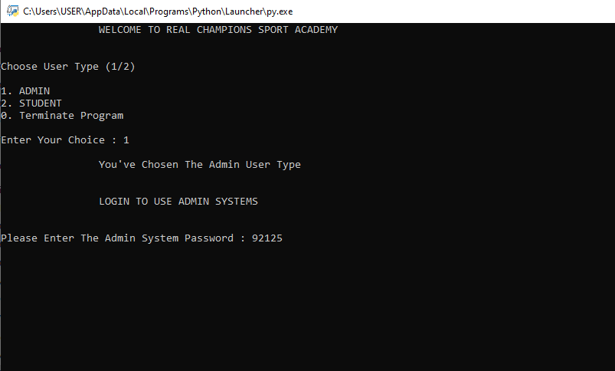

**ADMIN FUNCTIONS**

After entering the admin password, it will take me to the main admin menu, showing me the welcome message. Here all the admin functionalities are listed and program awaits a choice.

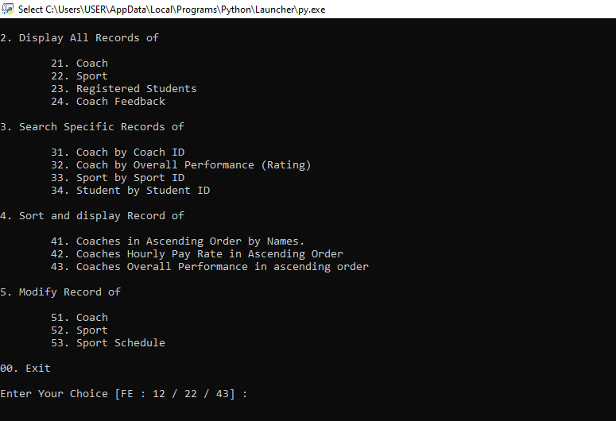

From here on out, each of the choices will take to their respective sections, where it will either await further input or display the respective part.

For Choice 11, Comes the option of adding Coach Details, which I will fill in.After that, it will ask me if I want to continue. Upon Entering 1, it will rerun this section and if I enter 0, it will returnme to the main admin menu awaiting further operation.

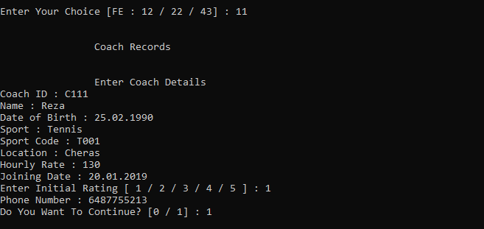

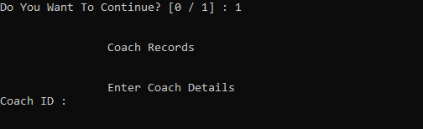

For Choice number 12, comes the option of adding Sport Details. I will enter the details and the program will ask me in I want to continue. If I enter 1, it will re run the section and if I enter 0, it will take me back to the main admin menu.

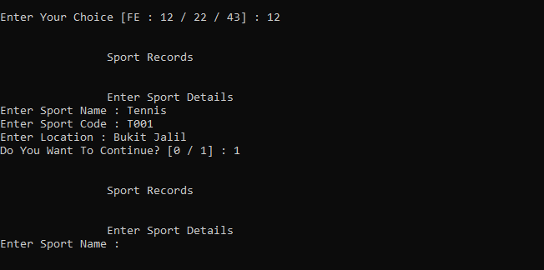

For Choice number 13, come the option of Adding Sport Schedule. I will fill this in and the program will ask me if I want to continue. If I enter 1, it will re run the section. If I enter 0, it will take me back to the main admin menu.

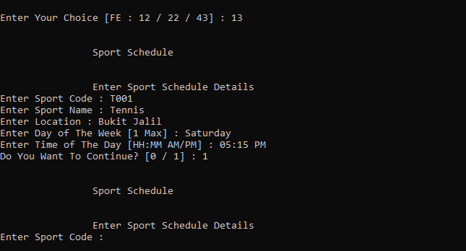

For Choice number 21, the program displays all coach records and asks me if I want to continue to admin menu. If I enter 1, it takes me back to the admin menu and if I enter 0, it terminates the progam.

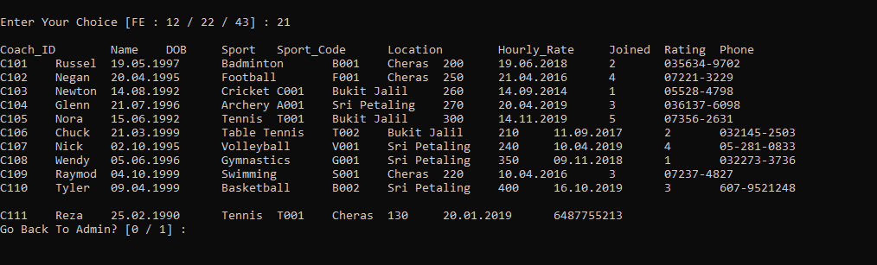

For Choice number 22, the program displays all sport records and asks me if I want to continue to admin menu. If I enter 1, it takes me back to the admin menu and if I enter 0, it terminates the progam.

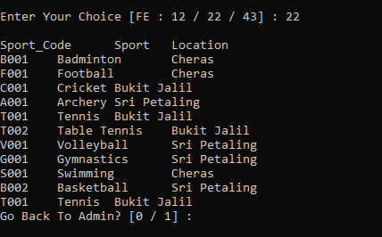

For Choice number 23, the program displays all registered student records and asks me if I want to continue to admin menu. If I enter 1, it takes me back to the admin menu and if I enter 0, it terminates the progam.

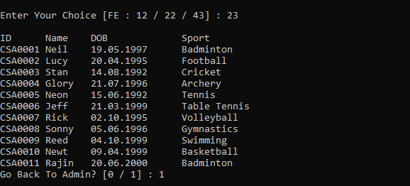

For Choice number 24, the program displays all coach feedbacks given by students and asks me if I want to continue to admin menu. If I enter 1, it takes me back to the admin menu and if I enter 0, it terminates the progam.

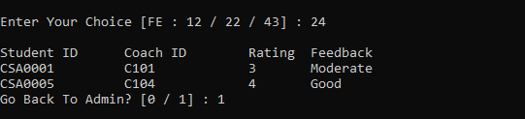

For Choice number 31, the program asks for Coach ID and displays the details of that coach and asks me if I want to continue to admin menu. If I enter 1, it takes me back to the admin menu and if I enter 0, it terminates the progam.

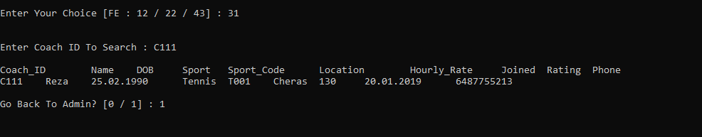

For Choice number 32, the program asks for a rating between 1 and 5 and displays the details of that coaches that have that rating.Then it asks me if I want to continue to admin menu. If I enter 1, it takes me back to the admin menu and if I enter 0, it terminates the progam.

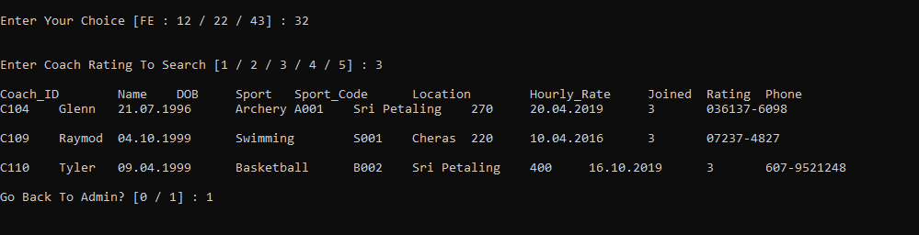

For Choice number 33, the program asks for a Sport Code and displays the details of that sport. Then it asks me if I want to continue to admin menu. If I enter 1, it takes me back to the admin menu and if I enter 0, it terminates the progam.

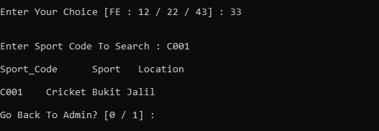

For Choice number 34, the program asks for Student ID and displays the details of that student and asks me if I want to continue to admin menu. If I enter 1, it takes me back to the admin menu and if I enter 0, it terminates the progam.

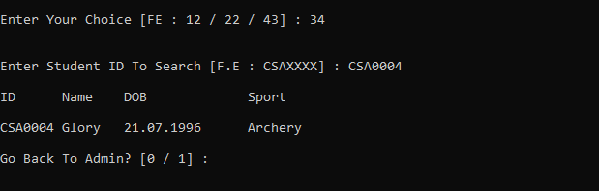

For Choice number 41, the program sorts and displays the details of coaches by Name and asks me if I want to continue to admin menu. If I enter 1, it takes me back to the admin menu and if I enter 0, it terminates the progam.

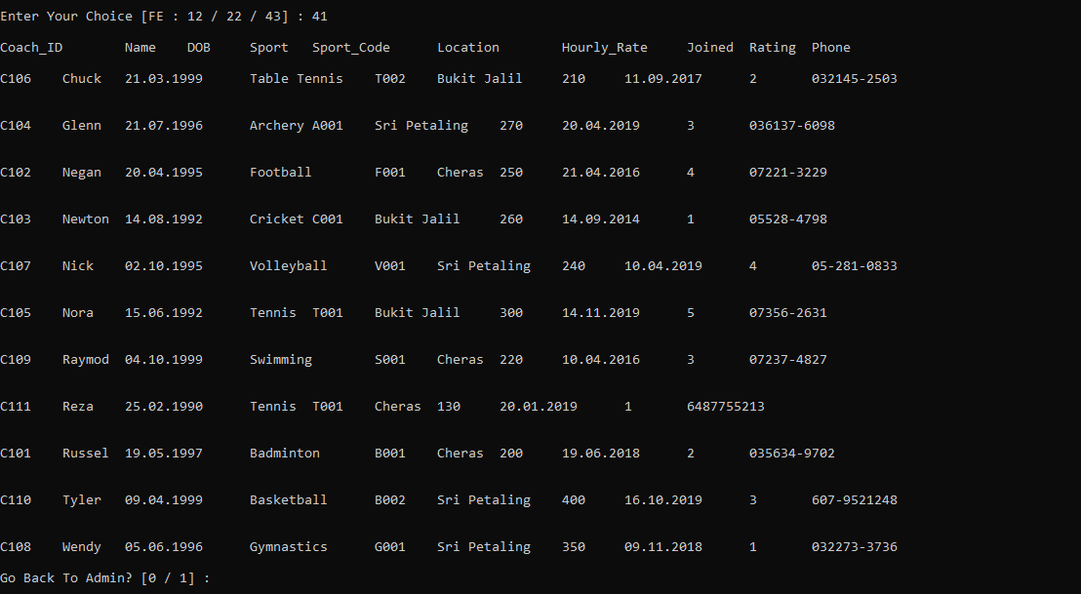

For Choice number 42, the program sorts and displays the details of coaches by Hourly Pay Rate and asks me if I want to continue to admin menu. If I enter 1, it takes me back to the admin menu and if I enter 0, it terminates the progam.

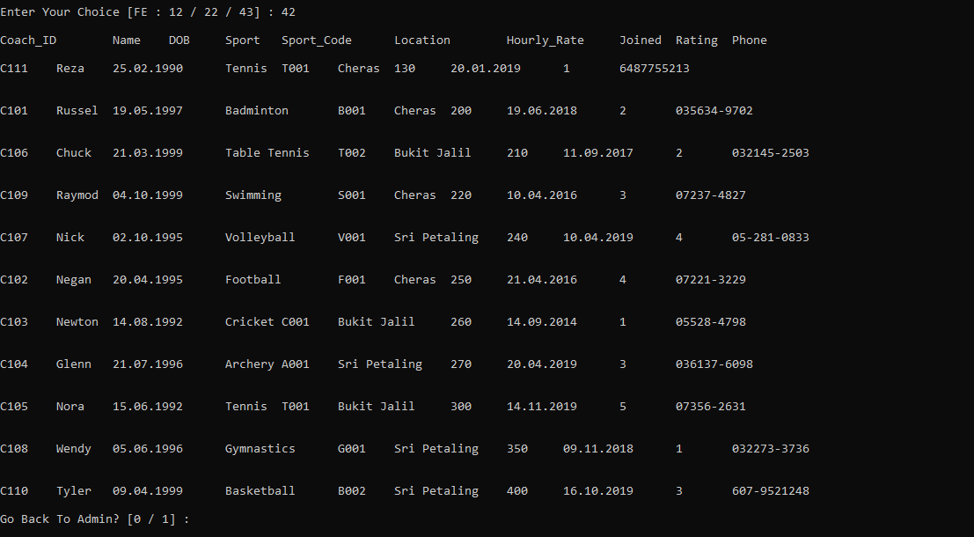

For Choice number 43, the program sorts and displays the details of coaches by Rating and asks me if I want to continue to admin menu. If I enter 1, it takes me back to the admin menu and if I enter 0, it terminates the progam.

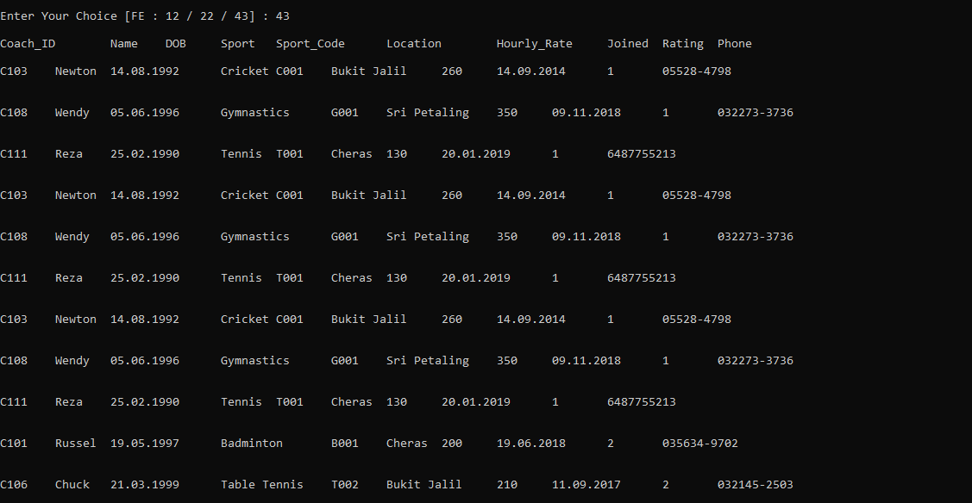

For Choice number 51, the program displays the details of coaches and asks for the word to replace and the raplacement. Then it replaces the entered word and asks me if I want to continue to admin menu. If I enter 1, it takes me back to the admin menu and if I enter 0, it terminates the progam.

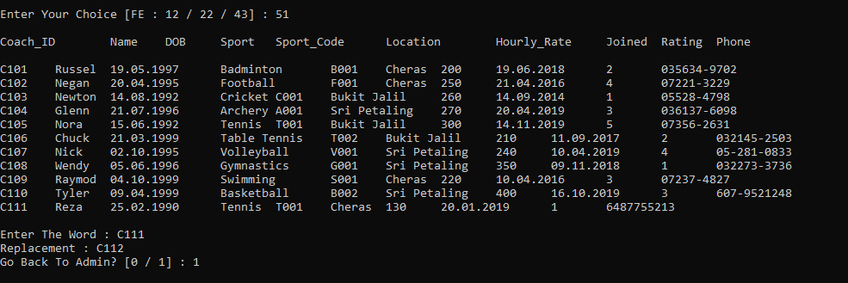



For Choice number 52, the program displays the details of sports and asks for the word to replace and the raplacement. Then it replaces the entered word and asks me if I want to continue to admin menu. If I enter 1, it takes me back to the admin menu and if I enter 0, it terminates the progam.

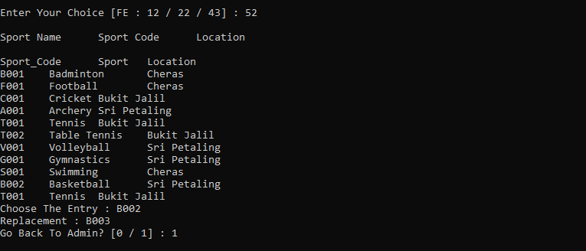



For Choice number 53, the program displays the details of sports schedule and asks for the word to replace and the raplacement. Then it replaces the entered word and asks me if I want to continue to admin menu. If I enter 1, it takes me back to the admin menu and if I enter 0, it terminates the progam.

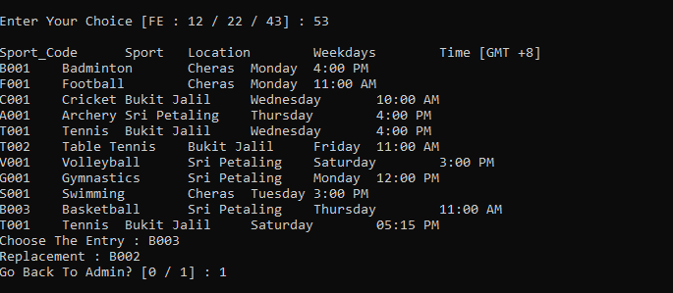

For Choice number 00, the programs returns me to the main menu and asks for user type again.

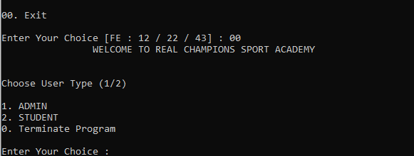

**Student Functions**

Upon entering 2 in the main menu, it takes me to the Student User section. Then it shows me the welcome message and asks me if I am a registered student or not.

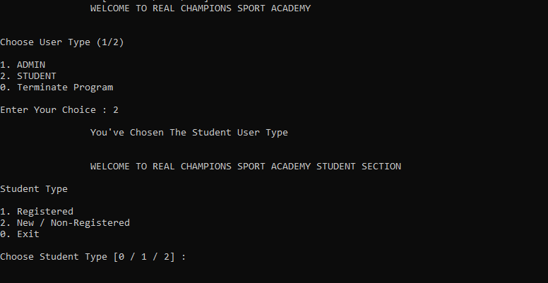

**Registered Student Functionalities [Student choice 1]**

Upon entering 1 and choosing Registered student type, it will take me to the student login section. For each student, password is their unique Student ID that they get to set for themselves. In this instance, we will enter CSA0002.

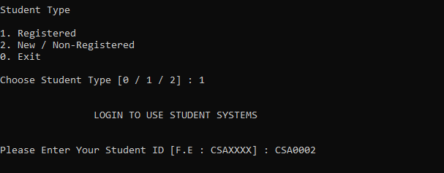

Upon entering the Student ID, it will take to the student terminal of that respective student, display the functionalities and await further choice.

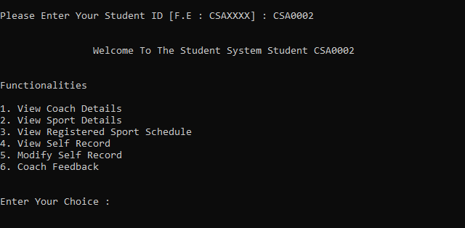

For Choice number 1, the program will display all coach details and ask if I want to go back to student systems. If I enter 1, it returns me to the student system and if I enter 0, it terminates the program.

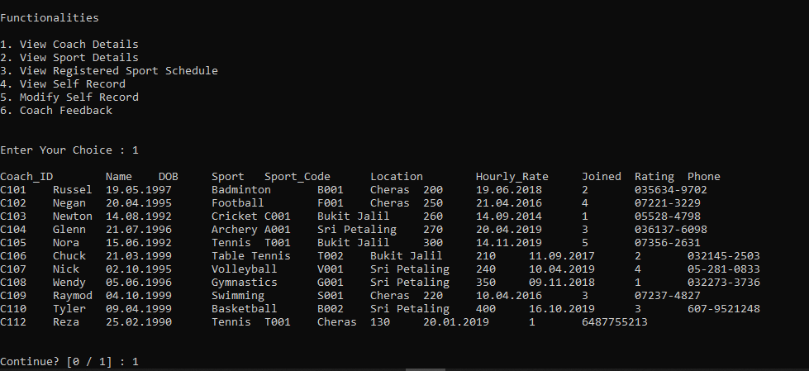

For Choice number 2, the program will display all sport details and ask if I want to go back to student systems. If I enter 1, it returns me to the student system and if I enter 0, it terminates the program.

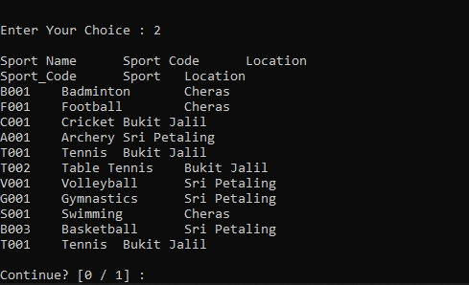

For Choice number 3, the program will display schedule of the sport that the student has registered for and ask if I want to go back to student systems. If I enter 1, it returns me to the student system and if I enter 0, it terminates the program.

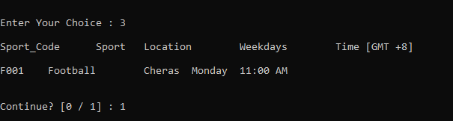

For Choice number 4, the program will display self-record of the student and ask if I want to go back to student systems. If I enter 1, it returns me to the student system and if I enter 0, it terminates the program.

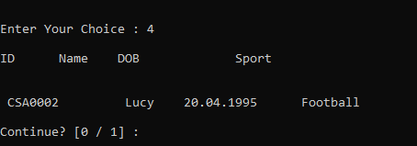

For Choice number 5, the program will display self-record of the student and ask which word to replace and the replacement. After entering, the word will be replaced and the program will ask me if I want to go back to student systems. If I enter 1, it returns me to the student system and if I enter 0, it terminates the program.

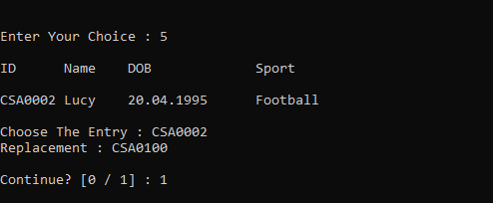

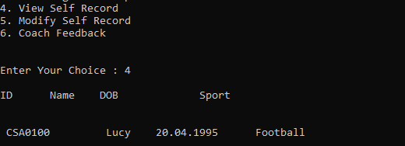

For Choice number 6, the program will ask for Coach ID, rating and feedback. After entering, the program will ask me if I want to go back to student systems. If I enter 1, it returns me to the student system and if I enter 0, it terminates the program.

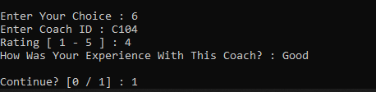

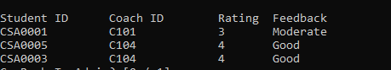

**Non-Registered Student Functionalities [Student choice 2]**

If I enter 2 and choose Non-Registered student type, it will take me to the non-registered student section, show me all functionalities and await further choice.

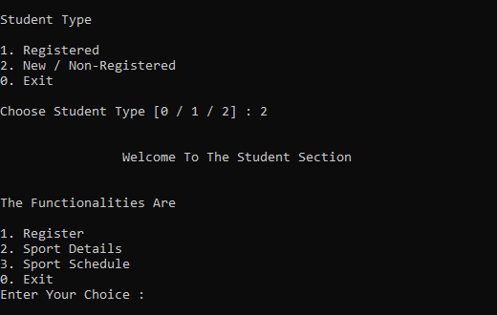

For Choice number 1, the program will take me to the registration section. Here program will ask for information that I must provide. After that, it will ask me if I want to continue. If I enter 1, it will take to the student login section and if I enter 0, it will take me back to student type selection menu.

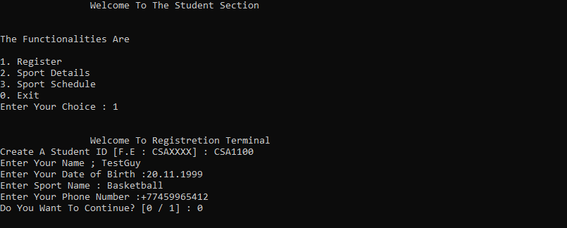

For Choice number 2, the program will display all Sport records. After that, it will ask me if I want to continue. If I enter 1, it will take to the student login section and if I enter 0, it terminate the program.

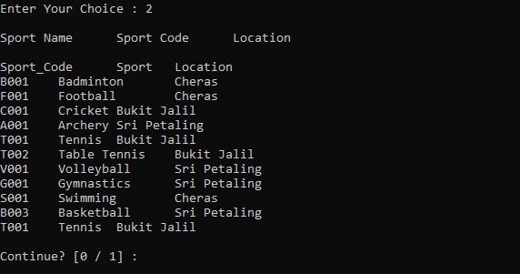

For Choice number 3, the program will display all Sport schedule records. After that, it will ask me if I want to continue. If I enter 1, it will take to the non-registered student section and if I enter 0, it will terminate the program.

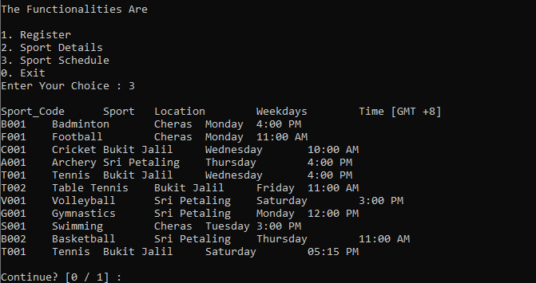

From this point onwards, entering 0 continuously will take me back to the main menu and entering 0 after that will terminate the program.

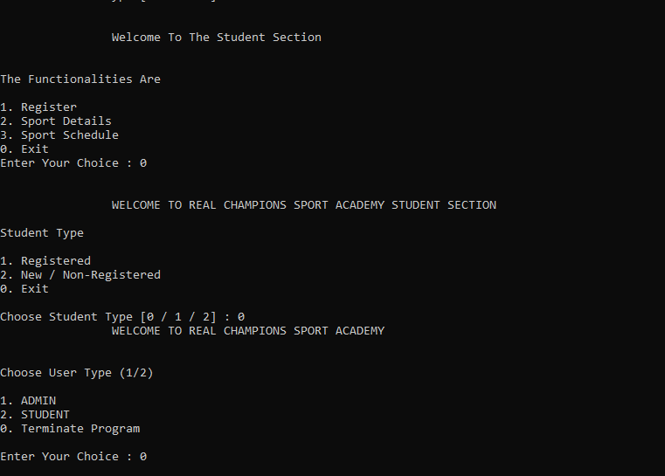

**Additional Features**

* **Strip():** Strip() returns a copy a string after stripping it of all default whitespaces form start to end. It’s often used while turning strings into lists.



Figure : Use of Strip()

* **Split():** Split() can split a string into an array of substrings. Split uses an operator to while choosing elements for the sub strings.



Figure : Use of Split()

**Conclusion**

As per the progression of the assignment, I conclude that:

The System is able to provide two user types [Admin , Student]

1. User can access to respective user type sections via Password or ID.

2. The Admin staff can add and modify records of:

* Coach
* Sports
* Sports schedule

1. The Admin staff can search for specific records, such as :

* Coach by Coach ID
* Coach by Overall Performance (Rating)
* Sport by Sport ID
* Student by Student ID

1. The Admin staff can sort and display records of :

* Coaches in ascending order by names
* Coaches in ascending order by hourly pay rate
* Coaches in ascending order by overall performance

1. Registered students can:

* View records of coach, sport, sport schedule
* View and modify self-records
* Rate coaches and provide feedback

1. Unregistered students can:

* Register
* View sport details and schedule

**References**

* DigitalOcean. 2021. How To Read And Write Files In Python 3 | Digitalocean. [online] Available at: <https://www.digitalocean.com/community/tutorials/how-to-handle-plain-text-files-in-python-3> [Accessed 22 January 2021]
* H. and Aidley, J., 2021. How To Search And Replace Text In A File?. [online] Stack Overflow. Available at: <https://stackoverflow.com/questions/17140886/how-to-search-and-replace-text-in-a-file> [Accessed 22 January 2021].
* Kite.com. 2021. Code Faster With Line-Of-Code Completions, Cloudless Processing. [online] Available at: <https://www.kite.com/python/answers/how-to-update-and-replace-text-in-a-file-in-python> [Accessed 22 January 2021].
* Pythonexamples.org. 2021. Python – How To Replace String In File? - Python Examples. [online] Available at: <https://pythonexamples.org/python-replace-string-in-file/> [Accessed 22 January 2021].
* Python, C., Fabre, J. and Biradar, P., 2021. Copying From One Text File To Another Using Python. [online] Stack Overflow. Available at: <https://stackoverflow.com/questions/15343743/copying-from-one-text-file-to-another-using-python/32977473> [Accessed 22 January 2021].
* python, R. and Koushik, J., 2021. Restarting At Line 0 In A "For Line" Statement In Python. [online] Stack Overflow. Available at: <https://stackoverflow.com/questions/23148996/restarting-at-line-0-in-a-for-line-statement-in-python> [Accessed 22 January 2021].
* P., Crow, E., Bowyer, J. and Orshanskiy, S., 2021. Python 3: Unboundlocalerror: Local Variable Referenced Before Assignment. [online] Stack Overflow. Available at: <https://stackoverflow.com/questions/10851906/python-3-unboundlocalerror-local-variable-referenced-before-assignment> [Accessed 22 January 2021].
* Sanfoundry. 2021. Python Program To Copy The Contents Of One File Into Another - Sanfoundry. [online] Available at: <https://www.sanfoundry.com/python-program-copy-contents-file-another/> [Accessed 22 January 2021].