**Data:**

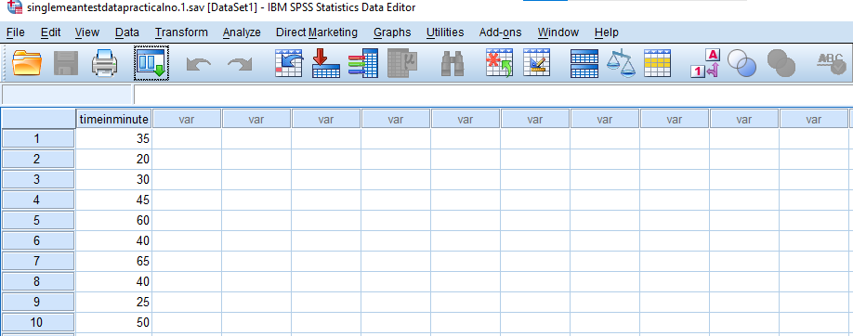

**Syntax:**

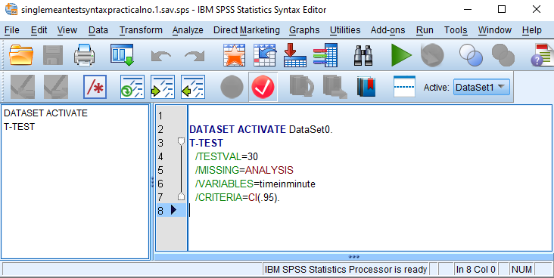

**Output:**

**T-Test**

|  |  |  |  |  |
| --- | --- | --- | --- | --- |
| **One-Sample Statistics** | | | | |
|  | N | Mean | Std. Deviation | Std. Error Mean |
| timeinminute | 10 | 41.00 | 14.491 | 4.583 |

|  |  |  |  |  |  |  |
| --- | --- | --- | --- | --- | --- | --- |
| **One-Sample Test** | | | | | | |
|  | Test Value = 30 | | | | | |
| t | df | Sig. (2-tailed) | Mean Difference | 95% Confidence Interval of the Difference | |
| Lower | Upper |
| timeinminute | 2.400 | 9 | .040 | 11.000 | .63 | 21.37 |

**Data:**

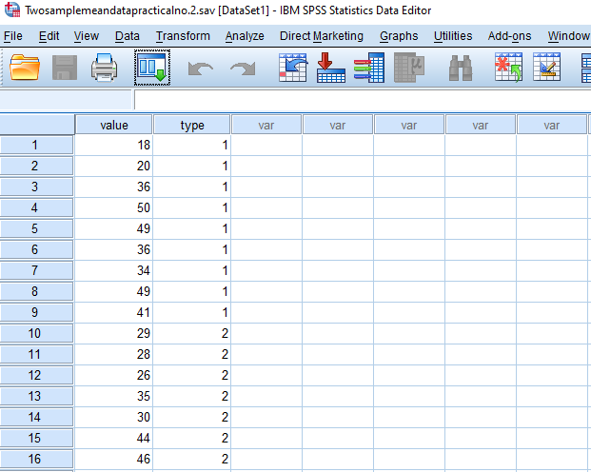

**Syntax:**

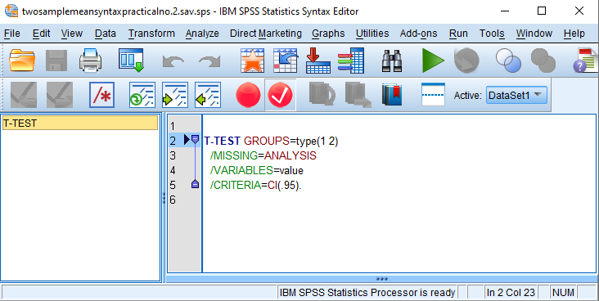

**Output:**

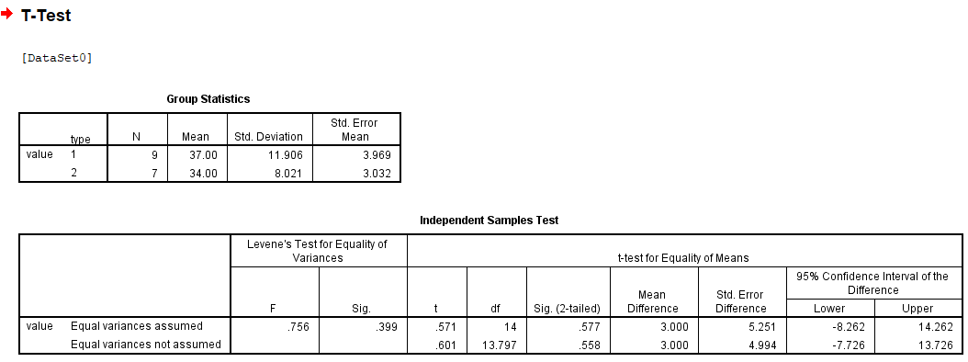

**Data:**

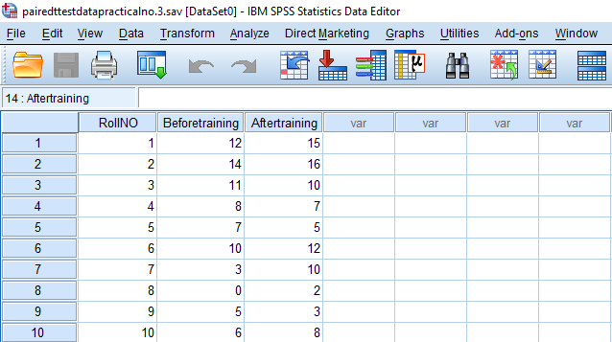

**Syntax:**

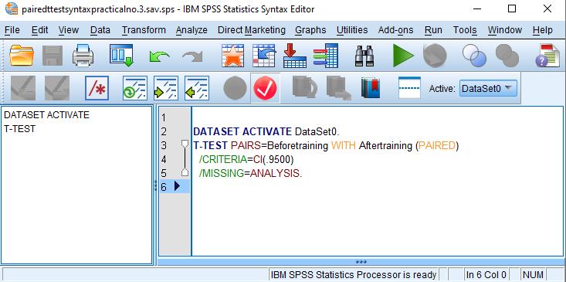

**Output:**

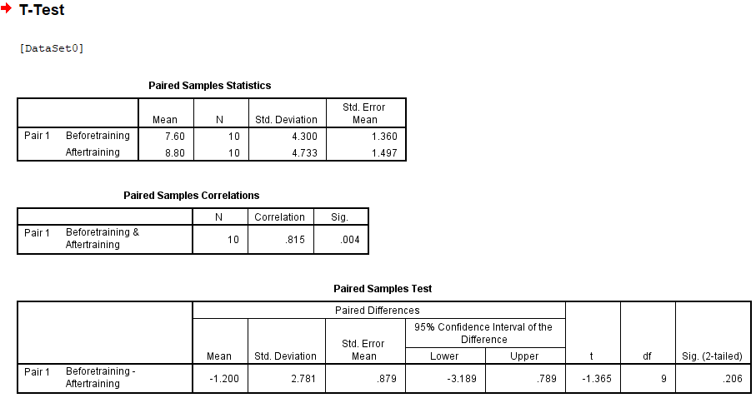

**Data:**

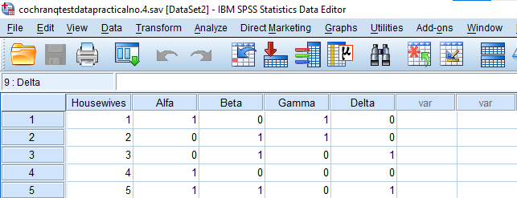

**Syntax:**

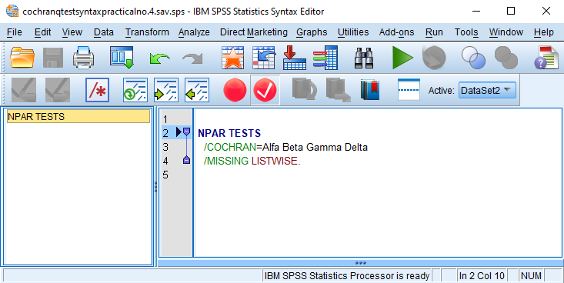

**Output:**

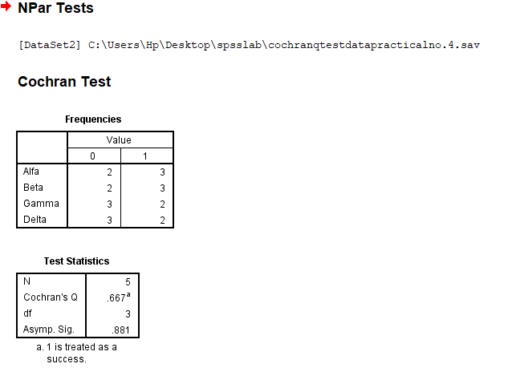

**Data:**

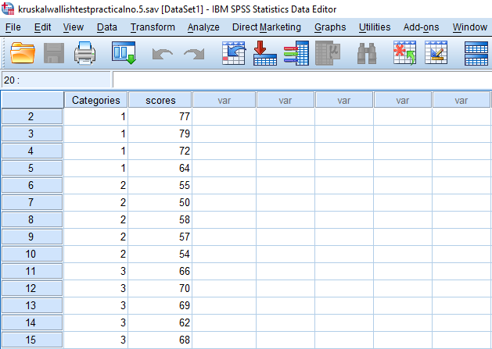

**Syntax:**

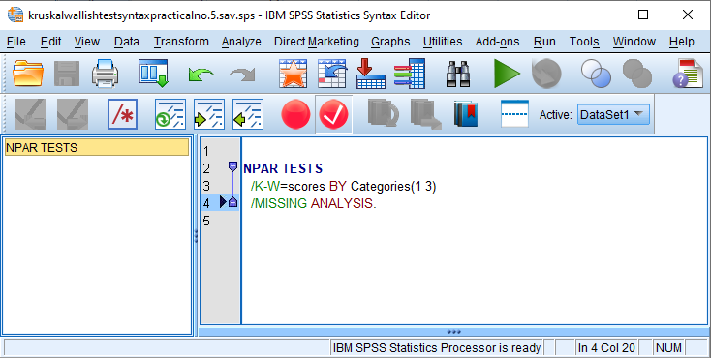

**Output:**

**Kruskal-Wallis Test**

|  |  |  |  |
| --- | --- | --- | --- |
| **Ranks** | | | |
|  | Categories | N | Mean Rank |
| scores | 1 | 5 | 11.60 |
| 2 | 5 | 3.00 |
| 3 | 5 | 9.40 |
| Total | 15 |  |

|  |  |
| --- | --- |
| **Test Statisticsa,b** | |
|  | scores |
| Chi-Square | 9.980 |
| df | 2 |
| Asymp. Sig. | .007 |
| a. Kruskal Wallis Test | |
| b. Grouping Variable: Categories | |

**Data:**

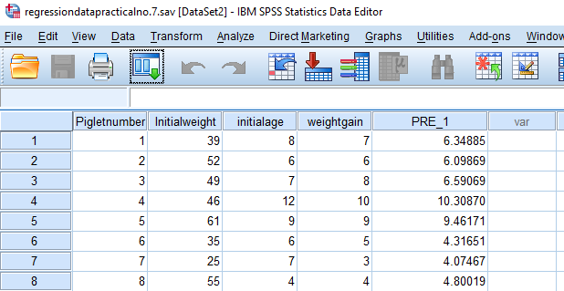

**Syntax:**

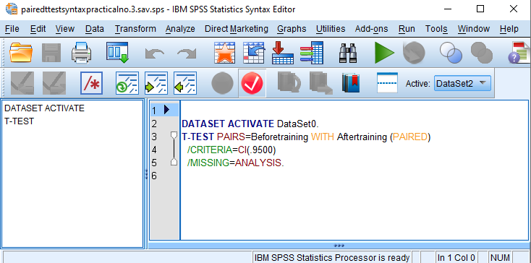

**Output:**

**Regression**

|  |  |  |  |
| --- | --- | --- | --- |
| **Descriptive Statistics** | | | |
|  | Mean | Std. Deviation | N |
| weightgain | 6.50 | 2.449 | 8 |
| Initialweight | 45.25 | 11.696 | 8 |
| initialage | 7.38 | 2.387 | 8 |

|  |  |  |  |  |
| --- | --- | --- | --- | --- |
| **Correlations** | | | | |
|  | | weightgain | Initialweight | initialage |
| Pearson Correlation | weightgain | 1.000 | .514 | .794 |
| Initialweight | .514 | 1.000 | .017 |
| initialage | .794 | .017 | 1.000 |
| Sig. (1-tailed) | weightgain | . | .096 | .009 |
| Initialweight | .096 | . | .484 |
| initialage | .009 | .484 | . |
| N | weightgain | 8 | 8 | 8 |
| Initialweight | 8 | 8 | 8 |
| initialage | 8 | 8 | 8 |

|  |  |  |  |
| --- | --- | --- | --- |
| **Variables Entered/Removeda** | | | |
| Model | Variables Entered | Variables Removed | Method |
| 1 | initialage, Initialweightb | . | Enter |
| a. Dependent Variable: weightgain | | | |
| b. All requested variables entered. | | | |

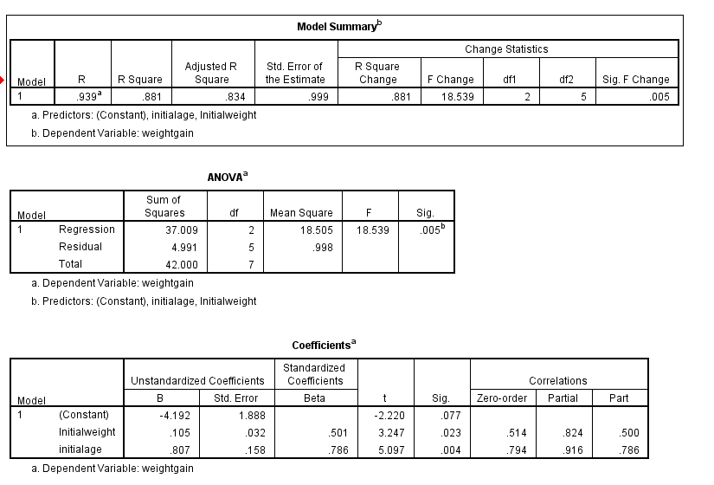

|  |  |  |  |  |  |
| --- | --- | --- | --- | --- | --- |
| **Residuals Statisticsa** | | | | | |
|  | Minimum | Maximum | Mean | Std. Deviation | N |
| Predicted Value | 4.07 | 10.31 | 6.50 | 2.299 | 8 |
| Residual | -1.075 | 1.409 | .000 | .844 | 8 |
| Std. Predicted Value | -1.055 | 1.656 | .000 | 1.000 | 8 |
| Std. Residual | -1.076 | 1.411 | .000 | .845 | 8 |
| a. Dependent Variable: weightgain | | | | | |

**Charts**

