### EXPERIMENT 1:

### Demonstrate version control in Git and Github using simple html code.

### PROCEDURE

Step1: Downloading and Installing Git (go to <https://git-scm.com/downloads>)

To configure Git, we need to specify the name, email address, and branch by using the

**git config - -global** command.

Step2: Open a cmd window or terminal on your computer and execute all commands.

git --version

git config --global user.name "Your Name"

git config --global user.email <your email address>

git config --list

git init

git status

git add .

git commit -m "first commit"

git log --oneline

git checkout <second commit's number> index.html

git remote add origin <repository URL>

git push -u origin master

git clone <repository URL>

Syntaxes of some git commands:

git config --global user.name “ [username]”

git config --global user.email [email address]

git init  = to start git in your Project.

git add (file name)= adds the name of the particular file you want to commit in the staging area.

git commit –m “first commit”

git clone (repository name)= to copy an existing repository in another location to the current location.

git push (remote storage name)= to upload/push files from the local repository/storage to another storage.

git rm (filename) = to remove a file from a working repository

git branch = to check the current branch you are working on, either main or master

* Get familiar with version control, git and GitHub
* Create your own repository and project folder structure

### SOURCE CODE:

While [working on Git,](https://www.simplilearn.com/tutorials/git-tutorial/git-tutorial-for-beginner) we actively use two repositories.

* (Git)Local repository: The local repository is present on our computer and consists of all the files and folders. This Repository is used to make changes locally, review history, and commit when offline.
* (GitHub)Remote repository: The remote repository refers to the server repository that may be present anywhere. This repository is used by all the team members to exchange the changes made.

Both repositories have their own set of commands. There are separate Git Commands that work on different types of repositories.

Step 1:-Create one Folder week1

Step2:-Create one HTML File index.html in week1 folder.

Code:-

<!DOCTYPE html>

<html lang="en">

<head>

    <meta charset="UTF-8">

    <meta http-equiv="X-UA-Compatible" content="IE=edge">

    <meta name="viewport" content="width=device-width, initial-scale=1.0">

    <title>Week1</title>

</head>

<body style="background-color:rgb(0, 217, 255)">

   <center>

       <h1 style="color:red">Welcome to CSD-C Sec</h1>

       <p style="color:blue">My classroom is also a beautiful place for me.<br>

         There are many types of students in my class. <br>

         Some are good at extracurricular activities, some at academics, and some love participating in competitions.

         <br> My classroom also has different students from all over the country, which makes it unique.</p>

         <img src="class.jfif" alt="class room">

   </center>

</body>

</html>

Write above code in index.html. After completion of code save and run you get output like

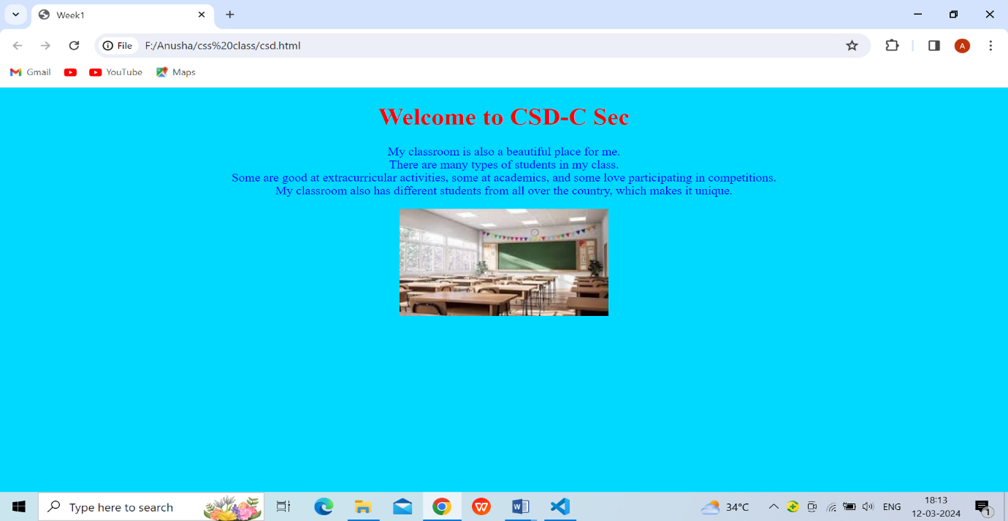

Step 3:-use cmd (or) terminal in visual studio (or) git bash

Open Git bash and check current directory use command **pwd**(print working directory)

If you are folder available in other directory use this command to change directory

Cd ( directory location)

🡪Cd “F:\Anusha\week1”

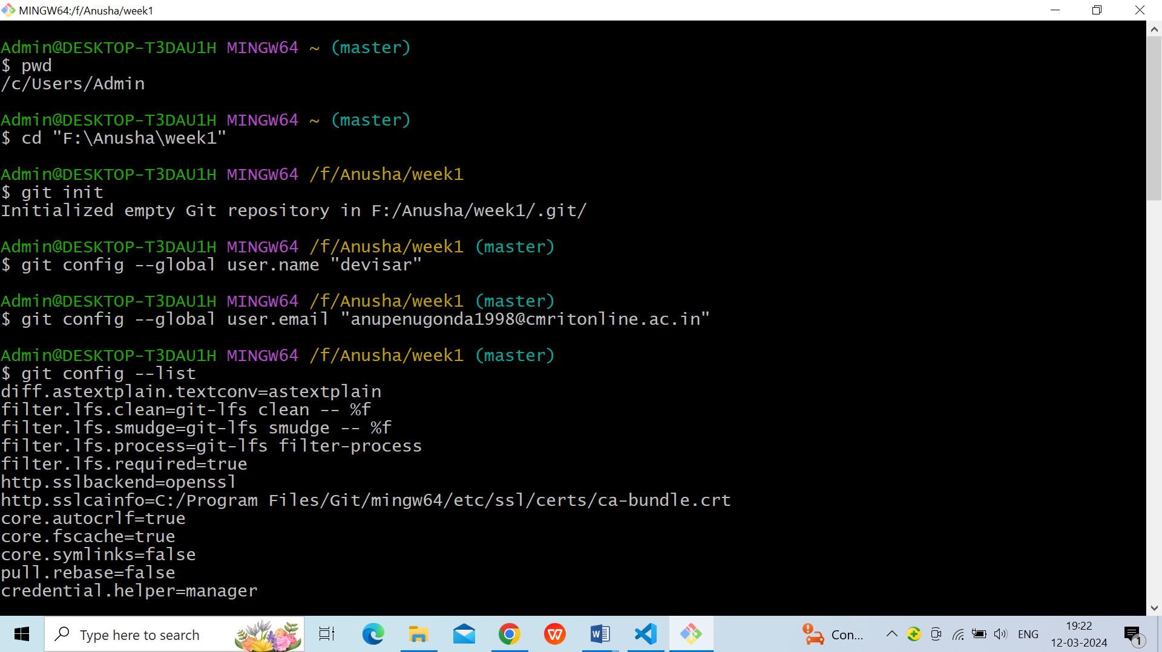

## Step 4:- **Git Commands: Working With Local Repositories(default branch master)**

### 1.git init

* The command git init is used to create an empty Git repository.
* After the git init command is used, a .git folder is created in the directory with some subdirectories. Once the repository is initialized, the process of creating other files begins.



### 2.git config

* The git config command is used initially to configure the user.name and user.email. This specifies what email id and username will be used from a local repository.
* When git config is used with --global flag, it writes the settings to all repositories on the computer.

**git config –global user.name “user name”**

**git config –global user.email “email id”**

****

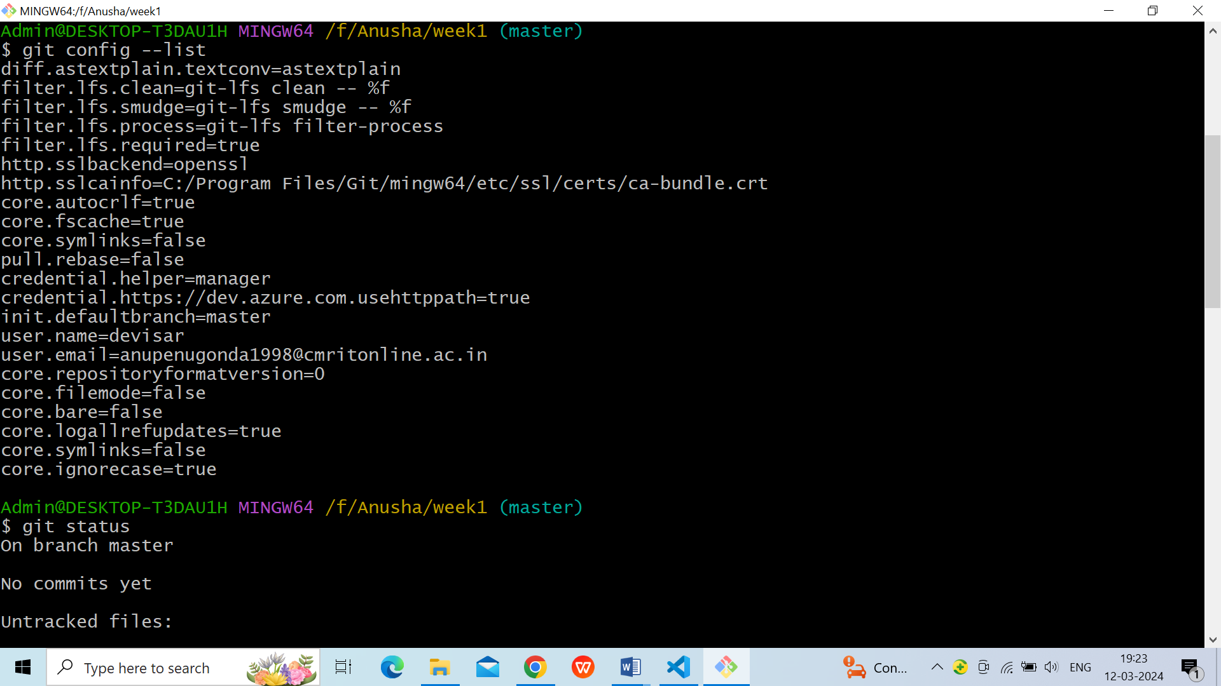

**3.git add**

* Add command is used after checking the status of the files, to add those files to the staging area.
* Before running the commit command, "git add" is used to add any new or modified files.

**git add . (or) git add file name**

**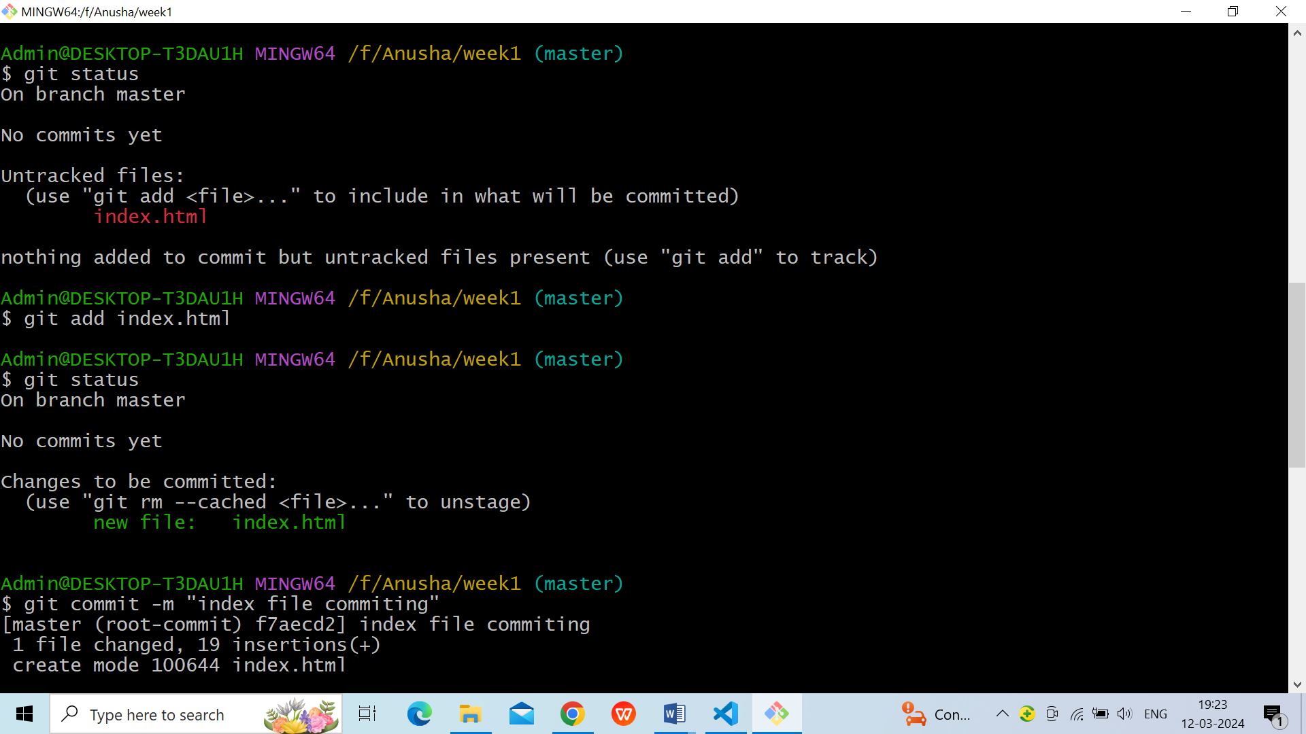**

### 4.git commit

* The commit command makes sure that the changes are saved to the local repository.
* The command "git commit –m <message>" allows you to describe everyone and help them understand what has happened.

**git commit -m “commit message”**

****

### 5.git status

* The git status command tells the current state of the repository.
* The command provides the current working branch. If the files are in the staging area, but not committed, it will be shown by the git status. Also, if there are no changes, it will show the message no changes to commit, working directory clean.

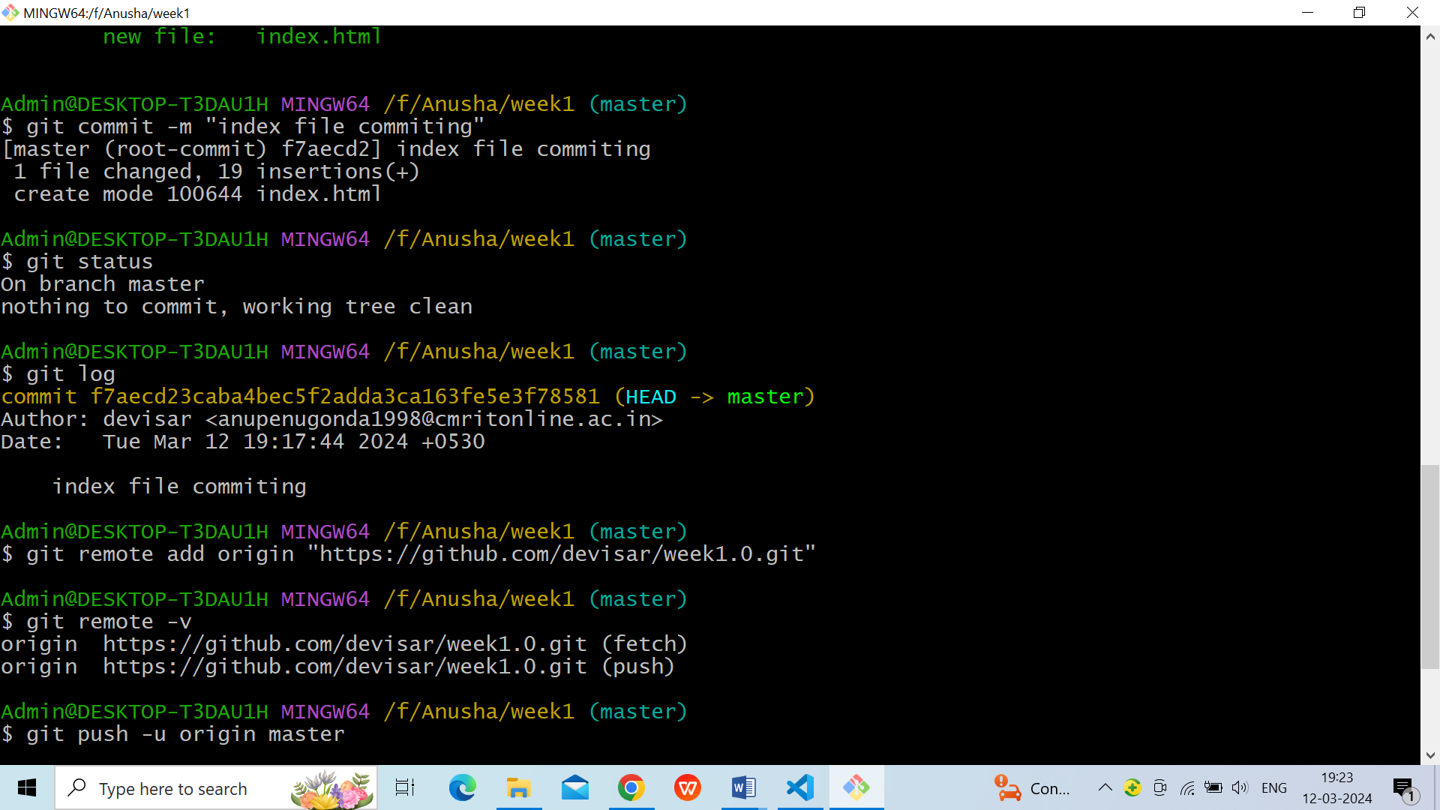

### 6.git log

* The git log command shows the order of the commit history for a repository.
* The command helps in understanding the state of the current branch by showing the commits that lead to this state.



**Step5:-Git Commands: Working With Remote Repositories**

1. First Create GitHub Account and Login

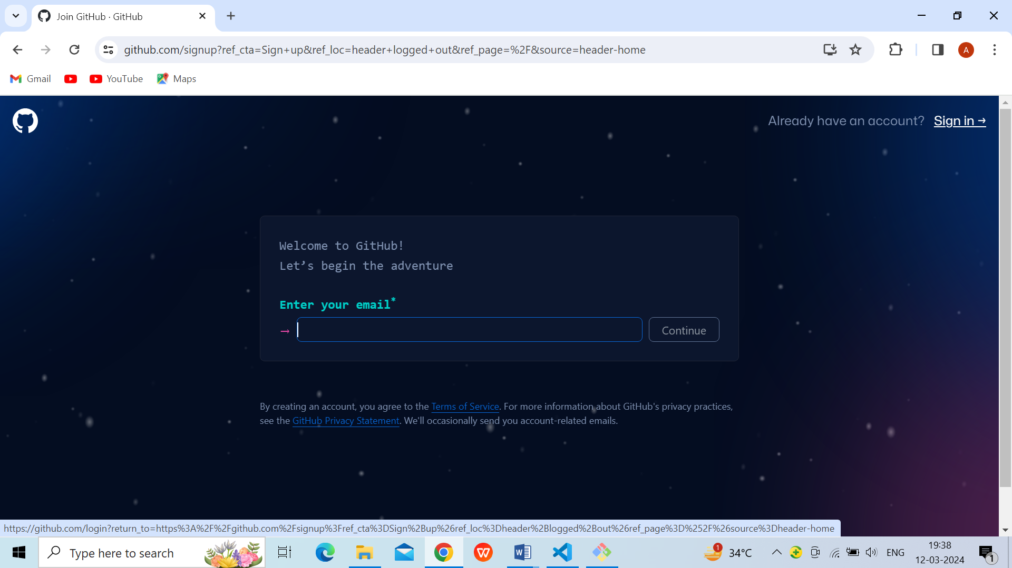

Fig.1.Github sign in and sign up page

1. Next create new Repository

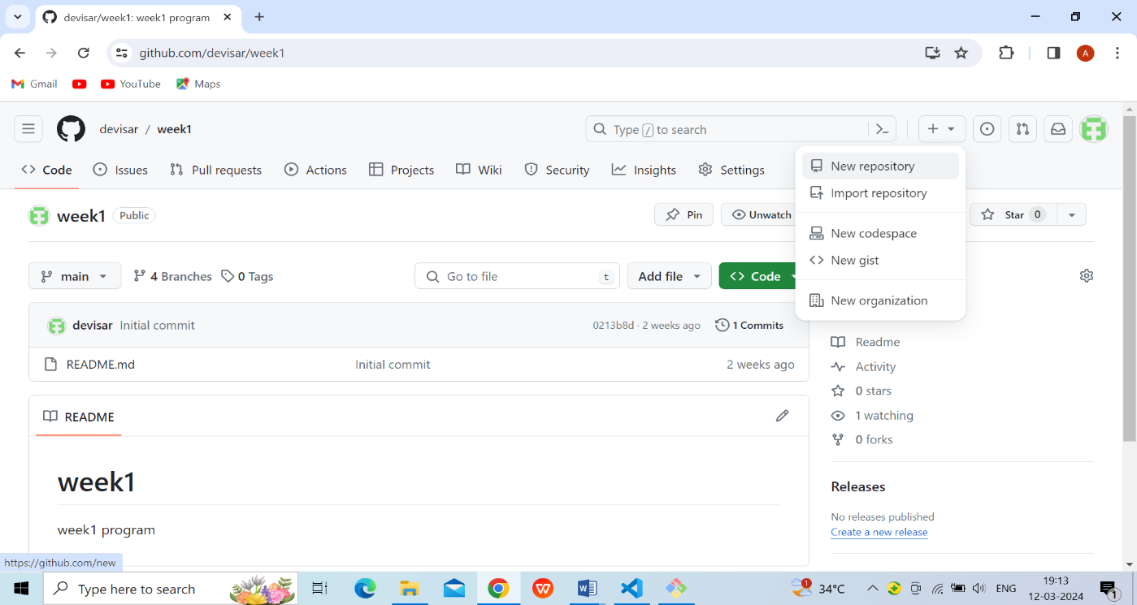

Fig.2.creating new repository page

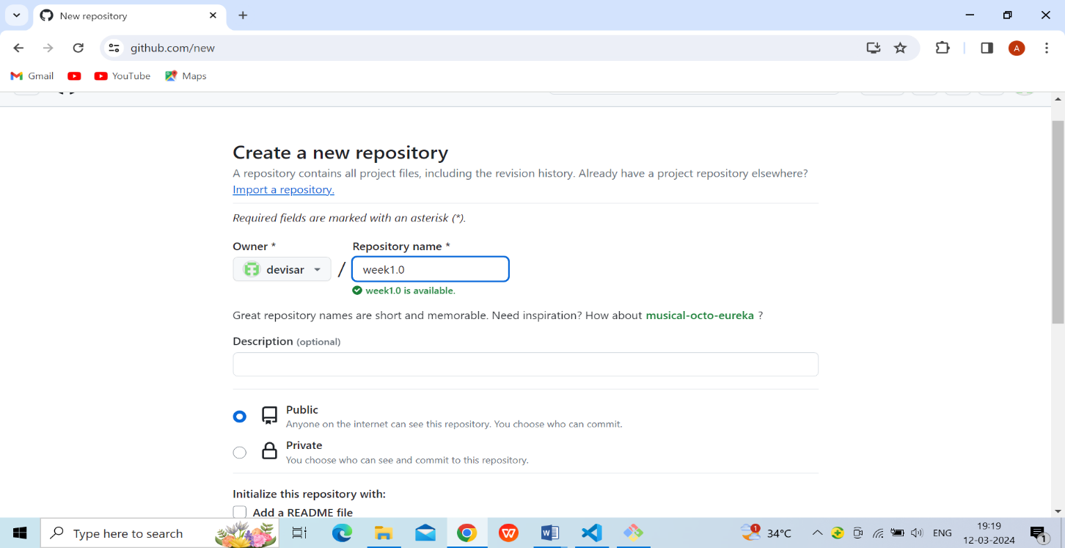

Fig.3.Enter repository name page

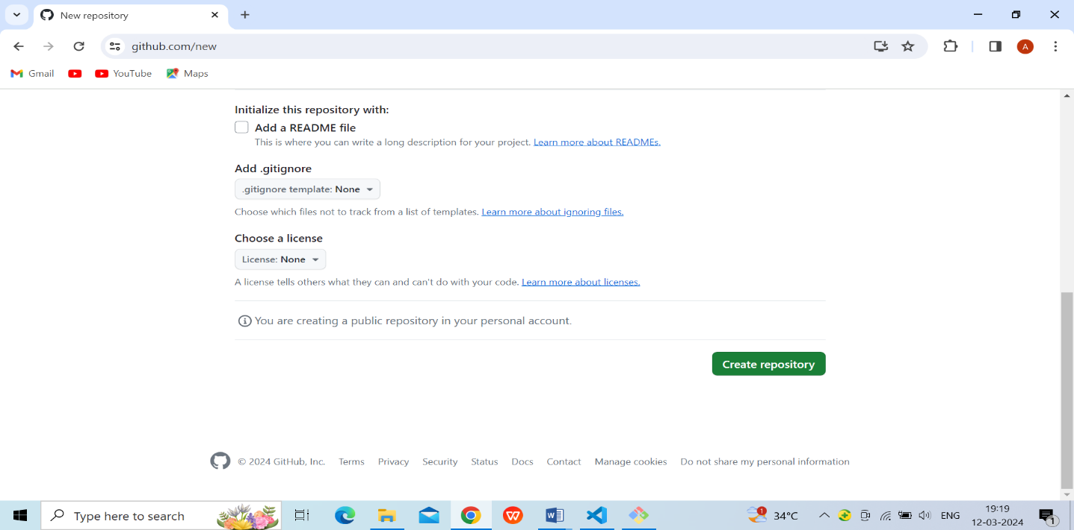

Fig.4.Click button to create repository page

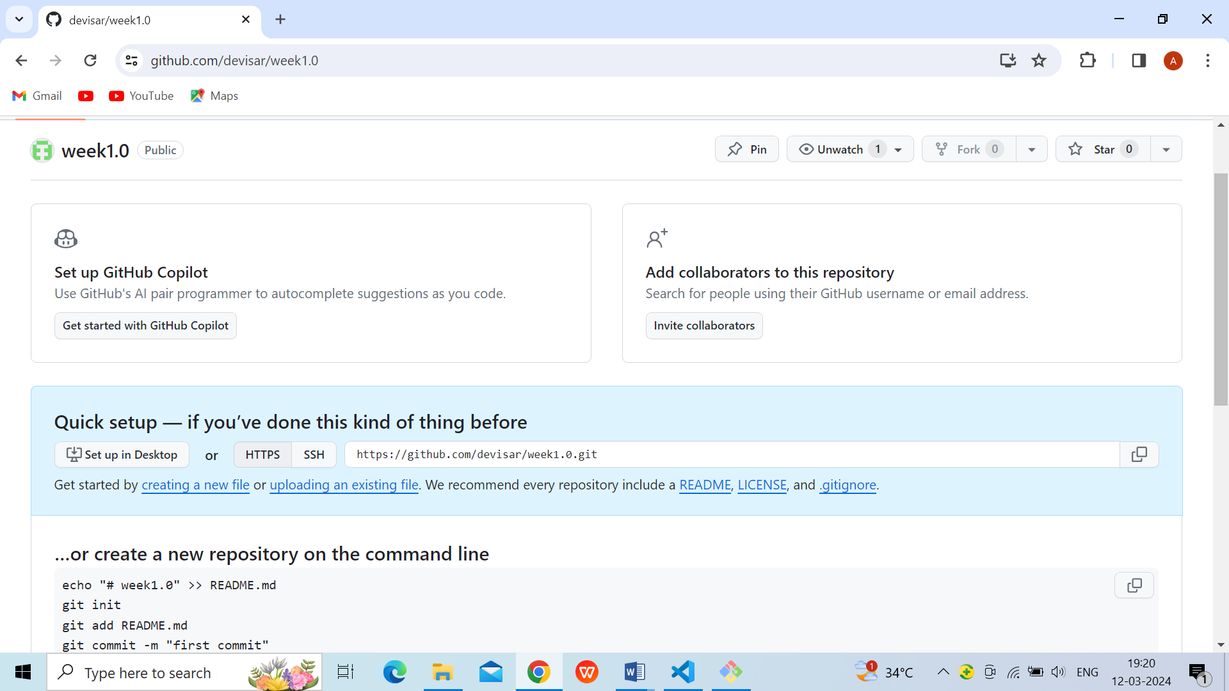

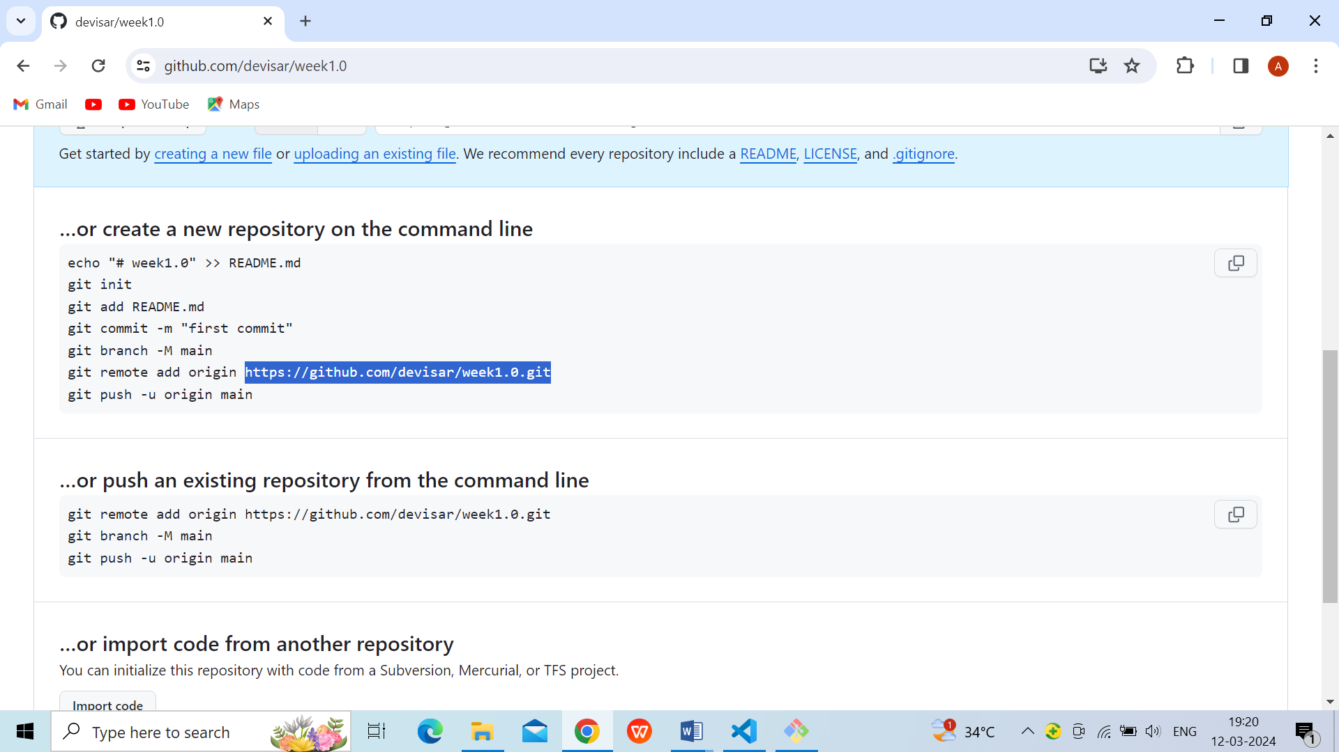

Fig.5.After opening page

### 7.git remote

* The git remote command is used to create, view, and delete connections to other repositories.
* The connections here are not like direct links into other repositories, but as bookmarks that serve as convenient names to be used as a reference.

**Git remote add origin <address>**

**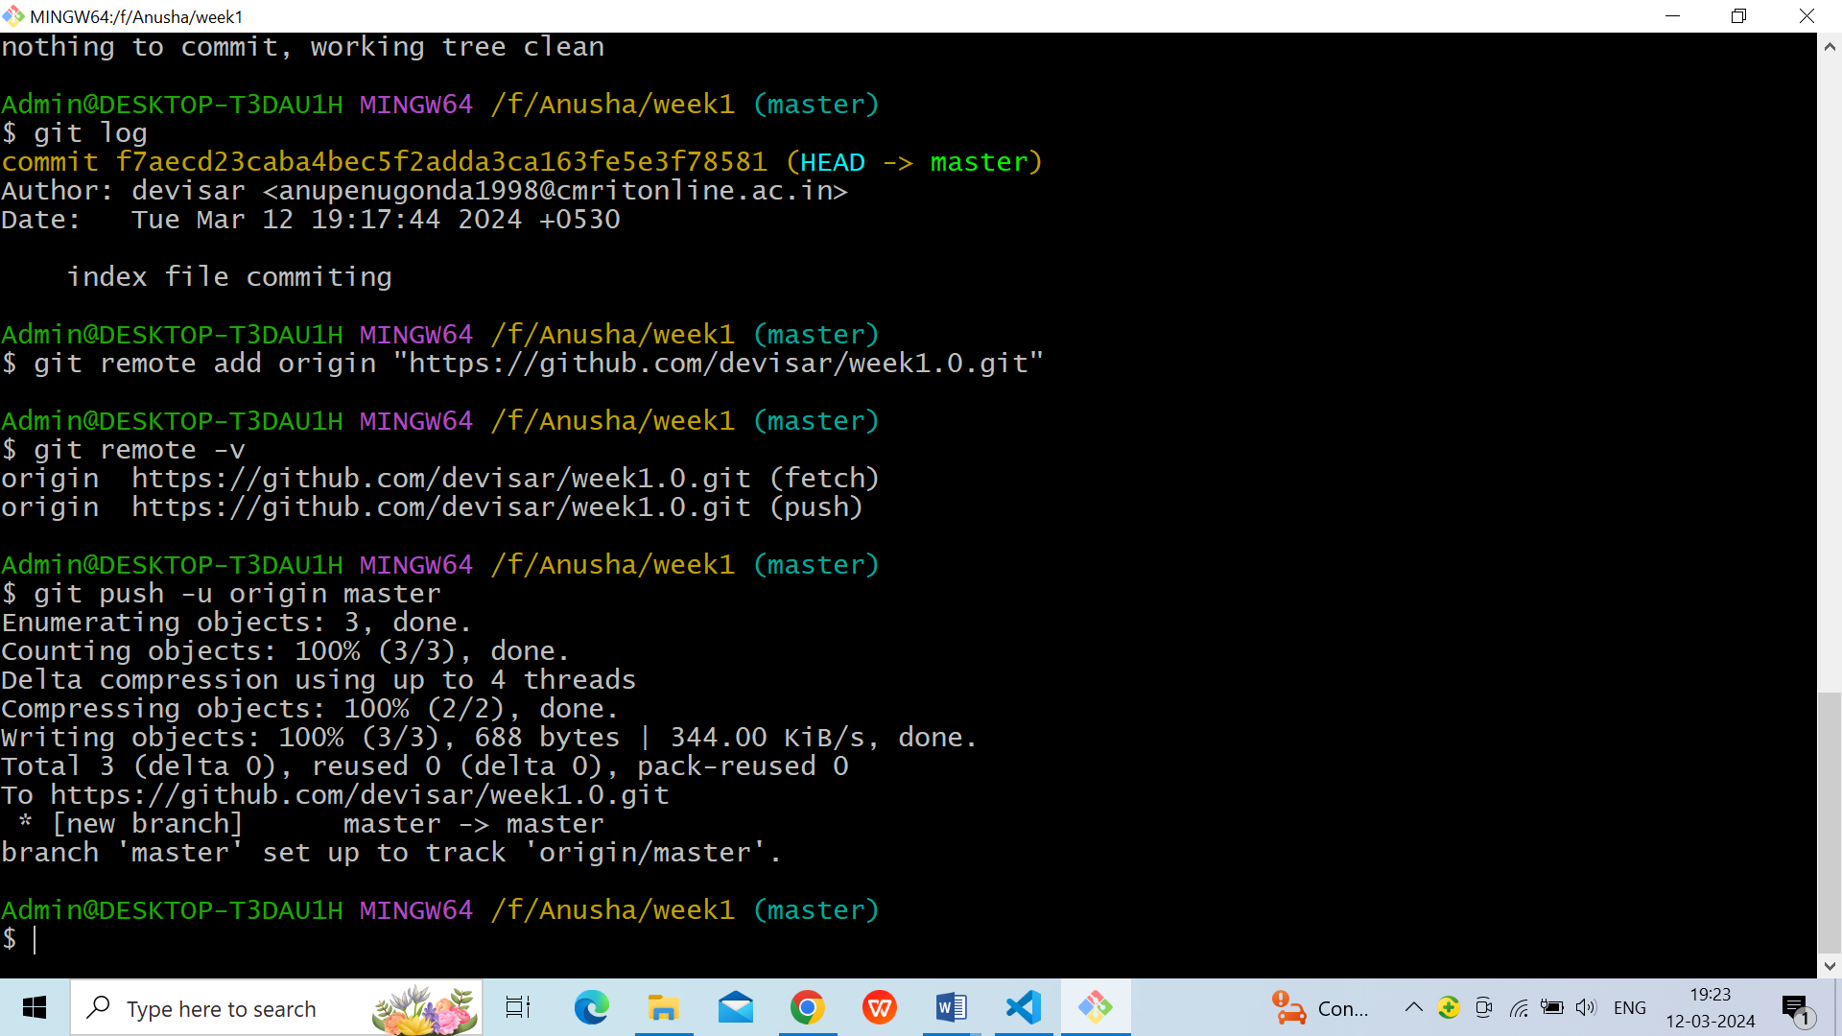**

### 8.git push

* The command [git push](https://www.simplilearn.com/tutorials/git-tutorial/git-push-command" \t "_blank" \o "git push) is used to transfer the commits or pushing the content from the local repository to the remote repository.
* The command is used after a local repository has been modified, and the modifications are to be shared with the remote team members.

**git push –u origin master**

****

### 

### Fig.6.Now File is uploaded

### 

### Fig.7.Git Working Process

### 9.git clone

### The git clone command is used to create a local working copy of an existing remote repository.

* The command downloads the remote repository to the computer. It is equivalent to the Git init command when working with a remote repository.

**Git clone <remote URL>**

### 10.git pull

* The [git pull command](https://www.simplilearn.com/tutorials/git-tutorial/git-pull-request" \t "_blank" \o "git pull command) is used to fetch and merge changes from the remote repository to the local repository.
* The command "git pull origin master" copies all the files from the master branch of the remote repository to the local repository.

**Git pull <branch name> <remote URL>**

**VIVA QUESTIONS:**

## What is Git?

## **Git** is an **open-source distributed version control system**. It is designed to handle minor to major projects with high speed and efficiency. It is developed to co-ordinate the work among the developers. The version control allows us to track and work together with our team members at the same workspace. Git was created by **Linus Torvalds** in **2005** to develop Linux Kernel. It is also used as an important distributed version-control tool for **the DevOps**.

1. What is the difference between Git and Github?

Git is a version control system that allows developers to track changes in their code. GitHub is a web-based hosting service for git repositories. In simple terms, you can use git without Github, but you cannot use GitHub without Git.

1. What are the benefits of version control system?

* Enhances the project development speed by providing efficient collaboration,
* Reduce possibilities of errors and conflicts meanwhile project development through traceability to every small change,
* Employees or contributors of the project can contribute from anywhere irrespective of the different geographical locations through this **VCS.**

## What is a repository in Git?

A Git repository is a central storage location for managing and tracking changes in files and directories. It is a crucial component of the Git version control system, which enables collaborative development and allows multiple developers to work on a project simultaneously.

1. How to create a repository in Git?

* git init: Initializes a new Git repository.
* git clone <repository\_url>: Clones a remote repository to your local machine.
* git add <file\_name>: Stages a specific file for the next commit.
* git commit -m "Commit message": Creates a commit with the staged changes.

## What is the difference between git pull and git fetch?

Git Fetch command fetches all the changes **from the remote repository to the local repository** without merging the changes into the working directory. Git Pull on the other hand brings the copy of the **remote directory changes into the working directory**.