**EXPERIMENT 2:**

### Design a simple webpage using bootstrap template.

### PROCEDURE:

Step 1: Include Bootstrap 4 from a CDN

Step 2: Use a <div> element with class .jumbotron to create a jumbotron:

Step 3: Use the .container class to create a responsive, fixed-width container.

Step4: Use the .col class on a specified number of elements, use three- column elements, which gets a width of 33.33% each

**Source Code:-**

Create a folder Week2 Create a file bootstrap.html inside the folder and also save an image inside the folder.

<!DOCTYPE html>

<html lang="en">

**//Head Tag**

<head>

    <meta charset="UTF-8">

    <meta name="viewport" content="width=device-width, initial-scale=1.0">

    <title>Week2 Bootstrap</title>

//Css style

<style>

footer {

      color: white;

      padding: 15px;

      bottom: 0;

      position: absolute;

    }

</style>

**//Bootstrap CDN Links**

<link href="https://cdn.jsdelivr.net/npm/bootstrap@5.1.3/dist/css/bootstrap.min.css" rel="stylesheet" integrity="sha384-1BmE4kWBq78iYhFldvKuhfTAU6auU8tT94WrHftjDbrCEXSU1oBoqyl2QvZ6jIW3" crossorigin="anonymous">

<script src="https://cdn.jsdelivr.net/npm/bootstrap@5.1.3/dist/js/bootstrap.bundle.min.js" integrity="sha384-ka7Sk0Gln4gmtz2MlQnikT1wXgYsOg+OMhuP+IlRH9sENBO0LRn5q+8nbTov4+1p" crossorigin="anonymous">

</script>

</head>

**//body tag**

<body>

**//Creating NavBar**

<nav class="navbar navbar-expand navbar-dark bg-success">

        <div class="container-fluid">

**//Attaching Navbar brand image**

    <a class="navbar-brand" href=""><img src="dora.jfif" alt="dora" width="40" height="40"></a>

**//Attaching navbar About us and Contact using Unorder list tags and anchor links tags**

    <ul class="navbar-nav me-auto mb-2 mb-lg-0">

        <li class="nav-item">

     <a class="nav-link active" href="">About us</a>

        </li>

        <li class="nav-item">

            <a class="nav-link" href="">Contact</a>

        </li>

**//Attaching navbar dropdown-toggle button same unorder list tag**

        <li class="nav-item dropdown">

        <a class="nav-link dropdown-toggle"

        role="button"

        id="navbarDropdown"

        data-bs-toggle="dropdown"

        href="">Episodes</a>

**//Attaching dropdown-items in dropdown menu**

        <ul class="dropdown-menu">

            <li>

    <a class="dropdown-item" href="">Episode1</a>

            </li>

            <li>

                <a class="dropdown-item" href="">Episode2</a>

            </li>

        </ul>

        </li>

</ul>

**//attaching navbar search type and submit button**

    <form class="d-flex">

        <input class="form-cotrol me-2"

        type="search"

        placeholder="search website"/>

        <button class="btn btn-primary"

            type="submit">search</button>

        </button>

    </form>

**//closing div tag**

        </div>

**//closing navbar tag**

    </nav>

**//creating grid dividing columns col-sm-4 and col-sm-8**

    <div class="container mt-5">

        <div class="row">

            <div class="col-sm-4">

                <h3>Doraemon Biography</h3>

            </div>

            <div class="col-sm-8">

                <h2>Article Title</h2>

                <h5>Created on 06 march 2024</h5>

                <p>Doraemon is a male robotic earless cat that travels back in time from the 22nd century to aid a preteen boy named Nobita.

                An official birth certificate for the character gives him a birth date of 3 September 2112 and lists his city of residency as Kawasaki, Kanagawa,

                the city where the manga was created.</p>

            </div>

        </div>

    </div>

**//creating footer tag**

<footer class="container-fluid text-center bg-success">

        <p>copy right CMRIT_2024<br>

      </footer>

**//closing body and html tags**

</body>

</html>

**Output:-**

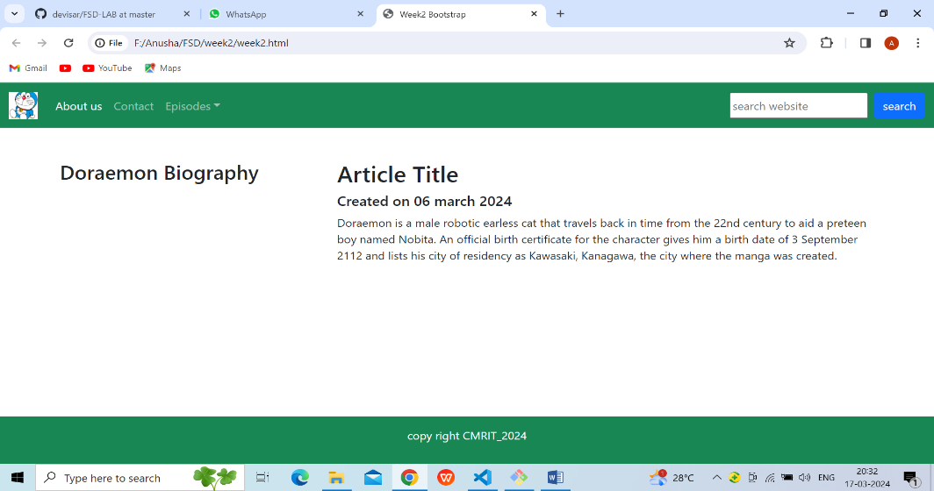

Fig.1.simple webpage using bootstrap webpage template

**VIVA QUESTIONS:**

### What is Bootstrap Grid System?

### Bootstrap's grid system uses a series of containers, rows, and columns to layout and align content. It's built with flexbox and is fully responsive.

### Could you explain how to use the Dropdown plug-in in Bootstrap?

The .dropdown class indicates a dropdown menu.To open the dropdown menu, use a button or a link with a class of .dropdown-toggle and the data toggle="dropdown" attribute.Add the .dropdown-menu class to a <div> element to actually build the dropdown menu. Then add the .dropdown-item class to each element (links or buttons) inside the dropdown menu.

### Name some CSS style components?

**CSS consists of two components:**

* Properties: These are human-readable identifiers that indicate which stylistic features you want to modify. For example, font-size , width , background-color .
* Values: Each property is assigned a value. This value indicates how to style the property.

background-color: lightgrey;  
  color: blue;

width: 300px;  
  border: 15px solid green;  
  padding: 50px;  
  margin: 20px;

### What is image map in HTML5?

An image map is an image with clickable areas. The required name attribute of the <map> element is associated with the <img>'s usemap attribute and creates a relationship between the image and the map. The <map> element contains a number of <area> elements, that defines the clickable areas in the image map.

* 1. What is <Div> tag?

The <div> tag is known as the Division tag. The div tag is used in HTML to make divisions of content in the web page like (text, images, header, footer, navigation bar, etc).

* 1. What is SVG stands for?

SVG (Scalable Vector Graphics)  
  
SVG defines vector-based graphics in XML, which can be directly embedded in HTML pages. SVG graphics are scalable, and do not lose any quality if they are zoomed or resized: SVG. SVG is supported by all major browsers.

* 1. What are the two types of web storage in HTML5?

**HTML5 there are two types of web storage API.**

* localStorage.
* SessionStorage.