**Experiment-4:**

Write a jquery code to show the website slider.

### PROCEDURE

Step1: Include bootstrap.min.css, jquery.min.js, bootstrap.min.js in <head> Section Step2: Create outermost <div> with id="myCarousel" class="carousel slide"

data-ride="carousel" Step3: Add Indicators

Step4: Add Wrapper for slides

Step5: Add Left and right controls

Step6: Add Captions to Slides

**SOURCE CODE**

create file jquery.html and download any 3 images are

1.f1.jfif

2.f2.jfif

3.f3.jfif

<!DOCTYPE html>

<html lang="en">

<head>

    <meta charset="UTF-8">

    <meta http-equiv="X-UA-Compatible" content="IE=edge">

    <meta name="viewport" content="width=device-width, initial-scale=1.0">

    <title>jQuery</title>

    <link rel="stylesheet" href="https://maxcdn.bootstrapcdn.com/bootstrap/3.4.1/css/bootstrap.min.css">

    <script src="https://ajax.googleapis.com/ajax/libs/jquery/3.5.1/jquery.min.js"></script>

    <script src="https://maxcdn.bootstrapcdn.com/bootstrap/3.4.1/js/bootstrap.min.js"></script>

</head>

<body>

    <div class="container">

        <div id="myCarousel" class="carousel slide">

        <ol class="carousel-indicators">

        <li class="item1 active"></li>

        <li class="item2"></li>

        <li class="item3"></li>

        </ol>

        <div class="carousel-inner" role="listitem">

        <div class="item active">

        <img src="f1.jfif" alt="image1" width="100%" height="100%">

        </div>

        <div class="item">

        <img src="f2.jfif" alt="image2" width="100%" height="100%">

        </div>

        <div class="item">

        <img src="f3.jfif" alt="image3" width="100%" height="100%">

        </div>

    </div>

    <a class="left carousel-control" href="#myCarousel" role="button">

    <span class="glyphicon glyphicon-chevron-left" ariahidden="true"></span>

    <span class="sr-only">Prev</span>

    </a>

    <a class="right carousel-control" href="#myCarousel" role="button">

    <span class="glyphicon glyphicon-chevron-right" ariahidden="true"></span>

    <span class="sr-only">Next</span>

    </a>

    </div>

    </div>

    <script>

    $(document).ready(function(){

    $("#myCarousel").carousel();

    $(".item1").click(function(){

    $("#myCarousel").carousel(0);

    })

    $(".item2").click(function(){

    $("#myCarousel").carousel(1);

    })

    $(".item3").click(function(){

    $("#myCarousel").carousel(2);

    })

    $(".left").click(function(){

    $("#myCarousel").carousel("prev");

    })

    $(".right").click(function(){

    $("#myCarousel").carousel("next");

    })

    });

    </script>

</body>

</html>

**Output:-**



Fig.1.carousel Slide 1 Image

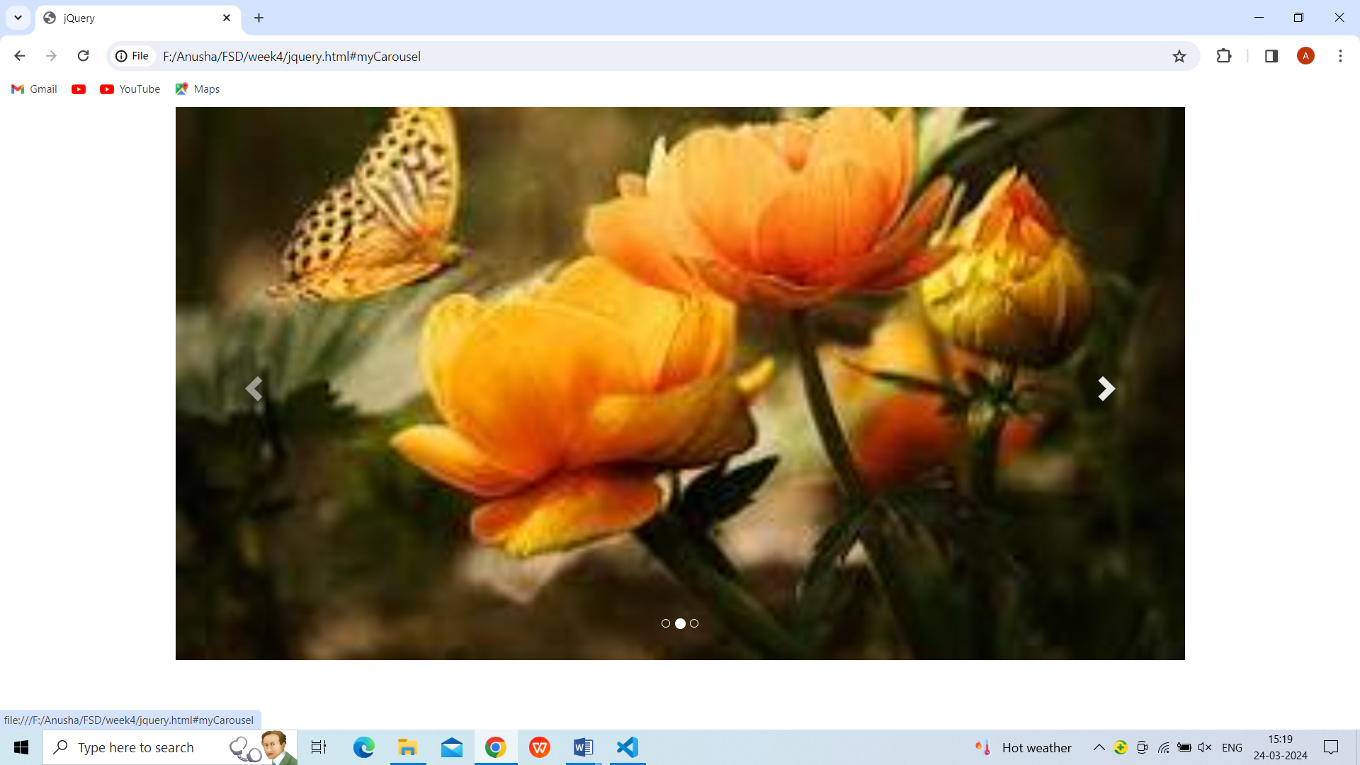

Fig.2. carousel Slide 2 Image

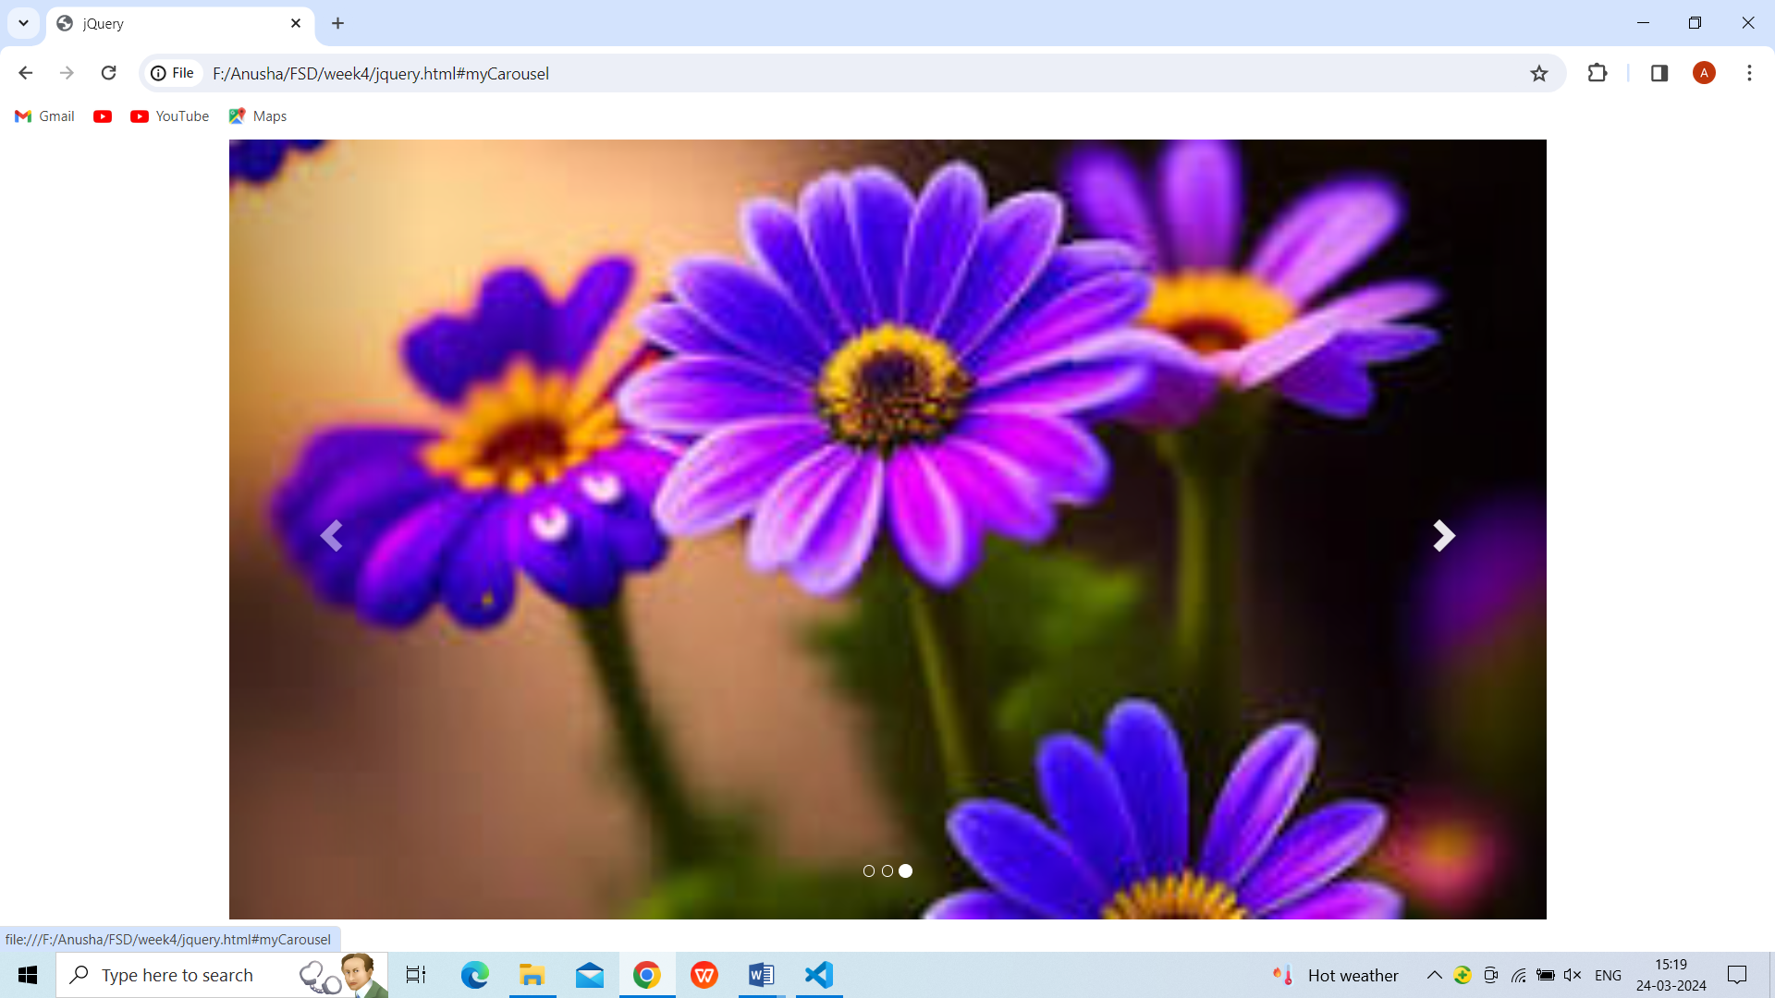

Fig.3. carousel Slide 3 Image

**VIVA QUESTIONS**

1. What are the jQuery methods used to provide effects?

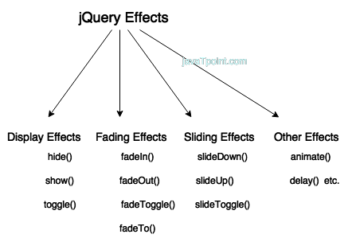

Jquery Effects

1. Why do we use jQuery?

* jQuery is a lightweight, "write less, do more", JavaScript library. The purpose of jQuery is to make it much easier to use JavaScript on your website. jQuery takes a lot of common tasks that require many lines of JavaScript code to accomplish, and wraps them into methods that you can call with a single line of code.

1. What are the basic selectors in jQuery?

* All Selector (“*”) Selects all elements.
* Class Selector (“. class”) ...
* Element Selector (“element”) Selects all elements with the given tag name.
* ID Selector (“#id”) ...
* Multiple Selector (“selector1, selector2, selectorN”)

1. What is the use of jQuery load method?

* jQuery load() method is a simple but very powerful AJAX method. The Load() method in jQuery helps to load data from the server and returned it to the selected element without loading the whole page. Syntax: $(selector).

1. Is it possible that jQuery HTML work for both HTML and XML document?

* Yes, jQuery is designed to work seamlessly with both HTML and XML documents. The core functionalities of jQuery, such as DOM traversal and manipulation, event handling, and AJAX operations, apply to both HTML and XML.