HTML is the standard markup language for creating Web pages.

What is HTML?

* HTML stands for Hyper Text Markup Language
* HTML is the standard markup language for creating Web pages
* HTML describes the structure of a Web page
* HTML consists of a series of elements
* HTML elements tell the browser how to display the content
* HTML elements label pieces of content such as "this is a heading", "this is a paragraph", "this is a link", etc.

<!DOCTYPE html>  
<html>  
<head>  
<title>Page Title</title>  
</head>  
<body>  
  
<h1>My First Heading</h1>  
<p>My first paragraph.</p>  
  
</body>  
</html>

### **Example Explained**

* The <!DOCTYPE html> declaration defines that this document is an HTML5 document
* The <html> element is the root element of an HTML page
* The <head> element contains meta information about the HTML page
* The <title> element specifies a title for the HTML page (which is shown in the browser's title bar or in the page's tab)
* The <body> element defines the document's body, and is a container for all the visible contents, such as headings, paragraphs, images, hyperlinks, tables, lists, etc.
* The <h1> element defines a large heading
* The <p> element defines a paragraph

## What is an HTML Element?

An HTML element is defined by a start tag, some content, and an end tag:

<tagname>Content goes here...</tagname>

The HTML **element** is everything from the start tag to the end tag:

<h1>My First Heading</h1>

<p>My first paragraph.</p>

## Web Browsers

The purpose of a web browser (Chrome, Edge, Firefox, Safari) is to read HTML documents and display them correctly.

A browser does not display the HTML tags, but uses them to determine how to display the document

## HTML Page Structure

Below is a visualization of an HTML page structure:

<html>

<head>

<title>Page title</title>

</head>

<body>

<h1>This is a heading</h1>

<p>This is a paragraph.</p>

<p>This is another paragraph.</p>

</body>

</html>

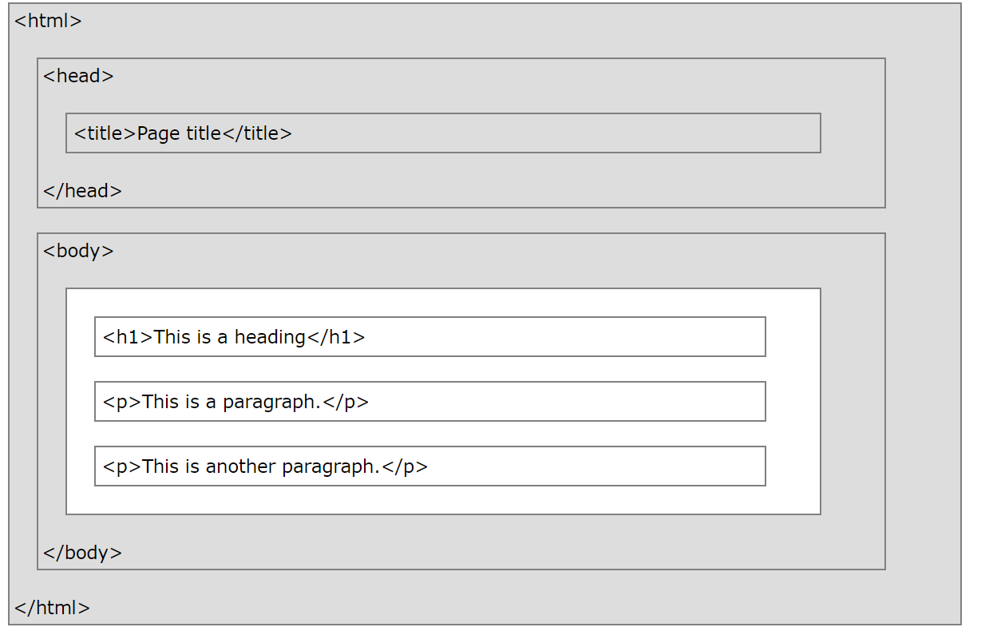

# **HTML Basic Examples**

## HTML Documents

All HTML documents must start with a document type declaration: <!DOCTYPE html>.

The HTML document itself begins with <html> and ends with </html>.

The visible part of the HTML document is between <body> and </body>.

### **Example**

<!DOCTYPE html>  
<html>  
<body>  
  
<h1>My First Heading</h1>  
<p>My first paragraph.</p>  
  
</body>  
</html>

[Try it Yourself »](https://www.w3schools.com/html/tryit.asp?filename=tryhtml_basic_document)

## The <!DOCTYPE> Declaration

The <!DOCTYPE> declaration represents the document type, and helps browsers to display web pages correctly.

It must only appear once, at the top of the page (before any HTML tags).

The <!DOCTYPE> declaration is not case sensitive.

The <!DOCTYPE> declaration for HTML5 is:

<!DOCTYPE html>

## HTML Headings

HTML headings are defined with the <h1> to <h6> tags.

<h1> defines the most important heading. <h6> defines the least important heading:

### **Example**

<h1>This is heading 1</h1>  
<h2>This is heading 2</h2>  
<h3>This is heading 3</h3>

[Try it Yourself »](https://www.w3schools.com/html/tryit.asp?filename=tryhtml_basic_headings)

## HTML Paragraphs

HTML paragraphs are defined with the <p> tag:

### **Example**

<p>This is a paragraph.</p>  
<p>This is another paragraph.</p>

[Try it Yourself »](https://www.w3schools.com/html/tryit.asp?filename=tryhtml_basic_paragraphs)

## HTML Links

HTML links are defined with the <a> tag:

### **Example**

<a href="https://www.w3schools.com">This is a link</a>

[Try it Yourself »](https://www.w3schools.com/html/tryit.asp?filename=tryhtml_basic_link)

The link's destination is specified in the href attribute.

Attributes are used to provide additional information about HTML elements.

You will learn more about attributes in a later chapter.

## HTML Images

HTML images are defined with the <img> tag.

The source file (src), alternative text (alt), width, and height are provided as attributes:

### **Example**

<img src="w3schools.jpg" alt="W3Schools.com" width="104" height="142">

[Try it Yourself »](https://www.w3schools.com/html/tryit.asp?filename=tryhtml_basic_img)

## How to View HTML Source?

Have you ever seen a Web page and wondered "Hey! How did they do that?"

### **View HTML Source Code:**

Right-click in an HTML page and select "View Page Source" (in Chrome) or "View Source" (in Edge), or similar in other browsers. This will open a window containing the HTML source code of the page.

### **Inspect an HTML Element:**

Right-click on an element (or a blank area), and choose "Inspect" or "Inspect Element" to see what elements are made up of (you will see both the HTML and the CSS). You can also edit the HTML or CSS on-the-fly in the Elements or Styles panel that opens.