# Bus Pass – User Manual

**WELCOME PAGE**

When user login to Bus pass application, Welcome page displays about the guidelines for bus transport users.

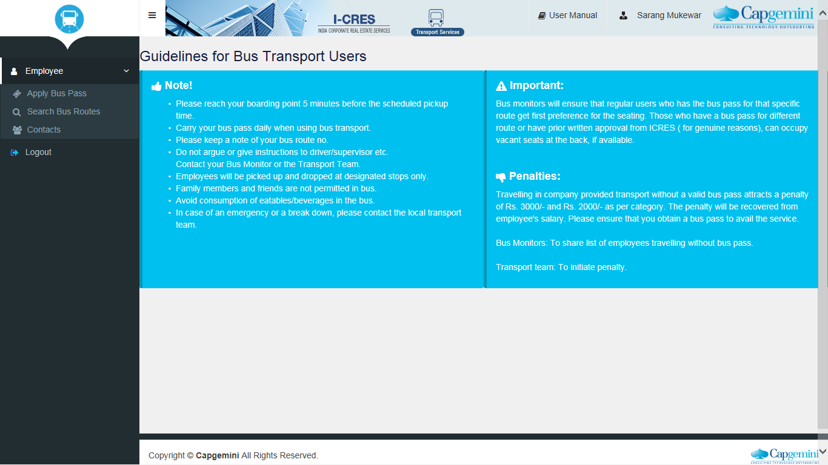

**Apply Bus Pass**

User can click on Apply Bus Pass, fill all the required fields and submit on Apply Bus Pass Button. If user want to search the bus route, they can click in Search Bus Route button, and the below option appears.

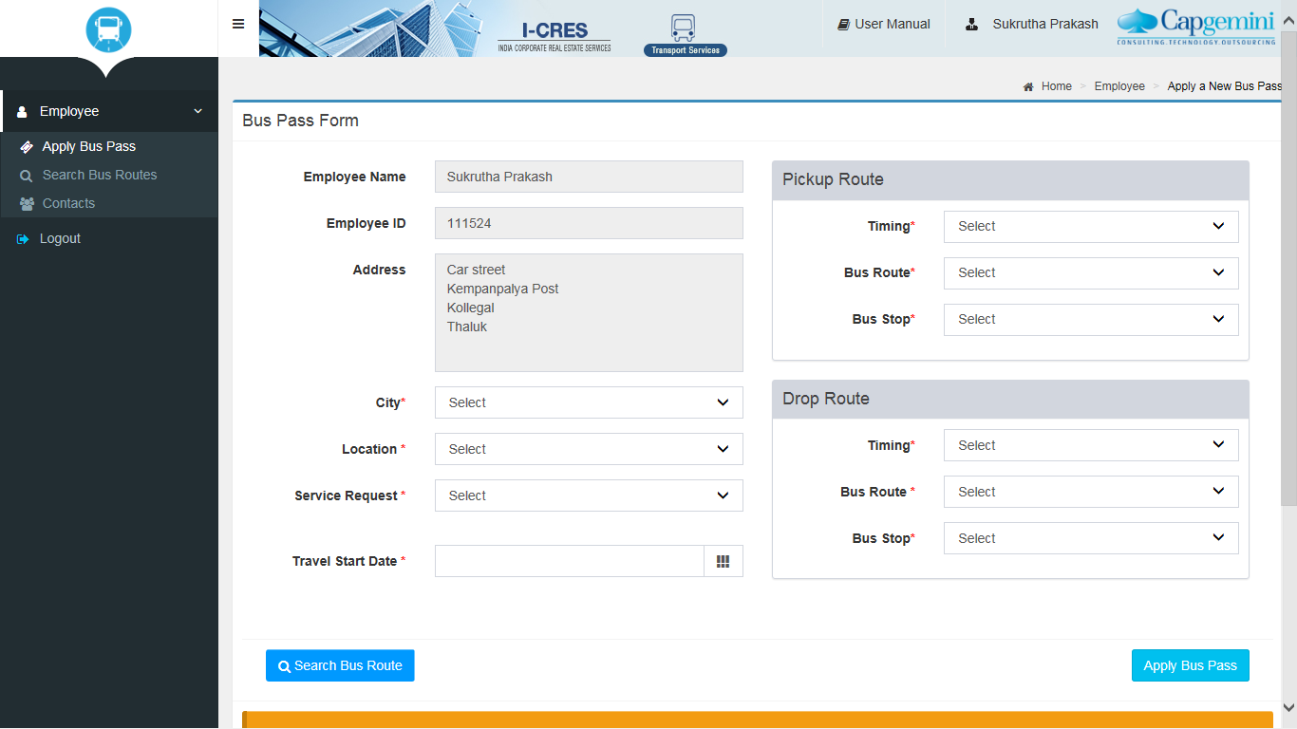

**Search Bus Routes**

User can click on Search Bus Routes, to check for bus routes avaliability.

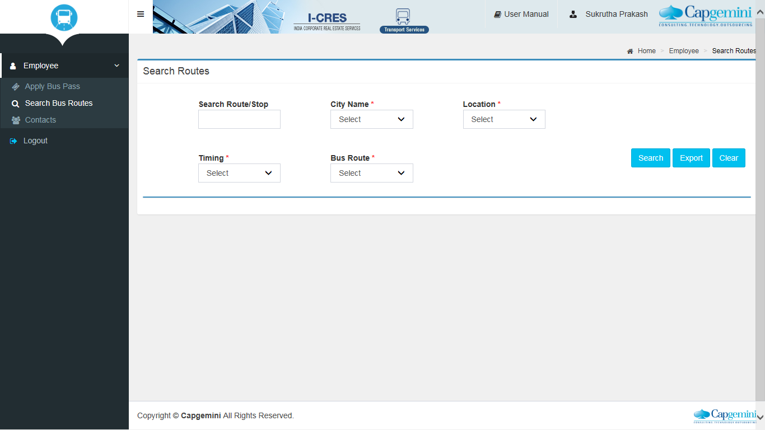

**Contact Information**

User can view the transport team contact numbers using Contacts option.

