GAMING AND ESPORTS COMMUNITY WEBSITE
HTML and CSS Project

1. Project Description
This project presents a gaming portal for a gaming and esports community. It contains game profiles, tournament schedules, team information, player profiles, a leaderboard and gaming news. The design uses a dark background, neon cyan and magenta accents, hover effects and a responsive layout.

2. Website Output Page
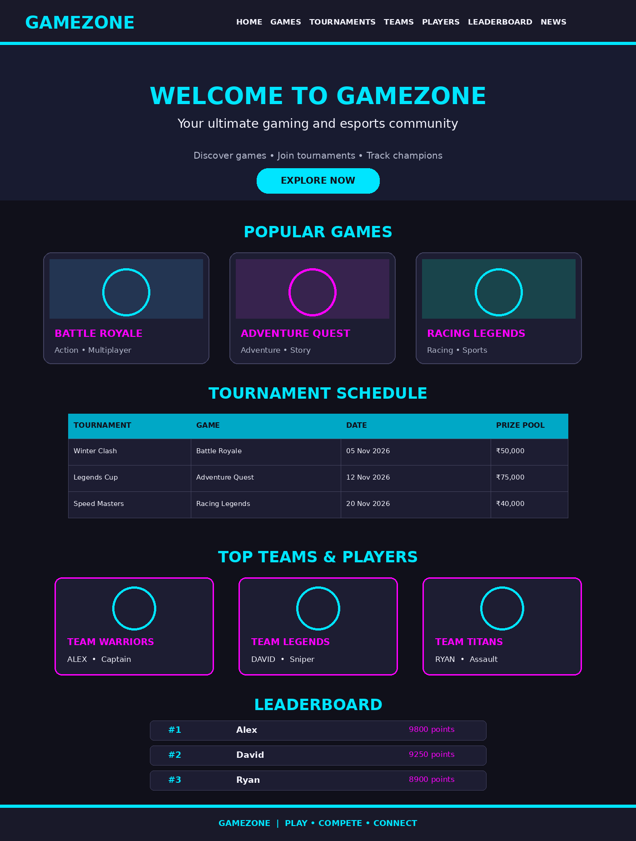
Illustrative output preview of the website layout. Actual images and page appearance may vary depending on internet access and browser rendering.

3. HTML Code (index.html)
Create a file named index.html and paste the following code:
<!DOCTYPE html>
<html lang="en">
<head>
<meta charset="UTF-8">
<meta name="viewport" content="width=device-width, initial-scale=1.0">
<title>GameZone - Gaming and Esports</title>
<link rel="stylesheet" href="style.css">
</head>
<body>
<header>
<h1>GAMEZONE</h1>
<nav>
<a href="#home">Home</a>
<a href="#games">Games</a>
<a href="#tournaments">Tournaments</a>
<a href="#teams">Teams</a>
<a href="#players">Players</a>
<a href="#leaderboard">Leaderboard</a>
<a href="#news">News</a>
</nav>
</header>

<section class="hero" id="home">
<h2>Welcome to GameZone</h2>
<p>Your ultimate gaming and esports community</p>
<a href="#games" class="btn">Explore Games</a>
</section>

<section id="games">
<h2>Popular Games</h2>
<div class="container">
<div class="card">
<img src="https://images.unsplash.com/photo-1542751371-adc38448a05e?w=600" alt="Esports gaming event">
<h3>Battle Royale</h3><p>Fight, survive and become the champion.</p><span>Genre: Action</span>
</div>
<div class="card">
<img src="https://images.unsplash.com/photo-1511512578047-dfb367046420?w=600" alt="Gaming setup">
<h3>Adventure Quest</h3><p>Explore exciting worlds and complete missions.</p><span>Genre: Adventure</span>
</div>
<div class="card">
<img src="https://images.unsplash.com/photo-1493711662062-fa541dbc3fc8?w=600" alt="Gaming controller">
<h3>Racing Legends</h3><p>Race against top players and win the track.</p><span>Genre: Racing</span>
</div>
</div>
</section>

<section id="tournaments">
<h2>Upcoming Tournaments</h2>
<div class="table-container">
<table>
<tr><th>Tournament</th><th>Game</th><th>Date</th><th>Prize Pool</th></tr>
<tr><td>Winter Clash</td><td>Battle Royale</td><td>05 Nov 2026</td><td>₹50,000</td></tr>
<tr><td>Legends Cup</td><td>Adventure Quest</td><td>12 Nov 2026</td><td>₹75,000</td></tr>
<tr><td>Speed Masters</td><td>Racing Legends</td><td>20 Nov 2026</td><td>₹40,000</td></tr>
</table>
</div>
</section>

<section id="teams">
<h2>Top Gaming Teams</h2>
<div class="container">
<div class="card"><h3>Team Warriors</h3><p>Known for teamwork and strategy.</p><span>Members: 5</span></div>
<div class="card"><h3>Team Legends</h3><p>Skilled players with championship experience.</p><span>Members: 5</span></div>
<div class="card"><h3>Team Titans</h3><p>Rising stars in competitive gaming.</p><span>Members: 5</span></div>
</div>
</section>

<section id="players">
<h2>Featured Players</h2>
<div class="container">
<div class="card player"><h3>Alex</h3><p>Role: Captain</p><span>Wins: 25</span></div>
<div class="card player"><h3>David</h3><p>Role: Sniper</p><span>Wins: 21</span></div>
<div class="card player"><h3>Ryan</h3><p>Role: Assault</p><span>Wins: 19</span></div>
</div>
</section>

<section id="leaderboard">
<h2>Top Players Leaderboard</h2>
<div class="table-container">
<table>
<tr><th>Rank</th><th>Player</th><th>Team</th><th>Points</th></tr>
<tr><td>1</td><td>Alex</td><td>Team Warriors</td><td>9800</td></tr>
<tr><td>2</td><td>David</td><td>Team Legends</td><td>9250</td></tr>
<tr><td>3</td><td>Ryan</td><td>Team Titans</td><td>8900</td></tr>
<tr><td>4</td><td>Sam</td><td>Team Warriors</td><td>8500</td></tr>
</table>
</div>
</section>

<section id="news">
<h2>Gaming News</h2>
<div class="container">
<div class="card"><h3>New Game Releases</h3><p>Discover the latest games and updates.</p></div>
<div class="card"><h3>Esports Championship</h3><p>Follow exciting competitive gaming events.</p></div>
<div class="card"><h3>Gaming Technology</h3><p>Explore new trends in gaming hardware.</p></div>
</div>
</section>

<footer>
<h2>GameZone</h2>
<p>Play • Compete • Connect</p>
<p>© 2026 GameZone. All rights reserved.</p>
</footer>
</body>
</html>

4. CSS Code (style.css)
Create a file named style.css in the same folder. This is the CSS styling supplied for the project:
/* General Styling */
* {
margin: 0;
padding: 0;
box-sizing: border-box;
font-family: Arial, sans-serif;
scroll-behavior: smooth;
}

body {
background-color: #10101a;
color: white;
}

/* Header */
header {
background-color: #191929;
padding: 20px;
display: flex;
justify-content: space-between;
align-items: center;
flex-wrap: wrap;
border-bottom: 2px solid #00e5ff;
}

header h1 {
color: #00e5ff;
font-size: 28px;
}

nav a {
color: white;
text-decoration: none;
margin: 10px;
font-weight: bold;
}

nav a:hover {
color: #00e5ff;
}

/* Hero Section */
.hero {
background: linear-gradient(#0009, #0009),
url("https://images.unsplash.com/photo-1542751371-adc38448a05e?w=1200");
background-size: cover;
background-position: center;
text-align: center;
padding: 130px 20px;
}

.hero h2 {
color: #00e5ff;
font-size: 45px;
margin-bottom: 20px;
text-shadow: 0 0 15px #00e5ff;
}

.hero p {
font-size: 22px;
margin-bottom: 30px;
}

.btn {
background-color: #00e5ff;
color: #10101a;
padding: 13px 25px;
text-decoration: none;
border-radius: 25px;
font-weight: bold;
}

.btn:hover {
background-color: #ff00ff;
color: white;
}

/* Sections */
section {
padding: 50px 20px;
}

section h2 {
text-align: center;
color: #00e5ff;
font-size: 32px;
margin-bottom: 35px;
}

/* Cards */
.container {
display: flex;
justify-content: center;
flex-wrap: wrap;
gap: 25px;
}

.card {
background-color: #1d1d32;
width: 280px;
padding: 18px;
border-radius: 12px;
text-align: center;
border: 1px solid #343454;
transition: 0.3s;
}

.card:hover {
transform: translateY(-8px);
border-color: #00e5ff;
box-shadow: 0 0 20px #00e5ff66;
}

.card img {
width: 100%;
height: 180px;
object-fit: cover;
border-radius: 10px;
}

.card h3 {
color: #ff00ff;
margin: 15px 0;
}

.card p {
line-height: 1.5;
margin-bottom: 10px;
}

.card span {
color: #00e5ff;
font-weight: bold;
}

/* Tables */
.table-container {
max-width: 950px;
margin: auto;
overflow-x: auto;
}

table {
width: 100%;
border-collapse: collapse;
background-color: #1d1d32;
}

th, td {
padding: 16px;
text-align: center;
border: 1px solid #44445f;
}

th {
background-color: #00a8c6;
color: #10101a;
}

tr:hover {
background-color: #343454;
}

/* Player Cards */
.player {
border-top: 4px solid #ff00ff;
}

.player h3 {
font-size: 25px;
color: #00e5ff;
}

/* Footer */
footer {
background-color: #191929;
border-top: 2px solid #00e5ff;
color: white;
text-align: center;
padding: 30px;
}

footer h2 {
color: #00e5ff;
margin-bottom: 12px;
}

footer p {
margin-top: 10px;
}

/* Responsive Design */
@media (max-width: 768px) {

header {
flex-direction: column;
gap: 15px;
}

nav {
text-align: center;
}

nav a {
display: inline-block;
margin: 8px;
}

.hero h2 {
font-size: 30px;
}

.card {
width: 100%;
max-width: 400px;
}

th, td {
padding: 10px;
font-size: 14px;
}
}

5. How to Run the Website
- Create a folder named Gaming-Esports-Website.
- Save the HTML code as index.html.
- Save the CSS code as style.css in the same folder.
- Make sure the HTML head contains: <link rel="stylesheet" href="style.css">.
- Open index.html in a web browser.
Note: The tournament dates, teams, player names, scores and news shown are sample project content, not live esports data. The game and hero images use online image links and require an internet connection.

