**Q1.)**

**a.)**

library(datasets)

attach(trees)

**b.)**

summary(trees)

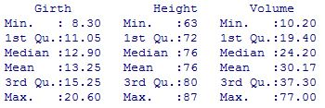

So there are three variables in this dataset. We can plot each of them as follow.

plot(density(trees$Girth,na.rm=T),main="Distribution of Girth", xlab="girth", ylab="density")

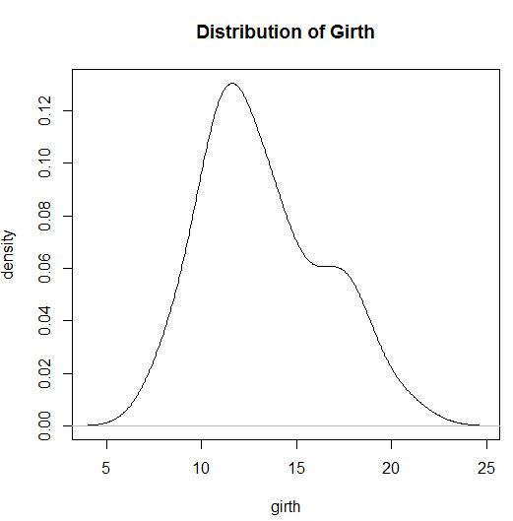

plot(density(trees$Height,na.rm=T),main="Distribution of Height", xlab="height", ylab="density")

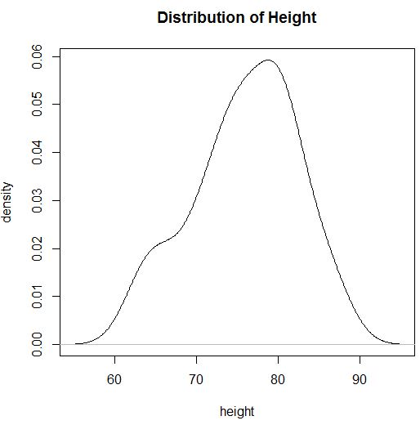

plot(density(trees$Volume,na.rm=T),main="Distribution of Volume", xlab="volume", ylab="density")

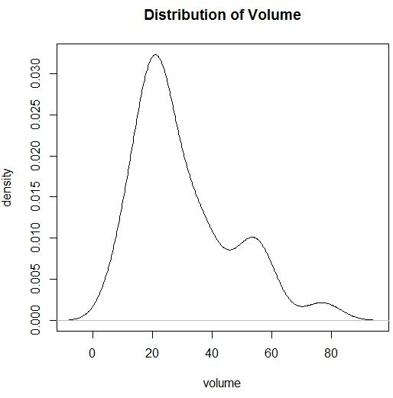

**c.)**

length(trees$Girth)

mean(trees$Girth)

sd(trees$Girth)

error <- qnorm(0.975)*sd(trees$Girth)/sqrt(length(trees$Girth))

left <- mean(trees$Girth)-error

right <- mean(trees$Girth)+error

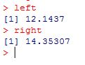

length(trees$Height)

mean(trees$Height)

sd(trees$Height)

error <- qnorm(0.975)*sd(trees$Height)/sqrt(length(trees$Height))

left <- mean(trees$Height)-error

right <- mean(trees$Height)+error

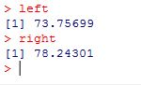

**d.)**

x <- mean(trees$Height)

val <- 72

s <- sd(trees$Height)

n <- length(trees$Height)

z <- (x - val)/(s/sqrt(n))

pval <- pnorm(z)

I got is o.999 for pval. And also alpha is 0.05. So we can reject the hypothesis. So the average height of black cherry trees is more than 72 ft.

**Q2.)**

**a.)**

noodor <- c(15.9,18.5,15.9,18.5,18.5,21.9,15.9,15.9,15.9,15.9,15.9,18.5,18.5,18.5,20.5,18.5,18.5,15.9,15.9,15.9,18.5,18.5,15.9, 18.5, 15.9,18.5,15.9,25.5,12.9,15.9)



lavenderodor <- c(21.9,18.5,22.3,21.9,18.5,24.9,18.5,22.5,21.5,21.9,21.5,18.5,25.5,18.5,18.5,21.9,18.5,18.5,24.9,21.9,25.9,21.9,18.5,18.5,22.8,18.5,21.9,20.7,21.9,22.5)



plot(density(noodor,na.rm=T),main="Distribution of NO ODOR", xlab="no odor", ylab="density")

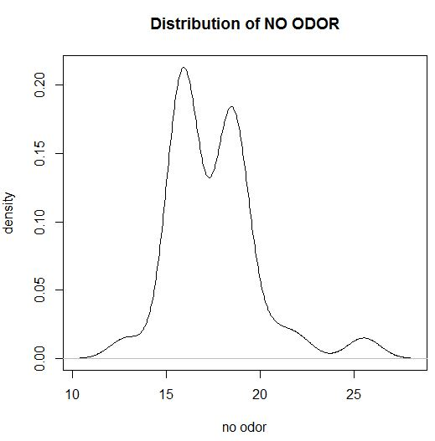

plot(density(lavenderodor,na.rm=T),main="Distribution of LAVENDER ODOR", xlab="lavender odor", ylab="density")

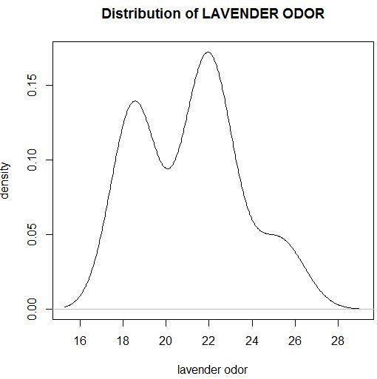

**b.)**

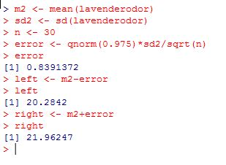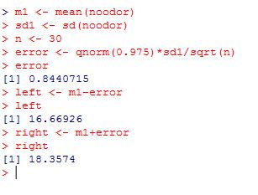

**c.)**

t.test(noodor,lavenderodor,alternatine="greater")