SCS2111 take Home Assignment – 3 Name– G. S. I. M Perera Index No - 14001111

1)

a)

library(datasets)

> attach(trees)

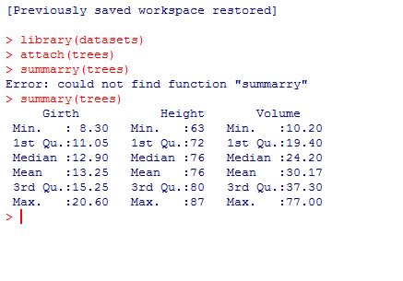

b)

As shown above the tree dataset contains three variables Girth, Height and Volume and a summary of their values.

Density graph distribution for the Girth- plot(density(trees$Girth,na.rm=T),main="Girth Distribution", xlab="Girth", ylab="Density")

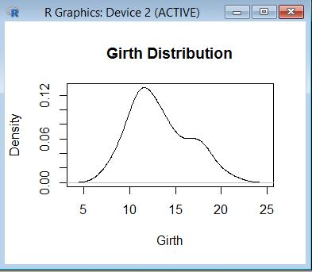

Density graph distribution of height- plot(density(trees$Height,na.rm=T),main="Height Distribution", xlab="Height", ylab="Density")

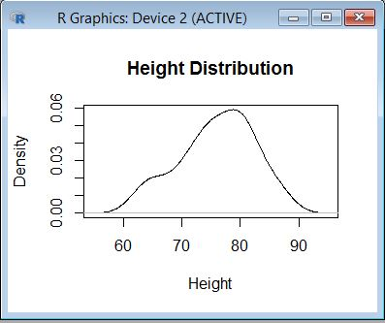

Density graph distribution of Volume- plot(density(trees$Volume,na.rm=T),main=Volume Distribution", xlab="Volume", ylab="Density")

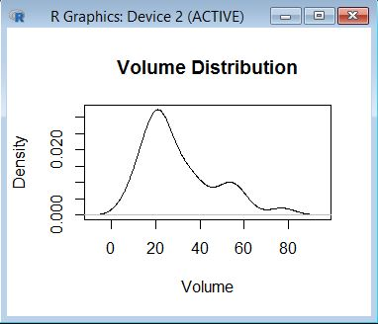

c)

length(trees$Girth)

mean(trees$Girth)

sd(trees$Girth)

error <- qnorm(0.975)*sd(trees$Girth)/sqrt(length(trees$Girth))

left <- mean(trees$Girth)-error

right <- mean(trees$Girth)+error

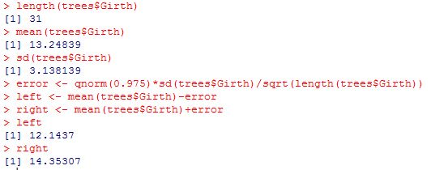

length(trees$Height)

mean(trees$Height)

sd(trees$Height)

error <- qnorm(0.975)*sd(trees$Height)/sqrt(length(trees$Height))

left <- mean(trees$Height)-error

right <- mean(trees$Height)+error

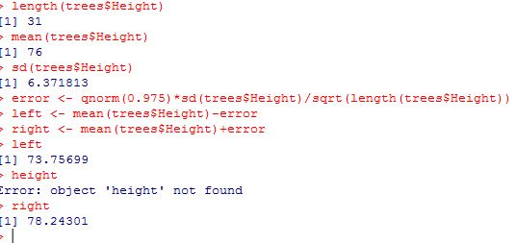

d)

mean_height <- mean(trees$Height)

> value <- 72

> sd_height <- sd(trees$Height)

> len <- length(trees$Height)

> val <- (mean_height-value)/(sd_height/sqrt(len))

> p_value <- pnorm(val)

> p_value

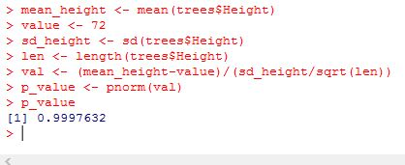

So the answer is 0.999. that means p-value is greater than 0.05 which means that the hypothesis is accepted. Therefore the average height of blackberry trees is less than 72 ft.

2)

a)

NO_ODOR <- c(15.9,18.5,15.9,18.5,18.5,21.9,15.9,15.9,15.9,15.9,15.9,18.5,18.5,18.5,20.5,18.5,18.5,15.9,15.9,15.9,18.5,18.5,15.9,18.5, 15.9,18.5,15.9,25.5,12.9,15.9)

C:\Users\Sunith\Desktop\kkk.JPG

LAVENDER_ODOR <- c(21.9,18.5,22.3,21.9,18.5,24.9,18.5,22.5,21.5,21.9,21.5,18.5,25.5,18.5,18.5,21.9,18.5,18.5,24.9,21.9,25.9,21.9,18.5,18.5,22.8,18.5,21.9,20.7,21.9,22.5)

C:\Users\Sunith\Desktop\ee.JPG

plot(density(NO_ODOR,na.rm=T),main="Distribution of NO_ODOR", xlab="no odor", ylab="density")

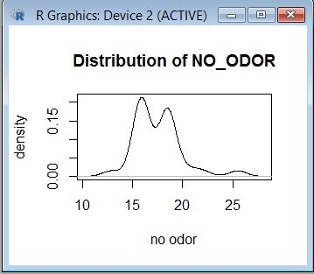

plot(density(LAVENDER_ODOR,na.rm=T),main="Distribution of LAVENDER_ODOR", xlab="lavender odor", ylab="density")

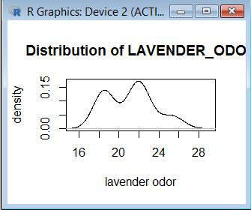

b)

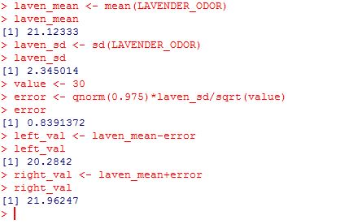

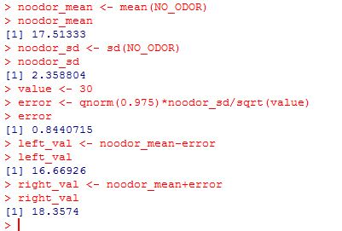

c)

t.test(NO_ODOR,LAVENDER_ODOR,alternatine="greater")

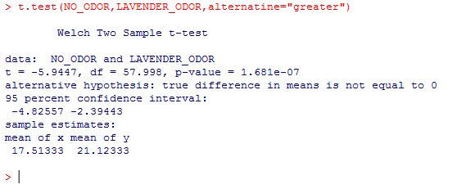

So the alpha value which is 0.05 is less than the p-value obtained. Therefore the final conclusion would be that Nicolas Gueguens’s that the odor will not bring good to the business.