Project Superviser: Mr. L.P. Jayasinghe BSc(col) (Instrutor Gr. I)

Web based system for computing service center

Group 14

Content

Group Members ……………………………………………………………………… 2

Use case Diagram …………………………………………………………………… 3

Class Diagram .………………………………………………………………………. 4

E-R Diagram ………………………………………………………………………… 5

System Architecture Diagram …………………………………………………….. 6

Individual Contribution …………………………………………………………….. 7

Group Members

|  |  |  |
| --- | --- | --- |
| NAME | INDEX NUMBER | REGISTRATION NUMBER |
| T.M.R.S Thennakoon | 2014/IS/081 | 14020815 |
| A. D. F Humairah | 2014/IS/081 | 14020272 |
| G.S.I.M Perera | 2014/CS/111 | 14001111 |
| I.S Weerakkody | 2014/CS/152 | 14001527 |
| C.N Ariyasiri | 2014/CS/006 | 14000067 |

**Use case Diagram**

dii.png

**Class Diagram**

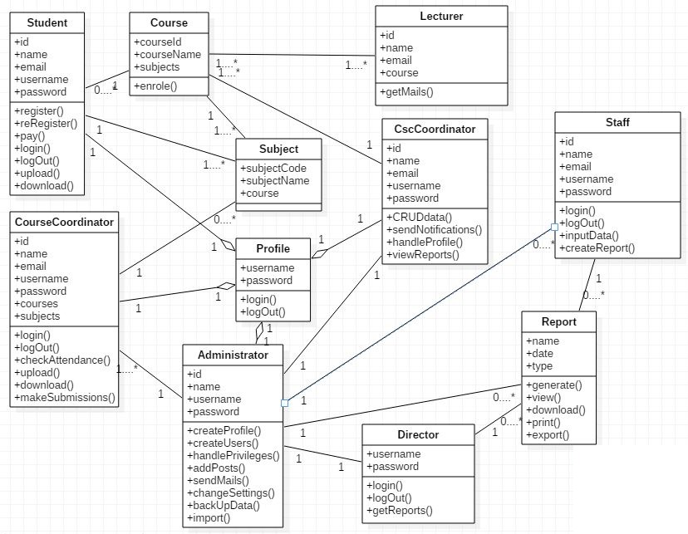

**ER-Diagram**

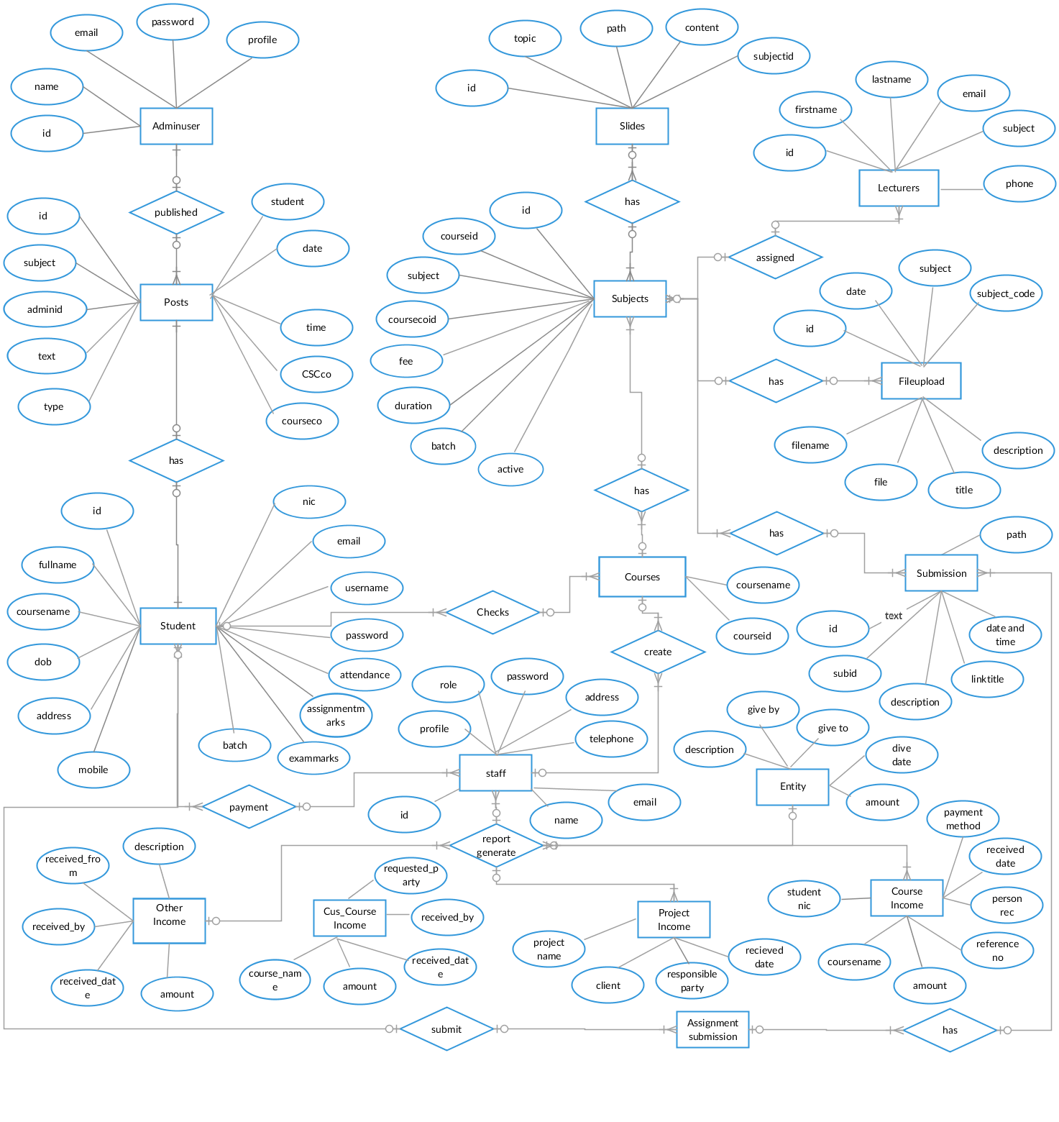

**System Architecture Diagram**

**System architecture is following simple MVC design pattern**

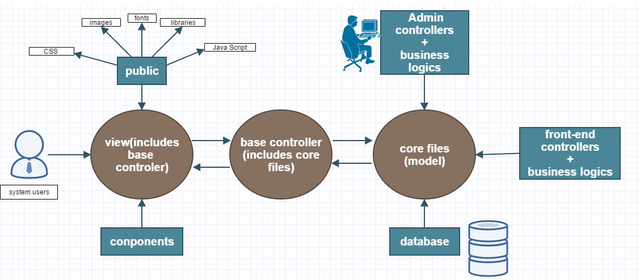

**Individual Contribution**

|  |  |  |  |
| --- | --- | --- | --- |
| Group No: | 14 | Supervisor: | L.P Jayasinghe |
| Project Title: | Web Based System For Computing Service Center | | |

|  |  |  |  |
| --- | --- | --- | --- |
| Student’s Name | A. D. F Humairah | Signature |  |
| Index No | 14020272 |

|  |
| --- |
| * CSC Coordinator home page UI, * CSC Coordinator Handle Lecturer, Handle courses UIs and Functionalities (Front to Back ends, complete implementation) * CSC Coordinator Handle Report, UIs (Front and some report handling back ends) * Email, Notification UIs * Database design and implementation (For the related backend) * Preparation of user manual. * User experience designing |

|  |  |  |  |
| --- | --- | --- | --- |
| Student’s Name | T.M.R.S Thennakoon | Signature |  |
| Index No | 14020815 |

|  |
| --- |
| * + - Design and implement Complete system Architecture. * Implemet Complete system login functionality * implement Overrall System session Management * Complete Admin panel of the system including   User interfaces  Database  Backend Functionalities  Plugin intergration and configuring  Security   * Contribute to database design (with shehan weerakkody and suneth perera)   Implement System security |

|  |  |  |  |
| --- | --- | --- | --- |
| Student’s Name | G.S.I.M Perera | Signature |  |
| Index No | 14001111 |

|  |
| --- |
| * Designed and developed the user interfaces of course coordinator. * Developed the login system of the course coordinator. * Developed the acoount settings system. * Developed the file upload mechanism. * Developed the file submission and file download system.(with T.M.R.S Thennakoon). * Developed the newfeed of the coursecoordinator (with T.M.R.S Thennakoon). |

|  |  |  |  |
| --- | --- | --- | --- |
| Student’s Name | I.S Weerakkody | Signature |  |
| Index No | 14001527 |

|  |
| --- |
| * Designed and developed user interfaces for all the staff interfaces. * Developed all the report submission part with respect to the staff(Front to Back ends, complete implementation) * Developed all the report generating parts with respect to the staff. * Developed report downloading part (pdf format). (with T.M.R.S Thennakoon) * Developed manual student registration part. |

|  |  |  |  |
| --- | --- | --- | --- |
| Student’s Name | C.N. Ariyasiri | Signature |  |
| Index No | 14000067 |

|  |
| --- |
| * Design the user interface of student login page. * Design and develop user interfaces and back end functionalities of student home page ,subject page,submission page. (with T.M.R.S Thennakoon) * Design and develop the student account setting part. * Complete the student application form. (UI and back end funtionalities) * Complete the SMS notification system. |