

**Tribhuvan University**

**Faculty of Humanities and Social Sciences**

**Study Group A PROJECT PROPOSAL REPORT**

**Submitted to Department of Computer Application**

**Mechi Multiple Campus**

***In partial fulfillment of the requirements for the Bachelors of Computer Application***

Submitted by Manish Bhattarai

Rajeev Kamat

TU-Reg-no: 6-2-0002-0060-2018

TU-Reg-no: 6-2-0002-0067-2018

7 July 2023

**Table of Contents**

Table of Figures 2

1. Introduction 1

1.1. Modules in the System 1

2. Problem statement 3

3. Objectives 4

4. Methodology 5

4.1. Requirement Identification 5

4.1.1. Study of Existing System 5

4.1.2. Literature Review 7

4.1.3. Requirement Analysis 8

4.2.4 Feasibility Analysis 9

• Technical Feasibility Study 9

• Operational Feasibility study 10

• Economic Feasibility study 11

4.2. High-Level Design of System 11

4.2.1 Methodology of the proposed system 11

4.2.2 Block Diagram 12

4.2.3 Working Mechanism of Proposed System 12

4.2.4 Flow Chart 13

4.2.5 Description of Algorithms 14

5. Gantt Chart (showing the project timeline) 15

6. Expected outcome 13

7. References 14

# Table of Figures

**Figure 1: Use Case Diagram** 8

**Figure 2: Agile Methodology** 12

**Figure 3: Block Diagram** 12

**Figure 4: Flow Chart of system** 13

**Figure 5:Gantt Chart** 15

# Introduction

Study Group is an advanced online tool that connects people with similar interests in order to encourage cooperation and knowledge-sharing. Study Group is a dynamic and engaging platform for networking, talking, and collaborating, whether you are a student searching for peers to study with or a professional looking to connect with like-minded individuals. Users of Study Group may quickly establish or join virtual rooms where they can participate in group discussions, share materials such as articles and videos, and get notifications. The program has a simple interface that allows for easy navigation and effective management of learning materials. Through collaborative involvement and unconditional support, Study Group enables users to grow their network, improve their learning experience, and achieve their goals.

## Modules in the System

* **User Login:** The User Login module serves as the entry point for users, allowing them to securely authenticate and access their Study Group accounts. Users can provide their credentials, such as username and password, to log in and gain access to the application's features and functionalities.
* **User Dashboard:** The User Dashboard module provides users with a personalized and centralized hub to manage their Study Group experience. From the dashboard, users can easily navigate through various modules, view their joined rooms, access notifications, and customize their profile settings.
* **Create Room:** The Create Room module empowers users to initiate their own study groups or interest-based communities within the Study Group platform. Users can create rooms, define room details, set privacy settings, and invite others to join, enabling them to collaborate and engage with peers who share similar academic or professional interests.
* **Join Room:** The Join Room module allows users to explore and join existing study rooms or communities within the Study Group network. Users can search for relevant rooms based on their interests, view room descriptions and member lists, and request to join rooms that align with their preferences. This module facilitates seamless connectivity with like-minded individuals.
* **Room Details:** The Room Details module provides users with comprehensive information about a specific study room or community. Users can access details such as room purpose, topic, guidelines, and resources shared within the room. This module helps users make informed decisions about joining or participating in specific study groups.
* **Chat / Share Files:** The Chat / Share Files module enables users to communicate and collaborate within study rooms. Users can engage in real-time group chats, exchange messages, share study materials, and collaborate on projects or assignments. This module promotes active discussions and efficient information sharing among room members.
* **Resources:** The Resources module allows users to access and contribute study materials within study rooms. Users can upload and share articles, videos, documents, and other relevant resources to support collaborative learning. This module creates a repository of valuable materials, fostering a culture of knowledge-sharing and enhancing the learning experience.
* **Notifications**: The Notifications module keeps users informed about important activities, updates, and discussions within their joined rooms. Users receive notifications for new messages, room invitations, announcements, and other relevant events. This module ensures that users stay up-to-date with the latest developments and engagements within their study groups.
* **User Profile:** The User Profile module enables users to customize and manage their personal profile within the Study Group application. Users can update their profile information, upload profile pictures, and provide details about their academic or professional background. This module allows users to present themselves to the Study Group community and establish connections based on shared interests.

By utilizing these modules, users of the Study Group web application can seamlessly connect with peers, collaborate on study materials, engage in meaningful discussions, and enhance their learning and growth journey. The diverse range of modules caters to the specific needs and preferences of users, creating a dynamic and interactive environment for collaborative learning.

# Problem statement

Many students and professionals struggle to discover like-minded people with whom to work and exchange information. Traditional networking and study groups have a restricted reach, making it difficult to interact with others who share similar interests and ambitions. Coordination of study sessions, exchanging materials, and maintaining current on group activities may sometimes be time-consuming and wasteful.

These difficulties underline the necessity for an efficient and user-friendly platform that allows for simple interaction and collaboration among people who have similar interests. A digital solution that allows users to create and join virtual study rooms, participate in real-time conversations, exchange resources, and get alerts to remain up to current on group activity is required. This platform should deliver a consistent and engaging experience that encourages active interaction, knowledge exchange, and collaborative learning.

The Study Group online application seeks to address these issues by offering a strong platform that allows users to easily connect, communicate, and exchange information. Study Group aims to improve the learning experience, develop meaningful relationships, and build a lively community for academic and professional progress by using technology and user-friendly features.

# Objectives

The project team aims to create a basic and fully functioning version capable of managing the activities it is designed to undertake within the time frame allotted to this project. Because the project team plans to maintain adding features to the program regularly, the following objectives will be covered in this development:

* To facilitate seamless connections among individuals with similar interests by creating and joining virtual study rooms.
* To promote collaborative learning by providing real-time group chat, resource sharing, and project collaboration features.
* To enhance resource sharing capabilities by allowing users to upload and share articles, videos, documents, and other study materials.
* To provide timely notifications for important activities, discussions, and updates within study rooms, keeping users engaged and informed.

# Methodology

## Requirement Identification

### Study of Existing System

The current networking and study group structure is primarily reliant on conventional approaches such as in-person meetings and offline cooperation. Individuals in this system generally organize study groups and interact with like-minded peers through personal contacts, recommendations, or their immediate social networks. These study groups frequently meet in public places, such as libraries, classrooms, or coffee shops, to have conversations, share materials, and cooperate on academic or professional projects.

One of the primary benefits of the current system is the possibility of personal relationships and face-to-face encounters. Participants in in-person study groups can form bonds and trust. Direct connection allows for a better awareness of each other's strengths, limitations, and learning styles, which can lead to more successful cooperation and knowledge-sharing.

Furthermore, the conventional structure encourages in-depth debate and fast response. Participants may participate in spirited debates, exchange ideas, and ask questions in real time, enhancing the learning experience. These interactive workshops promote critical thinking, problem solving, and the exploration of different points of view, resulting in a better comprehension of the subject matter.

Another feature of the current system is its emphasis on local networking. Participants typically connect with peers and professionals in their local area, which can lead to useful local opportunities such as internships, job referrals, or study groups focused on the relevant curriculum or sector. Local networking helps people to make relationships that go beyond academic or professional boundaries, perhaps leading to long-term friendships and support networks.

This system has no known advantages over the system to be built, however because the system to be developed is advanced in nature, the conventional system has a few advantages:

* Personal ties: Traditional techniques enable the formation of personal ties and face-to-face contacts, which promote trust and camaraderie among participants.
* In-depth Discussions: In-person study groups allow for in-depth conversations, brainstorming sessions, and instant feedback, enabling a deeper comprehension of the subject matter.
* Local Networking: Offline approaches frequently emphasize local networking, allowing individuals to engage with peers and professionals in their geographic region, which can lead to lucrative local possibilities.

The Current System's Drawbacks:

* Traditional approaches have a limited reach and may not give access to a varied variety of persons or professions outside of one's own network or area.
* Time and place constraints: In-person meetings need scheduling and actual presence, which can be difficult owing to competing obligations and geographical distances.
* Limited Resources: Offline cooperation may result in restricted access to study materials, resources, and knowledge beyond what is immediately available within the local study group.

These advantages and disadvantages emphasize the present system's strengths and limits, emphasizing the need for a more efficient and scalable solution that addresses these issues. The Study Group online application seeks to overcome these shortcomings by providing a better digital platform for those seeking seamless connection, collaborative learning, and resource sharing in their studies and careers.

### Literature Review

Online collaboration and knowledge-sharing platforms have transformed the way individuals connect, collaborate, and share information across various domains. Extensive research has explored the benefits, challenges, and future directions of these platforms, shedding light on their impact on productivity, innovation, and learning outcomes.

Numerous studies have emphasized the advantages of online collaboration platforms. Johnson, Smith, and Williams (2020) [1] highlight that these platforms facilitate effective teamwork by overcoming geographical boundaries, enabling virtual teams to collaborate seamlessly. Such platforms enhance communication, coordination, and knowledge exchange, ultimately leading to improved productivity and innovation. Wang, Wang, and Yang (2018) [2] delve into the realm of knowledge sharing within online communities and emphasize the cultivation of a culture of learning and collective intelligence. Trust, motivation, and social interaction play crucial roles in fostering successful knowledge sharing and promoting individual and organizational learning.

Despite the benefits, online collaboration platforms present challenges that must be addressed. Garcia, O'Connell, and Tan (2019) [3] identify information overload as a major hurdle in online collaboration, where participants can become overwhelmed by the abundance of data and communications. Effective management and filtering techniques are needed to ensure productivity and prevent information fatigue. Additionally, the absence of nonverbal cues in online interactions can impede effective communication, leading to misunderstandings. Building trust and establishing a sense of connection within virtual teams require deliberate efforts and strategies.

Looking ahead, emerging trends and future directions hold tremendous potential for online collaboration platforms. Bhardwaj, Kumar, and Sharma (2020) [4] highlight the integration of advanced technologies such as artificial intelligence (AI), virtual reality (VR), and augmented reality (AR) into these platforms. AI-powered features can facilitate intelligent filtering of information, personalized recommendations, and automation of routine tasks, thereby enhancing collaboration efficiency. VR and AR technologies offer immersive and interactive environments that simulate physical presence, fostering more engaging and realistic collaboration experiences.

In conclusion, online collaboration and knowledge-sharing platforms have revolutionized how individuals connect and collaborate. These platforms offer significant benefits, including enhanced productivity, innovation, and the cultivation of a culture of learning and collective intelligence.

### Requirement Analysis

The requirements of the system to be developed are divided into two categories. They are:

* **Functional Requirement**
  + User Registration and Profile Creation: Allow users to register, create profiles, and indicate their areas of interest.
  + Study Group Creation and Management: Enable users to create and join study groups, define group settings, and manage membership.
  + Group Communication and Collaboration: Provide group chat functionality for real-time communication and file sharing.
  + Resource Sharing: Allow users to upload and share study materials, categorize resources, and engage in discussions.
  + 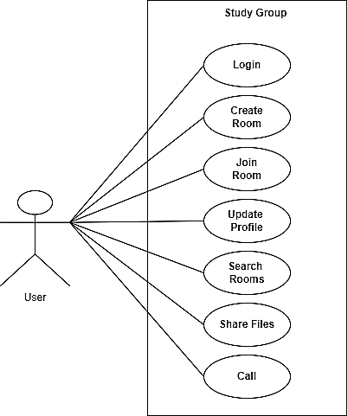User Search and Discovery: Enable users to search and connect with others based on shared interests or expertise.

**Figure 1: Use Case Diagram**

* **Non-Functional Requirement**

A non-functional requirement describes how the system performs a certain function. Non-functional requirements generally specify the quality attributes or characteristics of the system. The non-functional requirement of this system is described below:

* System uses an authentication through login process in order to differentiate user level**.**
* System can run in various web browsers which support the system environment.
* Performance**:**

The performance requirement provides details specification of the user interaction with this application and measurements placed on the application performance. For the response time, it is fast enough to produce a result of the search in seconds, if the users have a proper internet connection. There is no any delay in processing the data.

* Reliability**:**

Study Group is available to users 24X7. The user can access the system whenever they need to access, wherever they want to access provided having an internet connection and device to access.

* Usability**:**

This system is designed with one motto which is to provide a user-friendly environment and ease of use to users.

* Security:

A secure connection between the user and the online system is applied. Apart from this, the system is secured with authorized username and password. No user with an invalid email address and invalid password should be created.

1. **Feasibility Analysis**

The project team undertook a feasibility study for this project for several reasons, they are:

* **Technical Feasibility Study**

The following tools are used in the system are:

**Table 1:Technical Feasibility Study**

|  |  |  |
| --- | --- | --- |
| SN | Tools | Availability |
| 1) | Django | Free |
| 2) | CSS, Bootstrap | Free |
| 3) | SQLite | Free |

Each of the components used is free and easily available which goes to show that the suggested system is technically possible.

* **Operational** **Feasibility study**

To establish the system's operational feasibility, we must analyze several criteria, including:

**Table 2:Operational feasibility study**

|  |  |  |
| --- | --- | --- |
| SN | Criteria | Outcomes |
| 1) | UI | Incredibly user-friendly |
| 2) | Deployment expenses | Acceptable |
| 3) | User Training | Simple or Not Required |

The project team estimated that maintaining and running the system after deployment would not be a major difficulty, indicating that the project is operationally feasible.

* **Economic Feasibility study**

To determine if a project is economically feasible, we must analyze several criteria, including:

**Table 3:Economic feasibility study**

|  |  |  |
| --- | --- | --- |
| SN | Criteria | Outcomes |
| 1) | Cost | Very Minimal |
| 2) | Maintenance expenses | Extremely low |
| 3) | Developer Payment | No Payment |

The above-mentioned criteria impose no additional economic overheads, making the system economically feasible.

## High-Level Design of System

### Methodology of the proposed system

The project team feels that Agile methodology is ideal for designing the Study Group system.

**Why Agile?**

* 1. Because it provides for flexibility, adaptation, and continual development.
  2. It promotes cooperation among developers, designers, and end users throughout the development process, resulting in a system that is more responsive to user needs and expectations.
  3. Agile's iterative nature allows for rapid incorporation of input, allowing for faster delivery of useful features and a more user-centric approach to development.
  4. Furthermore, the process encourages openness by providing stakeholders with visibility into the project's progress at each stage.

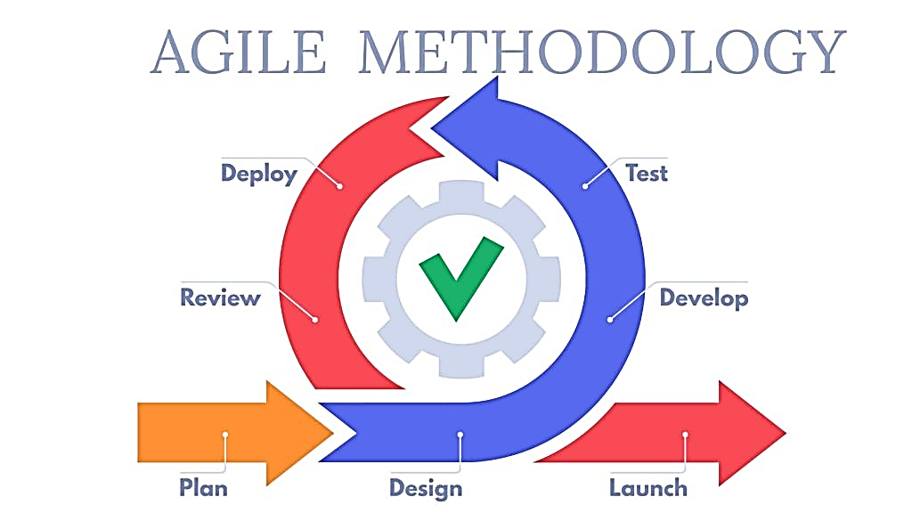

**Figure 2: Agile Methodology**

### Block Diagram

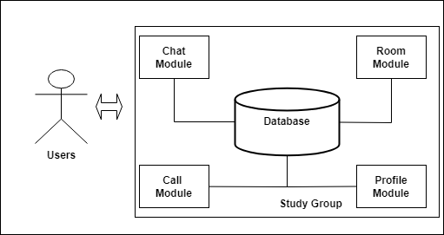

**Figure 3: Block Diagram**

1. **Working Mechanism of Proposed System**

The Study Group application employs a user-friendly and straightforward method to promote successful cooperation and information exchange among its users. Users can create or join study groups based on their interests or academic disciplines after signing up. The platform offers a unified interface for communication and engagement, allowing users to participate in group chats to debate subjects, ask questions, and share ideas. Furthermore, Study Group has a resource-sharing tool that allows users to upload and exchange study materials, articles, and videos that are related to the group's subject. Because users may access a wide range of information and views, this encourages a diversified and thorough learning experience.

Overall, the Study Group operating mechanism relies around the creation of a collaborative and interactive platform where users may connect, discuss, and share materials, generating an atmosphere favorable to successful learning and knowledge sharing.

### Flow Chart

**Figure 4: Flow Chart of system**

### Description of Algorithms

During the implementation of this proposed system, the following algorithms will be used:

* + - * **Sorting Algorithms**- A Sorting Algorithm is used to rearrange a given array or list elements according to a comparison operator on the elements. In the proposed system, it will be used for sorting students scoring highest marks in the ascending order.
      * **Searching Algorithms**- Searching Algorithms are designed to check for an element or retrieve an element from any data structure where it is stored. In the proposed system, it will be used for searching required data in the system.
      * **Hashing Algorithms**- Hashing is a technique or process of mapping keys, values into the hash table by using a hash function. In the proposed system, it will be used during the encryption of plain-text password into hash for security.

# Gantt Chart (showing the project timeline)

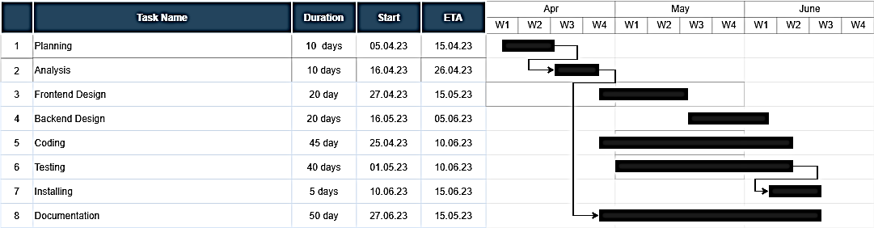

**Figure 5:Gantt Chart**

# Expected outcome

The Study Group application is expected to provide various benefits to its users. For starters, it will build a sense of community and belonging among persons who share similar interests or are studying in the same subject. Users will be able to interact with like-minded peers, share ideas, and participate in meaningful debates, developing a better grasp of the subject matter. Second, features like group chat and resource sharing on the site will enable seamless knowledge-sharing and collaboration on study materials, articles, and videos. This will contribute to a more thorough and diversified learning experience, in which users will be able to benefit from a diverse variety of viewpoints and resources.

Furthermore, the interactive aspect of Study Group will encourage active involvement and engagement, which will enhance motivation and overall learning results. Users will be able to ask questions, get clarification, and get help from their peers, creating a helpful and conducive learning environment. Finally, the platform's notification system will keep users up to speed on the activity in their study groups, ensuring that they are aware of crucial debates and resource upgrades. Overall, the Study Group application is designed to encourage cooperation, knowledge sharing, and interactive learning, while also offering a vital platform for individuals to connect, study, and accomplish their academic goals.

# References

[1] Johnson, A., Smith, B., & Williams, C. (2020). The Power of Online Collaboration: A Review of Research on Virtual Teams.

[2] Wang, L., Wang, Y., & Yang, S. (2018). Knowledge Sharing in Online Communities: A Systematic Literature Review.

[3] Garcia, M., O'Connell, S., & Tan, F. (2019). Challenges of Online Collaboration: A Review of the Literature.

[4] Bhardwaj, P., Kumar, P., & Sharma, M. (2020). Emerging Trends in Online Collaboration: A Future Perspective.