211 Quality Circle
College Station, TX 77845
Phone +1 (979) 691-7700
Fax +1 (979) 691-7750
www.cognizant.com
March 04, 2018
U.S. Department of Homeland Security
United States Citizenship and Immigration Services
Re: Mr. Rajiv Chaudhuri
Dear Officer:
I offer this letter to detail in-depth the conditions of the direct employment of Mr. Rajiv Chaudhuri by Cognizant Technology Solutions U.S. Corporation ("Cognizant"), which has filed an H-1B petition with the U.S. Citizenship and Immigration Services ("USCIS") on his behalf.
When Cognizant employees, such as Mr. Rajiv Chaudhuri, are placed at a Cognizant client's worksite, the Client is not in any way their employer. At all times, Cognizant remains the sole and direct employer, and has control over the work of our employees. It is Cognizant that selects which of its employees will conduct work activities at a Client's worksite, determines what activities those employees will perform, and directly supervises and controls the work of those employees. At all times, Cognizant is responsible for paying salaries, benefits, and expenses for those employees, and the Client does not employ those individuals nor does the Client in any way function as their employer.
As well, the Performance Management Process at Cognizant is a structured formal interaction between an employee and his manager. This process includes evaluating performance against set objectives and competencies applicable for that role, providing performance feedback, identifying development needs and setting goals for the future. The on-going performance communication takes place between the employee and that employee's manager, which results in a performance rating for the employee. Mr. Rajiv Chaudhuri will be evaluated by me, his Cognizant managers. The objective of this Performance Management Process is to fuel the success of Cognizant and its employees.
Cognizant is among the 80% of U.S. businesses that permits employees to work remotely, e.g., from an employee's home and/ or a client worksite. Throughout Cognizant maintains its employer-employee relationship with all Cognizant employees, including those who may work remotely, through the managerial control that Cognizant generally exerts over its employees. Such Cognizant supervisory control over employees encompass many levels, including hire/ fire, assignment deployment/ re-deployment, productivity, desired outcomes, and actual processes and tools. As well, Cognizant assumes all responsibilities of an employer, including the payment of wages, the withholding of payroll taxes, the payment of federal and state taxes for unemployment, and other similar legal requirements. In the course of controlling the work activities of employees, Cognizant managers use a multitude of communication media and tools, including reporting and meetings, in person or through technology, such as video conferencing, desktop video, VoIP, mobile phones, and instant messaging, as well as through Cognizant systems and tools. As Mr. Rajiv Chaudhuri's direct Cognizant manager, I oversee, assign, control and review his work on a regular basis both in-person and with the alternate means of communication noted above.
Mr. Rajiv Chaudhuri will perform his duties on a full-time, 40 hour per week basis, under my direct and close supervision over his day-to-day work activities. I will have direct control over his day-to-day specialty occupation work duties, I will assign and review his work product, and I will appraise his work performance. To be clear, Mr. Rajiv Chaudhuri's will perform his duties as an individual contributor under my direct and close supervision. The role held by Mr. Rajiv Chaudhuri's at Cognizant requires minimal experience in the software industry and at minimum a Bachelor's degree in a field of study related to computer systems. The minimum requirements are normal for the occupation within the industry in the United States, bear a reasonable relationship to the occupation in the context of our leadership position in the IT software development and consulting industry, and are essential to perform the job in a reasonable manner. Cognizant's key differentiators are our domain knowledge wherein we continuously drive towards increasingly deeper domain knowledge in conjunction with our organization of focus and changing business models. Cognizant's uniquely integrated services and industry domain-aligned go-to-market methodology has enabled us to consistently grow our business and build a competitive advantage in the continuously evolving and highly competitive IT industry. Thus, to continue to maintain our competitive advantage in the marketplace, the complexities of the job duties could not be properly performed by an individual who does not possess the professional background specified above.
Mr. Rajiv Chaudhuri will perform the following work activities:
Ref. | Description of Job Duty | Percent
1 | Work with product owners and other development team members to determine new features and user stories needed in large/complex development projects as part of the requirements gathering activity. Author, review and update documentation in support of building and maintaining project artifacts. This includes detailed requirements specifications, implementation guides, architecture diagrams and design documents. | 15%
2 | Implement and develop scalable complex application functionalities using programming languages- Java, J2EE; frameworks - Spring Core, Spring REST, Spring Boot, Spring MVC, Spring Gemfire, Spring LDAP, Spring Web Services, Spring AOP. Build reusable components and design the custom framework using different open source API, third party tools and use those components in the application. | 40%
3 | Actively participate in all Agile ceremonies including Sprint and release planning, Sprint retrospectives, backlog grooming, and product demonstration for internal and external users and customers. Participate in code reviews with peers and managers to ensure that each increment adheres to original vision as described in the user story and all standard resource libraries and architecture patterns as appropriate. | 15%
4 | Follow the Test-Driven Development approach and develop test framework using JUnit, Spring Test, Mockito and execute the unit tests as part of the build cycle. Use standard quality tools like Sonar, CAST, and Fortify to measure code quality and metrics and ensure that the application meets the high standard defined by the client and internally at Cognizant. Prepare performance scripts using JMeter and run performance tests scripts ensuring the application is adhering and exceeding the performance benchmark based on peak load of the session, by fine tuning the application including JVM OPTS settings and tuning the code. | 15%
5 | Coordinate across teams including performance engineering team for conducting the performance tests, production deployment teams and release management teams, AWS teams for cloud deployment. Provide post-production warranty support, production issue analysis and analyze improvement area, document the findings and address it as features to improve and enhance the system overall quality. | 10%
6 | Attend Cognizant meetings to learn about business unit updates and actively participate in the organizational sessions for technical and directional. | 5%
The below organization chart is specific to the assignment which Mr. Rajiv Chaudhuri has been selected for in the U.S. within our Banking & Financial Service business unit:
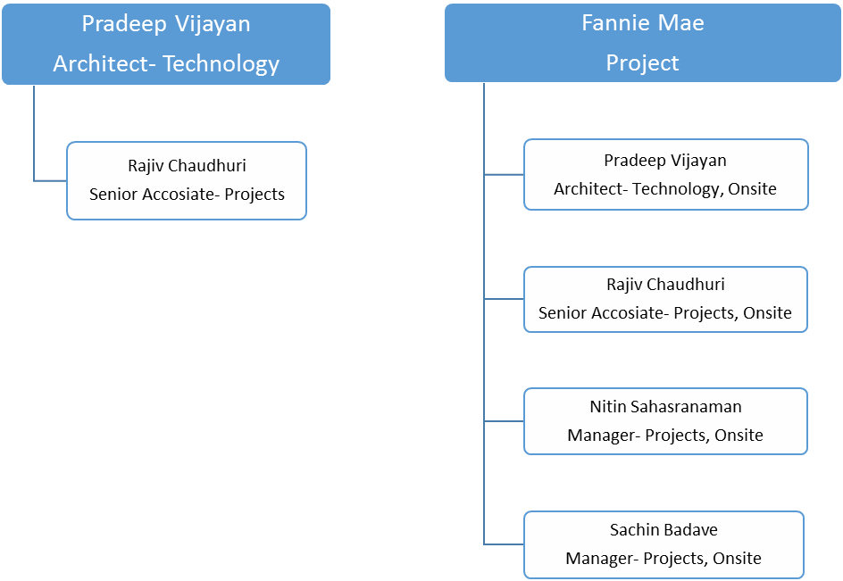
Cognizant's practice of entering into MSAs, and other contractual agreements that are under the governance of the relevant MSA, is premised on a host of business and legal concepts. These considerations serve as the underlying basis for a validity period of the agreement, which may not be representative of the full length or duration of our client relationship and Cognizant's provision of services. Indeed, most of our short term agreements entered into under the governing MSA are renewed subsequent to negotiations between each client and Cognizant, either prior to or after the expiration of the existing agreement. One consideration for Cognizant limiting the validity of a customer agreement is risk of payment default, specifically bankruptcy where a court could require that Cognizant continue to provide services if our agreement is in effect on the date of the bankruptcy petition filing. Another example involves a warranty that begins only once the specified phase of the work is completed whereas a longer duration agreement would essentially extend the warranty to the interim services which is not commercially reasonable for Cognizant. In this instance, the validity period of the Statement of Work (SOW), or equivalent short term agreement between Cognizant and Fannie Mae, or equivalent alternate contractual agreement, is not definitive of the extent and duration of Cognizant's customer engagements.
Please feel free to contact me for additional information. Thank you.
Sincerely,

Pradeep Vijayan
Architect – Technology
+1-973-307-5281

