**JAR- (For User Define Function at Pig to Capitalize the Name and Result)**



**Folder Hierarchy Maven Project-**

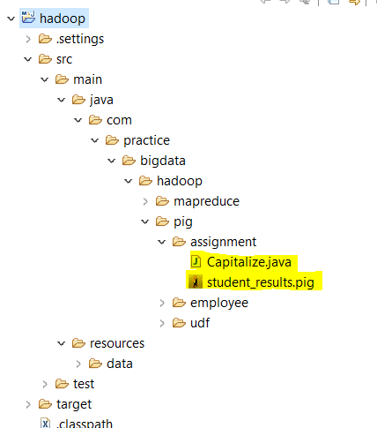

**Script: (Run all commands one by one till the STORE) at Grunt shell**



**Output:**

