AT&T API Platform SDK Plugins for Adobe® PhoneGap®

Installation and Setup Guide

Publication Date: September 28, 2014

This document and the information contained herein (collectively, the "Information") is provided to you (both the individual receiving this document and any legal entity on behalf of which such individual is acting) ("You" and "Your") by AT&T, on behalf of itself and its affiliates ("AT&T") for informational purposes only. AT&T is providing the Information to You because AT&T believes the Information may be useful to You. The Information is provided to You solely on the basis that You will be responsible for making Your own assessments of the Information and are advised to verify all representations, statements and information before using or relying upon any of the Information. Although AT&T has exercised reasonable care in providing the Information to You, AT&T does not warrant the accuracy of the Information and is not responsible for any damages arising from Your use of or reliance upon the Information. You further understand and agree that AT&T in no way represents, and You in no way rely on a belief, that AT&T is providing the Information in accordance with any standard or service (routine, customary or otherwise) related to the consulting, services, hardware or software industries.

AT&T DOES NOT WARRANT THAT THE INFORMATION IS ERROR-FREE. AT&T IS PROVIDING THE INFORMATION TO YOU "AS IS" AND "WITH ALL FAULTS." AT&T DOES NOT WARRANT, BY VIRTUE OF THIS DOCUMENT, OR BY ANY COURSE OF PERFORMANCE, COURSE OF DEALING, USAGE OF TRADE OR ANY COLLATERAL DOCUMENT HEREUNDER OR OTHERWISE, AND HEREBY EXPRESSLY DISCLAIMS, ANY REPRESENTATION OR WARRANTY OF ANY KIND WITH RESPECT TO THE INFORMATION, INCLUDING, WITHOUT LIMITATION, ANY REPRESENTATION OR WARRANTY OF DESIGN, PERFORMANCE, MERCHANTABILITY, FITNESS FOR A PARTICULAR PURPOSE OR NON-INFRINGEMENT, OR ANY REPRESENTATION OR WARRANTY THAT THE INFORMATION IS APPLICABLE TO OR INTEROPERABLE WITH ANY SYSTEM, DATA, HARDWARE OR SOFTWARE OF ANY KIND. AT&T DISCLAIMS AND IN NO EVENT SHALL BE LIABLE FOR ANY LOSSES OR DAMAGES OF ANY KIND, WHETHER DIRECT, INDIRECT, INCIDENTAL, CONSEQUENTIAL, PUNITIVE, SPECIAL OR EXEMPLARY, INCLUDING, WITHOUT LIMITATION, DAMAGES FOR LOSS OF BUSINESS PROFITS, BUSINESS INTERRUPTION, LOSS OF BUSINESS INFORMATION, LOSS OF GOODWILL, COVER, TORTIOUS CONDUCT OR OTHER PECUNIARY LOSS, ARISING OUT OF OR IN ANY WAY RELATED TO THE PROVISION, NON-PROVISION, USE OR NON-USE OF THE INFORMATION, EVEN IF AT&T HAS BEEN ADVISED OF THE POSSIBILITY OF SUCH LOSSES OR DAMAGES.

Contents

1. Introduction 1
2. Architectural Overview 2
3. Installation Guidelines 2
   1. Prerequisites 3
   2. Downloads 3
4. Installing the Plugin from Github 3
5. Installing the Plugin from File System 3
6. Loading the Plugins 5
7. Documentation 5

# 

Figure 1: Architecture diagram of AT&T PhoneGap Mobile SDK 2

Table 1: JavaScript installation files 3

# Introduction

The AT&T PhoneGap Mobile SDK simplifies access to AT&T API Platform services to developers creating mobile applications using Adobe PhoneGap. This SDK helps developers to quickly bring robust apps to market by significantly reducing the complexity of building apps that use AT&T Platform services.

The AT&T PhoneGap Mobile SDK enables other interfaces to access the following AT&T APIs:

* Advertising
* Device Capabilities
* In-App Messaging
* MMS
* OAuth
* SMS
* Speech

# Architectural Overview

The AT&T PhoneGap Mobile SDK uses a CommonJS-compliant JavaScript wrapper library to expose interfaces to AT&T APIs. The wrapper library works in conjunction with the PhoneGap mobile SDK native component for iOS or Android.

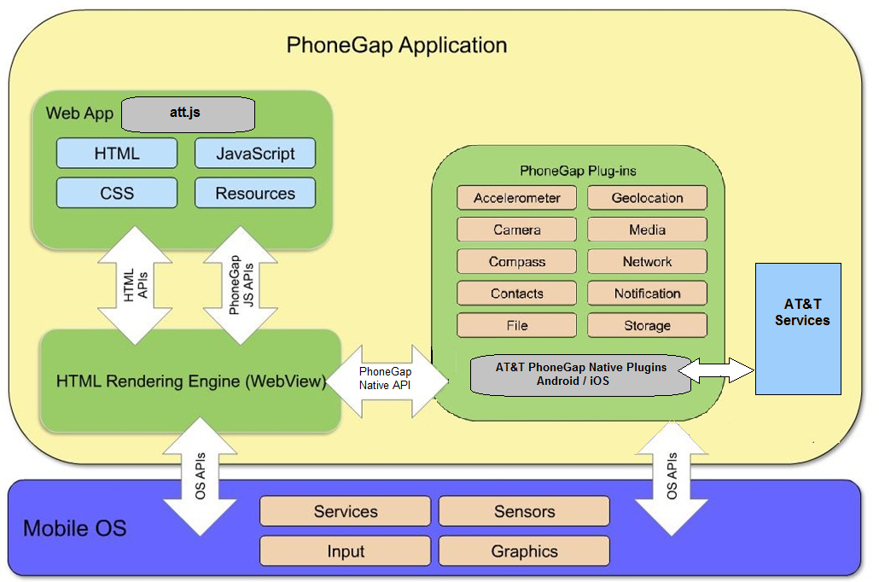

Figure 21: Architecture diagram of the AT&T PhoneGap Mobile SDK.

# Installation Guidelines

An Internet connection is required for API calls. The plugins are designed for the PhoneGap Mobile SDK application, and may not work with an SDK version earlier than 3.4.

Your organization must abide by the AT&T API agreement to use the AT&T network. While all AT&T APIs work within the AT&T network, we do not support SMS, MMS and other messages sent to phones using outside the network on other carriers.

An app key and an app secret are required for sending messages. These keys can be obtained by joining the AT&T developer program:

* Sandbox keys, available with a free AT&T Developer Program account, enable proof-of-concept and testing with AT&T APIs, but do not allow production deployment.

Production keys are designed to handle a much larger amount of traffic, and require a paid AT&T Developer Program account.

## Prerequisites

The following components are required to run the AT&T API Platform SDK Plugins for Adobe PhoneGap:

* Xcode integrated development environment (IDE) for iPhone version 5.1 or later.
* Android SDK for Android version 2.3.3 or later.
* PhoneGap mobile SDK version 3.4 or later.

The PhoneGap plugins require the file require.js, available from <http://github.com/jrburke/requirejs> to be included in your project.

| JavaScript File | Download Location |
| --- | --- |
| require.js | <http://github.com/jrburke/requirejs> |

Downloads

You can download the AT&T API Platform PhoneGap SDK documentation, samples, and source code from the [Github repository](https://github.com/attdevsupport/att_apiplatform_phonegap) or [in a zip file](http://developer.att.com/home/api/sdk_tools/attplugin_phonegap.zip).

# Installing the Plugin from Github

Follow these steps to install the AT&T PhoneGap plugin from Github

1. Navigate to an existing project. All subsequent commands need to be run within the project's directory on the Command Line.

Enter the following command to install the plugin.

**$ phonegap plugin add** [**https://github.com/attdevsupport/ATT_APIPlatform_PhoneGap.git#:/plugins**](https://github.com/attdevsupport/ATT_APIPlatform_PhoneGap.git#:/plugins/)

# Installing the Plugin from File System

Follow these steps to install the AT&T PhoneGap plugin from the File System

1. Navigate to an existing project. All subsequent commands need to be run within the project's directory on the Command Line.
2. Enter the following command to install the plugin.

**$ phonegap plugin add <Path to Repository on File System>/plugins**

# Loading the Plugins

To load the plugin in your application code, use the require.js library.

e.g

require(["att"], function(att) {

attAPIs = att;

console.log('ATT is initialized');

});

# Documentation

For more information on using PhoneGap, see the [PhoneGap Documentation](http://docs.phonegap.com/en/3.0.0/guide_platforms_index.md.html#Platform%2520Guides). For more on using AT&T APIs, see the [AT&T Developer Program Web site](http://developer.att.com).