AT&T API Platform SDK Plugins for Adobe® PhoneGap®

Installation and Setup Guide

Publication Date: August 28, 2013

This document and the information contained herein (collectively, the "**Information**") is provided to you (both the individual receiving this document and any legal entity on behalf of which such individual is acting) ("**You**" and "**Your**") by AT&T, on behalf of itself and its affiliates ("**AT&T**") for informational purposes only. AT&T is providing the Information to You because AT&T believes the Information may be useful to You. The Information is provided to You solely on the basis that You will be responsible for making Your own assessments of the Information and are advised to verify all representations, statements and information before using or relying upon any of the Information. Although AT&T has exercised reasonable care in providing the Information to You, AT&T does not warrant the accuracy of the Information and is not responsible for any damages arising from Your use of or reliance upon the Information. You further understand and agree that AT&T in no way represents, and You in no way rely on a belief, that AT&T is providing the Information in accordance with any standard or service (routine, customary or otherwise) related to the consulting, services, hardware or software industries.

AT&T DOES NOT WARRANT THAT THE INFORMATION IS ERROR-FREE. AT&T IS PROVIDING THE INFORMATION TO YOU "AS IS" AND "WITH ALL FAULTS." AT&T DOES NOT WARRANT, BY VIRTUE OF THIS DOCUMENT, OR BY ANY COURSE OF PERFORMANCE, COURSE OF DEALING, USAGE OF TRADE OR ANY COLLATERAL DOCUMENT HEREUNDER OR OTHERWISE, AND HEREBY EXPRESSLY DISCLAIMS, ANY REPRESENTATION OR WARRANTY OF ANY KIND WITH RESPECT TO THE INFORMATION, INCLUDING, WITHOUT LIMITATION, ANY REPRESENTATION OR WARRANTY OF DESIGN, PERFORMANCE, MERCHANTABILITY, FITNESS FOR A PARTICULAR PURPOSE OR NON-INFRINGEMENT, OR ANY REPRESENTATION OR WARRANTY THAT THE INFORMATION IS APPLICABLE TO OR INTEROPERABLE WITH ANY SYSTEM, DATA, HARDWARE OR SOFTWARE OF ANY KIND. AT&T DISCLAIMS AND IN NO EVENT SHALL BE LIABLE FOR ANY LOSSES OR DAMAGES OF ANY KIND, WHETHER DIRECT, INDIRECT, INCIDENTAL, CONSEQUENTIAL, PUNITIVE, SPECIAL OR EXEMPLARY, INCLUDING, WITHOUT LIMITATION, DAMAGES FOR LOSS OF BUSINESS PROFITS, BUSINESS INTERRUPTION, LOSS OF BUSINESS INFORMATION, LOSS OF GOODWILL, COVER, TORTIOUS CONDUCT OR OTHER PECUNIARY LOSS, ARISING OUT OF OR IN ANY WAY RELATED TO THE PROVISION, NON-PROVISION, USE OR NON-USE OF THE INFORMATION, EVEN IF AT&T HAS BEEN ADVISED OF THE POSSIBILITY OF SUCH LOSSES OR DAMAGES.

Contents

1 Introduction 1

2 Architectural Overview 2

3 Installation Guidelines 2

3.1 Prerequisites 3

3.2 Download Files 3

4 Installing the Android Plugin 4

5 Installing the iPhone Plugin 5

6 Using the Plugins 8

# 

Figure 1: Architecture diagram of AT&T PhoneGap Mobile SDK 2

Figure 2: Structure of js folder in android 4

Figure 3: Structure of libs folder in Android 5

Figure 4: Structure of js folder in Xcode 6

Figure 5: Structure of Plugins folder in Xcode 6

Figure 6: Adding outputLibrary in Plugins folder in Xcode 7

Figure 7: Cordova.plist file 7

Table 1: JavaScript installation files 3

Example 1: Edits for config.xml 5

# Introduction

The AT&T PhoneGap Mobile SDK provides simplified access to AT&T API platform services. It helps mobile developers bring robust PhoneGap mobile applications to market quickly by significantly reducing the complexity of building applications that use AT&T platform services.

The AT&T PhoneGap Mobile SDK lets other interfaces access the following APIs from the AT&T platform:

* Advertising
* Device Capabilities
* In-app Messaging
* Location
* MMS
* Notary Management
* OAuth
* Payment
* SMS
* Speech

# Architectural Overview

The AT&T PhoneGap Mobile SDK exposes JavaScript interfaces. It complies with common JavaScript specifications to access the AT&T platform API. The following components provide access to the AT&T platform API:

• PhoneGap Mobile SDK Native component (iOS & Android)

• Java Script Wrapper Library (compliant with CommonJS specification)

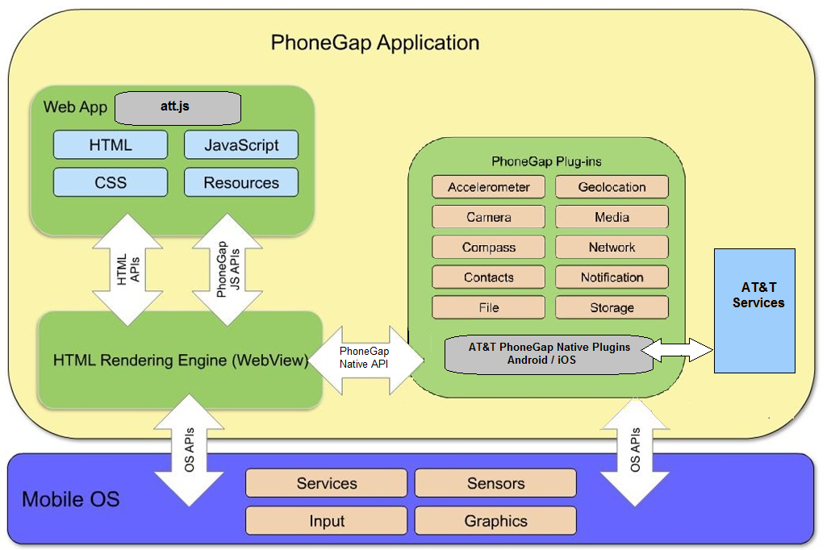

Figure 1: Architecture diagram of AT&T PhoneGap Mobile SDK

# Installation Guidelines

The following components run the AT&T API Platform SDK Plugins for Adobe PhoneGap:

* Xcode integrated development environment (IDE) for iPhone version 4.5 or later
* Eclipse IDE for Android version 3.4 or later and installed ADT plugin
* Phonegap mobile SDK version 2.5. or later

## Prerequisites

An Internet connection is required for all API calls. The plugins are designed for the PhoneGap Mobile SDK application (iOS & Android) and may not work if you use an SDK version below the specified minimum version.

All APIs can work with the AT&T network. However, we do not support sending SMS, MMS and other messages to phones outside the network on other carriers. Your organization must abide by the AT&T API agreement to use the AT&T network. A secret key and an API key are required to send messages. These keys can be obtained by joining the AT&T developer program.

The AT&T API uses two key types:

* Sandbox keys, with free availability, that let you demonstrate proof-of-concept and perform application testing with the AT&T APIs.
* Production keys with the same capabilities as sandbox keys that are designed to handle a much larger amount of traffic.

## Download Files

[AT&T API Platform PhoneGap plugins](http://developer.att.com/home/api/sdk_tools/ATTPlugin_PhoneGap.zip) are available for developers to download and use in their applications. Or you can visit [GitHub](https://github.com/attdevsupport/ATT_APIPlatform_PhoneGap) to download one of the platform-specific plugins to a local directory on your computer.

* [AT&T PhoneGap plugin for Android](https://github.com/attdevsupport/ATT_APIPlatform_PhoneGap/tree/master/plugins/android)
* [AT&T PhoneGap plugin for iOS](https://github.com/attdevsupport/ATT_APIPlatform_PhoneGap/tree/master/plugins/ios)

The plugins require JavaScript (js) files that you should download before starting.

| **JavaScript File** | **Download Location** |
| --- | --- |
| require.js | <http://github.com/jrburke/requirejs> |

Table 1: JavaScript installation files

# Installing the Android Plugin

Follow these steps to install the AT&T PhoneGap plugin for android.

1. Create a PhoneGap android project in your IDE such as Eclipse.
2. Create a folder structure for js and lib under the www folder, for example, /www/js/lib.
3. Add att.js to the lib folder. This is the main file for the common JavaScript module wrapping the AT&T API. Find this file in the android plugin that you downloaded (in the *plugins/android* folder).
4. Add the JavaScript files that you downloaded to the lib folder, for example:

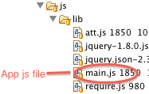

Figure 2: Structure of js folder in android

1. Add AttAndroidPhoneGapPlugin-1.3.jar to the libs folder of the project, for example:

Screen Shot 2012-12-14 at 2

Figure 3: Structure of libs folder in android

1. Edit the config.xml file found in the /res/xml folder as follows.

* Add a reference to native plugins for AT&T APIs in the <plugins> tag
* Edit the value for access origin to add a domain for network calls under the <cordova> tag.

|  |  |  |
| --- | --- | --- |
| **Config.xml file** | | |
| 1 | | | <plugin name="Battery" value="org.apache.cordova.BatteryListener"/> |
| 2 | | | <plugin name="SplashScreen" value="org.apache.cordova.SplashScreen"/> |
| 3 | | | <plugin name="AttPlugin" value="org.att.phonegap.plugin.AttPlugin"/> |
| 4 | | | <access origin=".*"/> |
| 5 | | | plugins> |

Example 1: Edits for config.xml

# Installing the iPhone Plugin

Follow these steps to install the AT&T PhoneGap plugin for iPhone.

1. Create a PhoneGap iPhone project in your IDE such as XCode.
2. Create a folder structure for js and lib under the www folder, for example, /www/js/lib.
3. Add att.js to the lib folder. This is the main file for the common JavaScript module wrapping the AT&T API. Find this file in the iPhone plugin that you downloaded (in the *plugins/ios* folder).
4. Add the JavaScript files that you downloaded to the lib folder, for example:

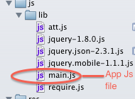

Figure 4: Structure of js folder in Xcode

1. Add the following native files to the Plugins folder as shown in Figure 5.

* ATTPhonegapHelper.h
* ATTPhonegapHelper.m

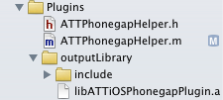

Figure 5: Structure of Plugins folder in Xcode

1. Ensure that an outputLibrary folder exists in the folder structure under Plugins. For the outputLibrary in Xcode, you must select “Create folder references for any added folders” as shown in Figure 6.

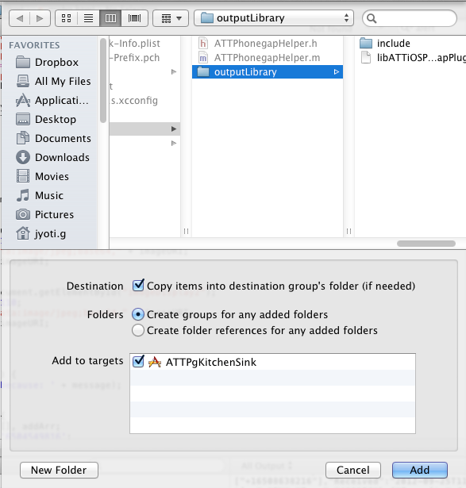

Figure 6: Adding outputLibrary to Plugins folder in Xcode

1. Ensure that the include folder exists under outputLibrary folder in Plugins. If it is not there add it, for example, outputLibrary/include.
2. Add the following native file to the include folder under outputLibrary as shown in Figure 5.

* libATTiosPhonegapPlugin.a

1. Edit the Cordova.plist file under the Resources folder as follows:

* Add a reference to native plugins for AT&T APIs under the Plugins section. Use AttPlugin as the key and ATTPhonegapHelper as the corresponding value.
* Set the value for OpenAllWhitelistURLsInWebView to YES to open consent in a web view.
* Set the value for ExternalHosts to * to add a domain for network calls.

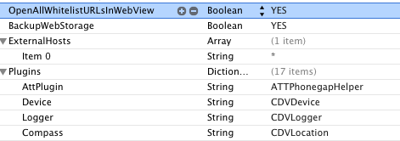

Figure 7: Cordova.plist file

# Using the Plugins

To load the plugin in your application code use the require.js library.

See the [PhoneGap Documentation, Getting Started Guides](http://docs.phonegap.com/en/3.0.0/guide_platforms_index.md.html#Platform%20Guides) for more information.