Google Cloud SDK Installation

1. Download and install Google Cloud SDK by running the following command in your shell or Terminal:

curl <https://dl.google.com/dl/cloudsdk/release/install_google_cloud_sdk.bash> | bash

2. Restart your shell or Terminal.

3. Authenticate to Google Cloud Platform by running gcloud auth login

4. It will move to brower where we will provide the Gloud credentials and we will be logged in Gloud.

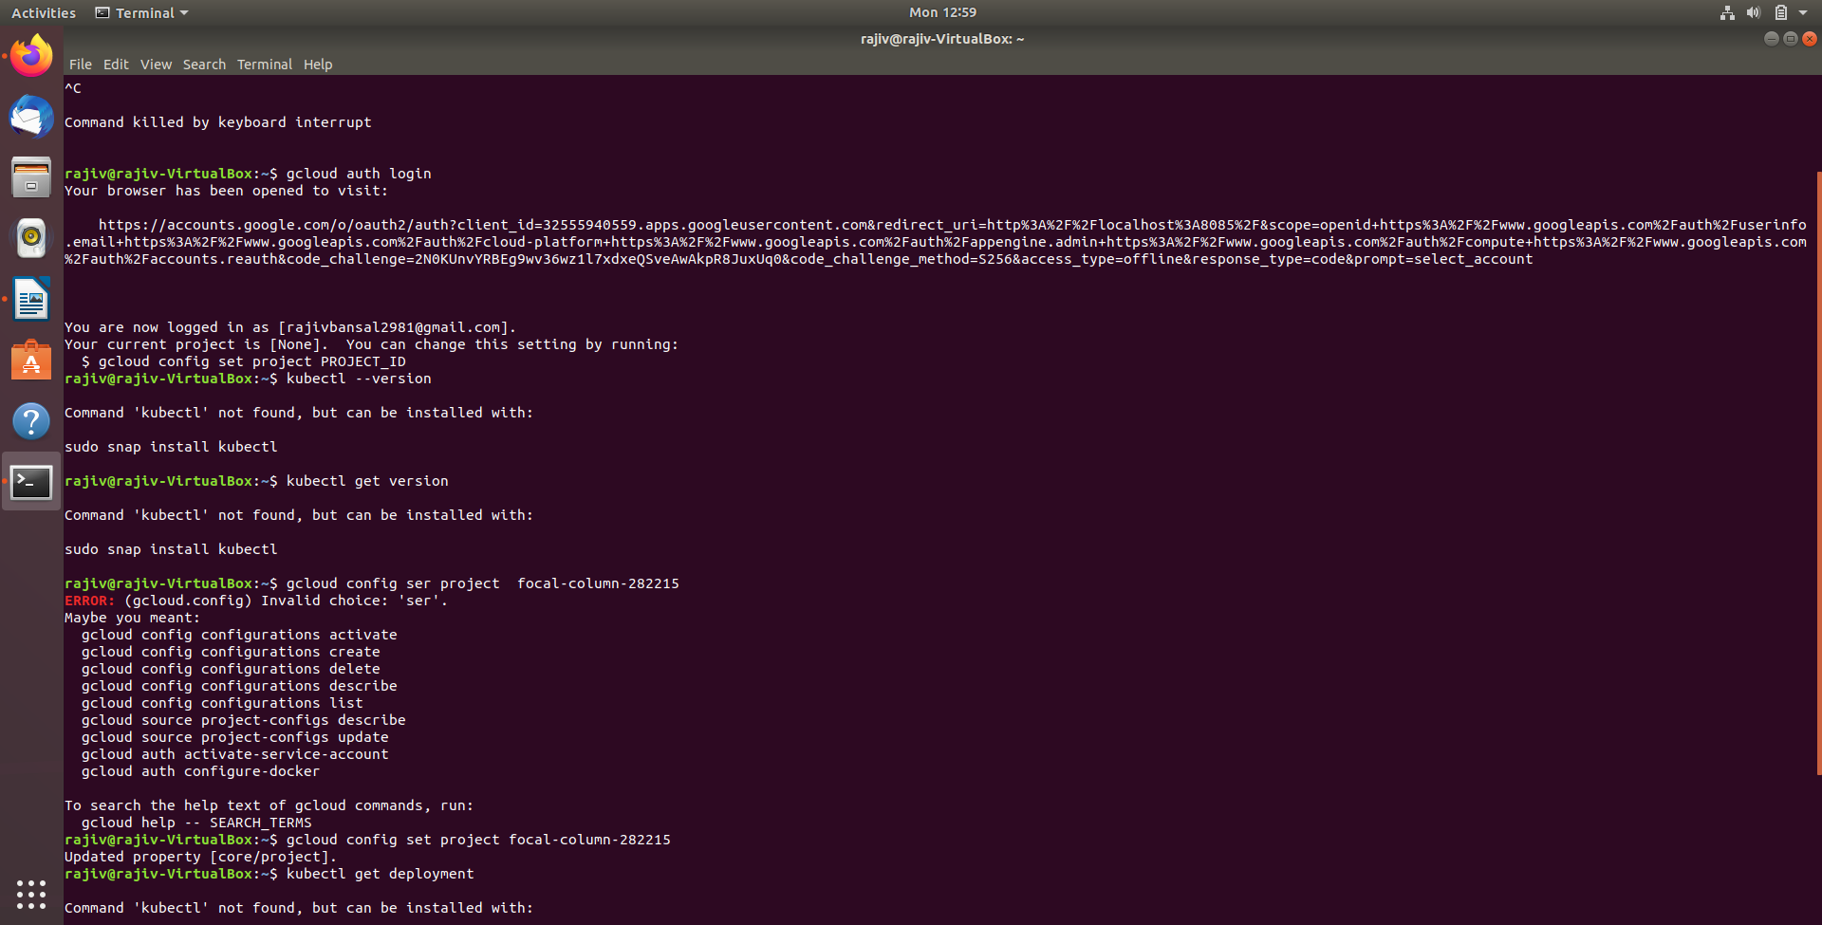

5. Now we need to provide the project-id ( can check into Google Console.

Command: gcloud config set project focal-column-282215

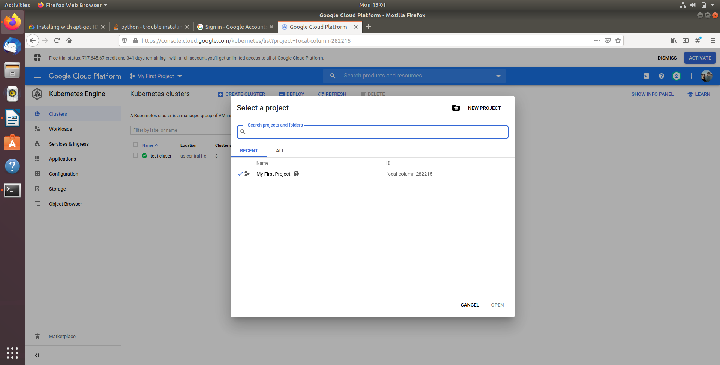

**Output:**

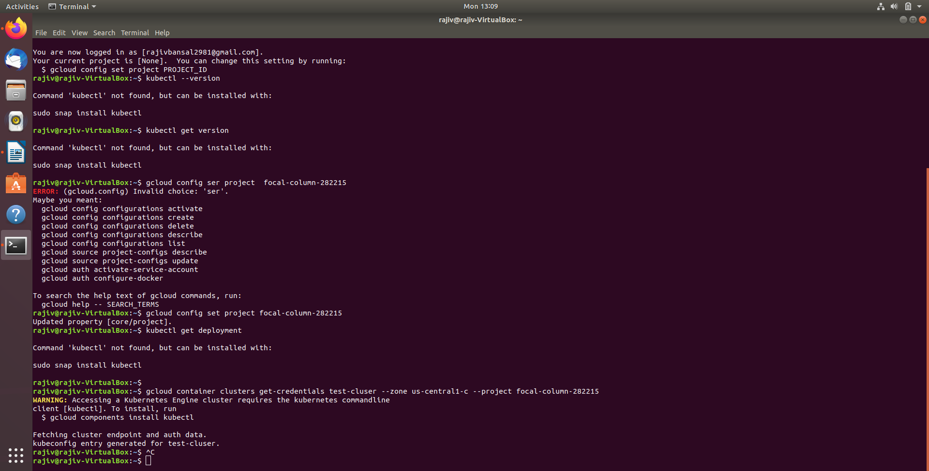

**6. Try to connect Kubernetes engine from Gcloud Interface but getting error says**

**“Accessing a Kubernetes Engine cluster requires the kubernetes commandline”**

**Command:gcloud container clusters get-credentials test-cluser --zone us-central1-c --project focal-column-282215**

**Output:**

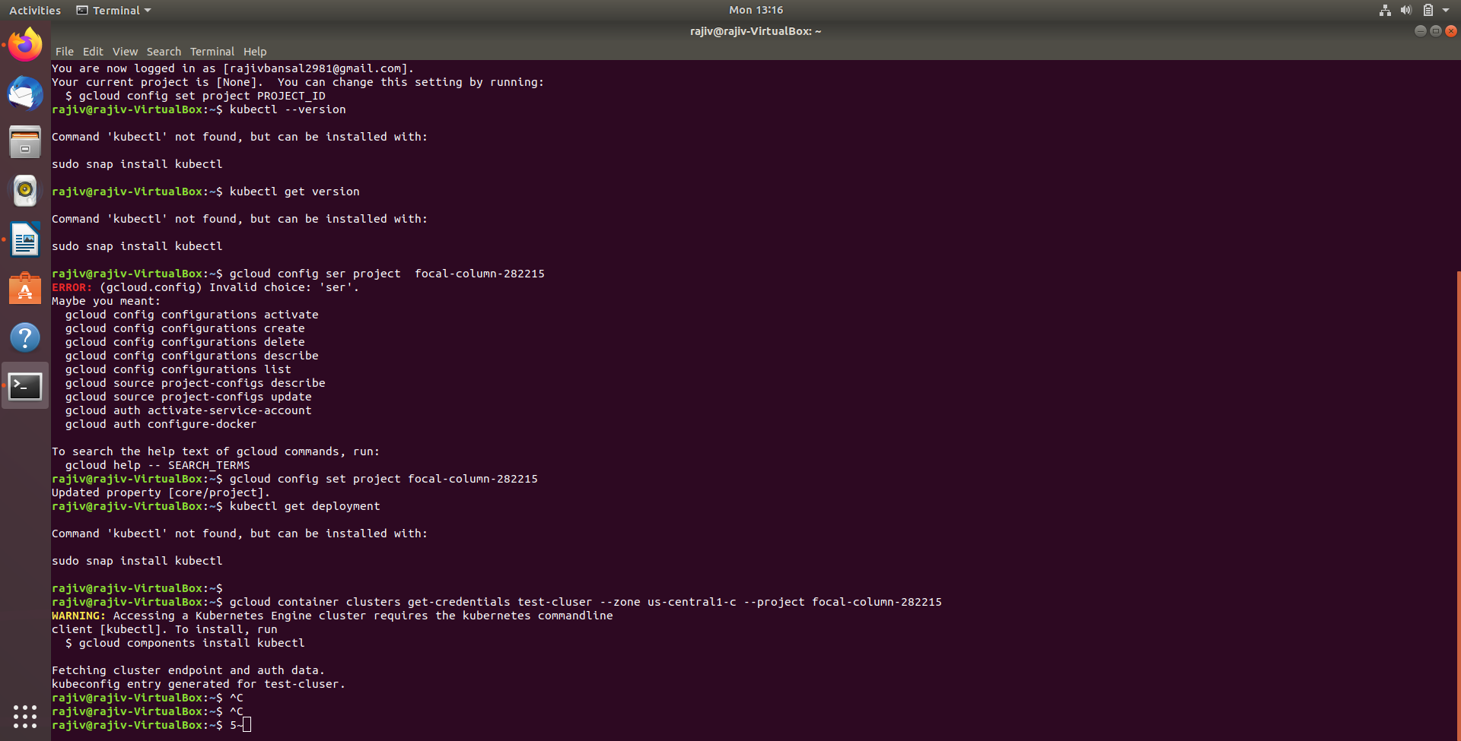

**Kubectl installation**

**7. Next step is to install Kubectl**

### **Install kubectl binary with curl on Linux**

1. Download the latest release with the command:

curl -LO "https://storage.googleapis.com/kubernetes-release/release/$(curl -s https://storage.googleapis.com/kubernetes-release/release/stable.txt)/bin/linux/amd64/kubectl"

Output:

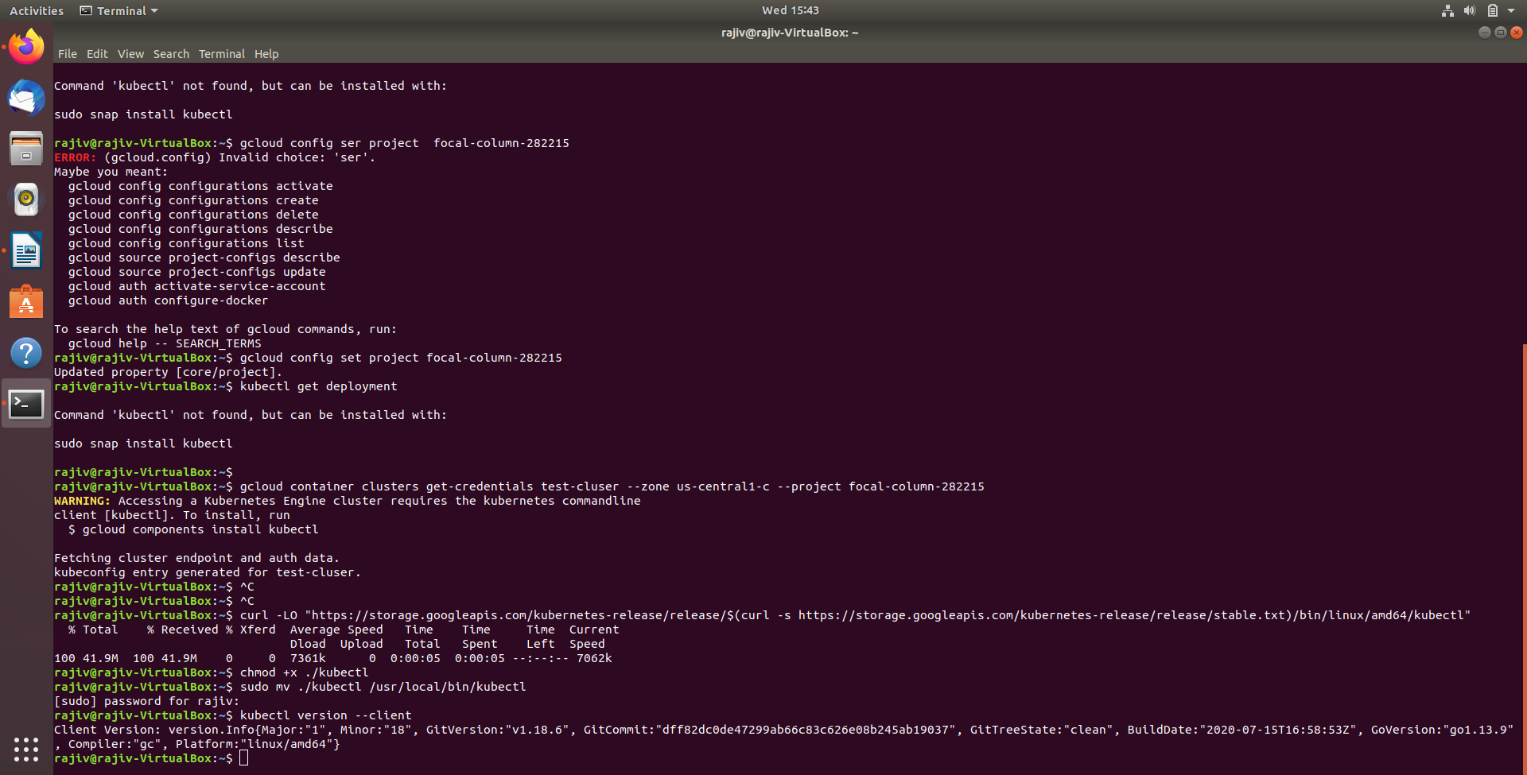

1. Make the kubectl binary executable.

chmod +x ./kubectl

1. Move the binary in to your PATH.

sudo mv ./kubectl /usr/local/bin/kubectl



1. Test to ensure the version you installed is up-to-date:

kubectl version --client

