SCB

Siam Commercial Bank Implements Payment Hub to support payment requirements as part of National E-Payment Roadmap driven by Thai government to promote nationwide digital economy.

Besides the features and functionalities which support Prompt Pay and payment eco-system, ATM Cardless is introduced to facilitate cash withdrawal from SCB ATM machines without the need of physical cards. The request is made from Fast Easy, the mobile application. All deposit accounts & credit cards are eligible for ATM Cardless Withdrawal request. The ATM Cardless Withdrawal could take place at any time of the day.

ATM Cardless withdrawal is a secured transaction using One-Time Password Authentication (OTA). The customer will request One-Time Password through Fast Easy, and will verify the password on ATM machine. After that the customer will proceed with the normal ATM transaction.

# Cardless Cash Withdrawal

ATM Cardless is introduced to facilitate cash withdrawal from SCB ATM machines without the need of physical cards. The request is made from Fast Easy, the mobile application. All deposit accounts & credit cards are eligible for ATM Cardless Withdrawal request. The ATM Cardless Withdrawal could take place at any time of the day.

ATM Cardless withdrawal is a secured transaction using One-Time Password Authentication (OTA). The customer will request One-Time Password through Fast Easy, and will verify the password on ATM machine. After that the customer will proceed with the normal ATM transaction.

Assumptions

1. It is assumed that a customer
2. Is eligible for Fast Easy and has deposit account or credit card registered with SCB, and
3. Has mobile phone number registered with the bank.
4. The currency of all ATM Cardless Withdrawal will be THB.
5. Each channel (SCB Channel App, Payment Gateway) will only have a single product code (as used by GN/CBS) associated with it.

* OTA Generation (Request sent by SCB Customer using Fast Easy App)
  + Verify Daily Limits
  + Generate OTA Request to ISprint
* Cash Withdrawal (Request sent by SCB Customer using ATM)
  + ATM Id Verification
  + Cash Out

## OTA Generation

OTP Generation request is sent by the SCB Customer having account with the Bank.

**Preconditions**:

1. The customer is permitted to perform the transaction on single-owned deposit accounts or credit cards.
2. The customer has a registered mobile phone number with SCB.

3. The customer will request One-Time Password through Fast Easy

**Block Diagram of OTP Generation**



**Cardless Cash OTA Generation Request**

**Header**

| Tag | M/O. | Type | Max. Len | Remark |
| --- | --- | --- | --- | --- |
| X-Request-ID | M | string | 3..36 | A unique request reference.  The X-Request-ID for each OTA Generation request is stored in Payment Hub as the tracking reference for the end-to-end flow, and will be used as the identifier for the original request in the Push Notification request to the API Gateway.  Legal characters are A-Z, a-z, 0-9 and – (hyphen). |

**Body**

| Tag | M/O. | Type | Max. Len | Remark |
| --- | --- | --- | --- | --- |
| rmId | M | string | 30 | RM Id of the customer |
| mobileNo | M | string | 15 | The customer’s mobile number |
| accountNumber | M | string | 32 | The account number to withdraw cash from |
| branchId | M | string | 4 | The branch associated with the account |
| tranAmount | M | number |  | The amount of cash to withdraw (in THB) |
| channelDateTime | M | date-time |  | Format: CCYY-MM-DDThh:mm:ss.sss±hh:mm  Eg. 2017-03-13T09:00:00.000+07:00 |

**Sample Message**

{

"rmId": "012345678",

"mobileNo": "0865123369",

"accountNumber": "384995886",

"branchId": "3245",

"tranAmount": 10000.0

}

### Verify Limit



1. When a customer initiates an OTA Request, he will inquire the number of successful withdrawal transactions and withdrawal transaction amount daily limit.
   1. The limit is based on an individual customer, i.e. RMID.
   2. Each customer may own several accounts or credit cards.
   3. The customer may be able to withdraw cash from any account or card, but he will be restricted by following daily limits per day per payment type:
      1. The number of successful withdrawal transaction limit.
      2. The withdrawal transaction amount limit.
   4. The limits are stored in Payment Hub Parameter table as it could be inquired by SCB channel applications, and the limits are configurable per payment type.
2. **SCB Channel App** initiates a <**DayLimitInqRq>** Message to the Payment Hub.
3. Payment Hub on receipt of the <**DayLimitInqRq>** will perform the following:
   1. Inquire Payment Hub transaction log using Limit Inquiry **< DayLimitInqRq>** by RMID and Payment Type.
   2. Calculate the number of successful withdrawal transactions of ATM Cardless occurred “today.”
   3. Calculate the total amount of successful withdrawal transactions of ATM Cardless occurred “today.”
   4. Calculate the remaining number of withdrawal transactions that the customer can perform.
   5. Calculate the remaining amount of withdrawal transactions that the customer can withdraw.
   6. Return a response <**DayLimitInqRs>** to **SCB channel applications** with
      1. Flag “true” or “false”, where “true” = Allow to perform ATM Cardless, and “false” = Limit equals or exceeds the daily limit
      2. The daily number of successful withdrawal transaction limit
      3. The daily transaction amount limit
      4. The remaining number of withdrawal transactions that the customer can perform using ATM Cardless Withdrawal.
      5. The remaining amount of withdrawal transactions that the customer can withdraw using ATM Cardless Withdrawal.
4. Upon receiving the response, the customer decides whether he continues requesting OTA or not.

### OTP Generation

1. Upon receiving Limit information from Payment Hub, the customer selects Payment Type on mobile App and requests OTA.

1. If the customer chooses to request OTA, **SCB Channel App** initiates a **<GenerateAuthenticationRequest>** requestMessage to the Payment Hub.
2. Payment Hub on receipt of the **<GenerateAuthenticationRequest**> will perform the following:
   1. Ensure that the request is as per the interface specification.
   2. Validate and store the information received from channel.
   3. Verify Total Daily Limit
   4. Cancel the previous OTA request by updating the OTA **<status> = “Cancelled”**
   5. Initiate a new request <**GenerateOTPRq>** to **iSprint** interface via API Gateway
3. Payment Hub will receive <**GenerateOTPRs>** from **iSprint** interface via API Gateway performs the following:
   1. Ensure that the response is as per the interface specification.
   2. Validate and store the response.
   3. Payment Hub will return **<GenerateAuthenticationResponse**> to SCB Channel Apps.
   4. Update the OTA **<status> = “Pending”**

## 1.2. Cash Withdrawal

The ATM Cardless Withdrawal is composed of two steps, Verify ID and Cash Out.

**Pre-Conditions**

1. The customer has successfully obtained OTA Password for ATM Cardless Withdraw.
2. The customer will use OTA at an ATM Machine within the specific time.
3. ISprint has set the expiry of OTA to a specific duration.

There are two steps:

* Verify ID
* Cash Out

### 1.2.1. Verify ATM Id



1. The customer is at ATM Machine and initiates the ATM Cardless Withdraw process by entering the customer mobile phone no. registered for the withdraw on ATM Machine.
2. The request is received by **Base24** which is integrated with ATM.
3. **BASE24** initiates a <**ATMIDVerRq>** Message to the Payment Hub via FAAT and MQ.
4. Payment Hub on receipt of the <**ATMIDVerRq>** will get the Cardless Cash OTA Transaction information from database, using mobile number and OTA status “Pending” as the key:
5. If wrong mobile no. is entered, OTA will not be found. Payment will create a response <**ATMIDVerRq**> with Response Code ”**87**” and Response Code Description <RsDecs> = “**Invalid Mobile No.**” to Base24 via FAAT and MQ.
6. Payment Hub creates <**ATMIDVerRs>** and send the response with transaction information for which customer has requested through Fast Easy App to BASE24 via FAAT and MQ.

**Verify Request Format**

| Tag | Mult. | Type | Max. Len | Initial /Values | Remark |
| --- | --- | --- | --- | --- | --- |
| Message root <CardlessCashRq> | [1..1] |  |  |  |  |
| Request Id <RqUID> | [1..1] | Text | 36 |  | A unique request reference (from FAAT). |
| Transaction Info <TranInfo> | [1..1] |  |  |  |  |
| Message Type <MsgType> | [1..1] | Text | 4 | 0700 |  |
| Terminal ID <TerminalId> | [1..1] | Text | 16 |  | From ATM |
| Transaction Code <TranCode> | [1..1] | Text | 6 | 301800 |  |
| Terminal Sequence No. <Sequence> | [1..1] | Text | 6 |  |  |
| Transaction Date <Date> | [1..1] | Text | 6 |  | Format YYMMDD. |
| Transaction Time <Time> | [1..1] | Text | 6 |  | Format HHMMSS. |
| Mobile No.<MobileNo> | [1..1] | Text | 15 |  | From input at ATM. |

**Sample Message**

<?xml version="1.0" encoding="TIS-620"?>

<CardlessCashRq xmlns="http://www.clear2pay.com/SCBRTP/CardlessCash/1" >

<RqUID>4f994da6-d018-4e12-8161-c2e9fb1dcbcc</RqUID>

<TranInfo>

<MsgType>0700</MsgType>

<TerminalId>012345678901234</TerminalId>

<TranCode>301800</TranCode>

<Sequence>000001</Sequence>

<Date>170429</Date>

<Time>112355</Time>

</TranInfo>

<MobileNo>0865123369</MobileNo>

</CardlessCashRq>

### 1.2.2. Cash Out



1. After receiving transaction information from Payment Hub, the customer will enter OTA obtained from the SCB Channel.
2. **BASE24 App** initiates a **<ATMWithdrawalRq>** requestMessage to the Payment Hub via FAAT and MQ.
3. Upon receiving **<ATMWithdrawalRq>,** Payment Hub will perform the following OTA verification:
   1. Payment Hub Validation
   2. Payment Hub initiates a request **<VerifyOTPRq>** to **iSprint** using OTA status **“Pending”**.
   3. iSprint creates **<VerifyOTPRs>** and return to Payment Hub.
   4. If OTA verification is successful-
      1. OTA status is set to **“Activated”.**
      2. For CASA Account Withdrawal, a posting request **<DebitCreditSvcRq>** is sent to GN. If GN returns an **ERROR** response, Payment Hub looks up the mapping of response codes in the configurable parameter table, determines the matching ATM Response code **<RsCd>** and Response Description **<RsDecs>** and creates a response **<ATMWithdrawalRs>** to Base24 via FAAT and MQ (ATM will not dispense cash to customer).
      3. For Credit Card Withdrawal, a posting request is sent to B2K. If B2K returns an **ERROR** response, Payment Hub looks up the mapping of response codes in the configurable parameter table, determines the matching ATM Response code **<RsCd>** and Response Description **<RsDecs>** and creates a response **<ATMWithdrawalRs>** to Base24 via FAAT and MQ (ATM will not dispense cash to customer).
      4. Creates a response **<ATMWithdrawalRs>** to instruct ATM to dispense cash.
      5. A Push notification is sent to the customer.
   5. If OTA verification has failed, Payment Hub-
      1. Creates a response **<ATMWithdrawalRs>** with **“reject”** transaction status to Base24 via FAAT and MQ.
      2. Additionally, OTA status is set to **“Failed”** if ISPRINT error response is “10403 - Maximum of tries” or “10404 - Policy Token Expired”.
      3. Sends push notification to SCB Channel Application.

**Withdrawal Request**

|  |  |  |  |  |  |
| --- | --- | --- | --- | --- | --- |
| Tag | Mult. | Type | Max. Len | Initial /Values | Remark |
| Message root <CardlessCashRq> | [1..1] |  |  |  |  |
| Request Id <RqUID> | [1..1] | Text | 36 |  | A unique request reference (from FAAT). |
| Transaction Info <TranInfo> | [1..1] |  |  |  |  |
| Message Type <MsgType> | [1..1] | Text | 4 | 0200 |  |
| Terminal ID <TerminalId> | [1..1] | Text | 16 |  | From ATM |
| Transaction Code <TranCode> | [1..1] | Text | 6 | 101800 |  |
| Terminal Sequence No. <Sequence> | [1..1] | Text | 6 |  |  |
| Transaction Date <Date> | [1..1] | Text | 6 |  | Format YYMMDD. |
| Transaction Time <Time> | [1..1] | Text | 6 |  | Format HHMMSS. |
| Mobile Number <MobileNo> | [1..1] | Text | 15 |  |  |
| OTP Code <OTP> | [1:1] | Text | 6 |  | From input at ATM |
| Fee Amount <FeeAmt> | [1..1] | Decimal | 18 |  | minInclusive 0; fractionDigits 5. Currency assumed to be “THB”. If Inter-Region fee does not apply, value will be 0.00. |
| Transaction Amount <TranAmount> | [1..1] | Decimal | 18 |  |  |
| Branch Id <BranchId> | [1..1] | String | 4 |  |  |
| Account Id <AcctId> | [1..1] | String | 32 |  |  |

**Sample Message**

<?xml version="1.0" encoding="TIS-620"?>

<CardlessCashRq xmlns="http://www.clear2pay.com/SCBRTP/CardlessCash/1" >

<RqUID>59b01000-96bb-4f2d-82d7-f166a4372ffe</RqUID>

<TranInfo>

<MsgType>0200</MsgType>

<TerminalId>012345678901234</TerminalId>

<TranCode>101800</TranCode>

<Sequence>000002</Sequence>

<Date>170429</Date>

<Time>112357</Time>

</TranInfo>

<MobileNo>0865123369</MobileNo>

<OTP>123456</OTP>

<FeeAmt>5.00</FeeAmt>

..<TranAmount>1000.12</TranAmount>

<BranchId>3245</BranchId>

<AcctId>1123412341234244</AcctId>

</CardlessCashRq>

1. Cross Bank Bill Payments

* The Prompt Pay Bill Payment is part of National E-Payment Roadmap driven by the Thai government to promote nationwide digital economy.
* Prompt Pay ‘Bill Payments’ is all about paying Bills. It provides the ability for SCB Customers or other banks customers to pay a Bill. The Bill can be from a SCB Biller or from a Biller that is a customer of another bank.
* Prompt Pay ‘Bill Payment’ will allow consumers to use their banking channel to enter their Bill Details and make the payment online.

**Business Scenarios**

* PromptPay Bill Payments – On Us (SCB Payer: SCB Biller)

A SCB Customer pays a Bill issued by another SCB Customer

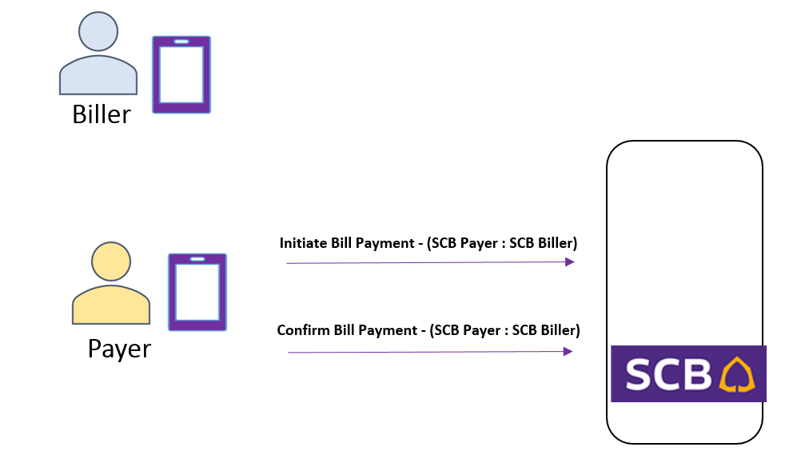

.

* PromptPay Bill Payments – Outbound OFF-US (SCB Payer : Other Biller)

A SCB Customer pays a Bill issued by a customer from another bank.

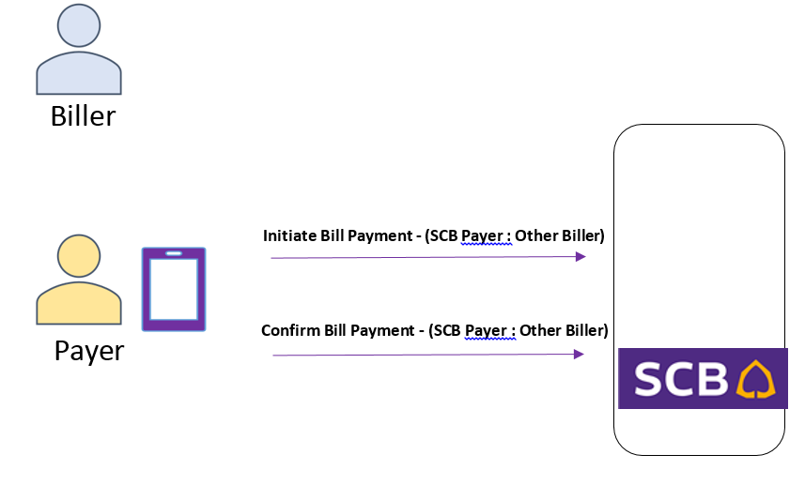

* PromptPay Bill Payments – Inbound OFF-US (Other Payer : SCB Biller)

A Customer from another bank pays a Bill issued by a SCB Customer.

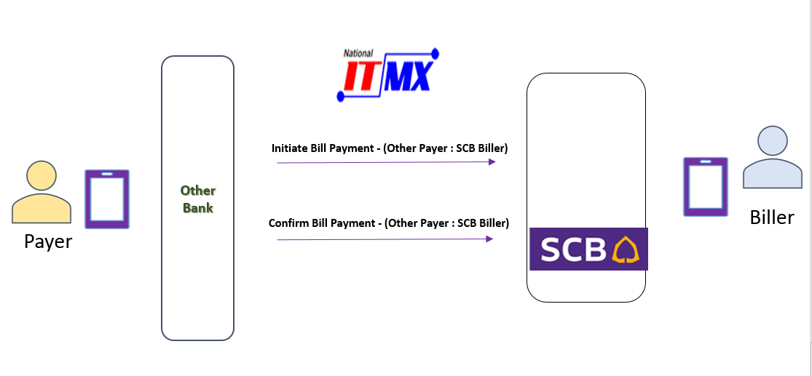

2.1. Outbound OnUs / OffUs PromptPay Bill Payment – (SCB Payer : Any Biller)

This flow describes the steps for an SCB Payer paying a Bill from either an SCB Biller or another bank’s Biller.

The flow is a 2-step process:

* Flow 1: Payer initiates a bill payment by supplying Bill Details for Payment Hub to verify and store.
* Flow 2: Payer sends a bill payment confirmation so that Payment Hub can orchestrate the payment for the Biller.
  + 1. Flow 1a: Outbound Initiate PromptPay Bill Payment - (SCB Payer : Any Biller)

A SCB Payer initiate a payment for a bill that must be validated and stored to Payment Hub.

* For ON-US initiate, both the Payer and the Biller are SCB Customers.
* The SCB Biller can be a normal Biller, eWallet Biller or an Online Biller.
* The SCB Payer can pay via an account or directly with cash. No Payer details will be supplied if paying by cash.
* For Outbound OFF-US initiate, the Payer is a SCB Customer, and the Biller is a customer of another bank.
* **Determine if Biller is ON-US, OFF-US, Normal Biller or QR**

1. The type of Biller can be derived from the GN response - **<PaySvcRs>** during the verification step of an Initiate Bill Payment request from SCB Channel (API Gateway).

It will depend on the enumerated value in response field ‘BillerType’ & ‘BillerSubType’.

|  |  |  |  |  |
| --- | --- | --- | --- | --- |
| <BillerType> | <BillerSubType> | <MCNProfileID> | ON-US / OFF-US / ON-US eWallet | Scenario |
| ‘N’ | Blank | Blank | ON-US | SCB Normal Billers |
| ‘S’ | Blank | Blank | ON-US | On Us SCB Normal Billers |
| ‘Q’ | Blank | Blank | ON-US | Off Us PromptPay Biller |
| ‘O’ | Blank | Blank | OFF-US | On Us SCB PromptPay Biller - QR payment |
| ‘R’ | Blank | Blank | OFF-US | Off Us PromptPay Biller - QR payment |
| ‘S’ | ‘EW’ or ‘AW’ or ‘AG’ | NA | ON-US eWallet | e-Wallet PP On-Us |
| ‘Q’ | ‘EW’ or ‘AW’ or ‘AG’ | NA | ON-US eWallet | e-Wallet QR On-Us |
| N or S or Q | NA | Not Blank | ON-US | Online Biller |

1. GN will be called to verify all Bill details. If GN indicates that a biller not a SCB Biller, Payment Hub will initiate a request to ITMX to perform the verification.
2. If the biller is ON-US eWallet, Payment Hub will perform an additional bill payment verification to eWallet Provider <BillLookupRequest (Receiving)> through API Gateway to verify the eWallet Bill Payment.
3. Payment Hub determines that the biller is an ON-US ‘Online Biller’ based on BRL001 - Determine if Biller is ON-US, OFF-US, Normal Biller or QR & GN Response (**PaySvcRs**) <MCNProfileID> field having a value (i.e NOT Null)

If PH is configured to call MCN interface for Online Biller verification, PH initiates a request to MCN to verify the Online Biller details.

* 1. The message format is **<MerchantSyncRq>** with /TranType = ‘AINQ’.

This diagram describes PART-1 INITIATE of the Prompt Bill Payment flow.

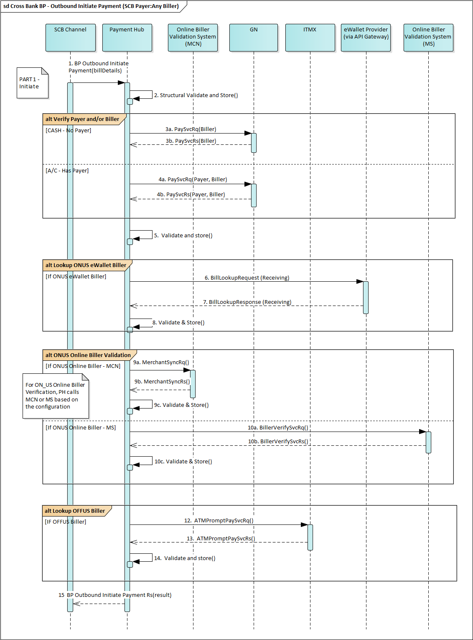

|  |  |
| --- | --- |
| URL | POST /scbph/v1/custbp/verification |
| Consumes: | application/json |
| Produces: | application/json |
| Scheme | https |

* **BP Initiate Payment Request**

**Header**

| Tag | M/O. | Type | Max. Len | Initial /Values | Remark |
| --- | --- | --- | --- | --- | --- |
| X-Request-ID | M | string | 3..36 |  | A unique request reference  Legal characters are A-Z, a-z, 0-9 and – (hyphen). |
| X-Channel | M | string | 3..36 | ENET  BCMS  VTMA  VTMC  TBS  TBSM  MOBI  AGN_TMG_SDO | The channel identifier such as ”ENET”..This value must be defined as an External Id on an Exchange Condition within the PH.  Legal characters are A-Z, a-z, 0-9 and – (hyphen).  TBS – Internet Comarch  TBSM – Mobile Comarch  BCMS – S1 |

**Body**

| Tag | M/O | Type | Len | Initial /Values | Remark |
| --- | --- | --- | --- | --- | --- |
| channelDateTime | M | date-time |  |  | Format: CCYY-MM-DDThh:mm:ss.sss±hh:mm  Eg. 2017-03-13T09:00:00.000+07:00 |
| region | M | string | 4 |  | The terminal's branch region.  Format: “9999” |
| branchNo | M | string | 4 |  | The terminal's branch ID.  Format: “9999” |
| branchName | M | string | 25 |  | The terminal's branch name |
| terminalNo | M | string | 5 |  | Terminal Number or Teller ID  Terminal number required by FAAT for ITMX interfaces |
| sequence | M | string | 6 |  | Sequence of transaction, Unique by Terminal  Terminal sequence required by FAAT for ITMX interfaces |
| bp | M |  |  |  | Cross-bank bill payment |
| payer | O |  |  |  | Payer detail |
| accountNumber | O | string | 1..20 |  | Payer account number |
| accountName | O | string | 1..40 |  | Name registered against the account  Default to Account Name unless there is a specific requirement for biller that requires Customer Name instead of Account Name  E.g. Insurance companies requires Customer Name |
| accountType | O | enum |  | DPA, LNA | To use for GN PmtSvcRq interface  DPA - Standard bill payment  LNA - Loan payment |
| taxID | O | string | 13 |  | Conditional on AMLO requirement  Tax ID for Thai Citizens  Passport Number for non-Thai Citizens |
| proxyIdentification | O | aggregate |  |  | Optional pass-through fields required in payer notification |
| proxyType | O | enum |  | CID,  MOB,  EWALLETID,  BILLERID | National ID : “CID”  Mobile Number : “MOB”  E-Wallet : “EWALLETID”  Biller ID : “BILLERID” |
| proxyId | O | string | 8..20 |  | Payer proxy identification  e.g.:  MOB: 0066891228788  CID: 1234567890123  BILLERID: 13 digit TaxID + 2 digit suffix  EWALLETID: 014123456789012 |
| payee | O |  |  |  | Payee detail |
| proxyIdentification | O | aggregate |  |  | Conditional if Payee is identified by proxy ID. |
| proxyType | M | enum |  | BILLERID |  |
| proxyId | M | string | 8..20 |  | Biller ID in ITMX Spec.  Format is Tax id (13 digits) + Suffix (2 digits) |
| accountIdentification | O | aggregate |  |  | Conditional if Payee is identified by account info. |
| accountNumber | M | string | 1..20 |  | Biller account number |
| accountName | M | string | 1..40 |  | Biller name registered against the account. |
| tranAmount | M |  |  |  | Transaction amount |
| amount | M | number | 16 |  | Amount with 2 decimal places  Valid values must be from 0.01 to 9,999,999,999,999.99  e.g: 1234.56 |
| currency | M | string | 3..3 | THB | Currency code must be Thai Baht (THB) |
| equivalentAmount | O | aggregate |  |  | Contains details of the exchange rate. |
| amount | M | number | 16 |  | Amount with 2 decimal places  Valid values must be from 0.01 to 9,999,999,999,999.99  e.g: 1234.56 |
| currency | M | string | 3..3 |  | Currency code EG "AUD" |
| exchangeRateInformation | O | aggregate |  |  | Details of the exchange rate. |
| exchangeRate | O | number | 11 |  | Rate used to convert from one currency to another.  Length includes up to 5 decimal places. |
| billRef1 | M | string | 20 |  | Bill reference number 1 |
| billRef2 | O | string | 20 |  | Bill reference number 2 |
| billRef3 | O | string | 20 |  | Bill reference number 3  Note: For QR payments, FastEasy will map the store terminal id in this field. PH will still treat this as billRef3 (pass-through field) and not apply any special business rule to handle terminal id. |
| miscRef1 | O | string | 20 |  | Additional miscellaneous information pass-through to GN.  Applicable for Normal Bill only.  Use to fill in the information received from specific billers  E.g. Transaction ID, Receipt Serial Number |
| miscRef2 | O | string | 20 |  | Additional miscellaneous information pass-through to GN.  Applicable for Normal Bill only.  Use to fill in the information received from specific billers  E.g. Transaction ID, Receipt Serial Number |
| miscRef3 | O | string | 20 |  | Additional miscellaneous information pass-through to GN.  Applicable for Normal Bill only.  Use to fill in the information received from specific billers  E.g. Transaction ID, Receipt Serial Number |
| tranCode | M | string | 4 | ‘BLPY’ | Default value as “BLPY” |
| thaiQRTag | O | string | 99 |  | Note: Additional information for “thaiQRTag” refer to Tag 31 in Thai QR Code |
| paymentType | O | enum |  | QRS  QRP | “QRS” - QR Bill Payment - Scan  “QRP” - QR Bill Payment – Key in |
| valueDate | O | date-time |  |  | Value date pass-through to GN.  Format: CCYY-MM-DDThh:mm:ss.sss±hh:mm  Eg. 2017-03-13T09:00:00.000+07:00 |
| annotation | O | string | 40 |  | Annotation text provided by Payer  This field will support following character types:  - Thai characters (ASCII 8 Bit Code Page 874 - Refer ITMX spec)  - Special characters |
| verificationType | O | ENUM |  | PAYMENTSTDVERIFY  PAYMENTTXNVERIFY | Determines the level of validations GN should apply on the payment.   * PAYMENTSTDVERIFY – Validations excluding biller/ payer account status * PAYMENTTXNVERIFY – All the validations including biller/ payer account status   If not set, PH will use the default value ‘PAYMENTSTDVERIFY’ |
| batchBooking | O | boolean | 0…5 | true  false | Used to indicate whether a lump sum posting is requested.   * If true, the lump sum amount of all transactions within the payment is requested. * If false, a single entry for each transaction within the payment is requested. |
| partner | O |  |  |  | Identifies a partner such as a particular merchant. |
| partnerId | O | string | 0…20 |  | Id of the partner |
| partnerName | O | string | 0…50 |  | Name of the partner |
| locationBranchId | O | string | 0…20 |  | Partner’s Branch id |
| terminalId | O | string | 0…16 |  | Terminal Id of the partners physical device |
| additionalNote | O | string | 0…40 |  | Must be able to support Thai characters. |
| instructedCurrencyCode | O | string | 3 |  | The instructed currency of the payment  EG. If the amount to be paid is $10 AUD, then the instructedCurrencyCode is “AUD” |
| initiatingPartyCountryCode | O | string | 2 |  | The country code of the country where the payment is intiated. |
| initiatingPartyNationality | O | string | 35 |  | Senders nationality. |
| processingBranchId | O | string | 4 |  | Processing Branch Identification |

**Sample Message (Scenario: Payee Identification by ProxyID)**

{

"channelDateTime": "2017-04-20T09:00:01.000+07:00",

"region": "0000",

"branchNo": "0111",

"branchName": "SCB Head Office",

"terminalNo": "00001",

"sequence":"042304",

"bp": {

"payer": {

"accountNumber": "384995886",

"accountName": "PRAKIT DEEPROM",

"accountType": "DPA",

"taxID": "T12345678H",

"proxyIdentification": {

"proxyType": "BILLERID",

"proxyId": "200001099988768"

}

},

"payee": {

"proxyIdentification": {

"proxyType": "BILLERID",

"proxyId": "200001021234500"

}

},

"tranAmount": {

"amount": 250.00,

"currency": "THB"

},

"billRef1": "True20170317 Ref1",

"billRef2": "True20170317Ref2",

"billRef3": "True20170317Ref3",

"miscRef1": "1111",

"miscRef2": "2222",

"miscRef3": "3333"

},

"tranCode": "BLPY",

"thaiQRTag": "additional information for QR",

"paymentType": "QRS",

"valueDate": "2017-04-19T09:00:00.000+07:00",

"annotation": "Payment towards personal loan",

"verificationType": "PAYMENTSTDVERIFY",

"batchBooking": "true",

"partner": {

"partnerId": "WW0011",

"partnerName": "Woolworth Merchant",

"locationBranchId": "123ABC",

"terminalId": "987654321"

},

"additionalNote": "Additional Note",

"InstructedCurrencyCode": "AUD",

"initiatingPartyCountryCode": "TH",

"processingBranchId": "864"

}

**Sample Message (Scenario: Payee Identification by Account Number)**

{

"channelDateTime": "2017-04-20T09:00:01.000+07:00",

"region": "0000",

"branchNo": "0111",

"branchName": "SCB Head Office",

"terminalNo": "00001",

"sequence":"042304",

"bp": {

"payer": {

"accountNumber": "384995886",

"accountName": "PRAKIT DEEPROM",

"accountType": "DPA",

"taxID": "T12345678H",

"proxyIdentification": {

"proxyType": "BILLERID",

"proxyId": "200001021234500"

}

},

"payee": {

"accountIdentification": {

"accountNumber": "9994995888",

"accountName": "True Mobile Ltd",

}

},

"tranAmount": {

"amount": 250.00,

"currency": "THB"

},

"billRef1": "True20170317",

"billRef2": "True20170317Ref2",

"billRef3": "True20170317Ref3",

"miscRef1": "1111",

"miscRef2": "2222",

"miscRef3": "3333"

},

"tranCode": "BLPY",

"thaiQRTag": "additional information for QR",

"paymentType": "QRS",

"valueDate": "2017-04-19T09:00:00.000+07:00",

"verificationType": "PAYMENTSTDVERIFY",

"batchBooking": "true",

"partner": {

"partnerId": "WW0011",

"partnerName": "Woolworth Merchant",

"locationBranchId": "123ABC",

"terminalId": "987654321"

},

"additionalNote": "Additional Note",

"InstructedCurrencyCode": "AUD",

"initiatingPartyCountryCode": "TH"

}

* + 1. Flow 1b: Outbound Confirm PromptPay Bill Payment – (SCB Payer : Any Biller)

A SCB Payer confirms or gives permission to pay an existing bill that has already been validated and stored to Payment Hub.

* For ON-US confirmation, both the Payer and the Biller are SCB Customers.
* The SCB Biller can be a normal Biller, eWallet Biller or an Online Biller.
* The SCB Payer can pay via an account or directly with cash. No Payer details will be supplied if paying by cash..
* For Outbound OFF-US confirmation, the Payer is a SCB Customer and the Biller is a customer of another bank.

This diagram describes PART-2 CONFIRM of the Prompt Bill Payment flow.

**Postings**

Payment Hub determines that the payment is to an ON-US or OFF-Us or ON-US eWallet Biller

ON-US Posting / ON-US eWallet Posting to GN – 4a, 4b OR 4c, 4d then 4.2

1. If the Biller is a SCB Customer, then this is an ON-US posting as the payer will always be a SCB Customer.
2. The message format is **<PaySvcRq>** with appropriate /tranType**.**
3. Payment Hub sends the request to GN.
4. Payment Hub receive a response in <**PaySvcRs**> message format from GN.

Outbound OFF-US Posting – 5, 5.1, 5.2, 6, 6.1, 6.2, 11, 11.1

1. Payment Hub determines that the Biller is from another bank.
   1. Note the Payer will always be a SCB Customer.
2. Payment Hub initiate a request to Debit the Payer account held at GN.
   1. The message format is <**DebitCreditSvcRq**>.
   2. Payment Hub sends the request to GN.
   3. Payment Hub receives a response in <**DebitCreditSvcRs**> message format from GN.
3. If the debit was posted successfully at core banking
   1. Payment Hub sends a Credit Transfer request to credit the Biller’s account at another bank via ITMX.
      1. The message format is <**ATMPromptPaySvcRq**> with:
         1. MsgType = **220** (Credit Transfer)
         2. TranCode = **55** (Bill Payment)
         3. TranProd = **PPBP**” (PromptPay Bill Payment)
   2. Payment Hub receives a response in **<ATMPromptPaySvcRs**> message format from ITMX.

Payment Confirmation to eWallet Provider – 8, 8.1, 8.2

1. Payment Hub determines that the Biller is an ON-US eWallet Biller (Refer BRL001) and initiates a Payment Confirmation to the eWallet provider.
   1. The message format is **<BillPayment_Request (Receiving)>** with <promptPayFlag> = ‘02’**.**
      1. Payment Hub sends the request to at eWallet provider through API Gateway.
2. Payment Hub receive a response in < **BillPayment_Response (Receiving)**> message format from eWallet provider.
3. Irrespective of the outcome, Payment Hub will log a history message with the response status

Payment Confirmation to Biller System via Micro-service (MS) – 9, 9.1

1. Payment Hub will send a confirmation message to Biller System via MS interface if-
2. Biller is an Online Biller (Refer BRL001)
3. Payment Hub has been configured to call MS interface for Online Billers
4. Successful GN posting response has been received
5. Payment Hub will send Payment Confirmation message to the Biller System via MS interface in Asynchronous mode.
6. The message format is <**BillerConfirmSvcRq**> with tag /tranType = ‘ALDB’
7. Payment Hub will send the request to MS through API Gateway
8. Payment Hub receives a response in <**BillerConfirmSvcRs**> message format from MS Interface.
9. Irrespective of the outcome, Payment Hub will store the response and log a history message with the response status.

Send Push Notification to SCB Payee via Universal Bus – 10, 11

1. PH will initiate a push notification to Payee **ONLY IF** the ‘BillerType’ field in GN response (**PaySvcRs)** is one of the following values.
   1. Biller Type = ‘Q’ or ‘R’ or ‘S’ or ‘O’ or ‘N’
2. A Push Notification will be sent to the Payee via Universal Bus only if the confirmation request is successful.
3. No payee notification if the confirmation is failed.
4. Payment Hub will receive a Notification response from Universal Bus asynchronously.
5. Payment Hub will log a history message with the response status.

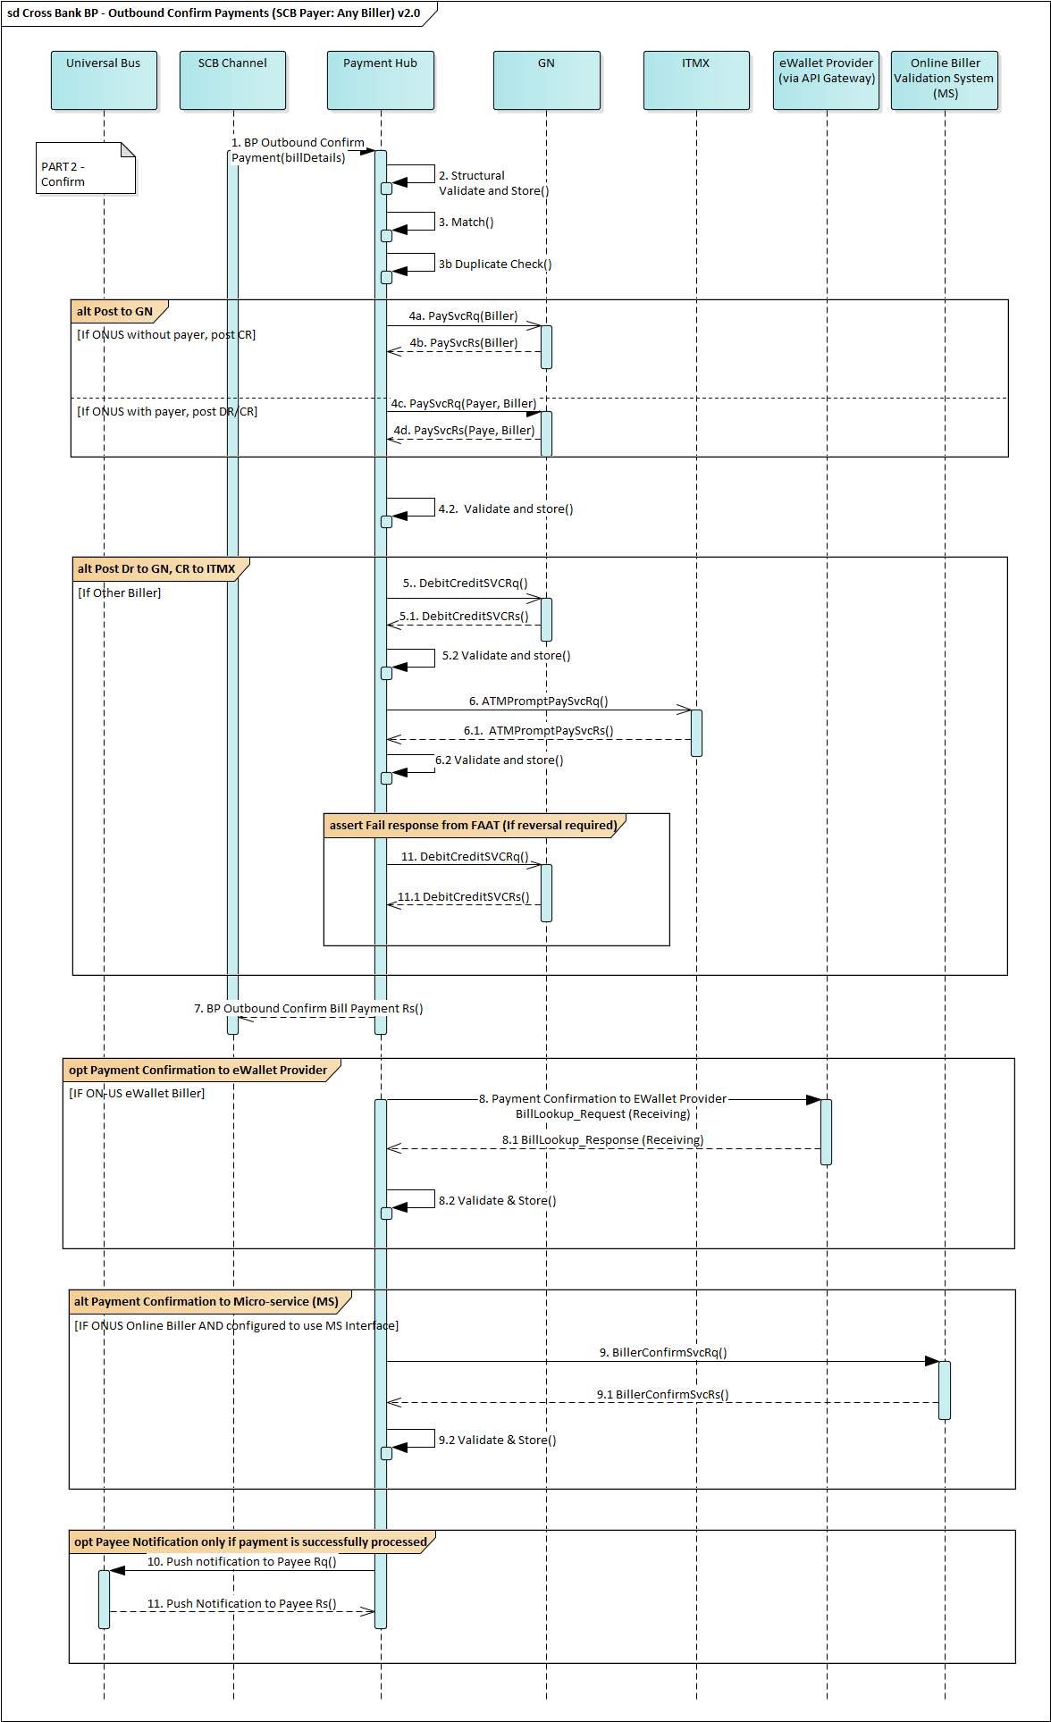

|  |  |
| --- | --- |
| URL | POST /scbph/v1/custbp/payment |
| Consumes: | application/json |
| Produces: | application/json |
| Scheme | https |

* **BP Confirm Payment Request**

**Header**

| Tag | M/O. | Type | Max. Len | Initial /Values | Remark |
| --- | --- | --- | --- | --- | --- |
| X-Request-ID | M | string | 3..36 |  | A unique request reference  Legal characters are A-Z, a-z, 0-9 and – (hyphen). |
| X-Channel | M | string | 3..36 | ENET  BCMS  VTMA  VTMC  TBS  TBSM  MOBI  AGN_TMG_SDO | The channel identifier such as ”ENET”.. This value must be defined as an External Id on an Exchange Condition within the PH.  Legal characters are A-Z, a-z, 0-9 and – (hyphen).  TBS – Internet Comarch  TBSM – Mobile Comarch  BCMS – S1 |

**Body**

| Tag | M/O. | Type | Max. Len | Initial /Values | Remark |
| --- | --- | --- | --- | --- | --- |
| channelDateTime | M | date-time |  |  | Format: CCYY-MM-DDThh:mm:ss.sss±hh:mm  Eg. 2017-03-13T09:00:00.000+07:00 |
| bp | M |  |  |  |  |
| bpReference | M | string | 16..16 | BBBByddd######## | Generated by Payment Hub in Initiate Payment response. |
| paymentID | O | string | 36 |  | Customer Receipt No. from Channel |
| payer | O |  |  |  | Payer detail |
| accountNumber | O | string | 1..20 |  | Payer account number |
| accountName | O | string | 1..40 |  | Name registered against the account  Default to Account Name unless there is a specific requirement for biller that requires Customer Name instead of Account Name  E.g. Insurance companies requires Customer Name |
| accountType | O | enum |  | DPA, LNA | To use for GN PaySvcRq interface  DPA - Standard bill payment  LNA - Loan payment |
| tranAmount | O |  |  |  | Transaction amount |
| amount | M | number | 16 |  | Amount with 2 decimal places  Valid values must be from 0.01 to 9,999,999,999,999.99  e.g: 1234.56 |
| currency | M | string | 3..3 | THB | Currency code must be Thai Baht (THB) |
| equivalentAmount | O | aggregate |  |  | Contains details of the exchange rate. |
| amount | M | number | 16 |  | Amount with 2 decimal places  Valid values must be from 0.01 to 9,999,999,999,999.99  e.g: 1234.56 |
| currency | M | string | 3..3 |  | Currency code EG "AUD" |
| exchangeRateInformation | O | aggregate |  |  | Details of the exchange rate. |
| exchangeRate | O | number | 11 |  | Rate used to convert from one currency to another.  Length includes up to 5 decimal places. |
| senderFee | O |  |  |  | As received from ITMX (For Bill payment this is filled as zero) |
| amount | M | number | 16 |  | Amount with 2 decimal places  e.g: 1234.56 |
| currency | M | string | 3..3 | THB | Currency code must be Thai Baht (THB) |
| payerBankFee | O |  |  |  | Payer Bank fee that will be posted to GN. |
| amount | M | number | 16 |  | Amount with 2 decimal places  e.g: 1234.56 |
| currency | M | string | 3..3 | THB | Currency code must be Thai Baht (THB) |
| payeeBankFee | O |  |  |  | Per ITMX spec. From Biller sponsor bank.  For Bill payment this is filled as zero |
| amount | M | number | 16 |  | Amount with 2 decimal places  e.g: 1234.56 |
| currency | M | string | 3..3 | THB | Currency code must be Thai Baht (THB) |
| interBranchFee | O |  |  |  | IB fees in this field is not used for posting to GN |
| amount | M | number | 16 |  | Amount with 2 decimal places  e.g: 1234.56 |
| currency | M | string | 3..3 | THB | Currency code must be Thai Baht (THB) |
| interRegionFee | O |  |  |  | IR fees in this field is not used for posting to GN |
| amount | M | number | 16 |  | Amount with 2 decimal places  e.g: 1234.56 |
| currency | M | string | 3..3 | THB | Currency code must be Thai Baht (THB) |
| billRef1 | M | string | 20 |  | Bill reference number 1 |
| billRef2 | O | string | 20 |  | Bill reference number 2 |
| billRef3 | O | string | 20 |  | Bill reference number 3  Note: For QR payments, FastEasy will map the store terminal id in this field. PH will still treat this as billRef3 (pass-through field) and not apply any special business rule to handle terminal id. |
| miscRef1 | O | string | 20 |  | Additional miscellaneous information pass-through to GN.  Applicable for Normal Bill only.  Use to fill in the information received from specific billers  E.g. Transaction ID, Receipt Serial Number |
| miscRef2 | O | string | 20 |  | Additional miscellaneous information pass-through to GN.  Applicable for Normal Bill only.  Use to fill in the information received from specific billers  E.g. Transaction ID, Receipt Serial Number |
| miscRef3 | O | string | 20 |  | Additional miscellaneous information pass-through to GN.  Applicable for Normal Bill only.  Use to fill in the information received from specific billers  E.g. Transaction ID, Receipt Serial Number |
| tranCode | M | string | 4 | ‘BLPY’ | Required by GN |
| valueDate | O | date-time |  |  | Value date pass-through to GN.  Format: CCYY-MM-DDThh:mm:ss.sss±hh:mm  Eg. 2017-03-13T09:00:00.000+07:00 |
| annotation | O | string | 40 |  | Annotation text provided by Payer  This field will support following character types:  - Thai characters (ASCII 8 Bit Code  - Special characters |
| statementDescriptionInfo | O |  |  |  |  |
| accountStatement | O | string | 50 |  | Payer's statement description.  If "DSC-" is supplied, the statement description will be blank |
| changeAccountStatement | O | string | 50 |  | Change account statement description.  If "DSC-" is supplied, the statement description will be blank. |

**Sample Message**

{

"channelDateTime": "2017-04-20T09:00:01.000+07:00",

"bp": {

"bpReference": " B014709400000001",

"paymentID": "abcd1234",

"payer": {

"accountNumber": "384995886",

"accountName": "PRAKIT DEEPROM",

"accountType": "DPA"

},

"tranAmount": {

"amount": 250.00,

"currency": "THB"

},

"senderFee": {

"amount": 0.00,

"currency": "THB"

},

"payerBankFee": {

"amount": 0.00,

"currency": "THB"

},

"payeeBankFee": {

"amount": 0.00,

"currency": "THB"

},

"interBranchFee": {

"amount": 0.00,

"currency": "THB"

},

"interRegionFee": {

"amount": 0.00,

"currency": "THB"

},

"billRef1": "True20170317",

"billRef2": "True20170317Ref2",

"billRef3": "True20170317Ref3",

"miscRef1": "1111",

"miscRef2": "2222",

"miscRef3": "3333"

},

"tranCode": "BLPY",

"valueDate": "2017-04-19T09:00:00.000+07:00",

"annotation": "Payment towards personal loan",

"statementDescriptionInfo": {

"accountStatement": "DSC-Payer statement from channel",

"changeAccountStatement": "DSC-Payer change account statement from channel"

}}

2.2. Inbound Prompt Bill Payment – (Other Payer : SCB Biller)

This flow describes the steps for another bank’s Payer paying a Bill from a SCB Biller.

The flow is a 2-step process:

* Flow 1: Other bank’s Payer initiates a bill payment by supplying Bill Details for Payment Hub to verify and store.
* Flow 2: Other bank’s Payer sends a bill payment confirmation so that Payment Hub can post the payment to the SCB Biller.
  + 1. Flow 2a: Inbound Initiate PromptPay Bill Payment – (Other Payer: SCB Biller)

This diagram describes PART-1 INITIATE of the PromptPay Bill Payment flow.

Another bank’s Payer initiates a payment for a bill that must be validated and stored to Payment Hub.

* This is an Inbound OFF-US initiate request where the Payer is a customer of another bank and the Biller is a SCB Customer.
* The SCB Biller can be a normal biller, an eWallet Biller OR an Online Biller.

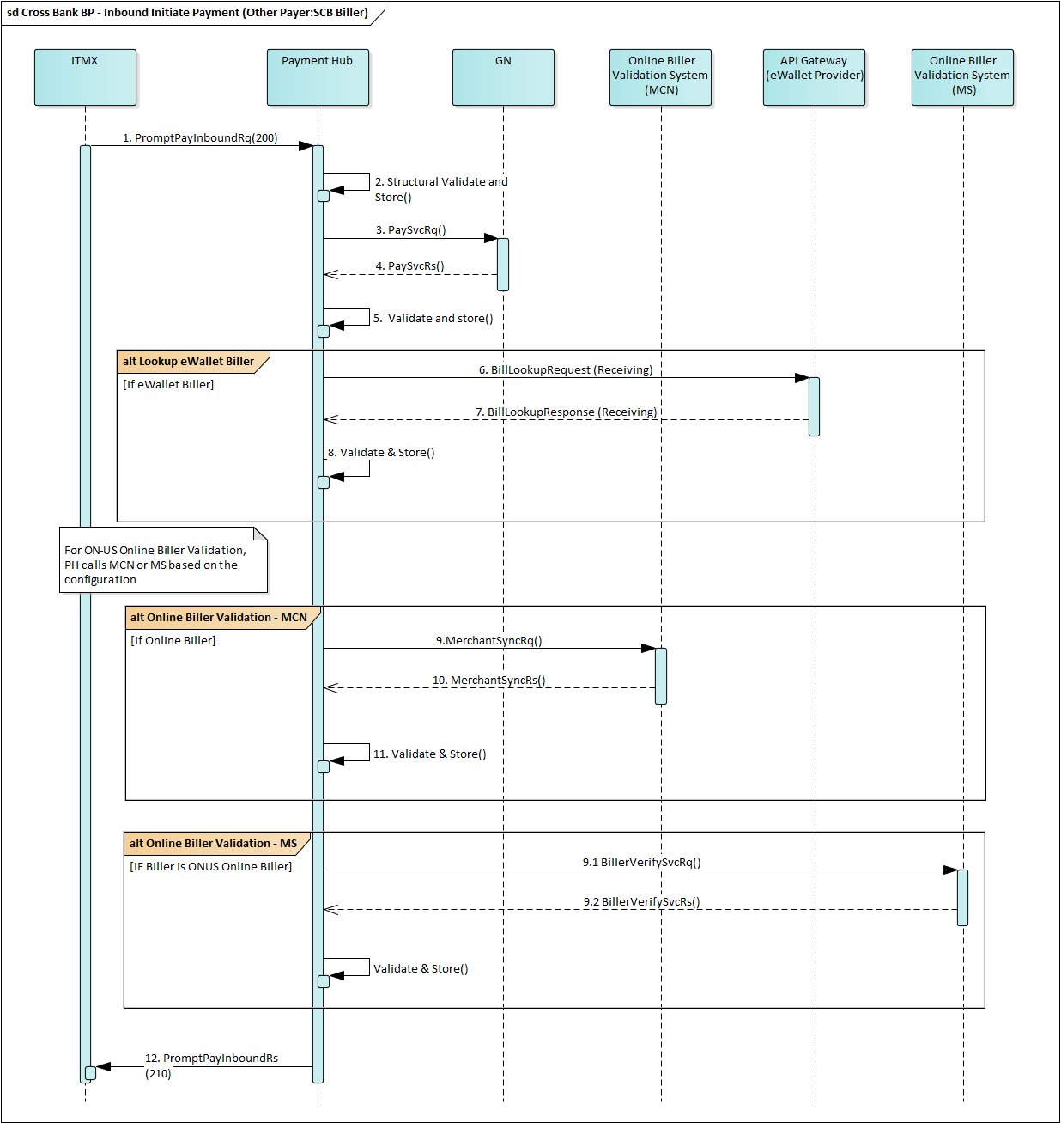

* + 1. Flow 2b: Inbound Confirm Prompt Bill Payment – (Other Payer : SCB Biller)

This diagram describes PART-2 CONFIRM of the Prompt Bill Payment flow.

Another bank’s Payer confirms or gives permission to a pay an existing bill that has already been validated and stored to Payment Hub.

* This is an Inbound OFF-US initiate request where the Payer is a customer of another bank and the Biller is a SCB Customer.
* The SCB Biller can be a normal biller, an eWallet Biller or an Online Biller.

