Food Delivery Business Intelligence & AI-Based Customer Retention Dashboard
Turning Food Delivery Data into Actionable Business Decisions

Prepared by: Rajiv Sharma
Business Intelligence Internship Project

Executive Summary
This project is an end-to-end interactive Business Intelligence platform built for a food-delivery business. It transforms raw transactional food-delivery data into actionable business insights, predictive risk analysis, and concrete recommendations for management.

Introduction
Food delivery platforms generate massive amounts of data but often struggle to translate this data into strategic decisions. Management needs to understand business drivers, identify operational bottlenecks, and proactively manage customer churn to maintain profitability and growth.

Business Problem
The core business problem revolves around maximizing revenue and order volume while identifying and mitigating operational bottlenecks (like delivery delays) and customer churn risks.

Project Objectives
1. Provide a clear, real-time snapshot of business performance.
2. Identify major drivers of revenue.
3. Segment customers based on behavior.
4. Implement an AI-assisted risk scoring system.
5. Translate analytical findings into concrete business actions.

Dataset Description
The dataset contains ~1,898 food delivery orders with 9 columns capturing order IDs, customer details, restaurant names, cuisine types, order costs, day of the week, ratings, preparation time, and delivery time.

Dataset Source
The dataset used is the FoodHub Order Analysis Dataset, available via public GitHub repository at: https://raw.githubusercontent.com/prneidhardt/Python-Foundations/main/foodhub_order.csv.

Data Cleaning
Data cleaning involved removing duplicate records, coercing 'Not given' ratings into NaN numeric values to prevent type errors, ensuring proper numeric types for cost and time columns, and flagging cost outliers using the IQR method.

Feature Engineering
We created several key features: total_time (prep + delivery), delivery speed bins (Fast/Normal/Slow), order value categories, RFM-inspired segmentation metrics (frequency_score, monetary_score, engagement_score), and customer value tiers.

Exploratory Data Analysis
EDA revealed strong weekend demand preferences, identified top-performing cuisines (e.g., American, Japanese), and highlighted that food preparation time often represents the majority of the total wait time.

KPI Analysis
Key Performance Indicators include Total Revenue, Total Orders, Average Order Value, Repeat Customer Rate, Average Rating, and Average Delivery Time. These are prominently displayed on the Executive Overview page.

Sales & Restaurant Analysis
Our Pareto analysis confirmed that a small percentage of restaurants generate a large portion of the revenue, highlighting the importance of strategic partnerships with top-tier vendors.

Customer Intelligence
Customers were segmented into categories such as Champions, Loyal Customers, and At-Risk based on order frequency, total spend, and engagement (rating response rate and cuisine diversity).

Delivery & Operational Analysis
The analysis showed that long preparation times are a primary bottleneck. Weekend operations handle higher volume but must maintain strict SLAs to prevent service degradation.

AI/ML Risk Analysis
An AI-Assisted Customer Risk Scoring model was implemented using Scikit-Learn (Logistic Regression, Random Forest, Gradient Boosting). It scores customers on behavioral risk factors (low frequency, low spend, poor service experience) to proactively flag churn risks.

Dashboard Design
The Streamlit dashboard uses a professional, 7-page navigation structure with KPI cards, interactive Plotly visualizations, dynamic data tables, and an auto-generated insights engine.

Key Business Insights
Key insights include the heavy reliance on weekend orders, a significant gap in customer feedback (many unrated orders), and the disproportionate impact of a few top restaurants on overall revenue.

Risks
Key risks identified include operational bottlenecks (high prep times) and revenue concentration among top restaurants.

Opportunities
Opportunities exist in driving weekday order volume, converting single-order users to repeat customers, and proactively reaching out to high-risk customers identified by the AI model.

Recommended Actions
1. Implement AI-driven retention alerts.
2. Introduce in-app rating incentives.
3. Optimize routing and SLAs with top restaurants.
4. Launch targeted weekday corporate promotions.

Limitations
The dataset lacks temporal/timestamp data, preventing traditional time-series forecasting. There is also no geographic or promotional data available.

Future Scope
Future enhancements could include real-time streaming integration, spatial/mapping analysis, and a personalized recommendation engine for customers.

Conclusion
This project successfully demonstrates the transformation of raw transactional data into a strategic business asset, equipping management with the tools necessary to protect revenue and drive growth.

References
- Streamlit Documentation
- Plotly Documentation
- Scikit-learn Documentation
- Public GitHub FoodHub Dataset

Dashboard Screenshots

📊 Executive Overview
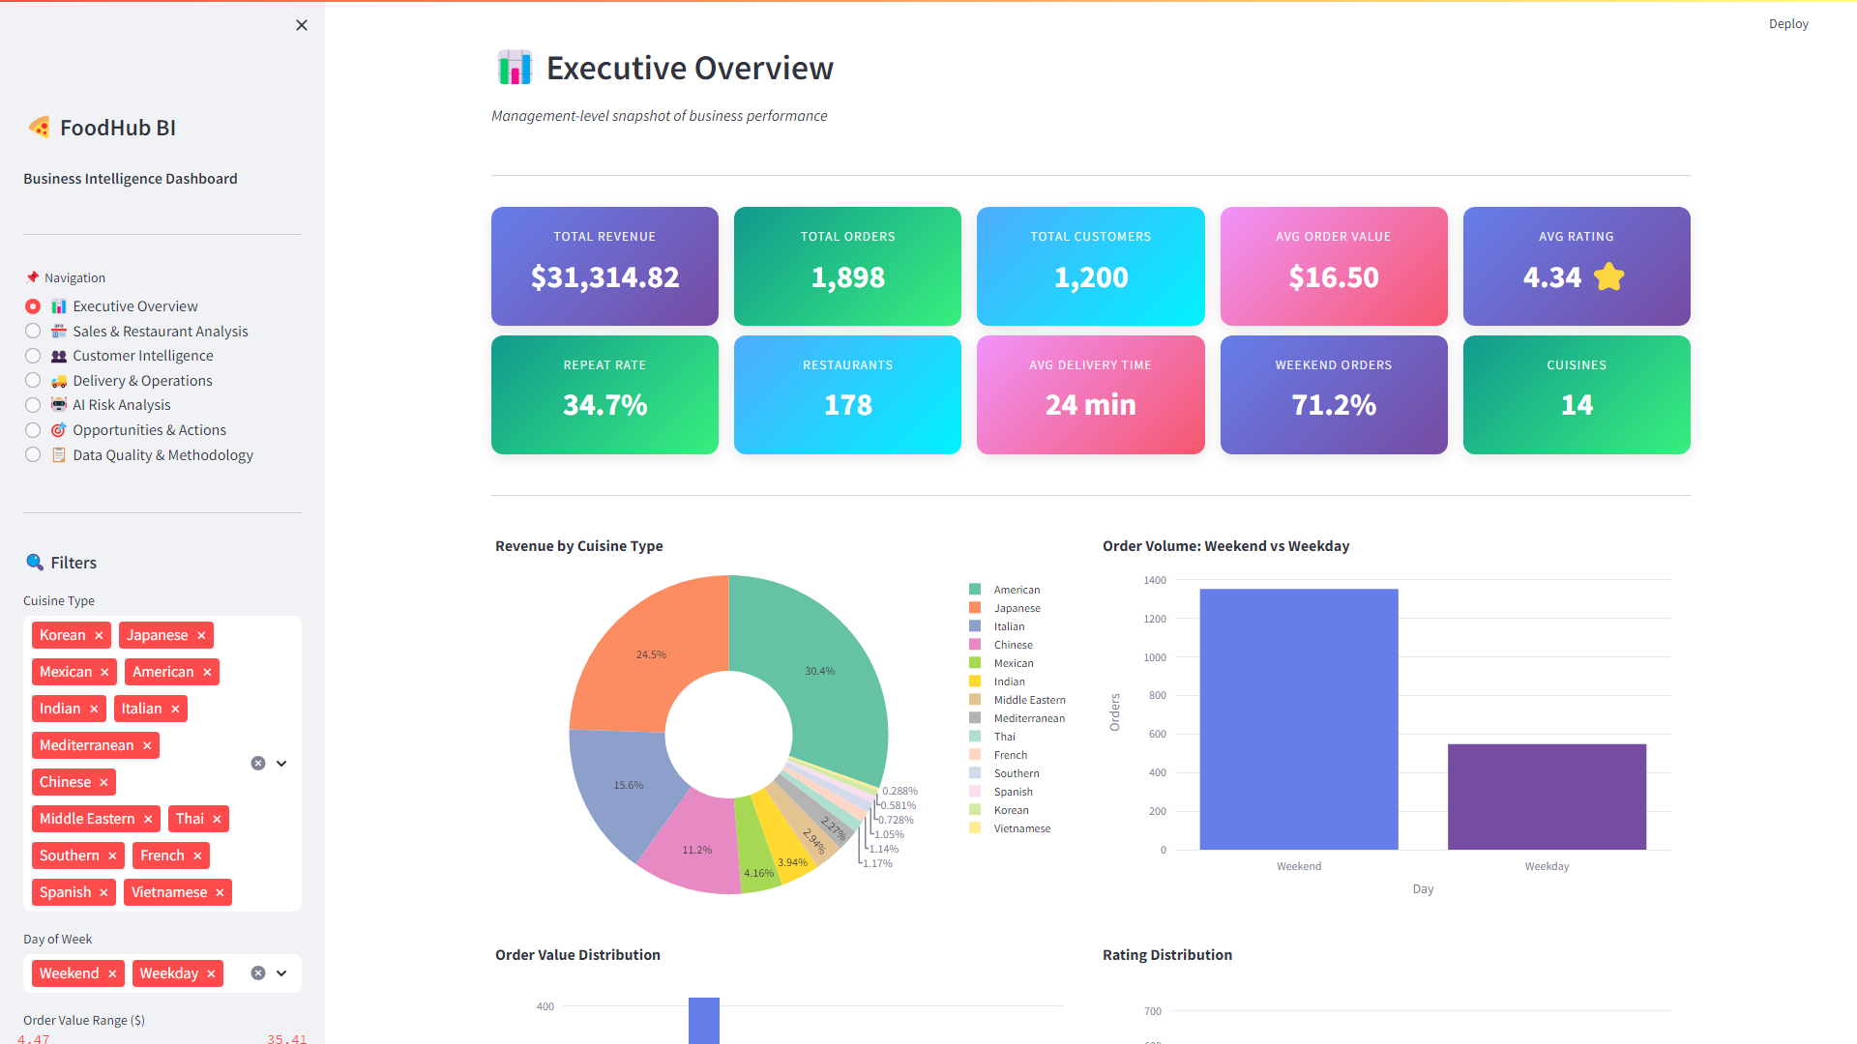

🏪 Sales & Restaurant Analysis
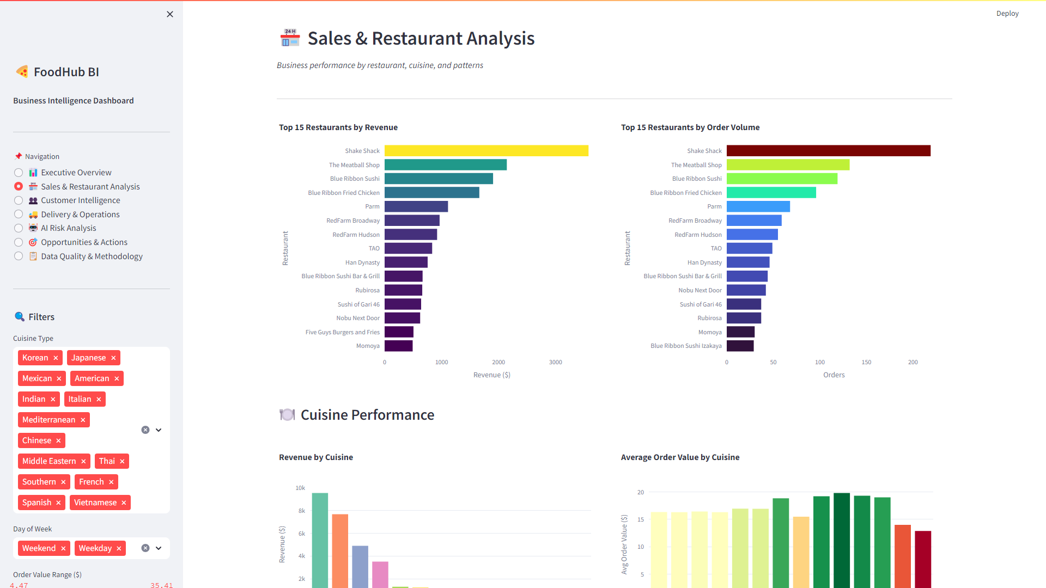

👥 Customer Intelligence
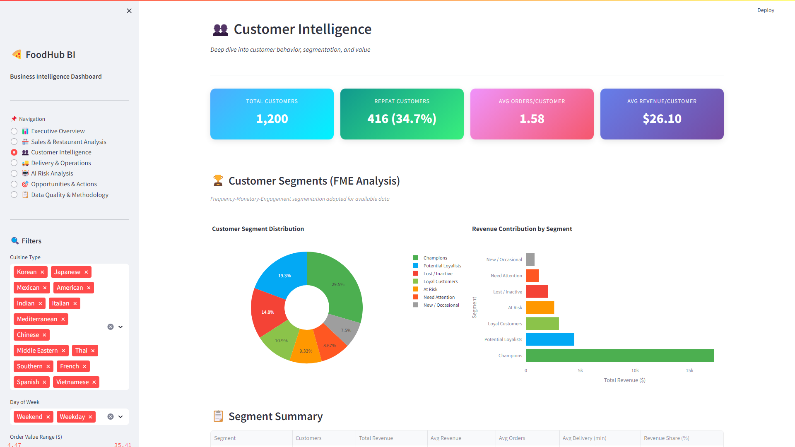

🚚 Delivery & Operations
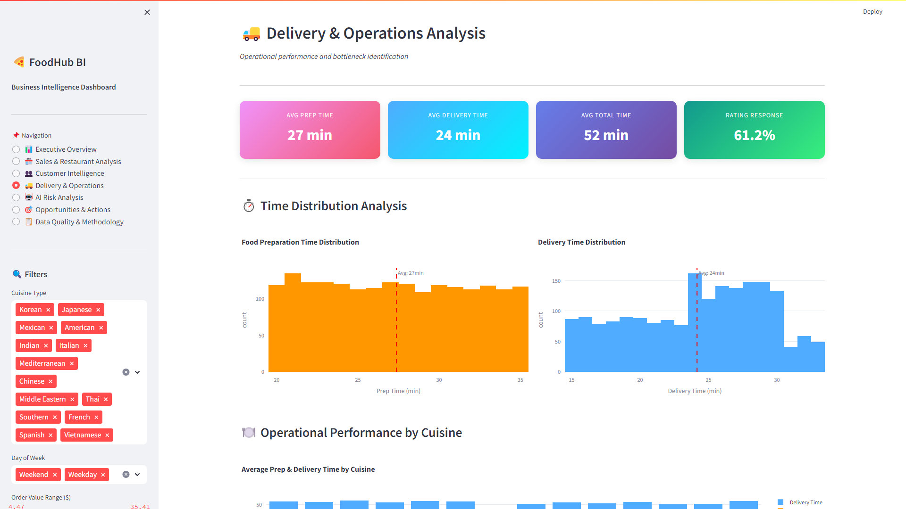

🤖 AI Risk Analysis
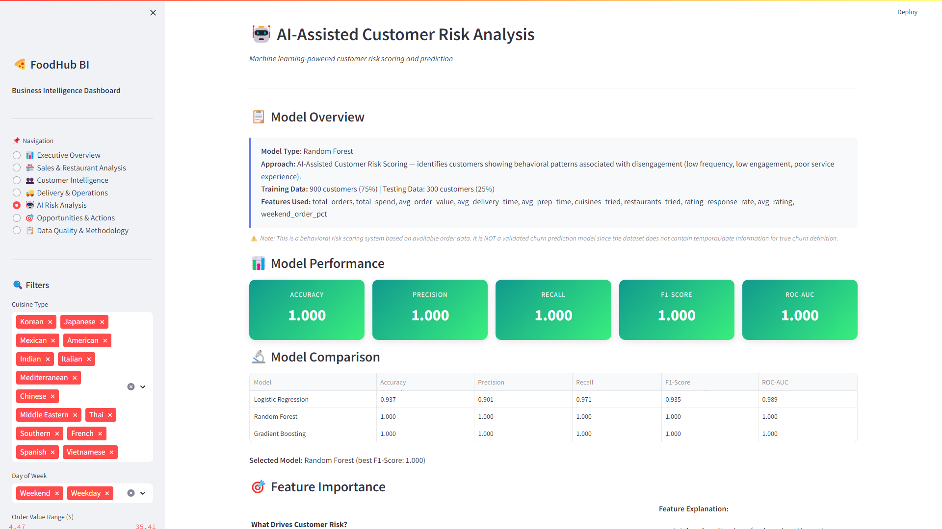

🎯 Opportunities & Actions
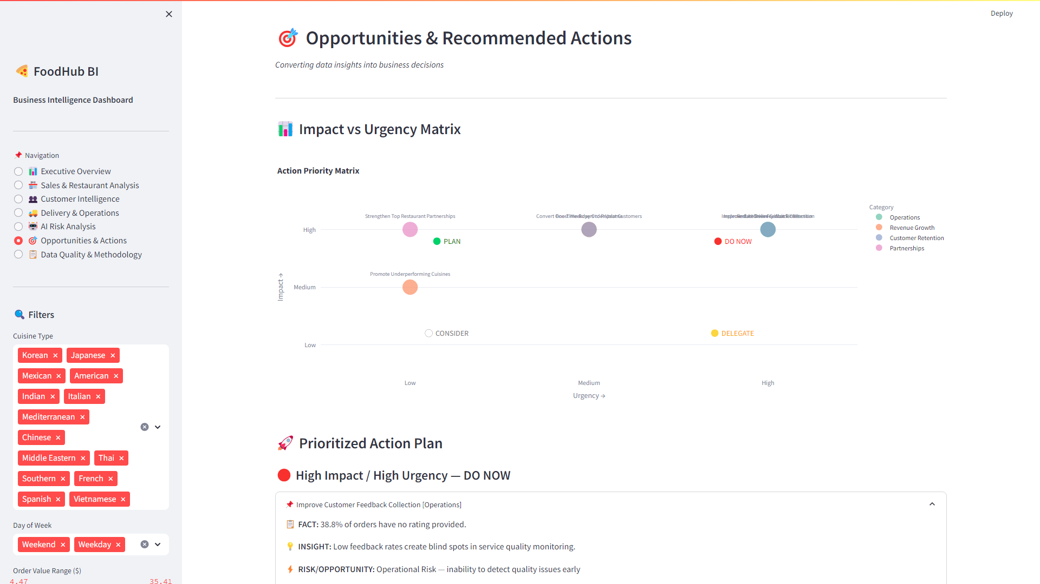

📋 Data Quality & Methodology
