* **User for demo purpose**

|  |  |  |  |
| --- | --- | --- | --- |
| User for demo purpose | | | |
| Sr.No | User | Pass | Role |
| 1 | rajiv | test123 | [ROLE_USER] |
| 2 | ansh | test123 | [ROLE_ADMIN] |
| 3 | ayush | test123 | [ROLE_NA] |

* **Login Screen**

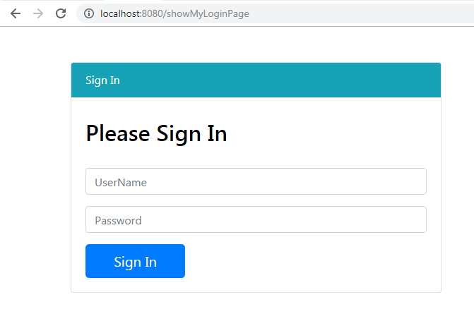

* + Login with error message(invalid user/pass)

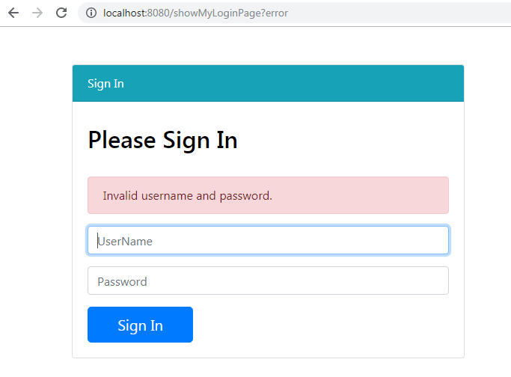

* + Login with no appropriate role ie. Ayush with Role -> [ROLE_NA] , an error message will be displayed.

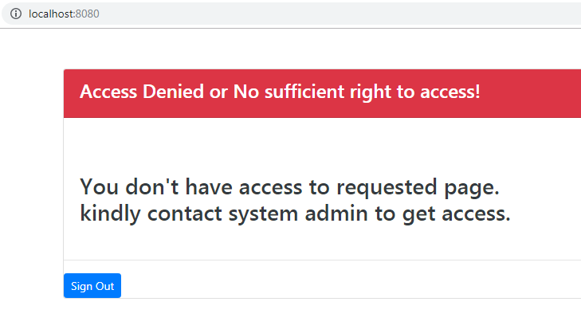

* **Login as User – As a user. A user can perform following activities.**
  + Can login to application
  + Can add text comment (new entry ) to guest book.
  + Can add image (new entry) to guest book.
  + Can view his previous comment.
  + logout

Screen shots for demo purpose.

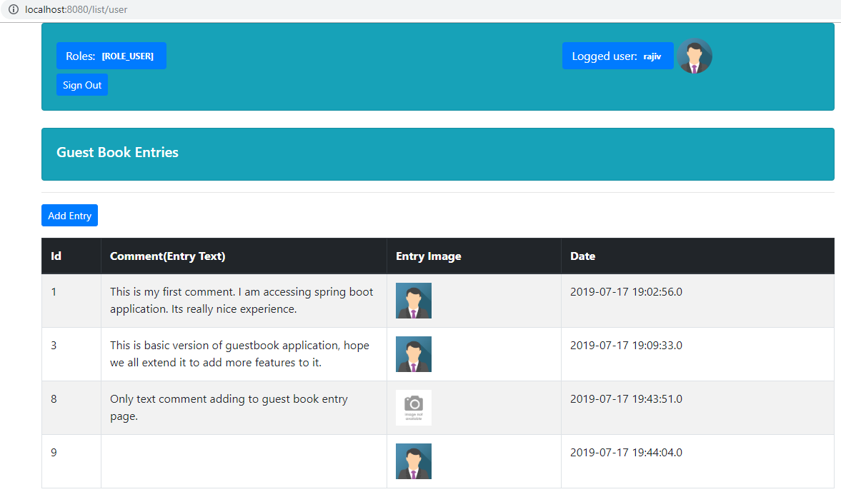

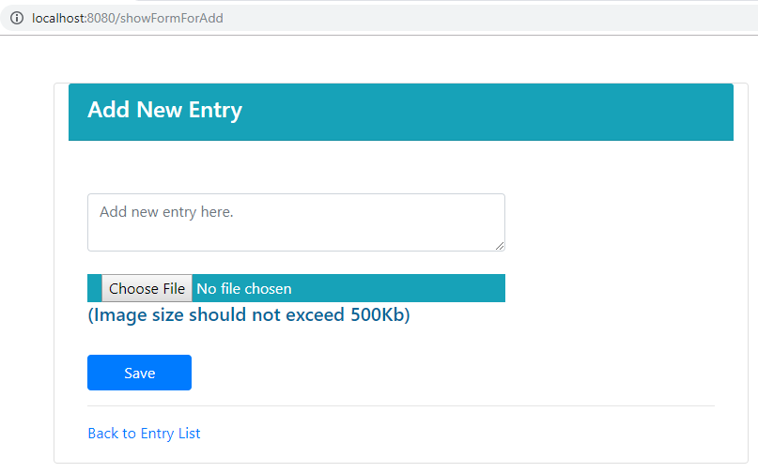

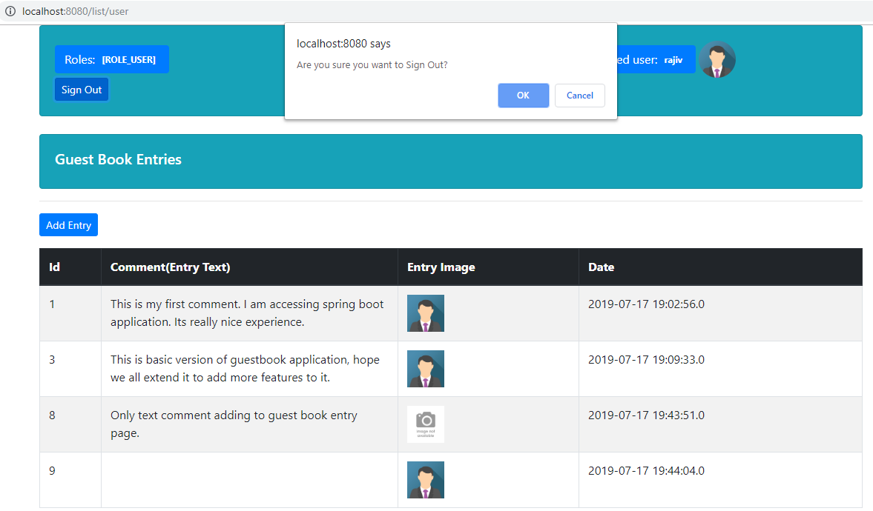

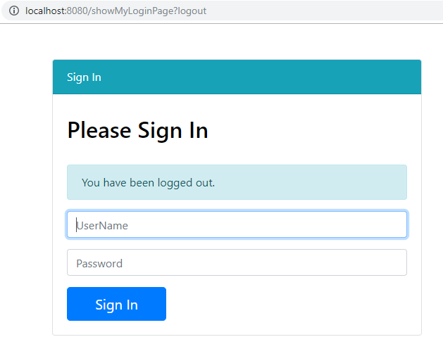

* **Login as Admin– As an Admin. An Admin can perform following activities.**
  + Can Login
  + Can view comments of all other user.
  + Can approve / cancel other users comment.
  + Can add comment.
  + Can logout

Screen shots for demo purpose.

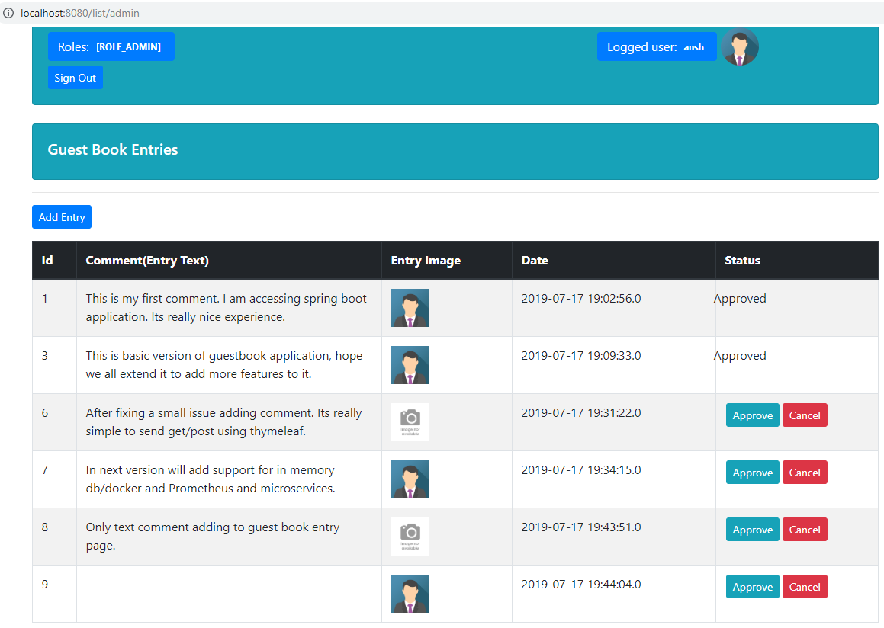

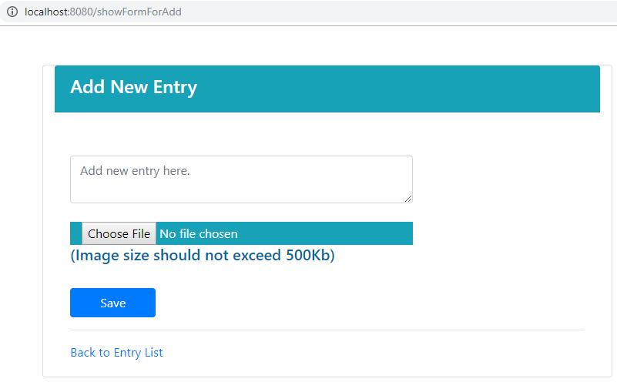

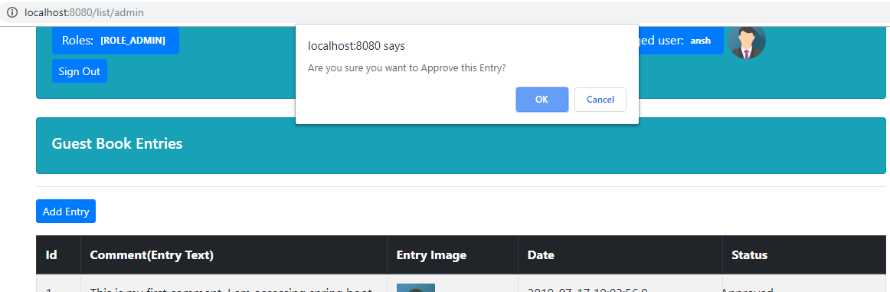

* **Login as User and doesn’t have any role assigned to him. Will redirect to access –denied page.**
  + Can login but redirected to access-denied page.
  + Can logout.

