Azure API Publish + APIM Step-by-Step Guide

Step 1
Open Visual Studio, create a new ASP.NET Core Web API project, build the controller endpoints, and verify it runs locally.

Step 2
Right-click the project and choose Publish. Select Azure as the target and choose Azure App Service (Windows).

Step 3
Create a new App Service: choose subscription, resource group, app name, runtime stack, region, and App Service Plan.

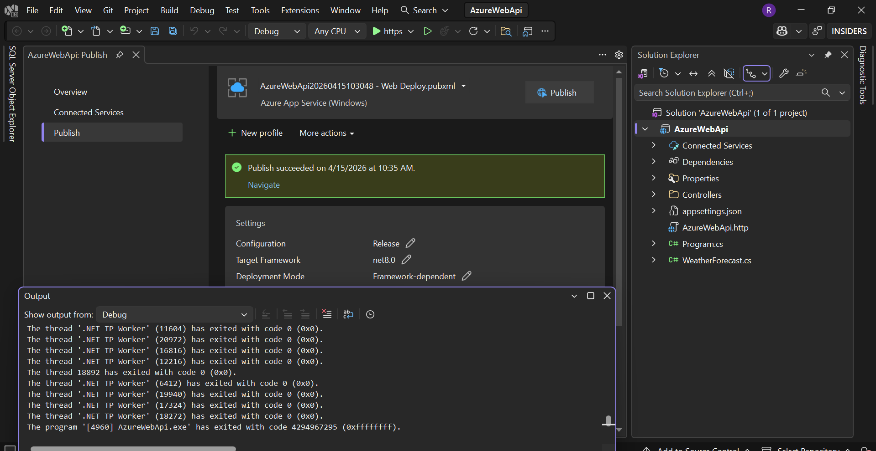

Step 4
Click Finish and then Publish. Wait for deployment to complete and verify the live Web App URL opens successfully.
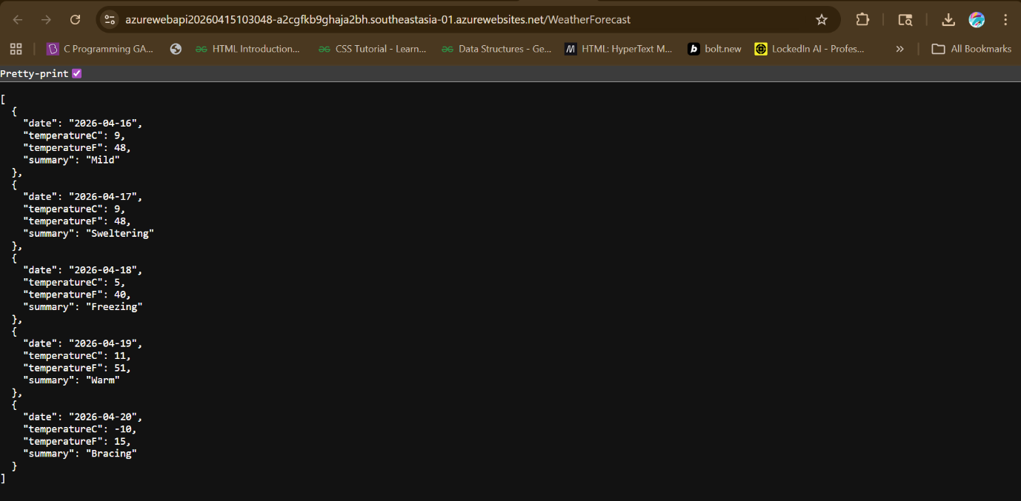
Step:5 Created Resource Group .
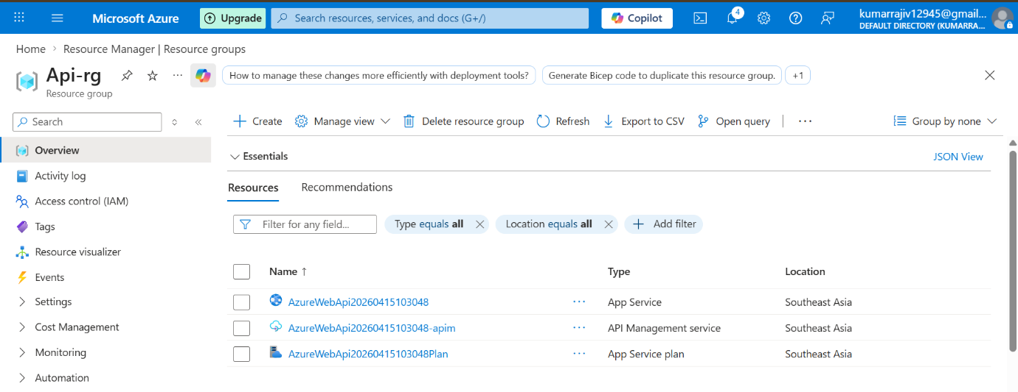

Step 6
Created API Management.

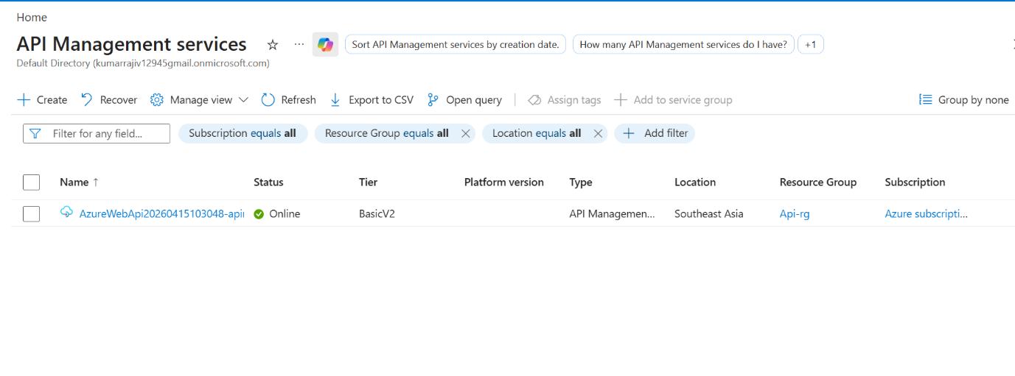

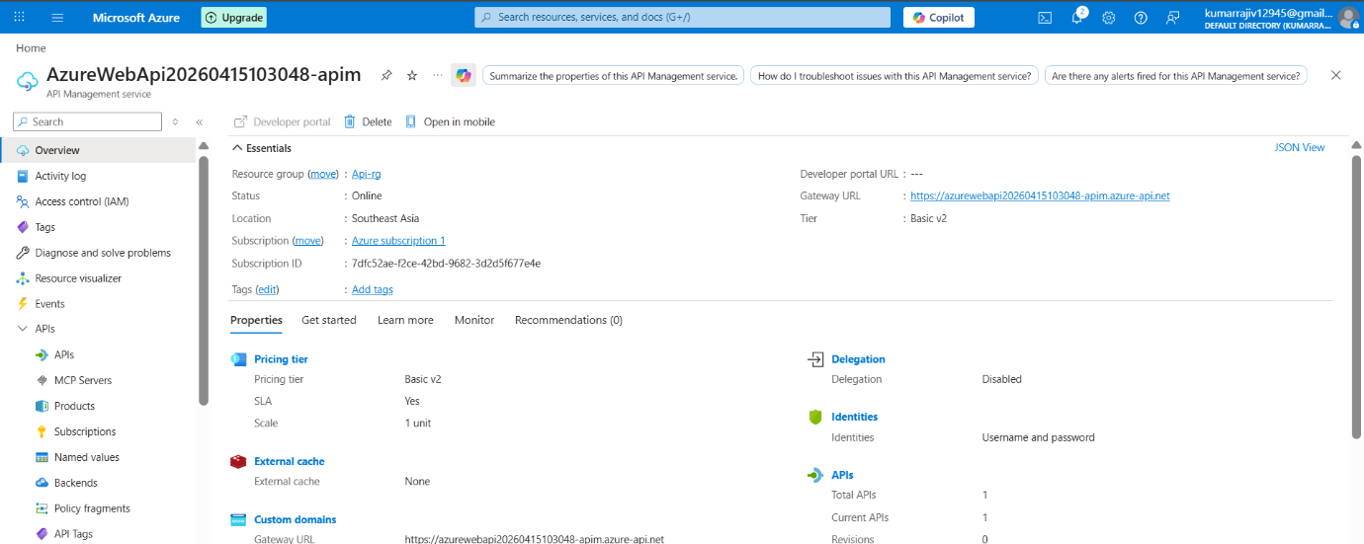

Step 7
After provisioning, import the published Web API into APIM so controllers/actions appear as API operations.

Step 8
Open Azure Portal → API Management → APIs and verify your imported API, routes, backend URL, and revisions. 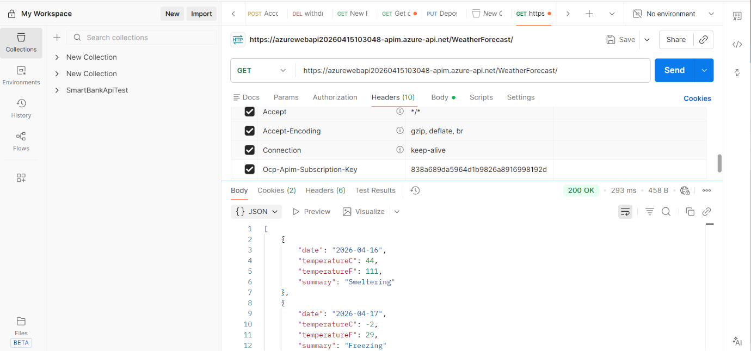

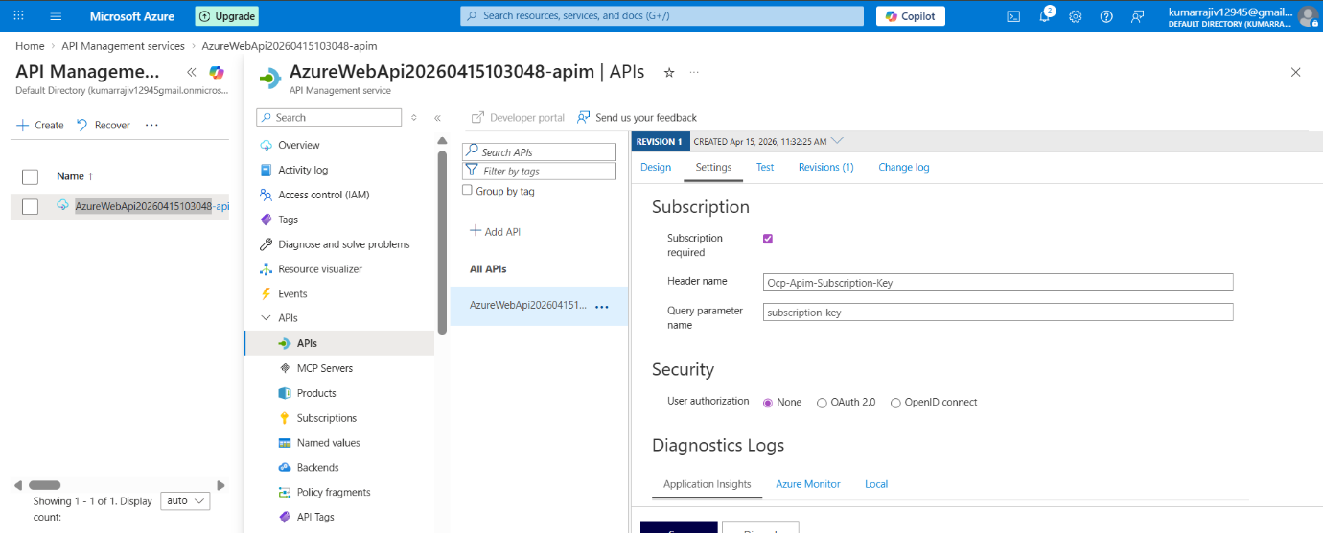

Step 9
Test the endpoint from APIM Test tab. First test without subscription key, then enable subscription requirement and test with the Ocp-Apim-Subscription-Key header.
Call URL and check on azure Api management -METRICS.
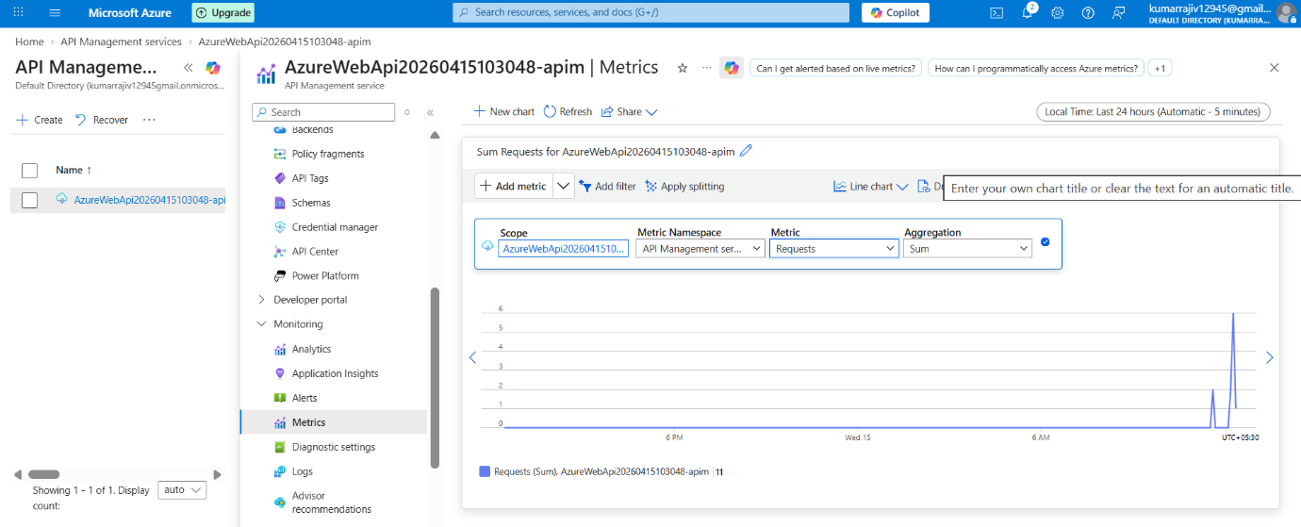

Step 10
Apply inbound policy such as rate-limit-by-key (e.g., 5 calls/minute), save, and test throttling behavior from APIM.
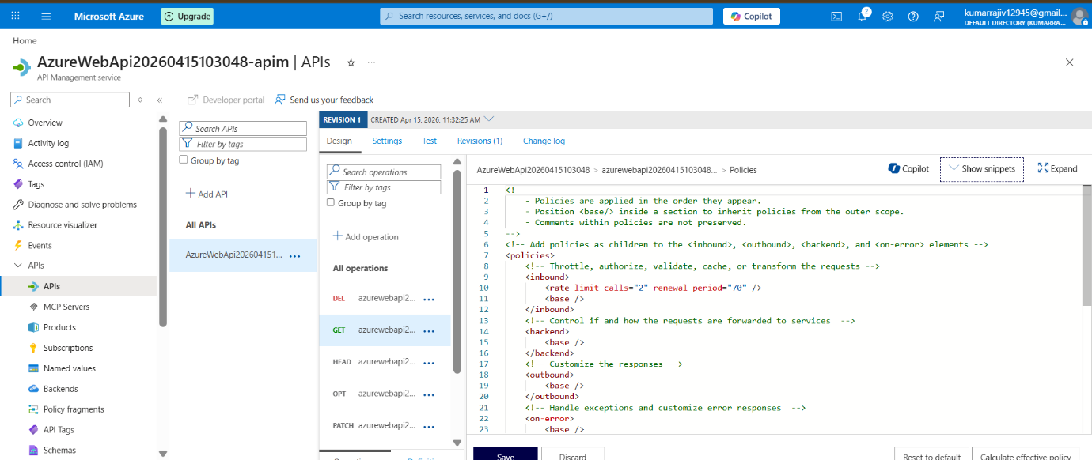
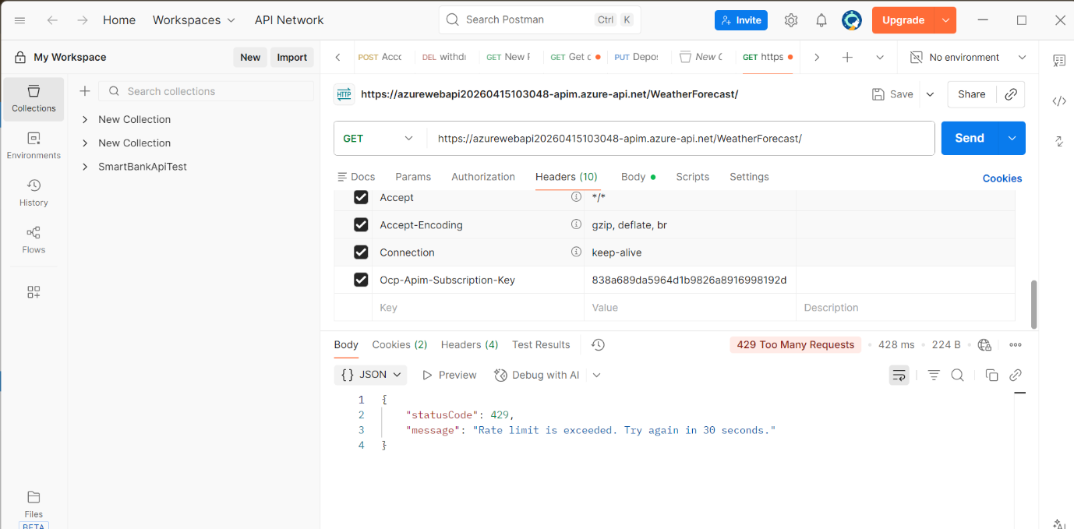

Post-Publish Validation Checklist
- Web App URL returns Swagger/API response
- APIM API appears under APIs blade
- Test tab returns 200 OK
- Subscription key enforcement works
- Rate limiting returns 429 after threshold

