Congratulatory letter from Tony Ridder, Chairman and CEO, Knight Ridder
(Published with permission.)
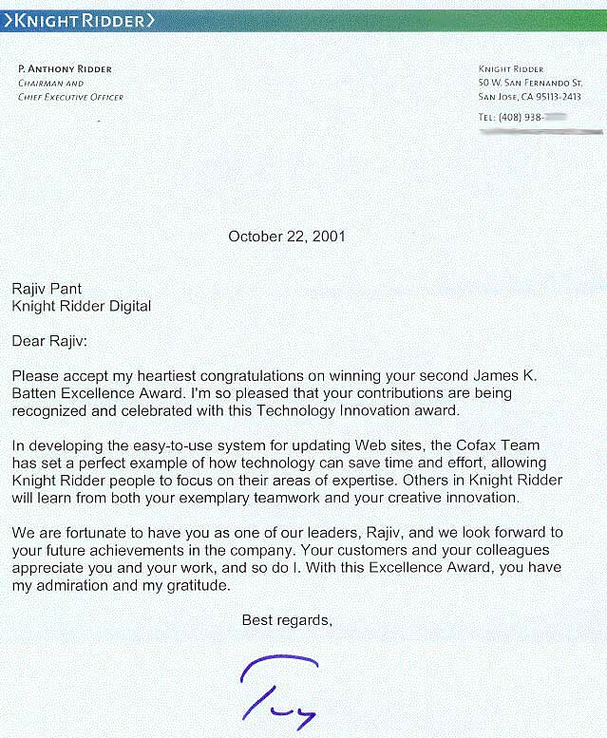
Reference letter from Steve Rossi, President, Newspaper Division, Knight Ridder
(Published with permission.)
December 16, 2003
To Whom It May Concern:
I have personally known Rajiv Pant to be an outstanding professional since 1995 when he started working at Philadelphia Newspapers. I watched his career and accomplishments as he grew from programmer to manager, director and vice president of engineering over a short period of six years. Over the years, he has built a reputation as a highly respected technologist and expert problem solver.
Rajiv did not limit his scope to his own department, but was a technology consultant to the entire company. People from other departments and offices regularly requested his help. His strong desire for helping others and helping the company were exemplary. While he helped others be successful, his work within his own department never suffered as he led several successful projects.
Rajiv has superior interpersonal and communication skills. He gets along extremely well with employees across the organization. He is highly respected and liked, as both a person and a professional, by senior management, colleagues, employees, suppliers, and customers alike. His ability to work well with others and win people over has helped him solve problems and get things done that seemed insurmountable. People know him as a go-to problem solver who makes effective use of technology. Rajiv was awarded the prestigious Knight Ridder Excellence Award twice in his career.
From early on in his career, Rajiv showed great leadership skills. He would take charge of a challenge until all the issues were resolved and customers satisfied. People liked working with him, and I frequently heard good things about how he helped them succeed. He has shown the ability to quickly gain a solid understanding of the business and customer needs, and how to get things done quickly and effectively. He has repeatedly demonstrated a good vision for the future in strategies and products.
Rajiv is a resourceful, creative, and solution-oriented person who is frequently able to come up with new and innovative ideas and solutions. He is both a good leader and a follower. He is an exceptional technologist, leader, manager, businessperson and worker all in one.
When Rajiv decided to start a consulting practice, I was saddened to see him leave. I wish him the greatest success in his new undertaking. His presence, both as a person and as an exemplary employee, will always be missed here.
Steve Rossi
President, Newspaper Division
Knight Ridder
Reference letter from Fred Mann; former VP, National Programming and Regional VP, Knight Ridder Digital; GM, Philly.com
(Published with permission.)
April 25, 2006
To Whom It May Concern:
In my long career as a journalist, and digital media manager, I have learned that hiring the right people is probably the single most important accomplishment an executive can make. Find great talent, nurture it, let it bloom and then try to keep it – that was my strategy. (And I must say, it was a recipe that worked … and brought a great deal of reflected glory and success to me personally.)
In my three decades of journalism management, the last 11 years spent starting and running the Philly.com website for Knight Ridder, I have made no hire more important or successful than that of Rajiv Pant. I was lucky enough to find Rajiv back in 1995, when both he and the Internet were young. Brought in as a software developer, he showed brilliant technical and programming skills, as well as a strategic maturity that belied his age. Within a couple of months, he was practically running the place, and the publisher of The Philadelphia Inquirer was calling him in for chats about new online publishing ideas. Another boss might have been threatened. But I had enough sense to see that Rajiv could help me grow my business both tactically and strategically. Philly.com became an early leader among newspaper websites, and much as I enjoyed taking the credit, I knew where the real credit lay.
After more than five years in Philadelphia and the development of many unique and creative online publishing successes, I proudly recommended Rajiv to Knight Ridder Digital’s headquarters office in California for promotion to network-wide responsibilities. At KRD, his technical expertise and project management skills were greatly prized. And his ability to lead a team of people was fully recognized. The situation at KRD was not an easy one; there was no shortage of aggressive would-be leaders vying for dominance in a quickly growing company. Many were either very talented, or were very good at pretending to be. It was a politically-charged environment, not easy to navigate. But through it all, Rajiv’s quiet strength and resolve made him stand out. Throughout the company, people knew that Rajiv was smart, approachable, loyal and dedicated. Plus they just plain liked him and liked working for him. It’s a rare treat to find someone who has his talents who is also a truly nice guy. His staff trusted his judgment in large part because it was always based on both a wealth of technical knowledge and a clear desire to do what was right for the company and its people.
After he left Knight Ridder, I no longer worked directly with Rajiv. But I have followed his career with great interest. I could not be more proud of his successes, or of the fact that he continues to be so highly regarded in digital media circles. Sadly, I can no longer steal any credit from his successes. But I take great joy in seeing how fully his great potential has been realized. I count him as both my greatest hire and as a true friend. I would be happy to discuss Rajiv and his work with you if that would be of further help.
Fred Mann
Fred Mann was formerly Vice President, National Programming, and Regional Vice President, Knight Ridder Digital and General Manager, Philly.com. He was Rajiv’s boss for 5+ years.
Reference letter from Robin Palley, Vice President, Marketing & Communications, Big Brothers Big Sisters of America
(Published with permission.)
March. 8, 2004
To whom it may concern:
It is a pleasure to talk about Rajiv Pant.
It is rare to meet someone who combines the breadth of engineering skills Rajiv brings to the table with great political skills and a solid comprehension of business process and business goals.
Best of all, Rajiv's unshakeable steady manner and his winning personality make strangers into friends, even in the heat of workplace crisis situations where he is adept at applying cross-functional approaches to delivering robust solutions on tight deadlines.
I have had the privilege of working closely with Rajiv quite a bit of the years in my positions as vice president of Marketing & Communications at Big Brothers Big Sisters of America, vice president of Global eBusiness at GlaxoSmithKline, senior vice president of WebMD Health, and an editor and then health editor of Philadelphia Online (web home of the Philadelphia Inquirer and Daily News). Our work together has spanned online publishing solutions, content management systems, and general problem-solving on deadline.
Rajiv brings mature solid leadership and business-focused problem-solving to everything he approaches. He is that rare breed of engineer / businessman who doesn't just say “Write me a specification and send it along.” Instead (maybe from his years around reporters), he sits with the “customer” for the project and asks enough questions to thoroughly understand the goal. Then he lays out possible approaches to the solution and collaboratively (to the business owner of the project) and picks the most effective and flexible path. As a side benefit, as I served as business lead on many projects with Rajiv, he has taught me enough about the conceptual framework of technologies I work with that I can work easily with other programmers, IT team leaders and consultants.
His solutions are informed by understanding of where the business is going and what the demands on software and technology will be in the future. And by his vision on the new directions technologies are making available and how “ripe” new technologies are. Whether he's approaching conceptual solutions, programming, configuring or ordering hardware, Rajiv isn't just designing for today. He's looking at current and future needs and designing for them – educating his business customer about the practical pros and cons of each approach.
Most recently, Rajiv delivered extraordinary service in the wee hours of a cold January night to the national office of Big Brothers Big Sisters of America -- and to the children we serve. The organization had spent months preparing for the launch of its new website and Centennial Year Celebration. The launch plan was heavily tied to a new partnership with Yahoo! that would give BBBSA the front page of Yahoo!, with its 143 million impressions, for a critical 24 hour period. The date and time of launch were fixed with no chance of rescheduling.
But three hours before the site was to go live, disaster struck. The site was down. And no one really knew the whole scope of “why”. Our organization's national IT team along with representatives of many of our vendors – from ISP to CMS, web hosting, et al – all were working on diagnosis. But despite the deep skills and good intentions of all, the situation felt like a circular firing squad. Effort and blame splattered everywhere, but the complex and thorny issues were not yielding to any of the proposed solutions. As the minutes crept by and the crisis deepened, the BBBSA management team worried that the opportunity would be lost. New ideas thinned down. Minutes ticked by. Tempers grew short, and we moved into the wee hours of the morning.
That's when I remembered to call Rajiv.
Within five minutes on the call, he had calmed down the rest of the frazzled team and begun teasing the problem apart. He listened in turn to each of the United Nations of participants on our 3-hour conference call, undaunted by the multiplicity of accents and sheer number of different perspectives on what might be happening (and by the fact that many of the players were already “dug in” on their own theories). He asked careful diagnostic questions, gently challenged assumptions with probes. Listened carefully before he spoke. Knew when to crack a joke to ease the tension.
He quickly earned the respect of all and convinced all the strangers of his leadership. And his sense of humor and ease settled the grumpy rousted-from-sleep crowd and brought straight-line focus to the issues at hand. Each time the team effort led to a wall, he had a new angle to try. On the way through the thicket, he articulated three different fall-back positions in case Plan A didn't work. But in the end, they weren't needed. He kept at it until the site went live.
When our site appeared on the front of Yahoo! and generated 11,000 new volunteers to be Big Brothers and Big Sisters, the national organization on behalf of our 500 local agencies had Rajiv to thank.
And for Rajiv, that's not an extraordinary moment. It's just the way he works. I think he figures the really hard problems are brain candy. When my colleagues asked how on earth I'd persuaded him to help and to stay with it when things looked really messy, I could honestly answer that Rajiv would always willingly, helpfully, jump into the fray. And he's especially delighted to hang on until done when the problem at hand is really, really challenging and requires out-of-the-box solutions.
Rajiv brings a special combination of maturity and innovativeness to his work. He has enthusiasm for supporting the visions and plans of others but also the ability to opportunistically see and explain the places where technology can make business process more efficient or more effective.
In short, Rajiv is mature beyond his years, thoughtful, steady, likeable, a collaborative player, cheerful, willing and skilled.
He'd make a great addition to any team.
Robin Palley
Vice President, Marketing & Communications
Big Brothers Big Sisters of America
www.bigbrothersbigsisters.org
Reference letter from Ken Doctor, VP/Content Services, Knight Ridder Digital
(Published with permission.)
Feb. 22, 2004
Letter of Reference
Re: Rajiv Pant
From: Ken Doctor, VP/Content Services, Knight Ridder Digital
Few people elicit great enthusiasm from reference writers. In my now-30-year-career in journalism, I can count those on just several hands. Rajiv Pant, happily, is one of those.
HR professionals, or baseball managers, would tell you that Rajiv has a full set of tools. He’s already deployed those tools well, as a pioneer, an innovator, a survivor and a very good human being.
I first met Rajiv at some online conference somewhere about six years ago. He immediately impresses, with his intelligence, his enthusiasm and his natural courtesy. These are traits that I found to be consistent and growing, as we first worked long-distance, he in Philadelphia and I in San Jose, for the then-nascent Knight Ridder online operations.
In a field in which many “techies” could quickly overwhelm the non-techies with jargon, or make the simplest problem an unbelievable complexity, Rajiv stood out. He combines a techie’s love of how things work, with an entrepreneur’s love of how they could work. Importantly, he’s a collaborator by instinct as well, helping others – whether colleagues in the hierarchy, subordinates or superiors – bring their ideas to life, describing options to bringing those ideas to fruition.
I believe his resume speaks for itself, in the breadth of projects he’s taken on and led, from Philadelphia’s publishing and entertainment systems to Knight Ridder’s own digital publishing solutions. What further stands out in my mind is that in the midst of such accomplishments, he knows how to make time for the ideas of others, or for such projects as creating a prototypical KR toolbar on the weekend, for “fun.”
It’s hard to figure out or suggest a career path for him. His expertise, already extends both to core print publishing operations and to digital ones. Importantly, my work on the digital side (after 20+ in print) has taught me that it is the marriage of such systems that is the future of publishing. The courtship has begun, and it hasn’t been pretty. It will continue for years, and Rajiv’s experience positions him well for the many challenges involved. Further, he would bring more purely “digital” companies the accumulated experience of those experienced in the content world.
At the same time, I hope that Rajiv’s natural leadership skills are nurtured as well. He works well with people and I believe he’ll be able to lead larger and more complex teams as he takes on further challenges.
I can give the rarest reference – hire him, before someone else does – and offer any further view you may require.
Ken Doctor
References for Rajiv on LinkedIn.com
From Kim Marcille, Vice President, Circulation, The Miami Herald Newspaper
“Rajiv and I worked together at Knight Ridder Digital. The platform for Knight Ridder's network of websites is built on Rajiv's original Cofax platform. That's quite an accomplishment! He's very quick to understand requirements and believes that everything is possible. Rajiv is very customer service-oriented, always friendly, and a fun person to have around. I highly recommend him! --K.” (September 16, 2005)

From Dan Finnigan, Senior Vice President, Yahoo & GM of Yahoo HotJobs (former President and CEO, Knight Ridder Digital)
“Rajiv is very bright, hard-working, creative and passionate about his enginerring and development work on the internet. Rajiv never wants to do things the way they have already been done, Rajiv has always been top engineer in non-tech companies, requiring him to figure out how to get to the goal on his own. That is perhaps Rajiv's greatest strength - his resourcefulness and self-reliance.” (April 24, 2005)

From Shannon Kinney, former Senior Director, Product Development, Knight Ridder Digital
“I managed Product Development at KRD and looked to Rajiv to help me find innovative solutions to our business goals and objectives, and was continually impressed by his ability to see the market trends and our requirements and create technical solutions for them.” (November 18, 2005)

From Ches Wajda, former Design Director, Philly.com, Knight Ridder Digital
“Rajiv already was at legendary status when I arrived at Philly.com (while still a full-time student at Temple, he wrote the application that converted ATEX to HTML -- something thought near-impossible). In my own experience with him, I found Rajiv to be a willing parter in my efforts to update the look of the product. "Yes, that is no problem," was the common reply from Rajiv.” (September 27, 2004)

From Patrick Burke, former Sr. Manager, Product, at a major media company
“Rajiv works well in a rapidly evolving, high-demand environment. He has more than 10 major stakeholders to keep happy, each with their own unique sense of urgency. He is responsible not only for the development of new technology, but continued support for the dozens of live products in production for a growing network of media web sites. He leads his team with skill and compassion.” (February 22, 2006)

Congratulatory letter from Cox on being selected for inclusion in the 2005 Annual Report
