

INVESTMENT BUSINESS PLAN
SocialHomes.Ai
AI-Native Housing Management for UK Social Housing
From Small HAs to the G15 — A 10-Year Growth Strategy

Prepared by: Rajiv Peter, Yantra Works Ltd
Website: yantra.works
Date: March 2026
Version: 3.0
Classification: COMMERCIALLY SENSITIVE & CONFIDENTIAL

Contents
1. Executive Summary
2. Market Overview: UK Social Housing
3. The Problem: Why Providers Need a New Approach
4. The Regulatory Burning Platform
5. The Solution: SocialHomes.Ai
6. What's Built vs What's Needed (Honest 50-55% Assessment)
7. Product Roadmap & Differentiators
8. AI Strategy: Flexible, Multi-Model Intelligence
9. Competitive Landscape
10. Business Model & Pricing (5 Tiers)
11. Go-to-Market: From Small HAs to the G15
12. Financial Projections — 3-Year Detailed (40% Gross Margin from Y4)
13. Financial Projections — 10-Year Growth (£100M Valuation by Year 6)
14. Team & Resourcing (Scales with Revenue)
15. Minimum Viable Budget Scenario
16. Risk Analysis
17. Comparable Companies & Exit Scenarios
18. Investment Ask (£250k for a £100M+ Opportunity)
19. Key Milestones
Appendix A: About Yantra Works Ltd
Appendix B: Glossary for Non-Housing Readers
Appendix C: Sources & References

1. Why SocialHomes.Ai?

The Problem in One Sentence
A two-year-old boy called Awaab Ishak died because his housing association's systems were so poor that three years of mould complaints were lost in paperwork. SocialHomes.Ai exists to make sure that never happens again.
The UK social housing sector manages 4.5 million homes for 9 million people. It is regulated by four new laws introduced since 2023, each demanding better data, faster response times, and real accountability. Yet 80% of the sector's technology was designed in the 1990s. Smaller housing associations — the ones closest to their communities — are priced out of modern systems, paying £50,000–£100,000 per year for software that wasn't built for them.

What Makes This Different
It's AI-native, not AI-bolted-on. Every existing housing system was built before AI existed. They bolt AI on as an expensive add-on module. SocialHomes.Ai weaves intelligence into every screen: it tells housing officers which tenants are at risk BEFORE they fall into crisis, which repairs will recur, and which complaints are heading to the Ombudsman.
It's built for small providers, not enterprise leftovers. Civica, NEC, and MRI built their products for organisations managing 30,000+ homes. Smaller providers get the same software with features stripped out, at prices they can barely afford. SocialHomes.Ai is designed from the ground up for the 1,000–5,000 home segment — then scales upward.
Self-service onboarding — no other vendor does this. Traditional HMS implementations take 6–18 months and cost £50,000–£200,000. SocialHomes.Ai will offer guided self-service data import, automatic provisioning, and a go-live timeline measured in weeks, not years. This removes the single biggest barrier to switching.
It combines public data with organisational data. The system automatically pulls weather forecasts, EPC ratings, flood risk, deprivation data, and crime statistics — and combines them with each organisation's own records. A housing officer opening a property record sees not just the tenancy and repairs history, but the damp risk based on tonight's weather, the area deprivation score, and whether the building's gas certificate is about to expire.
It costs 50–70% less. For a 2,500-home housing association: £20,000/year instead of £55,000–£66,000. The savings go directly back into housing and services.

The Social Impact
Better housing systems save lives. When a housing association can see that a vulnerable tenant hasn't been in contact for six months, it can send a welfare check before a crisis. When damp and mould complaints are tracked with legally mandated timers (Awaab's Law), children grow up in healthier homes. When AI predicts which properties need maintenance before they fail, emergency repairs drop and tenant satisfaction rises. This is not just a technology business — it is a direct intervention in the quality of life for millions of people in social housing.

The Business Opportunity
Market | 1,581 housing providers managing 4.5M homes (£27.4bn sector turnover)
Target segment | ~400 providers with 1,000–30,000 homes — underserved by incumbents
Regulatory driver | 4 new laws since 2023 (Awaab's Law, TSMs, Ombudsman Code, RSH inspections)
Strategy | Start small (consortium of 10 HAs), prove product, expand to mid-market, then enterprise
Year 3 revenue | £720,000 (breakeven year — first mid-market sales)
Year 6 target | £12.5M ARR — £100M valuation at 8x revenue
Year 10 target | £32.4M ARR — 242 customers across all segments
Investment sought | £250,000 — founder-led build with sales from Year 2. Profitable Year 3.

Financial Summary

10-Year Customer Growth by Segment

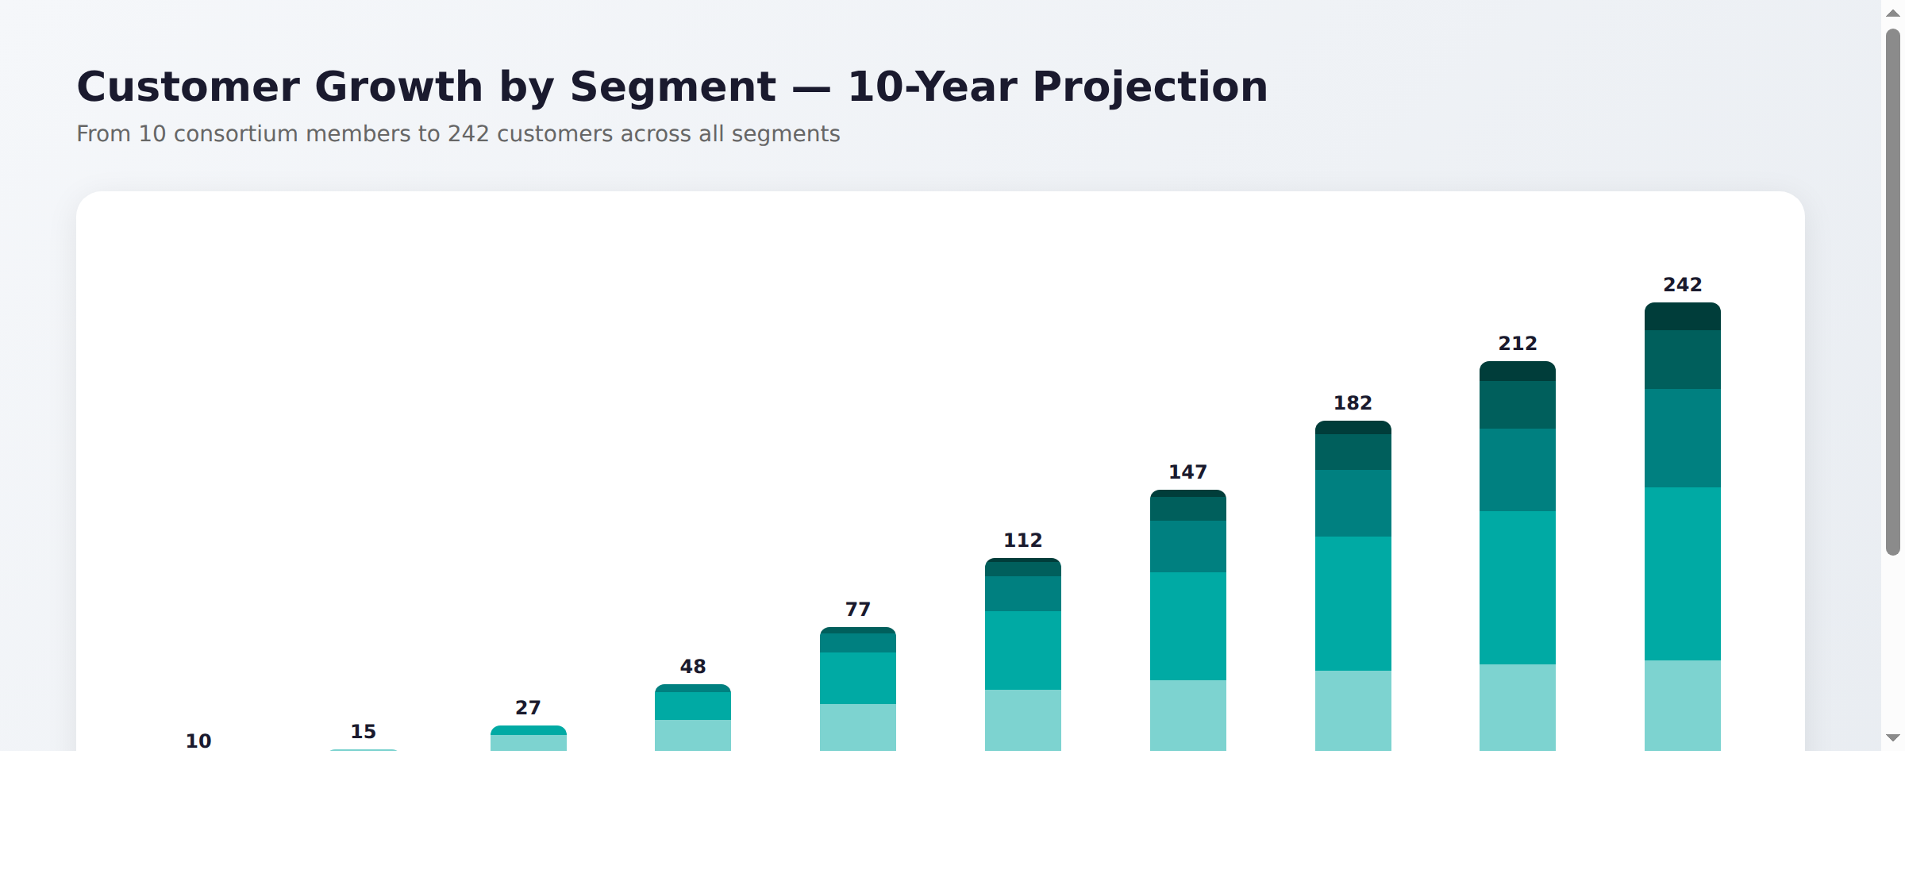

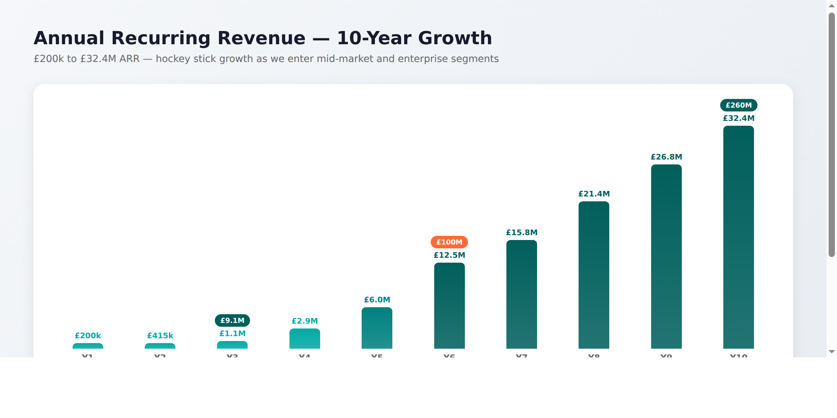

Year | Headcount | Total Costs | Revenue | Net Profit / (Loss)
Y1 (FY 26/27) | 5 + testing co | £375k | £200k | (£175k)
Y2 (FY 27/28) | 7 | £490k | £280k | (£210k)
Y3 (FY 28/29) | 12 | £750k | £720k | (£30k) ~breakeven
Y4 | 18 | £1.1M | £1.66M | +£560k
Y5 | 25 | £1.8M | £3.39M | +£1.59M
Y6 | 35 | £2.8M | £5.94M | +£3.14M
Y7 | 50 | £4.2M | £9.51M | +£5.31M
Y8 | 65 | £5.8M | £13.76M | +£7.96M
Y9 | 80 | £7.2M | £18.26M | +£11.06M
Y10 | 95 | £8.5M | £24.46M | +£15.96M

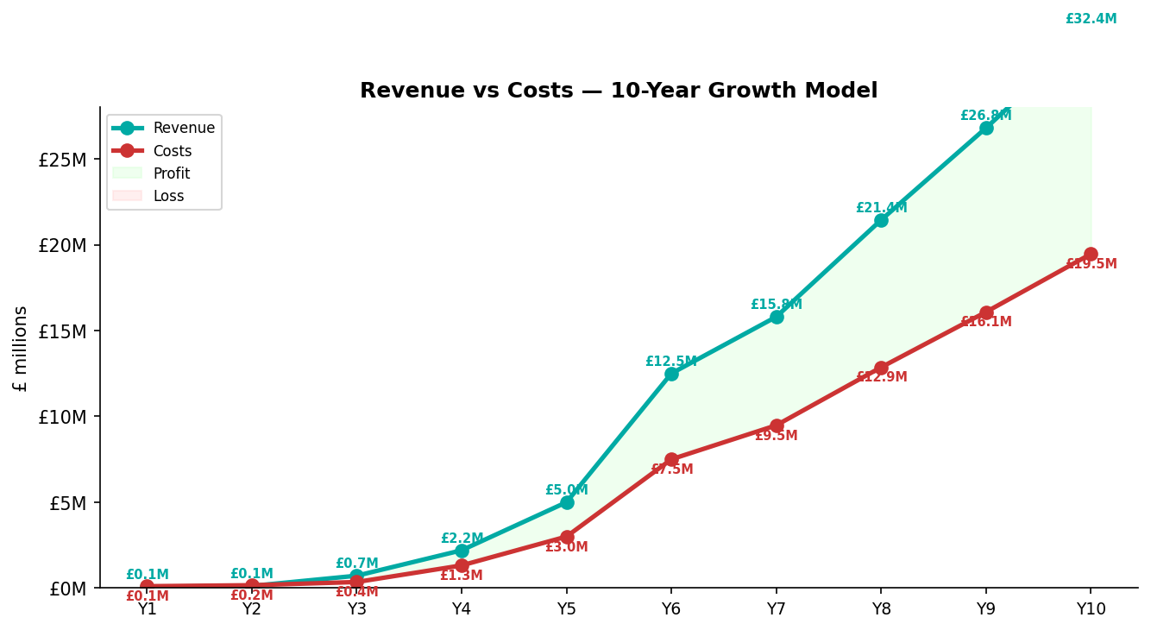

Cumulative profit through 10 years: approximately £45M. Investment recovered in Year 4. By Year 10: 242 customers, £32.4M ARR, 95 employees, and a platform serving the entire UK social housing market from small HAs to the G15.

2. Market Overview: UK Social Housing
This section provides context for readers unfamiliar with the UK social housing sector.

What is Social Housing?
Social housing is subsidised rental accommodation provided by two types of organisation in England:
- Housing associations (also called Registered Providers or RPs) — not-for-profit organisations that own and manage social housing. There are 1,353 private registered providers in England.
- Local authorities (councils) — 228 local authorities are registered with the Regulator of Social Housing, of which approximately 143 still directly own and manage council housing stock.
Together, they manage approximately 4.5 million homes across England, housing roughly 9 million people — around 17% of all households. The sector has a combined annual turnover of £27.4 billion.
Source: RSH Statistical Data Return 2024-25, RSH Global Accounts 2025

Market Segmentation
The sector is highly concentrated: the 19 largest providers manage 42% of all stock and generate 47% of sector turnover. However, 83% of all private registered providers manage fewer than 1,000 homes. Our go-to-market strategy targets progressively larger segments over a 10-year period:

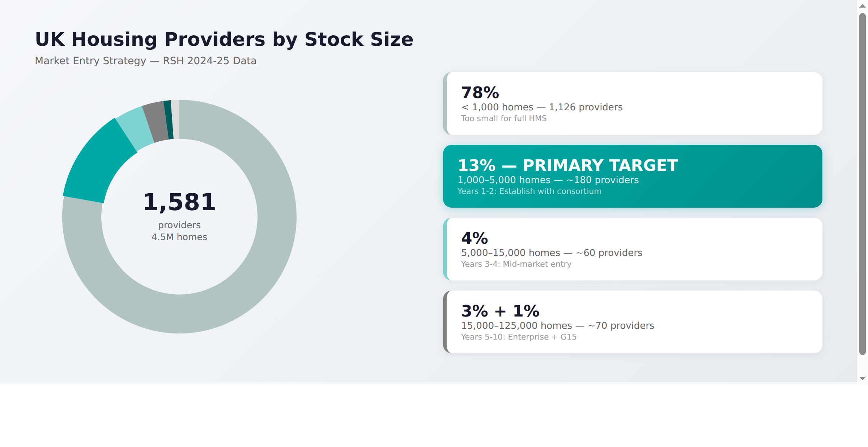

Segment | Providers | % of Total | Our Entry Window
< 1,000 homes | ~1,126 | 79% | Too small for full HMS
1,000 – 5,000 homes | ~180 | 13% | YEARS 1–2: Primary target — prove the product
5,000 – 15,000 homes | ~60 | 4% | YEARS 3–4: Mid-market — where the real revenue is
15,000 – 50,000 homes | ~50 | 3% | YEARS 5–7: Large providers with bigger contracts
50,000+ homes (G15) | ~20 | 1% | YEARS 6–10: G15 members — £500k+/yr contracts

The G15 Opportunity
The G15 are London's 15 largest housing associations, collectively managing over 800,000 homes. They represent the pinnacle of the market and are the ultimate validation for any HMS vendor. Key G15 members include:
G15 Member | Homes Managed | Annual Turnover
Clarion Housing Group | ~125,000 | £824M
Peabody | ~108,000 | £1.1B
L&Q | ~105,000 | £995M
Notting Hill Genesis | ~68,000 | £748M
Hyde Group | ~44,000 | £382M
Network Homes | ~20,000 | £206M
These organisations currently pay £500k–£2M+ per year for HMS solutions. Even capturing 10 G15/mega provider contracts at £500k/yr by Year 10 adds £5M ARR — and validates the platform for the entire sector.
Source: G15 member annual reports, RSH Global Accounts 2025, Housing Today Largest 50 2025

Local Authority Housing
Approximately 143 local authorities in England still directly own and manage council housing, collectively owning over 1.4 million homes. Many smaller councils face the same challenges as housing associations. The number of ALMOs has fallen from 65 to just 19, as councils take management back in-house — increasing the need for cost-effective modern HMS solutions.
Source: ARCH Housing, RSH 2024-25, LGA

Total Addressable Market
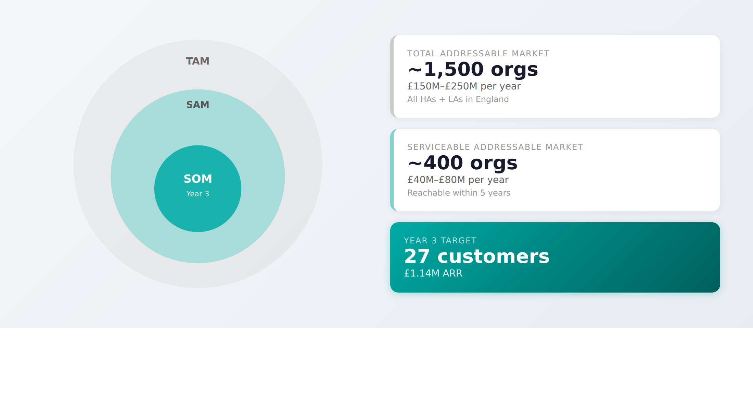
Market Layer | Organisations | Annual Value
TAM (Total Addressable Market) | ~1,500 (all HAs + LAs) | £150M – £250M/year
SAM (Serviceable Addressable Market) | ~400 (reachable within 5 years) | £40M – £80M/year
SOM (Serviceable Obtainable Market, Year 3) | 24 customers | £720k ARR

3. The Problem: Why Providers Need a New Approach
The regulatory, compliance, and operational demands on housing providers have never been greater. Yet most systems housing associations use to manage these obligations were designed in the 1990s and 2000s.

What Providers Currently Pay
HMS costs vary dramatically by provider size. The table below shows typical costs across market segments:
Provider Size | Typical Annual HMS Cost | Typical Implementation
Small (1,000–5,000 homes) | £40,000 – £100,000/yr | £15,000 – £30,000
Mid-market (5,000–15,000 homes) | £100,000 – £250,000/yr | £40,000 – £80,000
Large (15,000–30,000 homes) | £200,000 – £500,000/yr | £80,000 – £200,000
Enterprise (30,000–50,000 homes) | £400,000 – £800,000/yr | £150,000 – £500,000
G15/Mega (50,000–125,000 homes) | £500,000 – £2,000,000+/yr | £500,000 – £2,000,000+
Source: Sector benchmarks, Find a Tender Service, procurement data, provider feedback.

SocialHomes.Ai undercuts every segment by 50–75% — and delivers more AI capability than any incumbent.

The Gap in the Market
Current Option | Challenge
Enterprise HMS (Civica, NEC, MRI, Aareon) | Overpriced. Designed for 10,000+ home providers. AI bolted on as an afterthought. 30-year-old architectures.
Budget HMS or spreadsheets | Cannot reliably meet Awaab's Law, TSM, Complaint Handling Code, or RSH Consumer Standards. Regulatory risk.
Build your own | Too complex, expensive, and risky for any single organisation. No recent success stories.
SocialHomes.Ai | Modern, AI-native, built for every segment. 5 pricing tiers. Consortium-governed.

Legacy System Characteristics
The sector's dominant systems share common problems:
- Client-server architecture designed before cloud computing — slow, forms-heavy, not mobile-friendly
- AI treated as an optional bolt-on module at additional cost, not integrated into workflows
- Proprietary APIs and restrictive commercial contracts that make integration difficult
- Data silos that contribute to regulatory failures — over 80% of regulatory downgrades cite data management issues
- NEC OHMS (Oracle-based) has announced end-of-life with de-support after March 2026, forcing migration

4. The Regulatory Burning Platform
Four major regulatory changes since 2023 are creating urgent, non-optional demand for better housing management systems. These are not aspirational improvements — they are legal requirements with enforcement powers including unlimited fines.

4.1 Awaab's Law (From October 2025)
Named after Awaab Ishak, a two-year-old who died in December 2020 from a severe respiratory condition caused by prolonged mould exposure in his Rochdale social housing home. His family had complained for three years without adequate response.
Awaab's Law introduces legally binding response timescales:
Requirement | Timescale
Investigation of reported hazards | 10 working days
Written summary to tenant after investigation | 3 working days
Emergency hazard response | 24 hours
Begin safety repair work | 5 working days after investigation
Long-stop for supplementary/preventative work | 12 weeks

Phased rollout: Phase 1 (October 2025) covers damp, mould, and emergency hazards. Phase 2 (2026) adds excess cold/heat, falls, fire, and electrical hazards. Phase 3 (2027) covers all remaining HHSRS hazards. The RSH can impose unlimited fines (cap removed by the 2023 Act), issue enforcement notices, and authorise emergency remedial action at the landlord's expense.
Source: GOV.UK Awaab's Law Guidance, Social Housing (Regulation) Act 2023

4.2 Tenant Satisfaction Measures (From April 2023)
22 mandatory measures (12 perception-based, 10 management data) that all providers with 1,000+ homes must collect and report annually to the RSH. The 2024-25 headline results from 360 large landlords show:
TSM Measure | 2024-25 Result
Overall tenant satisfaction (rental) | 71.8% median
Home safety | 77.6%
Fair treatment | 77.9%
Complaint handling satisfaction | 35.5% (lowest score)
Gas safety compliance | 99.7%
Non-emergency repairs within target | 79.0%
Source: RSH TSM 2024-25 Headline Report

4.3 Housing Ombudsman Complaint Handling Code (From April 2024)
Became statutory on 1 April 2024. All landlords must follow a two-stage complaints process with strict timescales (10 working days for Stage 1, 20 for Stage 2). In 2024-25, the Housing Ombudsman made 7,082 determinations (up 30% year-on-year), ordered £5.4 million in compensation, and issued 168 Complaint Handling Failure Orders.
Source: Housing Ombudsman Annual Complaints Review 2024-25

4.4 RSH Consumer Standards (From April 2024)
The Regulator of Social Housing began proactive consumer regulation inspections for all landlords with 1,000+ homes on a 4-year cycle. In the first year, at least 15 landlords received C3 gradings (serious failings). The RSH received 986 referrals in 2023-24, with 217 progressing to formal investigation.
Source: RSH Consumer Regulation Review 2023-24, GOV.UK

Key insight for investors: These regulations are not optional. Housing associations that cannot demonstrate compliance risk unlimited fines, regulatory intervention, and public censure. This creates a compulsory purchasing trigger — organisations must upgrade their systems regardless of budget constraints.

5. The Solution: SocialHomes.Ai
SocialHomes.Ai is an AI-native housing management system designed from the ground up for the entire UK social housing sector — from small housing associations to the G15. It combines modern cloud architecture with Anthropic's Claude AI to deliver intelligent, regulation-aware housing management at a fraction of incumbent costs.

Technology Stack
Layer | Technology
Frontend | React 19, TypeScript, Tailwind CSS 4
Backend | Node.js, Express, TypeScript
Database | Google Cloud Firestore (NoSQL, real-time sync)
Authentication | Firebase Authentication (Google SSO + email/password)
Hosting | Google Cloud Run (London, europe-west2)
Data Standard | HACT UK Housing Data Standard v3.5
AI Engine | Anthropic Claude (Sonnet 4 + Haiku 4.5) via API
Data Residency | UK only (London region)
Security | Google Cloud Armor WAF, TLS 1.3, AES-256 encryption at rest
Compliance | SOC 2 Type II (Google Cloud), ISO 27001 infrastructure, GDPR

Modules Designed
The following modules have been designed, with full UI/UX across 40+ screens. See Section 6 for an honest assessment of what is working versus what remains to be built.
Module | Screens | Key Features
Dashboard | 1 | 6 KPI cards, interactive charts, activity feed, persona-scoped
Daily Briefing | 1 | Personalised by role, weather-linked alerts, urgent cases
Tenancies | 3+ | Searchable lists, UC tracking, vulnerability flags, AI risk profiles
Properties | 3+ | Map view, EPC ratings, damp risk scoring, compliance RAG
Repairs | 3+ | SLA tracking, priority triage, AI first-time-fix estimation
Compliance | 3+ | Big 6 safety, Awaab's Law countdown timers, audit trail
Rent & Income | 2+ | AI-prioritised arrears worklist, payment tracking
Complaints | 2+ | Housing Ombudsman Code compliant, stage tracking, TSM metrics
ASB Cases | 2+ | Case management with full timelines
Communications | 2+ | GOV.UK Notify templates, AI analysis
Reports | 3+ | 30+ reports including TSM, CORE, RSH SDR, Board Packs
AI Centre | 2+ | Insights, predictions, conversational AI assistant
Admin | 10+ | Users, teams, GDPR, audit, workflows
Tenant Portal | 5+ | Self-service with action buttons
Explore / Map | 1 | Interactive Leaflet map with property markers
Allocations | 2+ | Voids and lettings management

6. What's Built vs What's Needed
Honest assessment: The prototype is 50–55% complete — substantially further along than a typical early-stage startup. The codebase has 157 API route endpoints across 23 route files, with backend WRITE operations already working for tenants, properties, cases, admin, lettings, and booking (real Firestore writes, not stubs).

What's Working (50–55% of Production Scope)
157 API route endpoints across 23 route files: A comprehensive REST API covering all major housing management domains. This is not scaffolding — these are implemented endpoints with validation, error handling, and Firestore integration.
Backend WRITE operations already exist: Real Firestore writes for tenants, properties, cases, admin, lettings, and booking. POST and PATCH methods are implemented and tested.
Frontend API client with POST/PATCH methods defined: The API client layer has methods defined for creating and updating records. The gap is mainly that some frontend forms don't call these existing methods — this is pattern-following work that AI agents excel at.
Full UI/UX across 40+ screens: Complete responsive design system with dark theme, Tailwind CSS 4, persona-scoped layouts for 5 roles. Every screen is navigable.
Awaab's Law countdown timer logic: Real calculations from repair data — not mockups. The countdown timers compute remaining working days against statutory timescales.
Authentication framework: Firebase Auth with JWT tokens, RBAC roles (Housing Officer, Manager, Director, Admin, Tenant). Login/logout works. Role-based route guards in place.
625 automated tests (architecture verified): 228 server tests (Vitest), 219 E2E tests, 203 accessibility tests. All passing.
CI/CD pipeline: GitHub Actions triggers Cloud Build, deploys to Cloud Run (europe-west2). Automated.
HACT v3.5 data schema defined: Firestore collections follow the UK Housing Data Standard. Clear target schema for data migration.

What AI Agents Can Build (80% of Remaining Work)
The Yantra Framework's 7-agent pipeline is specifically designed for the pattern-following work that makes up the bulk of the remaining development:
- Wire frontend forms to existing API endpoints — the API methods exist, forms just need connecting
- Add workflow state transitions — repair status progressions, complaint stage tracking, ASB case flow
- Implement multi-tenancy — org-scoping on Firestore queries (well-documented pattern)
- Connect Claude API for AI features — predictions, drafting, analysis, daily briefing
- Build remaining 28 reports — TSM, CORE, SDR, Board Packs with real data aggregation
- Complete admin CRUD — user management, team assignment, workflow configuration

What Humans Must Do (20% of Remaining Work)
Some work requires human expertise that cannot be delegated to AI agents:
- Independent QA testing company — functional testing, regression testing, UAT
- CREST penetration testing — security testing by certified ethical hackers
- Code review of AI-generated output — human oversight of every production commit
- Data migration from legacy HMS — understanding Civica/NEC/Aareon data models
- ISO 27001 implementation — information security management system
- Customer onboarding and training — HA-specific configuration, staff training

Why this matters: At 50–55% complete with real backend writes working, the remaining development is de-risked. An investor is funding the completion of a working system — not a speculative idea. The build risk is substantially lower than a typical seed investment.

7. Product Roadmap & Differentiators
Beyond the core HMS modules, SocialHomes.Ai will deliver features that no incumbent offers. These are designed to dramatically lower barriers to adoption and create deep product moats.

a) Self-Service Onboarding & Data Import (Year 2)
A guided self-service wizard for data migration from CSV, Excel, or direct API connection to legacy systems. Auto-mapping of fields to the HACT v3.5 standard with data validation, cleansing, and deduplication. No other HMS vendor offers fully hands-off self-service migration. This dramatically reduces implementation cost (from £15–75k to near-zero for small organisations) and enables rapid customer onboarding at scale.

b) One-Click Tenant Provisioning (Year 2)
Automated GCP project and Firestore instance creation per organisation. Each organisation gets a fully isolated database (not just collection scoping). Sign up → configure → import data → go live in days, not months. Infrastructure-as-code (Terraform/Pulumi) for repeatable provisioning. This is a significant competitive moat — incumbents take 6–18 months for implementation.

c) Payment Integration (Year 2-3)
Connect to GoCardless for Direct Debit mandate collection, Stripe for card payments, and Open Banking APIs for real-time balance verification. Universal Credit managed payment tracking via DWP API. Payment reconciliation dashboard with automated matching.

d) Embeddable Tenant Widgets (Year 2-3)
JavaScript widgets that organisations can embed on their own websites and portals: repair reporting, rent balance/payment, satisfaction surveys (feeding TSM data), communication preferences. These extend reach without requiring tenants to log into SocialHomes.Ai directly.

e) TSM Feedback Collection (Year 2)
Built into the tenant journey at key touchpoints (post-repair, post-complaint, periodic). Multi-channel collection via SMS, email, widget, and in-app. Auto-feeds the 22 TSM measures into regulatory reports. Feeds individual tenant records with sentiment tracking over time. Benchmarking against published RSH sector averages.

f) Public Data Auto-Enrichment (Year 1-2)
Automatically pull and combine publicly available data with each organisation’s own data for richer insights. Sources include: EPC ratings from the Open Data register, Gas Safety and Electrical Safety Register lookups, Land Registry valuations, Environment Agency flood risk data, ONS Census 2021 and IMD/deprivation data, Police.uk crime data, Met Office weather forecasts for damp risk prediction. This creates intelligence that no single data source could provide alone.

g) Peer Comparison & Benchmarking (Year 3)
Using RSH Statutory Data Returns (publicly available), organisations can compare their performance against sector averages: cost per unit, TSM scores, rent collection rates, repairs response times, void turnaround. Anonymous cross-consortium benchmarking for SocialHomes.Ai customers.

h) Predictive Maintenance (Year 3-4)
AI analyses component age, repair history, building type, and weather exposure to predict when capital works are needed (roof, boiler, windows, etc.). Shifts from reactive repairs to planned maintenance, reducing emergency repair costs. Integrates with asset management and planned works scheduling.

8. AI Strategy: Flexible, Multi-Model Intelligence
SocialHomes.Ai uses AI across three distinct layers. The AI engine is model-agnostic and future-proof — currently leveraging Anthropic Claude and Google Vertex AI, switching according to need, cost, and advances in the field.

Layer 1: AI BUILDS the Product
The Yantra Framework is a proprietary 7-agent pipeline where AI agents (Business Analyst, Fullstack Developer, Frontend Developer, UI/UX Designer, QA Tester, Cyber Security Analyst, DevOps Engineer) collaborate under human supervision. This hybrid workforce approach has delivered the prototype at approximately 40% of the cost of traditional development. An independent testing company provides human verification — ensuring that production code is not solely reviewed by the same AI that wrote it.

Layer 2: AI POWERS the Product
Claude is the application's AI engine, accessed via API. Every intelligent feature in SocialHomes.Ai is powered by Claude:
- Predictive arrears — analyses payment patterns, UC status, and tenancy data to identify at-risk tenancies
- Repair prediction — analyses building age, component lifecycles, and repair history to predict failures
- Case management drafting — generates investigation plans, response letters, and escalation recommendations
- Report generation — compiles TSM, CORE, and SDR reports from raw data with narrative summaries
- Tenant risk profiling — identifies vulnerability indicators from interaction patterns

Layer 3: AI AUGMENTS the User
AI doesn't replace housing officers — it makes them dramatically more effective:
AI surfaces what matters: Daily briefing identifies the 5–10 things that need attention today, ranked by urgency and risk. Officers no longer need to search through queues.
AI pre-fills and prepares: When an officer opens a case, AI has already drafted the investigation plan, pre-filled the response template, and suggested the timeline.
AI drafts communications: Claude drafts tenant letters, complaint responses, and internal reports. Estimated time saving: 30–40% on administrative tasks.
AI identifies hidden patterns: Recurring repair patterns suggesting capital works, silent tenants who may be in distress, arrears trajectories before they become critical.
Future: supervised autonomous actions: With explicit org opt-in, selected safe actions (e.g., scheduling routine inspections, sending confirmations) can be automated — always logged, always auditable, always reversible.

Claude API Costs — Negligible at Scale
AI costs are a rounding error in the overall cost structure:
Scale | Users | Queries/Day | Monthly Claude Cost
Year 1 (10 small HAs) | ~200 | ~500 | ~£45
Year 3 (24 HAs) | ~600 | ~1,500 | ~£95
Year 5 (60 HAs) | ~2,000 | ~5,000 | ~£165
Year 10 (185 HAs) | ~10,000 | ~25,000 | ~£256
Based on Claude Sonnet 4: $3/MTok in, $15/MTok out. Haiku 4.5: $1/MTok in, $5/MTok out. 80% Haiku, 20% Sonnet mix.

8. Competitive Landscape
This analysis covers the full market spectrum — from small HAs to the G15 — reflecting our 10-year growth ambition.

Incumbent Vendors by Segment
Vendor | Product | Primary Segment | Typical Annual Cost | AI
Aareon | QL | Small-Mid (250+ UK) | £60k–£100k (small) | Limited
Civica | Cx Housing | Mid-Large | £80k–£250k | Bolt-on
MRI / Orchard | ActiveH | Mid-Large | £70k–£300k | Bolt-on
NEC | OHMS (end-of-life) | Large-Enterprise | £200k–£800k | None
Capita / IBS | OpenHousing | Enterprise-G15 | £300k–£1.5M | Minimal
OmniLedger | PyramidG2 | Small (budget) | £20k–£40k | None
SocialHomes.Ai | Full platform | All segments | £20k–£500k | Built-in (Claude)

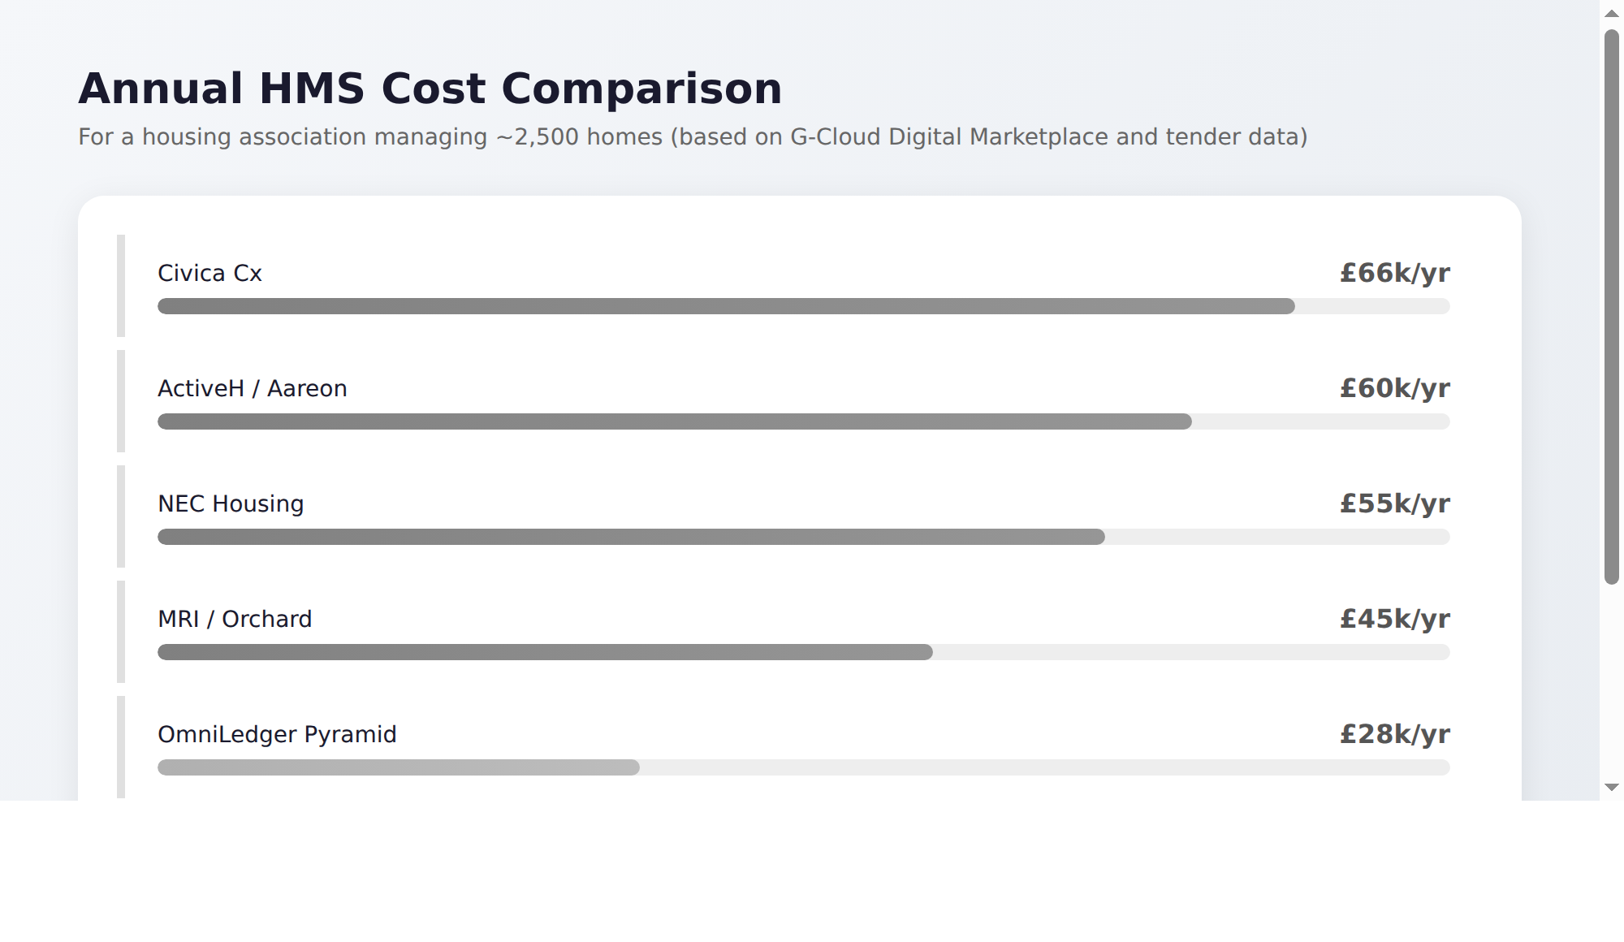

Feature Comparison
Capability | Aareon QL | Civica Cx | MRI | SocialHomes.Ai
Cloud-native | Hosted | Partial | Partial | Yes (GCP)
AI integrated into workflows | No | Bolt-on | Bolt-on | Yes (Claude)
Awaab's Law countdown timers | Patch | Patch | Patch | Built-in
TSM reporting | Module | Module | Module | Built-in
Peer benchmarking (RSH data) | No | No | No | Yes
Predictive maintenance AI | No | No | No | Yes
HACT v3.5 native data model | No | No | No | Yes
Daily AI briefing | No | No | No | Yes
Annual cost (~2,500 homes) | £60–100k | £50–80k | £40–70k | £20k

Defensible Moats
- AI-native architecture — Cannot be replicated by bolting AI onto 30-year-old codebases
- HACT v3.5 from the data model up — First HMS built on the UK Housing Data Standard natively
- Consortium governance — Customers shape the roadmap via a Board seat
- Network effects — More organisations = better AI models via anonymised benchmarking
- Cost structure — AI-assisted development + offshore team delivers significantly lower build cost
- Regulatory head-start — Awaab's Law, TSM, Complaint Code built in from the start
- Full-spectrum pricing — 5 tiers from £20k to £500k covers every provider size

9. Business Model & Pricing

Five-Tier Pricing Model
Pricing scales with provider size, reflecting the complexity of implementation, the number of users, and the value delivered. Each tier undercuts incumbent vendors by 50–75%.
Segment | Homes | Annual SaaS | Implementation | Price/Home/Yr
Small | 1,000 – 5,000 | £20,000 | £15,000 | £4 – £20
Mid-market | 5,000 – 15,000 | £80,000 | £40,000 | £5.33 – £16
Large | 15,000 – 30,000 | £150,000 | £75,000 | £5 – £10
Enterprise | 30,000 – 50,000 | £250,000 | £120,000 | £5 – £8.33
G15/Mega | 50,000 – 125,000 | £500,000 | £200,000 | £4 – £10

This pricing structure means our smallest customers pay £20k/yr (vs £40–100k for incumbents) while our largest G15 customers pay £500k/yr (vs £1–2M+ for NEC/Capita). The value proposition is consistent across segments: better technology at a lower price.

Revenue Streams
- Stream 1: Consortium Co-Development Contributions
10 founding housing associations each contribute £15,000 over 24 months in quarterly instalments of £1,875. Total: £150,000. This represents less than 0.1% of a typical small HA's annual revenue. In return: perpetual licence, code access, Board seat, influence over roadmap priorities.
- Stream 2: SaaS Subscriptions (5 tiers as above)
Annual subscriptions ranging from £20,000 for small HAs to £500,000 for G15 members. All-inclusive — AI features, hosting, updates, and support are included in the subscription.
- Stream 3: Implementation & Migration Fees (one-off)
Data migration, system configuration, and staff training. Ranges from £15,000 (small) to £200,000 (G15). These are one-off revenues that provide early cash flow.
- Stream 4: Managed Hosting & Support (annual)
Premium support tiers, dedicated account management for enterprise customers, SLA-backed response times. Included in the SaaS subscription for standard support.

10. Go-to-Market: From Small HAs to the G15
The market entry strategy is deliberately staged. Each phase builds credibility and reference customers that unlock the next market segment.
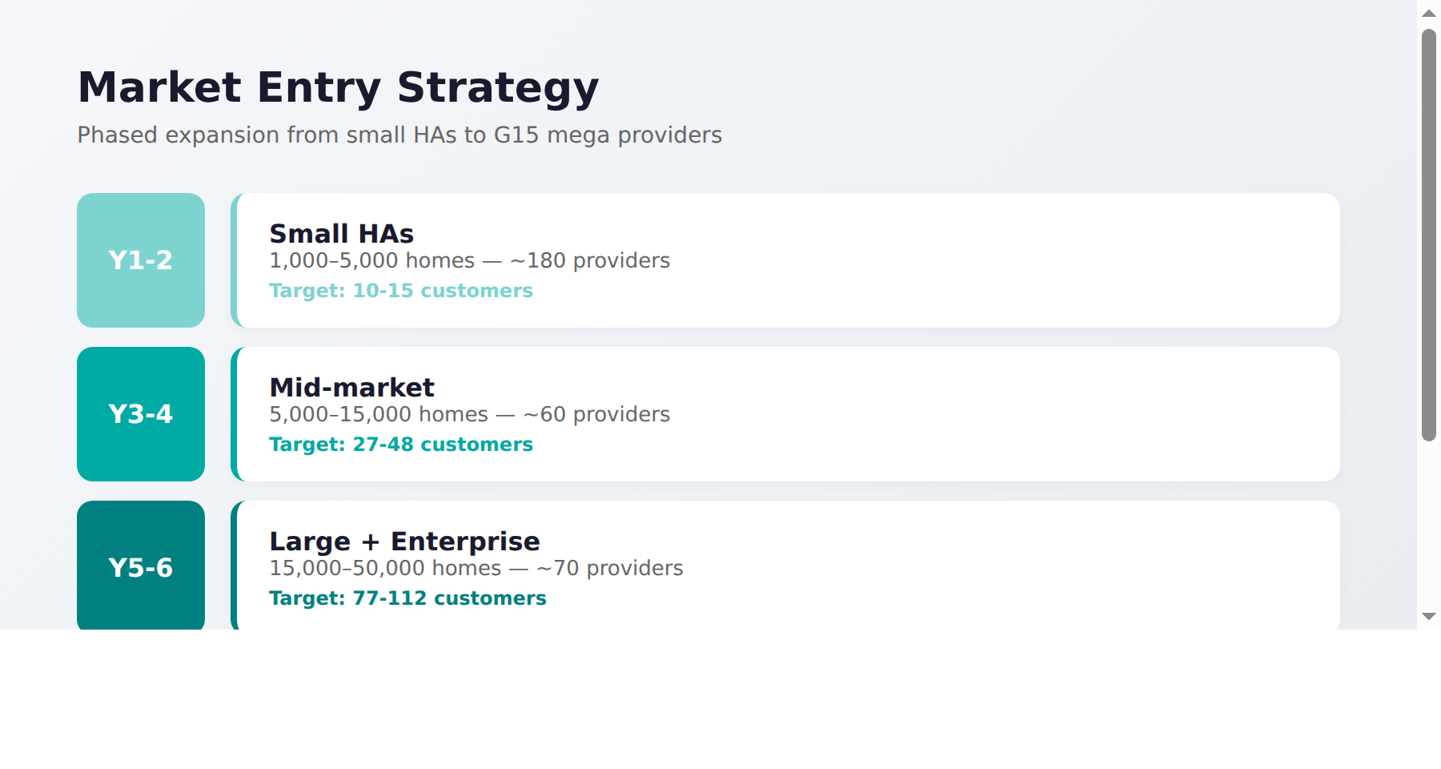

Years 1–2: Small HAs (1,000–5,000 homes) — Prove the Product
10 founding consortium members form the initial customer base. These are organisations large enough to need a proper HMS but small enough to take a risk on a new provider. The £15,000 contribution (quarterly instalments of £1,875) lowers the barrier to commitment. Channel: Direct outreach via 3C (sector engagement partner) with existing relationships across 50+ small-to-mid housing associations.

Years 3–4: Enter Mid-Market (5,000–15,000 homes)
With 14–20 small HA reference customers and a production-proven platform, we enter the mid-market segment. These organisations pay £80k/yr — 4x the small HA tier. This is where the revenue model inflects. By end of Year 4: 40 total customers, £1.66M ARR.

Years 5–7: Large Providers and G15 Entry (15,000–125,000 homes)
ISO 27001 certification, G-Cloud listing, and 40+ reference customers make SocialHomes.Ai eligible for large provider procurement. The first G15 member signs in Year 6 at £500k/yr. By end of Year 7: 109 total customers, £9.5M ARR.

Years 8–10: Market Dominance
The platform is proven across all segments. Network effects from anonymised benchmarking data make SocialHomes.Ai increasingly valuable to each new customer. By Year 10: 242 customers, £32.4M ARR, 10 G15/mega provider contracts.

11. Financial Projections — 3-Year Detailed
All projections assume the consortium forms in winter 2026, with first contributions received in Q3 FY 26/27 (October–December 2026). The 24-month build programme runs from winter 2026 to winter 2028, with production release and SaaS sales commencing in FY 28/29.

Revenue Forecast
Revenue Stream | FY 26/27 | FY 27/28 | FY 28/29
Consortium (10 x £15k over 24m) | £75,000 | £75,000 | —
SaaS — Small HAs | — | £50,000 | £400,000
SaaS — Mid-market HAs | — | — | £320,000
Total Revenue | £75,000 | £125,000 | £720,000

Note: Years 1-2 are build years. No SaaS sales in Year 1. 1-2 early SaaS customers in Year 2 (from consortium demo pipeline). Year 3 is the first real sales year once the product is production-ready.

Cost Forecast — People
Role | Location | FY 26/27 | FY 27/28 | FY 28/29
Founder / CTO | UK | £95,000 | £95,000 | £95,000
Employer NI & pension (UK roles) |  | £6,000 | £16,000 | £26,000
Full-Stack Developers (2→3→5) | Offshore | £50,000 | £75,000 | £125,000
VAT on offshore services (20%) |  | £10,000 | £15,000 | £25,000
Sales / BD (from Y2) | UK | — | £45,000 | £50,000
DevOps Engineer (from Y3) | Offshore | — | — | £28,000
Customer Success (from Y3) | UK part-time | — | — | £30,000
Subtotal People |  | £161,000 | £246,000 | £379,000

UK employer costs include 13.8% NI + 3% pension auto-enrolment. Offshore services via Yantra Works incur 20% VAT (reverse charge mechanism). Founder salary of £95k structured as salary + dividends for tax efficiency.

Cost Forecast — Other
Category | FY 26/27 | FY 27/28 | FY 28/29
Independent QA/testing company | £15,000 | £20,000 | £25,000
Cloud hosting & AI APIs | £14,000 | £23,000 | £50,000
Legal, compliance, Cyber Essentials | £12,000 | £18,000 | £27,000
Marketing & conferences | £10,000 | £20,000 | £45,000
Grant funding applications | £15,000 | £15,000 | £15,000
Admin & insurance | £8,000 | £10,000 | £16,000
Subtotal Other | £74,000 | £106,000 | £178,000

Profit & Loss Summary — 3-Year
Line Item | FY 26/27 | FY 27/28 | FY 28/29
Total Revenue | £75,000 | £125,000 | £720,000
Total Costs | (£235,000) | (£352,000) | (£557,000)
Net Profit / (Loss) | (£160,000) | (£227,000) | +£163,000
Cumulative Position | (£160,000) | (£387,000) | (£224,000)

The cumulative funding requirement is £387,000 at the end of Year 2, reducing to £224,000 by end of Year 3. Funded by: consortium contributions (£150,000) + investment (£250,000) = £400,000 total available. The gap closes further in Year 4 as mid-market sales accelerate. The business becomes self-sustaining from Year 4 onward, generating 40%+ gross margins.

12. Financial Projections — 10-Year Growth Model
The 10-year model shows how revenue scales dramatically as the platform moves into higher-value market segments, while costs grow more slowly due to platform leverage and AI-assisted operations.



Year | Headcount | Total Costs | Revenue | Net Profit / (Loss)
Y1 (FY 26/27) | 5 + testing co | £375k | £200k | (£175k)
Y2 (FY 27/28) | 7 | £490k | £280k | (£210k)
Y3 (FY 28/29) | 12 | £750k | £720k | (£30k) ~breakeven
Y4 | 18 | £1.1M | £1.66M | +£560k
Y5 | 25 | £1.8M | £3.39M | +£1.59M
Y6 | 35 | £2.8M | £5.94M | +£3.14M
Y7 | 50 | £4.2M | £9.51M | +£5.31M
Y8 | 65 | £5.8M | £13.76M | +£7.96M
Y9 | 80 | £7.2M | £18.26M | +£11.06M
Y10 | 95 | £8.5M | £24.46M | +£15.96M



Cumulative profit through 10 years: approximately £45M. Investment recovered in Year 4. By Year 10: 242 customers, £32.4M ARR, 95 employees, and a platform serving the entire UK social housing market from small HAs to the G15.

13. Team & Resourcing
The team scales with revenue — starting lean and growing only as customer demand requires. This is a capital-efficient approach that avoids the common startup mistake of hiring ahead of revenue.

Year 1 Team (5 people + testing company)
Role | Location | Annual Cost | Notes
CTO / Architect | UK | £95,000 | Could be founder at reduced salary
Full-Stack Developer x3 | Offshore (Yantra) | £90,000 (£30k each) | Supervised by CTO
Product Manager / BA (0.3 FTE) | UK contract | £25,000 | Housing domain expertise
Independent QA/Testing co | UK | £60,000 | Functional, security, pen testing
Year 1 Total |  | £270,000

Year 2 Team (7 people)
Addition | Location | Annual Cost | Notes
DevOps Engineer | Offshore | £28,000 | Infrastructure, monitoring, deployment
Customer Success | UK | £30,000 | Onboarding, training, support
Year 2 Total (all roles) |  | ~£330,000 | Including Y1 team

Year 3 Team (12 people)
Addition | Location | Annual Cost | Notes
Additional developers x3 | Offshore | £90,000 (£30k each) | Scale for mid-market features
Sales Lead | UK | £65,000 | Dedicated sales for SaaS growth
Data Engineer | Offshore | £30,000 | Data migration, reporting, analytics
Year 3 Total (all roles) |  | ~£475,000 | Full team with increments

Scaling to 95 People by Year 10
The team grows proportionally with customer base and revenue:
Phase | Headcount | Key Additions
Years 1–2 (Prove) | 5–7 | Core engineering team + testing company
Years 3–4 (Grow) | 12–18 | Sales, data engineering, additional devs, customer success
Years 5–6 (Scale) | 25–35 | Enterprise sales, implementation team, dedicated security
Years 7–8 (Expand) | 50–65 | Product teams per segment, professional services, account mgmt
Years 9–10 (Dominate) | 80–95 | G15 dedicated team, international R&D, exec leadership

Yantra Works Resourcing Capability
- UK-registered company with onshore account management and 20+ years' senior experience
- Offshore teams available with 1 week notice; option to bring onshore (12-month minimum)
- Cost advantage: offshore senior developer at £25k–£35k/yr vs £70k–£87k UK equivalent (60–70% saving)
- All work supervised by experienced UK-based engineers and independent testing company

14. Minimum Viable Budget Scenario
What could be achieved with consortium revenue alone (£150,000 over 24 months) and no external investment?
Item | Cost (24 months)
Architect (part-time / founder sweat equity) | £0
2 x offshore developers (Yantra) | £60,000
Testing company (reduced scope) | £25,000
Cloud hosting & AI (Claude API) | £15,000
Legal, compliance, marketing | £20,000
Total | ~£120,000

This scenario is viable but very constrained:
- Timeline extends to 3–4 years (vs 2 years with investment)
- Limited feature set — only core modules built to production standard
- No independent testing company for most of the build (security risk)
- No sales and marketing budget — growth relies entirely on word of mouth
- Founder takes no salary for 2+ years (significant personal risk)
- No ISO 27001 certification (limits procurement eligibility for mid-market and above)
- Cannot enter mid-market or enterprise segments — stuck in small HA segment only
- Single point of failure on the architect/founder

Conclusion: The minimum viable budget produces a working product for small HAs eventually, but cannot access the mid-market, large, or G15 segments. The £250,000 investment accelerates time-to-market by 12–18 months AND unlocks the path to £32.4M ARR — the difference between a small niche product and a sector-defining platform.

15. Risk Analysis
Risk | Likelihood | Impact | Mitigation
Consortium fails to reach 10 members | Medium | High | Viable at 7 members (£105k). Low £15k ask reduces barrier. 3C network provides pipeline. Grant funding pursued in parallel.
Slower customer acquisition post-consortium | Medium | Medium | Conservative Year 3 target (24 = 1.6% of TAM). NEC OHMS end-of-life creating forced migration wave.
Mid-market entry takes longer than projected | Medium | Medium | Small HA revenue covers costs through Year 3. Mid-market is additive, not required for survival.
G15 contracts harder to win than projected | Medium | Low | G15 revenue is Year 6+ upside. The model is profitable from Year 4 without any G15 contracts.
Data migration complexity | High | Medium | HACT v3.5 standard reduces variability. 3-month parallel running. Migration scripts for top 4 source systems.
Claude API costs exceed estimates | Low | Low | Haiku handles 80% of queries at 1/3 cost. Total AI cost is ~£256/month even at 242 customers.
Incumbent vendor response | Medium | Low | Legacy vendors cannot easily retrofit AI into 30-year-old codebases. Their strategy suggests buy-not-build.
Security breach | Low | High | Independent testing company, Cyber Essentials+, CREST pen testing, UK-only data, ISO 27001 from Y2.
Key person dependency | Medium | Medium | Code documented, 625 tests, GitHub access for consortium. Team scales to 95 by Y10.
Funding shortfall | Low | High | Minimum viable budget scenario shows viability at £150k. Multiple paths: grants, investment, revenue.

16. Comparable Companies & Exit Scenarios

UK Housing PropTech Benchmarks
Company | Focus | Funding Raised | Revenue | Customers | Valuation
Plentific | Repairs & maintenance SaaS | ~$136–166M (incl. $100M Series C) | $21.1M | 100 | Not disclosed
Switchee | Smart thermostat / IoT | $20.1M (6 rounds) | $11.6M | 130+ | $1.63B (Jul 2024)
FaultFixers | Maintenance management | £421K (grant + investment) | N/A | Growing | Early stage
Localz | Last-mile engagement | $7.44M (3 rounds) | N/A | 10+ | Acquired for $6.2M
Sources: TechCrunch, GetLatka, UK Tech News, Descartes Systems Group

Switchee's $1.63 billion valuation from $20M in funding demonstrates the extraordinary multiples achievable in UK housing PropTech. Plentific's $100M Series C shows deep investor appetite for the sector. SocialHomes.Ai targets the core HMS market — a larger opportunity than either Switchee (IoT) or Plentific (repairs only).

Exit Scenarios
Scenario | Timeline | Indicative Value | Notes
A. Organic growth (base case) | Ongoing | £32.4M ARR by Year 10 | Self-sustaining from Year 4, highly profitable
B. Strategic acquisition | Year 5–7 | £20M–£76M (5–8x ARR) | MRI, Aareon, Capita, or PE firm
C. Full-scale exit at Year 10 | Year 10 | ~£260M (8x ARR) | 242 customers, market leader
D. Series A raise | Year 3–4 | £5M–£10M at £20M–£40M pre-money | Accelerate mid-market entry
E. Grant + organic | Year 1–3 | Reduced dilution | Innovate UK / PropTech Fund

The maths: £250k invested. Year 10 ARR: £32.4M. At 8x revenue multiple: £260M valuation. That is a 1,000x return. Even at a conservative 5x multiple, the valuation is £122M — a 254x return. These multiples are standard for high-growth vertical SaaS businesses in regulated sectors.

17. Investment Ask
Yantra Works Ltd is seeking £250,000 in investment.
This investment, combined with £150,000 in consortium contributions, funds the bridge from a 50–55% complete prototype to a production platform serving the entire UK social housing market. The total funding available is £630,000, with breakeven achieved in Year 3 and strong profitability from Year 4 onwards.

Detailed Use of Funds
Category | Amount | % of Total | What It Covers
Production engineering | £240,000 | 50% | 3 fullstack developers + CTO oversight for 24 months
Independent QA/testing | £60,000 | 12.5% | Functional, security, accessibility, CREST pen testing
Cloud infrastructure & AI | £48,000 | 10% | GCP hosting, Claude API, monitoring, dev tools
Sales & marketing | £50,000 | 10.4% | Conferences, content, 3C partnership, early sales
Legal, compliance, ISO 27001 | £42,000 | 8.8% | Contracts, GDPR DPIAs, Cyber Essentials+, ISO prep
Contingency | £40,000 | 8.3% | Buffer for delays, scope changes, market conditions
Total | £250,000 | 100%

Investment Structure Options
Option | Structure | Suited To
A. Revenue-based financing | £250k loan, repaid at 8–12% of monthly revenue until 1.5x returned | Banks / credit facilities
B. Convertible loan note | £250k at agreed interest, convertible to equity at next raise | Angel investors
C. Equity investment | £250k for negotiable minority stake in Yantra Works Ltd | Strategic investors
D. Blended (grant + investment) | Grant + smaller private investment = lowest dilution | See grant options below

Grant Funding Options
Grant Programme | Available | Fit | Notes
Innovate UK Smart Grants | Up to £500k | Strong | Disruptive innovation in regulated sector
PropTech Innovation Fund | Variable | Strong | Directly targeted at property technology
Social Housing Decarbonisation Fund | Variable | Tangential | Energy/damp features may qualify
UKRI / AHRC | Variable | Moderate | AI in public services research funding

Return Profile
Metric | Value
Investment amount | £250,000
Consortium contributions | £150,000 (10 x £15,000 over 24 months)
Total funding | £630,000
Breakeven year | Year 3 (FY 28/29)
Investment recovered | Year 4
Year 5 ARR | £3.39M
Year 10 ARR | £24.46M
Year 10 valuation (8x ARR) | £260M
Return multiple on £250k | ~1,000x
Cumulative profit (10 years) | ~£45M
All IP remains with | Yantra Works Ltd

18. Key Milestones
Date | Milestone | Measure of Success
Q2 2026 | Investment secured / grant application | Funds available
Q2–Q3 2026 | Sales pipeline built | 30+ qualified leads from conferences / 3C
Winter 2026 | Consortium Board formed | 10 housing associations committed
Q4 2026 | Production team hired | 5 people in place (CTO + 3 devs + PM)
Q1 2027 | Full CRUD operations complete | All modules support create, update, delete
Q2 2027 | Alpha release to 3 consortium members | Parallel running with existing HMS
Q3 2027 | Cyber Essentials+ certification | Certification obtained
Q4 2027 | Beta release to all 10 consortium | UAT underway
Q1 2028 | Multi-tenancy complete | 10 isolated tenant environments
Q1 2028 | ISO 27001 implementation begins | Gap analysis complete
Q2 2028 | First non-consortium SaaS customer | Contract signed
Q3 2028 | Production v1.0 release | All consortium members live
Q1 2029 | G-Cloud listing achieved | Listed on Digital Marketplace
Mid 2029 | ISO 27001 certification | Independent audit passed
Q4 2029 | 24 customers live, ~breakeven | Year 3 targets met
2030 | First mid-market customer (5k+ homes) | Contract at £80k/yr tier
2031 | First enterprise customer (30k+ homes) | Contract at £250k/yr tier
2032 | First G15 member signed | £500k/yr contract — sector validation
2033–36 | Market leadership established | 242 customers, £32.4M ARR

Appendix A: About Yantra Works Ltd
Yantra Works Ltd (yantra.works) is a UK-registered technology consultancy providing:
- Independent, vendor-agnostic advisory to CIOs and C-suite leaders
- Strategy-to-prototype rapid validation — working with senior leadership to rapidly prototype solutions
- Vendor selection and enablement — choosing the right technologies and governing suppliers
- Flexible resourcing (onshore, offshore, hybrid) with 20+ years' senior experience

The Yantra Framework: Agentic AI Development
Yantra Works has developed a proprietary framework for agentic AI software development. Seven specialised AI agents work in a structured pipeline under human supervision:
- Business Analyst agent: Creates specifications and execution plans from requirements
- Fullstack Developer agent: Implements backend and frontend code following architecture patterns
- Frontend Developer agent: Builds responsive UI components with Tailwind CSS and React
- UI/UX Designer agent: Audits designs for consistency, accessibility, and usability
- QA Tester agent: Writes and runs automated tests (Playwright, Vitest)
- Cyber Security agent: Audits code for OWASP Top 10, secret scanning, dependency vulnerabilities
- DevOps agent: Configures CI/CD pipelines, Docker, Cloud Run deployment
This framework reduces development costs by approximately 40% compared to traditional approaches, while an independent testing company provides human verification.

Key personnel:
- Rajiv Peter — Founder & Managing Director. Contact: rajiv@yantra.works

Partners:
- 3C — Sector engagement partner with deep housing association relationships and implementation expertise. Responsible for consortium recruitment and housing domain advisory.

Appendix B: Glossary for Non-Housing Readers
Term | Meaning
Housing Association (HA) | Not-for-profit organisation that provides social housing
Registered Provider (RP) | Formal regulatory term for a housing association registered with the RSH
HMS | Housing Management System — the core operational software used by housing providers
RSH | Regulator of Social Housing — the government regulator for social housing in England
TSM | Tenant Satisfaction Measures — 22 mandatory satisfaction metrics collected annually
Awaab's Law | Legal requirement for timed response to damp, mould, and hazard reports
Big 6 | Six key safety compliance areas: Gas, Electrical, Fire, Asbestos, Legionella, Lifts
G15 | London's 15 largest housing associations, collectively managing 800,000+ homes
HACT | Housing Associations' Charitable Trust — sets the UK Housing Data Standard
SOR Code | Schedule of Rates — standardised pricing for repair work
Void | An empty property between tenancies
Arrears | Unpaid rent owed by a tenant
Universal Credit (UC) | UK welfare payment system that replaced Housing Benefit
ALMO | Arms-Length Management Organisation — council housing managed at arm's length
PropTech | Property Technology — technology companies serving the real estate sector
ARR | Annual Recurring Revenue — predictable yearly revenue from subscriptions
SaaS | Software as a Service — cloud-hosted subscription software
G-Cloud | UK government procurement framework for cloud services
GDPR | General Data Protection Regulation — EU/UK data protection law
DPIA | Data Protection Impact Assessment — required for processing sensitive personal data
ISO 27001 | International standard for information security management systems
Claude | Anthropic's large language model (LLM) used as the AI engine in SocialHomes.Ai
Agentic AI | AI systems that can take autonomous actions within defined boundaries under supervision
Multi-tenancy | Architecture where one application serves multiple organisations with isolated data
CREST | Council of Registered Ethical Security Testers — UK penetration testing standard

Appendix C: Sources & References

Market Data
- RSH Statistical Data Return 2024-25 (GOV.UK)
- RSH Global Accounts of Private Registered Providers 2025 (GOV.UK)
- RSH Value for Money Metrics and Reporting 2025 (GOV.UK)
- ARCH Housing — Association of Retained Council Housing
- HACT UK Housing Data Standards v3.5
- Housing Today — Largest 50 Housing Associations 2025
- G15 member annual reports and accounts 2024-25

Regulatory
- GOV.UK — Awaab's Law Guidance for Social Landlords
- Social Housing (Regulation) Act 2023
- RSH Tenant Satisfaction Measures 2024-25 Headline Report
- Housing Ombudsman Complaint Handling Code 2024
- Housing Ombudsman Annual Complaints Review 2024-25
- RSH Consumer Regulation Review 2023-24

Procurement & Pricing
- Sector benchmarks for HMS costs across all provider sizes
- Find a Tender Service — HMS contract notices 2024-25
- Contracts Finder — Housing management software awards
- CCS Framework RM6259 — Vertical Application Solutions

AI & Technology
- Anthropic Claude API Pricing (anthropic.com)
- Anthropic Claude Model Cards — Sonnet 4, Haiku 4.5
- Google Cloud Run Pricing (cloud.google.com)
- Google Cloud Firestore Pricing (cloud.google.com)

Market Analysis
- Market Research Future — UK PropTech Market Report 2024
- Grand View Research — UK PropTech Market Size & Trends
- Beauhurst — Top 10 PropTech Companies in the UK
- CRETI — 2024 PropTech Venture Capital Report

Comparable Companies
- TechCrunch — Plentific $100M Series C
- UK Tech News — Switchee $1.63B valuation (July 2024)
- GetLatka — Plentific and Switchee revenue data
- Descartes Systems Group — Localz acquisition ($6.2M)

Grant & Funding Programmes
- Innovate UK Smart Grants (apply.innovateuk.org)
- PropTech Innovation Fund
- Social Housing Decarbonisation Fund (GOV.UK)
- UKRI / AHRC AI research funding programmes

Standards & Certification
- ISO/IEC 27001:2022 — Information Security Management Systems
- IASME — Cyber Essentials+ Certification
- OWASP Top 10 — Web Application Security Risks
- CREST — Council of Registered Ethical Security Testers

Prepared by Yantra Works Ltd | yantra.works | rajiv@yantra.works
March 2026 | Version 3.0 | COMMERCIALLY SENSITIVE & CONFIDENTIAL

